Код программы №1:

KK2 STORAGE 2
KK4 STORAGE 3
KK5 STORAGE 4

GENERATE 7,5
TRANSFER .5,K1,K2

K1 QUEUE LOL1
SEIZE KK1
DEPART LOL1
ADVANCE 10,3
RELEASE KK1
TRANSFER ,OUT1

K2 QUEUE LOL2
ENTER KK2
DEPART LOL2
ADVANCE 35,8
LEAVE KK2

OUT1 TRANSFER .5,K3,K4

K3 QUEUE LOL3
SEIZE KK3
DEPART LOL3
ADVANCE 30,7
RELEASE KK3
TRANSFER ,OUT2

K4 QUEUE LOL4
ENTER KK4
DEPART LOL4
ADVANCE 45,5
LEAVE KK4

OUT2 QUEUE LOL5
ENTER KK5
DEPART LOL5
ADVANCE 20,5
LEAVE KK5

OUT3 TERMINATE 1
START 500
Результат программы №1:
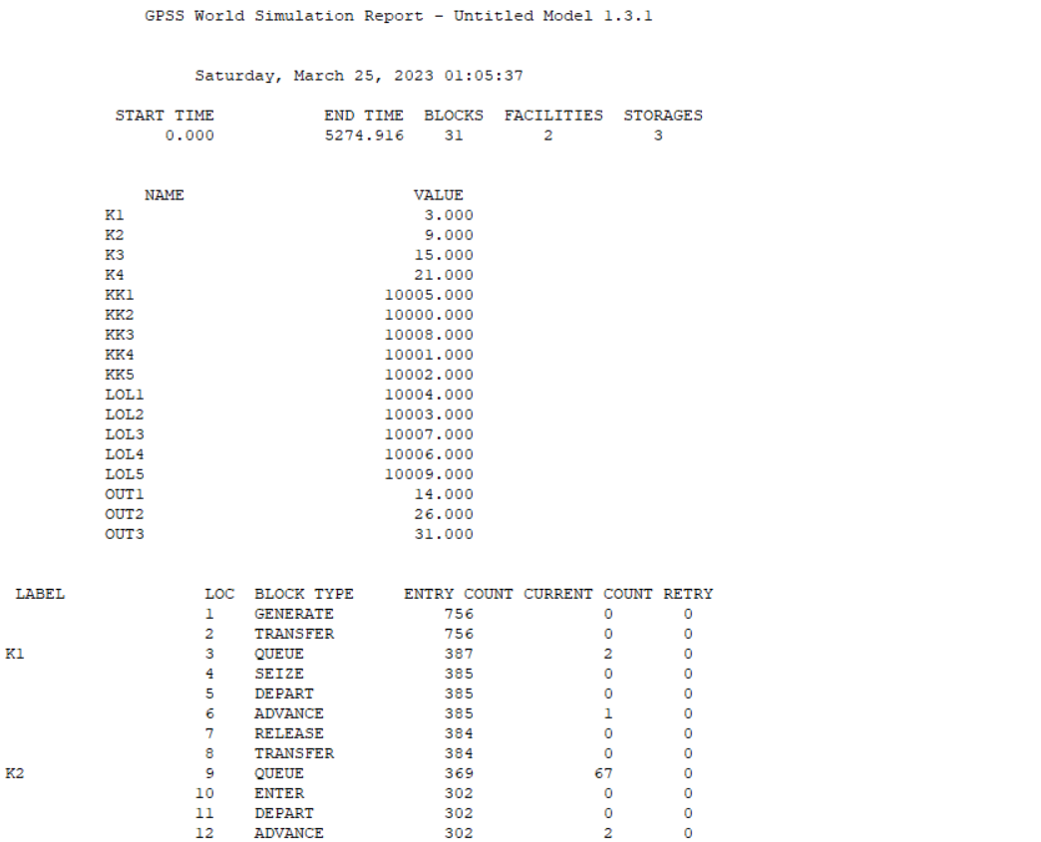
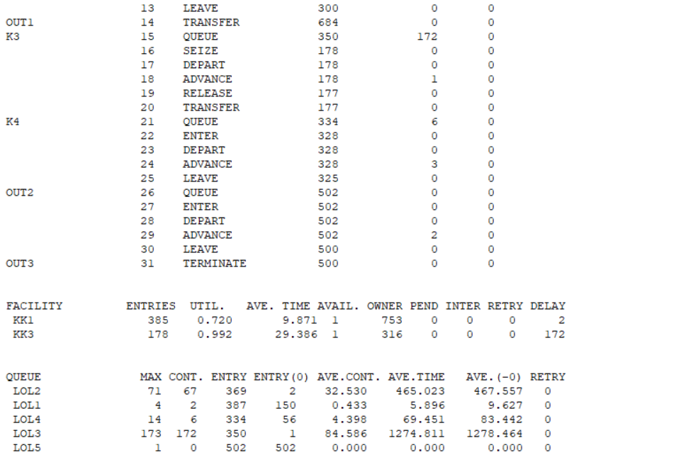
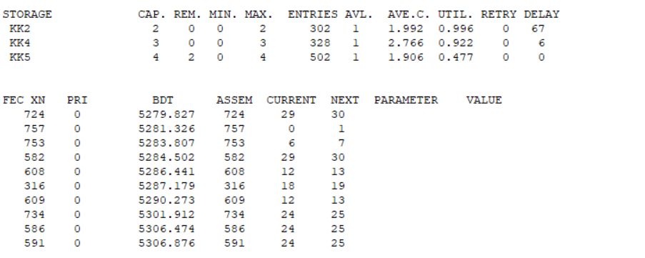
Код программы №2:
KK2 STORAGE 2
KK4 STORAGE 3
KK5 STORAGE 4

GENERATE 7,5
TRANSFER .5,K1,K2

K1 QUEUE LOL1
SEIZE KK1
DEPART LOL1
ADVANCE 10,3
RELEASE KK1
TRANSFER ,OUT1

K2 QUEUE LOL2
ENTER KK2
DEPART LOL2
ADVANCE 35,8
LEAVE KK2

OUT1 TRANSFER .5,K3,K4

K3 QUEUE LOL3
SEIZE KK3
DEPART LOL3
ADVANCE 30,7
RELEASE KK3
TRANSFER ,OUT2

K4 QUEUE LOL4
ENTER KK4
DEPART LOL4
ADVANCE 45,5
LEAVE KK4

OUT2 QUEUE LOL5
ENTER KK5
DEPART LOL5
ADVANCE 20,5
LEAVE KK5

OUT3 TERMINATE
GENERATE 480
TERMINATE 1
START 1
Результат программы №2:

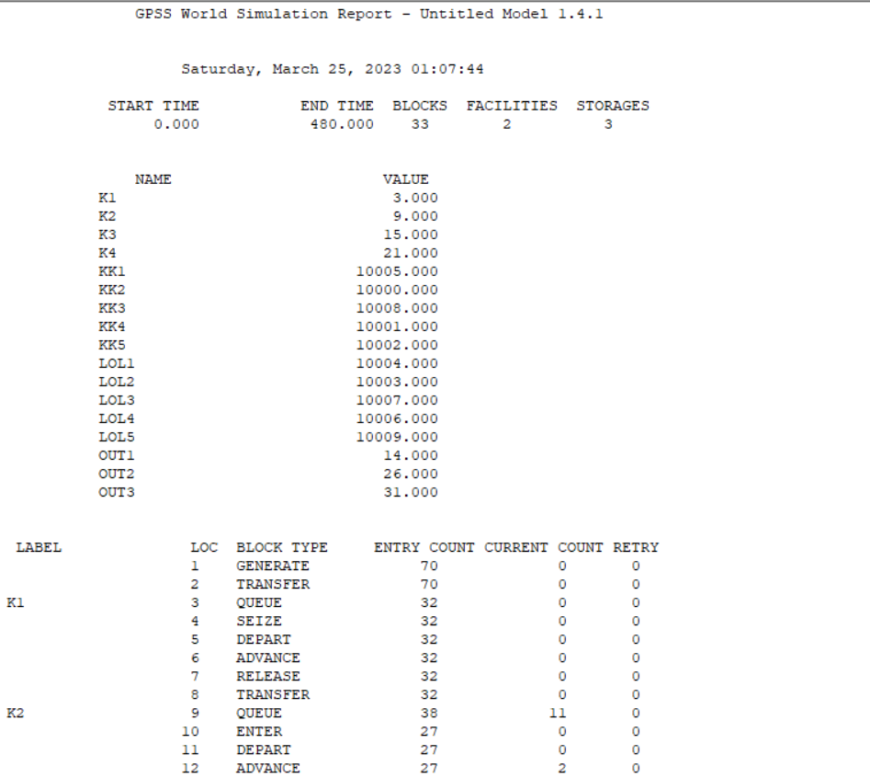
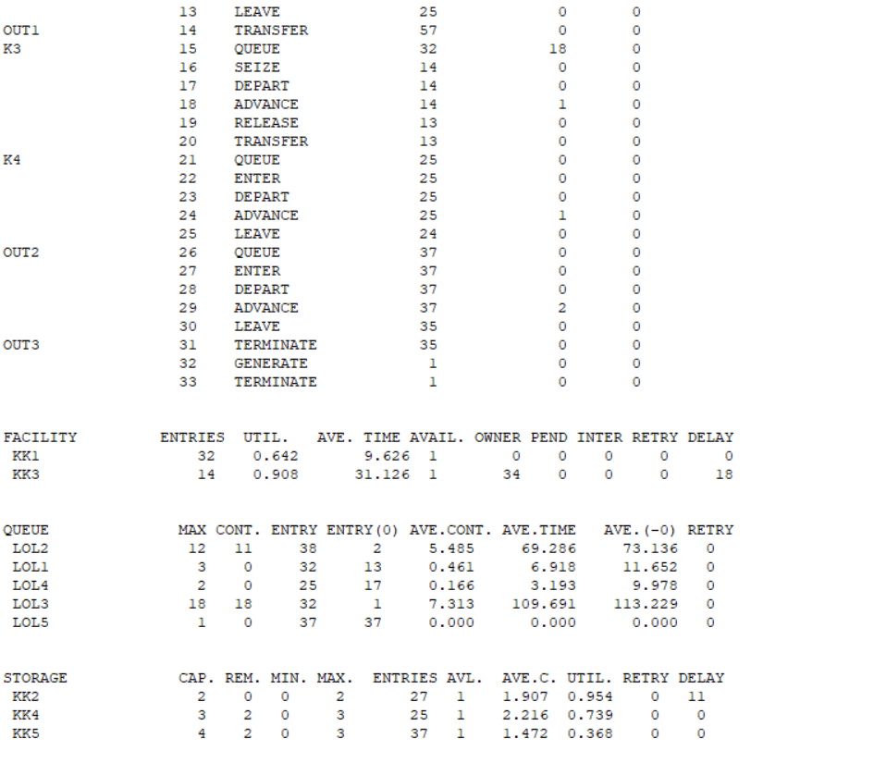

Код программы №3:
KK2 STORAGE 2
KK4 STORAGE 3
KK5 STORAGE 4

GENERATE 7,5
TRANSFER .5,K1,K2

K1 TEST L Q$LOL1,5,COUNTER
QUEUE LOL1
SEIZE KK1
DEPART LOL1
ADVANCE 10,3
RELEASE KK1
TRANSFER ,OUT1
K2 TEST L Q$LOL2,5,COUNTER
QUEUE LOL2
ENTER KK2
DEPART LOL2
ADVANCE 35,8
LEAVE KK2
OUT1 TRANSFER .5,K3,K4
K3 TEST L Q$LOL3,5,COUNTER
QUEUE LOL3
SEIZE KK3
DEPART LOL3
ADVANCE 30,7
RELEASE KK3
TRANSFER ,OUT2
K4 TEST L Q$LOL4,5,COUNTER
QUEUE LOL4
ENTER KK4
DEPART LOL4
ADVANCE 45,5
LEAVE KK4
OUT2 TEST L Q$LOL5,5,COUNTER
QUEUE LOL5
ENTER KK5
DEPART LOL5
ADVANCE 20,5
LEAVE KK5
OUT3 TERMINATE
GENERATE 720
TERMINATE 1
START 3
COUNTER TERMINATE

Результат программы №3:

