

|  |
| --- |
| DevOps Lab  LDAP |
| Home tasks |

## Task 1

1. Spin-up VM-1-server in GCP. It must match next conditions:
   1. OS Centos 7 should be installed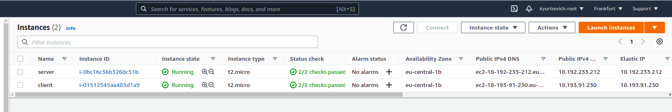
   2. LDAP server should be installed and configured

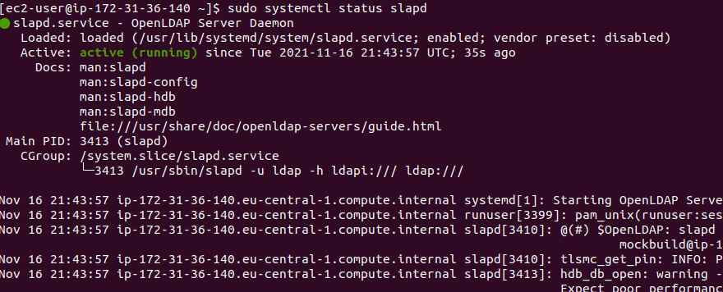

* 1. 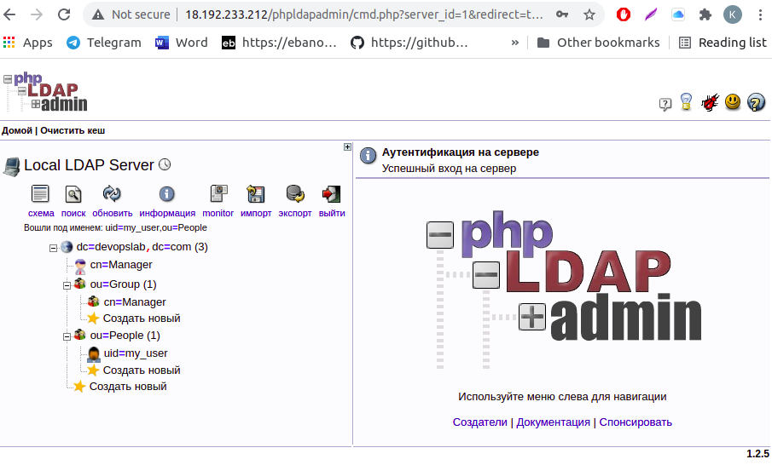UI (phpldapadmin) should be installed
  2. Provision via terraform

## Task 2

1. Spin-up second VM-2-client GCP. It must match next conditions:  
   a. OS Centos 7 should be installed

b. LDAP client installed and configured

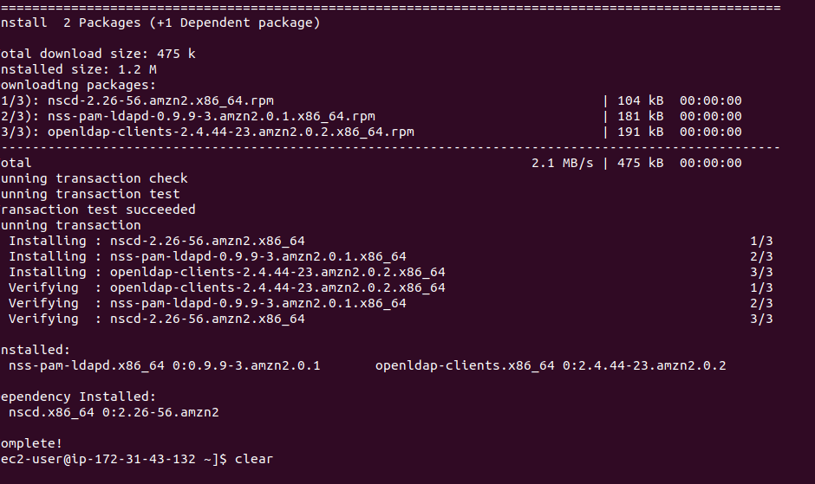

c. Provision via terraform

## Task 3

1. SSH to VM-2-client using ldap username / password

## Hometask requirements

1. GCP account configured
2. SH – scripts for installation/configuring of the necessary applications
3. Screenshots of the application’s state

## helpful materials

* “LDAP” presentation