以下将我们提取到的特征组即为feature1，作为比较的论文中的特征组记为feature2

Feature2中的“venous.nii_exponential_glrlm_RunVariance”特征我们并没有提取到，在特征提取文件pyradiomics的官网上也没找到该特征的内容。

1. 由于论文中并没有具体参数，我们使用SVM的默认参数，输入feature2，得到结果如下图所示，feature2分类效果十分不理想。

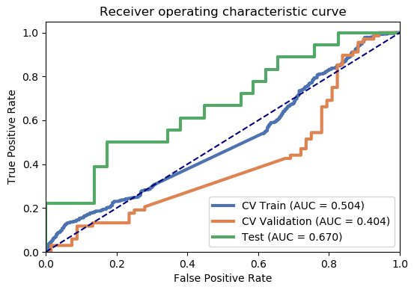

1. 我们比较了feature1和feature2的ICC值和特征分布中的奇异值个数，具体如下表所示。

|  |  |  |  |
| --- | --- | --- | --- |
| 组 | 特征名字 | ICC13 | 奇异值个数 |
| 2 | arterial.nii_wavelet-HLH_glszm_ZoneEntropy | 0.86 | 0 |
| arterial.nii_wavelet-HHL_glrlm_LongRunLowGrayLevelEmphasis | 1.00 | 4 |
| arterial.nii_wavelet-HHL_glszm_LargeAreaHighGrayLevelEmphasis | 1.00 | 3 |
| arterial.nii_original_glszm_LargeAreaLowGrayLevelEmphasis | 1.00 | 3 |
| venous.nii_exponential_glrlm_RunVariance | / | / |
| venous.nii_wavelet-HHL_firstorder_RootMeanSquared | 0.90 | 4 |
| arterial.nii_wavelet-LLH_glcm_SumEntropy | 1.00 | 4 |
| 1 | arterial.nii_original_shape_Maximum2DDiameterSlice | 1.00 | 2 |
| arterial.nii_original_shape_Maximum3DDiameter | 1.00 | 2 |
| arterial.nii_original_shape_Sphericity | 0.96 | 1 |
| arterial.nii_wavelet-LHH_gldm_DependenceEntropy | 1.00 | 0 |
| arterial.nii_wavelet-LHH_gldm_DependenceNonUniformityNormalized | 1.00 | 0 |
| arterial.nii_wavelet-LLH_glszm_GrayLevelNonUniformity | 1.00 | 4 |
| non_contrast.nii_original_firstorder_90Percentile | 1.00 | 3 |
| non_contrast.nii_original_firstorder_Energy | 1.00 | 4 |
| non_contrast.nii_original_shape_LeastAxisLength | 1.00 | 2 |
| non_contrast.nii_original_shape_MajorAxisLength | 1.00 | 2 |
| non_contrast.nii_original_shape_Maximum2DDiameterColumn | 1.00 | 2 |
| non_contrast.nii_original_shape_Maximum2DDiameterRow | 1.00 | 2 |
| non_contrast.nii_original_shape_Maximum2DDiameterSlice | 1.00 | 2 |
| non_contrast.nii_original_shape_Maximum3DDiameter | 1.00 | 3 |
| non_contrast.nii_original_shape_MinorAxisLength | 1.00 | 1 |
| non_contrast.nii_original_shape_Sphericity | 0.95 | 1 |
| non_contrast.nii_original_shape_SurfaceArea | 1.00 | 3 |
| non_contrast.nii_original_shape_SurfaceVolumeRatio | 1.00 | 2 |
| venous.nii_original_shape_Maximum2DDiameterSlice | 1.00 | 2 |

可以看出相比我们提取到的feature1，feature2个别特征ICC13（此处只列出了ICC13，因为它比ICC23低，更加分散）偏低，奇异值个数总体上更多但不明显。总体而言feature1的稳定性好于feature2。

根据以上的结论，请问刘医生您觉得有什么可以在discussion中加入的内容吗，另外这些内容是否需要在result部分中相应补充上数据支持？