use keypoints | accuracy | loss
batch=16 | 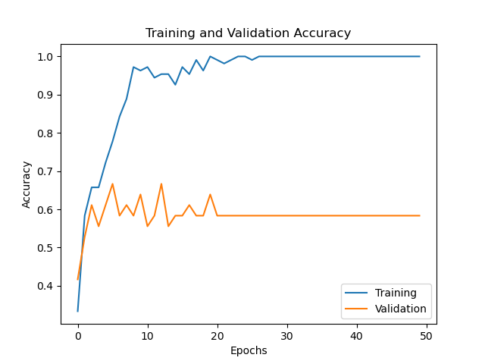  train=1.0, valid=0.58 | 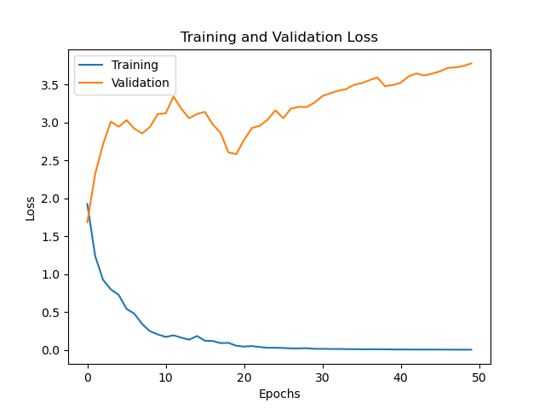  train=0.0045, valid=3.77
batch=32  epoch=50 | 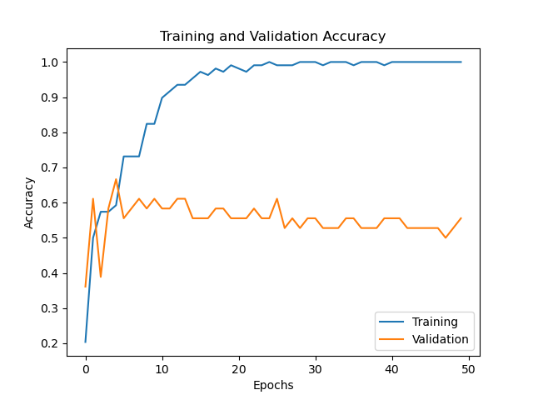  train=1.0, valid=0.055 | 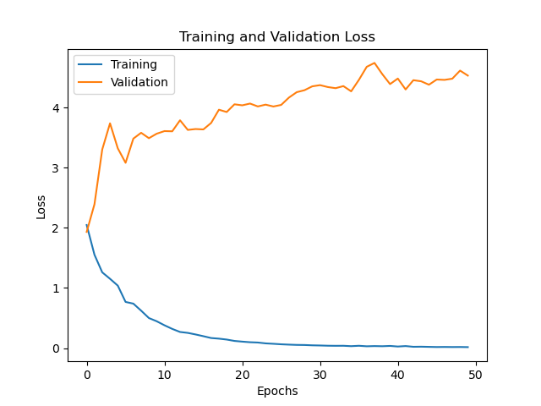  train=0.015, valid=4.53
batch=64  epoch=50 | 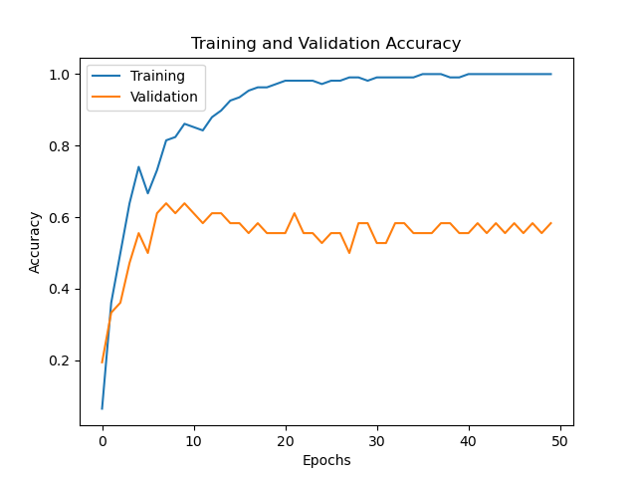  train=1.0, valid=0.58 | 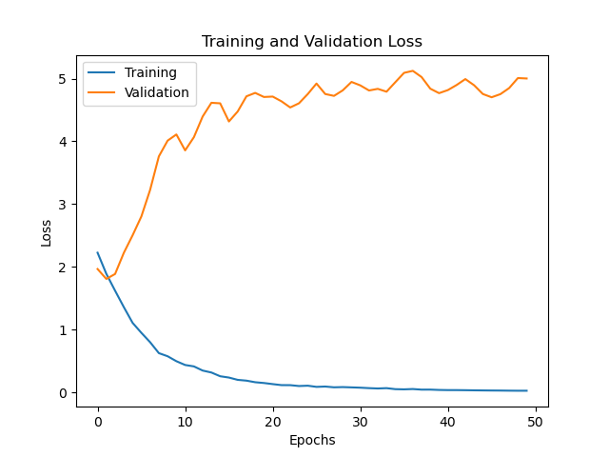  train=0.027, valid=5.00

use frames | accuracy | loss
batch=16  epoch=50  conv+maxpool+conv+maxpool+dropout0.2  dense=128  conv+maxpool+dropout0.2  dense=128  conv+maxpool+conv+maxpool+conv+maxpool+conv+maxpool+dropout0.2  dense=128 | 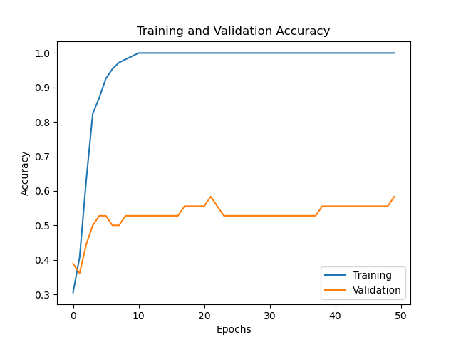  train_acc=1.0. val_acc=0.56  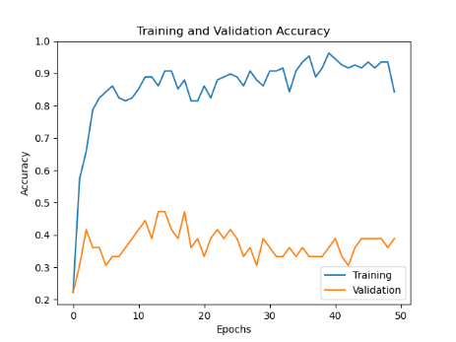  train=0.84, valid=0.39  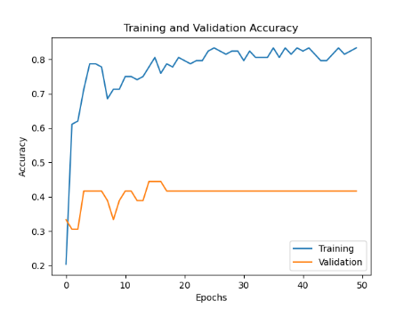  train=0.833 valid=0.4167  train=0.84 valid=0.4167 | 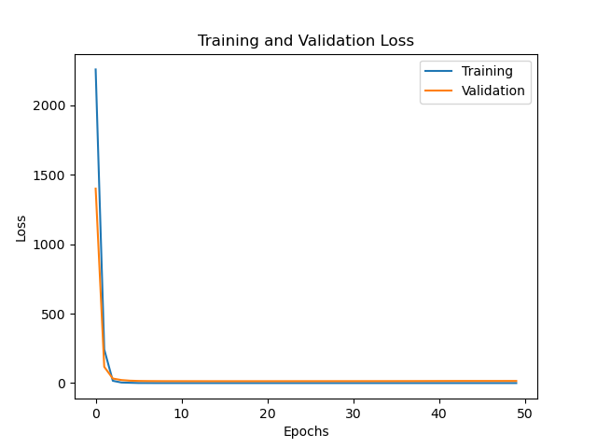  train_loss=0.0. val_loss=15  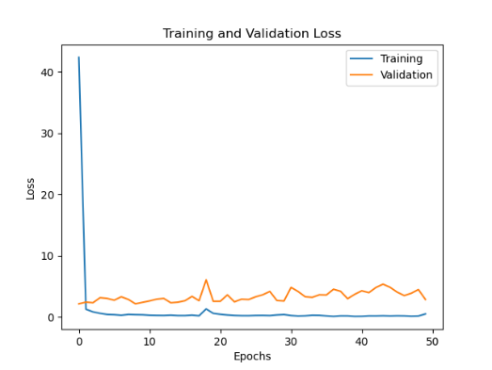  train=0.52, valid=2.87  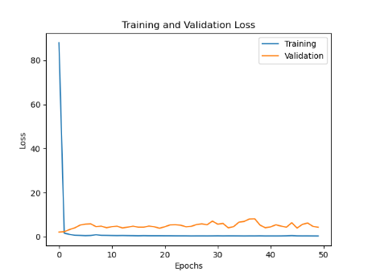  train=0.40, valid=4.37  train=0.38 valid=7.48
batch=32  epoch=50 | 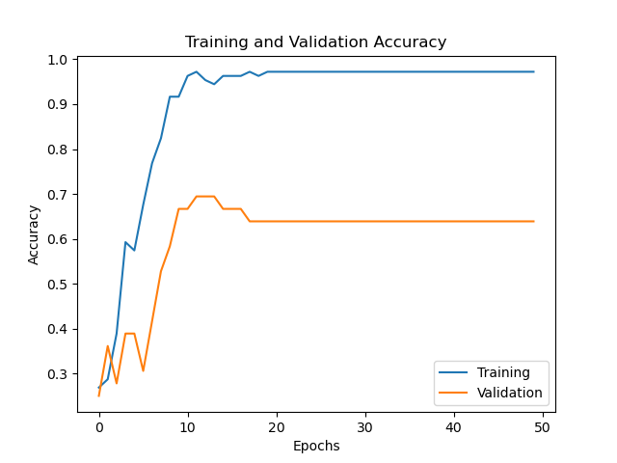  train_acc=0.97. val_acc=0.64 | 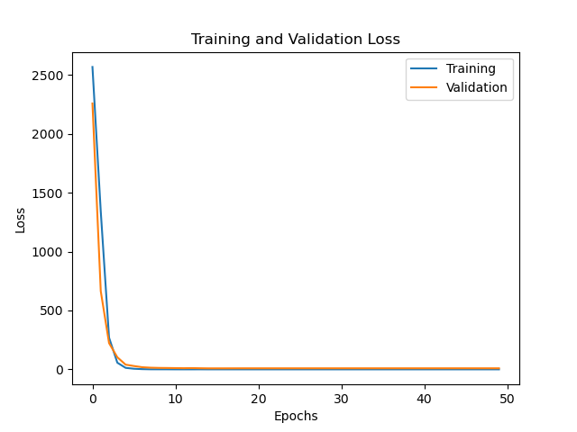  train_loss=0.2. val_loss=9.4,
batch=64  epoch=50 | 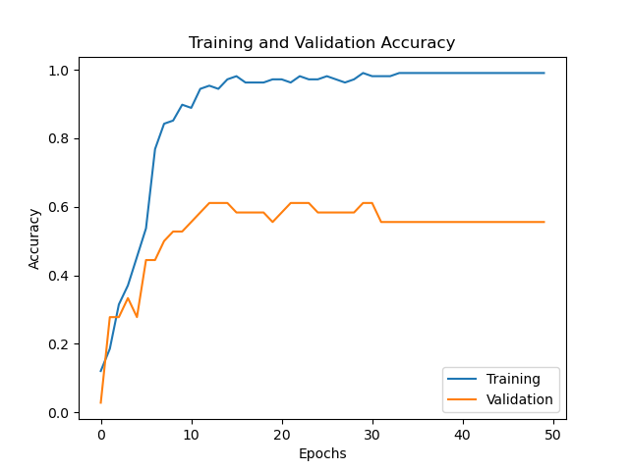  train_acc=0.99. val_acc=0.56 | 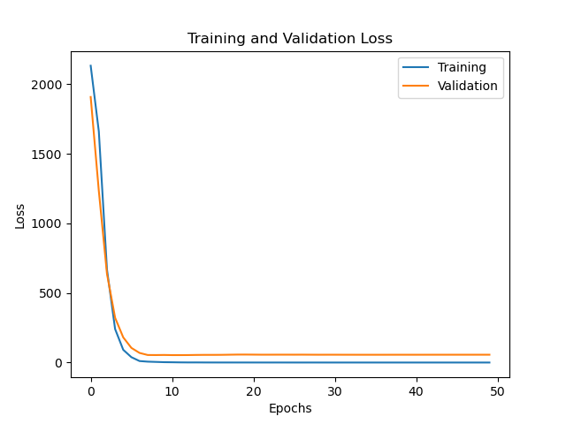  train_loss=0.01. val_loss=56.13,

use frames+key | accuracy | loss
batch=16  epoch=50 | 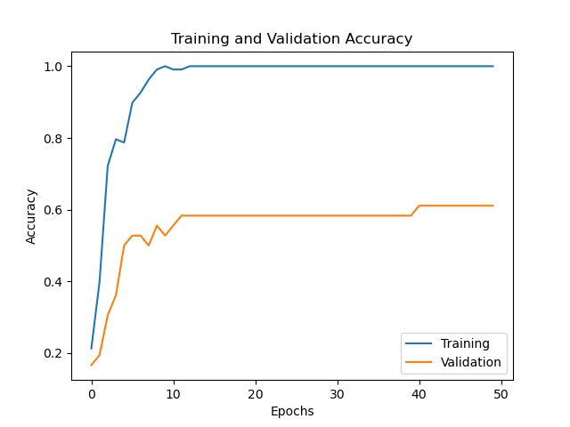  train_acc=1.0. val_acc=0.61 | 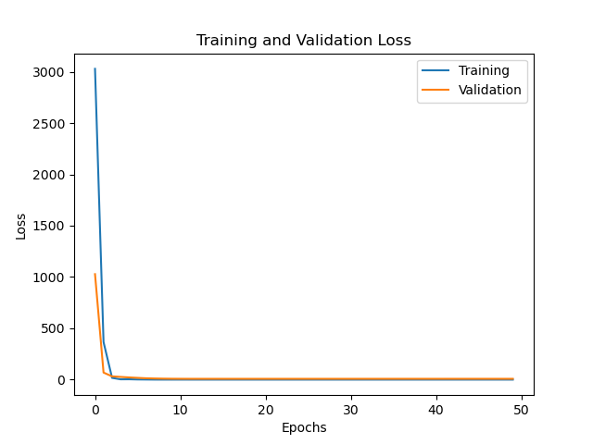  train_loss=0.0. val_loss=7.9
batch=32  epoch=50 | 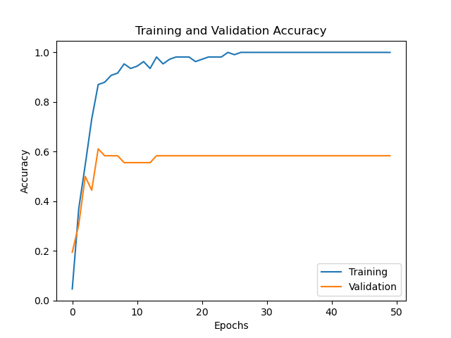  train_acc=1.0 , val_acc=0.58 | 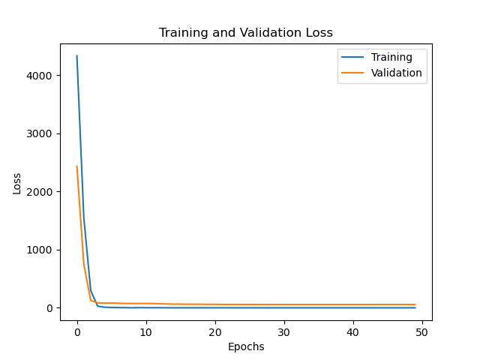  train_loss=0.0. val_loss=56.33,
batch=64  epoch=50 | 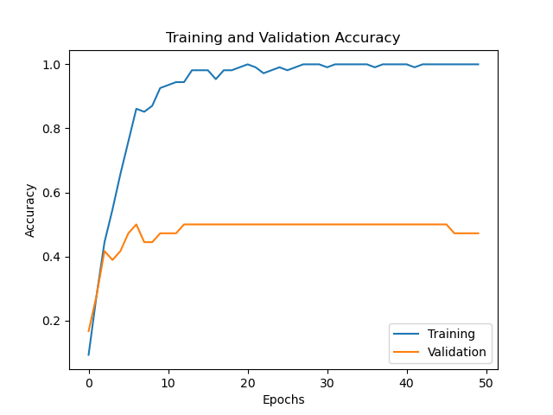  train_acc=1.0. val_acc=0.47 | 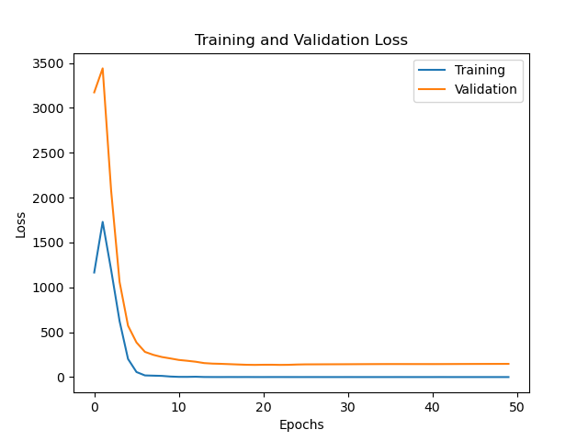  train_loss=0.0. val_loss=146.91

use frames+key  with normalize key+mask | accuracy | loss
batch=16  epoch=50 | 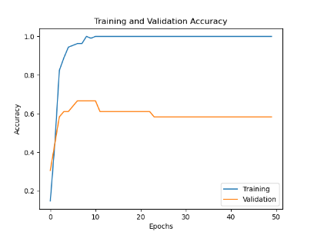  train_acc=1.0. val_acc=0.58 | 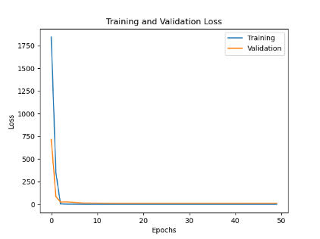  train_loss=0.0. val_loss=12.45
batch=32  epoch=50 | 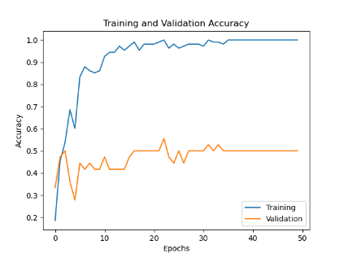  train_acc=1.0 , val_acc=0.5 | 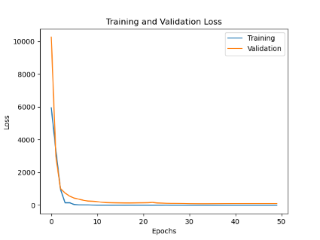  train_loss=0.0. val_loss=102.91
batch=64  epoch=50 | 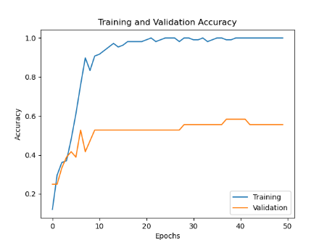  train_acc=1.0. val_acc=0.56 | 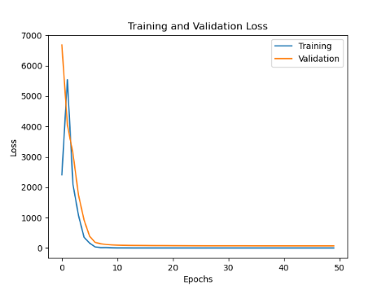  train_loss=0.0. val_loss=66.72

CNN+LSTM on frames
batch =16
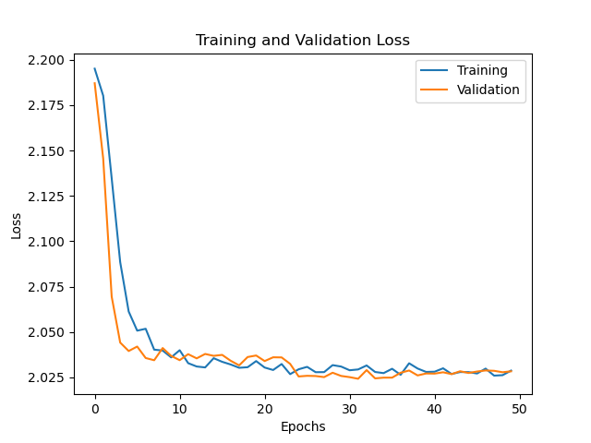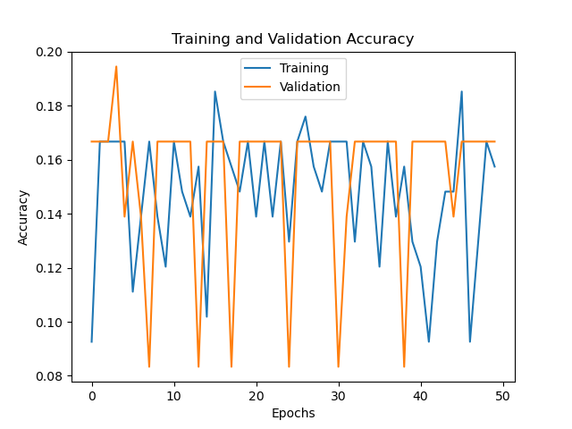add.mask layer

batch=32
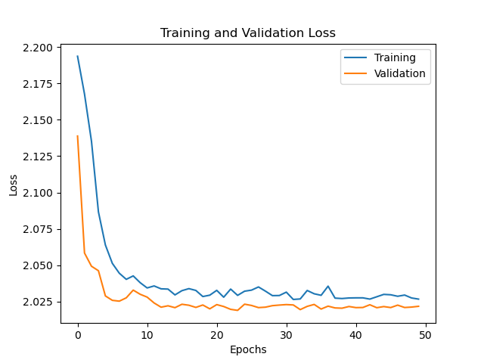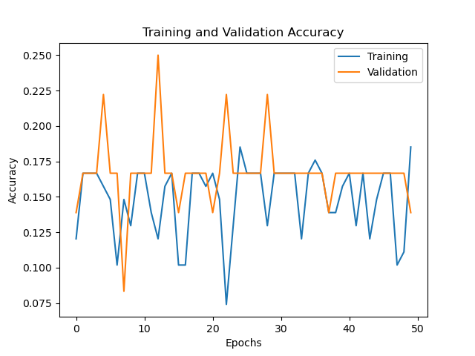with mask layer

use image data generator: train acc = 0.9695 ytain loss = 0.0751, valid acc = 0.2788, valid loss = 3.8421
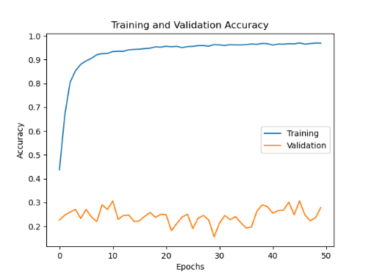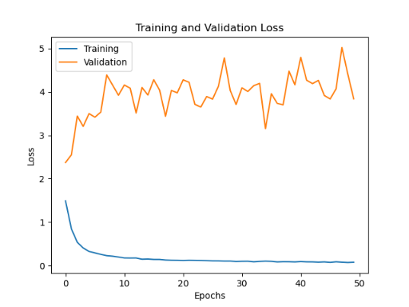
+LSTM : train acc = 0.9524, train
