Temperature changes in Australia

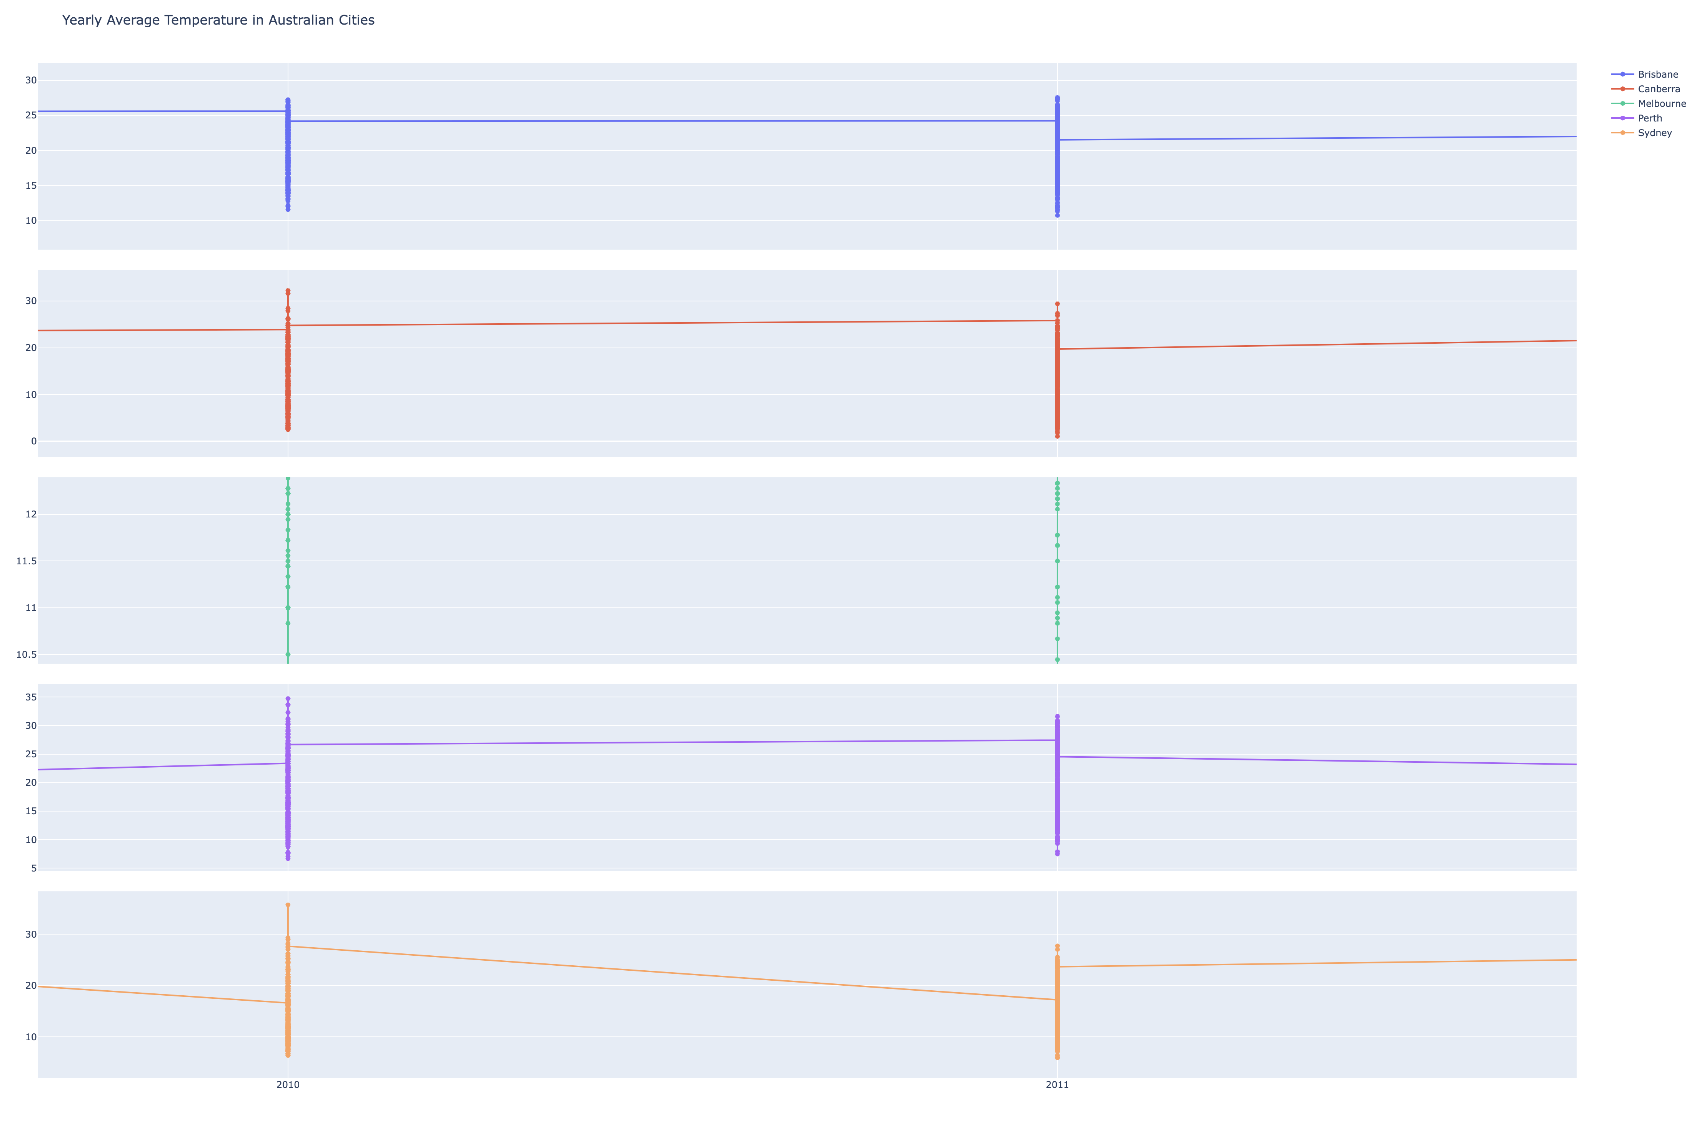

The provided climate visualization delineates the yearly average temperatures across several major Australian cities, showcasing distinct climatic patterns. Notably, Canberra demonstrates the most pronounced seasonal variability, with an extensive range of temperatures that suggests a climate with stark differences between summer and winter. Conversely, Melbourne's climate emerges as remarkably consistent, with minimal temperature fluctuations indicating a more stable, temperate environment. The warmer average temperatures evident in Brisbane and Sydney point to these cities having a subtropical to mild temperate climate. Perth, while also displaying warmth, has slightly cooler averages than Brisbane and Sydney. The graph hints at a potential gradual increase in Sydney's average temperature, raising questions about long-term warming trends. These observations, while insightful, are based on a limited dataset; a more thorough analysis would require a comprehensive temporal spread and additional contextual data.

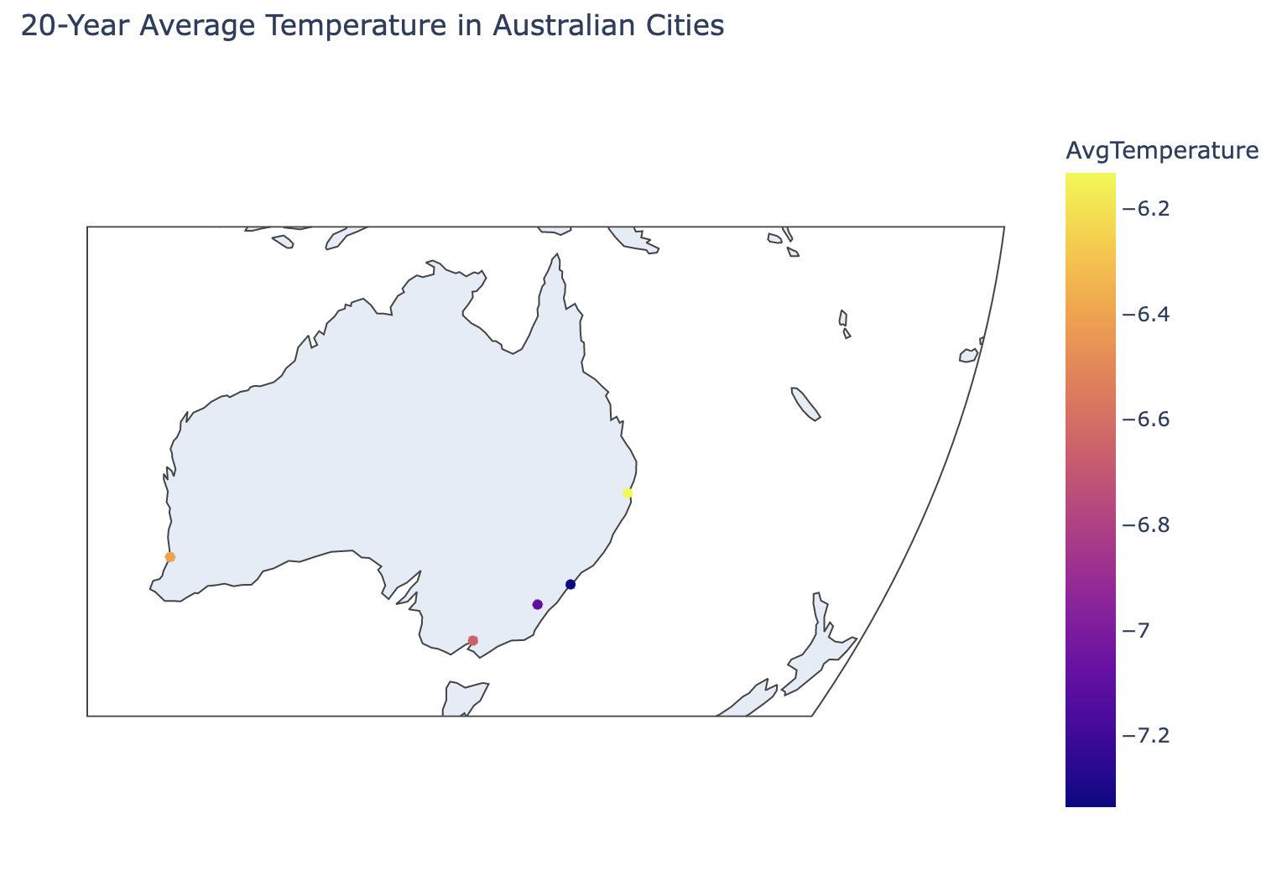

This map depicts the 20-year average temperature data for various Australian cities, using a color-coded scale to represent temperature values. The map shows Australia's outline with colored dots placed at specific locations, likely corresponding to the cities in question.

The color gradient on the right serves as a legend, with colors transitioning from yellow to dark purple, representing average temperatures from -6.2 to -7.2. The values are unusual as they are negative, which might imply a deviation from a mean temperature or could be indicative of an error unless these figures represent a temperature anomaly or a specific climatological metric.

From the color distribution, we can observe two things: Firstly, the city represented by the yellow dot appears to have the highest average temperature in the depicted range, while the city with the dark purple dot has the lowest. Secondly, the distribution of temperatures across the cities shows spatial variation, with the coastal cities, particularly on the eastern coast, exhibiting warmer temperatures than the locations represented by cooler colors.

电脑屏幕的照片

The image displays a heatmap of daily average temperatures in Sydney over a span of 20 years, from January 2000 to April 2020. Each row represents a month of a particular year, and each column corresponds to a day of the month.

The color scale on the right indicates the temperature deviation from a certain baseline, with dark blue representing lower deviations (down to -8), and dark red representing higher deviations (up to 2). The majority of the data points are in the blue range, suggesting that most days were cooler relative to the baseline.

Accordingly, there is a periodic pattern, likely representing seasons, with cooler temperatures (blue) occurring in what would be winter months and warmer temperatures (reds and oranges) during summer months. There are occasional spikes of warmer temperatures (red spots) that could represent heatwaves or particularly hot days. Over the years, there doesn't seem to be a clear trend of increasing or decreasing temperatures; however, specific months show variability. For instance, some years exhibit particularly warm or cool months outside the general seasonal pattern. The heatmap format allows for easy visualization of anomalies and patterns over time, providing a clear way to identify unusual temperature trends on specific days, months, or years. The heatmap is a useful visualization for observing long-term temperature patterns and anomalies, aiding in the study of climate variability and change within a specific locale.

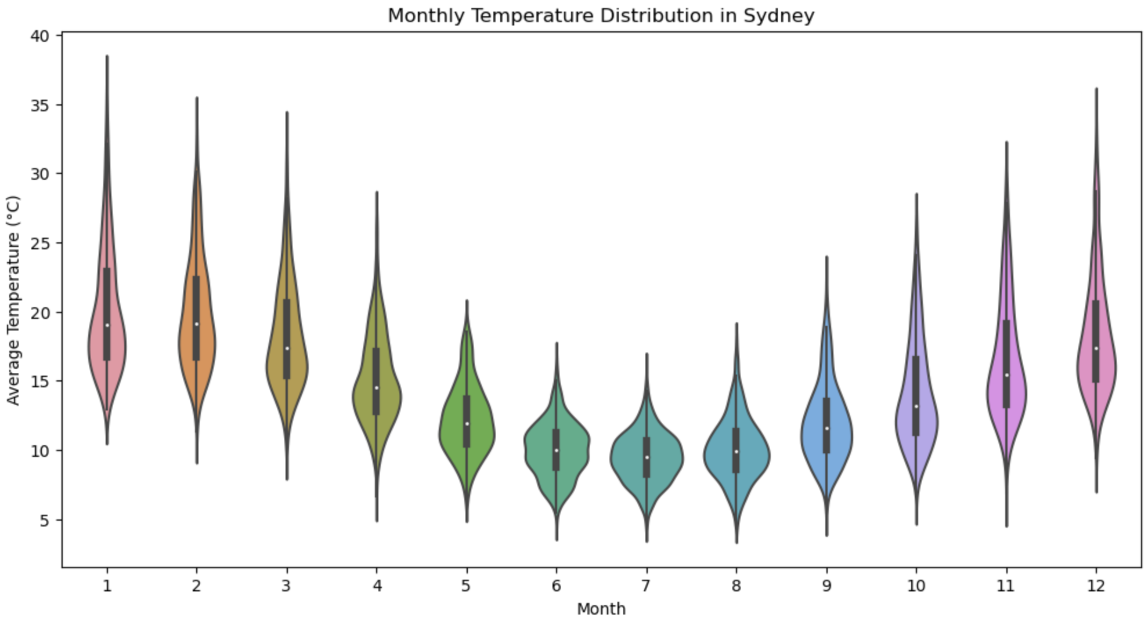

The image displays a violin plot depicting the distribution of average monthly temperatures in Sydney. Each 'violin' represents the temperature distribution for a specific month, with the x-axis denoting the month (1 through 12) and the y-axis indicating the average temperature in degrees Celsius. Key observations from the plot are listed as folloiws:

Seasonal Variability: The distribution of temperatures shows clear seasonal variability, with the warmest months (presumably December, January, and February, which are summer months in the Southern Hemisphere) displaying higher median temperatures and the cooler months (likely June, July, and August, which are winter months) showing lower median temperatures.

Temperature Extremes: The width of each violin indicates the frequency of temperatures; wider sections mean more days recorded at that temperature. The tails extending from the violins suggest days with extreme temperatures — shorter tails on the warmer violins imply less variability in high temperatures, while longer tails on the cooler violins indicate more variability in low temperatures.

Symmetry and Skewness: Some violins are symmetric around the median (indicated by the white dot), suggesting an even distribution of temperatures around the median. Others show some asymmetry, which indicates a skew in the data — for example, a longer lower tail suggests more cooler days than warmer ones within that month.

Median Temperatures: The black bar in the center of each violin denotes the interquartile range, and the white dot represents the median temperature for the month. The median temperatures seem to rise and fall in a predictable seasonal pattern.

Australia vs. China

The plot displays a line graph comparing the yearly average temperatures between China and Australia from the year 2000 to 2020. The x-axis represents the years, while the y-axis shows the average temperature in degrees Celsius.

From the graph, we can observe that: The average temperature in both countries shows fluctuations over the 20-year period, with no consistent trend of increase or decrease until around 2019.

The temperatures for Australia (represented in red) generally appear to be higher than those for China (in blue), which is consistent with Australia's warmer climate.

Around 2019, there is a noticeable divergence in trends: Australia's average temperature shows a sharp increase, while China's average temperature experiences a sharp decline.

The temperatures for both countries exhibit some parallel variability until the spike and drop in 2019, suggesting that they may be influenced by similar climatic patterns or global climate events.

The sudden change in temperature trends for both countries in 2019 is quite striking and could warrant further investigation to understand the underlying causes. It could be related to specific environmental events, such as wildfires or industrial changes, or it might be a result of broader climatic shifts such as global warming, although one year of change does not constitute a climate trend.

The graph is a clear representation of comparative climatology between two large countries, providing insights into their temperature profiles and raising questions about the factors affecting their climates, especially regarding the extreme changes observed in the last year of the dataset.

This line graph compares the monthly average temperatures between China and Australia, with the x-axis representing the months (labeled 1 through 9, which likely stands for January through September) and the y-axis showing the average temperature in degrees Celsius.

Key observations:

The blue line, representing China, shows lower temperatures at the beginning of the year, which gradually increase and peak around mid-year (June/July), and then decrease again.

The red line, representing Australia, begins with higher temperatures that decrease sharply as the months progress, reaching the lowest point at what appears to be the midpoint of the year, and then increasing again.

The crossover of the lines indicates that during certain months (around March and August), the average temperatures of the two countries are very similar.

The shape of the lines suggests that China experiences a warming trend in the first half of the year with temperatures decreasing in the latter half, while Australia shows an opposite trend due to its location in the Southern Hemisphere.

The graph effectively illustrates the contrasting seasonal patterns between the two countries due to their different hemispherical locations, with Australia experiencing its summer when China is in winter and vice versa.

Global climate changes

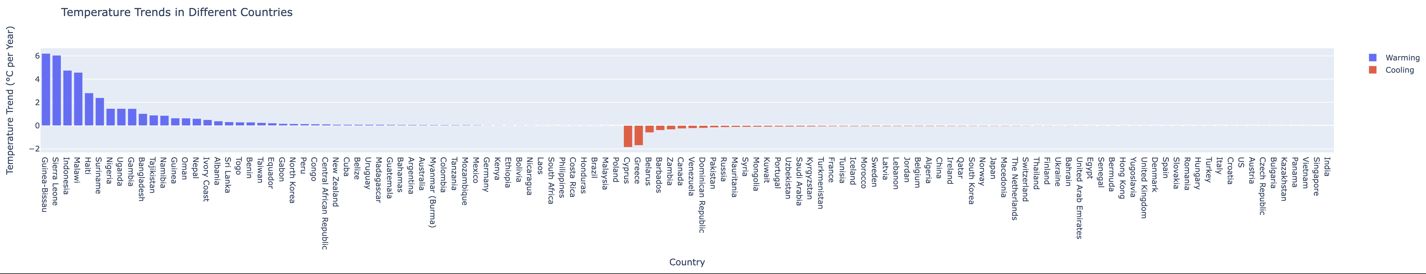

The horizontal bar graph titled "Temperature Trends in Different Countries" compares the rate of change in average temperatures for a selection of countries. Each bar represents the temperature trend in degrees Celsius per year for each country, with the x-axis listing the countries and the y-axis showing the temperature trend.

The bars are color-coded: blue indicates warming (positive temperature trend) and red indicates cooling (negative temperature trend). The majority of the bars are blue, which implies that most countries in the dataset are experiencing a warming trend. A few countries, however, are shown with red bars, indicating a cooling trend.

Some observations:

The countries with the highest warming trends have larger blue bars extending to the right.

The countries with cooling trends have smaller red bars extending to the left.

The length of the bars corresponds to the magnitude of the temperature change per year.

This graph is useful for quickly identifying which countries are warming the most or cooling, allowing for comparative climate change analysis across different geographic locations. It also visually communicates the general trend of global warming, with more countries experiencing rising temperatures than those with cooling trends.

In details, countries can be devided into the following groups

Significant Cooling: Cyprus and Greece top the list with the most pronounced cooling trends, showing declines of approximately -1.87 and -1.70 degrees Celsius per year, respectively.

Moderate Cooling: Countries like Belarus, Barbados, and Zambia exhibit moderate cooling trends, with values ranging from approximately -0.34 to -0.60 degrees Celsius per year.

Mild Cooling: Many countries, including Canada, Venezuela, and the Dominican Republic, exhibit milder cooling trends, closer to -0.2 degrees Celsius per year.

Slight Cooling: A large number of countries, including major economies like China, Japan, and the United States, show slight cooling trends, with declines less than -0.1 degrees Celsius per year.

Minimal Cooling: Countries at the bottom of the list, such as Singapore and India, have the smallest cooling trends, with changes near -0.002 degrees Celsius per year.

Rapid Warming: Guinea-Bissau and Sierra Leone are at the top with the most significant warming trends, with temperature increases of approximately 6.22 and 6.05 degrees Celsius per year, respectively.

Substantial Warming: Indonesia and Malawi also experience notable warming trends, with their average temperatures rising by approximately 4.75 and 4.58 degrees Celsius per year.

Moderate Warming: Haiti and Suriname show moderate warming trends, with temperature increases around 2.81 and 2.39 degrees Celsius per year.

Mild Warming: Countries like Nigeria, Uganda, and The Gambia are warming at a milder rate of about 1.46 degrees Celsius per year.

Slight Warming: Bangladesh and other countries exhibit slight warming trends with increases over 1 degree Celsius per year.

Minimal Warming: Towards the bottom of the list, countries like Poland are experiencing minimal warming, with a temperature trend increase of nearly 0.005 degrees Celsius per year.

This data could be valuable for climate scientists and policymakers to understand regional climate patterns and could potentially influence agricultural planning, infrastructure development, and adaptation strategies for changing weather patterns. The cooling trends in these countries may counter the general global warming narrative, suggesting complex regional climatic behaviors that might be influenced by various factors such as ocean currents, atmospheric conditions, or other natural and anthropogenic factors.

These warming trends are indicative of the varying impacts of climate change across different regions. The substantial warming trends in certain countries could have profound implications for their ecosystems, agriculture, water resources, and overall climate resilience. Such trends necessitate comprehensive strategies for mitigation and adaptation to safeguard against adverse environmental and socio-economic consequences. The data underscores the complexity of global warming, showing how it affects each region differently.

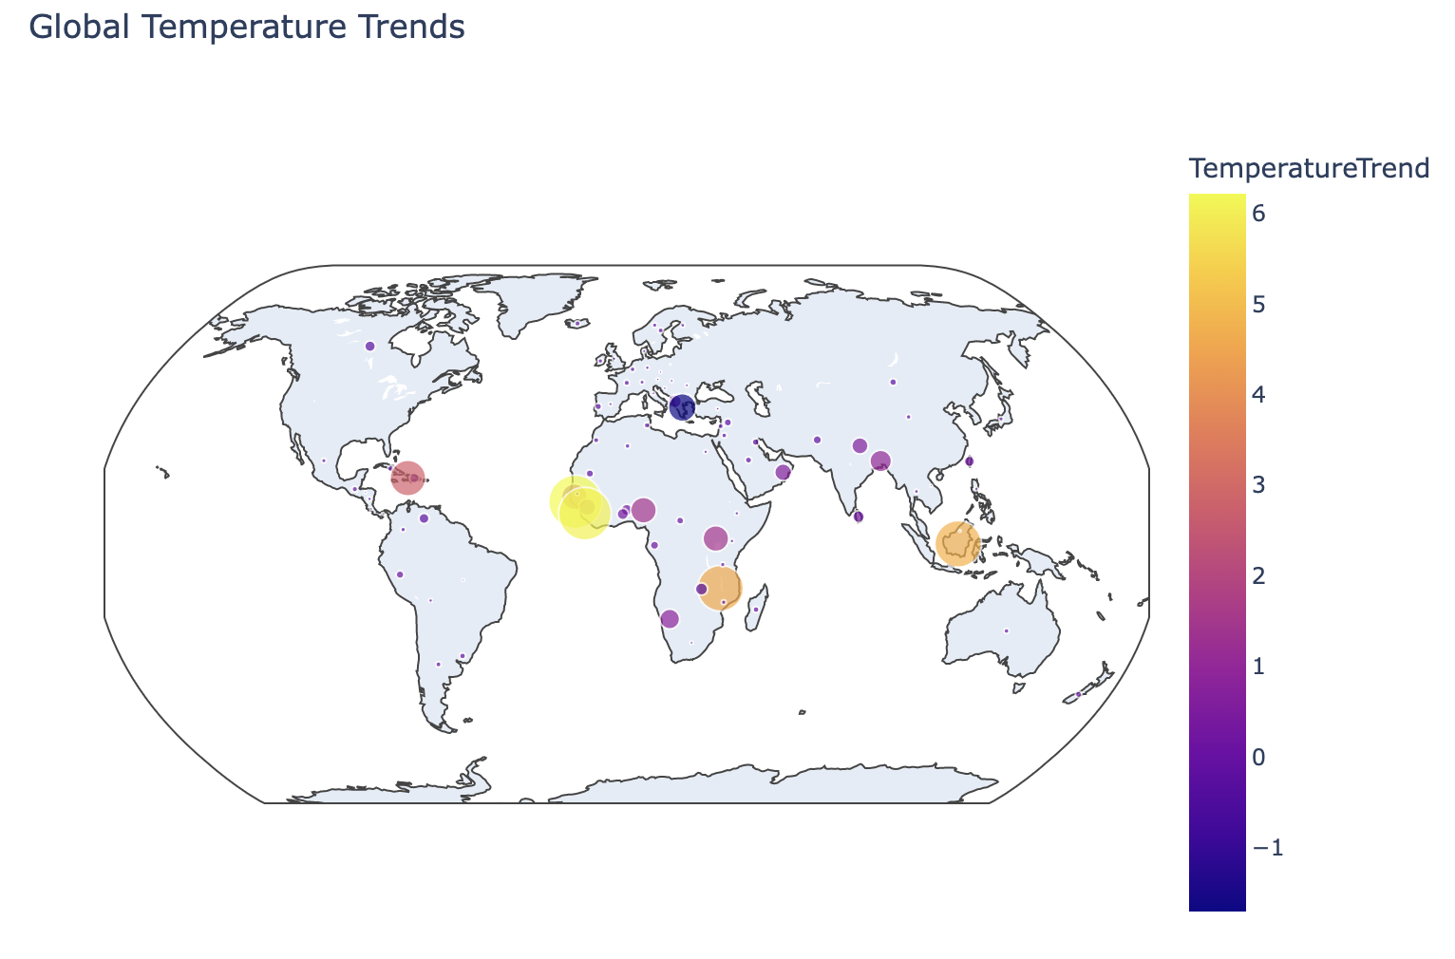

The map presents a global view of temperature trends, with color-coded circles overlaid on a world map to indicate the magnitude of temperature change in various regions. The scale on the right, ranging from -1 to 6, represents the temperature trend in degrees Celsius. Larger circles with warmer colors (yellow to red) indicate a higher increase in temperature, while smaller circles with cooler colors (purple) suggest a decrease or a smaller increase.

Key observations:

Regions with the most significant warming trends are highlighted with large, prominently colored circles. Notably, a large yellow circle appears over South America, suggesting a substantial temperature increase in that region.

A large purple circle, indicative of a cooling trend or less significant warming, is visible in the northern part of the globe, possibly over Russia or Northern Asia.

The spread of circles across the continents indicates that temperature changes are a global phenomenon affecting nearly all parts of the world.

The varying sizes of the circles suggest that while the general trend is towards warming, the rate and extent of temperature change are not uniform across different geographic locations.

This map succinctly illustrates the uneven impact of climate change on different regions, emphasizing the complexity of global climate dynamics and the diverse range of changes that countries and regions are experiencing.