Uterine Fibroids

July 25, 2016

|

CFIM



www.Ask4UFE.com is a website developed specifically for women who suffer from uterine fibroids. The website offers information on treatment options that are less invasive and have a shorter recovery time than a typical hysterectomy. Please share if you know someone that would benefit from this information!

July is Fibroid Awareness Month

July 14, 2016

Here is a link to an interesting read on fibroids.

[http://www.huffingtonpost.com/alicia-armeli-msed-msn-rdn-chlc/african-american-women-and-uterine-fibroids-why-more-awareness-is-needed-to-overcome-this-health-disparity\_b\_10516392.html?platform=hootsuite](http://www.huffingtonpost.com/alicia-armeli-msed-msn-rdn-chlc/african-american-women-and-uterine-fibroids-why-more-awareness-is-needed-to-overcome-this-health-disparity_b_10516392.html?platform=hootsuite" \t "_blank)

JCC of Northern VA Health Fair

May 13, 2016

Fun day yesterday at The Jewish Community Center of Northern Virgina Spring Into Health Fair! Thanks to all the folks who stopped by our booth and participated in our free ultrasound screenings.  Thanks again JCC for letting us vendor at this wonderful event!

Thanks for coming to see us this past weekend at the 2nd Annual Action Chapel Health & Wellness Fair! It was a fun day filled with wonderful folks and great conversation!

April 25, 2016

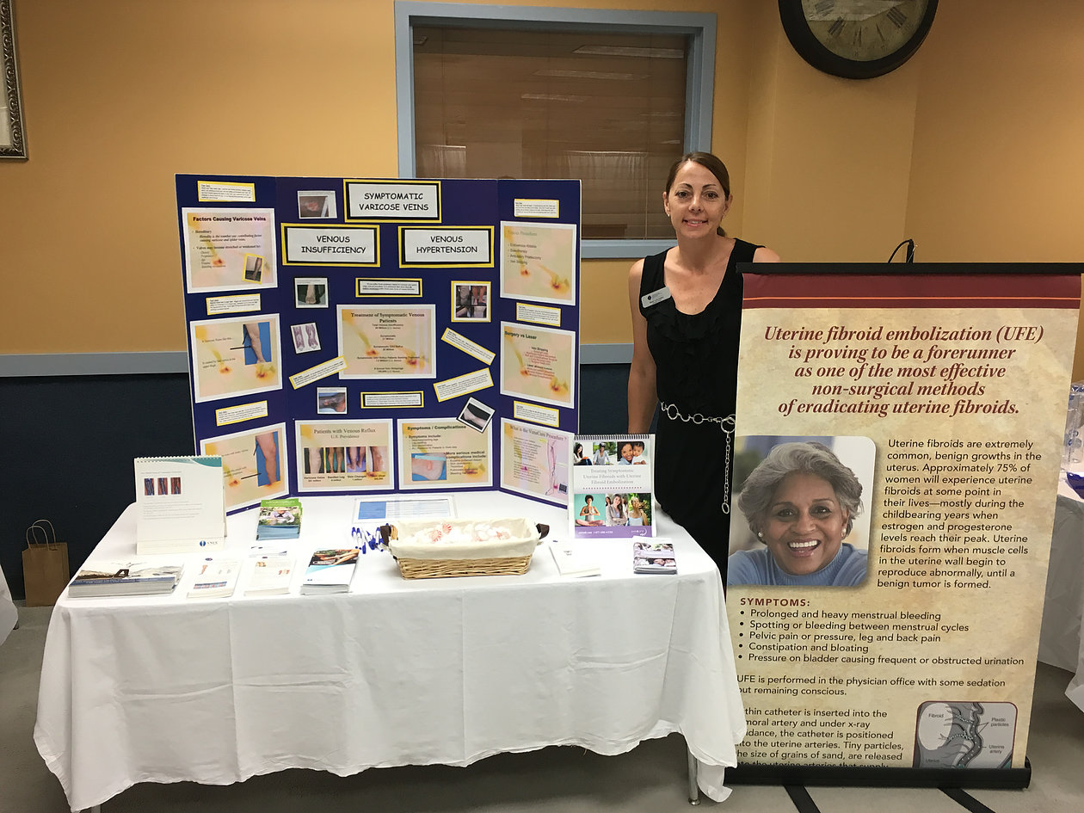

FDA discourages use of laparoscopic power morcellation for removal of uterus or uterine fibroids

February 11, 2015

The FDA has strongly recommended that a particular technique called power morcellation that is often performed during a hysterectomy to remove fibroids should NOT be performed because it may result in spread of uterine cancer.

Power morcellation basically involves grinding up the uterine tissue in smaller fragments, which are then removed. The FDA estimates that about 1 in 350 women undergoing a hysterectomy for fibroid removal has an unsuspected form of cancer called uterine sarcoma.  According to the FDA, hysterectomy performed with power morcellation may cause cancer cells to be spread throughout the patient's abdomen and pelvis, resulting in much worse prognosis for the patient.  
  
Research performed at Brigham and Womens Hospital in Boston, MA found a nine-fold higher rate of unexpected uterine sarcomas during a review of the medical records of over 1000 women who underwent hysterectomy with power morcellation.

This is a very important recommendation because women who undergo a hysterectomy have another very effective alternative to treat the fibroids, called uterine fibroid embolization (UFE), that does not cause the spread of cancer.

For more information, see the FDA news release here:  
http://www.fda.gov/NewsEvents/Newsroom/PressAnnouncements/ucm393689.htm

http://www.fda.gov/NewsEvents/Newsroom/PressAnnouncements/ucm393689.htm

Tags:

[fibroid](http://www.cfim.biz/blog/tag/fibroid)

[fibroid embolization](http://www.cfim.biz/blog/tag/fibroid-embolization)

[hysterectomy](http://www.cfim.biz/blog/tag/hysterectomy)

[uterine fibroids](http://www.cfim.biz/blog/tag/uterine-fibroids)

[ufe](http://www.cfim.biz/blog/tag/ufe)

[cancer of uterus](http://www.cfim.biz/blog/tag/cancer-of-uterus)

[uterine cancer](http://www.cfim.biz/blog/tag/uterine-cancer)

[fibroid treatment](http://www.cfim.biz/blog/tag/fibroid-treatment)

Varicose Veins in Men

January 15, 2015

You enjoy being outside, and it's not easy to feel confident about your looks.

You can't concentrate on your swing if you're worried that your golfing buddies are looking at the purplish cluster on your ankle. And, if you dangle your legs at the edge of the pool, you don't want to be mistaken for the kids' grandfather.

Older men are now vain when it comes to their veins, observes Dr. Meghal Antani, a Washington DC vein specialist. Sclerotherapy, a treatement for spider and varicose veins, has become the No. 2 most performed cosmetic surgical procedure, due in large part to men, says the Chicago-based American Academy of Cosmetic Surgery.  Sclerotherapy, an office procedure, involves injecting veins with a solution, causing them to collapse and fade away

An AACS survey shows that nearly 10,000 men opted for sclerotherapy, an in-office procedure for the removal of spider veins or smaller varicose veins, last year. That's up from 3,000 in 2002, a 226 percent increase. By contrast, the increase in women seeking the procedure over the last five years increased just 3.5 percent, says the AACS. Spider veins, red and purplish clusters of fine lines, are typically a female problem, often caused by pregnancy.

But as men age, "their skin gets thinner," Antani said. "The average age I'm seeing [among male sclerotherapy patients] is 65. It used to be that men didn't want to think about how they looked, but now it's different, the opposite is true, you don't want to look old. Many of my patients are men in their second marriage."

The spider veins that older men experience can be caused from trauma, years of standing for long periods, or even exercise such as weight lifting.  Antani said. Men who experience varicose veins usually have a genetic predisposition to the condition.

Dr. Antani says that many men also seek treatment for leg discomfort, swelling, and other symptoms associated with varicose veins. Endovenous ablation is a modern day minimally invasive procedure that treats the underlying cause of varicose veins and spider veins, called venous reflux disease.   According to Antani, as long as one has venous reflux disease, they will probably continue to develop new varicose veins and spider veins.

Insurance usually covers endovenous ablation, but may or may not cover sclerotherapy treatment.   Dr. Antani recommends consulting with an experienced vein professional to fully discuss one’s options.

New study suggests that early initiation of interventional varicose vein treatment was significantly associated with a decreased risk of disease progression and costs.

February 10, 2016

|

JVIR January 2016

Real-World Assessment of Interventional Treatment Timing and Outcomes for Varicose Veins: A Retrospective Claims Analysis

Abstract

Purpose

To evaluate the impact of delaying interventional treatment on varicose vein disease progression, complications, and health care costs in a real-world setting.

Materials and Methods

This was a retrospective analysis of adults diagnosed with varicose veins between January 2008 and June 2010. Patients were followed for 2 years after diagnosis and categorized into three cohorts based on the timing of interventional therapy: early (≤ 2 mo), intermediate (> 2 mo but ≤ 6 mo), and late (> 6 mo). Disease progression and all-cause health care costs were evaluated.

Results

A total of 44,206 patients were included, with 43% classified as receiving early interventional therapy, 33% as intermediate, and 24% as late. Early interventional treatment was associated with lower disease progression rates (29.2%) compared with intermediate (42.5%; P < .0001) and late treatment (52.2%; P < .0001). Also, early interventional treatment was associated with lower costs ($17,564) than intermediate ($17,923; P > .05) and late treatment ($18,399; P < .05). Each 30-day delay in treatment initiation was associated with a 7% higher risk of disease progression (P < .0001) and a 1% increase in costs (P < .0001).

Conclusions

Findings suggest that early initiation of interventional varicose vein treatment was significantly associated with a decreased risk of disease progression and costs.

FOR STUDY INFORMATION CLICK HERE: [http://www.jvir.org/article/S1051-0443(15)00965-3/fulltext](http://www.jvir.org/article/S1051-0443(15)00965-3/fulltext" \t "_blank)

As potentially harmful devices make headlines, patients have an alternative in IR

June 2, 2015

A medical device primarily used for hysterectomies is in the news again, this time for being investigated by the FBI—and the development may lead to more patients turning to interventional radiologists for an alternative procedure.  Read more here:

http://www.radiologybusiness.com/topics/practice-management/quality/potentially-harmful-devices-make-headlines-patients-have-alternative?utm\_source=RBNW&utm\_medium=3778693&utm\_content=quicklinks&utm\_campaign=newsletter\_referral

Interventional radiology technique minimizes blood loss during complex deliveries

April 3, 2015

Interventional radiologists are at the forefront of many areas in womens' health.  A new technique involves temporarily blocking the uterine arteries just before delivering a baby in a woman who has placenta accreta (a complication of the placenta that can lead to heavy bleeding).   Read the full story here:

http://www.eurekalert.org/pub\_releases/2014-12/rson-irp112414.php

Tags:

[fibroid treatment](http://www.cfim.biz/blog/tag/fibroid-treatment)

[uterus](http://www.cfim.biz/blog/tag/uterus)