**New Patient Form: Varicose Veins/Peripheral Arterial Disease**

**Patient Name**: ______________________________________________________________________

**Date**: ______/_________/_________ **Date of Birth:** ______/_________/_________

**Directions: Please answer the following questions. Provide estimates for dates of occurrence.**

1. Why are you here today? _______________________________________________________________
2. How did you hear about us? _____________________________________________________________
3. Name, address and telephone number of your primary care provider. ____________________________________________________________________________________
4. Do you experience any of the following in your legs? **Please Circle**

Aching/pain? Yes No Left Leg Right Leg Both

Heaviness? Yes No Left Leg Right Leg Both

Tiredness/fatigue? Yes No Left Leg Right Leg Both

Itching/burning Yes No Left Leg Right Leg Both

Leg swelling? Yes No Left Leg Right Leg Both

Leg pain with walking? Yes No Left Leg Right Leg Both

Leg cramps? Yes No Left Leg Right Leg Both

Foot pain at night? Yes No Left Leg Right Leg Both

Restless legs? Yes No Left Leg Right Leg Both

Throbbing? Yes No Left Leg Right Leg Both

Skin Discoloration? Yes No Left Leg Right Leg Both

Skin/hair changes? Yes No Left Leg Right Leg Both

Ulcer now or in the past? Yes No Left Leg Right Leg Both

Varicose or spider veins? Yes No Left Leg Right Leg Both

Other: ______________________________________________________________________________

1. How long have you had these symptoms? __________________________________________________
2. Have your symptoms gotten **better** or **worse** in the past 6 months? ______________________________
3. How far can you walk before your symptoms begin to bother you? ______________________________
4. What helps the symptoms improve? **(Please Circle all that apply)**

Leg elevation Tylenol or Ibuprofen Walking

Stopping and resting Compression Stockings Other_______________________________

1. What makes the symptoms worse: **(Please Circle all that apply)**

Leg elevation Walking Climbing stairs or walking inclines

Stopping and resting Compression Stockings Other_______________________________

1. Are your symptoms **better** or **worse** by the end of the day? ____________________________
2. Overall, how much of an impact do your symptoms have on your personal or work life?

**(None)** 0 1 2 3 4 5 **(Severe)**

1. Have you ever had an ultrasound test done on your legs? Yes No

If yes, when, where, and which leg? ____________________________________________________________________________________

1. Describe any treatments, procedures or surgeries you have done to help relieve this problem.

________________________________________________________________________________________________________________________________________________________________________

**SOCIAL HISTORY:**

1. Current or previous Occupation: _________________________________________________________
2. Hours you sit or stand during the day: ____________
3. **(WOMEN ONLY)**

Number of pregnancies: ________ Number of live births: ____________

1. Exercise per week: □ None □ 1-5 hours □ 5-10 hours □ more than 10 hours

Type of exercise: _____________________________________________________________________

1. Tobacco use:

□ Never □ Quit If so, when? _________________

□ Current: □ Cigarettes □ Pipe □ Cigar □ Chew

Amount per day: ____________ Number of years: _____

1. Alcohol: □ Never □ Social □ Occasionally □ Daily
2. Recreational Drug use: □ Never □ Social □ Occasionally □ Daily

**SURGICAL HISTORY:** (Please include any major operations you have had)

**____________________________________________________________________________________**

**____________________________________________________________________________________**

**____________________________________________________________________________________**

**____________________________________________________________________________________**

**____________________________________________________________________________________**

**FAMILY HISTORY:**

Please indicate whether there is a family history of any of the following:

**Circle as many as apply**

* Aneurysm Mother Father Brother/Sister
* Diabetes Mother Father Brother/Sister
* Heart disease □ or heart attack Mother Father Brother/Sister
* Peripheral vascular disease Mother Father Brother/Sister
* Stroke Mother Father Brother/Sister
* Vein disease □ Varicose veinsMother Father Brother/Sister

**MEDICAL HISTORY:** **Height:** _____feet _____inches **Weight:** __________pounds

Please indicate whether you have a history of any of the following:

**Eyes:** □ No problems **Musculoskeletal:** □ No problems □ Temporary Vision Loss □ Joint Pain

□ Other_______________________________ □ Back Pain

□ Leg trauma or surgery

**Ear/Nose/Throat:** □ No problems □ Other________________________

□ Other_______________________________

**Respiratory:** □ No problems

**Cardiac:** □ No problems□ Asthma

□ High blood pressure  □ COPD □ Emphysema □ TB

□ Heart attack □ Lung clot or pulmonary embolism (PE)

□ Heart stents □ Other________________________

□ Irregular heart beat

□ Other______________________________ **Genitourinary:** □ No problems

□ Kidney disease

**Endocrine** □ No problems □ Sexual dysfunction/Impotence

□ Diabetes □ Other________________________

□ Goiter

□ Hyperthyroid **Hematological/ Lymphatic:** □ No problems

□ Hypothyroid □ Blood clotting problems/disorders

□ Other______________________________ □ Blood borne such as HIV/AIDS

□ Blood borne such as Hepatitis B or C

**Gastrointestinal:** □ No problems □ Cancer, type___________________

□ Bleeding □ Other________________________

□ Liver disease

□ Ulcer **Psychological:** □ No problems

□ Other______________________________ □ Anxiety

□ Depression

**Neurological:** □ No problems Other_________________________

□ Stroke □ TIA

□ Arm or leg weakness

□ Other______________________________ **Additional comments:**

**Vascular:** □ No problems _________________________

□ Blood clot or deep vein thrombosis (DVT)

□ Bypass surgery _________________________

□ Leg stent(s) Right Left Both

□ Leg swelling Right Left Both _________________________

□ Peripheral arterial disease

□ Phlebitis (inflammation or infection of the veins) _________________________

□ Varicose veins

□ Vein stripping Right Left Both _________________________

□ Vein ablation Right Left Both

Other___________________________________________ _________________________

**ALLERGY HISTORY:** □ No known allergies

Allergies including medications, dye, iodine, shellfish, latex, and your reaction.

**____________________________ __________________________________________**

**Allergy Reaction Allergy Reaction**

**____________________________ __________________________________________**

**Allergy Reaction Allergy Reaction**

**MEDICATIONS:** □ None

Medications including over the counter, herbals and supplements.

|  |  |  |
| --- | --- | --- |
| **Medication Name:** | **Dosage** | **Frequency** |
|  |  |  |
|  |  |  |
|  |  |  |
|  |  |  |
|  |  |  |
|  |  |  |
|  |  |  |
|  |  |  |
|  |  |  |
|  |  |  |
|  |  |  |

**Physical Exam: (PRACTITIONER USE ONLY)**

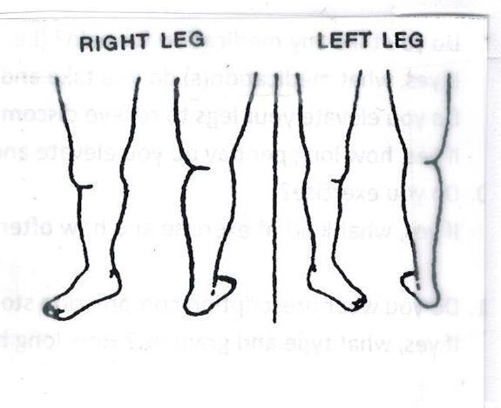Pulses: Right: 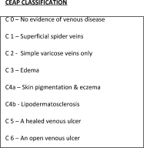

Left:

Notes:_______________________________________________________________________________________________________________________________________________________________________________ Signature: ________________________________________