Diploma Project
Business Analysis Block
Automated Lead Generation SaaS-Platform for Web Developers Using Deterministic Website Audits and LLM-Generated MVP Prototypes
Author: Yury Kurouski
Supervisor: Liubov Ivanova
Project type: Individual
October 2026
Contents
Introduction 3
Chapter 1. Analysis of the Subject Area 5
1.1 Current State of the Process 5
1.2 Review of Sources 6
1.3 Analysis of Analogs 8
1.4 Conclusions to Chapter 1 11
Chapter 2. Requirements for the Revamp Platform 12
2.1 Vision and Business Goals 12
2.2 Stakeholders and Users 13
2.3 Scope 14
2.4 Solution Concept 14
2.5 Functional Requirements 16
2.6 Use Cases 18
2.7 Non-Functional Requirements 19
2.8 Legal and Ethical Requirements 19
2.9 Risks 20
2.10 Conclusions to Chapter 2 21
References 22
Appendix A. Product Backlog 25
Appendix B. Diagrams 27
Statements 33

Introduction

Relevance and problem
Small local businesses such as clinics, restaurants, repair shops and beauty salons rely on their websites to be found and contacted, yet many of these sites are slow, hard to use and visibly dated. Web-wide measurements show how common such defects are: in 2026 automated tests detected WCAG 2 accessibility failures on 95.9% of the one million most popular home pages, with an average of 56.1 errors per page [1], and in 2024 only 43% of websites had good Core Web Vitals on mobile devices [2]. These figures describe popular sites in general, not local businesses specifically.
For web development studios and freelancers (called studios below) these businesses are natural clients, but reaching them takes manual work. A convincing first contact requires researching the business, assessing its website and preparing a personalised proposal, ideally with a visual example of a better site, and this work is lost when the business does not reply. Studios also draw on the same public sources, such as map services and business directories, so the pool of prospects in a city is finite and shared: one business can receive several competing pitches.
The question is timely because multimodal large language models (LLMs) can now turn a screenshot of a web page into front-end code; a NAACL 2025 benchmark of 484 real web pages found that their main weaknesses are missing visual elements and incorrect layouts [3]. A draft prototype can therefore be generated automatically for each prospect, provided that the output is checked. The same technology sets the limit of automation: language models produce fluent content that their input does not support [4], so metrics, contact details and facts in an offer cannot be left to a model, and sending generated e-mails without human review adds legal and reputational risk.
The problem is therefore twofold: the first contact with a local business takes manual work that is repeated for every prospect, and the shared pool of businesses is contested without rules, while full automation with LLMs alone is unreliable. The project addresses it with a multi-tenant SaaS platform, called Revamp below, that audits each business website once with deterministic tools and publishes masked listings. A studio buys the exclusive right to contact a business for a fixed period at a price derived from the audit, receives an LLM-generated MVP prototype of the improved site, and sends the offer from its own address after its operator approves every message.

Goal and objectives
The goal of the project is to reduce a web studio’s effort in acquiring qualified clients from among local businesses by developing a multi-tenant SaaS platform that provides deterministic website audits, LLM-generated MVP prototypes and exclusive contact rights. Its objectives are:
- Analyse how web studios find clients today, review the literature and existing tools, and identify the gaps (Chapter 1).
- Define the vision, measurable KPIs, stakeholders, scope and solution concept of the platform (sections 2.1–2.4).
- Specify the functional requirements as epics E1–E5 and prioritised user stories with Given/When/Then acceptance criteria traced to the KPIs (sections 2.5–2.6).
- Specify the non-functional and legal requirements (GDPR, ePrivacy, WCAG 2.1 AA) and the project risks (sections 2.7–2.9).
- Define how the result is verified against the KPIs: automated tests and a market simulation of the pricing rule (section 2.10).

Object and subject
The object of the project is the process by which web development studios and freelancers acquire new clients among small local businesses. The subject is the part of this process that can be automated: finding businesses, auditing their websites, allocating the right to contact a business between studios, preparing a personalised prototype and offer, and sending outreach that a human has approved.

Methods
The requirements were gathered with document analysis of legal texts and standards (GDPR, ePrivacy rules, WCAG 2.1) and of the project’s concept and decision log; a literature review (section 1.2); a comparative analysis of existing lead generation and website audit tools (section 1.3); an analysis of the existing prototype, a working single-operator Revamp pipeline (discovery, audit, MVP generation, review and e-mail) on which the KPI baselines K2 and K3 will be measured; and modelling with UML diagrams and a planned market simulation of pricing rules. No interviews or surveys with studios or business owners were conducted: the personas in section 2.2 are constructed, and statements about studio behaviour without a source are marked as assumptions.

Chapter 1. Analysis of the Subject Area

1.1 Current State of the Process
Studios and freelancers win clients through referrals, through directories where businesses search for them, such as Clutch (section 1.3), and through their own outbound search. This section describes the outbound path, the one Revamp automates. The description is the author’s model, built from the project concept, the analogs in section 1.3 and the existing Revamp prototype. It was not validated with studios, because no interviews were held, so the duration and frequency of each step are assumptions to be measured in a pilot.
Three parties take part (Fig. 1). A person at the studio (the owner of a small studio or a freelancer) chooses a niche and an area, finds local businesses in map services and directories, opens each website and judges its quality, looks for contact details, checks the studio’s own records to avoid a second pitch, prepares a proposal with a mock-up and sends a personal e-mail. The business owner receives the e-mail and either replies or ignores it and asks to stop. The tools involved are public map services and directories, website audit tools, the studio’s spreadsheet or CRM, a design tool and an e-mail client.
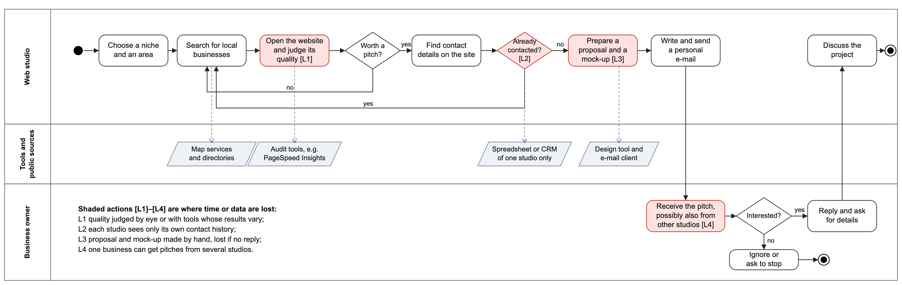
Fig. 1. AS-IS process of a web studio acquiring a client, UML activity diagram (full size in Appendix B)
Time and data are lost at four points, marked L1–L4 in Fig. 1:
- L1, quality assessment. The site is judged by eye or with a tool whose lab scores can change between runs [5], and a fast page can still look dated (section 1.3). The result is neither repeatable nor reusable, and it cannot justify a price.
- L2, contact history. Each studio checks only its own records. No studio knows whether another one has already pitched the business, and an opt-out reaches only the studio that received it.
- L3, proposal and mock-up. The work is done by hand for each prospect before the studio knows whether the business is interested, and it is lost if there is no reply.
- L4, repeated pitches. Because studios search the same public sources, one business can receive pitches from several studios and has no single way to stop them.
Every step up to the e-mail is manual and is repeated for each business, including those that never reply, so the studio’s time grows with the number of businesses it checks rather than with the clients it wins. How long a lead takes was not measured (assumption A3). For context only: sales professionals in general report spending 70% of their time on tasks other than selling [6]; the survey does not cover web studios.
TO-BE. With Revamp the platform searches an area and audits each website once with deterministic tools, so the evidence is repeatable and shared (L1). Studios browse masked listings and buy the exclusive right to contact a business for a fixed period at a price derived from the audit; a contact registry across all studios blocks repeated pitches and applies every opt-out (L2, L4). The prototype is generated only for the buyer, and the studio’s operator reviews it and approves the e-mail, which is sent from the studio’s own address (L3). A business owner can also audit their own site on a public page and consent to be contacted.

1.2 Review of Sources
The sources were chosen to answer four questions that shape the requirements: how good the websites of potential clients are and how this can be measured; how far LLMs can be trusted to prepare an offer; what the law requires from B2B outreach; and how a market for leads should be priced. They include standards and legal texts, peer-reviewed papers and industry reports. Industry reports are used for context only, never as the basis of a KPI.

Website quality and its measurement
Industry measurements show that accessibility and performance defects are common on the web [1], [2], and Google’s case studies report business gains after Core Web Vitals were improved, for example 8% more sales after a 31% improvement of Largest Contentful Paint at Vodafone Italy [7]. These case studies are published by the author of the metric and describe large companies, so Revamp may use them to explain an offer but never to promise a result. WCAG 2.1 [8] gives a shared vocabulary for accessibility defects and three conformance levels (A, AA and AAA). Automated checking of it has clear limits: Vigo et al. [9] found that six automated tools covered at most 50% of the WCAG 2.0 success criteria and caught 14% to 38% of the violations, and the more complete tools produced more false positives. Two requirements follow. The audit reports violations detected by automated rules and never states that a site does or does not conform to WCAG. And because the audit result sets the price, it must be repeatable rather than complete: the same site must give the same result (KPI in section 2.1, determinism requirement in section 2.7).

Reliability of LLM-generated content
Si et al. [3] show that multimodal models can produce a web page from a screenshot, but that they miss visual elements and get layouts wrong. Ji et al. [4] describe hallucination, content that is not supported by the source, as a general problem of neural text generation. For Revamp this means that a model may design and write the prototype, but code must check the page before anyone sees it and must keep every fact: metrics, contact details, prices and names come only from deterministic extraction. The operator reviews the prototype and approves every e-mail (US3; the grounding and human-in-the-loop requirements in section 2.7; the share of generated pages that pass the code checks as a KPI in section 2.1).

Legal rules for B2B outreach
The GDPR [10] applies whenever a business contact identifies a natural person, for example the e-mail address of a sole trader. Recital 47 states that processing for direct marketing may be regarded as carried out for a legitimate interest, so Article 6(1)(f) can be the legal basis for outbound contact after a balancing test. Article 21(2)–(3) gives the person the right to object at any time, after which the data may no longer be processed for marketing; Article 5(1)(c) requires data minimisation and Article 25 data protection by design. The ePrivacy Directive [11] requires prior consent for marketing e-mail to natural persons (Article 13(1)), apart from similar products offered to existing customers, leaves the protection of legal persons to national law (Article 13(5)), and prohibits marketing e-mail that conceals the sender or has no valid address for opting out (Article 13(4)). The platform therefore stores only business contacts published by the business, applies every opt-out across all studios (US4), shows the sending studio’s identity in each message, needs a legal review for each target country, and offers a consent-based inbound flow (US8) as the lawful channel where prior consent is required (section 2.8).

Pricing a market for leads
Rochet and Tirole [12] model platforms that must attract both sides of a market and analyse what determines how prices are allocated between the sides. Revamp has two such sides: studios pay for contact rights, while business owners pay nothing and are protected by the contact registry and offered a free public audit (US4, US8). Einav et al. [13] explain why eBay sellers moved from auctions to posted prices as a trade-off between competitive price discovery and convenience, driven mainly by falling demand for auctions. This supports selling contact rights at a fixed, published price derived from the audit (US5) and deferring the auction until the platform has enough studios (section 2.4).
Overall, the sources confirm the need for the product and set three limits on it: automated audits are partial, LLM output must be checked, and outreach must respect objections and, in some countries, prior consent. Table 1 links each source to the requirements it informs.
Table 1. Sources and the requirements they inform
Source | Finding used | Requirement in Chapter 2
[1] | WCAG 2 failures detected on 95.9% of the top one million home pages | Accessibility check in the audit; audit signal in the price (US5)
[2] | 43% of websites have good Core Web Vitals on mobile | LCP and CLS measured in the audit; audit signal in the price (US5)
[7] | Vendor case studies link Core Web Vitals gains with business results | Context for the offer only; no KPI is based on it
[8] | Defines accessibility success criteria and levels A, AA and AAA | Dashboard and public audit page meet WCAG 2.1 AA (2.7, 2.8)
[9] | Automated tools cover at most 50% of criteria and catch 14–38% of violations | Audit reports detected violations, never conformance; audit repeatability KPI (2.1)
[3] | Screenshot-to-code models miss elements and get layouts wrong | Code checks of every generated page; first-attempt pass rate KPI (2.1)
[4] | Language models generate content not supported by their input | Metrics and contacts only from deterministic code; human approval (US3, 2.7)
[10] | Legitimate interest for direct marketing; right to object; minimisation; protection by design | Opt-out across all studios (US4); business contacts only; masking and tenant isolation (US2, US10)
[11] | Prior consent for natural persons; national rules for legal persons; sender identity and opt-out address | Legal review per country; studio sender identity; consent-based inbound flow (US8, 2.8)
[6] | Sales professionals report spending 70% of their time on tasks other than selling | Context for G1 only; the K1 baseline is measured, not taken from it (A3)
[12] | Platforms must attract both sides; prices are allocated between the sides | Studios pay, business owners use the platform free of charge (US8)
[13] | Online sellers moved from auctions to posted prices for convenience | Fixed-price purchase (US5); auction deferred (2.4)

1.3 Analysis of Analogs
Three existing solutions were compared, one from each group that covers part of the studio’s task: a commercial B2B contact database with outreach automation (Apollo.io), an open-source website audit tool (Lighthouse with its hosted front end PageSpeed Insights), and a commercial marketplace where businesses look for web development companies (Clutch). Each fact in the comparison comes from the vendor’s own pages or from the author’s hands-on trials in October 2026, and a property the sources do not state is marked "not stated". A fourth candidate, the SEOptimer embeddable audit widget for agencies, was dropped because its website blocked automated access with a bot check, so its features could not be verified. Table 2 summarises the comparison.

Apollo.io (commercial, tried)
Apollo.io presents itself as a single platform for B2B data, AI agents and outreach and advertises a database of more than 240 million contacts and 30 million companies [14]. It offers Free, Basic, Professional and Custom plans with credits shared by the team; the pricing page lists no amounts, shows a "GDPR Compliant" label and says nothing about exclusive contacts [15]. Outreach runs as sequences whose steps can be automatic or manual e-mails [16], so messages can be sent without a person approving each one. The author tried Apollo with a personal account. It offers a very broad set of functions for finding leads, but none of them is focused on the quality of a prospect’s website. The website data it does offer is visitor tracking: the Apollo Script is installed on the customer’s own websites and shows which companies visit them [17], so it describes the studio’s own site, not the sites of its prospects. Apollo is therefore a source of contacts rather than an alternative to an offer built on a website audit.

Lighthouse and PageSpeed Insights (open source, tried)
Lighthouse is an open-source tool under the Apache-2.0 license that audits a page for performance, accessibility, best practices and SEO and can run from Chrome DevTools, the command line or a Node module [18]; PageSpeed Insights runs it in a simulated environment [5]. It was tried on the W3C "Before and After" demonstration page, a site built to be inaccessible: the mobile report gave Performance 100, Accessibility 50, Best Practices 88 and SEO 75 (Fig. 6 in Appendix B). Two observations matter for Revamp. First, a visibly dated page scored 100 for performance, so speed alone does not show that a site needs a redesign. Second, Google states that lab scores can change between runs even when the page has not changed [5], so a single run is a weak basis for a price. Lighthouse finds no leads and sends nothing.

Clutch (commercial, tried without an account)
Clutch is a directory where business buyers look for service providers; its web development category listed 99,797 companies, sorted by "Sponsored" by default, with the note "We may earn a fee for some placements" [19] (Fig. 7 in Appendix B). The directory was browsed without an account. It works in the opposite direction to outbound lead generation: the business owner must already know that the site needs work and must start the search, and studios pay for visibility to all buyers, not for access to a particular business.
Table 2. Comparison of analogs with the proposed solution
Criterion | Apollo.io | Lighthouse / PSI | Clutch | Revamp (proposed)
Type; tried | Commercial SaaS; tried | Open source, Apache-2.0; tried | Commercial marketplace; browsed | Diploma project
Lead source | Own database: 240M+ contacts, 30M+ companies [14] | None: audits a URL the user enters | Business buyers search a directory [19] | Public map data, each site audited once
Evidence for the offer | Contact and company data; visitors tracked only on the customer’s own site [17]; no site audit | Audit report in four categories, no offer | Provider reviews; no audit of the buyer’s site | Deterministic audit and an LLM-generated prototype
Repeatability of results | Not applicable | Lab scores can vary between runs [5] | Not applicable | Same site gives the same audit result (KPI)
Exclusive access to a lead | Not stated [15] | Not applicable | No; studios buy placements [19] | Exclusive right for a fixed period
Human approval before sending | Optional: automatic or manual e-mail steps [16] | Not applicable (no outreach) | Not applicable (buyer contacts studio) | Required for every e-mail
Consent and opt-out | "GDPR Compliant" label; details not stated [15] | Not applicable | Not applicable | Opt-out across all studios; consent-based inbound flow
Pricing model | Plans with credits; amounts not listed [15] | Free | Free for buyers; paid placements for providers | Fixed price per contact right, derived from the audit
Several studios on one platform | Team seats share credits [15] | No accounts | One profile per provider | Organizations with roles and isolated data

What is missing
None of the compared solutions links the three parts of the studio’s task. Apollo supplies contacts and automates sending, but gives no evidence about the business’s website, no exclusivity and no mandatory human approval. Lighthouse gives such evidence, but only for a URL the user already has, with no lead, no offer and results that can vary between runs. Clutch connects businesses with studios, but only when the business starts the search, and it sells visibility rather than access to a specific business. Revamp is meant to fill this gap with four properties, which are the input to section 1.4: a repeatable deterministic audit as the evidence for each lead, an LLM-generated prototype of the improved site, an exclusive right to contact the business at a price derived from the audit, and human approval of every message with an opt-out that applies to all studios.

1.4 Conclusions to Chapter 1
The analysis of the process (section 1.1), the sources (section 1.2) and the analogs (section 1.3) leads to five problems. Table 3 links each problem to the epic that addresses it and, where one exists, to the KPI that measures the result; epics E1–E5 and the existing core pipeline E0 are specified in section 2.5, and KPIs K1–K4 in section 2.1.
Table 3. Problems, epics and KPIs
ID | Problem | Epic | KPI
P1 | The first contact takes manual work: research, assessment and a mock-up are made by hand for every prospect and are lost without a reply (L1, L3). | E0, E3 | K1 operator time per reviewed lead
P2 | Website quality is judged by eye or by tools whose results vary between runs, so it cannot serve as evidence or as the basis of a price (L1) [5], [9]. | E0, E3 | K2 audit repeatability
P3 | Automation with LLMs alone is unreliable: models miss layout details and produce unsupported content, and unreviewed e-mail creates legal risk [3], [4]. | E0, E2 | K3 generated pages passing code checks on the first attempt
P4 | The pool of businesses is shared and finite: one business gets several pitches, opt-outs are not shared, and no studio can secure exclusive access at a known price (L2, L4). | E2, E3, E5 | K4 businesses contacted by two studios within the cooldown
P5 | Studios keep their histories in separate tools, and a shared platform must keep each studio’s leads private while sharing audits and opt-outs; a business owner can get an offer only by searching for studios (section 1.3). | E1, E4 | No KPI; isolation checked by NFR3

The new solution must therefore audit each business once and repeatably, generate a checked prototype only for the studio that holds the contact right, sell that right exclusively at a deterministic price, keep a human approval before every message, apply opt-outs across all studios, and isolate each studio’s data while sharing the audit.

Chapter 2. Requirements for the Revamp Platform

2.1 Vision and Business Goals
Vision. Revamp gives web studios ready, evidence-backed leads. It audits the websites of local businesses once with deterministic tools, builds an LLM-generated prototype of a better site from the business’s own content, and sells each studio the exclusive right to contact a business at a fixed price, with a human approving every message.
The business goals follow from the problems in section 1.4:
- G1. Cut the time a studio spends on each reviewed lead, while keeping a human approval before every message (P1).
- G2. Replace the contested pool of businesses with a fair market: one studio at a time holds the right to contact a business, at a transparent price (P4).
- G3. Keep every metric and contact detail deterministic and verifiable, and check every generated page by code (P2, P3).
- G4. Serve many studios on one platform with strict data isolation, and let business owners audit their own site and consent to be contacted (P5).
Table 4 defines the KPIs that measure these goals. The targets are proposals to be confirmed in a pilot. A baseline marked "not yet measured" is measured before epics E1–E3 are built (section 2.10); none is estimated without data.
Table 4. Key performance indicators: baseline, target and measurement
ID | KPI | Baseline | Target | Measurement | Goal
K1 | Operator time per reviewed lead | Manual process: not measured (A3); timed on the manual process before the pilot | At most 15 minutes | Median time from purchase of the right to approval of the e-mail, from dashboard timestamps | G1
K2 | Audit repeatability | Manual or Lighthouse assessment: lab scores vary between runs [5]; Revamp audit: not yet measured | At least 95% of sampled sites get the same audit band and price on two runs | Audit at least 20 public sites twice, one day apart, and compare the price inputs | G3
K3 | Generated pages that pass the code checks on the first attempt | Current generator: not yet measured | At least 80% | Results of the page checks over at least 30 generations | G3
K4 | Businesses contacted by two studios within the cooldown | Not controlled today: no shared contact history (section 1.1, L2) | 0 | Query of the contact registry after the pilot and in the market simulation | G2

2.2 Stakeholders and Users
Table 5 lists the stakeholders with their interest in the project and their influence on it (H, M or L).
Table 5. Stakeholders: role, interest and influence
Stakeholder | Interest | Influence | User of the system
Web studio owner or freelancer | Qualified leads, exclusive access, control of outgoing e-mail, predictable cost | H | Yes (owner role)
Studio operator | Fast review of prototypes and drafts; no message sent without approval | M | Yes (operator role)
Business owner | An honest audit, a relevant offer, no repeated pitches, control over own data | M | Yes (public page, opt-out)
Platform operator | Revenue from contact rights, a healthy market, low LLM and hosting cost | H | Yes (administration)
Data protection authority | Lawful B2B contact, consent where required, working opt-out | H | No
Payment provider | Payments within its terms; card data stays with the provider | M | External system
LLM and e-mail providers | Use within their terms and rate limits | M | External system
Supervisor and committee | Clear scope, verifiable results, honest evidence | H | No

The system has four kinds of users: studio owners, who manage the organization, its members and its budget; studio operators, who browse listings, buy rights, review prototypes and approve e-mails (a viewer role can read but not approve or send); business owners, who use the public audit page and the opt-out; and the platform operator, who schedules scans, sets release times and prices and runs the market simulation. Two constructed personas summarise the studio side. They are derived from the problem analysis in Chapter 1, not from interviews with real people.
Persona A, the solo freelancer. Builds sites for local businesses in one city and does outreach alone after client work. Needs a few qualified leads a week with evidence to show the owner, cannot afford unanswered mock-ups, and fears complaints that would hurt their own domain. Key stories: buy a contact right (US5), browse masked listings (US10), contact only businesses they hold the right for (US3).
Persona B, the small studio owner. Runs a few developers and one person who handles outreach. Needs a shared workspace with roles, control of spending on leads, and certainty that two members never pitch the same business. Key stories: create a studio organization (US1), keep the studio’s data isolated (US2), save interests in a niche and an area (US11).

2.3 Scope
In scope. The existing core pipeline E0 (discovery, audit, MVP generation with code checks, review, e-mail and tracking) and its extension with epics E1–E5 as prioritised in section 2.5: E1 multi-tenancy, E2 contact registry and rights and E3 purchase and payments (Must), E4 inbound flow (Should) and E5 market map (Could).
Out of scope. Sending e-mail from a platform domain on behalf of studios; building or hosting full multi-page production websites; collecting data about private individuals (only business contacts published by the business); native mobile applications; payouts between studios. Auctions of contact rights or of whole areas, and self-serve publishing for business owners with a reverse auction of studios, are deferred as possible future work.
Table 6. Assumptions and constraints
ID | Type | Statement | Effect if it does not hold
A1 | Assumption | Public map data and business websites stay available within their usage policies. | Discovery or audits stop for the affected source; the failure is shown, never filled with made-up data.
A2 | Assumption | At least one LLM provider with vision support is available, through the platform or the studio’s own key. | Prototypes cannot be generated; the run ends in a visible failure with no stand-in page.
A3 | Assumption | The manual process takes enough of a studio’s time per lead that cutting it to minutes matters; its duration was not measured. | G1 and K1 lose their value; the K1 baseline is timed on the manual process before the pilot.
C1 | Constraint | One developer and the diploma timeline; the BA block is due on 30 October 2026. | E1–E3 are mandatory; E4 and E5 are built only if time allows.
C2 | Constraint | GDPR and ePrivacy rules: lawful basis, identifiable sender, opt-out, consent where national law requires it [10], [11]. | Outreach is limited to markets after a legal review; the inbound flow is the consent-based channel.
C3 | Constraint | Node.js and TypeScript monorepo, MongoDB, Redis with BullMQ, S3-compatible storage; no mock data in runtime code. | Alternatives such as PostgreSQL or Temporal are out of scope for this project.

2.4 Solution Concept
Revamp is a multi-tenant SaaS platform; each studio is a tenant. A studio saves private interests (a niche and an area). An interest is only a demand signal: it gives no right and no priority, and other studios never see it. When there is enough demand, or when the platform operator schedules it, the platform scans the area, audits each matching website once and publishes masked listings at published release times. A listing shows the niche, the district, the audit result and the price, but not the business name, domain, screenshots or contacts; a listing that fewer than k similar businesses share is withheld so that a profile cannot single out a company.
A studio buys the exclusive right to contact a business for a fixed period. The price is derived deterministically from the audit, never by an LLM. The first studio to buy a lot holds it in a short reservation while it pays; if the payment fails or the reservation expires, the lot is released. Only then are the identity of the business revealed and the LLM prototype generated. The studio’s operator reviews the prototype and approves the e-mail, which is sent from the studio’s own address. A contact registry across all studios blocks other pitches during the right and a cooldown after it, and applies every opt-out to all studios. Business owners can also audit their own site on a public page and consent to be contacted, which creates an inbound lead.
The data model separates a shared Business (the company, its site and its audit, computed once) from a tenant-owned Lead (one studio’s pursuit of that business). Fig. 2 shows the platform with its users and external systems.
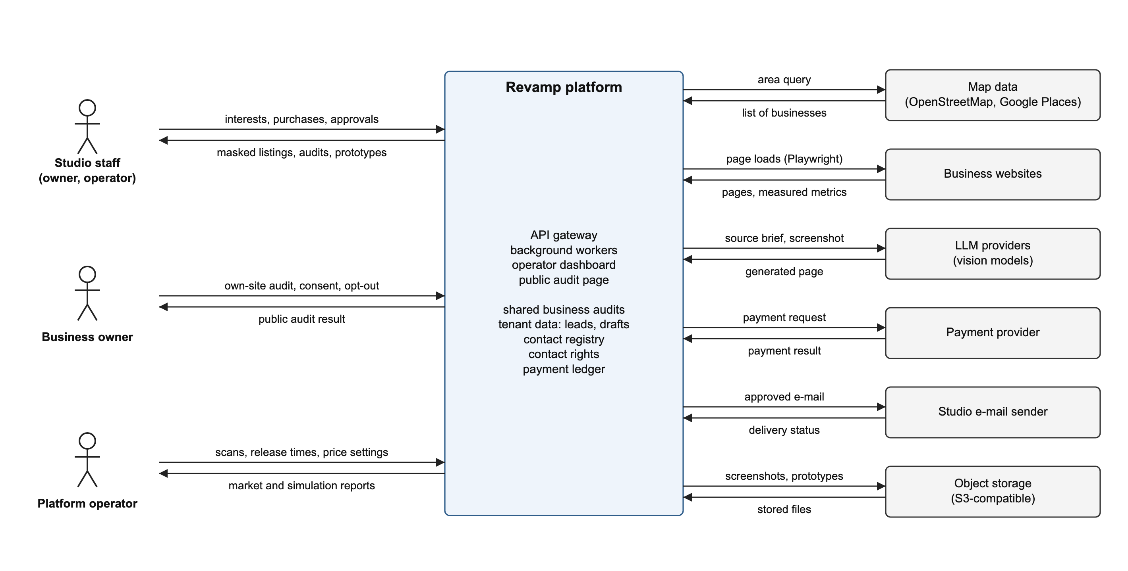
Fig. 2. Context diagram of the Revamp platform (full size in Appendix B)
Table 7 compares the main design decisions with the alternatives that were considered.
Table 7. Solution alternatives and rationale
Decision | Alternative | Chosen | Rationale
How a business is allocated to a studio | Auction of the contact right (sealed bid) | Fixed-price purchase; the first studio to reserve and pay gets the right | An auction needs enough bidders, which a young market lacks; posted prices trade some price discovery for convenience [13]. The auction stays as future work.
Where leads come from | Each studio searches and audits on its own | Shared pool: the platform scans on demand, audits each business once and releases lots at published times | Separate searches repeat the audit cost and cannot prevent repeated pitches (L2, L4); a shared audit is computed once and the registry enforces exclusivity.
Who sends the e-mail | The platform sends on behalf of studios (white label) | Each studio sends from its own address after approval | Keeps sender reputation and legal responsibility with the studio and meets the sender identity rule [11].

2.5 Functional Requirements
The functional requirements are organised into epics E1–E5, which extend the existing core pipeline E0. Each user story follows the form "As a … I want … so that …" and has a MoSCoW priority; every Must story has acceptance criteria in Given/When/Then form. Story IDs US1–US12 come from the project’s business analysis, US13–US14 describe the implemented core that the new epics rely on, and US15–US17 record the deferred ideas as Won’t. Table 8 lists the backlog; Appendix A repeats it unchanged, because both tables are generated from one source.
Table 8. Product backlog: epics and user stories
ID | User story | Acceptance criteria (Given / When / Then) | MoSCoW
E0. Core pipeline (implemented) (Must)
US13 | As a studio operator, I want to review the audit, the prototype and the e-mail draft and approve the e-mail myself, so that no message is sent without a human decision. | Given a lead with a generated draft, when no operator has approved it, then no background job sends the e-mail.  Given an approved e-mail, when it is scheduled, then the lead moves to Scheduled only through the lead state machine. | Must
US14 | As a studio operator, I want every metric, contact detail and fact in the offer to come from deterministic code, so that I never send invented data. | Given an audit, when a measurement fails, then its value is left out and the failure is recorded, never replaced by a stand-in value.  Given a generated page, when it fails the code checks twice, then nothing is published and the reason is shown.  Given a published page, when contact details appear in it, then they come only from verified contacts. | Must
E1. Multi-tenancy (Must)
US1 | As a studio owner, I want to register my studio and invite colleagues with roles, so that my team works in one private workspace. | Given a new user, when they register a studio, then an organization is created with them as its owner.  Given an invitation with a role, when the invitee accepts it, then they join the organization with that role.  Given a user with the viewer role, when they try to approve or send an e-mail, then the request is rejected. | Must
US2 | As a studio owner, I want other studios never to see my leads, drafts or prototypes, so that my work and clients stay confidential. | Given a record of studio B, when a user of studio A requests it, then the API answers "not found".  Given a background job of studio A, when it runs, then it reads and writes only studio A’s records. | Must
E2. Contact registry and rights (Must)
US3 | As a studio operator, I want to send outreach only to businesses my studio holds an active contact right for, so that I do not break the market rules. | Given a lead without an active right, when an operator schedules the e-mail, then the transition is rejected with a clear error code.  Given a scheduled e-mail, when the right expires before sending, then the send is cancelled. | Must
US4 | As a business owner, I want not to be pitched by several studios in a short time, so that my inbox is not spammed. | Given a business whose right ended within the cooldown, when another studio tries to buy or use a right for it, then the attempt is rejected.  Given a business that opted out, when any studio tries to contact it, then the contact is blocked and queued e-mails are cancelled. | Must
E3. Purchase and payments (Must)
US5 | As a studio operator, I want to buy the right to contact a business for a fixed period at a visible price, so that I secure exclusive access to the leads I value most. | Given a released lot, when a studio reserves it and its payment succeeds, then that studio gets the right and the lot closes for all others.  Given two businesses with identical audit results, when their prices are calculated, then the prices are identical.  Given a studio at its limit of simultaneous rights, when it tries to buy another lot, then the purchase is rejected. | Must
US6 | As a studio operator, I want the right to be granted to me exactly once when my payment succeeds, so that I never pay for a lead another studio holds. | Given two simultaneous purchases of one lot, when both are paid, then only one succeeds.  Given a payment job that retries, when it runs again, then no second right is created.  Given an unpaid reservation, when its time runs out, then the lot is released and no charge is recorded. | Must
US7 | As the platform operator, I want to simulate studios under different pricing rules, so that I can choose a rule with evidence. | Given the same seed and settings, when the simulation runs twice, then the results are identical.  Given several pricing rules, when the simulation ends, then the report compares revenue, unsold share, buyer concentration and overpayment per rule. | Must
US10 | As a studio operator, I want to filter open lots by niche, area and audit band, so that I can choose which businesses to buy without seeing who they are. | Given an open lot, when any studio requests the listing, then only masked fields are returned: niche, district, audit band, price and release time.  Given a profile that fewer than k businesses share, when listings are published, then that listing is withheld.  Given one studio’s listing requests, when they exceed the rate limit, then further requests are rejected. | Must
US11 | As a studio operator, I want to save an interest in a niche and an area, so that I am notified about new lots there and the platform knows where studios want leads. | Given an interest saved by studio A, when studio B lists interests, then studio A’s interest is not shown.  Given a saved interest, when matching lots are released, then the studio is notified and gets no priority over other studios. | Must
US12 | As the platform operator, I want to scan an area when demand reaches a threshold and to release lots at published times, so that audit cost follows demand and every studio has the same chance. | Given demand below the threshold and no scheduled scan, when the scheduler runs, then no scan is queued.  Given a lot with a published release time, when that time comes, then every studio can buy it.  Given a business that is already audited, when its area is scanned again, then the existing audit is reused. | Must
E4. Inbound flow (Should)
US8 | As a business owner, I want to check my website and see a better version, so that I can decide whether to hire a studio. | Given an owner without an account, when they enter their site address, then they get the audit result.  Given an audit result, when the owner gives explicit consent, then a lead is created and the consent is stored with its time and text.  Given a consented lead, when the owner withdraws consent, then the right ends, queued e-mails are cancelled and the unused part of the payment is refunded. | Should
E5. Market map (Could)
US9 | As a studio operator, I want a map of prices and available businesses by area and niche, so that I can choose where to buy. | Given a map cell with too few purchases, when the map is shown, then the cell shows no price and never reveals a buyer. | Could
F. Deferred (future work) (Won't)
US15 | As a studio owner, I want to bid for the right to contact a business in an auction, so that the price reflects competition. | — | Won't
US16 | As a business owner, I want to publish a new site myself and let studios bid to redesign it, so that I choose the offer. | — | Won't
US17 | As a studio owner, I want the platform to send e-mails for me from a platform domain, so that I need no sender of my own. | — | Won't

Table 9 traces the business goals and KPIs from section 2.1 to the epics and stories. Wireframes of four key stories (masked listing, purchase with reservation, lead review with approval, and the owner’s audit with consent) are shown in Fig. 5 in Appendix B.
Table 9. Traceability: goal and KPI → epic → user story
Goal | KPI | Epic | User stories
G1 | K1 | E0, E3 | US13 review and approve, US5 buy a right, US10 masked listing, US11 interests
G2 | K4 | E2, E3, E5 | US3 contact only with a right, US4 no repeated pitches, US5, US6 right granted once, US7 pricing simulation, US12 scans and releases, US9 market map
G3 | K2, K3 | E0, E3 | US14 deterministic facts and checked pages, US5 identical audit gives identical price, US7
G4 | NFR3 (no KPI) | E1, E4 | US1 studio organization, US2 data isolation, US8 owner audit and consent

2.6 Use Cases
Two use cases describe the key flows of the outbound and the inbound channel. Fig. 8 in Appendix B shows the system sequence diagram of UC1.
Table 10. UC1: a studio buys a contact right (US5, US6, US10)
Element | Description
Actor | Studio operator; secondary actor: payment provider
Precondition | The operator is signed in, the lot is released, and the studio is below its limit of simultaneous rights.
Main flow | 1. The operator filters open lots by niche, area and audit band; the system shows masked lots with price and release time.  2. The operator buys a lot; the system reserves it for the studio for a short time and requests a payment.  3. The operator pays on the payment provider’s page; the provider reports success.  4. The system records the charge in the ledger and creates the contact right exactly once.  5. The system re-checks the site, reveals the business and starts generating the prototype.
Alternative flows | 2a. The lot is already reserved or sold: the purchase is rejected and the lot is shown as unavailable.  3a. The payment fails or the reservation expires: the lot is released and no charge is recorded.  5a. The re-check finds the business invalid (closed, unreachable, already redesigned): the right is cancelled and the price refunded.
Postcondition | The studio holds the right for the fixed period; the registry blocks other studios.

Table 11. UC2: a business owner requests an audit and consents to contact (US8)
Element | Description
Actor | Business owner, without an account
Precondition | The owner’s site is publicly reachable.
Main flow | 1. The owner enters the site address; the system checks the rate limit and the captcha.  2. The system audits the site, or reuses a recent audit, and shows the result and a prototype.  3. The owner gives explicit consent; the system stores it with time, text and source and creates an inbound lead offered at a fixed price.
Alternative flows | 2a. The site cannot be loaded: the failure is shown and no result is made up.  3a. The owner leaves without consent: no lead is created. Later withdrawal ends any right, cancels queued e-mails and refunds the unused part.
Postcondition | A consented lead is on the market, or nothing is stored beyond the audit.

2.7 Non-Functional Requirements
Table 12 lists the non-functional requirements. Each has a measurable target and is linked to a KPI or a story; the targets are proposals to be confirmed together with the KPIs.
Table 12. Non-functional requirements
ID | Area | Requirement and measurable target | Link
NFR1 | Performance | The listing page with 100 open lots loads within 2 s (95th percentile). | US10, K1
NFR2 | Performance | Loading a site for the audit is bounded by the existing 25 s navigation timeout; a site that does not load gets a failed audit with a readable reason. | US14, K2
NFR3 | Security | Zero cross-tenant reads or writes in an isolation test suite that covers 100% of tenant-scoped endpoints and jobs. | US2
NFR4 | Integrity | Exactly one right per successful payment: 0 duplicate rights under 100 concurrent purchase attempts on one lot. | US6, K4
NFR5 | Availability | An unpaid reservation is released within 1 minute of its expiry, also after a worker restart. | US6
NFR6 | Determinism | Metrics and contacts come only from deterministic code; a failed measurement is left out (0 stand-in values in audits). | US14, K2
NFR7 | Human in the loop | 0 e-mails sent without the approval of a user with the operator role, checked against the send log. | US13, US3
NFR8 | Usability | The dashboard and the public audit page meet WCAG 2.1 AA, with 0 axe-core violations at levels A and AA on key screens; the dashboard is available in 5 languages. | US8, US10
NFR9 | Anti-scraping | Listing requests are rate limited per studio (proposed: 60 per minute); identity fields are never serialized before purchase. | US10
NFR10 | Testability | Automated test coverage of at least 70%, with dedicated suites for purchases and tenant isolation. | US2, US6

2.8 Legal and Ethical Requirements
Personal data. The platform processes business contact details that the business itself publishes (e-mail address, phone number, address), which identify a natural person in the case of a sole trader; the account data of studio users; and consent records of the inbound flow. It processes no data about private individuals. The legal basis for outbound B2B contact is legitimate interest under Article 6(1)(f) GDPR, supported by Recital 47 and a balancing test, with the right to object under Article 21 applied across all studios [10]. The inbound flow relies on consent, which is stored with its time and text and can be withdrawn; studio accounts and payments rely on the contract. Because Article 13 of the ePrivacy Directive leaves the rules for legal persons to national law [11], each target country needs a legal review before outreach starts there. The roles of the platform and the studios as controllers, retention periods and the handling of access and deletion requests will be fixed in a Privacy Notice and a Data Processing Agreement (task REV-176).
Participants. No interviews or surveys were carried out, so no participant consent was needed; Lighthouse and Clutch were tried on public pages without accounts, and Apollo with the author’s own account.
Licenses. The main dependencies are open source: Playwright (Apache-2.0), axe-core (MPL-2.0), Express, Mongoose, BullMQ, React and Material UI (MIT). OpenStreetMap data is available under the Open Database License and requires attribution [20]; Google Places data is used under Google’s terms.
Standards and ethics. The dashboard and the public audit page must meet WCAG 2.1 AA [8] (NFR8). Audit reports must never claim that a site conforms to WCAG, because automated checks cover only part of it [9]. Every e-mail must name the sending studio and carry an opt-out, and the k threshold of masked listings prevents profiling of a single business.

2.9 Risks
Table 13 lists the main risks with their probability (P) and impact (I), rated H, M or L by the author.
Table 13. Risk register
ID | Risk | P | I | Mitigation | Dependency
R1 | Thin market: too few studios per area, lots stay unsold | H | H | Start with large cities; calibrate prices in the simulation; consider a price that falls while a lot stays unsold | E3, US7
R2 | Scope too large for the timeline | H | H | MoSCoW: E1–E3 first, E4 and E5 only if time allows | C1
R3 | Marketing e-mail rules differ by country | M | H | Legal review per market; opt-out across studios; consent-based inbound flow | E2, E4, REV-176
R4 | Cross-tenant data leak | L | H | One data-access layer; isolation tests on every endpoint (NFR3) | E1
R5 | A masked profile identifies a business and the purchase is bypassed | M | M | Coarse areas, banded scores, k threshold, rate limits (NFR9) | E3, US10
R6 | LLM cost rises or the provider fails | M | M | Audit once per business; per-studio quotas; several providers; visible failure state | E0, A2
R7 | Overpayment for a business bought on a masked profile | M | M | Re-check before the right is granted; refund for invalid businesses | E3, US5

2.10 Conclusions to Chapter 2
The specification fixes the vision, four business goals and KPIs K1–K4 with their baselines and targets, the scope with its assumptions and constraints, the solution concept with the rejected alternatives, 17 user stories (14 in six epics and 3 deferred; all 12 Must stories have Given/When/Then criteria), two use cases, ten non-functional requirements, the legal basis of processing and seven risks. The result will be verified as follows:
- K1: the median operator time per reviewed lead is at most 15 minutes in a pilot, compared with a baseline measured on the manual process first.
- K2: at least 95% of at least 20 audited sites get the same band and price on two runs a day apart.
- K3: at least 80% of at least 30 generated pages pass the code checks on the first attempt.
- K4: the contact registry shows no business contacted by two studios within the cooldown, in the pilot and in the simulation.
- Stories and NFRs: every Given/When/Then criterion becomes an automated acceptance test, and NFR1–NFR10 are checked by load, isolation and accessibility tests. The market simulation (US7) compares revenue, unsold share, buyer concentration and overpayment for each pricing rule.

References
- WebAIM, "The WebAIM Million: The 2026 report on the accessibility of the top 1,000,000 home pages," Mar. 30, 2026. [Online]. Available: https://webaim.org/projects/million/ (accessed Oct. 25, 2026).
- J. Zigisova and I. Akrap, "Performance," in The 2024 Web Almanac, HTTP Archive, Nov. 2024. [Online]. Available: https://almanac.httparchive.org/en/2024/performance (accessed Oct. 25, 2026).
- C. Si, Y. Zhang, R. Li, Z. Yang, R. Liu, and D. Yang, "Design2Code: Benchmarking multimodal code generation for automated front-end engineering," in Proc. 2025 Conf. Nations of the Americas Chapter of the Assoc. for Computational Linguistics: Human Language Technologies (NAACL), Vol. 1: Long Papers, Albuquerque, NM, USA, Apr. 2025, pp. 3956–3974, doi: 10.18653/v1/2025.naacl-long.199.
- Z. Ji, N. Lee, R. Frieske, T. Yu, D. Su, Y. Xu, E. Ishii, Y. J. Bang, A. Madotto, and P. Fung, "Survey of hallucination in natural language generation," ACM Computing Surveys, vol. 55, no. 12, pp. 1–38, 2023, doi: 10.1145/3571730.
- Google, "About PageSpeed Insights," Google for Developers. [Online]. Available: https://developers.google.com/speed/docs/insights/v5/about (accessed Oct. 26, 2026).
- Salesforce, "Salesforce report: Sales teams using AI 1.3x more likely to see revenue increase," Salesforce News, Jul. 25, 2024 (summary of the 6th State of Sales report, a survey of 5,500 sales professionals in 27 countries). [Online]. Available: https://www.salesforce.com/news/stories/sales-ai-statistics-2024/ (accessed Oct. 28, 2026).
- S. Rajpal and S. Gopalakrishnan, "The business impact of Core Web Vitals," web.dev, Google, updated Sep. 1, 2021. [Online]. Available: https://web.dev/case-studies/vitals-business-impact (accessed Oct. 26, 2026).
- A. Kirkpatrick, J. O Connor, A. Campbell, and M. Cooper, Eds., "Web Content Accessibility Guidelines (WCAG) 2.1," W3C Recommendation, May 6, 2025. [Online]. Available: https://www.w3.org/TR/WCAG21/ (accessed Oct. 26, 2026).
- M. Vigo, J. Brown, and V. Conway, "Benchmarking web accessibility evaluation tools: Measuring the harm of sole reliance on automated tests," in Proc. 10th Int. Cross-Disciplinary Conf. on Web Accessibility (W4A ’13), Rio de Janeiro, Brazil, May 2013, pp. 1–10, doi: 10.1145/2461121.2461124.
- Regulation (EU) 2016/679 of the European Parliament and of the Council of 27 April 2016 on the protection of natural persons with regard to the processing of personal data and on the free movement of such data, and repealing Directive 95/46/EC (General Data Protection Regulation), OJ L 119, 4.5.2016, p. 1. [Online]. Available: https://eur-lex.europa.eu/eli/reg/2016/679/oj
- Directive 2002/58/EC of the European Parliament and of the Council of 12 July 2002 concerning the processing of personal data and the protection of privacy in the electronic communications sector (Directive on privacy and electronic communications), OJ L 201, 31.7.2002, pp. 37–47. [Online]. Available: https://eur-lex.europa.eu/eli/dir/2002/58/oj
- J.-C. Rochet and J. Tirole, "Platform competition in two-sided markets," Journal of the European Economic Association, vol. 1, no. 4, pp. 990–1029, Jun. 2003, doi: 10.1162/154247603322493212.
- L. Einav, C. Farronato, J. Levin, and N. Sundaresan, "Auctions versus posted prices in online markets," Journal of Political Economy, vol. 126, no. 1, pp. 178–215, Feb. 2018, doi: 10.1086/695529.
- Apollo.io, "Apollo.io," product website. [Online]. Available: https://www.apollo.io/ (accessed Oct. 26, 2026).
- Apollo.io, "Pricing," product website. [Online]. Available: https://www.apollo.io/pricing (accessed Oct. 26, 2026).
- Apollo.io, "Create a sequence," Apollo Knowledge Base. [Online]. Available: https://knowledge.apollo.io/hc/en-us/articles/4409231193101-Create-a-Sequence (accessed Oct. 26, 2026).
- Apollo.io, "Track website visitors to prioritize prospects," Apollo Knowledge Base. [Online]. Available: https://knowledge.apollo.io/hc/en-us/articles/20544185285389 (accessed Oct. 28, 2026).
- GoogleChrome, "Lighthouse," GitHub repository, Apache-2.0 license. [Online]. Available: https://github.com/GoogleChrome/lighthouse (accessed Oct. 26, 2026).
- Clutch, "Top web development companies," Clutch.co. [Online]. Available: https://clutch.co/web-developers (accessed Oct. 26, 2026).
- OpenStreetMap Foundation, "Copyright and license," OpenStreetMap. [Online]. Available: https://www.openstreetmap.org/copyright (accessed Oct. 26, 2026).

Appendix A. Product Backlog
Table 14. Product backlog (identical to Table 8)
ID | User story | Acceptance criteria (Given / When / Then) | MoSCoW
E0. Core pipeline (implemented) (Must)
US13 | As a studio operator, I want to review the audit, the prototype and the e-mail draft and approve the e-mail myself, so that no message is sent without a human decision. | Given a lead with a generated draft, when no operator has approved it, then no background job sends the e-mail.  Given an approved e-mail, when it is scheduled, then the lead moves to Scheduled only through the lead state machine. | Must
US14 | As a studio operator, I want every metric, contact detail and fact in the offer to come from deterministic code, so that I never send invented data. | Given an audit, when a measurement fails, then its value is left out and the failure is recorded, never replaced by a stand-in value.  Given a generated page, when it fails the code checks twice, then nothing is published and the reason is shown.  Given a published page, when contact details appear in it, then they come only from verified contacts. | Must
E1. Multi-tenancy (Must)
US1 | As a studio owner, I want to register my studio and invite colleagues with roles, so that my team works in one private workspace. | Given a new user, when they register a studio, then an organization is created with them as its owner.  Given an invitation with a role, when the invitee accepts it, then they join the organization with that role.  Given a user with the viewer role, when they try to approve or send an e-mail, then the request is rejected. | Must
US2 | As a studio owner, I want other studios never to see my leads, drafts or prototypes, so that my work and clients stay confidential. | Given a record of studio B, when a user of studio A requests it, then the API answers "not found".  Given a background job of studio A, when it runs, then it reads and writes only studio A’s records. | Must
E2. Contact registry and rights (Must)
US3 | As a studio operator, I want to send outreach only to businesses my studio holds an active contact right for, so that I do not break the market rules. | Given a lead without an active right, when an operator schedules the e-mail, then the transition is rejected with a clear error code.  Given a scheduled e-mail, when the right expires before sending, then the send is cancelled. | Must
US4 | As a business owner, I want not to be pitched by several studios in a short time, so that my inbox is not spammed. | Given a business whose right ended within the cooldown, when another studio tries to buy or use a right for it, then the attempt is rejected.  Given a business that opted out, when any studio tries to contact it, then the contact is blocked and queued e-mails are cancelled. | Must
E3. Purchase and payments (Must)
US5 | As a studio operator, I want to buy the right to contact a business for a fixed period at a visible price, so that I secure exclusive access to the leads I value most. | Given a released lot, when a studio reserves it and its payment succeeds, then that studio gets the right and the lot closes for all others.  Given two businesses with identical audit results, when their prices are calculated, then the prices are identical.  Given a studio at its limit of simultaneous rights, when it tries to buy another lot, then the purchase is rejected. | Must
US6 | As a studio operator, I want the right to be granted to me exactly once when my payment succeeds, so that I never pay for a lead another studio holds. | Given two simultaneous purchases of one lot, when both are paid, then only one succeeds.  Given a payment job that retries, when it runs again, then no second right is created.  Given an unpaid reservation, when its time runs out, then the lot is released and no charge is recorded. | Must
US7 | As the platform operator, I want to simulate studios under different pricing rules, so that I can choose a rule with evidence. | Given the same seed and settings, when the simulation runs twice, then the results are identical.  Given several pricing rules, when the simulation ends, then the report compares revenue, unsold share, buyer concentration and overpayment per rule. | Must
US10 | As a studio operator, I want to filter open lots by niche, area and audit band, so that I can choose which businesses to buy without seeing who they are. | Given an open lot, when any studio requests the listing, then only masked fields are returned: niche, district, audit band, price and release time.  Given a profile that fewer than k businesses share, when listings are published, then that listing is withheld.  Given one studio’s listing requests, when they exceed the rate limit, then further requests are rejected. | Must
US11 | As a studio operator, I want to save an interest in a niche and an area, so that I am notified about new lots there and the platform knows where studios want leads. | Given an interest saved by studio A, when studio B lists interests, then studio A’s interest is not shown.  Given a saved interest, when matching lots are released, then the studio is notified and gets no priority over other studios. | Must
US12 | As the platform operator, I want to scan an area when demand reaches a threshold and to release lots at published times, so that audit cost follows demand and every studio has the same chance. | Given demand below the threshold and no scheduled scan, when the scheduler runs, then no scan is queued.  Given a lot with a published release time, when that time comes, then every studio can buy it.  Given a business that is already audited, when its area is scanned again, then the existing audit is reused. | Must
E4. Inbound flow (Should)
US8 | As a business owner, I want to check my website and see a better version, so that I can decide whether to hire a studio. | Given an owner without an account, when they enter their site address, then they get the audit result.  Given an audit result, when the owner gives explicit consent, then a lead is created and the consent is stored with its time and text.  Given a consented lead, when the owner withdraws consent, then the right ends, queued e-mails are cancelled and the unused part of the payment is refunded. | Should
E5. Market map (Could)
US9 | As a studio operator, I want a map of prices and available businesses by area and niche, so that I can choose where to buy. | Given a map cell with too few purchases, when the map is shown, then the cell shows no price and never reveals a buyer. | Could
F. Deferred (future work) (Won't)
US15 | As a studio owner, I want to bid for the right to contact a business in an auction, so that the price reflects competition. | — | Won't
US16 | As a business owner, I want to publish a new site myself and let studios bid to redesign it, so that I choose the offer. | — | Won't
US17 | As a studio owner, I want the platform to send e-mails for me from a platform domain, so that I need no sender of my own. | — | Won't

Appendix B. Diagrams
Fig. 3. AS-IS process of a web studio acquiring a client, UML activity diagram (full size of Fig. 1)
Fig. 4. Context diagram of the Revamp platform (full size of Fig. 2)
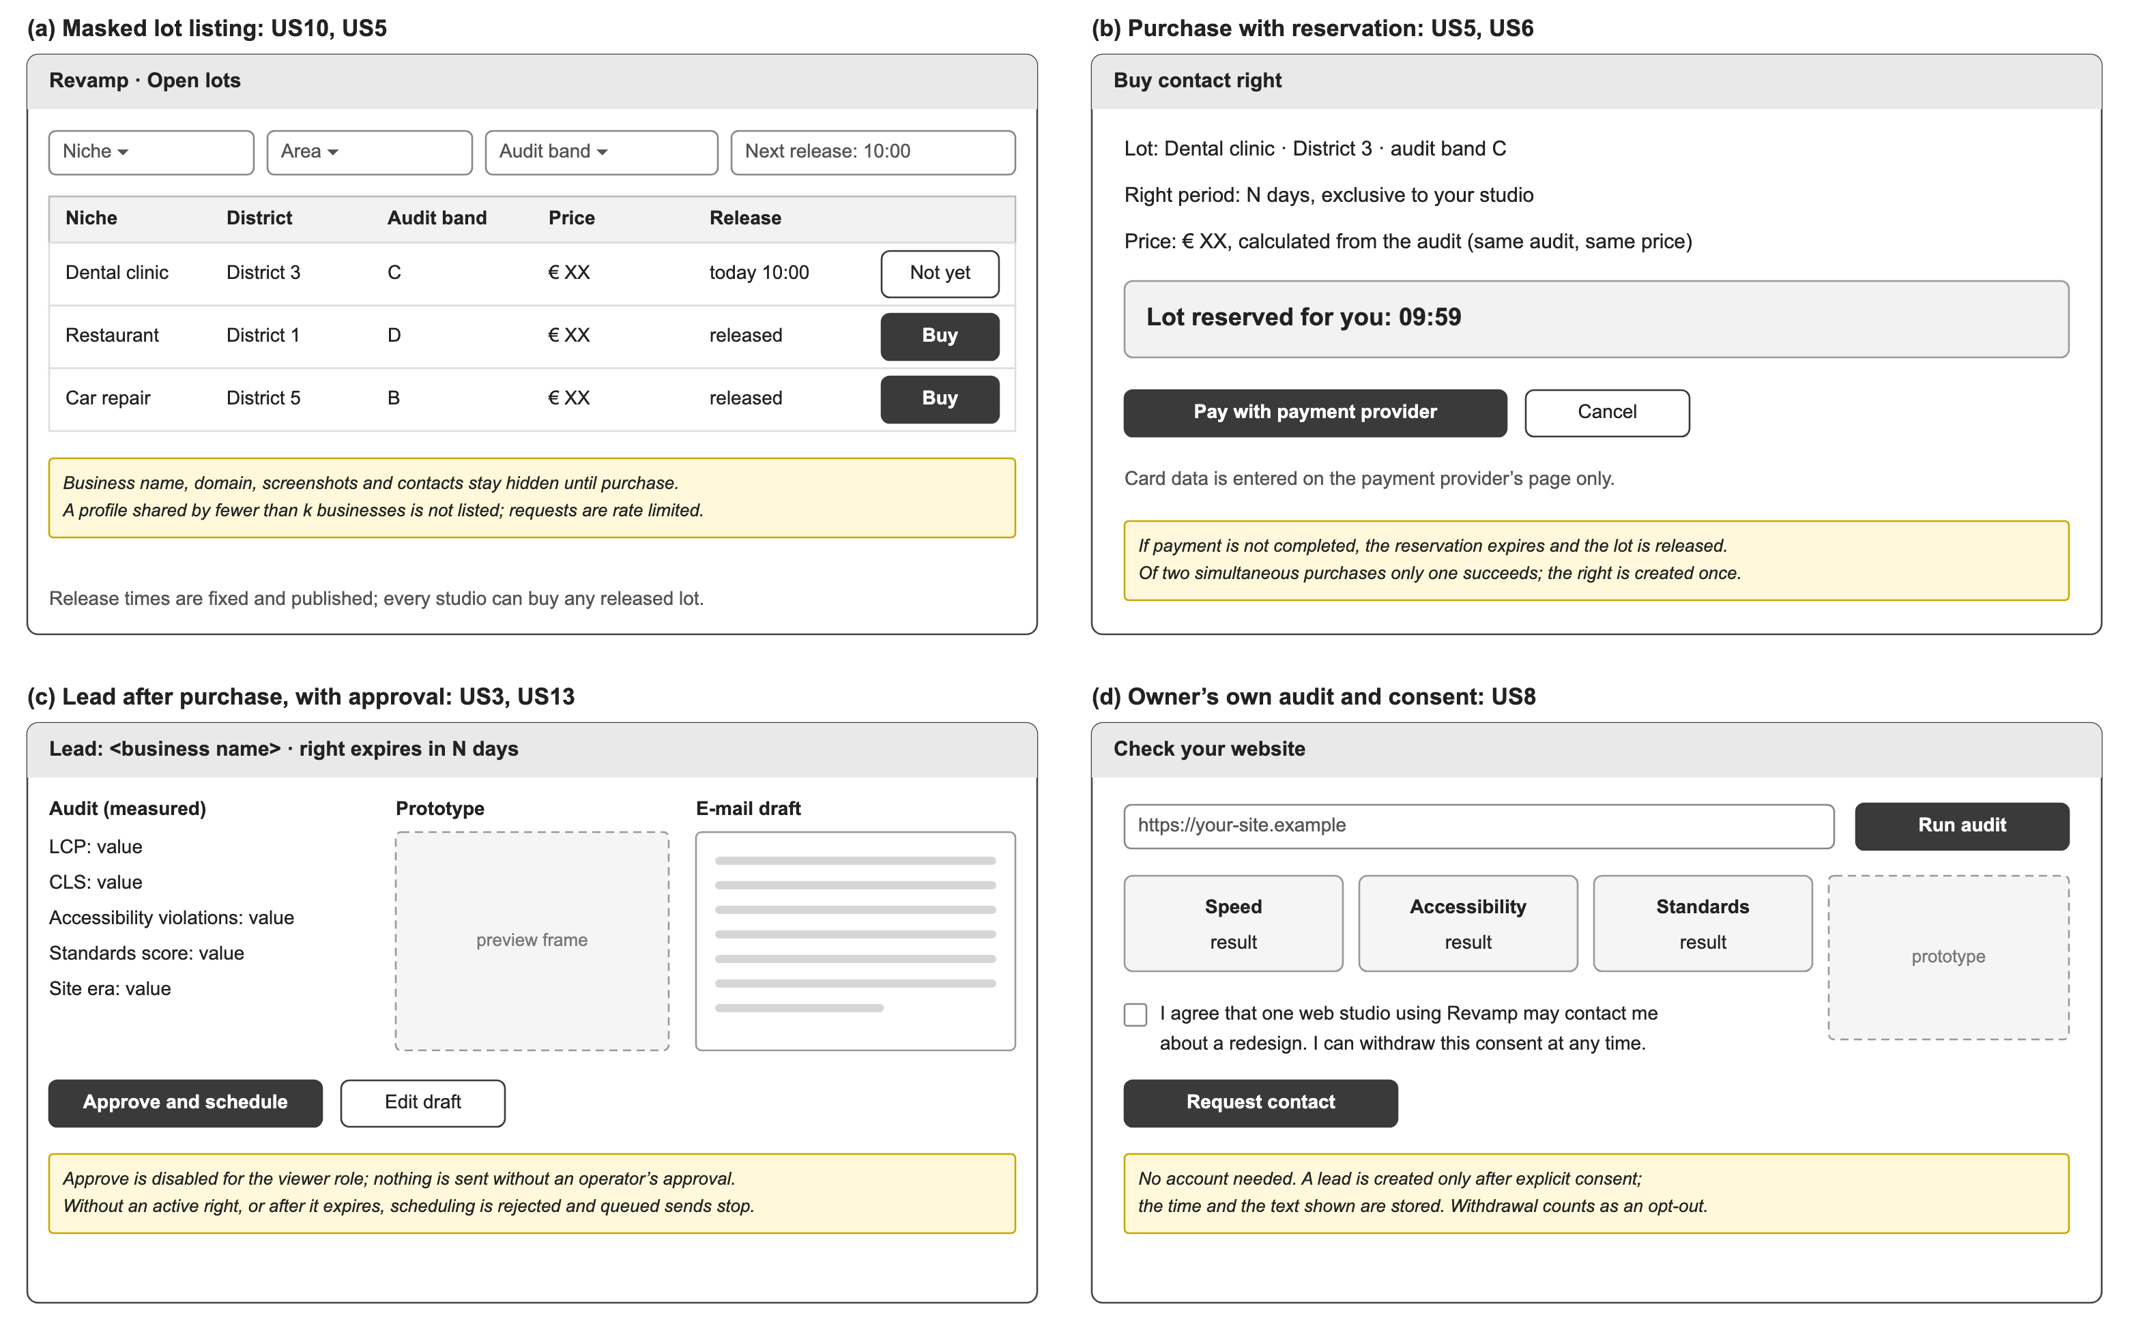
Fig. 5. Wireframes of key user stories: (a) masked lot listing, (b) purchase with reservation, (c) lead review with approval, (d) owner audit with consent
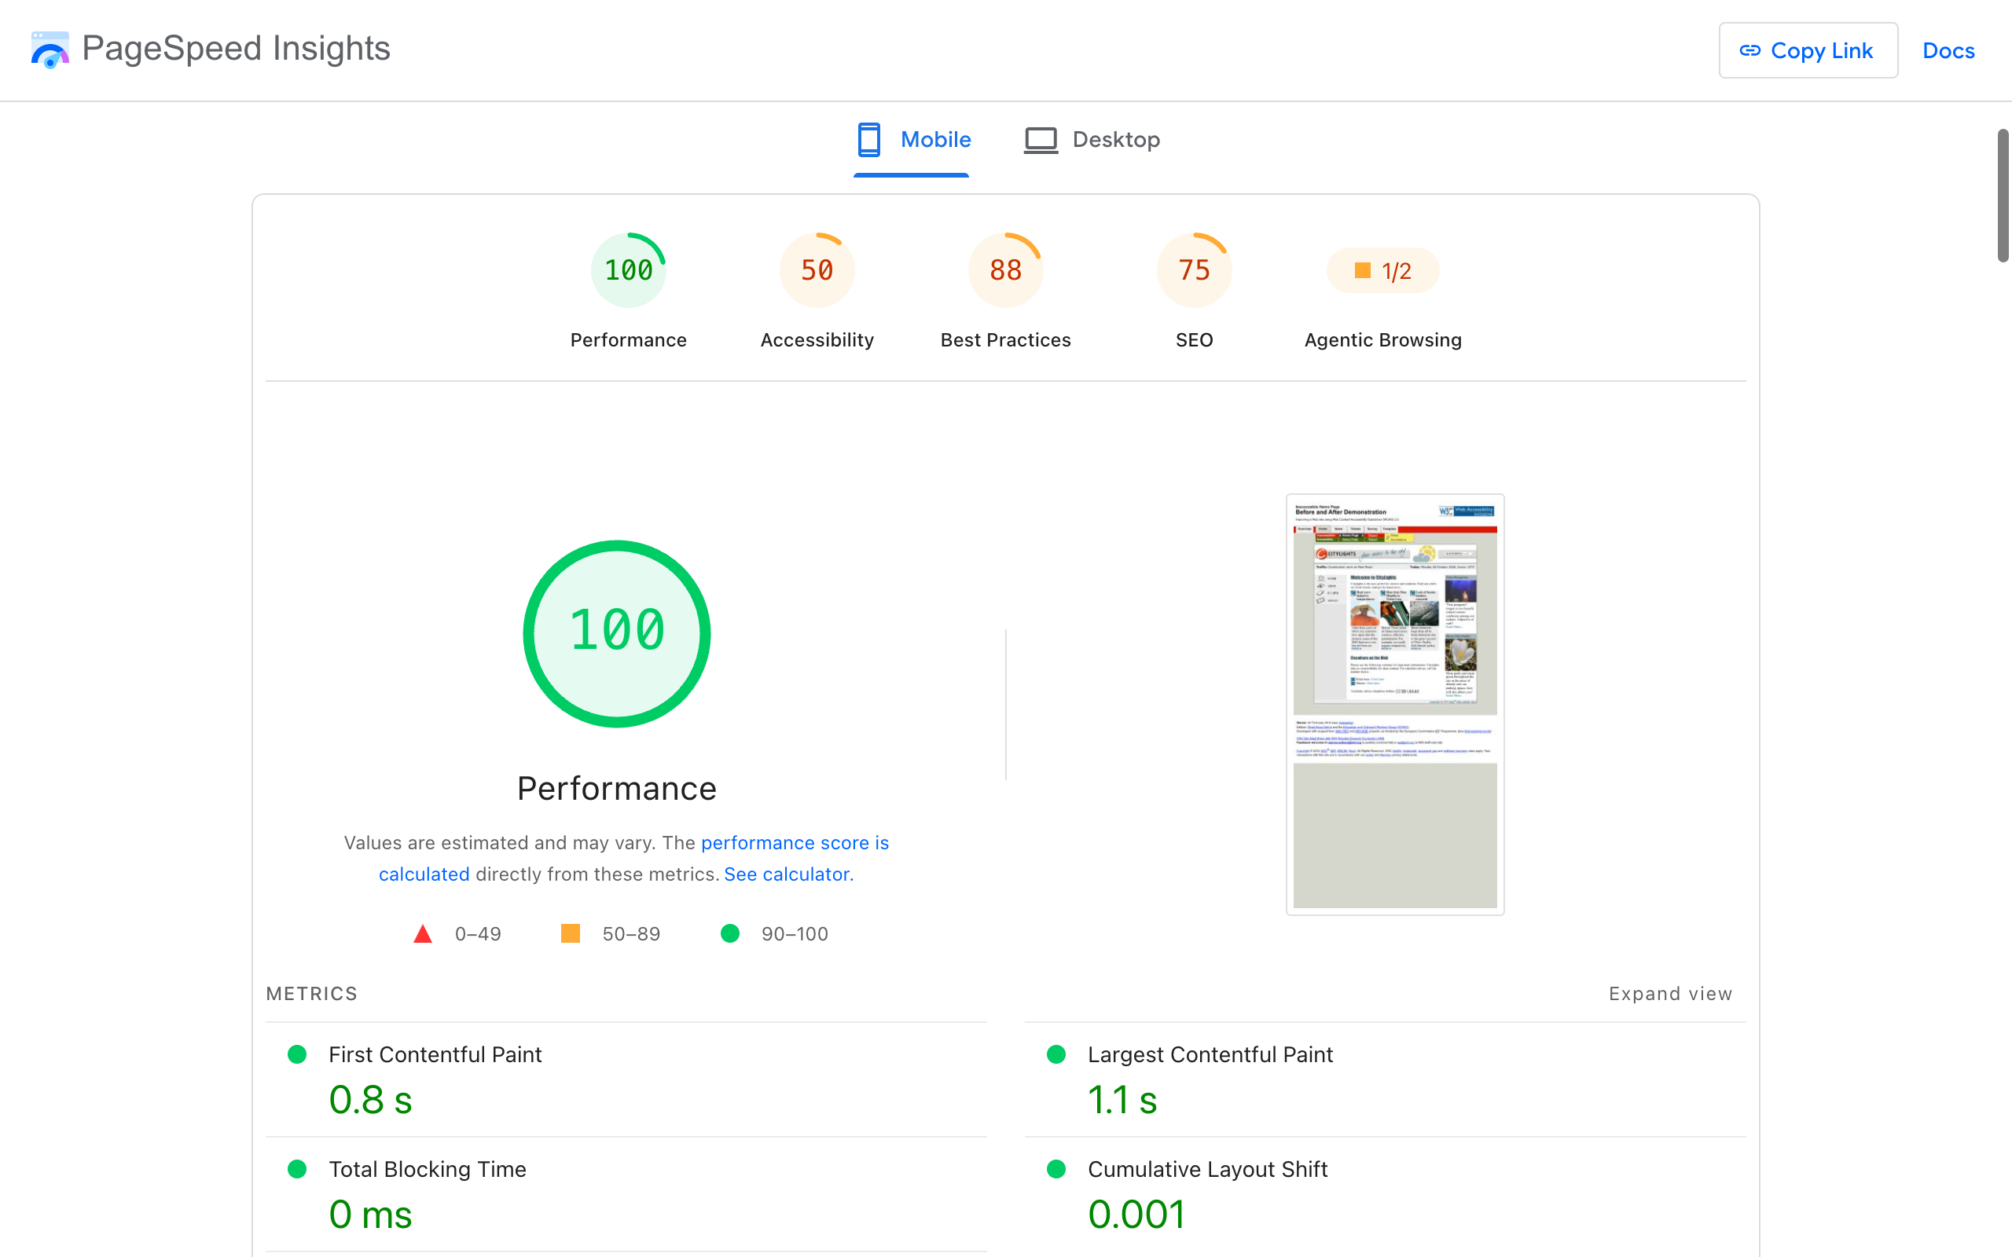
Fig. 6. PageSpeed Insights (Lighthouse) report for the W3C "Before and After" demonstration page, mobile, 26 October 2026
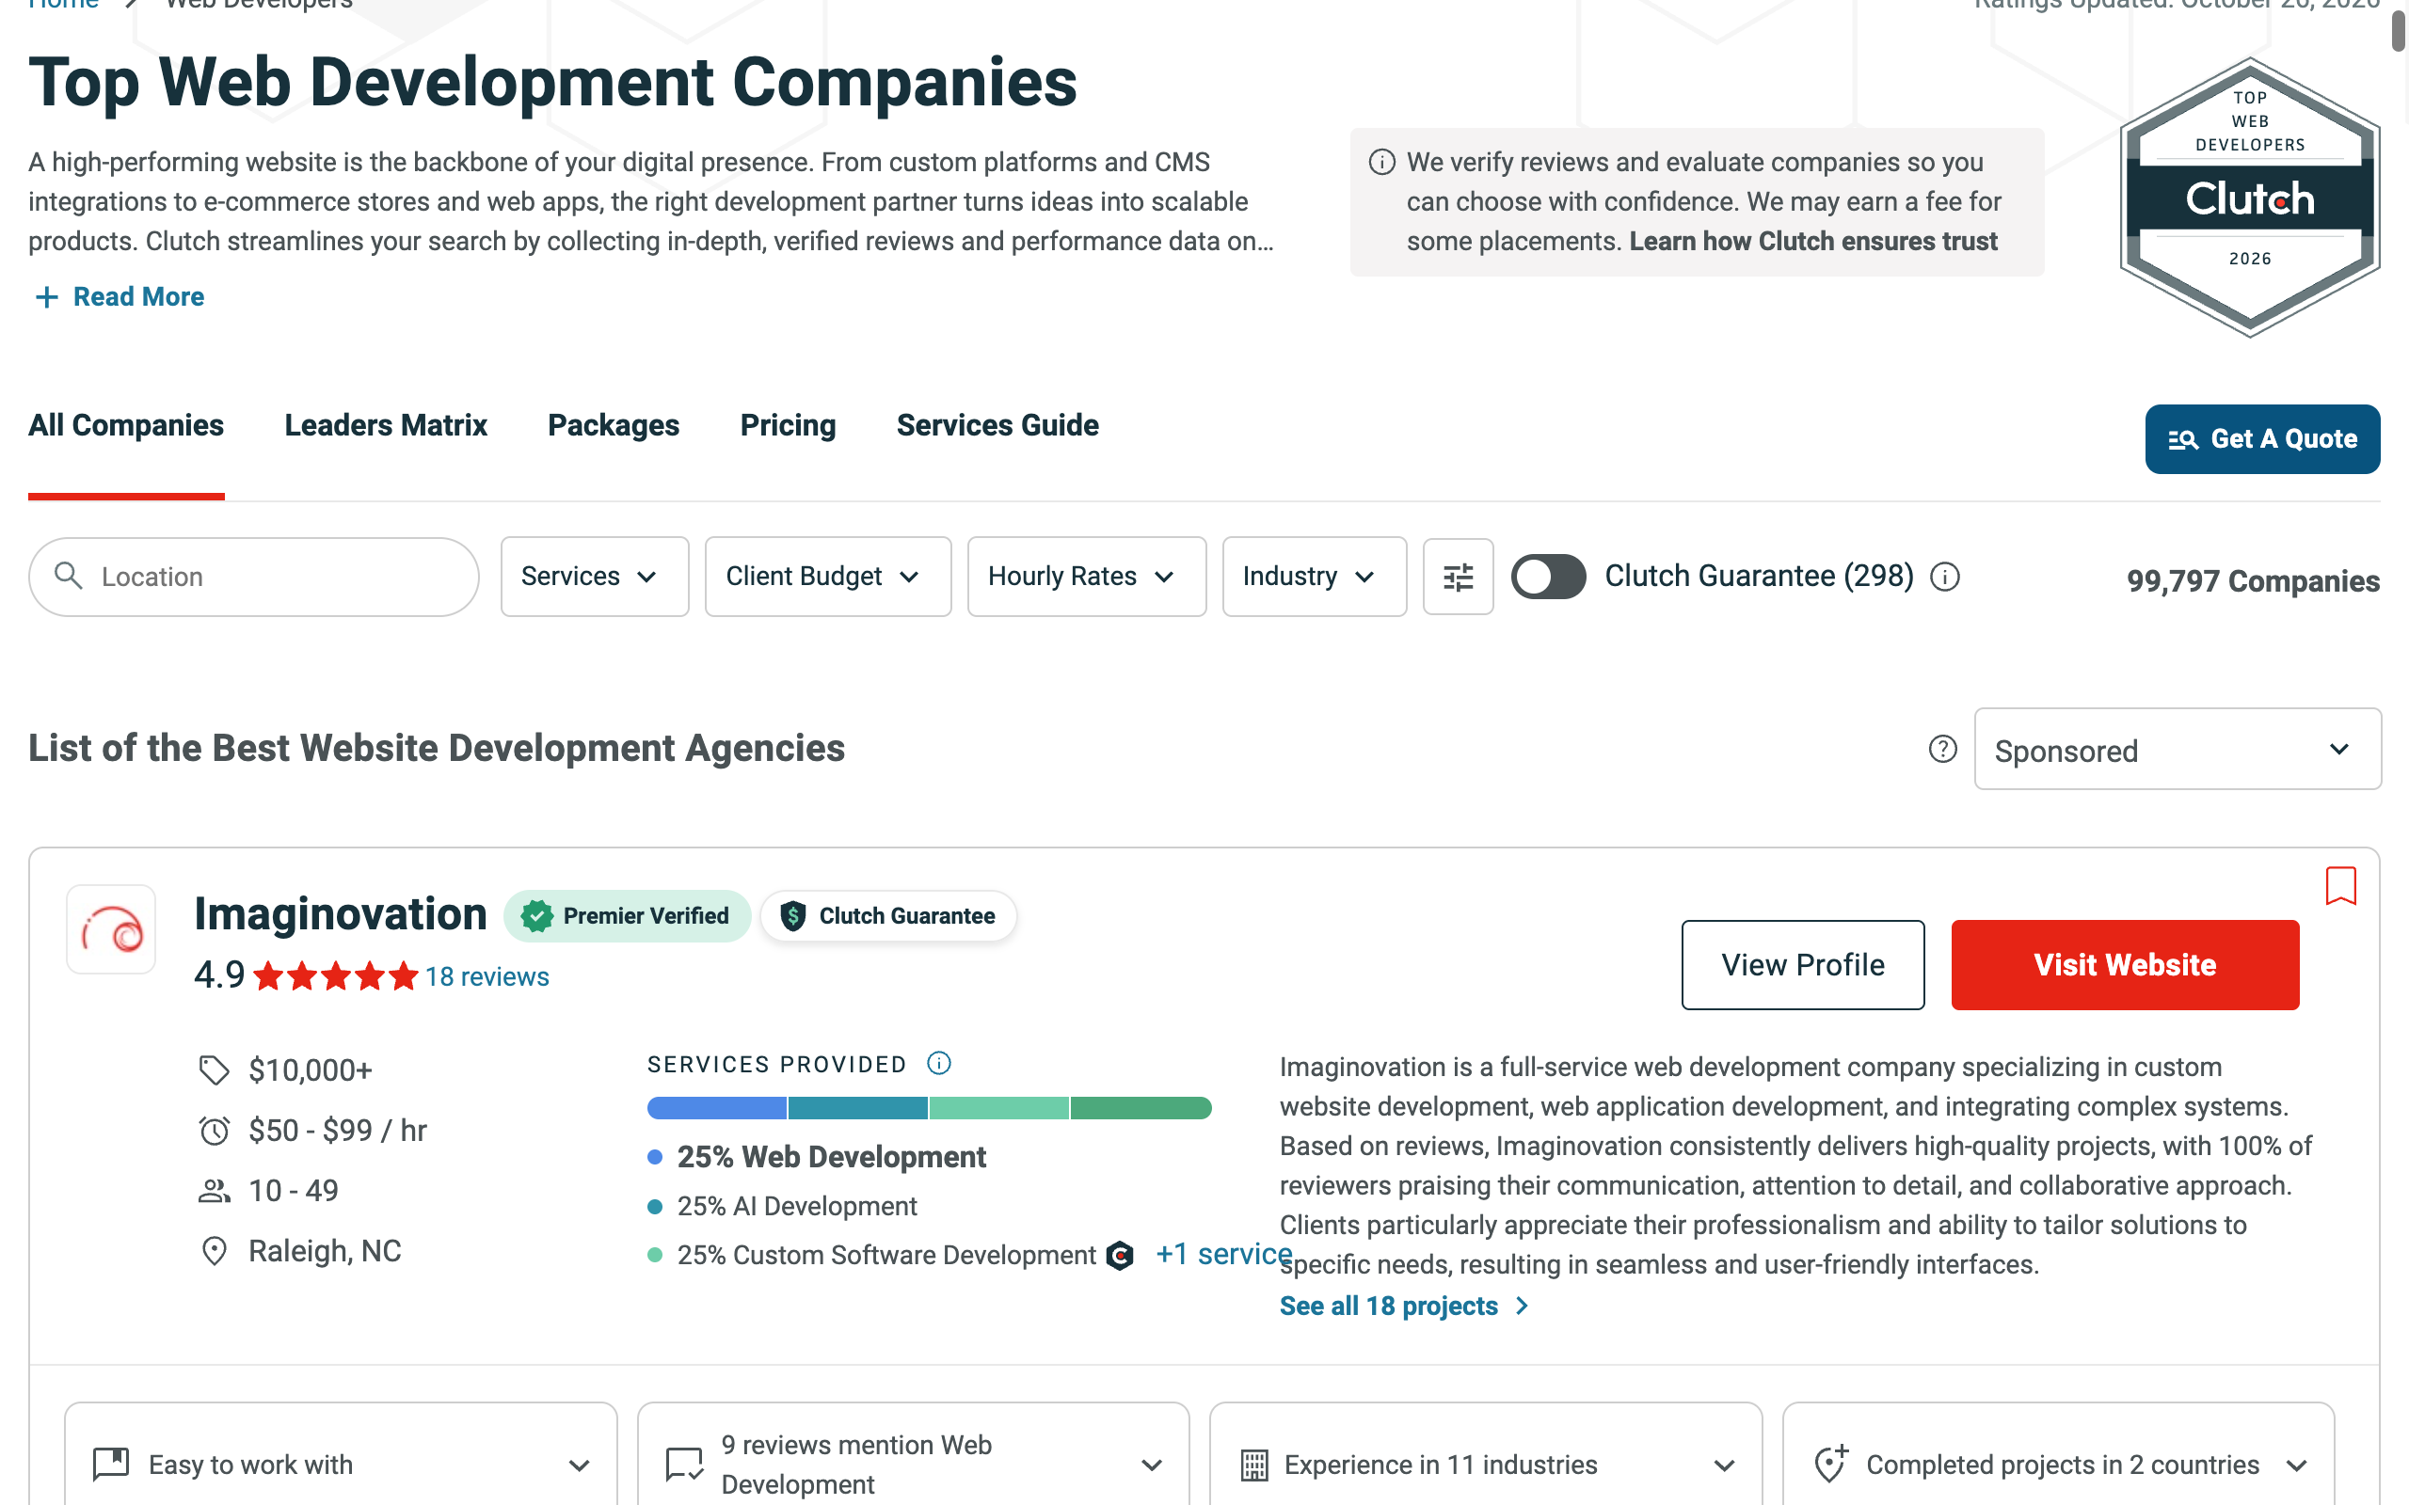
Fig. 7. Clutch directory of web development companies, 26 October 2026
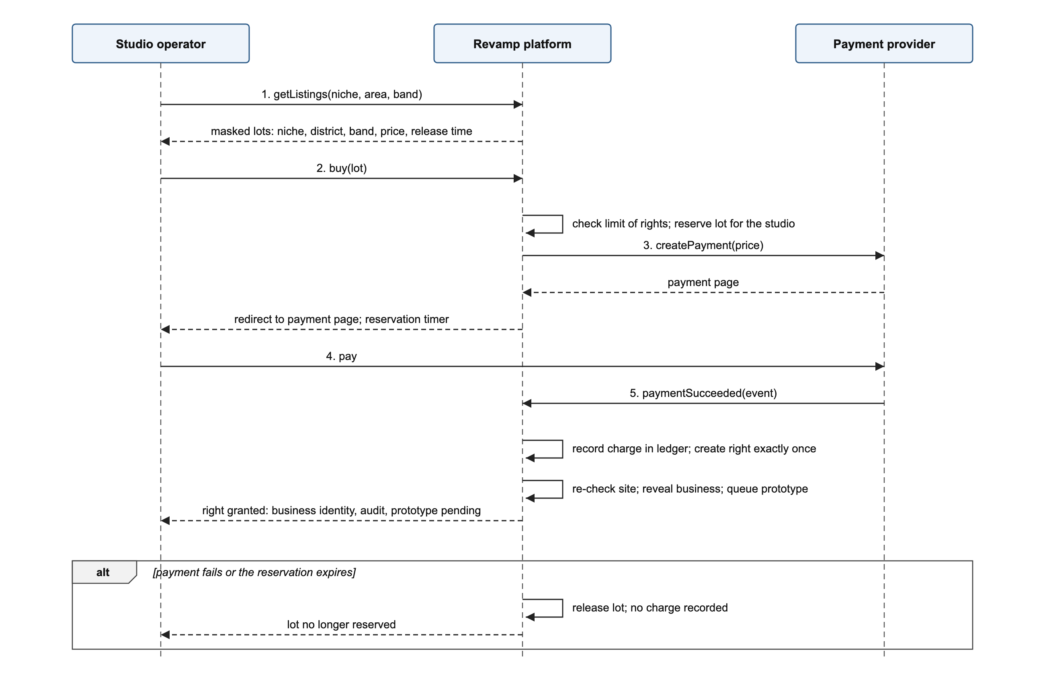
Fig. 8. System sequence diagram of UC1: a studio buys a contact right

Statements
Use of artificial intelligence. This document was prepared with the help of Claude (Anthropic), model Claude Opus 5.5, used through Claude Code. It was used to structure the document; to draft and edit the English text from the author’s project materials; to search for sources and check their bibliographic data against the publishers’ pages; to write the code that draws the diagrams and wireframes and builds this DOCX file; and to check the text against the requirements of the Business Analysis block. Every source was opened and checked. The goal, the objectives and the design decisions are the author’s, and the author reviewed the final text and is responsible for its content.
Consent of an organization. Not applicable: the project uses no internal data of any organization. No interviews or surveys were carried out, so no participant consent was required.

