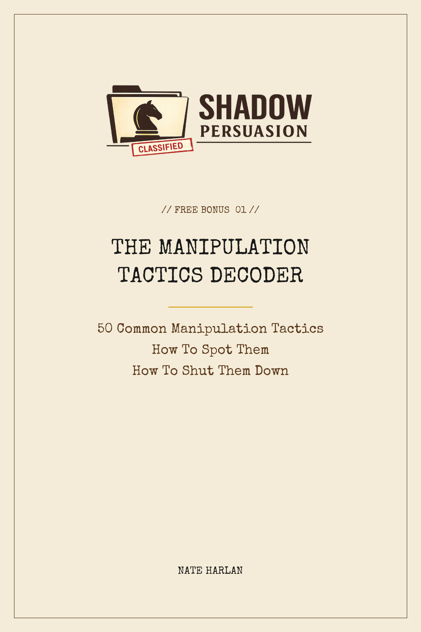

HOW TO USE THIS GUIDE
The fifty tactics in this guide are the most common forms of manipulation you will encounter in adult life. At work, in relationships, from family members, from vendors, and occasionally from your own internal narrator.
Each tactic is laid out in four lines: the name, the typical phrase or behavior you will hear, the red flag that tells you this is the tactic being used on you, and the counter-move that disarms it.
This is a defensive tool. The goal is not to learn these tactics so you can deploy them. The goal is to recognize them in real time, which shrinks their power from whatever they were before down to almost zero.
Screenshot any page. Keep it on your phone. When something feels wrong in a conversation, pull up this guide and find the row that matches. Most of the time, just naming what is happening to you in private is enough to change your behavior in the next thirty seconds, which changes the dynamic.
The tactics are grouped into five categories. Skim all five on your first read. Come back to specific ones when you need them.
EMOTIONAL MANIPULATION
______________________________
01. GASLIGHTING
You'll hear: "That never happened. You're imagining things."
Red flag: Your specific memories of events keep getting questioned or denied.
Counter: Document dates, screenshots, messages. Trust your records, not their retelling.
02. DARVO (DENY, ATTACK, REVERSE VICTIM/OFFENDER)
You'll hear: "How dare you accuse me of that. You're the one who hurt me."
Red flag: When you raise a concern, they immediately become the victim.
Counter: "We can talk about both. First let's finish the one I raised."
03. LOVE BOMBING
You'll hear: "You're the most amazing person I've ever met. Nobody else gets me like you do."
Red flag: Intensity too fast. Idealization before they actually know you.
Counter: Slow the pace. Watch what happens the first time you say no.
04. GUILT TRIPPING
You'll hear: "After everything I've done for you, you can't even do this one thing?"
Red flag: Past favors weaponized to compel present compliance.
Counter: "I appreciate what you did. My answer is still no."
05. SILENT TREATMENT
You'll hear: (prolonged refusal to engage after a disagreement)
Red flag: Sudden, complete withdrawal of communication as a punishment.
Counter: Don't chase. State your position once. Continue your life.
06. EMOTIONAL BLACKMAIL
You'll hear: "If you leave me, I don't know what I'll do."
Red flag: Threats of self-harm, crisis, or catastrophe tied to your choices.
Counter: Call a professional if the threat is genuine. Don't be the crisis line.
07. PLAYING VICTIM
You'll hear: "Everyone is always against me. You too, now?"
Red flag: Chronic victimhood narrative that prevents any accountability.
Counter: Engage with the specific issue, not the martyrdom frame.
08. MOVING GOALPOSTS
You'll hear: "Yes, you did X. But now I need Y. Then we'll be good."
Red flag: The requirement to satisfy them keeps shifting.
Counter: Name the pattern. "What would actually be enough?"
09. FUTURE FAKING
You'll hear: "Once I get past this stretch, everything will change, I promise."
Red flag: Promises about future behavior used to justify current bad behavior.
Counter: Evaluate based on what they do today, not what they promise about tomorrow.
10. TRAUMA WEAPONIZATION
You'll hear: "You know what I've been through. How can you bring this up?"
Red flag: Personal history invoked to shut down current accountability.
Counter: "Your history deserves compassion. My concern still needs addressing."
LANGUAGE TRICKS
______________________________
11. STRAW-MANNING
You'll hear: "So you think I should do nothing? Is that it?"
Red flag: Your actual position replaced with an extreme version.
Counter: "That is not what I said. Let me restate it."
12. WHATABOUTISM
You'll hear: "Well, what about the time you did X in 2021?"
Red flag: Your concern deflected with an unrelated grievance.
Counter: "We can address that next. First let's finish this one."
13. RAPID-FIRE QUESTIONING
You'll hear: (five questions in a row before you can answer one)
Red flag: You never get to finish a thought before the next question arrives.
Counter: "Let me answer one at a time. Starting with the first."
14. SEMANTIC MANIPULATION
You'll hear: "I never said I would. I said I might."
Red flag: Retroactive reinterpretation of their prior words.
Counter: "Regardless of the wording, what I heard was X. Is that no longer true?"
15. HYPOTHETICAL TRAPPING
You'll hear: "Imagine if I had actually done something terrible. You'd be mad about that too."
Red flag: Invented scenarios used to argue the real issue is trivial.
Counter: Refuse the hypothetical. "I am not here about what you did not do."
16. THE WEAPONIZED COMPLIMENT SANDWICH
You'll hear: "You're so smart, which is why what you did was so disappointing, but I love you."
Red flag: Praise bookending a criticism to make the criticism uncontestable.
Counter: Separate the parts. Address only the critique. Discard the packaging.
17. DEFLECTION THROUGH HUMOR
You'll hear: (turns your serious point into a joke, or rolls their eyes)
Red flag: Real issues consistently met with jokes, sarcasm, or mock incredulity.
Counter: "I am not joking. I am going to ask once more, seriously."
18. STRATEGIC INTERRUPTION
You'll hear: (cuts you off mid-sentence, repeatedly)
Red flag: You cannot complete a thought. Always talked over.
Counter: Silence. Wait them out. Restate your sentence verbatim when they stop.
19. RHETORICAL TRAP
You'll hear: "Are you really going to do this? Right now? Seriously?"
Red flag: Fake incredulity used to pressure you into retreating.
Counter: "Yes. Really." And then nothing else.
20. MEANING DRIFT
You'll hear: "Well, loyalty means different things to different people."
Red flag: Words you both understood suddenly become negotiable when it benefits them.
Counter: Pin down the definition in writing. "For this conversation, X means Y. Agreed?"
SOCIAL PRESSURE
______________________________
21. FALSE CONSENSUS
You'll hear: "Everyone in the family agrees with me on this."
Red flag: Invoking unseen third parties who allegedly agree with their position.
Counter: "Name one. Specifically."
22. FAKE AUTHORITY
You'll hear: "My therapist said you're the problem."
Red flag: Invoking an authority the other person can't verify or challenge.
Counter: "I'd like to understand their reasoning. Can I speak with them directly?"
23. PUBLIC SHAMING
You'll hear: (raises your failings in front of others)
Red flag: Private grievances aired in public settings to pressure compliance.
Counter: Do not engage publicly. "We can talk about this privately."
24. TRIANGULATION
You'll hear: "Your brother thinks you're being unreasonable too."
Red flag: Third parties inserted into what should be a two-person conflict.
Counter: "I'd like to hear that directly from him."
25. SOCIAL PROOF MANIPULATION
You'll hear: "My last partner never had a problem with this."
Red flag: Comparison to unnamed, idealized alternatives.
Counter: "I'm not them. What matters is what's happening between us."
26. SPLITTING
You'll hear: (plays mutual friends or family members against each other)
Red flag: People close to you turning against each other after interacting with this person.
Counter: Talk to the other people directly. Bypass the splitter.
27. ISOLATION
You'll hear: "Your friends don't really like you. I'm the only one who gets you."
Red flag: Subtle or overt campaigns to reduce your outside relationships.
Counter: Maintain your pre-existing relationships actively. Trust them.
28. STATUS THREAT
You'll hear: "I don't know if this is going to work if you keep bringing this up."
Red flag: The relationship itself held hostage to your compliance.
Counter: "If this is a dealbreaker for you, let's discuss that directly."
29. PEER PRESSURE FRAMING
You'll hear: "Anyone in my position would do the same."
Red flag: Norm claims used to make their behavior seem inevitable.
Counter: "I'm not asking about everyone. I'm asking about you."
30. APPEAL TO YOUR REPUTATION
You'll hear: "You're too smart to fall for something like that, aren't you?"
Red flag: Flattery used to make resistance feel stupid.
Counter: "Smart enough to notice what you just did there."
INFORMATION MANIPULATION
______________________________
31. SELECTIVE MEMORY
You'll hear: "I never promised that. You're misremembering."
Red flag: Specific commitments retroactively forgotten.
Counter: Get agreements in writing. Text messages are your friend.
32. REWRITING HISTORY
You'll hear: "Actually, you were the one who started that whole thing in 2021."
Red flag: Shared events reframed with you as the original aggressor.
Counter: "That's not how I remember it. Let's look at what I wrote at the time."
33. INFORMATION WITHHOLDING
You'll hear: "I didn't think you needed to know."
Red flag: Critical information reaches you after the moment it would have mattered.
Counter: State the pattern. "Finding out late is a trust issue, not a strategy."
34. FALSE URGENCY
You'll hear: "I need your answer right now. Otherwise..."
Red flag: Artificial deadlines on decisions that don't actually need to be fast.
Counter: "I am not making this decision today. If that's a problem, I understand."
35. PREMATURE COMMITMENT
You'll hear: "Just say yes in principle. We'll work out the details later."
Red flag: Asked to commit before the actual terms are clear.
Counter: "I'll commit once I understand what I'm committing to."
36. DECISION FATIGUE EXPLOITATION
You'll hear: (brings up major decisions late at night or after a fight)
Red flag: Timing of big asks consistently when your defenses are lowest.
Counter: "Let's sleep on this and talk in the morning." Always.
37. INFORMATION OVERLOAD
You'll hear: (overwhelms you with complexity, data, or jargon)
Red flag: You leave the conversation more confused than when you entered.
Counter: "Give me the three-sentence version."
38. SELECTIVE TRUTH
You'll hear: (tells you only the parts that support their narrative)
Red flag: Details emerge slowly over time that change the picture.
Counter: "What am I not asking that I should be?"
39. DOCUMENT DESTRUCTION
You'll hear: "I deleted those messages."
Red flag: Relevant records conveniently disappear.
Counter: Assume everything is preserved somewhere. Screenshot everything going forward.
40. FALSE DICHOTOMY
You'll hear: "Either you trust me or you don't."
Red flag: Complex situations collapsed into binary ultimatums.
Counter: "Neither of those. Here's what's actually true..."
POWER PLAYS
______________________________
41. INTIMIDATING SILENCE
You'll hear: (says nothing, just stares)
Red flag: Prolonged silence used to unnerve you into filling the gap.
Counter: Match the silence. Whoever speaks first loses.
42. POSTURING
You'll hear: "I don't need this. I have three other options lined up."
Red flag: Claims of abundant alternatives used to pressure you.
Counter: "Great. I'll wait to hear from one of them."
43. FLIPPING THE SCRIPT
You'll hear: "Actually, I am disappointed that you even brought this up."
Red flag: Any concern you raise results in you being the one on trial.
Counter: "We can talk about my behavior after we finish with yours."
44. STRATEGIC INCOMPETENCE
You'll hear: "I'm just not good at that."
Red flag: Selective incompetence always in areas that conveniently benefit them.
Counter: "Figure it out, or we do it together once."
45. FEIGNED HELPLESSNESS
You'll hear: "I don't know what to do. Please help me."
Red flag: Helplessness used to extract resources, then disappears when resources arrive.
Counter: "What have you tried? What's your plan before you ask for help?"
46. LIMIT TESTING
You'll hear: (pushes slightly past a stated boundary to see if you enforce it)
Red flag: Small violations used to probe what you will let slide.
Counter: Enforce every time. The first small violation predicts the big one.
47. SLOW BOUNDARY EROSION
You'll hear: (each ask slightly bigger than the last over months or years)
Red flag: The original agreement has shifted significantly without a renegotiation.
Counter: Reset to the original in writing. "Here's what we actually agreed to."
48. MALICIOUS FOOT-IN-THE-DOOR
You'll hear: "Just start with this small thing. It's no big deal."
Red flag: Escalating asks after the first small yes.
Counter: Break the sequence. The second ask is where you say no.
49. LOW-BALL ANCHORING
You'll hear: "I was thinking $30K for this" (for $90K of work)
Red flag: First offer is absurdly below any reasonable value.
Counter: "That is off by a factor of three. Let me know if you want to negotiate seriously."
50. PROJECTION
You'll hear: "You're the controlling one."
Red flag: Being accused of the exact behavior the other person is engaged in.
Counter: Note the projection silently. Do not defend. Their accusation is about them.
ONE LAST NOTE
The hardest part of defending against manipulation is not the tactical response. It is the act of naming, in your own head, that manipulation is what is happening to you.
Most targets of manipulation spend years trying to convince themselves that what they are experiencing is something else. Their own sensitivity. A misunderstanding. A rough patch. Once you can name the tactic in real time, the power dynamic shifts before you have said a single word out loud.
This guide is the naming tool. The counters matter, but the naming matters more.
For the full system behind these counters, see Shadow Persuasion: The 47 Counterintuitive Conversation Tactics That Make People Say Yes Without Realizing Why.

