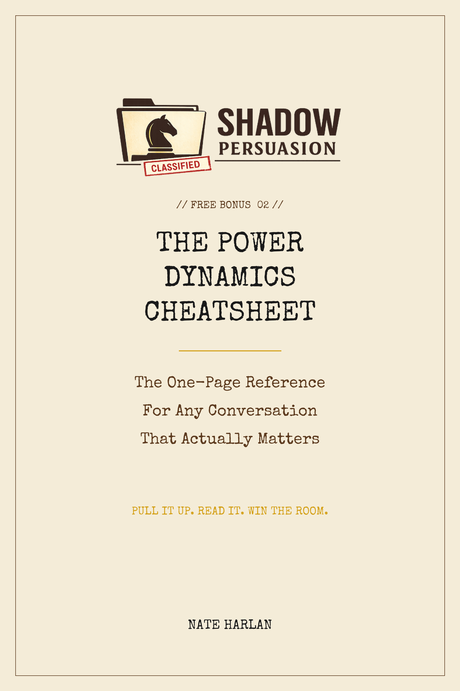


POWER DYNAMICS CHEATSHEET
Pull this up on your phone before any conversation that matters.
1. BEFORE YOU WALK IN
Three things to settle in your own head.
• Know what you'll do if the conversation fails. Without a clear backup plan, you'll give in under pressure.
• Pick ONE thing you want to focus on doing during the conversation. Not three. One.
• Decide your bottom line (the worst outcome you'd still accept). Keep this number in your head. Never say it out loud.
2. THE FIRST 30 SECONDS
The opening determines everything that follows.
• Match their energy level. If they're calm, be calm. Don't be more excited than they are.
• Skip the polite openers like "thanks for making time." Those are the exact words everyone else uses. Everyone else loses.
• Start with something specific about them, not a pitch. A real observation. Something that shows you paid attention.
3. DURING THE CONVERSATION
The small moves that quietly shift the dynamic in your favor.
• After they make a statement, pause for four full seconds before you respond. They'll often fill the silence themselves.
• When you don't know what to say, ask a "how" question. "How would that work?" "How did you arrive at that?" It keeps them talking.
• Let them suggest the next step, not you. The person who names the next move has more control.
• Don't explain things they didn't ask about. Over-explaining is the most common way people give away leverage.
4. IF YOU'RE LOSING GROUND
Recovery moves. Use in this order.
• First: stop talking. Count to four in your head. Do not break the silence.
• Second: ask a question. Any question. It slows the pace and puts them back in the work of answering.
• Third: repeat your main point using the exact same words you used earlier. Not new arguments. Same sentence.
• If none of that works: "Let me think about this. I'll follow up Monday." Leave. Re-engage when you're ready.
5. HOW TO END
The last thirty seconds matter as much as the first.
• If they agree to what you wanted, do not celebrate. Move to a different topic. Celebrating reminds them they just agreed to something.
• Send a short email within 24 hours. Two sentences, maximum. Long emails give them something to reconsider.
• Don't recap what was agreed. The recap is when people start finding things they wish they'd negotiated harder on.
• The emotional state you leave them in is what they'll remember. Choose it on purpose. Don't just drift out.
From Shadow Persuasion by Nate Harlan

