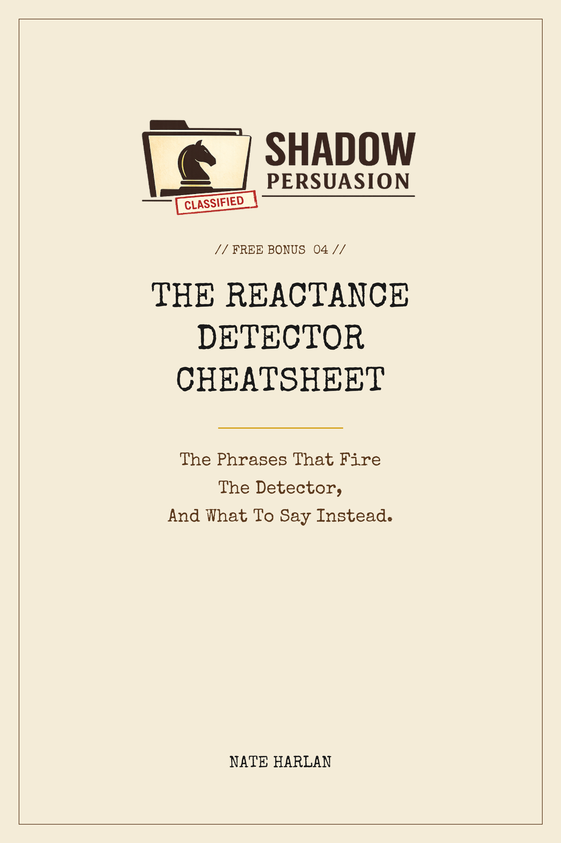

HOW TO USE THIS GUIDE
The Persuasion Detector is the automatic mental process that fires in a listener's head the moment they sense someone is trying to influence them. When it fires, they stop evaluating your message on its merits and start resisting it by reflex.
Sixty years of psychology research says the same thing: the harder you push, the harder they push back. The skill this guide teaches is how to say the same thing in a different way, so the detector never fires.
Part One is twenty-four phrase swaps across four categories. Each is a phrase that fires the listener's detector, and the quieter version that does the same work invisibly. Use it before your next important conversation: scan the list, eliminate the phrases you've been using, replace them with the alternatives.
Part Two flips the direction. It is ten signals that somebody is running a tactic on you, right now. When you notice any of them, you have thirty seconds of useful information about what's actually happening in the conversation. The guide tells you what the signal means and what to do.
This is a reference. Not a textbook. Come back to it the week before any conversation that matters.
PART 1
PHRASES THAT FIRE THE DETECTOR
Twenty-four phrase swaps across four categories. On the left: the phrase that fires the detector. On the right: the version that does the same work invisibly.
OPENING PHRASES
The words that signal 'I am about to sell you something' in the first five seconds.
01. INSTEAD OF: “Thanks so much for taking the time.”
SAY: [Skip it. Open with a specific observation about them or the situation.]
WHY IT FIRES: Every sales training starts with this exact phrase. Every sophisticated listener flags it instantly as the pre-pitch opener.
02. INSTEAD OF: “I was hoping we could...”
SAY: I wanted to...
WHY IT FIRES: "Hoping" telegraphs weakness and pre-apologizes for making the ask. The listener registers that you don't think you have the right to be asking.
03. INSTEAD OF: “I know you're busy, but...”
SAY: [Skip the preamble. Get to the ask.]
WHY IT FIRES: Everyone is busy. Stating it aloud signals you know you're low on their priority list. It invites them to say no before you've asked.
04. INSTEAD OF: “Can I ask you something?”
SAY: [Just ask.]
WHY IT FIRES: Asking permission to ask is two asks. Both can be refused. The second ask was the one you cared about.
05. INSTEAD OF: “If you have a minute...”
SAY: [Just ask. If they don't have a minute, they'll say so.]
WHY IT FIRES: Permission-seeking for basic attention reads as low-status and invites dismissal.
06. INSTEAD OF: “So, tell me about yourself.”
SAY: A specific question about something you already researched about them.
WHY IT FIRES: This is the line every interviewer and networking event uses. It signals zero effort and zero genuine interest.
PITCH AND SALES LANGUAGE
Phrases that announce you are about to do exactly what they're braced against.
07. INSTEAD OF: “To be honest with you...”
SAY: [Just say the honest thing.]
WHY IT FIRES: Prefacing a statement with "to be honest" implies the previous things you said may not have been.
08. INSTEAD OF: “Just to be transparent...”
SAY: [Same. Just be.]
WHY IT FIRES: Same problem. The phrase creates a distinction between your transparent moments and everything else.
09. INSTEAD OF: “Does that make sense?”
SAY: [Let the silence sit. If they have a question, they'll ask.]
WHY IT FIRES: The universal sales tell for "please validate that I am selling to you well." Every prospect has heard it a thousand times.
10. INSTEAD OF: “I'm going to shoot straight with you...”
SAY: [Shoot straight.]
WHY IT FIRES: Announcing straightforwardness implies a previous indirectness. Real straightness is just a direct sentence.
11. INSTEAD OF: “Can I be real with you for a second?”
SAY: [Be real.]
WHY IT FIRES: Same pattern. A real moment that needs labeling wasn't really real.
12. INSTEAD OF: “At the end of the day...”
SAY: [Skip it. State the point.]
WHY IT FIRES: Filler phrase. Every listener's brain tunes out on the first syllable. It is a verbal runway that tells them to stop paying attention.
WEAK SOFTENERS
Individual words and phrases that quietly downgrade whatever you say next.
13. INSTEAD OF: “I just wanted to...”
SAY: I wanted to...
WHY IT FIRES: "Just" is the single most damaging word in professional English. It signals the thing that follows isn't important.
14. INSTEAD OF: “Actually, I think...”
SAY: I think...
WHY IT FIRES: "Actually" signals disagreement or correction, triggering defensive posture before you've made your point.
15. INSTEAD OF: “Sorry to bother you...”
SAY: [Just ask.]
WHY IT FIRES: If the question is worth asking, there is no need to apologize for it. If it isn't worth asking, don't ask.
16. INSTEAD OF: “I don't mean to be pushy but...”
SAY: [Just ask. Naming it won't help.]
WHY IT FIRES: "I don't mean to be X but" is the setup for being X anyway. Listeners know the pattern. Naming it telegraphs what's coming.
17. INSTEAD OF: “I hope this isn't too much...”
SAY: [Make the request directly. Let them decide.]
WHY IT FIRES: Pre-apologizing for the size of your ask makes them notice the size. It primes them to think yes, it is too much.
18. INSTEAD OF: “Would you mind if I...”
SAY: I'm going to [do the thing]. Just wanted to give you a heads-up.
WHY IT FIRES: Asking permission is a request that can be refused. Stating an action with a courtesy notification is not.
QUESTIONS THAT ARE ACTUALLY PITCHES
Soft-sell questions that every listener over twenty-five has been trained to spot.
19. INSTEAD OF: “Would you be open to...?”
SAY: What do you think about...?
WHY IT FIRES: "Would you be open to" is the soft-sell structure every sales training program teaches. Pattern-matched instantly.
20. INSTEAD OF: “Does it make sense to...?”
SAY: How would that work on your side?
WHY IT FIRES: "Does it make sense" telegraphs that you've already decided the answer. The real question is how would this actually work.
21. INSTEAD OF: “Don't you think we should...?”
SAY: What's your read on...?
WHY IT FIRES: A leading question that pushes the listener toward agreement, which they resist by reflex. An open read-question invites them in.
22. INSTEAD OF: “Wouldn't it be great if...?”
SAY: [Skip it. State the actual idea.]
WHY IT FIRES: Rhetorical "wouldn't it be great" language is a transparent pitch setup. The listener knows you're about to propose something.
23. INSTEAD OF: “Isn't it true that...?”
SAY: My read on this is...
WHY IT FIRES: Demanding agreement with a premise is confrontational by design. Stating your read lets them respond without disputing a framing.
24. INSTEAD OF: “Can you see how...?”
SAY: Walk me through what you're seeing.
WHY IT FIRES: "Can you see how" implies the listener has failed to see something obvious. It triggers defensiveness. Asking them to walk you through makes them the expert.
PART 2
WHEN YOUR OWN DETECTOR FIRES
Ten signals that somebody is running a tactic on you, right now. What each one means, and what to do about it.
01. You feel a sudden urge to agree with whatever they just said.
What it means: They have reached the end of a carefully constructed sequence of micro-yeses. The urge to agree is the payoff of commitment-and-consistency priming.
What to do: Pause. Disagree out loud with something small, just to test whether you can.
02. You feel guilty for no clear reason.
What it means: They did something for you (solicited or not) and the guilt is reciprocity pressure.
What to do: Ask yourself whether the favor was something you actually wanted or needed. If not, the favor was a setup.
03. They are being unusually warm, flattering, or complimentary.
What it means: Love bombing, or the start of a sales sequence. Normal warm people do not escalate warmth during a request.
What to do: Slow the pace. Watch what happens when you say no to something small.
04. You notice they are repeating your last few words back to you.
What it means: They are running Voss's mirror. The fact that you noticed it means it is being deployed visibly.
What to do: Ask a clarifying question that requires their own words. "What exactly do you mean by...?"
05. They are naming what you are feeling, out loud.
What it means: Labeling. Not inherently bad, but when you notice it happening, the label usually wasn't quite right.
What to do: Correct the label out loud. The conversation moves into more honest territory.
06. You feel like you have to decide right now.
What it means: Manufactured urgency. Most real deadlines are flexible by more than the pressure suggests.
What to do: Ask yourself: is there an actual external deadline, or just their urgency? If the latter, say "I'll let you know by [48 hours from now]."
07. They're asking you a lot of questions, but you don't feel heard.
What it means: Calibrated questions being used as a sales funnel, not actual curiosity.
What to do: Stop answering. Ask one of your own: "What are you trying to figure out?"
08. You find yourself explaining something you weren't asked to explain.
What it means: Silence pressure. They left a pause; your brain filled it. This is almost always a leak.
What to do: Stop mid-sentence if you can. The over-explanation is usually the information they were trying to extract.
09. They're telling you what "everyone" thinks or does.
What it means: Social proof manipulation. The "everyone" is often just them.
What to do: Ask them to name one specific person. If they can't, you have your answer.
10. You leave the conversation feeling good but unsure what you agreed to.
What it means: Charm was used to smooth over a commitment they wanted you to make.
What to do: Go back to your notes, your email, your memory. Reconstruct the actual agreement. Then decide whether you would have agreed if you'd been less charmed.
ONE LAST NOTE
The phrases in Part One are not a complete list. Your own speech contains others. Over the next month, pay attention to your own openers, your own softeners, and the places where you catch yourself using a phrase right out of a sales playbook. Add them to your personal version of this list.
The signals in Part Two work the same way. Your own detector is better calibrated than you think. The ten in this guide are the most common. You will notice others in your own conversations once you start looking.
The goal is not to learn a new vocabulary. The goal is to speak in a way that doesn't announce itself as persuasion, so the content of what you actually mean can be heard.
For the full system behind this cheatsheet, see Shadow Persuasion: The 47 Counterintuitive Conversation Tactics That Make People Say Yes Without Realizing Why.

