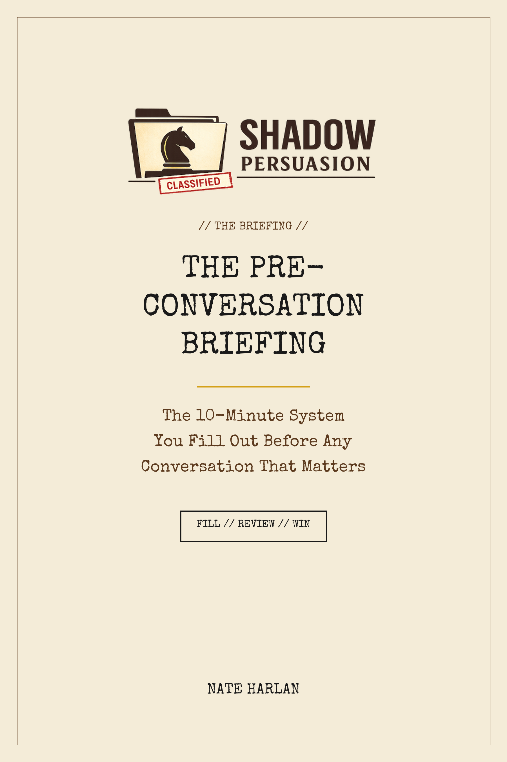

THE PRE-CONVERSATION BRIEFING
The 10-Minute System You Fill Out Before Any Conversation That Matters
by Nate Harlan
HOW TO USE THIS BRIEFING
You read Shadow Persuasion. You now know 47 tactics exist. Here's the problem I didn't fully solve for you in the book: when the real conversation starts Wednesday morning, you won't remember which tactic fits, you'll be nervous enough that your own detector fires, and you'll come out saying the thing you promised yourself you wouldn't say.
That's not a knowledge problem. It's a preparation problem. This briefing solves it.
The briefing is a ten-minute form you fill out before any conversation that matters. It forces you to pick 3 of the 47 tactics that fit your specific situation, draft your opening line, anticipate the pushback, pre-write your responses, run a 90-second nerves routine, and walk in with all of it loaded into short-term memory. Everyone I work with privately uses a version of this before every high-stakes call.
The payoff compounds. Every briefing you fill out makes the next one faster, because you start recognizing your own patterns. Three months in, the briefing takes five minutes. Six months in, you run it in your head while you walk to the meeting.
The 90 / 30 / 10 Rhythm
Use this briefing on a specific timing rhythm for best results. Block time intentionally. The calendar is the first tactic.
90 minutes before the conversation: Fill out the worksheet. Draft your opening line. Pre-write your responses to the two objections you most expect. Pick your three tactics. Identify your exit move.
30 minutes before: Run the nerves routine on the next page. Breath, body, reframe. Do not look at your phone during this window.
10 minutes before: Re-read the worksheet one time. Close it. Walk into the conversation with it in short-term memory, not in front of you.
Within 2 hours after: Fill out the debrief page. Even if it went well. Especially if it didn't. The debrief is where the next briefing gets sharper.
THE 90-SECOND NERVES ROUTINE
The book taught you to appear calm and low-status. That only works if you actually are calm. Nerves leak. A wobbly voice, a rushed pace, or over-explaining all fire your OWN detector-giveaways and the other side reads it. This 90-second routine resets your nervous system. It is not optional before any high-stakes conversation.
STEP 1 — The 4-7-8 Breath (45 seconds)
Inhale through the nose for 4 seconds. Hold for 7. Exhale through the mouth slowly for 8. Three full cycles, 57 seconds total. This lowers heart rate and activates the parasympathetic nervous system. It's the fastest physiological intervention you have. Works every time.
STEP 2 — The Physical Reset (30 seconds)
Roll your shoulders back and down. Unclench your jaw. Loosen your hands (nervous people clench them without noticing). Stand up if you're sitting, sit down if you're standing — the state shift breaks the anxiety loop. Smile for three seconds. Not because you feel like it. Because your facial muscles signal your brain that the situation is safe.
STEP 3 — The Reframe (15 seconds)
Say this in your head, slowly: “This is a conversation. I've had thousands of conversations. I will have thousands more. The outcome of this one does not define me. My bottom line is [fill in your worksheet number]. If we don't reach it, I walk away and come back later. That's it.”
The reframe works because it re-installs proportion. Nerves come from treating a conversation as existential. The reframe reminds your brain it isn't.
THE BRIEFING WORKSHEET
Fill out the following in under ten minutes. Be honest. The worksheet only works if you actually write answers — not if you think you could if you wanted to. Handwritten works better than typed for retention, but either is fine.
DATE: ____________________ TIME OF CONVERSATION: _______________
OTHER PERSON(S) IN THE CONVERSATION: ________________________________________
─ ─ ─
01. What am I walking into?
One sentence. Name the conversation in plain English. “Salary review with my manager.” “Custody mediation with my ex.” “Reconnection call with my sister after 2 years.” Don't editorialize. Name it.
__________________________________________________________________________________________
__________________________________________________________________________________________
__________________________________________________________________________________________
02. What outcome do I want?
The specific result. Not “the meeting goes well.” “$140K base salary starting October.” “We agree on every-other-weekend custody.” “We schedule a second conversation within a week.”
__________________________________________________________________________________________
__________________________________________________________________________________________
__________________________________________________________________________________________
03. What does the OTHER person want?
Force yourself to see it from their side. If you can't name what they want, you're not ready. Write at least two distinct things they're probably optimizing for.
__________________________________________________________________________________________
__________________________________________________________________________________________
__________________________________________________________________________________________
__________________________________________________________________________________________
04. What's my bottom line?
The number or answer I will NOT go below. Keep this in my head during the conversation. NEVER say it out loud.
__________________________________________________________________________________________
__________________________________________________________________________________________
05. Which 3 tactics (of the 47) am I deploying?
Check your book. Not all 47. Pick 3 that fit this specific situation. One opener, one mid-conversation move, one exit move. Write the technique name and the page number.
__________________________________________________________________________________________
__________________________________________________________________________________________
__________________________________________________________________________________________
__________________________________________________________________________________________
__________________________________________________________________________________________
06. My opening line — word for word.
Draft the first sentence you will say when the conversation starts. The opening sets the frame for everything that follows. Do not wing this.
__________________________________________________________________________________________
__________________________________________________________________________________________
__________________________________________________________________________________________
__________________________________________________________________________________________
07. The two objections/pushbacks I most expect.
For each one: (a) what they'll probably say, (b) my pre-drafted one-sentence response.
__________________________________________________________________________________________
__________________________________________________________________________________________
__________________________________________________________________________________________
__________________________________________________________________________________________
__________________________________________________________________________________________
__________________________________________________________________________________________
__________________________________________________________________________________________
08. My exit move.
How I end the conversation in a position of strength. What's the last sentence I say? What's the immediate next step I confirm before we separate?
__________________________________________________________________________________________
__________________________________________________________________________________________
__________________________________________________________________________________________
__________________________________________________________________________________________
09. What's ONE thing I will NOT do in this conversation?
The specific trap I know I fall into. “Don't defend my number.” “Don't apologize for bringing it up.” “Don't offer to think about it if they push back.” Name your trap.
__________________________________________________________________________________________
__________________________________________________________________________________________
__________________________________________________________________________________________
10. Nerves check. Where am I on a 1-to-10 anxiety scale right now?
If you're above 6, run the 90-second nerves routine BEFORE you walk in. If you're below 3, you're probably under-preparing. Real preparation produces mild-to-moderate anxiety. That's fine.
__________________________________________________________________________________________
__________________________________________________________________________________________
THE 3-TACTIC SELECTOR
Question 5 of the worksheet asks you to pick 3 tactics from the 47 in the book. This table is the shortcut. Find your conversation type in the left column. Read across for the 3 tactics that fit best. Go deeper into the book only for the ones you chose.
Salary / raise conversation → #5 The Consultant Stance, #11 The Strategic Pause, #41 The One-Line Email
Hard conversation with partner → #1 The Cold Open, #18 The Named Feeling, #17 The Earlier Agreement
Reconnection with estranged family → #1 The Cold Open, #6 The Confession First, #8 The Unrepayable Favor
Custody / divorce mediation → #4 The Assumption Audit, #19 The Pre-Understood Objection, #11 The Strategic Pause
Hostile customer / client → #4 The Assumption Audit, #18 The Named Feeling, #44 The Post-Agreement Bridge
Contractor / service price dispute → #11 The Strategic Pause, #13 The Impossible Answer, #41 The One-Line Email
Hard conversation with a teenager or adult child → #2 The Pre-Frame, #21 The Discovery Path, #37 The Unclosing
Business / sales discovery call → #33 The Reverse Qualifier, #21 The Discovery Path, #25 The Stakes Shift
Confronting a manipulator → #4 The Assumption Audit, #35 The Volcano, #40 The Public Witness
Reconciling after a fight → #6 The Confession First, #18 The Named Feeling, #41 The One-Line Email
Job interview / being interviewed → #5 The Consultant Stance, #22 The Misdirected Question, #33 The Reverse Qualifier
Any conversation you're avoiding → #2 The Pre-Frame, #11 The Strategic Pause, #43 The Minimum Viable Commitment
This table covers the twelve most common conversation types. For anything not on this list, grab the closest match and cross-reference the book's appendix, which indexes all 47 tactics by domain.
THE POST-CONVERSATION DEBRIEF
Fill this out within 2 hours of the conversation. This is the part most people skip. It's also the part that makes every future briefing better. The debrief is where you separate “the tactic worked” from “the situation happened to go well.”
01. What was the actual outcome?
Compare to question 2 on your briefing worksheet. Did you get what you wanted? Fully? Partially? Nothing?
__________________________________________________________________________________________
__________________________________________________________________________________________
__________________________________________________________________________________________
02. Which of the 3 tactics I picked did I actually deploy?
Be honest. Often you'll plan 3 and use only 1 or 2. That's information, not failure.
__________________________________________________________________________________________
__________________________________________________________________________________________
__________________________________________________________________________________________
__________________________________________________________________________________________
03. What worked that I didn't plan?
Frequently the best move was spontaneous. Name it. That's a tactic you're developing that isn't formal yet.
__________________________________________________________________________________________
__________________________________________________________________________________________
__________________________________________________________________________________________
__________________________________________________________________________________________
04. What didn't work that I thought would?
This is the single most valuable box on the debrief. Don't skip it.
__________________________________________________________________________________________
__________________________________________________________________________________________
__________________________________________________________________________________________
__________________________________________________________________________________________
05. What's the one thing I'd change about my preparation next time?
Not “me as a person.” The preparation. This is how the next briefing gets sharper.
__________________________________________________________________________________________
__________________________________________________________________________________________
__________________________________________________________________________________________
__________________________________________________________________________________________
THE BRIEFING TEMPLATE (BLANK)
A clean, one-page version of the full worksheet. Print it and use it. Duplicate it as needed. Some users keep a stack in their desk drawer.
Date / time / who:
__________________________________________________________________________________________
__________________________________________________________________________________________
What I'm walking into (1 sentence):
__________________________________________________________________________________________
__________________________________________________________________________________________
What I want (specific):
__________________________________________________________________________________________
__________________________________________________________________________________________
What THEY want:
__________________________________________________________________________________________
__________________________________________________________________________________________
My bottom line (don't speak this):
__________________________________________________________________________________________
__________________________________________________________________________________________
My 3 tactics (+ page #):
__________________________________________________________________________________________
__________________________________________________________________________________________
My opening line (word-for-word):
__________________________________________________________________________________________
__________________________________________________________________________________________
Two objections I expect + my pre-drafted response:
__________________________________________________________________________________________
__________________________________________________________________________________________
My exit move:
__________________________________________________________________________________________
__________________________________________________________________________________________
The ONE thing I won't do:
__________________________________________________________________________________________
__________________________________________________________________________________________
Nerves 1-10:
__________________________________________________________________________________________
__________________________________________________________________________________________
FILL // REVIEW // WIN
The best conversation is the one you walked into prepared,
and walked out of with what you came for.
— Nate Harlan

