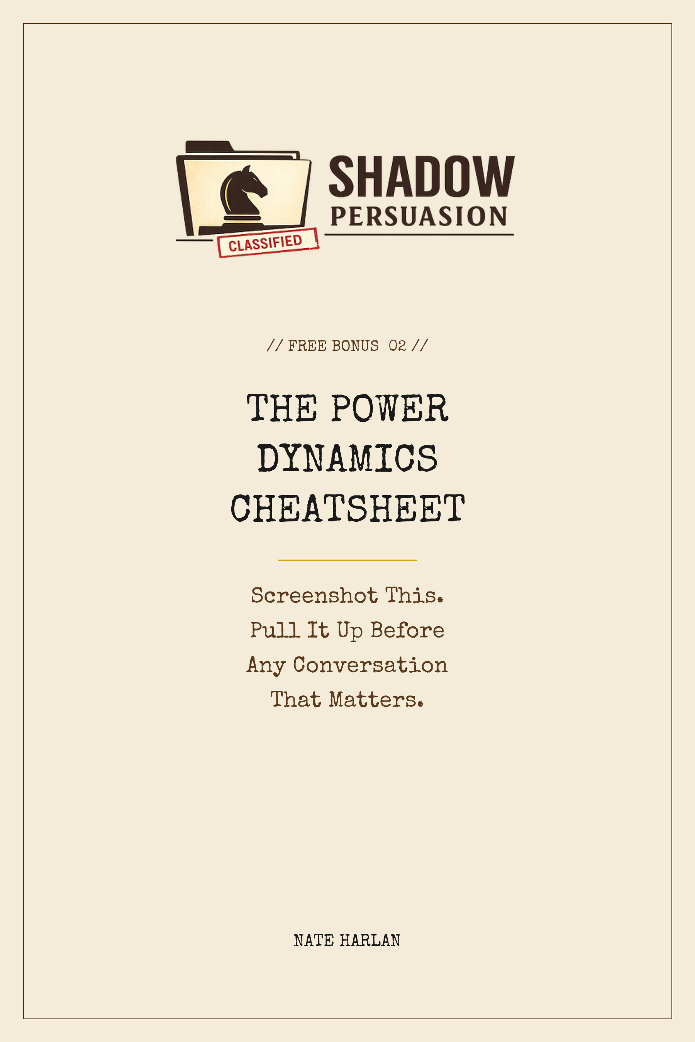


POWER DYNAMICS CHEATSHEET
Screenshot this. Check it before any conversation that matters.
________________________________________
PRE-FLIGHT CHECK
Before you walk in.
· Know your BATNA. What happens if this goes badly.
· Pick ONE tactic to deploy. Not three.
· Your walkaway number stays in your head. Never spoken.
FIRST 30 SECONDS
The window that determines everything.
· Match their energy. Do not exceed it.
· Skip the "thanks for making time." Open with a specific observation.
· Silence is okay. Filling it is not.
WHO HAS THE POWER
A two-second read, any moment in the conversation.
· YOU hold it if: they're asking more questions than you are.
· YOU hold it if: silences don't make you uncomfortable.
· THEY hold it if: you're asking more questions than they are.
· THEY hold it if: you're filling every pause.
POWER MOVES
Deploy when you feel the dynamic shifting toward you.
· Four seconds of silence after their statement.
· Ask a "how" question when cornered.
· Let them name the next step.
· Short emails beat long ones. Twelve words is often enough.
POWER LEAKS
Each of these cedes leverage you did not mean to give.
· Over-explaining when they did not ask.
· Apologizing for taking their time.
· Laughing at every joke to build rapport.
· Using "just" and "actually" as softeners.
· Answering questions you were not asked.
WHEN YOU'RE LOSING
Recovery moves. Use in order.
· Stop. Silence for four seconds.
· Ask a question. Any question at all.
· Restate your core point verbatim. Do not re-argue it.
· Worst case: "Let me think. I'll follow up Monday."
EXIT WELL
The last 30 seconds matter as much as the first.
· Do not celebrate a yes. Move to an unrelated topic.
· Do not summarize what was agreed.
· Twelve-word email within twenty-four hours.
· Choose the emotional state you leave them in. That is the memory.
From Shadow Persuasion by Nate Harlan

