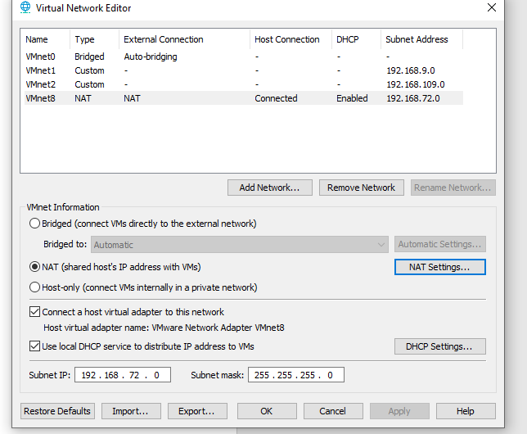

Vmnet1 (grün): 00:50:56:23:80:E6

Vmnet2 (orange): 00:50:56:27:37:A6

Vmnet8 (rot): 00:50:56:23:7E:BE

