Diabetes Health Prediction Project Report

^{1st} YuShi Gan
Software Engineering
University of Western Ontario
London, Canada
ygan29@uwo.ca
251065802

Abstract — This project uses the Diabetes Health Indicators dataset to predict an individual's likelihood of developing diabetes. It integrates database design and machine learning techniques to efficiently process data and perform accurate predictions. The system involves a relational database for structured storage and an ML model for classification.
I. INTRODUCTION
Diabetes is a chronic disease that affects millions of people worldwide and poses significant health risks. Effectively storing and analyzing relevant data is essential for early diagnosis and intervention. The project aims to develop a system that classifies individuals as diabetic or non-diabetic based on health indicators.
“This project uses the Diabetes Health Indicators Dataset[4].” The dataset contains multiple features related to individual health metrics and habits. The dataset consists of 253,680 samples and includes the following features: The Diabetes_binary is the target variable indicating if a person has diabetes (1) or not (0). Features include HighBp, HighChol, BMI, Smokers, Strokes, HeartDiseaseorAttack, Physical Activity, Fruits, Vegetables, Alcohol Consumption, GenHlth, MentHlth, and so on to provide a comprehensive view of the individual’s health habits and conditions.
Objectives include:
- Design a relational database: Create a structured database that stores an individual's health metrics, disease records, and other demographic information. Ensure efficient access and management of data by normalizing data tables and optimizing query performance. The database provides a solid foundation for subsequent machine learning analysis.
- Build a machine learning model
Using key features in health data, build a classification model that predicts an individual's likelihood of developing diabetes. Machine learning models learn feature patterns from the data extracted from the database, improving prediction accuracy.

Driven by the increasing prevalence of diabetes, the project focuses on leveraging data-driven solutions to aid early diagnosis and potential interventions. By combining relational databases and machine learning models, the project not only provides a system for storing and managing health data, but also provides a scientific basis for predicting diabetes risk.
II. Related Works
For diabetes detection, machine learning techniques have shown a significant role in predicting the likelihood of diabetes based on the health indicators. “One approach is to use the CatBoost classifier[5].” The CatBoost model in the approach is trained using 2000 iterations with a learning rate of around 0.1 and a depth of 6 for the decision trees. The loss function utilized is “Logloss”, commonly used in classification problems. The model was split into 80% for the training set and 20% for the testing set. The training process shows a gradual improvement in the accuracy of the model. After the training, the predictions are generated on the test set, and performance is evaluated by using metrics such as F1-score, Accuracy and so on.
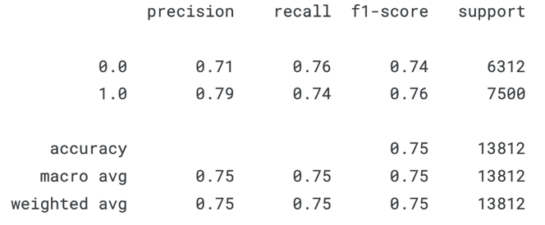
Fig. 1. CatBoost Classifier performance

III. Methodology
- Database Design
To efficiently store and manage data, a relational database was built to support the needs of subsequent data analysis and machine learning modeling.
Requirements analysis:
◦ Data set analysis revealed the need to store patient demographic information, health behavior data, and disease records.
◦ The design of data tables needs to support standardized structures to improve data query efficiency and avoid redundancy.
Table structure design:
◦ Patients table: Stores basic patient information, such as age, sex, education, and income.
◦ HealthStatus table: Stores patient health behavior information, including bmi, high_bp, smoker, etc.
◦ DiseasesAndSymptoms table: Records the patient's disease diagnoses and health scores, such as diabetes, stroke, and gen_hlth.
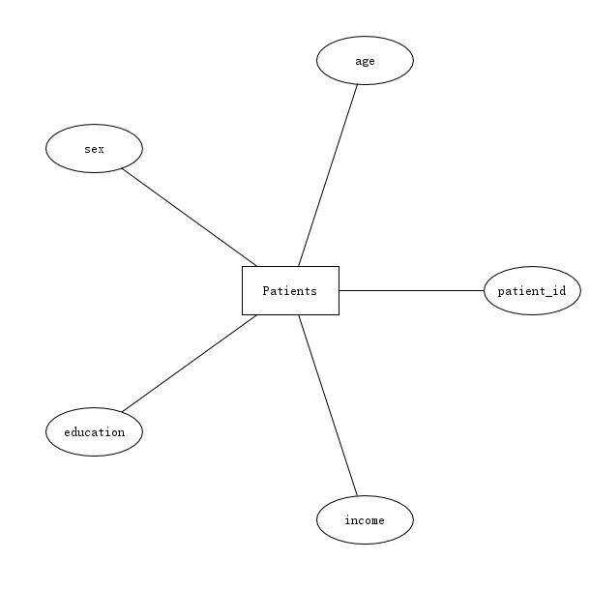
Fig. 2. ER Diagram of the Patients

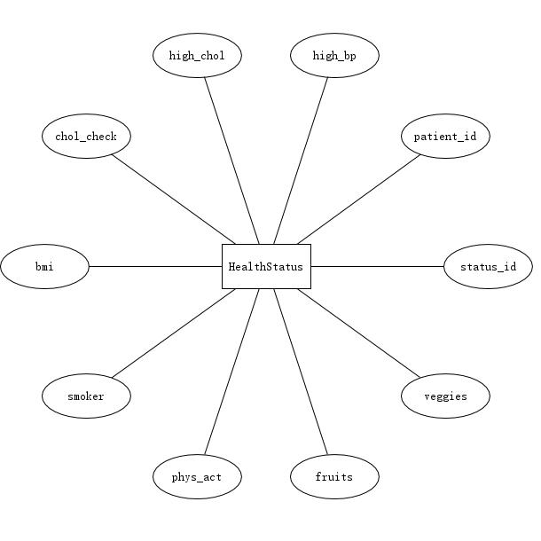
Fig. 3. ER Diagram of the HealthStatus

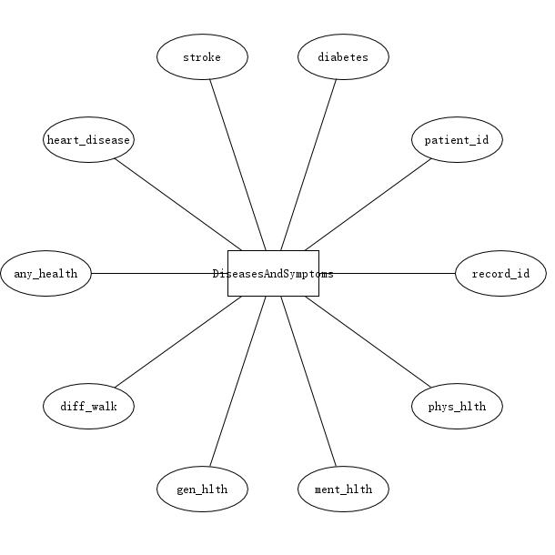
Fig. 3. ER Diagram of the DiseasesAndSymptoms

Relationship Design:
◦ The Patients table, as the primary table, is associated with the HealthStatus and DiseasesAndSymptoms tables through the foreign key patient_id to form a one-to-many relationship.
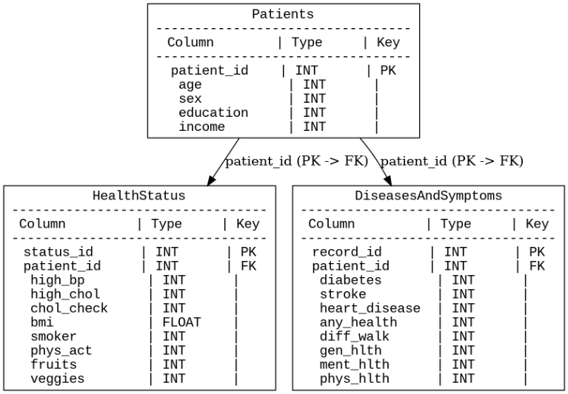
Fig. 4. Relational Schema

B. Machine Learning
To construct an efficient model that can predict diabetes, the project designed and implemented a Feed-Forward Neural Network model. A Feedforward Neural Network (FNN) is an artificial neural network in which information flows in a single direction, starting from the input layer, passing through any hidden layers, and ending at the output layer [3].
1. Dataset division
Training set: 60% of the dataset and is used to train the model. Validation Set: 20% of the dataset validate model performance. Test set: 20% of the dataset and is used to ultimately evaluate the generalization ability of the model.
2. The architecture of a feedforward neural network consists of the following three parts:
Input Layer: Extract features from the training set.
Input characteristics include key health indicators such as BMI, age, gender, physical activity, etc. Hidden Layer: Each hidden layer uses the ReLU activation function. Add a dropout layer after the hidden layer to reduce the risk of overfitting. Output Layer: The output layer contains a cell, which uses the Sigmoid activation function.
3. Hyperparameters optimization
For optimal model performance, the project uses Random Search to optimize the model's hyperparameters. Number of units in hidden layers: The range is 32-256 for the first layer and 32-128 for the remaining layers. Dropout rate: Range is 0.1 to 0.5. Learning rate: ranges from 0.0001 to 0.01
4.Model training
Loss Function: Binary Cross-Entropy is used as the loss function. Optimizer: With the Adam optimizer, its learning rate is determined based on random search results. The model training lasts for several rounds (Epoch) and stops when the accuracy of the validation set is no longer improving.

IV. Implementation

A．Database Environment Configuration
1. Database Management System (DBMS):
◦ Use MySQL as a relational database management system, which is suitable for storing and managing complex health data due to its support for ACID properties and powerful query capabilities.

2. Development tools:
◦ Database design and management using MySQL Workbench.
◦ Data insertion and query are performed through Python’s mysql-connector library.
3. Database creation and table creation
Use SQL scripts to create databases in MySQL and create tables based on designed table relationships.
4. Data import
Write a Python script to insert the cleaned data into the database in batches through the mysql-connector library.
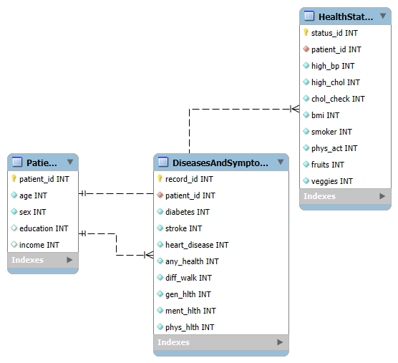
Fig. 5. Generated ER Diagram by MySQL

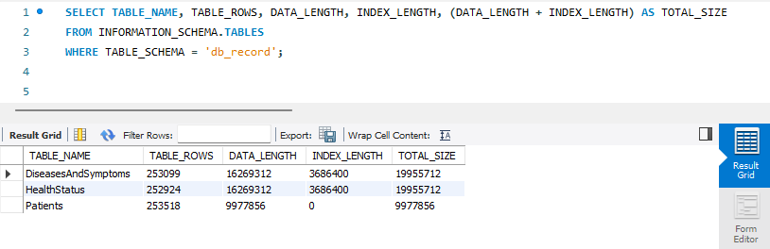
Fig. 6. Database Table Statistics

- Feature Selection
The reason why we use the feature selection technique is that reducing the number of features can help us to build an effective machine-learning model, including avoiding overfitting, reducing computational costs and improving model interpretability.
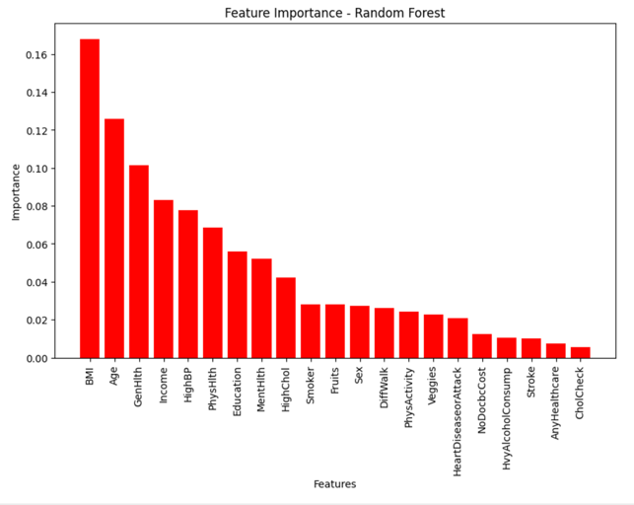
Fig. 7. Features importance by Random Forest Algorithm
The Fig 7. shows the feature importance plot generated by the Random Forest model highlights which features significantly influence predicting an individual with diabetes. In our dataset, features including BMI, age, GenHlth, income, and so on are the most influential. It gives us useful information to select the most importance features; however, Random Forest model does not provide a clear understanding of the relationship between the features and the target variable. Thus, we add linear correlation between features and target variable.
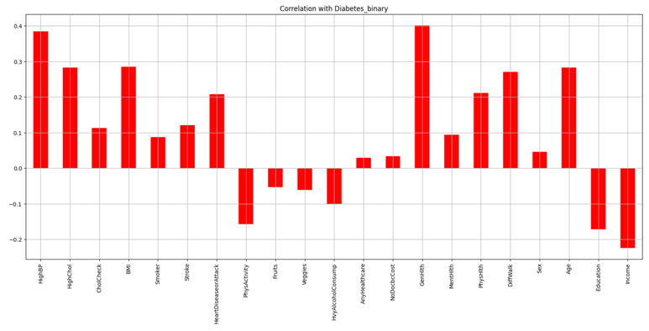
Fig. 8. Correlation with Diabetes_binary target
Fig 8. shows the linear correlation between each feature and the Diabete_binary target variable. It indicates that features including High Blood Pressure, High Cholesterol, BMI, Heart Disease or Attack, GenHlth, and Age are positively correlative. Features such as Income, Education, and Physical Activity are negative correlative. Features like HvyAlcoholConsump, Fruits, Veggies, and AnyHealthcare have very low or no significant correlation with diabetes in this dataset. In conclusion, based on the analysis of the features between Fig 7. and Fig 8., we decided to drop the features such as fruits, HvyAlcoholConsump, sex, AnyHealthcare, NoDocbcCost, and Veggies, which are both low-correlative and the least significant features.

- Binary Feature Analysis
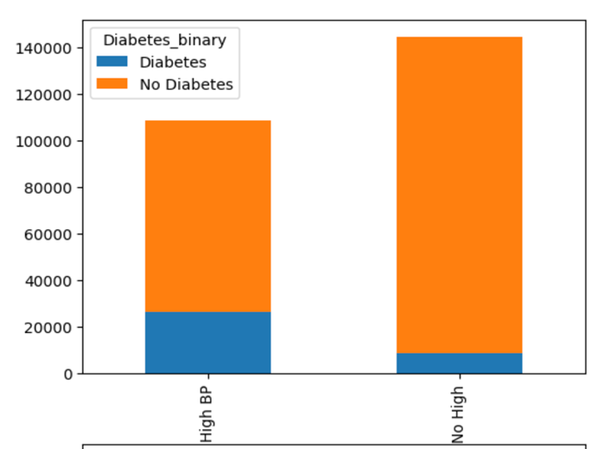
Fig. 9. distribution of individuals based on blood pressure
The HighBp represents whether the individual has been told by a health professional that they have high blood pressure. It is a binary variable. Zero means no high blood pressure, and one means high blood pressure.
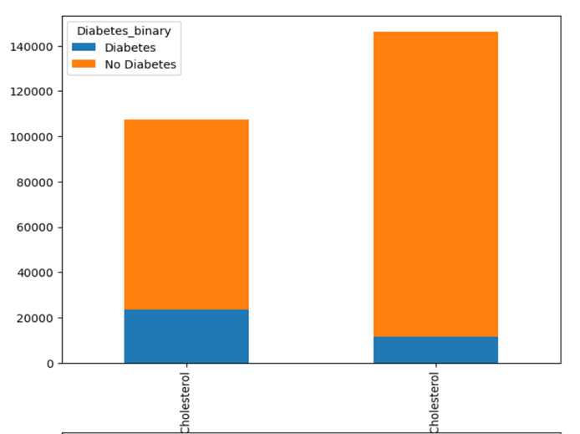
Fig. 10. distribution of individuals based on Cholesterol
The HighChol indicates whether a health professional has ever told the individual that their blood cholesterol is high. Zero means No High Cholesterol, and one means High Cholesterol.
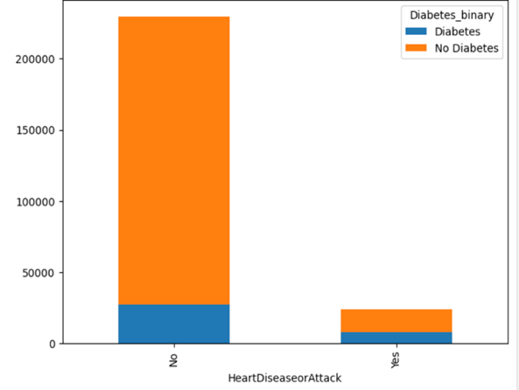
Fig. 11. Distribution of individuals based on blood pressure
The HeartDiseaseorAttack feature indicates whether the individual has ever been diagnosed with coronary heart disease (CHD) or had a myocardial infarction (MI).
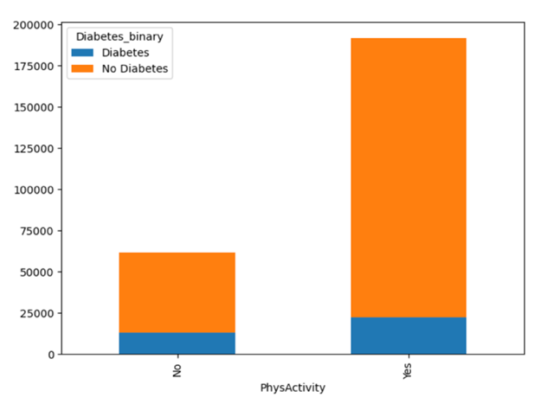
Fig. 12. distribution of individuals based on PhysActivity
The PhysActivity feature indicates whether the individual has engaged in any physical activity or exercise other than their regular job in the past 30 days.

- Categorical Features Analysis

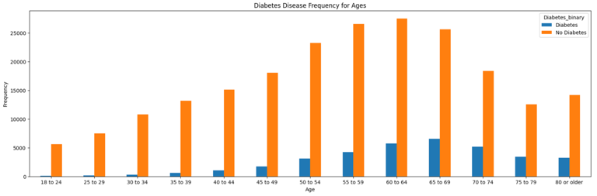
Fig. 13. Distribution of individuals based on ages
Fig 13. provides an overview of how the frequency of diabetes and non-diabetes individuals varies across different age groups. The x-axis represents various age categories, ranging from "18 to 24" to "80 or older." The y-axis represents the frequency count of individuals in each age group, split by diabetes status. The frequency indicates the number of individuals who have or do not have diabetes for each age category. The graph indicates that the number of individuals with diabetes increases when the ages go up until the “65-69” age group. After the “65-69” age group, the number of individuals with diabetes gradually decreases, probably because fewer individuals are available in these groups.
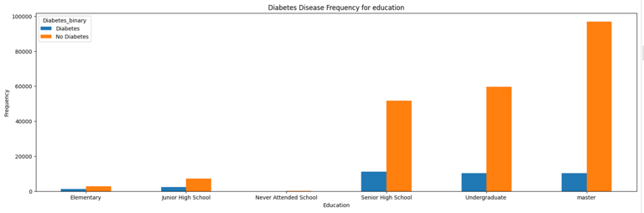
Fig. 14. Distribution of individuals based on Education

Fig 14. shows an overview of how the frequency of diabetes and non-diabetes individuals varies across different educational level groups. The x-axis represents different education levels including elementary, junior and senior high school, undergraduate, master and a non-education level. In the graph, the individuals with diabetes mainly have senior high school, undergraduate and master's degrees; however, there seems to be a negative correlation between education level and diabetes. Compared to individuals with high school degrees, individuals with higher education maintain a lower rate of diabetes. For instance, individuals with master degree has lower rate to get diabetes compared to individuals with undergraduate degree.

- Class Imbalance Handling
Although the dataset does not contain null and missing values, the target variable has a significant class imbalance. When a machine learning model deals with imbalance data, it could generate bias towards the majority class, leading to poor performance in predicting the minority class.
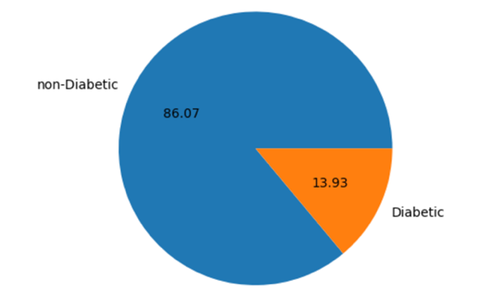
Fig. 15. Distribution of the target Diabetes_binary
The Fig 15. a pie chart. In the bar chart, the number of individual with no diabetes is 6 times the number of individual with diabetes. In the pie chart, the individuals with take up 13.93%, and rest of pie represents the individuals with no diabetes. As you can see, the target class is extremely imbalanced; hence, we decided to resample our dataset to balance the target, and the balanced data of the target is shown below.
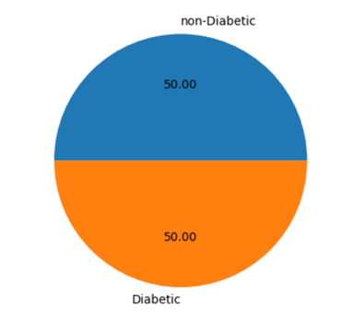
Fig. 16. Distribution of balanced target Diabetes_binary

- Outliers Detections
Since most of the features are binary and categorical, we only need to detect the numerical features such as the BMI value. “We make use of Interquartile range method to find the outliers, which is highly effective in handling extreme values and does not rely on any specific data distribution, making it helpful in detecting potential outliers in various scenarios [1].”In traditional, outliers are detected using a factor of 1.5 to define the boundary of IQR.
Lower Bound = Q1 – 1.5 * IQR
Upper Bound = Q3 + 1.5 * IQR
In our dataset, we let the factor equal to 7, which means boundaries are expanded significantly. In other words, only extreme values that are far from the main distribution of data will be considered the outliers.
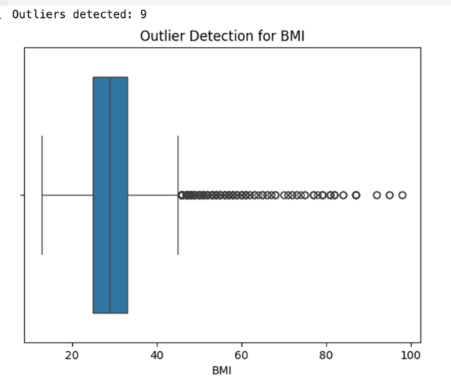
Fig. 17. Outlier Detections for BMI

- Standardization
“Standardization is a widely used preprocessing technique that transforms data to a standard scale [2].” With feature scaling, large-scale features like BMI will positively impact the model. Standardization ensures that all features in the model are on a standard scale.

- Model training and hyperparameter search
We split the dataset into training (60%), validation (20%), and testing (20%) sets. The feed-forward neural network consists of an input layer for feature extraction, hidden layers with ReLU activation and dropout to prevent overfitting, and an output layer with a sigmoid activation function, predicting 0 for non-diabetic and 1 for diabetic individuals. Hyperparameters, including the number of units (32-256 for the first layer, 32-128 for additional layers), dropout rate (0.1-0.5), and learning rate (0.0001-0.01), were optimized using Random Search with 10 trials, selecting the best configuration based on validation accuracy.

V. Results

- performance of Feed-Forward Neural Network model
The Fig 18. shows that the training loss starts pretty high and then decreases steadily to around 0.5. The validation loss also decreases initially but remains consistently above the training loss. Although the model learns from the training data, it struggles with the unseen validation data.

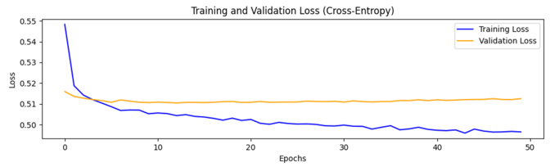
Fig. 18. Traning and validation loss throughout epochs
The Fig 19. shows a similar trend to the entropy loss plot. Although the training MAE starts at a high value, it decreases and stabilizes at around 0.33. It is lower compared to the validation loss. It suggests that the model’s predictions on the training data are more accurate.
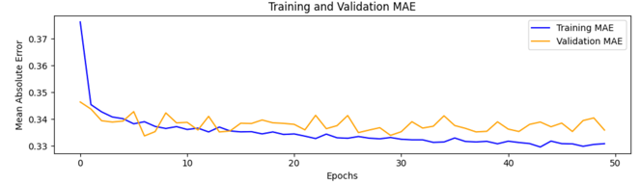
Fig. 19. Training and validation MAE throughout epochs

Because the training set has lower entropy loss and MAE, there is no suppression that its accuracy, around 0.76, is higher than that of the validation set, around 0.74. Although the training accuracy improves steadily, the validation accuracy shows less consistent improvement, stabilizing at a lower value.
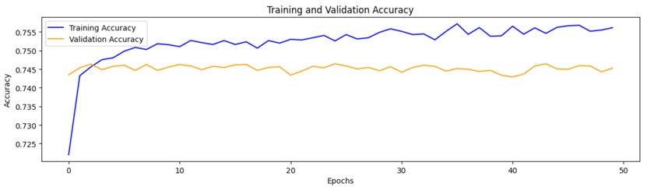
Fig. 20. Training and validation Accuracy throughout epochs

The Fig 21. shows four outcomes of binary classification for training set. The model successfully predicts 10,911 non-diabetes cases when the actual case is non-diabetic and 12171 diabetes cases when the actual case is diabetic. On the other hand, there are 4346 cases where the model incorrectly predicted No Diabetes for individuals who actually had diabetes, and there are 2978 cases where the model incorrectly predicted Diabetes for individuals who actually did not have diabetes

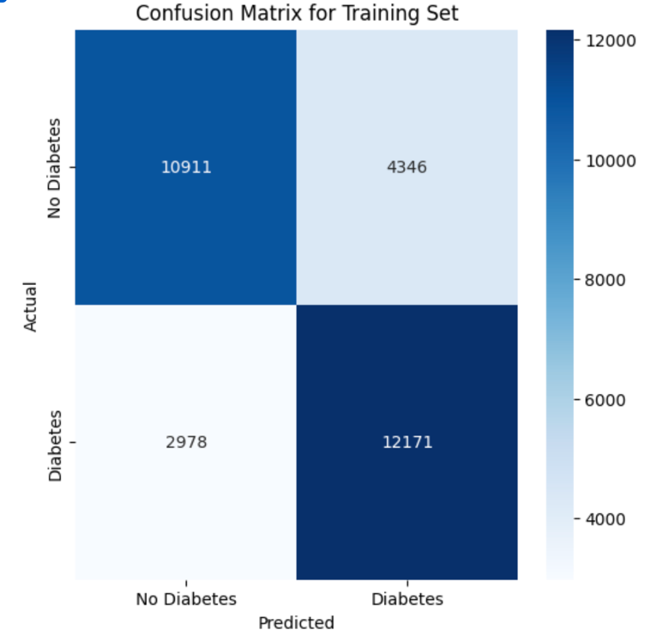
Fig. 21. Confusion Matrix for training set
This Fig 22. represents the model's classification performance on the testing dataset. The model successfully predicts 3489 non-diabetes cases when the actual case is non-diabetic and 4086 diabetes cases when the actual case is diabetic. On the other hand, there are 1482 cases where the model incorrectly predicted No Diabetes for individuals who actually had diabetes, and there are 1079 cases where the model incorrectly predicted Diabetes for individuals who actually did not have diabetes.

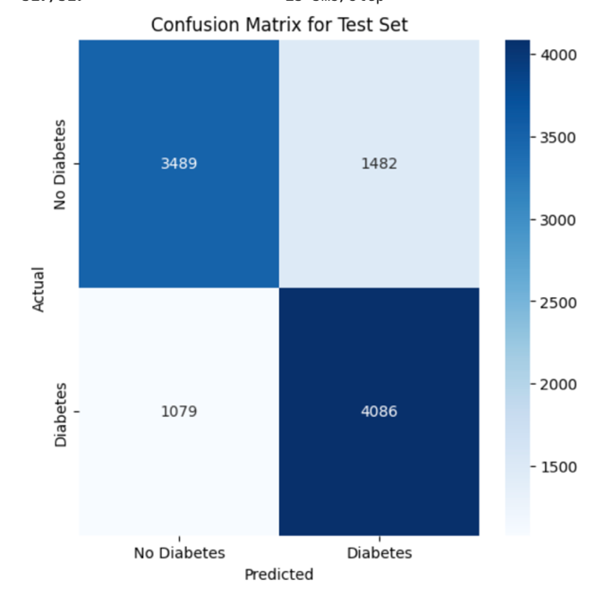
Fig. 22. Confusion Matrix for testing set

- Comparison

Table I
Training and Testing performance table
 | MSE | MAE | Cross-entropy | Accuracy | F1 Score
Train | 0.16 | 0.33 | 0.49 | 0.76 | 0.77
Test | 0.17 | 0.34 | 0.51 | 0.74 | 0.76
The MSE for the training set is 0.16. It is the average squared difference between predicted and actual values. A lower value like this suggests that the model fits the training data reasonably well. The MAE is 0.33. It represents the average magnitude of errors in predictions. This confirms the model's fairly accurate predictions on training data. The training set cross-entropy loss is 0.49, which reflects how well the model's predicted probabilities match the true labels. A lower value indicates better model confidence and performance. The accuracy of 0.76 (76%) means that the model correctly classifies about 76% of the training instances. This suggests that the model is learning well on the training set. The F1 score for the test set is 0.76, compared to the F1 score 0.77 for the training set. The F1 score shows a balance between precision and recall, and the closeness between the training and testing scores suggests that the model maintains its classification ability on new data without a significant drop in performance

VI. Evaluation & Discussion

- Strengths
Moderate training and testing accuracy: The model achieved moderate training and testing accuracy, which means it can effectively learn the patterns in the training data and recognize them in the unseen data. The F1 score for both training around 0.77 and testing sets around 0.76 was consistent, suggesting that the model balanced precision and recall well, even on unseen data.

- Drawbacks
The hyperparameter tuning process currently limits the number of layers and units. The hidden layers are restricted to 1-3, and units per layer are defined within a narrow range (32-256 for the first layer and 32-128 for additional layers). This limitation may hinder the model's ability to find a more complex architecture that can handle the complexity of the data
The training set performs better than the validation and testing sets. It indicates that there is a potential overfitting.

- Area of Improvement
Feature engineering, such as lagged features, could help the model learn deeper about the pattern, focusing on the most relevant features and reducing noise.

VII. Conclusion

The project successfully combined relational database design and machine learning to predict diabetes. The database was implemented using MySQL, with three normalized tables (Patients, HealthStatus, and DiseasesAndSymptoms) efficiently storing demographic, health behavior, and disease data. The design ensured data integrity and optimized query performance, supporting the subsequent machine learning analysis.

The feed-forward neural network achieved approximately 76% training accuracy, with slightly lower validation and test accuracies, indicating moderate generalization capability. While the model effectively classified individuals as diabetic or non-diabetic, challenges such as class imbalance and potential overfitting were observed. These results highlight the potential of integrating databases and machine learning in healthcare while emphasizing the need for further optimization and dataset enhancements for improved predictive performance.

VIII. REFERENCES
- Eslava, A. (2024, January 28). Outlier detection techniques for Time Series. Medium. https://medium.com/@alex.eslava96/outlier-detection-techniques-for-time-series-9868db2875c2
- Viswa. (2023, July 28). Support Vector Regression: Unleashing the power of non-linear predictive modeling. Medium. https://medium.com/@vk.viswa/support-vector-regression-unleashing the-power-of-non-linear-predictive-modeling-d4495836884
- Cota, S. (2023, December 7). Deep Learning Basics - part 7 - feed forward neural networks (FFNN). Medium. https://medium.com/@sasirekharameshkumar/deep-learning-basics part-10-feed-forward-neural-networks-ffnn-93a708f84a31
- Teboul, A. (2021, November 8). Diabetes health indicators dataset. Kaggle. https://www.kaggle.com/datasets/alexteboul/diabetes health-indicators-dataset/data
- cthng123. (2024, December 4). Diabetes detection. Kaggle. https://www.kaggle.com/code/cthng123/diabetes-detection

