[THE NAME OF OUR DESIGN]

Workbook

Xinyu Ge, Yu Shin Liou, Anna Jaakonaho, Marcus Påhlman
Group 15

This workbook provides insight into the process of developing the [THE NAME OF OUR DESIGN], which is designed for the purpose of capturing wedding moments.
We hope you like it!

Ritual

Design Brief
In this project, we were given a clear design brief: to design for rituals. That simple sentence points to a surprisingly rich question: what makes something a ritual, something more than just a habit? Unlike habits, rituals are done with intention – they carry emotion, meaning and connectivity.

When reflecting on rituals, our group noticed that they tend to be collective and enhance the connections between people. Instead of inventing something new, we decided to approach the design task by enriching an existing ritual: the wedding. However, that also presented us with a new challenge: how can we add meaning to a ritual already so well-established and layered with many smaller rituals?

Collecting Data
We used two data collection methods: an empirical approach through in-depth interviews, and an academic approach through a brief literature review.

Literature Review
Our literature review consists of two main parts: the meaning of weddings and the role of technology in weddings.
First, we found that weddings continue to serve as important family reunions that strengthen emotional bonds across generations. Even in contemporary contexts, they remain moments of connection that bring together relatives who may live apart or seldom meet (Barnes, 2014). Beyond the ceremony itself, people often revisit their weddings through shared activities such as viewing photos, exchanging memories, or rewatching videos (Massimi et al., 2014).
Second, we examined how technology has increasingly become part of wedding practices. It facilitates planning and entertainment, but also shapes how weddings are remembered and represented (Klüber et al., 2020; Mäder, 2024). For example, photographs and social media posts do not simply document the event, but also influence how people interpret and relive it afterwards. Moreover, the acts of photographing and filming a wedding can shape the event itself (Mäder, 2024, pp. 11-12).

Drawing on these insights, we focused our interviews on how people experience connection during weddings and how they later revisit and reflect on the wedding memories.
Interviews
Our target groups consisted of people who got married within the last five years. We conducted interviews with seven participants, including one married couple. We used a semi-structured interview format. In the interview guide, some of our questions covered logistical aspects, such as the overall wedding planning and procedure. We also included specific questions focusing on the emotional and connective experience. For example: When you think back on the wedding ceremony and reception, which parts felt particularly emotional for you? How do you revisit your memories of the wedding now? Or, on the contrary: Which parts did you feel less engaged with?
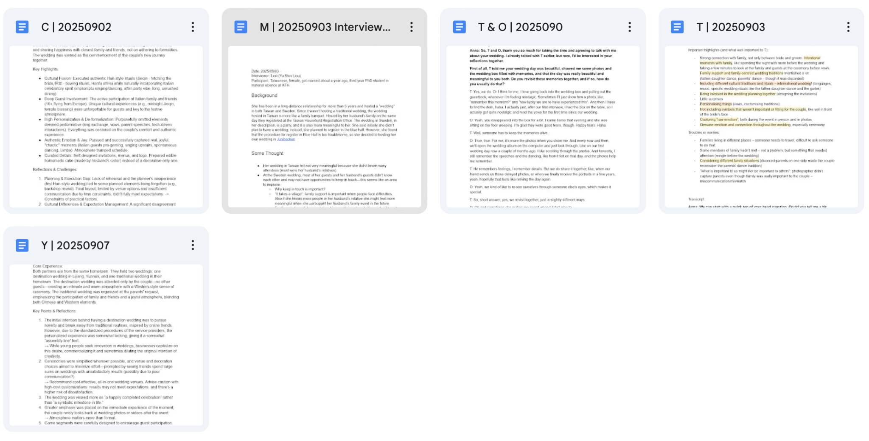

Interview Data Analysis
To analyze our interview data, we used an affinity diagram with four levels. The first round of analysis included codes and quotes describing and summarising our interview transcripts. The second level included clustering similar codes together. On the third level, we categorized our clusters into themes, some of which overlapped with each other. On the fourth level, we identified our main findings that reflected both a significant theme in our data and a focus area we were interested to explore further. Finally, we derived our point of view (POV) and how might we (HMW) statements from this theme.

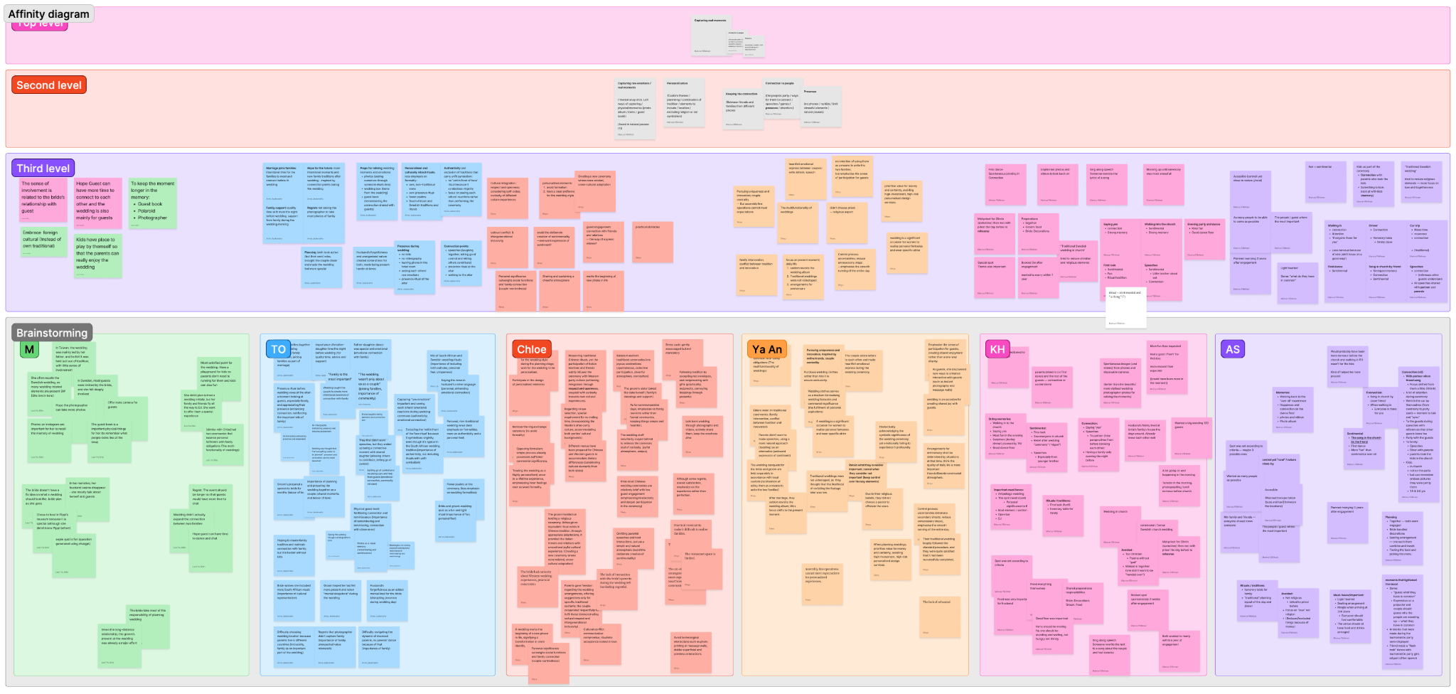
From bottom up: first, descriptive level; second, grouping level; third, thematic level; fourth, the main theme level.

Insight 1. Photos are a primary medium for revisiting wedding memories.
We found that three out of six couples revisited their wedding memories through photos and videos, engaging with various media formats. Some examples discussed were Instagram stories, digital photo albums and physical guests books. However, all participants emphasized that viewing photos is crucial for recalling the emotions of the wedding day.

- “T”: "Sometimes I'll just show him a photo, like, 'remember this moment?' and 'how lucky we are to have experienced this"
- “O”: "I like scrolling through the photos. And honestly, I still remember the speeches and the dancing, like how it felt on that day, and the photos help me remember."
- “M”: "It's pretty great – you get to remember how everyone looked that day."

We notice a clear social dimension of photo sharing; when couples share and revisit photos with each other, conversations about their wedding naturally emerge, which enhances the vividness of their memories. However, one bride mentioned that she rarely looks back at photos taken by the professional wedding photographer, because she found them emotionally distant.

- “Y”: "If we're not chatting with friends about it, we actually don't bring it up much. But if we specifically talk about it, we will. Nowadays, it's more about daily life and work. I don't constantly have my past wedding on my mind. We have photo albums, but we don't really look at them much."

This exception led us to investigate what makes a documentary media special and emotionally resonant.

Insight 2. Guest-taken photos hold unique meaning that professional photography cannot replace
Despite hiring a professional photographer, couples still seemed to value instant, lo-fi photography like Polaroid cameras. Instead of viewing them as a cheap, inferior way to document, couples felt that photos taken spontaneously by guests preserve the raw emotions and authenticity of the moment better.

- “M”: "I provided Instax cameras so people could take whatever photos they wanted and stick them in the guest book... you get to remember how everyone looked that day."

Two couples also mentioned a disconnect with their professional photographer. Weddings are unique and special for the couples and their guests, but for professional photographers, they can sometimes become routine work.

- “C”: "You only get married once, but for them, it's like an assembly line – a bit fast-food style, so it feels somewhat rough."
- “C”: "Because we only found out after going there that the staff who work on destination weddings have new couples every day – they do the same thing daily. In our eyes, we are participating in an important moment in our lives, but in their eyes, each batch of couples is the same, so it doesn't matter how it turns out or how it's photographed."

Moreover, the couple’s and the photographer’s expectations may differ, which may lead to disappointments, if not communicated about early.

- “T”: “The other day when I was going through the photos, I realized that he [photographer] didn't actually take photos of my parents. In my mind, I almost feel like, you know, like a little bit sick feeling that I don't have photos of my parents, from my wedding. Like, I think there may be one photo of my mom and maybe my dad in the background, but they're not actually in the photos.”

Insight 3: Couples prioritize staying present and avoiding intrusive documentation
Couples want to remain fully present during their wedding and avoid being interrupted by obtrusive documentation tools. One couple deliberately chose not to bring phones to focus entirely on the moment, and also wanted to ensure that recording equipment with a strong presence wouldn't disrupt guests' experiences.
Supporting quotes:

- “T”: "We didn't have videos on the day... It felt best to have that presence there and not think about someone filming all the time."
- “T”: "I literally left my phone in the hotel room, so, yeah, so I couldn't personally take any photos."

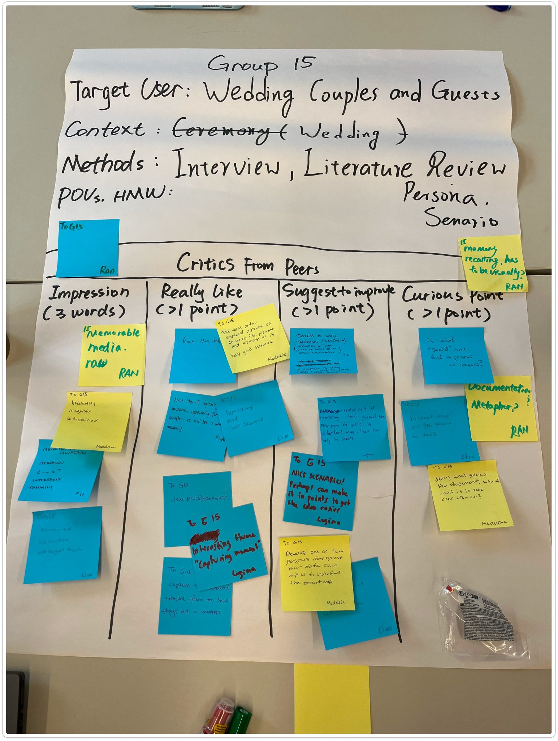

Feedback on our analysis, received at the first crit session. This feedback helped us sharpen and focus our POV statement and HMW questions.

Personas
To improve our understanding of our target users, we developed three different personas. Each one represents a unique type of need our interviewees expressed.

Type 1: Maggan – organized, cares about people’s experience
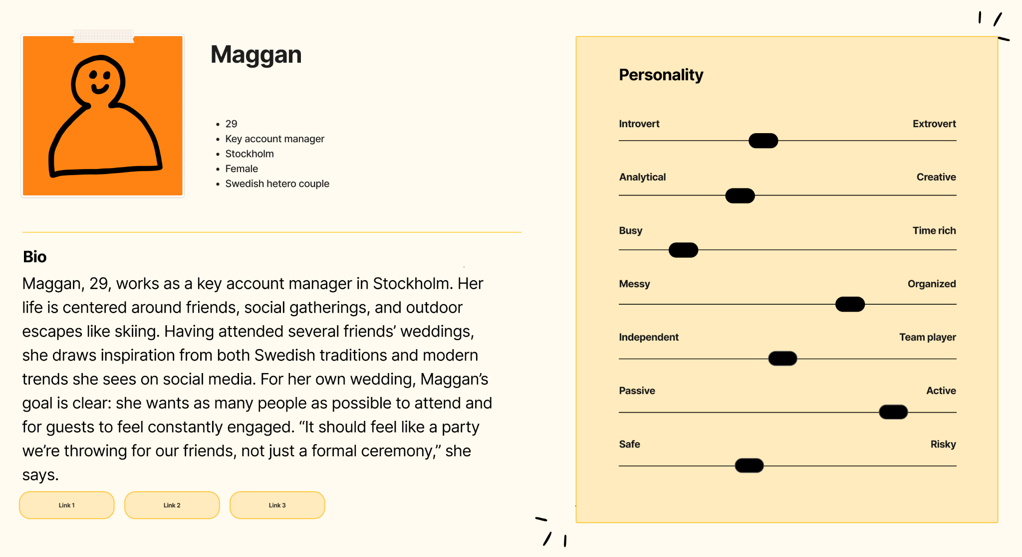

Type 2: Jan - highly active and concerned about being present
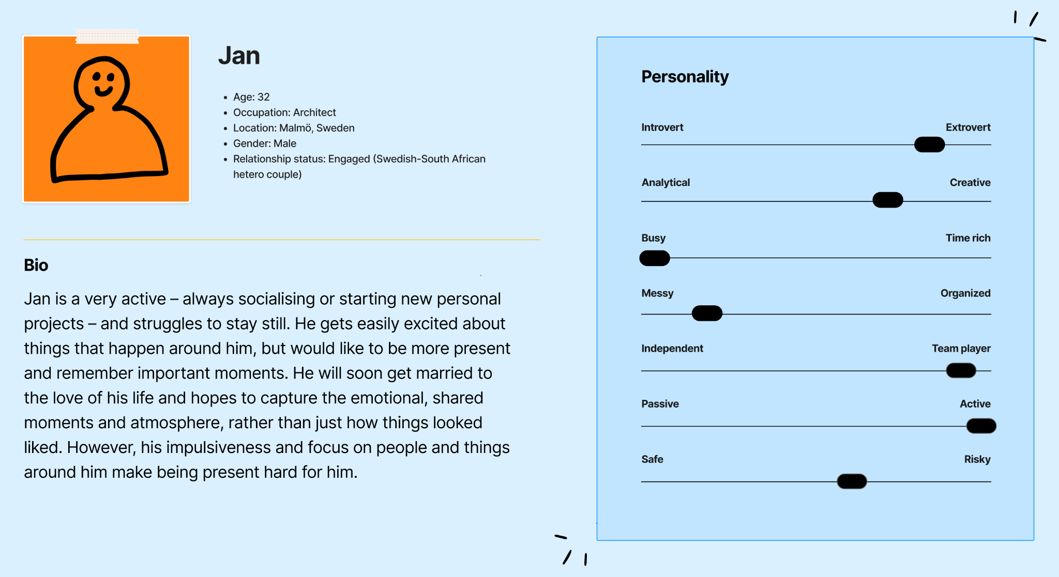

Type 3: Vivi - autonomous, balances the needs of family, friends and her own
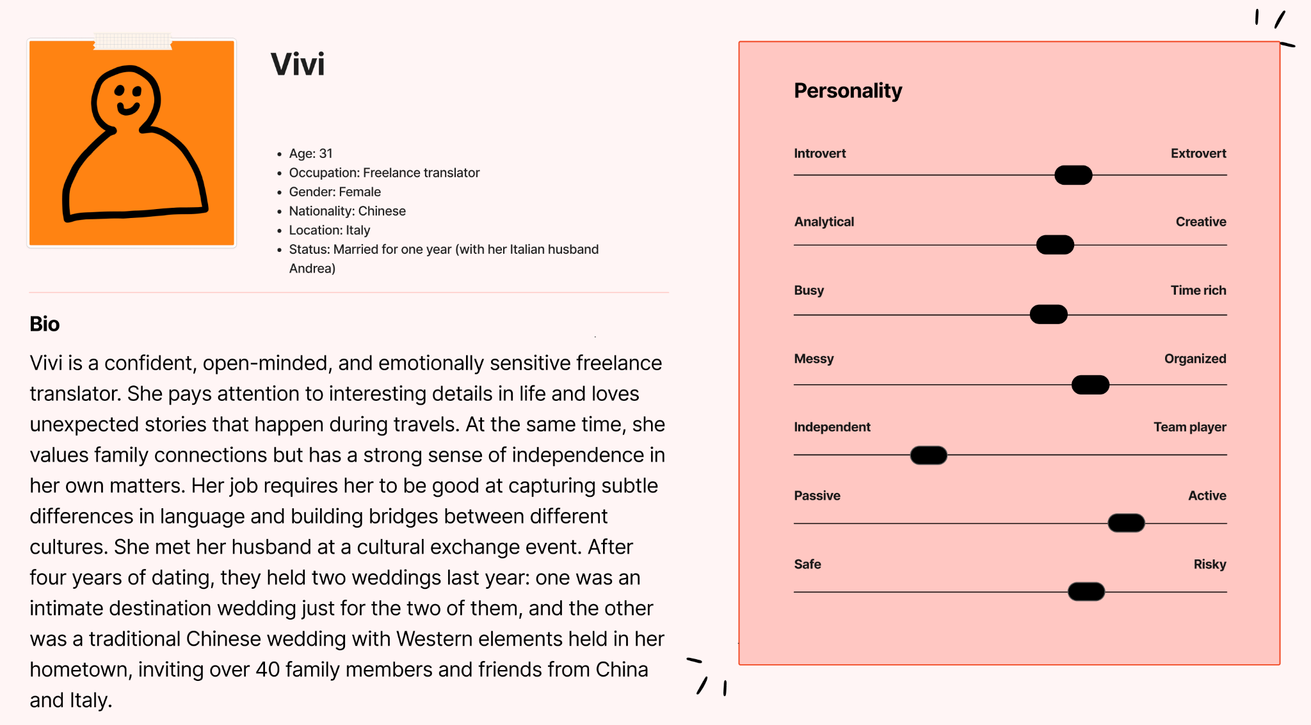

Scenario
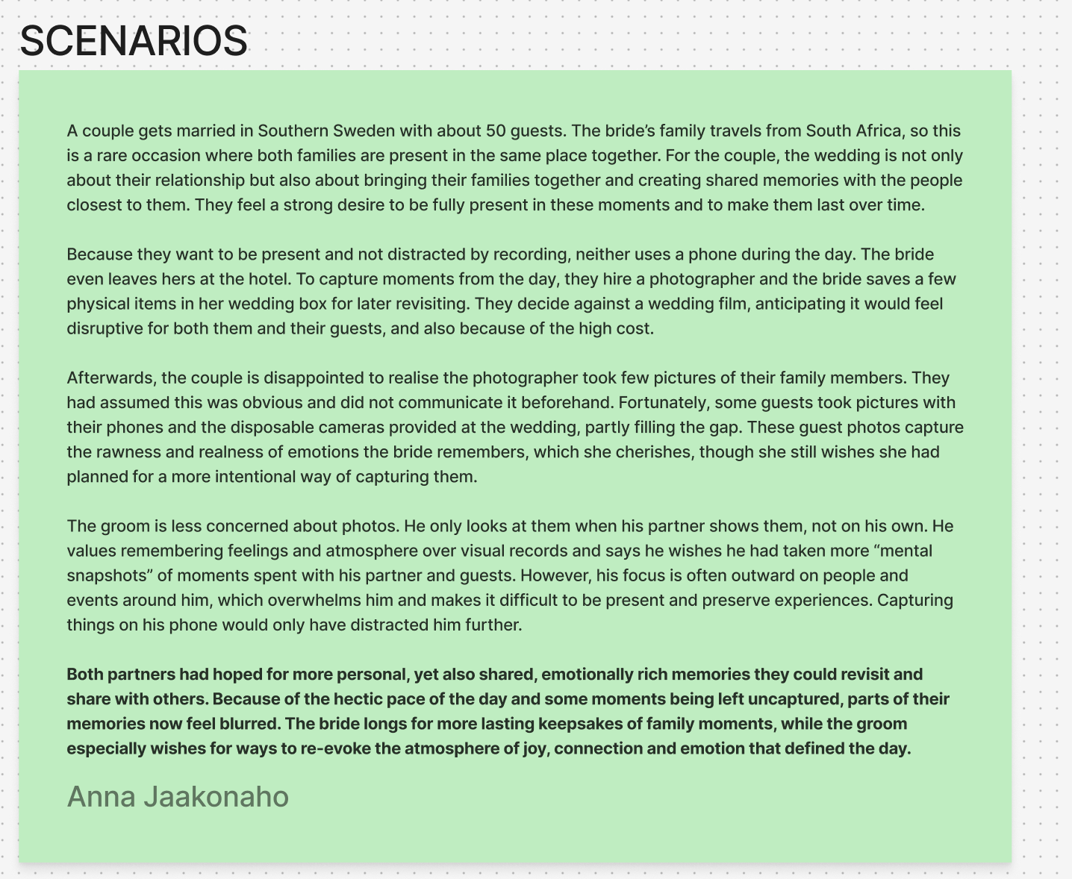

POV & HMW
Despite their different personalities and priorities, our personas share a point of view:
Couples getting married need help capturing their wedding moments in spontaneous, participatory forms, because an alternative method may help retain the emotional nuances and atmosphere.

Based on this statement, we constructed the following HMW question:

How might we capture the small, loving, and messy moments between people, while keeping the disruption to a minimum?

Ideation
In the ideation workshop, we used the “Worst Possible Ideas” method to uncover some issues we absolutely needed to avoid. Through generating the “worst” possible solutions to our problems, developing them together and voting and discussing the common ground, we confirmed that our design should be non-compulsoratory, non-distracting and serve the wedding couple and guests while avoiding major privacy issues. Whenever we had a new idea, we asked, "Does this avoid the worst-idea features?" It was an effective way to embed important design constraints into our thinking.

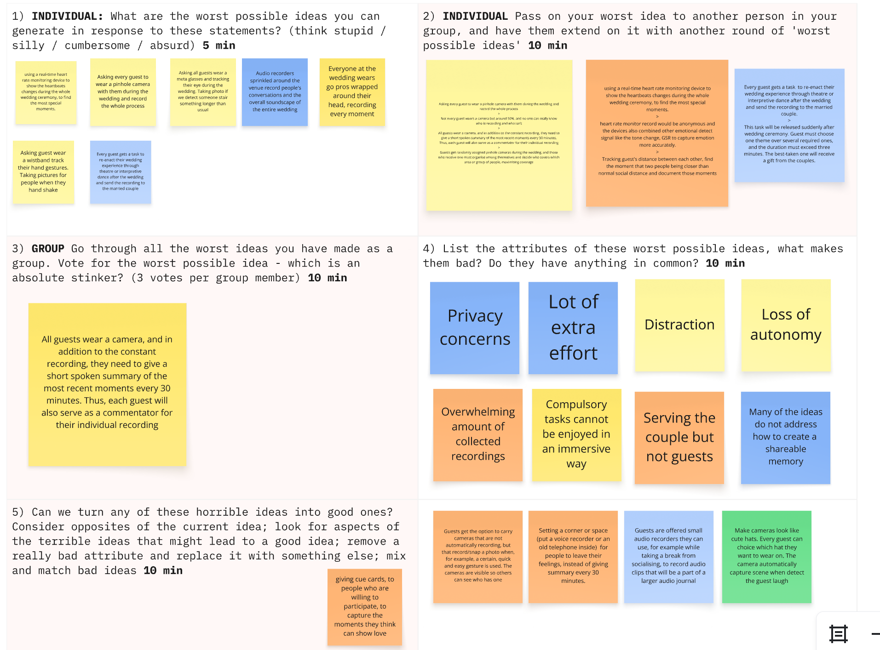

Then, we collected inspiration and spent some time doing individual brain dumping, keeping our minds open and encouraging as many ideas as possible – even the slightly crazy ones – to expand our thinking. We draw inspiration from multiple approaches, such as visiting art spaces and browsing web and social media, aiming to write down 10 ideas per person at first. Next, we discussed each others’ ideas and shared what we liked, which led to a list of our favourite ideas.
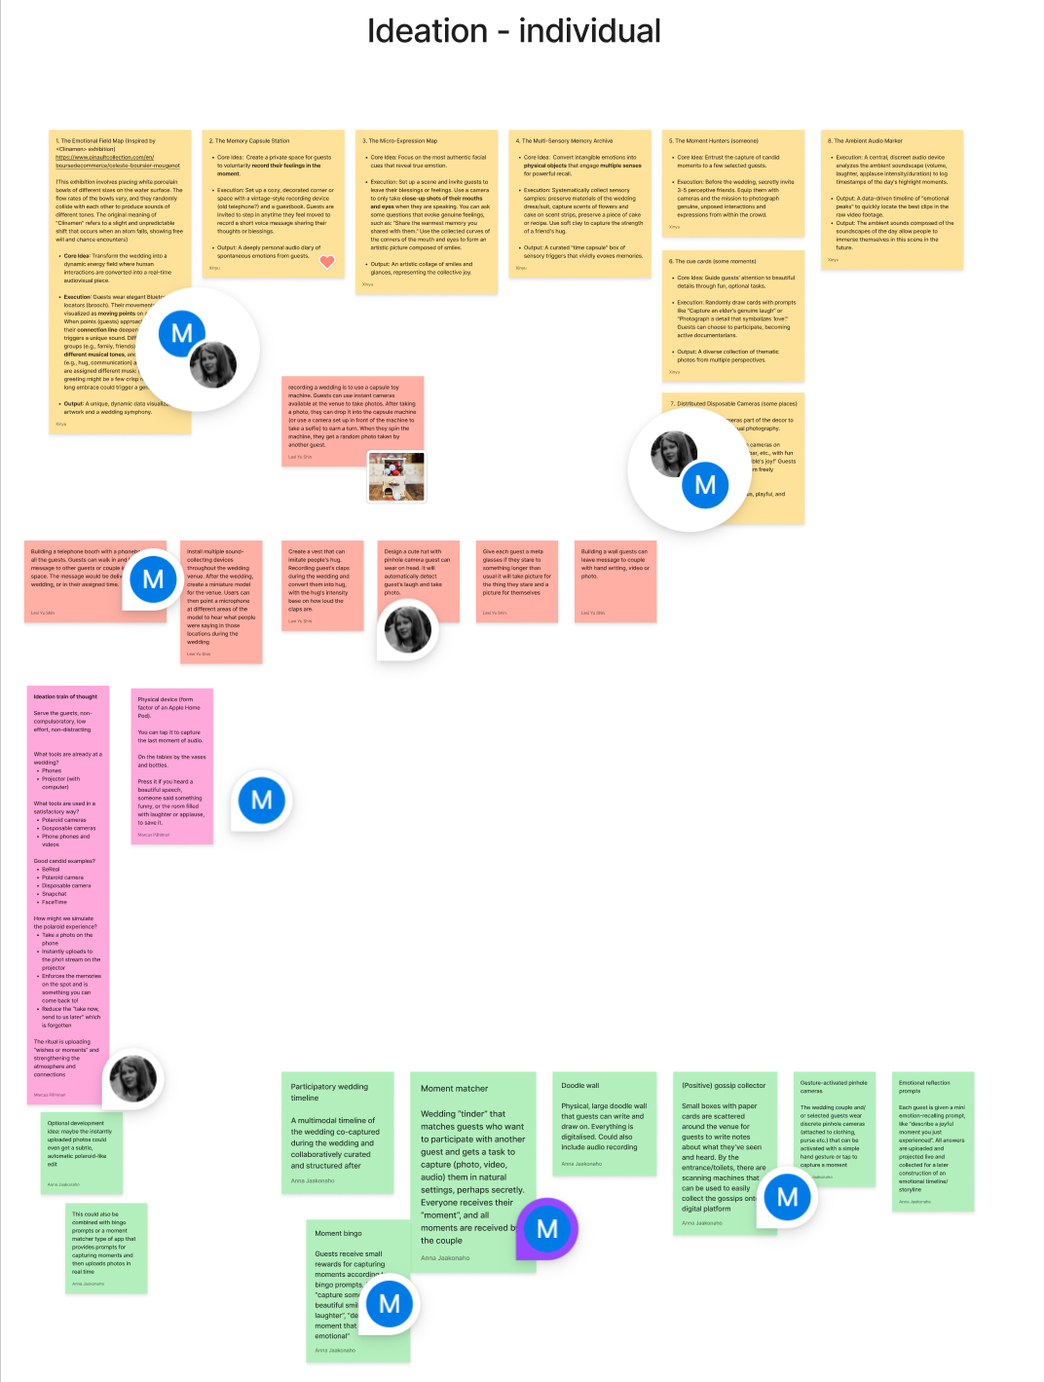

During our discussion, we conducted another round of ideation by brainstorming together. We then categorized similar ideas and thoroughly discussed the strengths and weaknesses of each one, consistently evaluating them against the criteria of how well they addressed our POV and HMW. Based on this process, we wrote down three important question questions and voted to select four favourite ideas.

Questions:
- “How to guide and motivate people to capture?”
- “How to capture fleeting moments?”
- “How to present collected memories?”

Ideas:
- Telephone booth: A telephone booth with a phonebook for all the guests, allowing guests to walk in and leave messages in a private space. The messages would be delivered after the wedding, or in their assigned time.
- Moment bingo: Guests receive small rewards for capturing moments according to bingo prompts, like “capture someone with a beautiful smile”, “record laughter”, “describe a moment that made you emotional”.
- Polaroid projector: Instantly uploaded polaroid pictures or phone photos edited with a polaroid filter are projected at the event as a photo stream, strengthening the atmosphere and fostering connection.
- Timeline: A multimodal timeline of the wedding co-captured by guests during the wedding and collaboratively curated and structured after.
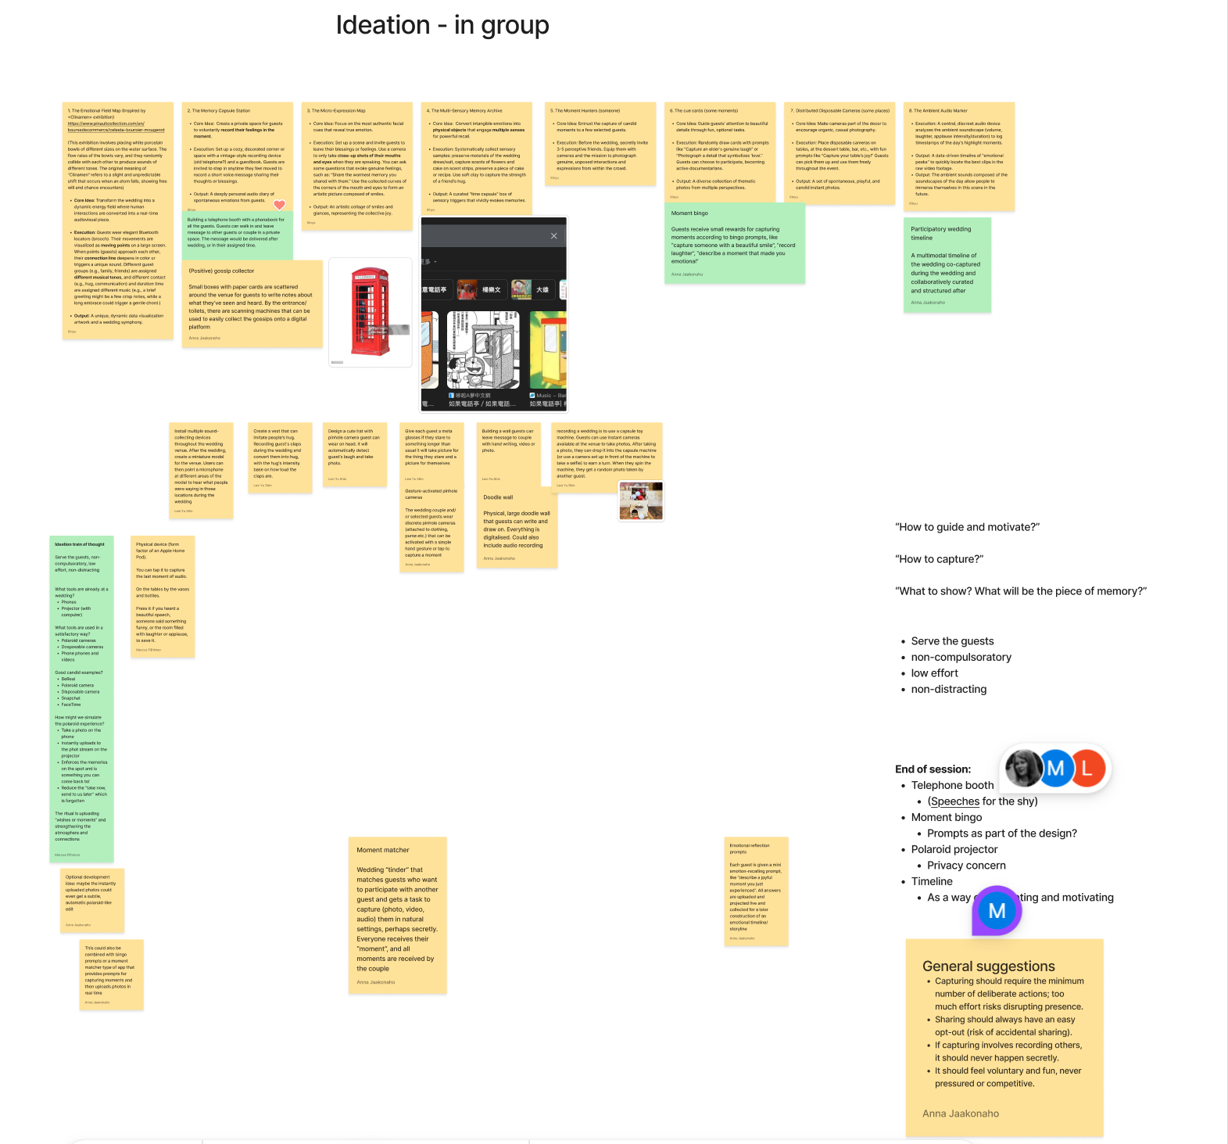

Taking into account the features identified through the “Worst Possible Idea”, we found that each idea had its own strengths and challenging aspects.
- The telephone booth would offer a private space that encourages the expression of deeper emotions, but it requires guests to step away and miss moments during the event, which could undermine the sense of participation.
- The moment bingo and polaroid projector would effectively capture in real time and enhance the event, but they run the risk of feeling competitive and, especially the latter, raising privacy concerns.
- The timeline enables co-capturing and collectively visualizing wedding moments. But I’whether its nature as a post-event collection can truly help capture those fleeting moments remains debatable.
During our supervision, we received a suggestion to use telephones or cameras as probes rather than using direct prompts. This shifted our question from "how can we guide or encourage guests to capture content?" to "how can we create an environment for them to capture content autonomously, without interference?" We realized that to avoid pushing people to do something, we should encourage people to capture moments in a way that feels natural to them.

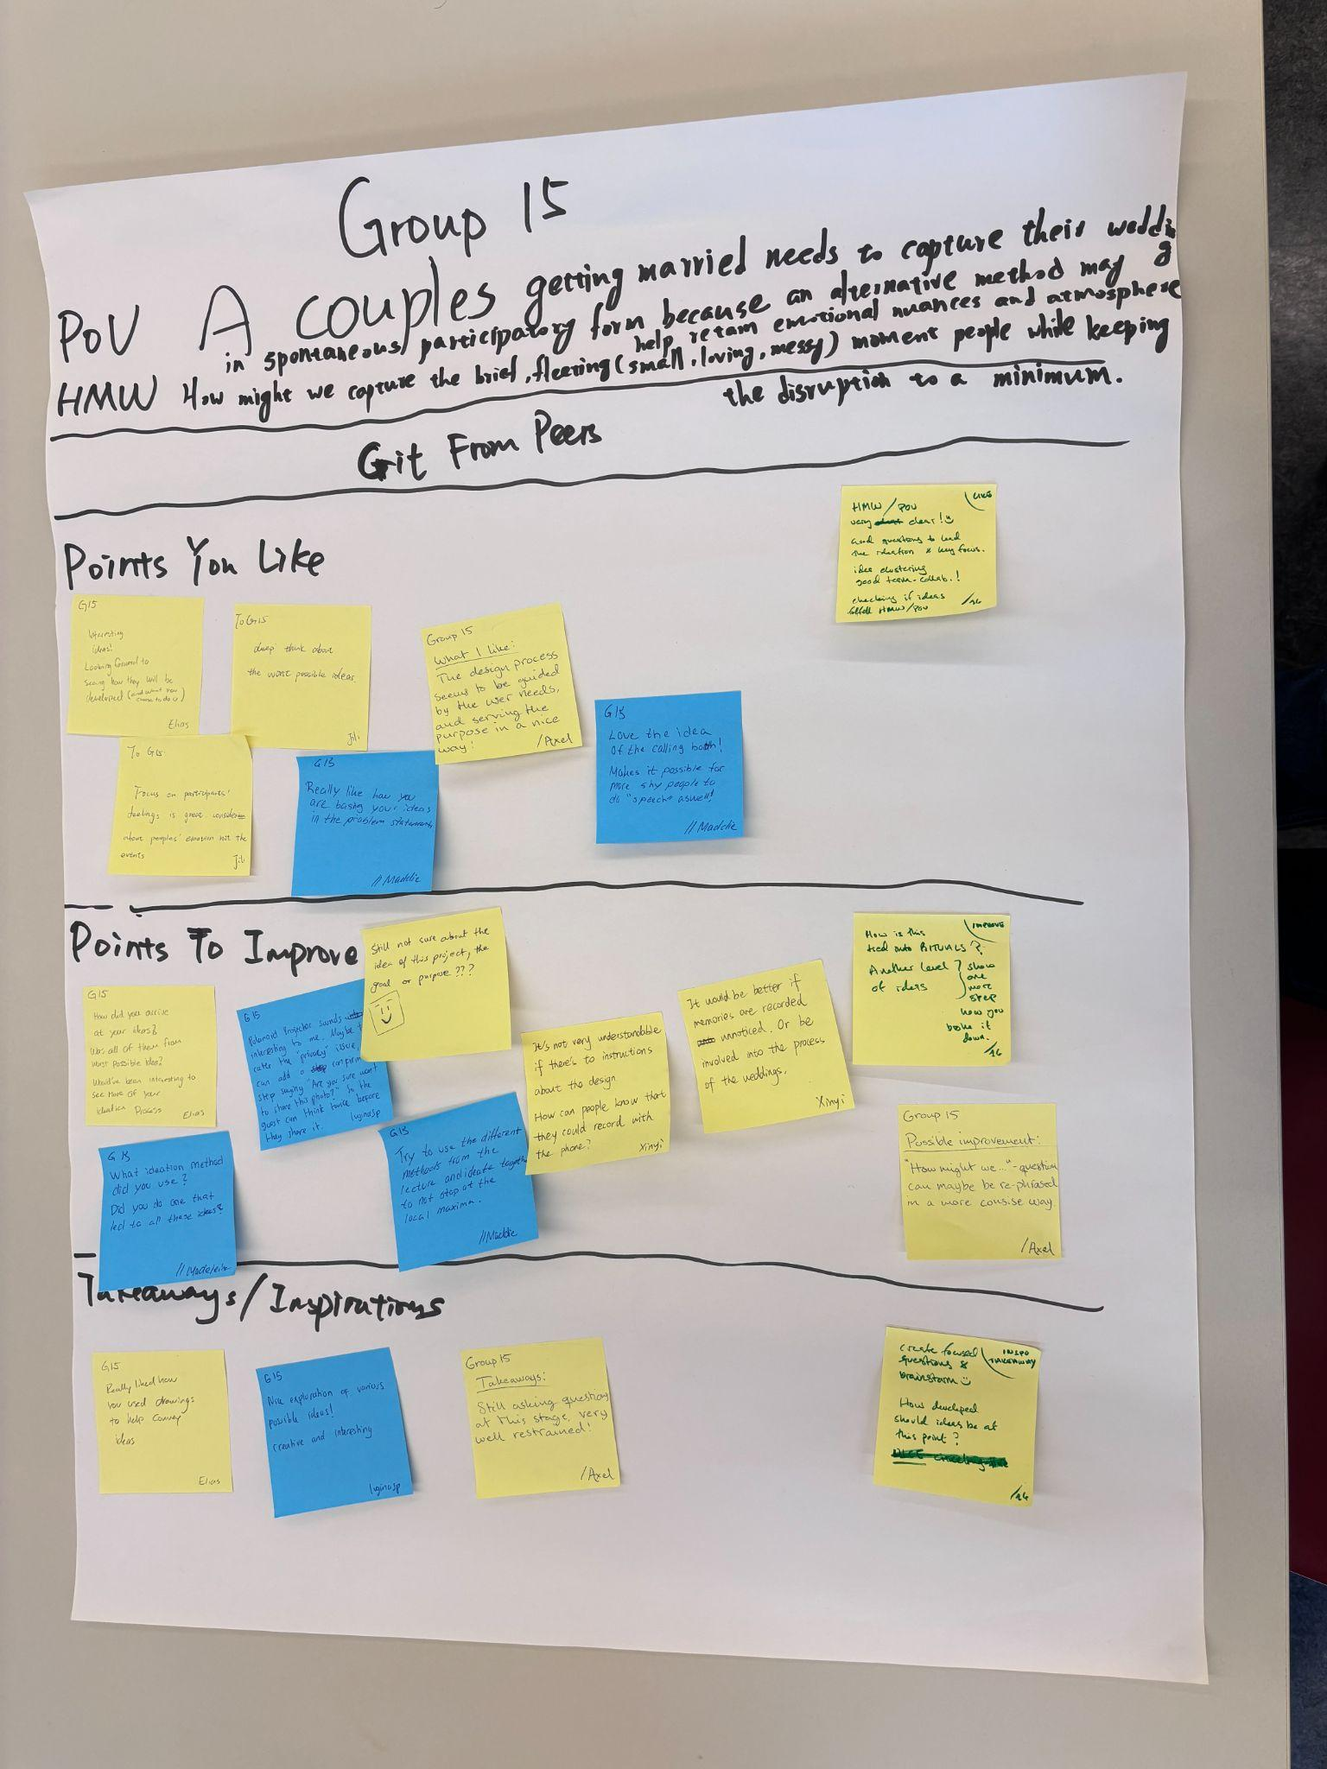
At this point, we created mood boards to diverge in our thinking. The purpose was not to define an aesthetic style, but to focus more on the overall atmosphere and core values of the design.

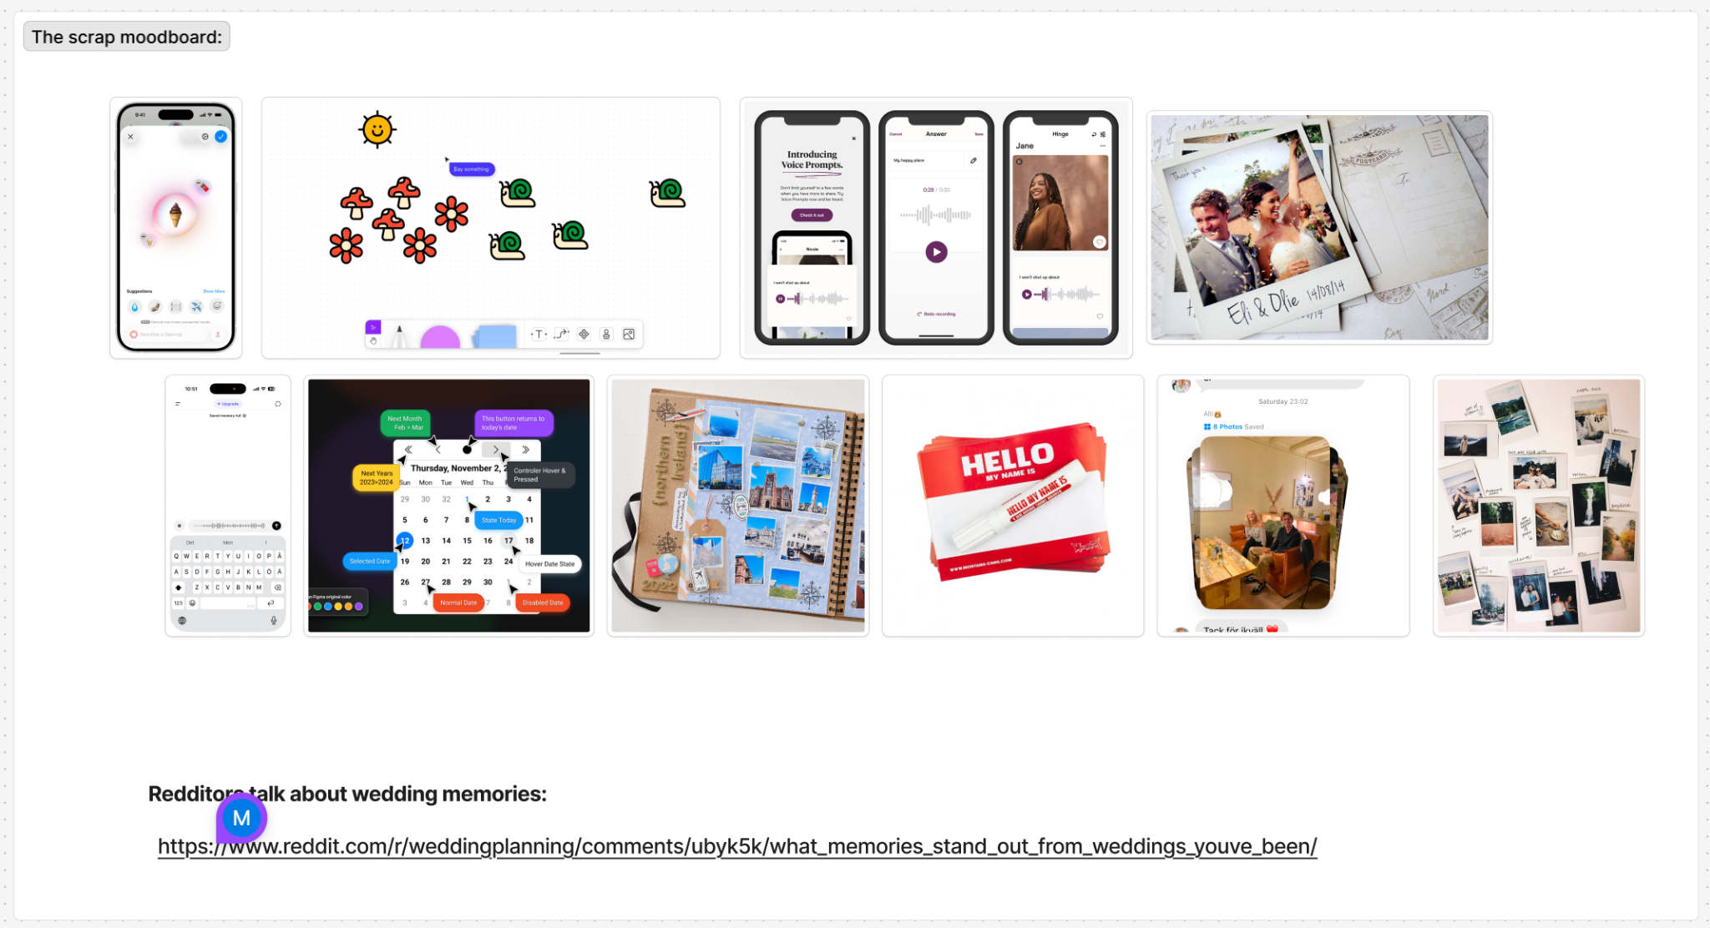
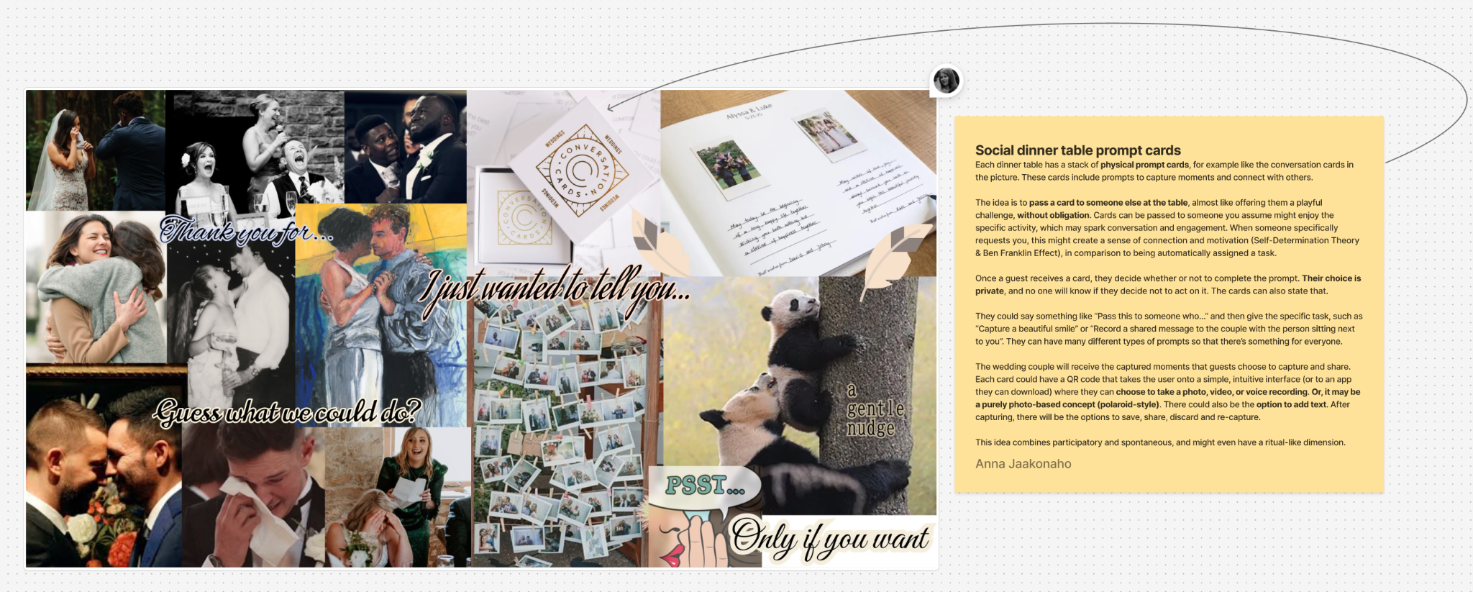
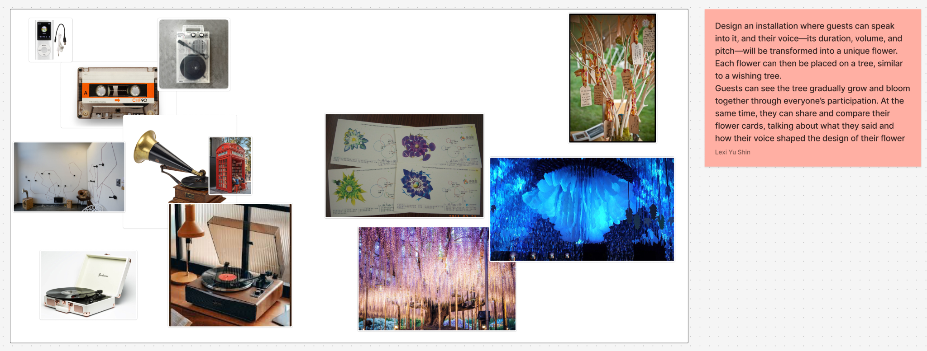
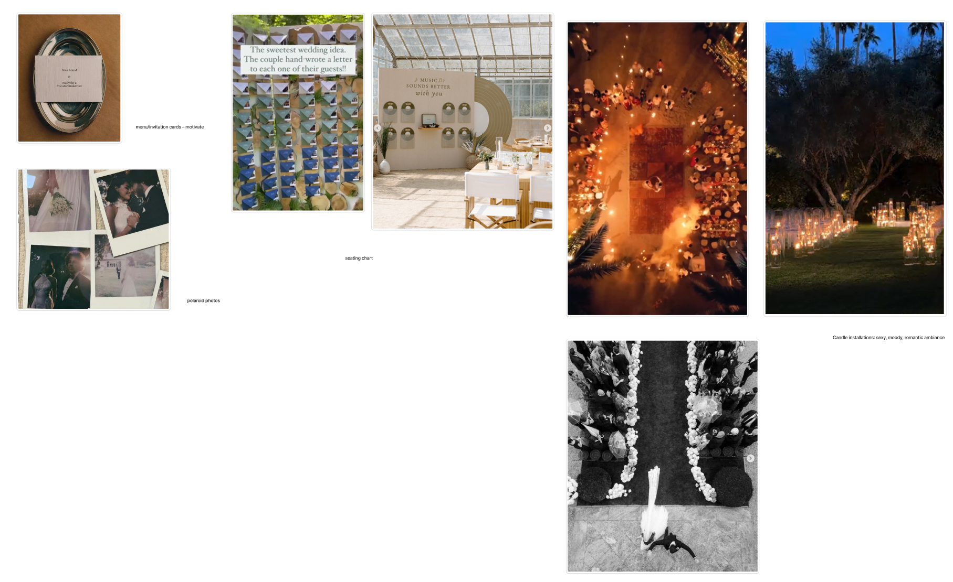

We realized that in the highly emotional context of a wedding, any capturing method that feels forced or overly guided could interrupt guests' immersive experience. This contradicted our core principle – keeping disruption during weddings to a minimum. Thus, we deepened our understanding of the initial HMW question: the real purpose of capturing is to enhance revisiting wedding moments, and co-creating the captured moments could add new layers and context to the small, individually captured moments.

Therefore, we ultimately selected the timeline as our core idea for the following reasons:
- It resolves the tension between not interrupting the experience and encouraging capturing. The timeline does not require guests to perform any specific actions during the wedding itself. Instead, it allows them to upload content afterward, at their own convenience. This achieves a higher degree of autonomy.
- The true essence of the timeline idea lies in co-creation. When guests collectively create wedding moments – for example, by adding content that provides another perspective of a moment compared to what other guests have captured – they transform from isolated moments into a multi-layered, multi-perspective narrative. The laughter I captured of you, and the touching moment you captured of me, all of these add richer context and emotional depth to every moment.
- Being aware of the opportunity to co-create the timeline later could also encourage people to take photos and videos of moments that matter to them during the wedding.

Sketching & Lo-fi Prototyping
Based on our analysis of different platforms, we carefully considered both a web-based solution and a native mobile app. While a website offers the advantage of a larger screen for potentially richer visual experience, we ultimately decided to develop a mobile app. This decision was driven by our core need for portability and the ability to enable spontaneous sharing, instant uploading, and effortless revisiting of memories anytime, anywhere.
During our prototyping phase, we adopted a parallel design approach to systematically transform abstract concepts into specific solutions. The process began with a workshop focused on our Timeline concept, where we created conceptual sketches to explore diverse styles.
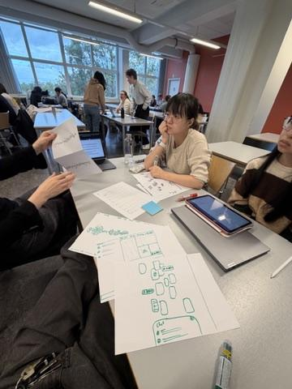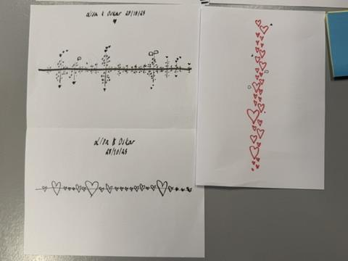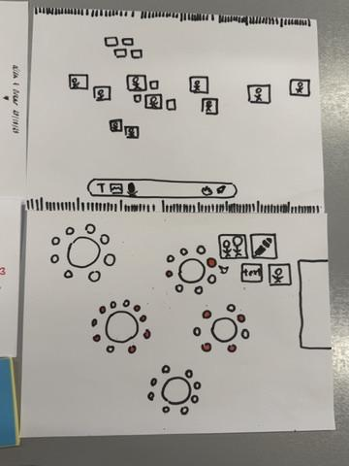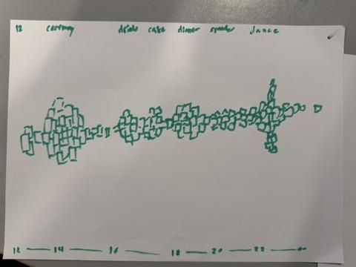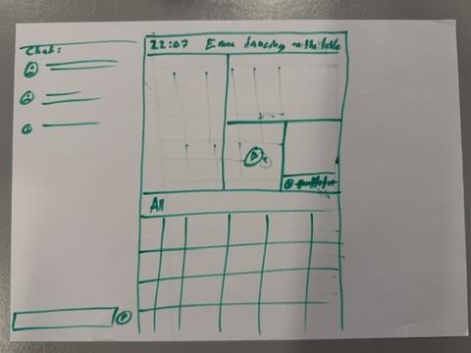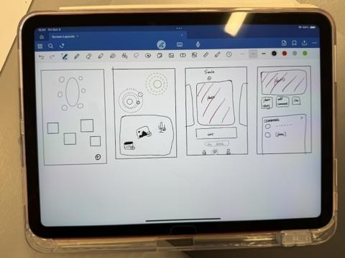
Subsequently, in follow-up sessions, we first mapped out the entire application workflow. We defined the primary content pages as the Timeline page that allows for broader exploration and functions as the landing page, and our Moment View for collecting content on individual moments that form the timeline, as well as a content adding function. The Timeline view features a scrollable timeline with moment overviews, giving users an immersive sense of the wedding as a whole. The Moment View page is designed for a special moment (e.g., the first dance), showing all related photos, videos, and audio shared by guests.
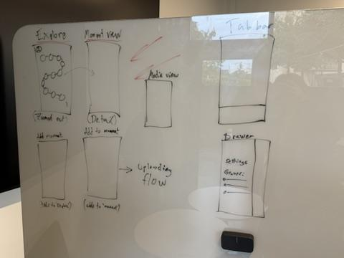
We then engaged in parallel wireframing for individual screens and functions. By consistently generating proposals for each key component, comparing them, and discussing their merits, we were able to explore effective ways to integrate these elements into a more comprehensive and user-friendly solution.
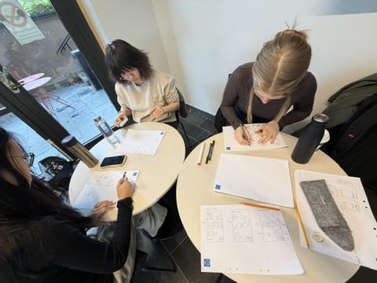
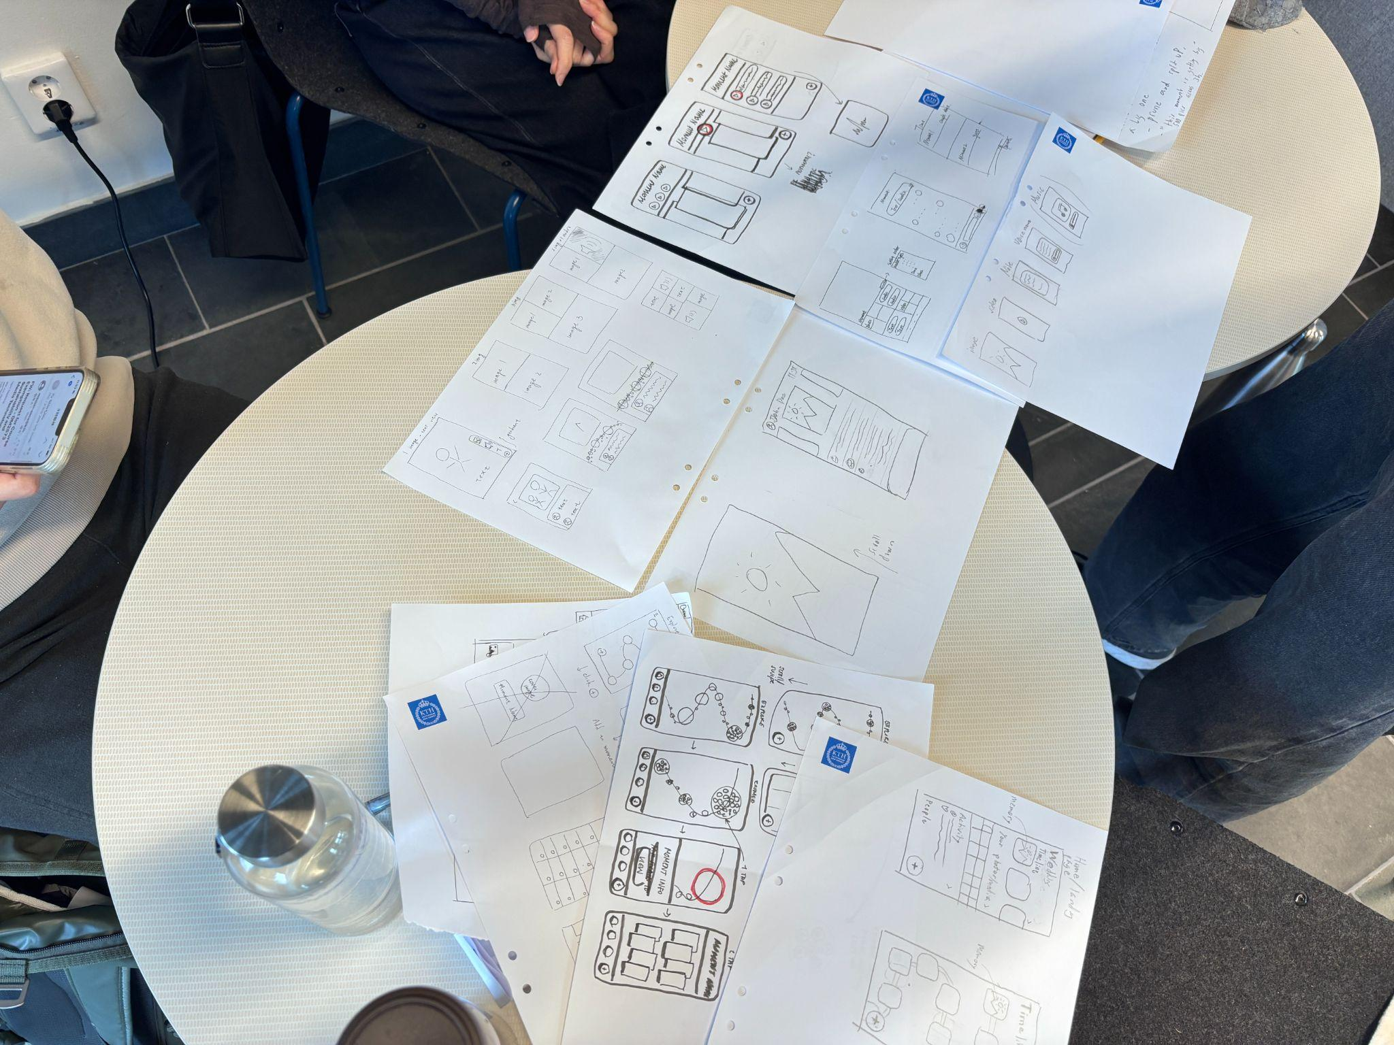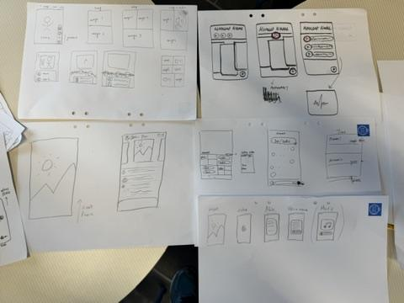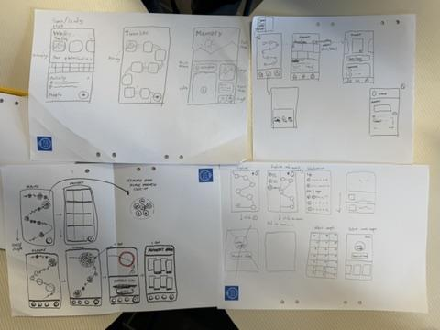
To be specific, our work included following key decisions:
- Timeline Visualization
With the shift to a mobile app, our timeline evolved from a horizontal line into a vertical curve. For individual moments on the timeline, we explored several visual approaches:
- A central photo surrounded by satellite images
- A single main image that expands to reveal more photos with a pinch-to-zoom gesture
- A slideshow of rotating featured images
We ultimately selected the third approach as it provides an intuitive overview of each moment directly on the Explore page while making individual moments stand out more distinctly.
- Timeline Logic
To prevent timeline messy due to varying user perspectives, we established a unified standard for adding new moments. We considered user-defined significant moments or category-based grouping, but we ultimately used the photo's timestamp as the primary criterion to minimize ambiguity.
- Moment View Layout
For the layout of a specific moment page, we discussed:
- iPhone album-style sections separating media types, activities, and contributors
- Audio files positioned at the top to set the vibe, with photos/videos below
- A top section with large rotating images for overview, followed by a mixed stream of media
We chose the third one as it combines an effective visual overview with an immersive experience through interspersed media. We did not choose the audio-top design because the uploaded audio clips might be too short and not long enough to provide the immersive browsing experience. We also retained filtering by "latest" and "most saved" to help users discover meaningful content.
- Distinguishing from social media
We discussed whether we should add a comment function to the Moment View or individual photo pages. While it helps to increase interaction, we finally decided to cancel it, because we want to differentiate our app from platforms like Instagram and keep the focus on the act of co-creation itself. Instead, we implemented a "save" feature, allowing users to privately mark meaningful photos for later reflection.
- Intentional UI & Navigation Design
For the main navigation, we talked about a standard tab bar but ultimately opted for a more focused solution. We placed a single, floating, and movable "Add" button on both the Explore and Moment View pages for maximum accessibility, which is based on our app's relatively simple functionality and our core goal of encouraging sharing. Secondary functions, such as settings and “my saves”, were placed at a sidebar accessible from the Explore page.

Evaluations
Before developing our hi-fi prototype, we conducted a formative evaluation by inviting four peers to assess our paper prototypes. To better simulate the real usage context, we cut the wireframes into the shape of mobile screens and cut out individual interactive components, allowing testers to physically manipulate them as they would in an actual app.

We were divided into two groups of two. In each group, one person acted as the facilitator while the other acted as recorder; these roles were swapped when testing the second tester to ensure balanced perspective-gathering.

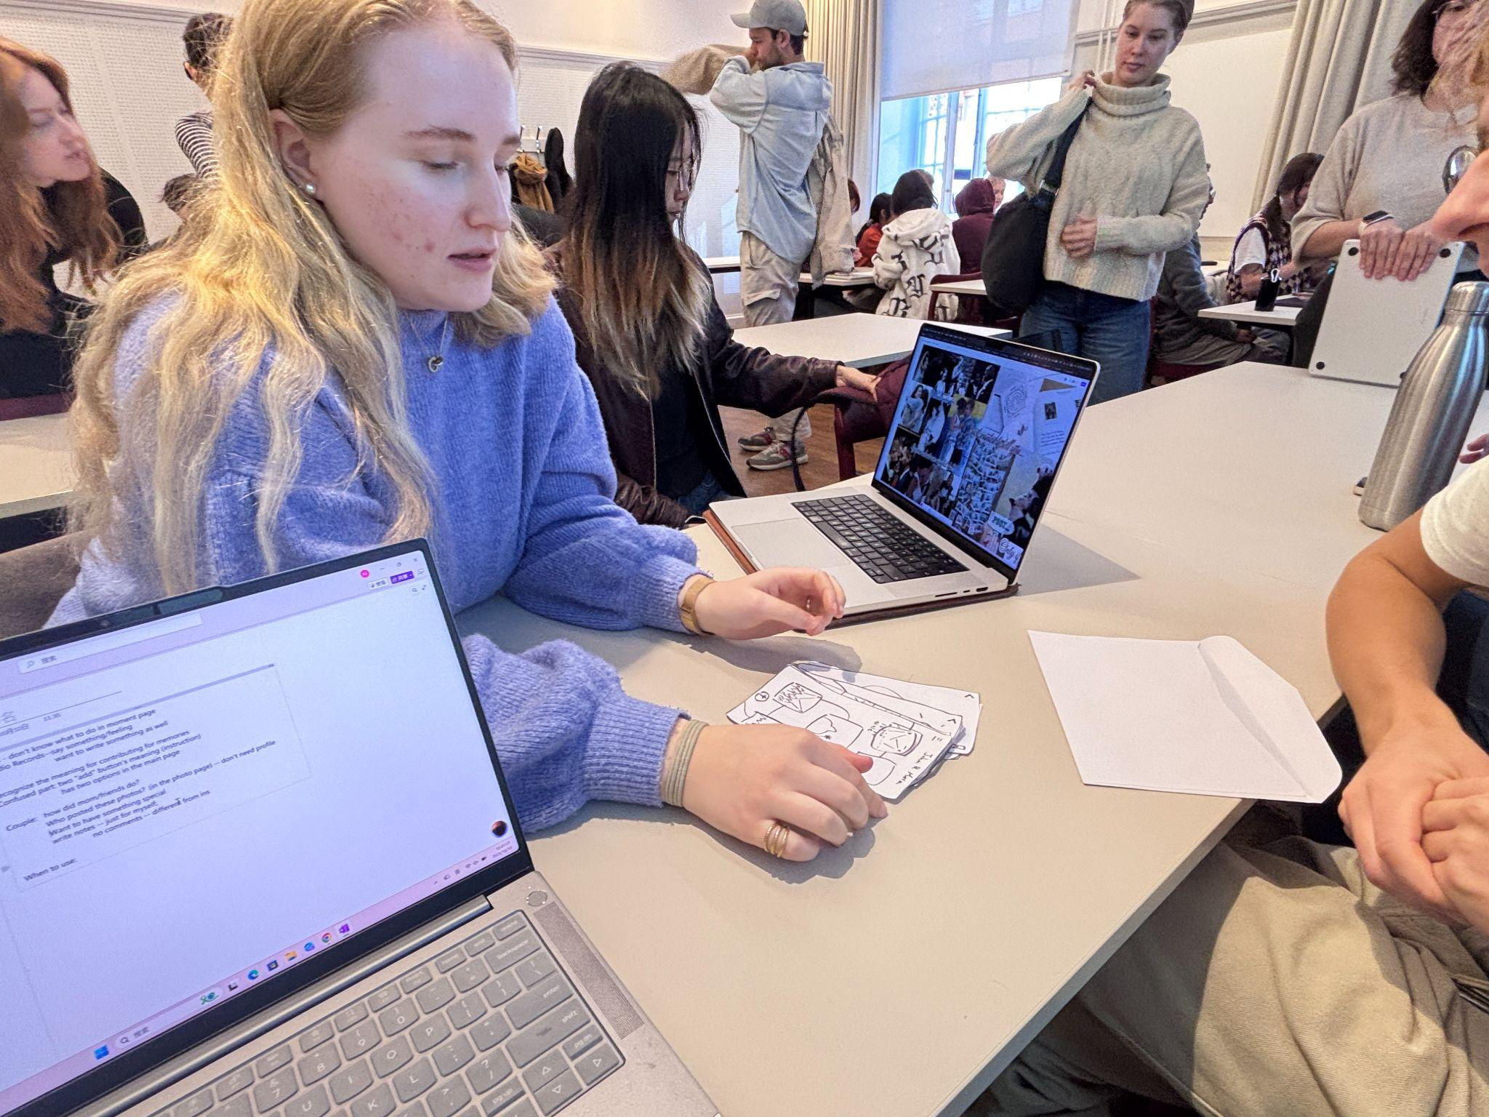
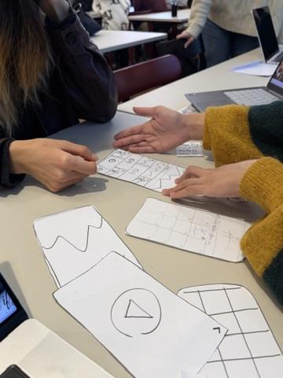
We combined the “Cognitive Walkthrough” and “Think Aloud” method by providing evaluators with specific role-playing scenarios. We also provided contextual cues using actual wedding photos. The scenarios were designed as follows:

- Guest version:
You were a guest at a wedding yesterday. Others have already started adding photos and memories to the couple’s shared platform. Now you’re joining in to share your own content and moments from the day.

- Couple version:
You got married yesterday. Most of your guests have already added their photos and memories to your shared platform. You’re logging in to see what everyone has shared.

This combined proved highly effective in validating our decisions about the flow and highlighting confusing aspects and common user errors.

We received the following feedback, which also inspired our further reflection.
1. Lack of Guidance on Key Pages
- Feedback: Testers felt unsure about what to do on the "Moment View" page and just navigated back without adding any content.
- Improvement: Enhance the visibility and guidance of the "Add" button, for example, by changing the label to "Share Your Unique Moment".
2. Confusion Between Two "Add" Buttons
- Feedback: Testers were confused by the same "Add" buttons for Timeline Page and Moment View Page, perceiving them as having the same function.
- Improvement: Redesign the "Add" button on the Timeline page to provide two clear options: "Create New Moment" or "Add to Existing Moment".
3. Need for Flexible Input Methods
- Feedback: While the audio recording feature met expectations to express emotions, testers also expressed a desire to add text descriptions.
- Improvement: Offer parallel input options such as "Record Audio" and "Write Text" to accommodate different expression preferences.
4. Visibility of Contributor Identity
- Feedback:
  - When playing the couple role, testers wanted to know "What did Mom/friends do?"
  - There was interest in seeing who posted specific photos.
- Improvement: Clearly display contributor identities on moments and media.
5. Special Design for the Couple's Perspective
- Feedback: Testers in the couple role wanted their wedding page to feel special and distinct from pages of other weddings they attended as guests.
- Improvement: Create visual or functional differentiation for the couple's view of their own wedding.
6. Pre-add Moments by Couples
- Feedback: Tester expected the couple to pre-establish moments, feeling that creating moments themselves would be too much work.
- Improvement: The couple can pre-add key moments to the timeline, guiding guests on when and what to share.
7. Varied Using Time
- Feedback:
  - Tester A said she would revisit the app when attending other weddings.
  - Tester B said she would use it during the wedding period, but would not revisit afterwards.
8. Interest in Stories Behind Moments
- Feedback: Testers expressed curiosity about "the stories behind" moments and photos, including stories from before the wedding (how the couple met, etc.)
9. Preference for Download Over Saving
- Feedback: Tester preferred download functionality over in-app saving, and indicated sharing is more important than saving.

Feedback Implementation
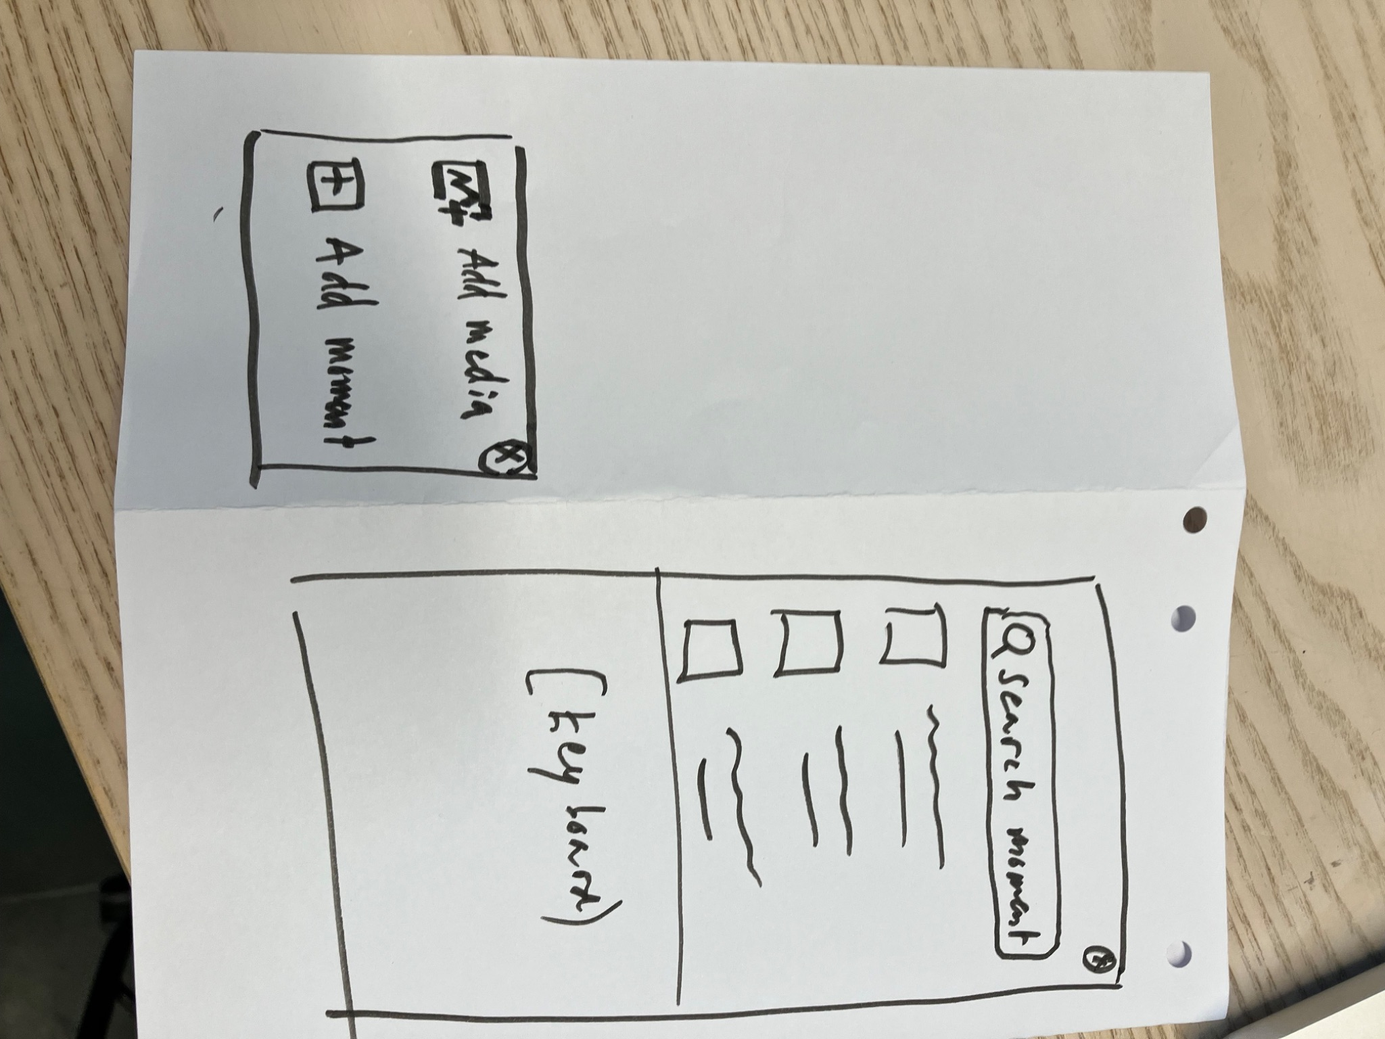

Hi-Fi Prototype Development
Add screenshots of different iterations (different moments timeline layouts, merging of the landing page and moments) and explain briefly any additional features not included or that aren’t interactive. Emphasise reasons behind decisions, like continuous usability testing, and refer back to our earlier timeline inspiration and discussion about how to capture multimodal moments of different sizes.

User Scenario
A quick story, including before, during and after the wedding. One guest scenario, one couple scenario.

Final Evaluation
Include main feedback from core users, possible further development proposals with sketches or adjustments made on our final prototype.

