《开源操作系统》

课程实验指导书

宋铁 编写

课程编号 950819Z10
总 学 时 32
实验学时 8
课外学时 4

中南大学计算机学院
2023年7月
实验一 Shell脚本编程

实验学时： 4
每组人数： 1
实验类型： 2 （1：基础性 2：综合性 3：设计性 4：研究性）
实验要求： 1 （1：必修 2：选修 3：其它）
实验类别： 3 （1：基础 2：专业基础 3：专业 4：其它）

一、实验目的

掌握Linux系统命令行模式下常用命令的使用方式，熟悉Linux系统Shell脚本编程的基本概念，能编写简单脚本完成Linux系统的常用管理功能，加深对Linux文件系统、用户管理、进程管理和网络管理等概念的理解。

二、实验内容
实验内容分为基本任务、进阶任务和挑战任务三个部分（其中基本任务和进阶任务提供参考脚本）：
- 基本任务

任务1：系统监控脚本 monitor.sh，实时获取并显示当前系统的关键资源使用情况，包括CPU占用、内存使用和磁盘空间占用等指标。

提示：
- 考虑使用Linux系统自带的命令来获取资源信息，例如：top获取CPU占用、free获取内存占用、df获取磁盘空间等 。这些命令可通过选项输出简洁的统计结果（如top -b -n1一次性输出、free -m以MB为单位输出）。
- 可以利用管道和文本处理命令提取需要的字段，例如用grep筛选关键信息，使用awk或cut提取数值部分，计算使用率百分比等。
- 如实现周期监控，可用sleep命令让脚本暂停指定秒数，然后循环采集；将多次采样结果追加重定向到文件可以形成简易日志。
- 阈值判断可通过条件语句实现，将获取的数值与阈值比较即可；触发告警时，可以结合ps命令列出当前占用最高的进程作为辅助信息。

参考脚本：

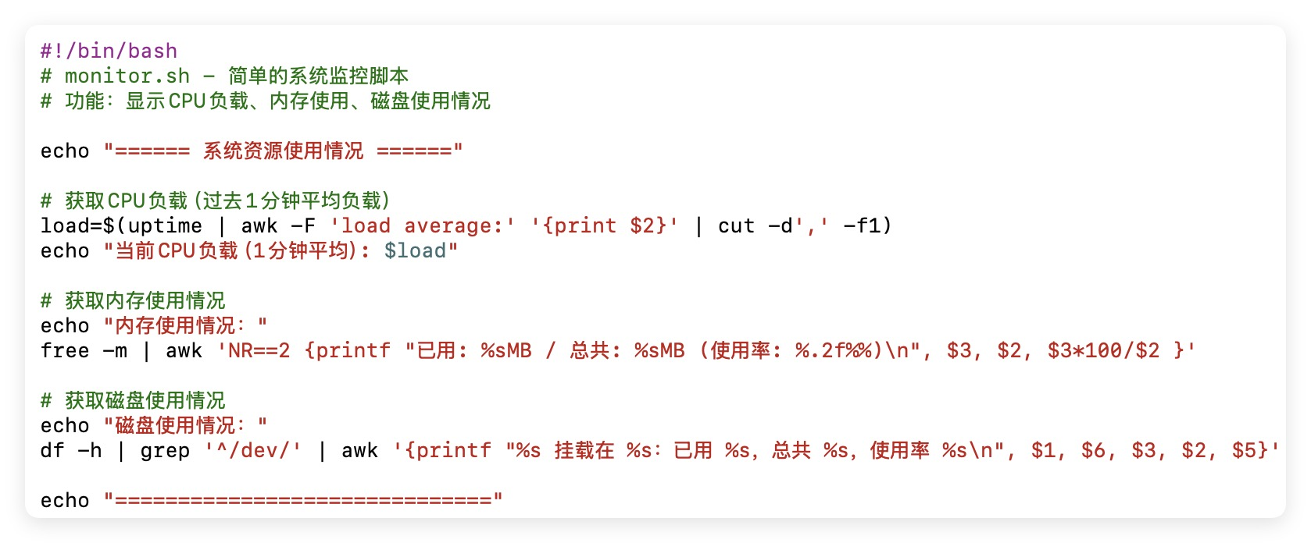

任务2：日志分析脚本，对给定的日志文件进行分析，统计其中包含的关键信息。典型的场景如分析服务器访问日志或系统日志，从中提取有用的数据统计结果。（示例脚本在附件1）
- 日志级别统计level_count.sh
- 错误日志提取与模块统计error_module_count.sh。

参考脚本：

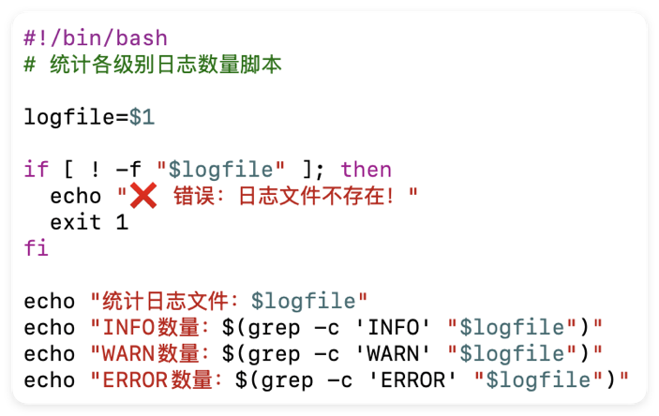

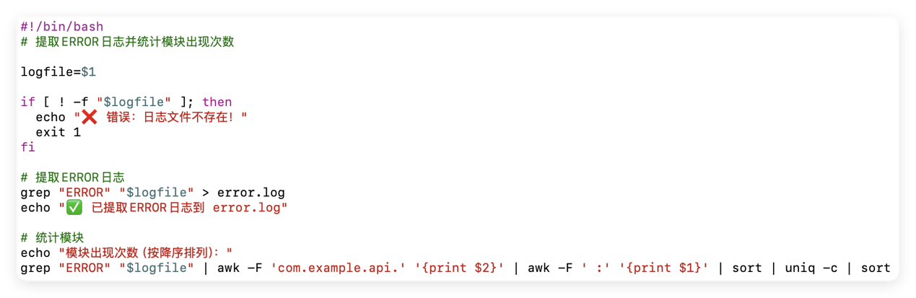

- 进阶任务
任务1： 自动备份与归档脚本 backup.sh。
具体要求：定期备份指定目录，生成压缩包，清理旧备份。
参考脚本：
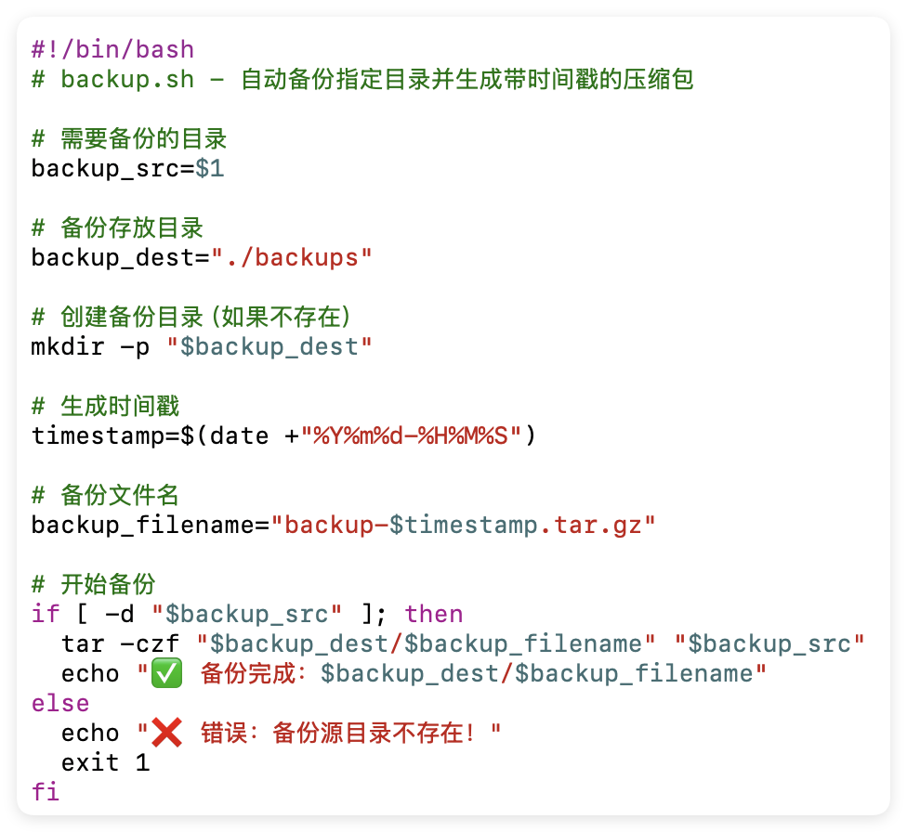
任务2：网络连通性监测脚本 ping_check.sh
具体要求：批量Ping检测IP，判断在线/掉线，生成检测日志。
参考脚本：
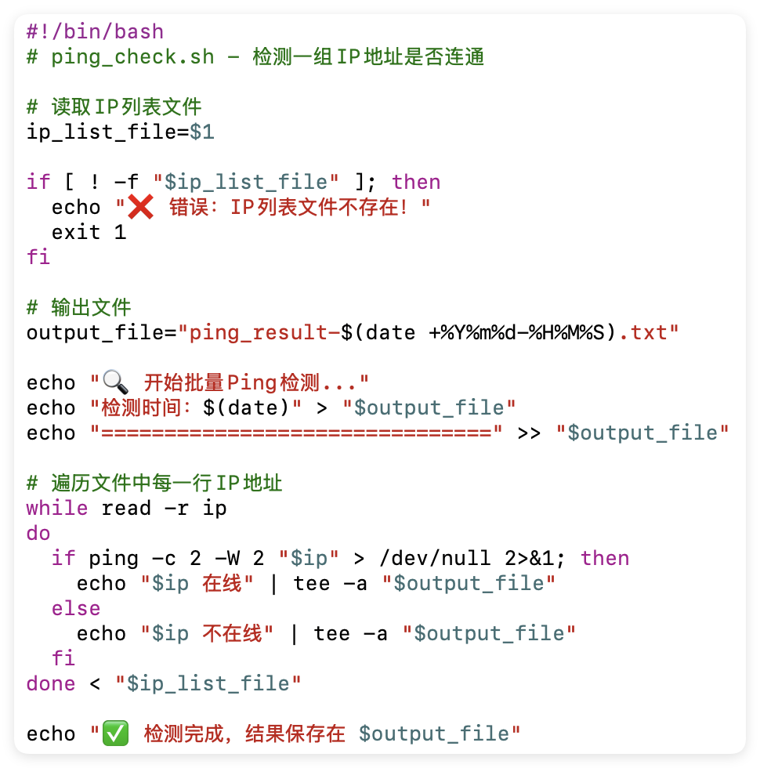
运行示例：bash ping_check.sh iplist.txt
iplist.txt文件中保存要测试的IP地址。

- 挑战任务
任务1：进阶版备份脚本 backup_advanced.sh
具体要求：在backup.sh的基础上，增加保留天数可自定义、自动清理7天以上老备份功能。
任务2：进阶版Ping监测脚本 ping_check_advanced.sh
具体要求：在backup.sh的基础上，增加在线率统计和断网报警功能（自动统计总IP数、在线数、离线数、在线率百分比，断线IP高亮报警输出>&2红色警告）。

三、实验要求
- 按上述实验内容的任务依次完成；
- 不一定要完全按照参考脚本进行实验，如果已熟练掌握相关命令和脚本编程，可自行编程实现，完成相同或类似功能即可。

四、实验报告要求
- 实验报告提供脚本源代码，并且给所有脚本的每一行都添加相关注释说明；
- 实验报告需提供脚本运行的结果截图；
- 实验的练习部分需记录脚本编写过程中遇到的问题（文字描述或截图），如无问题则编写一段不少于500字的心得体会；
- 请按实验报告模板编写。
附件1：
2025-04-26 10:00:00.000 INFO 12709 --- [nio-8080-exec-2] com.example.api.UserController : Product details fetched
2025-04-26 10:00:05.000 WARN 12949 --- [nio-8080-exec-1] com.example.api.UserController : Login attempt from unknown device
2025-04-26 10:00:12.000 INFO 12831 --- [nio-8080-exec-1] com.example.api.InventoryService : User profile updated
2025-04-26 10:00:19.000 INFO 12839 --- [nio-8080-exec-3] com.example.api.PaymentService : User token validated
2025-04-26 10:00:29.000 INFO 12650 --- [nio-8080-exec-8] com.example.api.UserController : Updated product details
2025-04-26 10:00:32.000 ERROR 12122 --- [nio-8080-exec-1] com.example.api.UserController : Payment gateway timeout
2025-04-26 10:00:36.000 INFO 12774 --- [nio-8080-exec-3] com.example.api.InventoryService : User profile updated
2025-04-26 10:00:41.000 INFO 12128 --- [nio-8080-exec-9] com.example.api.InventoryService : Received login request
2025-04-26 10:00:50.000 INFO 12264 --- [nio-8080-exec-7] com.example.api.AuthService : Received login request
2025-04-26 10:00:58.000 INFO 12923 --- [nio-8080-exec-5] com.example.api.OrderController : User token validated
2025-04-26 10:01:01.000 INFO 12058 --- [nio-8080-exec-4] com.example.api.PaymentService : Password reset request
2025-04-26 10:01:07.000 WARN 12606 --- [nio-8080-exec-4] com.example.api.OrderController : Delayed shipment alert
2025-04-26 10:01:11.000 INFO 12977 --- [nio-8080-exec-10] com.example.api.AuthService : Fetched product list
2025-04-26 10:01:14.000 INFO 12192 --- [nio-8080-exec-1] com.example.api.NotificationService : Restocked products
2025-04-26 10:01:23.000 INFO 12512 --- [nio-8080-exec-8] com.example.api.UserController : Session refreshed
2025-04-26 10:01:25.000 INFO 12737 --- [nio-8080-exec-8] com.example.api.InventoryService : Product details fetched
2025-04-26 10:01:31.000 INFO 12142 --- [nio-8080-exec-10] com.example.api.PaymentService : Fetched product list
2025-04-26 10:01:34.000 WARN 12376 --- [nio-8080-exec-6] com.example.api.AuthService : Stock level below threshold
2025-04-26 10:01:40.000 INFO 12140 --- [nio-8080-exec-5] com.example.api.UserController : Session refreshed
2025-04-26 10:01:49.000 INFO 12024 --- [nio-8080-exec-2] com.example.api.InventoryService : Session refreshed
2025-04-26 10:01:52.000 INFO 12954 --- [nio-8080-exec-4] com.example.api.OrderController : Sent notification email
2025-04-26 10:01:53.000 INFO 12234 --- [nio-8080-exec-2] com.example.api.NotificationService : SMS sent to user
2025-04-26 10:01:59.000 INFO 12159 --- [nio-8080-exec-1] com.example.api.PaymentService : SMS sent to user
2025-04-26 10:02:04.000 INFO 12401 --- [nio-8080-exec-5] com.example.api.NotificationService : Updated product details
2025-04-26 10:02:09.000 INFO 12783 --- [nio-8080-exec-9] com.example.api.OrderController : Fetched product list
2025-04-26 10:02:11.000 INFO 12627 --- [nio-8080-exec-9] com.example.api.AuthService : Product details fetched
2025-04-26 10:02:14.000 INFO 12430 --- [nio-8080-exec-5] com.example.api.InventoryService : User logout successful
2025-04-26 10:02:19.000 ERROR 12775 --- [nio-8080-exec-4] com.example.api.InventoryService : Internal server error
2025-04-26 10:02:22.000 INFO 12234 --- [nio-8080-exec-1] com.example.api.AuthService : Sent notification email
2025-04-26 10:02:32.000 INFO 12980 --- [nio-8080-exec-1] com.example.api.NotificationService : User token validated
2025-04-26 10:02:36.000 INFO 12432 --- [nio-8080-exec-5] com.example.api.NotificationService : Password reset request
2025-04-26 10:02:41.000 ERROR 12534 --- [nio-8080-exec-3] com.example.api.PaymentService : Insufficient funds
2025-04-26 10:02:50.000 ERROR 12883 --- [nio-8080-exec-8] com.example.api.UserController : Payment gateway timeout
2025-04-26 10:02:59.000 ERROR 12120 --- [nio-8080-exec-7] com.example.api.AuthService : Database connection error
2025-04-26 10:03:04.000 WARN 12450 --- [nio-8080-exec-5] com.example.api.OrderController : Stock level below threshold
2025-04-26 10:03:14.000 INFO 12855 --- [nio-8080-exec-5] com.example.api.InventoryService : User logout successful
2025-04-26 10:03:19.000 ERROR 12614 --- [nio-8080-exec-1] com.example.api.ProductService : Database connection error
2025-04-26 10:03:23.000 INFO 12218 --- [nio-8080-exec-6] com.example.api.NotificationService : Sent notification email
2025-04-26 10:03:28.000 INFO 12460 --- [nio-8080-exec-3] com.example.api.InventoryService : User token validated
2025-04-26 10:03:38.000 INFO 12713 --- [nio-8080-exec-1] com.example.api.PaymentService : Order placed successfully
2025-04-26 10:03:44.000 ERROR 12879 --- [nio-8080-exec-5] com.example.api.OrderController : Internal server error
2025-04-26 10:03:47.000 INFO 12715 --- [nio-8080-exec-2] com.example.api.PaymentService : Order placed successfully
2025-04-26 10:03:51.000 INFO 12763 --- [nio-8080-exec-3] com.example.api.OrderController : Received login request
2025-04-26 10:03:52.000 INFO 12047 --- [nio-8080-exec-3] com.example.api.ProductService : Session refreshed
2025-04-26 10:03:58.000 ERROR 12948 --- [nio-8080-exec-3] com.example.api.OrderController : Insufficient funds
2025-04-26 10:04:08.000 ERROR 12358 --- [nio-8080-exec-8] com.example.api.UserController : Internal server error
2025-04-26 10:04:10.000 INFO 12077 --- [nio-8080-exec-7] com.example.api.OrderController : Updated product details
2025-04-26 10:04:12.000 INFO 12846 --- [nio-8080-exec-1] com.example.api.AuthService : User profile updated
2025-04-26 10:04:20.000 INFO 12833 --- [nio-8080-exec-9] com.example.api.OrderController : User profile updated
2025-04-26 10:04:22.000 INFO 12703 --- [nio-8080-exec-7] com.example.api.UserController : Restocked products
2025-04-26 10:04:26.000 ERROR 12111 --- [nio-8080-exec-6] com.example.api.UserController : Card verification failed
2025-04-26 10:04:31.000 INFO 12473 --- [nio-8080-exec-8] com.example.api.AuthService : Product details fetched
2025-04-26 10:04:35.000 INFO 12533 --- [nio-8080-exec-3] com.example.api.ProductService : SMS sent to user
2025-04-26 10:04:43.000 INFO 12267 --- [nio-8080-exec-10] com.example.api.AuthService : User logout successful
2025-04-26 10:04:45.000 WARN 12620 --- [nio-8080-exec-9] com.example.api.NotificationService : Stock level below threshold
2025-04-26 10:04:52.000 INFO 12597 --- [nio-8080-exec-4] com.example.api.ProductService : Updated product details
2025-04-26 10:04:56.000 ERROR 12720 --- [nio-8080-exec-1] com.example.api.PaymentService : Internal server error
2025-04-26 10:04:57.000 INFO 12656 --- [nio-8080-exec-5] com.example.api.UserController : Fetched product list
2025-04-26 10:04:59.000 INFO 12228 --- [nio-8080-exec-1] com.example.api.NotificationService : Fetched product list
2025-04-26 10:05:04.000 INFO 12637 --- [nio-8080-exec-2] com.example.api.InventoryService : Password reset request
2025-04-26 10:05:08.000 INFO 12644 --- [nio-8080-exec-8] com.example.api.NotificationService : User profile updated
2025-04-26 10:05:15.000 INFO 12964 --- [nio-8080-exec-4] com.example.api.NotificationService : Password reset request
2025-04-26 10:05:25.000 ERROR 12949 --- [nio-8080-exec-2] com.example.api.AuthService : Insufficient funds
2025-04-26 10:05:26.000 INFO 12439 --- [nio-8080-exec-5] com.example.api.OrderController : Session refreshed
2025-04-26 10:05:27.000 INFO 12683 --- [nio-8080-exec-1] com.example.api.PaymentService : Received login request
2025-04-26 10:05:29.000 INFO 12781 --- [nio-8080-exec-9] com.example.api.UserController : Password reset request
2025-04-26 10:05:32.000 INFO 12819 --- [nio-8080-exec-4] com.example.api.UserController : Password reset request
2025-04-26 10:05:41.000 INFO 12360 --- [nio-8080-exec-10] com.example.api.PaymentService : Product details fetched
2025-04-26 10:05:42.000 INFO 12533 --- [nio-8080-exec-4] com.example.api.InventoryService : User profile updated
2025-04-26 10:05:47.000 INFO 12407 --- [nio-8080-exec-9] com.example.api.UserController : Product details fetched
2025-04-26 10:05:56.000 INFO 12667 --- [nio-8080-exec-2] com.example.api.PaymentService : Order placed successfully
2025-04-26 10:06:02.000 WARN 12341 --- [nio-8080-exec-5] com.example.api.OrderController : Stock level below threshold
2025-04-26 10:06:10.000 INFO 12175 --- [nio-8080-exec-1] com.example.api.InventoryService : Order placed successfully
2025-04-26 10:06:12.000 INFO 12425 --- [nio-8080-exec-4] com.example.api.ProductService : Updated product details
2025-04-26 10:06:21.000 INFO 12849 --- [nio-8080-exec-2] com.example.api.ProductService : Session refreshed
2025-04-26 10:06:22.000 INFO 12185 --- [nio-8080-exec-4] com.example.api.PaymentService : Order placed successfully
2025-04-26 10:06:23.000 INFO 12670 --- [nio-8080-exec-6] com.example.api.InventoryService : Received login request
2025-04-26 10:06:31.000 INFO 12174 --- [nio-8080-exec-9] com.example.api.NotificationService : User token validated
2025-04-26 10:06:39.000 INFO 12340 --- [nio-8080-exec-1] com.example.api.ProductService : Updated product details
2025-04-26 10:06:48.000 INFO 12567 --- [nio-8080-exec-7] com.example.api.AuthService : Session refreshed
2025-04-26 10:06:58.000 INFO 12302 --- [nio-8080-exec-9] com.example.api.ProductService : Received login request
2025-04-26 10:07:05.000 INFO 12392 --- [nio-8080-exec-9] com.example.api.InventoryService : Fetched product list
2025-04-26 10:07:12.000 ERROR 12905 --- [nio-8080-exec-9] com.example.api.OrderController : Failed to update order status
2025-04-26 10:07:22.000 INFO 12516 --- [nio-8080-exec-5] com.example.api.NotificationService : Received login request
2025-04-26 10:07:26.000 INFO 12174 --- [nio-8080-exec-1] com.example.api.ProductService : Sent notification email
2025-04-26 10:07:27.000 INFO 12742 --- [nio-8080-exec-7] com.example.api.NotificationService : Restocked products
2025-04-26 10:07:36.000 INFO 12832 --- [nio-8080-exec-9] com.example.api.NotificationService : Received login request
2025-04-26 10:07:38.000 ERROR 12134 --- [nio-8080-exec-4] com.example.api.InventoryService : Internal server error
2025-04-26 10:07:44.000 ERROR 12939 --- [nio-8080-exec-7] com.example.api.PaymentService : Failed to update order status
2025-04-26 10:07:47.000 INFO 12908 --- [nio-8080-exec-4] com.example.api.InventoryService : Restocked products
2025-04-26 10:07:56.000 ERROR 12796 --- [nio-8080-exec-3] com.example.api.AuthService : Insufficient funds
2025-04-26 10:08:06.000 WARN 12730 --- [nio-8080-exec-7] com.example.api.OrderController : Login attempt from unknown device
2025-04-26 10:08:10.000 INFO 12851 --- [nio-8080-exec-9] com.example.api.NotificationService : Session refreshed
2025-04-26 10:08:16.000 INFO 12125 --- [nio-8080-exec-4] com.example.api.UserController : Password reset request
2025-04-26 10:08:17.000 INFO 12683 --- [nio-8080-exec-8] com.example.api.PaymentService : Fetched product list
2025-04-26 10:08:26.000 INFO 12502 --- [nio-8080-exec-1] com.example.api.PaymentService : User token validated
2025-04-26 10:08:28.000 INFO 12277 --- [nio-8080-exec-3] com.example.api.UserController : Order placed successfully
2025-04-26 10:08:31.000 WARN 12938 --- [nio-8080-exec-5] com.example.api.ProductService : Login attempt from unknown device
2025-04-26 10:08:40.000 INFO 12689 --- [nio-8080-exec-10] com.example.api.ProductService : Sent notification email
2025-04-26 10:08:50.000 INFO 12821 --- [nio-8080-exec-9] com.example.api.AuthService : Order placed successfully

