**1. What are the different genres?**

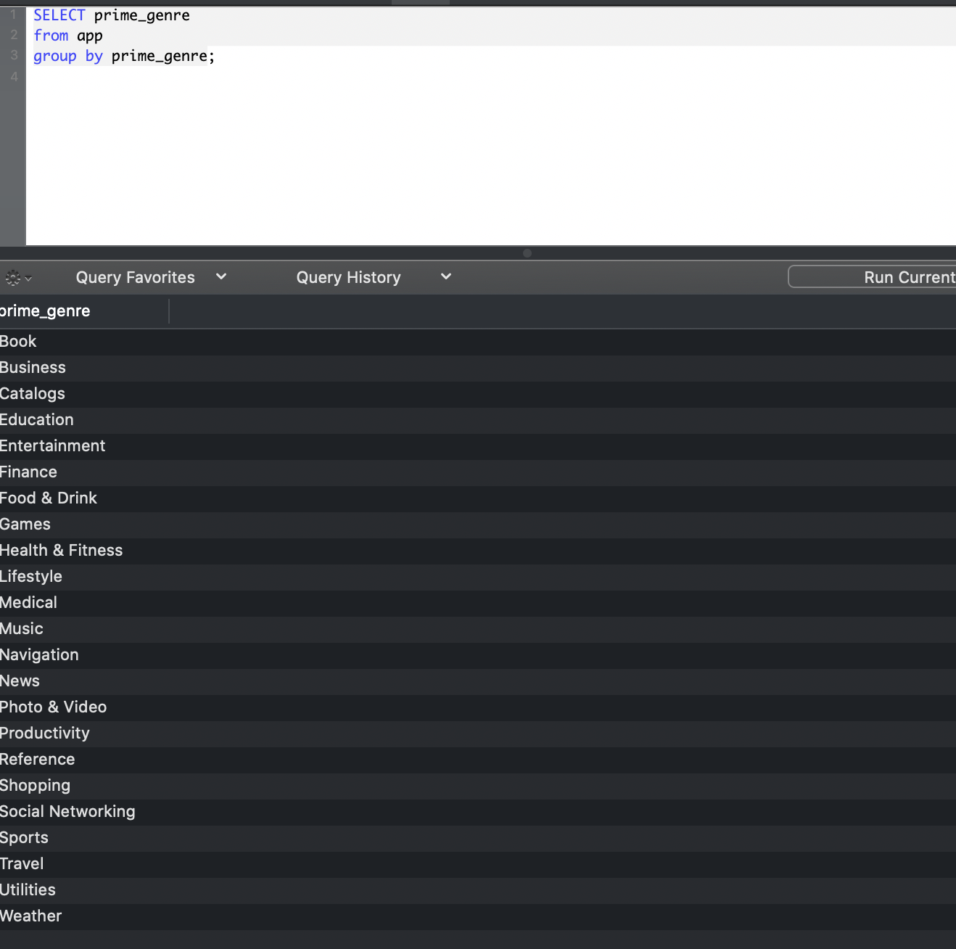

**2. Which is the genre with the most apps rated?**

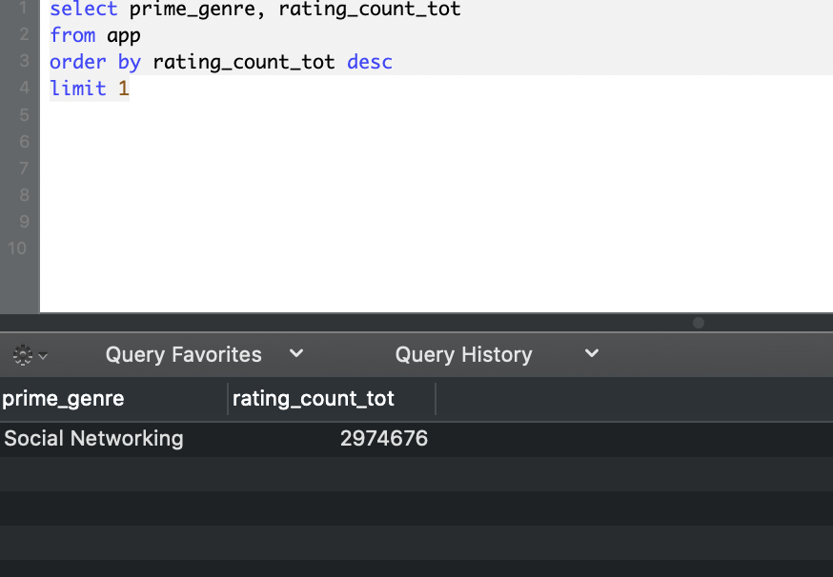

**3. Which is the genre with most apps?**

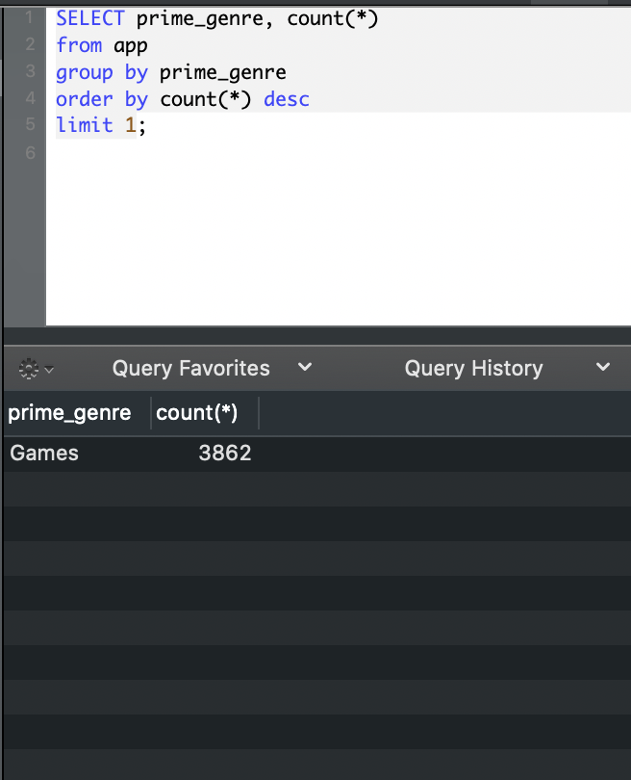

**4. Which is the one with least?**

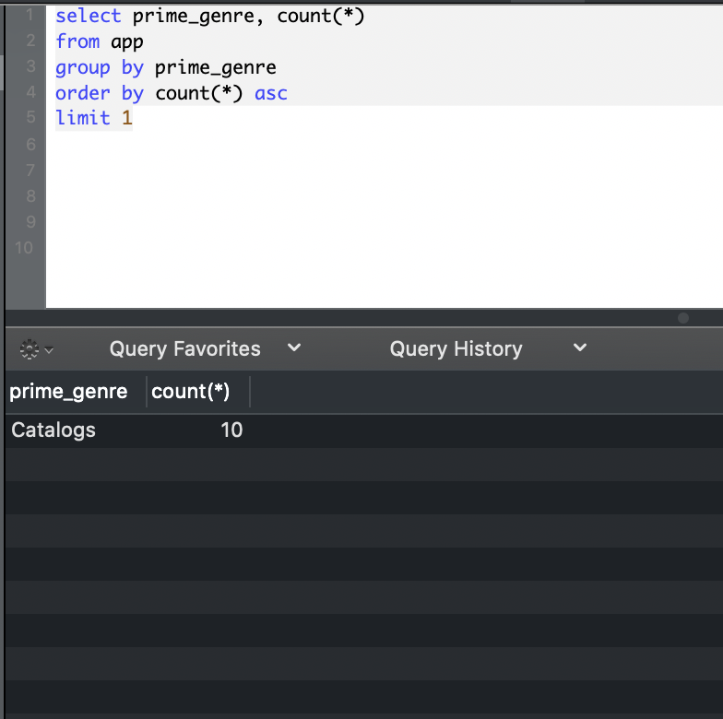

**5. Find the top 10 apps most rated.**

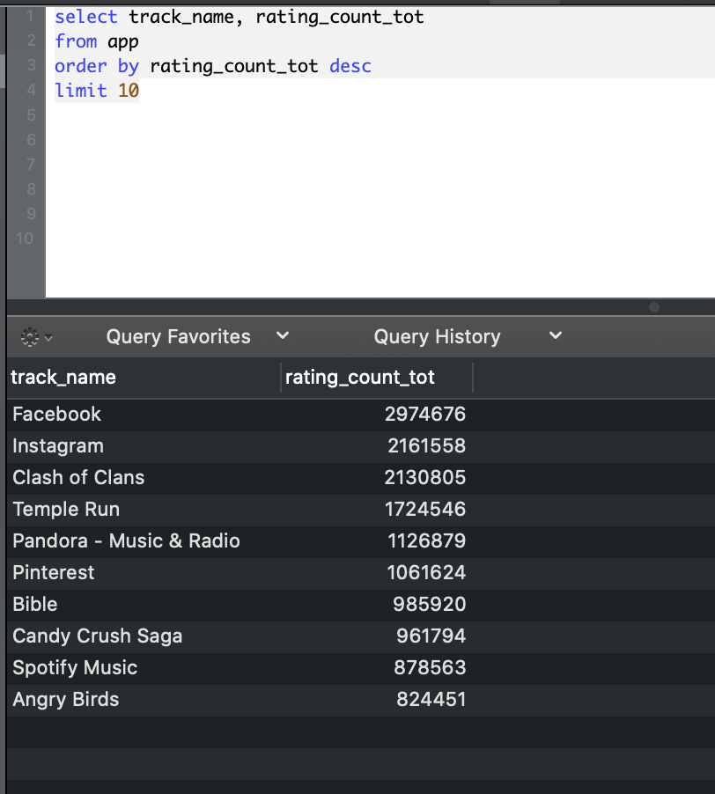

**6. Find the top 10 apps best rated by users.**

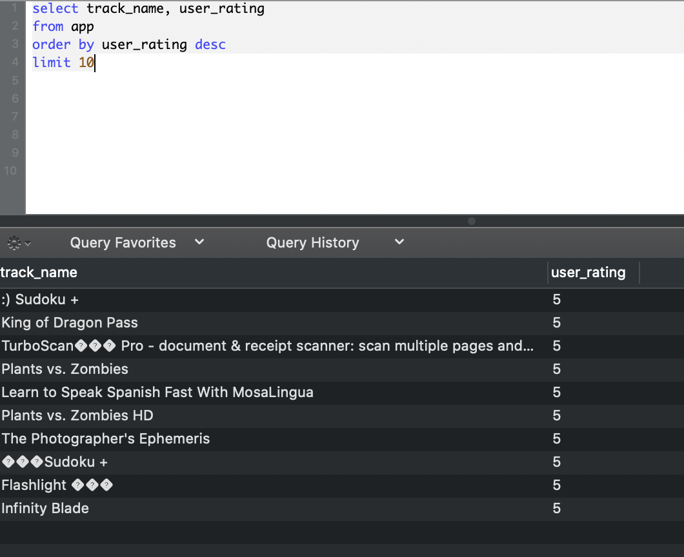

**7. Take a look at the data you retrieved in question 5. Give some insights.**

Social media apps (Facebook & Instagram) are most rated apps. Additionally, games are also very popular.

**8. Take a look at the data you retrieved in question 6. Give some insights.**

Highest rated apps in top 10 are Games.

**9. Now compare the data from questions 5 and 6. What do you see?**

The apps that are rated most are not rated highest.

It means that the most popular apps are not necessary voted high at the same time.

**10. How could you take the top 3 regarding both user ratings and number of votes?**

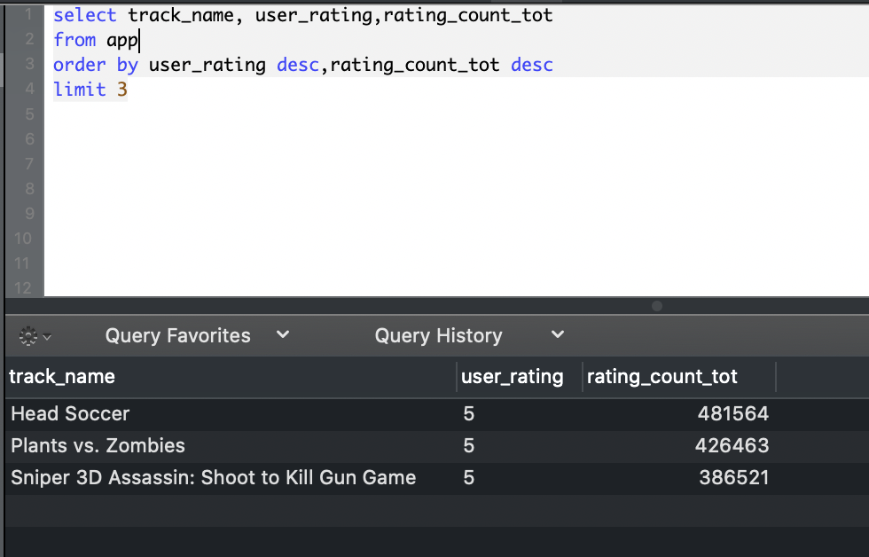

**11. Do people care about the price of an app?** **Do some queries, comment why are you doing them and the results you retrieve. What is your conclusion?**

YES, They care about the price

a. correlation between price and votes

conclusion

slightly negative correlation

people are more generous to give higher votes on free apps, more critical on paid apps.

|  |  |
| --- | --- |
| when price =0 | when price sorted from the most expensive downwards |
|  |  |

b. correlation between price and rating numbers

conclusion

strong positive correlation

People are more likely to give comments (download the app) when the app is free, and vice versa.

|  |  |
| --- | --- |
| when price =0 | when price sorted from the most expensive downwards |
|  |  |