Identification of a Quantitative Biomarker Derived From Urea Levels, Creatinine Levels, and BMI for End Stage Renal Disease Based on Common Clinical Features
Alabed Y
Abstract
End-stage renal disease (ESRD) is typically diagnosed using estimated glomerular filtration rate (eGFR), a late-stage indicator that offers limited capacity for early detection. This study investigated whether alternative clinical features and metabolomic data could reveal earlier biochemical signatures of renal deterioration. Principal Component Analysis (PCA) and Random Forest (RF) models were applied to both clinical and metabolomic datasets from Wang et al. (2020). Analysis of the full clinical dataset demonstrated perfect separation between ESRD and control groups driven almost entirely by eGFR, confirming its diagnostic dominance but highlighting the need for complementary biomarkers. When eGFR was removed, PCA revealed that the first principal component (PC1) captured a continuous gradient from healthy to diseased states primarily influenced by urea, creatinine and BMI. Dividing controls into PC1 quartiles showed steady increases in these variables, suggesting early biochemical changes before kidney function measurably declines. Metabolomic PCA and RF analyses showed broader variability and less informative separation, supporting the conclusion that clinical variables offer a more stable basis for early biomarker development. Collectively, these results propose PC1 as a potential quantitative biomarker representing gradual progression toward ESRD. Further prospective studies are required to validate whether PC1 provides earlier or more sensitive detection than eGFR and to determine its utility as a practical screening tool for identifying individuals at risk before irreversible renal damage occurs.

- Introduction
End stage renal disease (ESRD) represents one of the most severe public health challenges worldwide, leading to high rates of morbidity, mortality, and financial burden on healthcare systems. Each year more than 135,000 Americans are diagnosed with kidney failure (or ESRD) - an irreversible condition which is fatal without a kidney transplant or life sustaining dialysis treatment (1). Patients with ESRD often require dialysis or kidney transplant to survive, both of which are resource-intensive and carry their own risks. Both are also increasingly expensive with additional costs for dialysis and kidney transplant costing $87,538 and $124,271 respectively (5). There are many factors contributing to the global rise of this disease, namely diabetes and high blood pressure, and an aging population (2). These trends show no sign of slowing down, underscoring the importance of earlier detection strategies that intervene before patients reach the later stages of chronic kidney disease and develop end stage renal disease.

Despite advances in nephrology, current diagnostic approaches often detect ESRD only in its advanced stages, limiting opportunities for early intervention and prevention for a higher treatment success rate. Emerging research on the subject suggests that disruptions in the gut microbiota and host metabolome contribute to kidney dysfunction, potentially acting as biomarkers for disease detection. Common measurements clinicians rely on are serum creatinine, blood urea nitrogen, and eGFR. These biomarkers are quite useful, especially eGFR, however they have one main drawback being they only reveal substantial results once significant damage has already occurred, so patients are unable to receive treatment until it’s too late. In recent years, research has highlighted the importance of the gut microbiome and host metabolome in the development and progression of renal failure. It causes elevated production of bacteria-derived uremic toxins including indoxyl sulphate, p-cresyl sulphate, idole-3 acetic acid, TMAO, and phenylacetylglutamine (3). Blood uremic toxins are closely associated with the dysfunction of the intestinal epithelial barrier and can lead to the systematic translocation of endotoxins (3). A great example of this can be seen in Wang et al. (2020), a study that demonstrated that patients with ESRD showed signs of extreme alterations of gut microbiome compositions and metabolites compared to healthy controls. These findings suggest that metabolic products derived from the microbiota may directly influence kidney health, opening a range of possibilities for non-invasive biomarkers. However, even though these biological findings provide a strong basis for earlier detection, translating them into clinically actionable tools remains a major challenge. This gap creates a need for methods that can hadle complex, high-dimensional data and reveal patterns traditional diagnostics miss. This is where machine learning becomes a powerful solution.

Machine learning (ML) is a new and exciting approach to address this challenge. Unlike traditional methods, ML can uncover complex, nonlinear relationships that are very difficult to spot in datasets containing many features. The central premise of ML is that you optimize a model's performance on a dataset of tasks that adequately resemble the real-world problems it will be used for - through a process called model training - the model can make accurate predictions on the new data it sees in its ultimate use case (4). This makes it extremely suitable for biological data where there are many variables interacting with one another that are difficult to understand and analyze. In the past, previous uses of ML models in medicine have shown promising outcomes but most of these studies have relied on single categories of data, without incorporating metabolomic or microbiome information. The aim of this study is to firstly, determine whether an ML model can predict ESRD using only common clinical features of kidney health. Second, to test whether an ML model can predict ESRD metabolites detected in serum and feces. Third, to identify a biomarker other than eGFR that indicates progression towards ESRD. Throughout the study we used publicly available data from Wang et al. (2020), which provides both clinical and metabolomic data for both ESRD patients and healthy controls, allowing us to establish a clear difference between the two to build an ML model.

There are many future benefits of this research in clinical medicine. If ML models can integrate complex biological information and improve prediction of ESRD, they can form the basis and act as a blueprint of early detections used in primary care. These models might help identify at-risk patients’ years before ESRD develops, allowing preventative strategies to be implemented sooner. They could also enable personalized medicine by tailoring interventions to an individual’s specific metabolic and microbial profile. Furthermore, integration into electronic health records could help facilitate population-wide screening programs.
In summary, ESRD remains a major global health concern and new approaches are needed to improve early detection. This study seeks to evaluate whether such an approach can improve predictive accuracy and, if so, lay the groundwork for future applications in diagnostics, personalized care, and healthcare planning.

- Methods

The dataset used in this study was obtained from Wang et al. (2020) deposited in the MetaboLights repository. This dataset included both human and rodent samples; for the purposes of this analysis, only the human cohort was considered. The human dataset contains clinical information, serum and fecal metabolomics data, and gut microbiome sequencing profiles from patients with ESRD and healthy control subjects. The data includes demographic variables such as age and sex, as well as other clinical variables such as creatinine levels and eGFR. Before analysing the data, it was subjected to data cleaning and preprocessing to ensure it was suitable to be used in Principal Component Analysis (PCA) and for Random Forest (RF) Classification. Clinical features previously mentioned were standardized to ensure consistent units across subjects. Any patients with missing data were excluded to maintain the integrity of the dataset. Metabolomic data was scaled for PCA.

Due of the high dimensionality of metabolomics and microbiome data, PCA was applied to reduce feature space and highlight key patterns. PCA was used both as an exploratory tool, to visualize clustering between ESRD patients and controls. The usage of PCA allowed us to determine which factor was the main differentiation between patients with ESRD and healthy controls.

RF models were evaluated for accuracy, specificity, and sensitivity across three datasets: clinical data, clinical data with eGFR removed, and metabolomic data. Their performance was compared using the ROC AUC, which measures how well each model distinguishes ESRD patients from controls across varying classification thresholds. The 3 models were compared to determine which model was most accurate.
The coding language used for the project was Python 3.13.5, Random Forest was done using the SciKit Learn library. The pandas library was used for data cleaning and PCA, and the data was visualized into a graph using python's built-in functions

- Results

This study applied PCA and RF models to both the clinical and metabolomic datasets obtained from the Wang et al. (2020) study in order to identify potential early biomarkers distinguishing ESRD patients from controls.

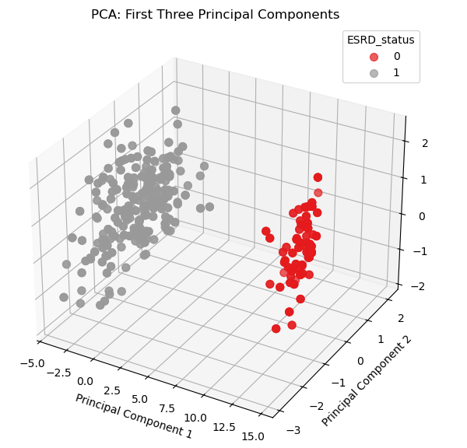
Figure 1a. 3D PCA score plot illustrating separation between ESRD and control samples.

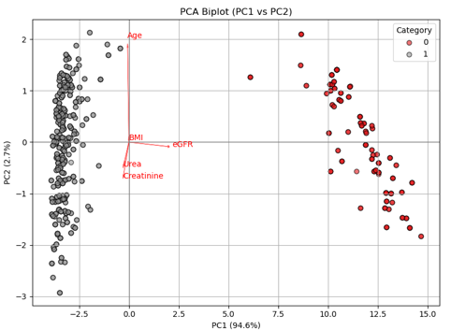
Figure 1b. PCA biplot illustrating sample separation and variable loading for PC1 and PC2.

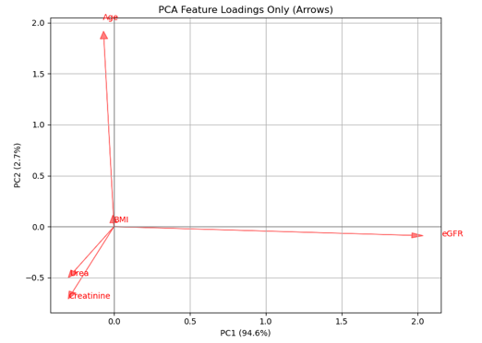
Figure 1c. PCA loading plot illustrating the contributions of clinical variables to PC1 and PC2.
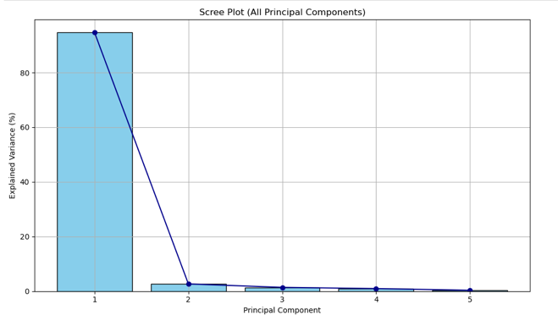
Figure 1d. Scree plot illustrating the explained variance of all principal components

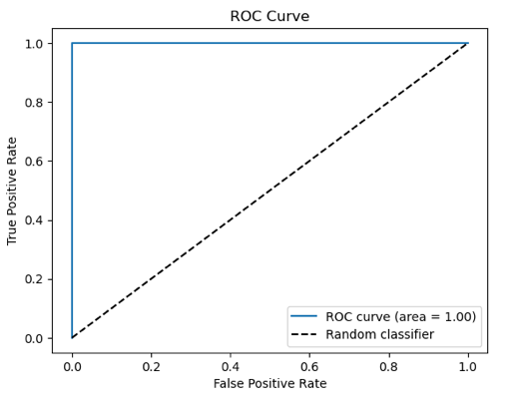
accuracy = 1.0
specificity = 1.0
sensitivity = 1.0

Creatinine 0.444408
eGFR 0.348655
Urea 0.201992
Age 0.003044
BMI 0.001901

Figure 1e. ROC curve and model performance metrics for classification of ESRD versus control samples.

3.1 Clinical data
Analysis of the full clinical dataset revealed a perfect separation between ESRD and control patients. The RF model shown in Figure 1e achieved 100% classification accuracy, with eGFR overwhelmingly dominating the feature importance ranking. Specifically, eGFR accounted for a large amount of total model importance (see figure 1e), while markers such as BMI and urea had only marginal influence. This result reflects eGFR’s established clinical reliability as the primary indicator of renal function and disease severity.

The PCA further supported this outcome. Projection of the clinical data into principal component space revealed a clear division along the first principal component (PC1) (see Figure 1b), which explained approximately 72% of total variance. ESRD samples were tightly clustered at low PC1 values, whereas control samples occupied higher PC1 regions, almost mirroring the decline in renal filtration capabilities in advanced kidney failure. The second and third components captured minimal additional variance, confirming what was believed to be true based off the RF model; the dataset’s variance stemmed almost entirely from eGFR rates.

Visual inspection of the PCA biplot (see Figure 1b) showed that the eGFR vector was strongly aligned with the first principal component (PC1), confirming that it was the main factor separating ESRD and control samples. Other biochemical markers had minimal influence on the clustering pattern. The tight grouping of ESRD reflected the similarity of patients with advanced diseases, those who suffered from these diseases experienced similar levels of certain biomarkers, whereas, in control samples, results were more spread out. These results confirm that the analysis worked correctly and that the dataset was consistent, but they also reveal a key limitation, one that would lead to the further scope of my research. The model’s perfect 100% accuracy relied on eGFR, which is already a very well-known and often used primary diagnostic measure (6). Therefore, including eGFR proves that the method is valid, but it does not help identify new or early-stage biomarkers for predicting ESRD.

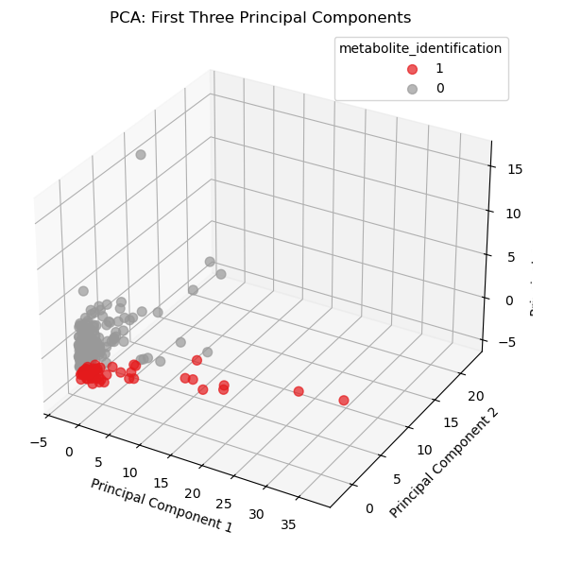
Figure 2a. 3D PCA score plot of metabolic data showing separation between ESRD and control samples.

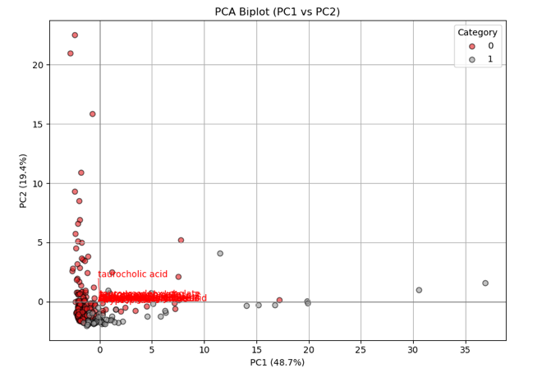
Figure 2b. PCA biplot showing sample distribution and metabolite loadings across PC1 and PC2.

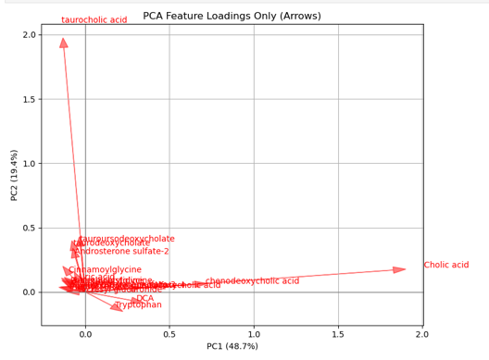
Figure 2c. PCA loading plot showing the contributions of individual metabolites.

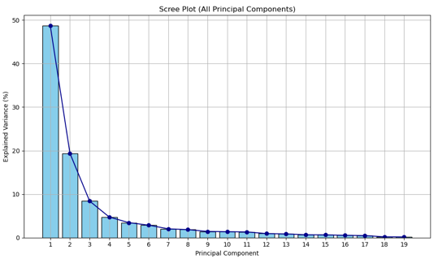
Figure 2d. Scree plot showing explained variance across all principal components in the metabolomic dataset.

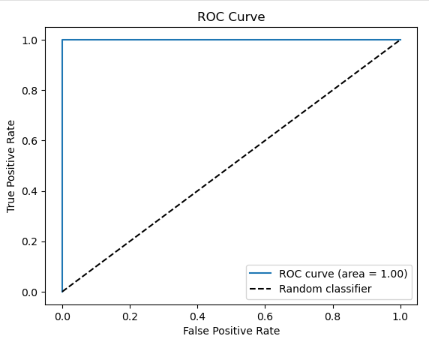
accuracy = 1.0
specificity = 1.0
sensitivity = 1.0

Creatinine 0.281355
Tryptophan 0.177866
Phenylacetylglycine 0.149405
P-cresyl glucuronide 0.104918
Phenyl sulfate 0.104796
Cinnamoylglycine 0.083617
3-Methylhistidine 0.034655
DCA 0.022261

Figure 2e. ROC curve and performace metrics for the metabolomic classifier distinguishing ESRD and control samples.

3.2 Metabolomic data
After discovering the key limitation of a model that includes eGFR, the next step was to complete an analysis of the metabolic dataset, and the results revealed a markedly different outcome from the clinical results. When PCA was applied (see figure 1a) to quantified metabolite levels, there was some clustering visible between ESRD and control groups across the first 3 principal components; however it wasn’t as clean as the clustering between the clinical data and didn’t provide as large of a gap. The variance explained by the first 3 PCs was under 40%, indicating that the majority of variance was dispersed across numerous low-importance metabolites. The Random Forest classifier based on serum metabolites performed at 100% accuracy (see figure 1e), the most likely reason for this being that a large majority of the metabolites in discussion were also as a direct result of ESRD status. This implies that relying solely on metabolomic features may, in fact, provide a considerable degree of discriminatory ability, although the extent and practical relevance of this distinction remain somewhat unclear and the data isn’t as informative.

Additionally, the PCA biplot (see Figure 2b) reinforces this observation by showing a reasonably distinct separation between ESRD and control samples based solely on metabolomic variables. This suggests a stronger discriminatory capacity than initially expected. However, despite this apparent separation, the result offers limited interpretative value because it does not provide meaningful biological insight or enhance the overall contribution of the metabolomic analysis to the paper.

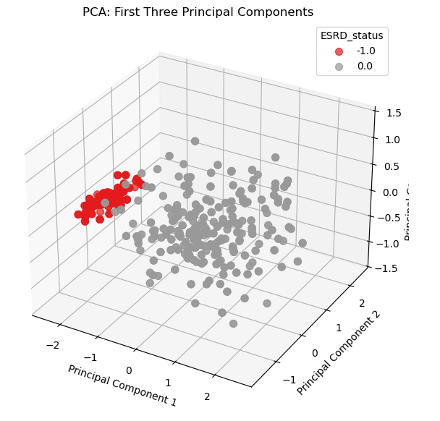
Figure 3a. 3D PCA score plot of clinical features (excluding eGFR) showing clustering of ESRD and control samples

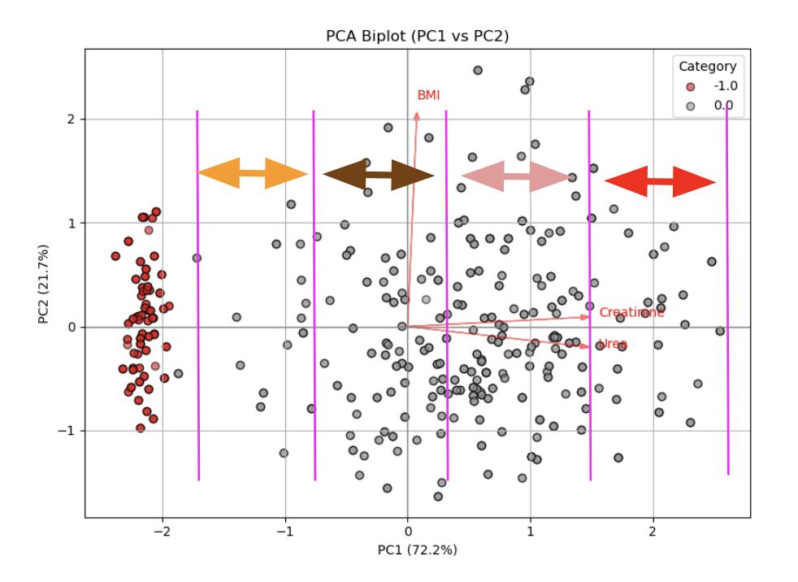
Figure 3b. PCA biplot (PC1-PC2) of eGFR-excluded clinical dataset with quartile boundaries and loading vectors.

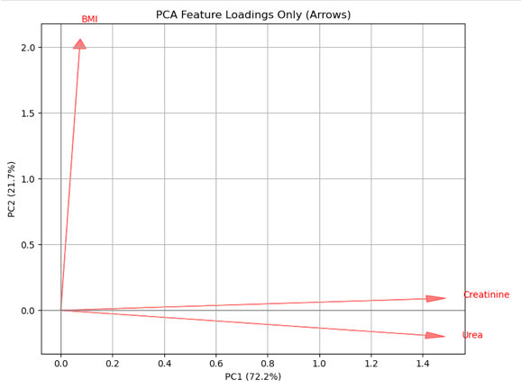
Figure 3c. PCA loading plot illustrating the contribution of BMI, creatinine, and urea to PC1 and PC2 in the eGFR-excluded dataset

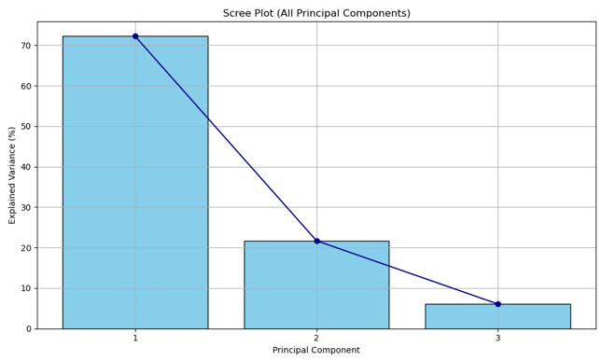
Figure 3d. Scree plot showing explaied variance for principal comonents of the eGFR-excluded clinical dataset

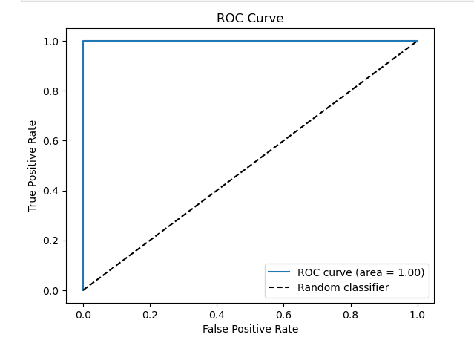
accuracy = 1.0
specificity = 1.0
sensitivity = 1.0

Urea 0.518028
Creatinine 0.460581
BMI 0.021391

Figure 3e. ROC curve and performance metrics for the clinical classifier using urea, creatinine and BMI.

3.3 Clinical data without eGFR
These findings align with prior studies (8) reporting that global metabolomic signatures in kidney disease often exhibit patient diversity rather than discrete clustering. While the metabolomic data confirm the presence of metabolic dysregulation, the absence of clear statistical segregation highlights the challenge of identifying reliable biomarkers for ESRD. This result therefore motivated further analysis of the clinical dataset excluding eGFR, to assess whether subtler patterns might emerge once the highly dominant renal filtration signal was removed.

The decision to remove eGFR was driven by the central aim of the study: to determine whether commonly collected clinical features, specifically urea, creatinine and BMI, could form together to form a quantitative biomarker capable of distinguishing ESRD patients from healthy controls. Since eGFR dominated both the variance structure made by PCA analysis and the RF classification accuracy, its presence prevented meaningful evaluation of these secondary features. In other words, as long as an already clinically important primary feature (6) remained in the model, it was impossible to assess whether other clinical features (urea, creatinine or BMI) contributed any independent discriminatory value. Excluding eGFR was therefore essential to reveal whether these routinely measured parameters contain underlying patterns relevant to ESRD identification, particularly at earlier or less clinically obvious stages of renal decline.

When eGFR was excluded from the clinical dataset, the landscape changed dramatically. The PCA biplot (see figure 3b) showed that while ESRD samples remained clusters within a distinct region of principal-component space, control samples became more dispersed, suggesting greater metabolic and biochemical variability within the healthy cohort (Figure 3d). To further investigate this, the PCA-transformed control samples were isolated and analysed separately, allowing clearer interpretation of feature loadings. The first principal component from this joint transformation of ESRD and control samples, without eGFR, appeared to capture a continuous gradient rather than a binary separation. This finding led to the hypothesis that this gradient likely represents a progression towards renal dysfunction, perhaps driven by subtle shifts in secondary biomarks instead of the stark division produced by eGFR itself.

The models (see Figure 3e) indicated that urea, creatinine, and BMI were the main contributors to PC1, together explaining over 70% of the variance. This aligns with known physiological relationships, as both urea and creatinine rise progressively as renal systems start to fail, while BMI can influence serum composition. The RF model reinforced these findings, the model achieved 100% accuracy using only these features, indicating that even without eGFR, there is still a clinically meaningful structure present.

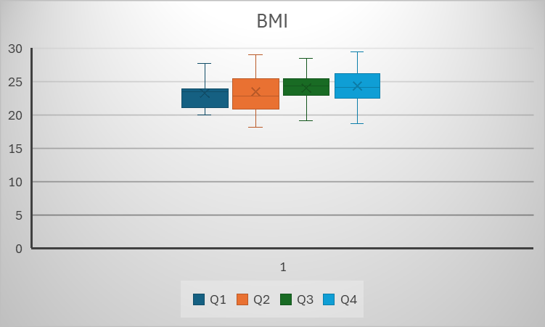
Figure 4a. Box-and-whisker plot showing BMI distributions across PC1-based quartiles in the eGFR excluded clinical dataset.

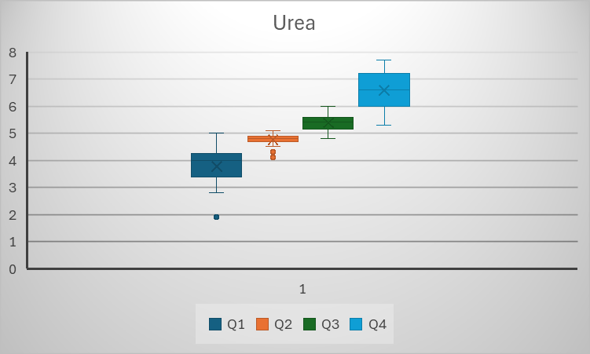
Figure 4b. Box-and-whisker plot showing urea distributions across PC1-based quartiles in the eGFR excluded clinical dataset.

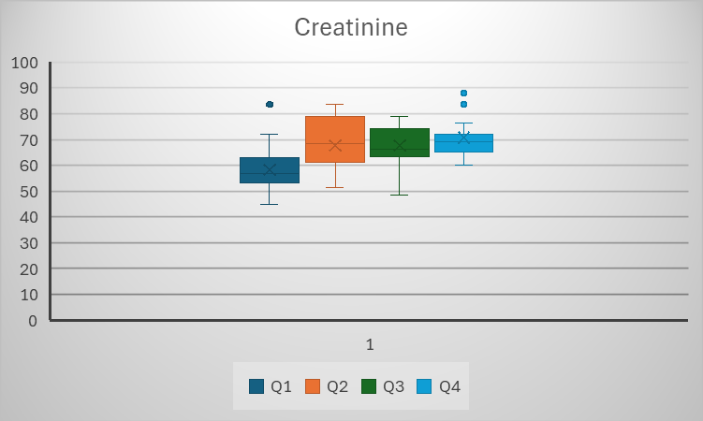
Figure 4c. Box-and-whisker plot showing creatinine distributions across PC1-based quartiles in the eGFR excluded clinical dataset.
To validate the PCA interpretation, box-and-whisker plots were generated for the top three features identified in the biplot (Figures 4a, 4b and 4c). The control patients in the study were separated into 4 quartiles a total of three times, one for each of the three most significant features once eGFR was removed (urea, creatinine and BMI). The box-and-whisker plots were then created based off of this data. As shown in Figures 4b and 4c, urea and creatinine displayed clear upward trends across quartiles of the control group, supporting the idea that these markers form a continuum reflecting early kidney function decline. Together, these results suggest that PC1, without the usage of eGFR, is a potential biomarker that captures the transition from healthy to dysfunctional renal status.

- Analysis and reasoning

The first stage of analysis, which included all clinical variables such as the eGFR, produced a model with perfect accuracy. Both the PCA and RF showed that eGFR completely dominated the dataset’s variation and predictive strength. This was expected because eGFR is the most reliable and widely used measure of kidney function (7). However, it also revealed a key limitation. Since eGFR is such a strong indicator, it overshadowed all the other clinical variables such as creatinine, urea, and body mass index (BMI). As a result, the model was not discovering anything new but was simply replicating existing medical knowledge that eGFR alone can separate healthy patients from those with kidney disease.

To explore whether there were hidden patterns that could reveal earlier clinical change it was best to remove eGFR from the dataset. This decision aimed to test if other clinical variables could still show meaningful structure when eGFR was excluded. Doing so forced the PCA to reorganise how it explained the variance, allowing new relationships between smaller variables to surface.

After eGFR was removed, the results changed in an interesting way. The first principal component (PC1) continued to explain most of the variance between healthy and diseased patients (see figure 3b). Along PC1, the control group formed a continuous gradient that appeared to exhibit a gradual transition in kidney health status. ESRD patients clustered tightly at one end of the axis, while the control group spread across the rest of it. The loadings showed that urea, creatinine, and BMI were the strongest contributors to this new component. These markers are biologically linked to kidney function, so it made sense that together they might represent a more subtle form of metabolic change related to early renal decline.

This observation led me to interpret PC1 as more than just a mathematical dimension; it might represent a biological process. Because urea and creatinine increase as kidney filtration worsens, their strong influence on PC1 suggested that the component was summarising the biochemical pathway of renal stress. The wider spread among the control samples suggested something even more intriguing: even among people considered healthy, there appeared to be internal variation that could represent early or preclinical stages of kidney stress that standard eGFR testing would not yet detect.

To evaluate whether the gradient observed along PC1 carried biological significance, the control cohort was stratified into quartiles according to their PC1 scores (see figures 4a, 4b and 4c). This stratification enabled examination of whether subtle, internally ordered variation existed even within the healthy groups. By comparing urea, creatinine and BMI across these quartiles, a clear stepwise pattern emerged: individuals in higher PC1 quartiles consistently showed marginally elevated values relative to those in lower quartiles. Rather than merely reiterating expected trends, this quartile-based analysis demonstrated that the variation captured by PC1 may reflect early changes in kidney function that occur before the disease becomes noticeable. In this sense, dividing the control samples into quartiles provided evidence that the underlying structure of the dataset captures a continuum of renal function, suggesting these changes could be detected before ESRD becomes clinically noticeable and can be diagnosed by doctors.

From this, I developed a new hypothesis: PC1, created from both healthy and ESRD patients but without eGFR, acts as a biomarker representing progression toward kidney disease. This means PC1 could reflect stages of biochemical change that occur long before eGFR starts to fall. Each quartile within the control group could represent one of these early stages, moving step by step from normal metabolism (Q1) toward early dysfunction (Q4), and eventually reaching ESRD. If this pattern holds true in larger studies, it suggests that kidney decline may not be a sudden event but a gradual, measurable continuum that can be tracked through biochemical variation.

This difference between PC1 and eGFR is key. eGFR is a single calculated value that estimates kidney filtration ability at one point in time. It works well for diagnosis but only shows change after significant damage has already occurred. PC1, however, combines small changes from several biochemical measures into one continuous value. It does not classify patients into fixed categories but instead, shows their position along a spectrum of renal progression. In this sense, PC1 might detect the beginnings of kidney stress that eGFR cannot yet measure.

The strength of this finding lies in how PCA combines weak signals into a stronger, more reliable indicator. Each marker on its own, such as urea or BMI, might not provide much information, but together they create a clearer picture of how kidney health changes over time. By examining variation across PC1 and splitting the data into quartiles, it became possible to see that there may be multiple biochemical stages between being fully healthy and developing ESRD.

In conclusion, removing eGFR transformed the analysis from confirming a known medical test into uncovering a new way of understanding kidney disease progression. The results suggest that PC1 captures a gradual biochemical shift from health to disease, with each quartile representing a potential stage along that path. eGFR remains an important diagnostic tool that tells us when kidney function has fallen below normal, but PC1 might show how that decline begins and develops. This makes PC1 a promising continuous biomarker for identifying early risk and understanding the subtle, stepwise changes that lead to ESRD. Future research using larger datasets and longitudinal tracking could confirm whether shifts along PC1 consistently predict later drops in eGFR, opening a new window into early detection and prevention of kidney disease.

Finally, the clinical implications of these findings are substantial. ESRD is typically diagnosed only after substantial, often irreversible loss of kidney function, at which point patients require dialysis or transplantation, both resource-intensive treatments associated with high morbidity, reduced quality of life, and heavy healthcare costs (5). Current diagnostic pathways rely heavily on eGFR, which is highly accurate at identifying advanced disease but is relatively insensitive to early or intermediate decline in renal function. By contrast, the quantitative biomarker proposed in this study - derived from routine measurements of urea, creatinine and BMI - offers a potential means of identifying risk at a much earlier stage. Detecting subtle physiological shifts before eGFR falls allows clinicians to intervene with preventative measures, slow disease progression, optimize patient monitoring, and potentially delay or even avoid the transition to ESRD. which could save hundreds of thousands of lives each year. In practice, such an early-stage biomarker could transform ESRD management from a reactive model centred on late-stage treatment to a proactive framework focused on early identification, prevention and targeted care.

- Conclusion & Scope for Future Study
This study explored new ways to interpret kidney function beyond the conventional dependence on eGFR by analysing both clinical and metabolomic datasets using PCA and Random Forest models. Removing eGFR from the clinical dataset uncovered patterns that were previously obscured; the first principal component (PC1) emerged as a strong continuous gradient separating healthy individuals from ESRD patients. This gradient was primarily driven by urea, creatinine and BMI, variables routinely collected in clinical practice but typically overshadowed by the dominant diagnostic role of eGFR. Their combined influence suggests that subtle biochemical changes associated with early renal impairment may be detectable before eGFR begins to fall.
Dividing the control group into quartiles along PC1 revealed that even within individuals classified as “healthy” there were consistent upward shifts in urea and creatinine levels. This suggests there are early changes that happen before the kidneys lose measurable filtering ability. The quartile analysis therefore supports the interpretation of PC1 not as a binary classifier, but as a marker of gradual deterioration offering insight into metabolic changes that occur before the onset of clinically recognisable kidney disease. These results led to the hypothesis that PC1 could serve as a quantitative biomarker reflecting underlying progression toward renal dysfunction.
Further research is needed to evaluate whether a PC1-derived biomarker provides meaningful clinical improvement over eGFR alone. Prospective patient studies comparing the predictive performance of both markers would be essential particularly to assess whether PC1 can detect early-stage kidney disease more reliably or earlier in the disease timeline. Determining the sensitivity, specificity and temporal advantage of PC1 relative to eGFR will clarify whether this technique represents a useful early diagnostic tool or whether eGFR remains the superior and more practical biomarker in clinical settings.

- References

(1) Kidney Care Partners. (n.d.). Kidney Disease. [online] Available at: https://kidneycarepartners.org/kidney-disease/.

(2) Rout, P. and Aslam, A. (2025). End-Stage Renal Disease. [online] National Library of Medicine. Available at: https://www.ncbi.nlm.nih.gov/books/NBK499861/.

(3) Chen, Y.-Y., Chen, D.-Q., Chen, L., Liu, J.-R., Vaziri, N.D., Guo, Y. and Zhao, Y.-Y. (2019). Microbiome–metabolome reveals the contribution of gut–kidney axis on kidney disease. Journal of Translational Medicine, 17(1). doi:https://doi.org/10.1186/s12967-018-1756-4.

(4) IBM (2021). What Is Machine learning? [online] IBM. Available at: https://www.ibm.com/think/topics/machine-learning.

‌(5) Keith A. Betts, P., Song, J., Faust, E., Yang, K., Du, Y., Sheldon X. Kong, P. and Singh, R. (2021). Medical Costs for Managing Chronic Kidney Disease and Related Complications in Patients With Chronic Kidney Disease and Type 2 Diabetes. Supplements and Featured Publications, [online] 27(20). Available at: https://www.ajmc.com/view/medical-costs-for-managing-chronic-kidney-disease-and-related-complications-in-patients-with-chronic-kidney-disease-and-type-2-diabetes.

‌(6) Johnson, D.W., Jones, G., Becker, G.J. and Mathew, T.H. (2009). Automated reporting of eGFR: a useful tool for identifying and managing kidney disease. Medical Journal of Australia, 190(4), pp.200–203. doi:https://doi.org/10.5694/j.1326-5377.2009.tb02349

(7) UK Kidney Association. (2021). Measurement of kidney function. [online] Available at: https://www.ukkidney.org/health-professionals/information-resources/uk-eckd-guide/measurement-kidney-function.

(8) D-Serine reflects kidney function and diseases by A Hesaka et al., published in Scientific Reports, 2019 — link: https://www.nature.com/articles/s41598-019-41608-0

