**RELIGIOUS AND MORAL EDUCATION**

**2016/17**

**SCHOOL BASED ASSESSMENT-2017**

**END OF THIRD TERM EXAMINATION**

1. Colour the picture that shows good emotions yellow and bad red.

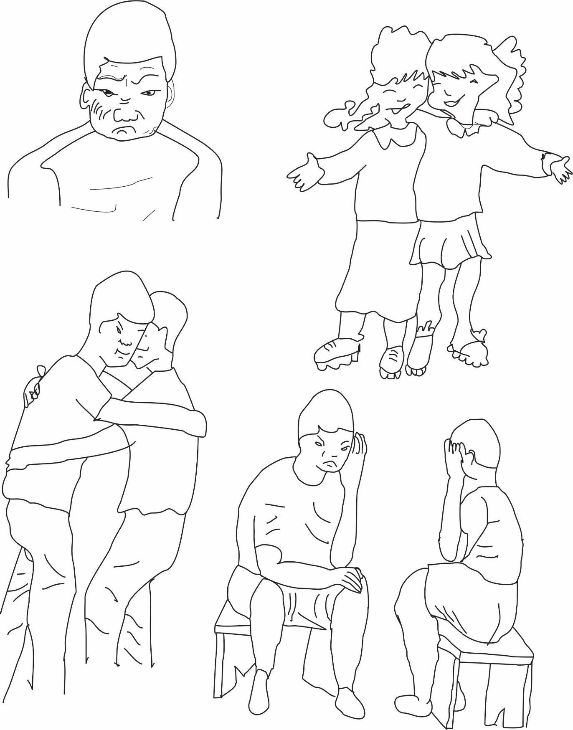

1. Colour the activity that show what a Christian family will do.

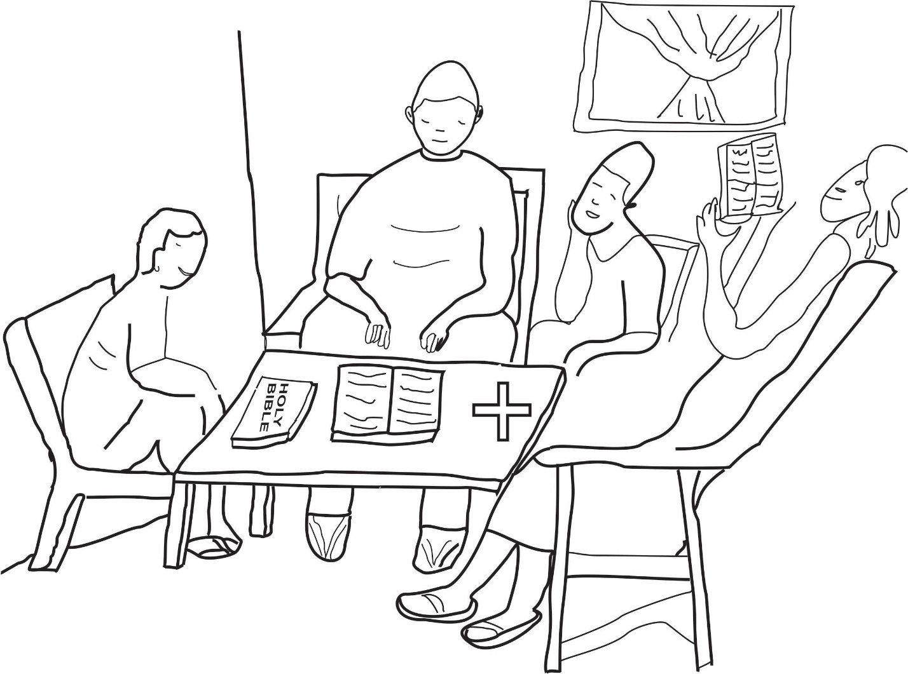

1. Draw and color one (1) object of worship used by traditional worshippers.

|  |
| --- |
|  |

1. Draw and colour the HOLY BIBLE and the QURAN.

|  |
| --- |
|  |