WTG scaling law
Yusik Kim
Yusik.kim.work@outlook.com

This report describes scaling analyses of wind turbine generator (WTG). Major components of WTG are geometrically similar, and thus their weight would follow power law scaring. The purpose of this report to find the power law relation based on the parameters readily available in public, i.e. rated power, rotor diameter, hub height.
The derived scaling laws are verified against publicly available WTG data.

Applications of this study include:
- Retrofit modeling for operating turbines where full WTG are is often unavailable.
- ILA for pre-FEED before where WTG supplier has not been selected.
- Owner’s Engineering for WTG specifications

- Tower
Tower scaling derivation starts with
- Tower base moment: $M \sim TH$ (1)
- Rotor thrust scaling: $T\sim P^{\frac{2}{3}}$ (2)
Where $P$ is the rated power, $H$ is the hub height. This leads to
$$M\sim P^{2/3}H$$

For geometrically similar tubular tower,
- $\dot{m}\sim D^{2}$
- $I\sim D^{4}$
Where $\dot{m}$=mass per unit length, $I$=moment of inertia $D$= the tower diameter.

Bending moment curvature relation: $M=kEI$
Where $k$=curvature. With the similarities above at given $k$,
- $M\sim I\sim D^{4}\sim {\dot{m}}^{2}$ (3)

Combining (1)-(3), ${\dot{m}}^{2}\sim P^{2/3}H$ and then
- $\dot{m}\sim P^{1/3}H^{1/2}$ (4)

Total tower mass $m\sim \dot{m}H$, and then finally,
- $m\sim P^{1/3}H^{3/2}$ (5)

The below figure shows the scaling for tower mass. Public turbine data fairly follows the linear line.
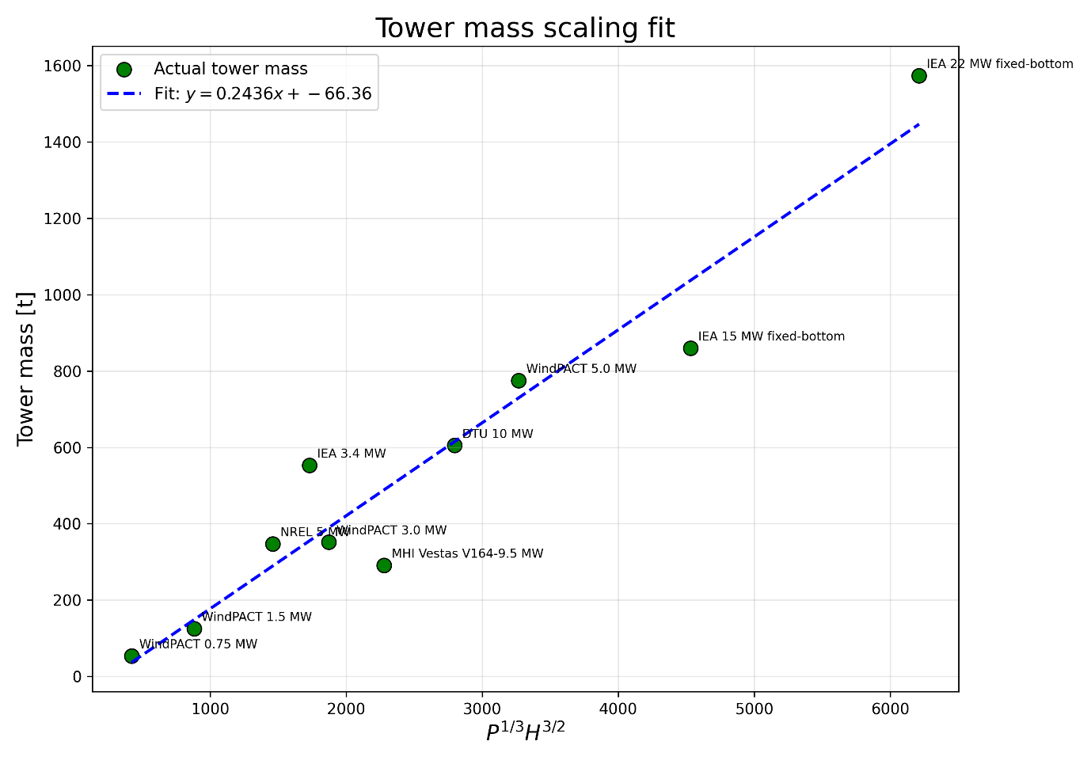

- Blade
Blade scaling derivation follows the nearly the same process as tower:

- $M_{b}\sim TR$ (1)
- $T\sim P^{2/3}$ (2)
Where $M_{b}$=blade root bending moment, $R$=rotor radius, $T$=rotor thrust, $P$=rated power

For gemoetricaly similar blades,
- $\dot{m} \sim d^{2}$
- $EI\sim d^{4}$
Where $\dot{m}$=mass per unit length, $E$= Young’s modulus, $I$=moment of inertia, $d$=blade root diameter

Bending moment curvature relation: $M_{b}=kEI$
Where $k$=curvature. With the similarities above at given $k$,
- $M_{b}\sim EI\sim d^{4}\sim {\dot{m}}^{2}$ (3)

Combining (1)-(3), ${\dot{m}}^{2}\sim P^{2/3}R$ and then
- $\dot{m}\sim P^{1/3}R^{1/2}$ (4)

Generally, blade mass would be $m=\int_{0}^{R}{\dot{m}dr}$. For scaling purpose, I set a hypothetical uniform blade which has effectively the same load and mass as the full blade. Then $\dot{m}$ of the uniform blade can be taken out from the integral. And the total mass is now proportional with the effective radius:
- $m=\dot{m}R_{eff}$. (5)
$R_{eff}$ varies depending on how load distributed along the blade and thrust density, $T/A$, would be indicative for the load distribution. Therefore, I set $R_{eff}=r_{st}R$

Where $r_{st}$ is specific thrust ratio $r_{st}=\left(\frac{{P_{target}^{2/3}}/{A_{target}}}{{P_{base}^{2/3}}/{A_{base}}}\right)$, $A$=swept area. Here $P^{2/3}$ is adopted instead of T. This is because peak T is sensitive to the controller tuning and P is more available in public.
Finally, combining (4) and (5):
$$m\sim r_{st}P^{1/3}R^{3/2}$$

For large offshore turbines, near the blade tip area is unloaded for the tower clearance. Such a change would be effectively covered via $r_{st}$ so that the scaling law above covers various load strategy of both on- and offshore blades.

The figure below shows the blade mass scaling. All blade data show very good linear relation considering weight ranges more than 40 times.
