实验三：多边形填充算法的实现
一、实验目的
1、掌握多边形有效边表填充算法；
2、掌握种子填充算法。

二、实验要求
1. 在MFC单文档应用程序中，利用MFC应用程序向导生成完整的应用程序基本框架，添加“图形填充”菜单，在“图形填充”菜单下添加“有效边表法”子菜单，如图1.1所示，对应五边形有效边表填充算法，顶点坐标不限，颜色为红色。

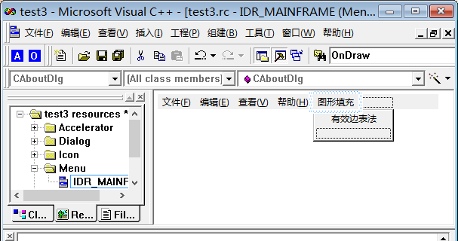
图1.1 菜单示例图

2. 在上题基础上，在“图形填充”菜单下再添加一个“种子填充法”子菜单，如图2.1所示，利用种子填充算法填充长方形，长方形由Rectangle函数生成，长方形左上顶点和右下顶点坐标以及种子点坐标由对话框实现输入，颜色不要求，如图2.2所示。

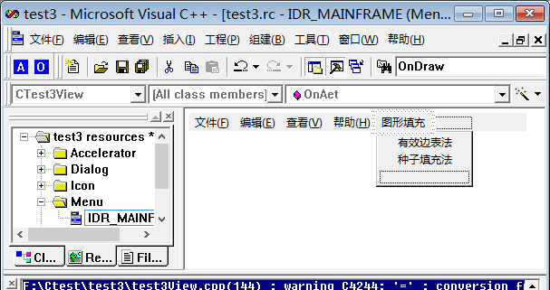
图2.1菜单示例图

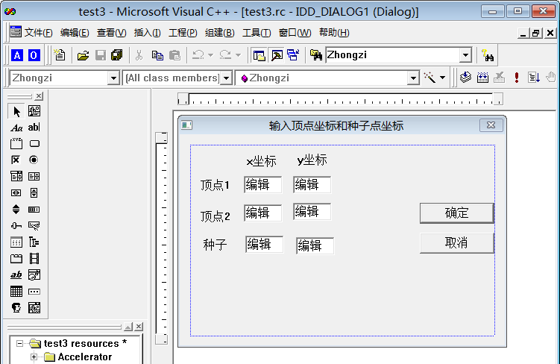
图2.2对话框示意图

- 实验内容
1、void CMFCApplication3View::OnPolyScan() {
CDC* pDC = GetDC();
point polypoint[POINTNUM] = { 370,10,560,100,560,200,430,130,340,170,340,80 };//多边形顶点
int MaxY = 0;
int MinY = 2000;
int i;
for (i = 0; i < POINTNUM; i++) {
if (polypoint[i].y > MaxY)
MaxY = polypoint[i].y;
if (polypoint[i].y < MinY)
MinY = polypoint[i].y;
}

/*******初始化AET表，即初始化活跃边表**********/
AET* pAET = new AET;
pAET->next = NULL;

/******初始化NET表，即初始化边表***************/
NET* pNET[1024];
for (i = MinY; i <= MaxY; ++i) {
pNET[i] = new NET;
pNET[i]->next = NULL;
}

/******扫描并建立NET表，即建立边表***************/
for (i = MinY; i <= MaxY; ++i) {
for (int j = 0; j < POINTNUM; ++j) {
if (polypoint[j].y == i) {
if (polypoint[(j - 1 + POINTNUM) % POINTNUM].y > polypoint[j].y) {
NET* p = new NET;
p->x = polypoint[j].x;
p->ymax = polypoint[(j - 1 + POINTNUM) % POINTNUM].y;
p->dx = (polypoint[(j - 1 + POINTNUM) % POINTNUM].x - polypoint[j].x) / (polypoint[(j - 1 + POINTNUM) % POINTNUM].y - polypoint[j].y);
p->next = pNET[i]->next;
pNET[i]->next = p;
}

if (polypoint[(j + 1 + POINTNUM) % POINTNUM].y > polypoint[j].y) {
NET* p = new NET;
p->x = polypoint[j].x;
p->ymax = polypoint[(j + 1 + POINTNUM) % POINTNUM].y;
p->dx = (polypoint[(j + 1 + POINTNUM) % POINTNUM].x - polypoint[j].x) / (polypoint[(j + 1 + POINTNUM) % POINTNUM].y - polypoint[j].y);
p->next = pNET[i]->next;
pNET[i]->next = p;
}
}
}
}

/******建立并更新活性边表AET***********************/
for (i = MinY; i <= MaxY; ++i) {
//计算新的交点x,更新AET***************************/
NET* p = pAET->next;
while (p != NULL) {
p->x = p->x + p->dx;
p = p->next;
}

//更新后新AET先排序***************************/
//断表排序,不再开辟空间
AET* tq = pAET;
p = pAET->next;
tq->next = NULL;

while (p != NULL) {
while (tq->next != NULL && p->x >= tq->next->x)
tq = tq->next;
NET* s = p->next;
p->next = tq->next;
tq->next = p;
p = s;
tq = pAET;
}

//(改进算法)先从AET表中删除ymax==i的结点**************/
AET* q = pAET;
p = q->next;
while (p != NULL) {
if (p->ymax == i) {
q->next = p->next;
delete p;
p = q->next;
} else {
q = q->next;
p = q->next;
}
}

//将NET中的新点加入AET,并用插入法按X值递增排序************/
p = pNET[i]->next;
q = pAET;
while (p != NULL) {
while (q->next != NULL && p->x >= q->next->x)
q = q->next;
NET* s = p->next;
p->next = q->next;
q->next = p;
p = s;
q = pAET;
}

/******配对填充颜色************************/
p = pAET->next;
while (p != NULL && p->next != NULL)
{
for (float j = p->x; j <= p->next->x; j++)
{
pDC->SetPixel(static_cast<int>(j), i, RGB(255, 0, 0));
} // pDC.MoveTo( static_cast<int>(p->x), i ); 用画直线来替换上面的设置像素点颜色，速度更快
// pDC.LineTo( static_cast<int>(p->next->x), i );

p = p->next->next;//考虑端点情况
}
}

NET* phead = NULL;
NET* pnext = NULL;
//释放边表
/*
for( i = MinY;i <= MaxY;i++ )
{
phead = pNET[i];

while( phead != NULL )
{
pnext = phead->next;
delete phead;
phead = pnext;
}

pNET[i] = NULL;
}
*/
//释放活跃边表
phead = pAET;
while (phead != NULL)
{
pnext = phead->next;
delete phead;
phead = pnext;
}
}
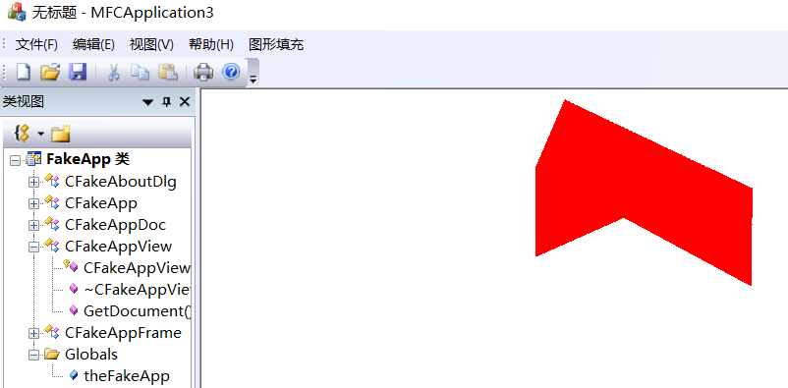
2、void CMFCApplication3View::OnBoundaryFill() {
CDC* pDC = GetDC();
BoundaryFillDlg inputDlg;
int nResponse = inputDlg.DoModal();
if (nResponse == IDOK) {
//这里获取输入并在客户区输出
point LU, RD, S;
LU.x = _wtoi(inputDlg.LUX.GetBuffer(0));
LU.y = _wtoi(inputDlg.LUY.GetBuffer(0));
RD.x = _wtoi(inputDlg.RDX.GetBuffer(0));
RD.y = _wtoi(inputDlg.RDY.GetBuffer(0));
S.x = _wtoi(inputDlg.SX.GetBuffer(0));
S.y = _wtoi(inputDlg.SY.GetBuffer(0));

pDC->Rectangle(LU.x, LU.y, RD.x, RD.y);
Bfs(S.x, S.y, RGB(255, 105, 180), RGB(0, 0, 0), pDC);
}
}

void CMFCApplication3View::Bfs(int x, int y, int col, int edgeCol, CDC* pDC) {
// TODO: 在此处添加实现代码.
long c;
c = pDC->GetPixel(x, y);
if (c != col && c != edgeCol) {
pDC->SetPixel(x, y, col);
//Sleep(2);
Bfs(x + 1, y, col, edgeCol, pDC);
Bfs(x - 1, y, col, edgeCol, pDC);
Bfs(x, y + 1, col, edgeCol, pDC);
Bfs(x, y - 1, col, edgeCol, pDC);
}
}
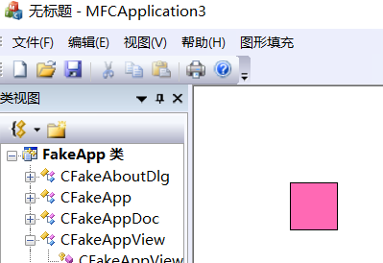
- 实验结果与总结
关于对话框如何生成这一块，在查阅资料从这个博客得知https://blog.csdn.net/qq_40909410/article/details/100712059

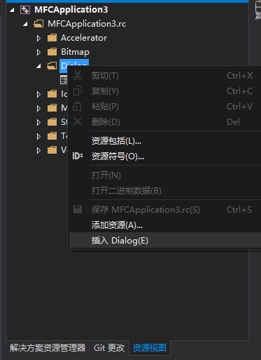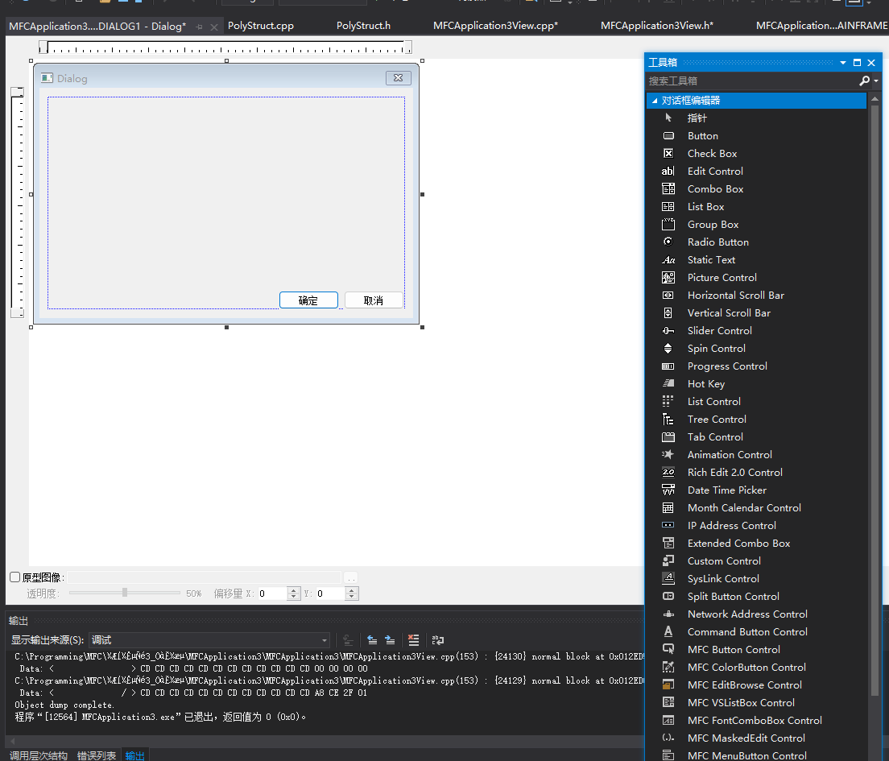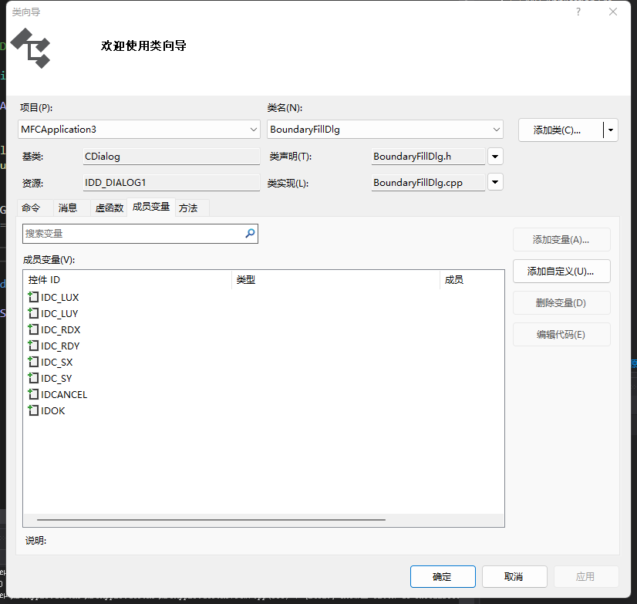
以及种子填充法，用老师的代码太大的图形时会堆栈溢出，建议优化，改成非递归。（大概是这样的）
int col = RGB(255, 105, 180);
int edgeCol = RGB(0, 0, 0);
pDC->SetPixel(S.x, S.y, col);
s.push(S);
long c;
while (!s.empty()) {
nowp = s.top();
s.pop();
int x = nowp.x;
int y = nowp.y;
c = pDC->GetPixel(nowp.x, nowp.y);
if (c != col && c != edgeCol) {
pDC->SetPixel(nowp.x, nowp.y, col);

nxtp.x = x + 1, nxtp.y = y;
s.push(nxtp);

nxtp.x = x - 1, nxtp.y = y;
s.push(nxtp);

nxtp.x = x, nxtp.y = y + 1;
s.push(nxtp);

nxtp.x = x, nxtp.y = y - 1;
s.push(nxtp);
}
}
}

