**Introduction**

This project is based on a Twitter account “WeRateDogs” that rates people’s dogs with a humorous comment about the dog. It was started in 2015 and rapidly growth. It reached millions of followers in 2017. In this project, I analyzed the dog breeds, dog characteristics, people’s rating on dogs and trends based on the favorite counts, retweets info, dog’s attributes, etc.

1 Most Popular Breeds

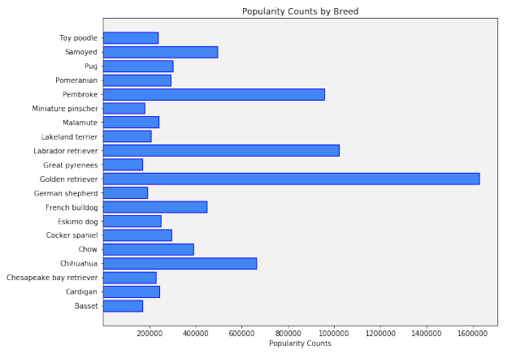

I analyzed the relationship between the favorite counts and dog breeds to figure out which breed is the most popular one. Results show that Golden Retriever is the most popular breed among the users with more than 1600000 likes, rank 2 breed is Labrador Retriever (about 1000000 likes) and Pembroke is rank 3 (slightly less than 1000000 likes).

2 Dog Characteristics

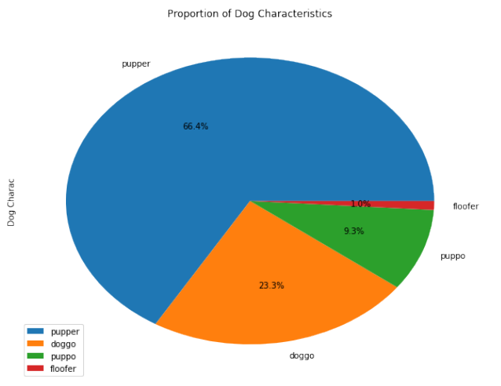

People used interesting language when they are discussing about dogs, for example a doggo is a dog. A pupper is a small doggo. A woofer is a big doggo. A yapper is a small pupper, and a big woofer is a floofer, etc. I created pie chart to see the proportions of the dog characteristics. The most frequent dog chrarcteristic is "pupper" with about 66%, the second one is "doggo" (about 23%). The rest of two "puppo and floofer" with about 10% altogether. Seems like people prefer smaller dogs.

3 Rating

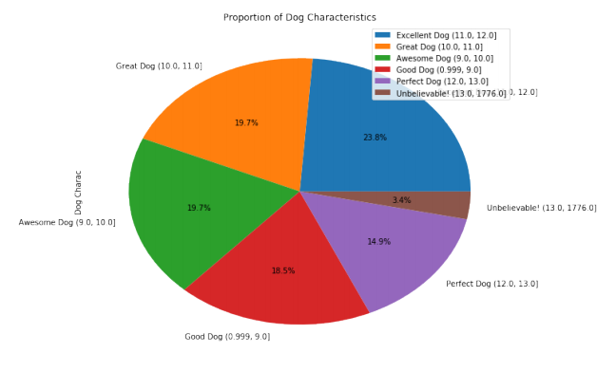

The proportions of people’s rating on dogs are analyzed in this section. I gave each ranking bucket a unique name:

* Good Dog: 0.999<x<=9.0,
* Awesome Dog: 9.0<x<=10.0,
* Great Dog: 10.0<x<=11.0,
* Excellent Dog 11.0<x<=12.0,
* Perfect Dog: 12.0<x<=13.0,
* Unbelievable!: 13.0<x<=1776.0

This ranking system indicates the higher the rating the better/cuter/popular the dog is. Based on the results, most of the dogs are rated between 0 and 13, only 3.4% of the dogs are rated higher than 13. It has outliers, such as 1176, 960, but still more than half the dogs have a rating greater than 10. Most popular rating is between 11 and 12.

4.Favorite vs Retweet Count

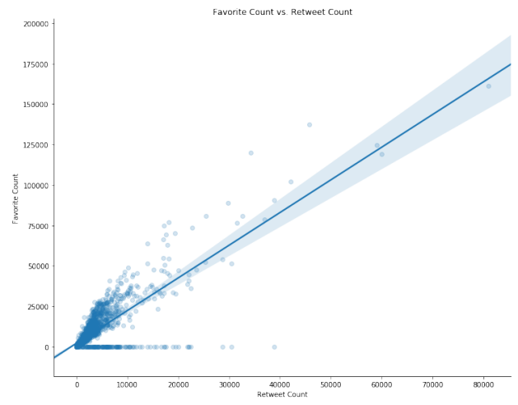

Since WeRateDogs has millions of followers, it definitely had huge amount of likes and retweets. In this figure, it can be seen that favorite and retweet counts are positively corelated. The majority of the data falls below 35000 favorite counts and 10000 retweet counts, so there is 1 retweet happening for every 3-4 favorites, basically means the more retweets the more favorites. The most popular tweet is about 155000 likes and 80000 retweets.