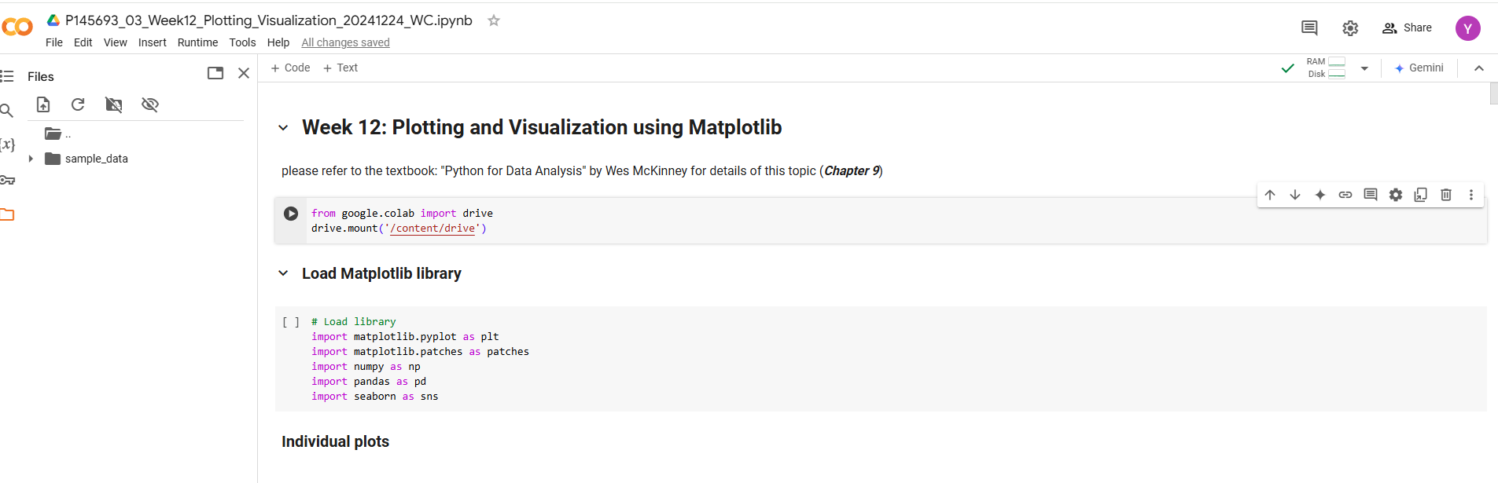

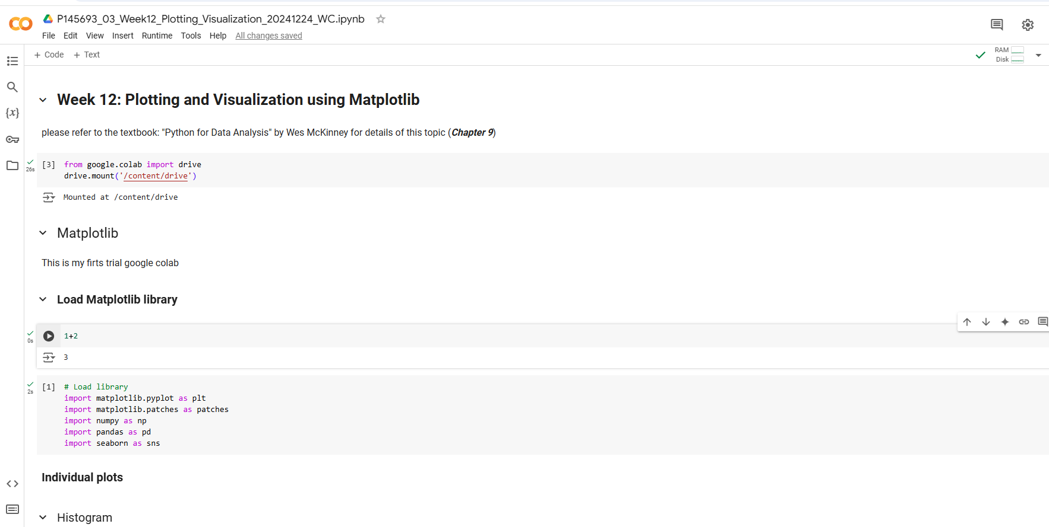

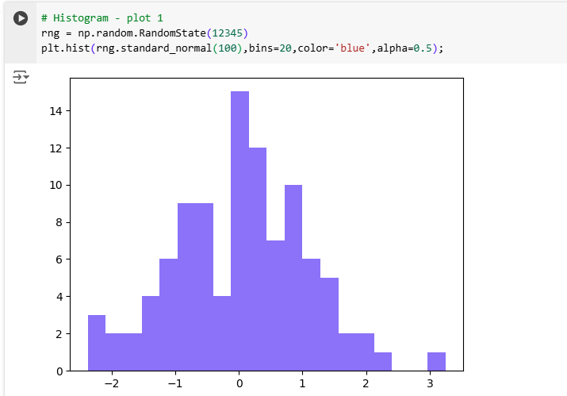

Random_state(12345)setseed:supaya semua sama

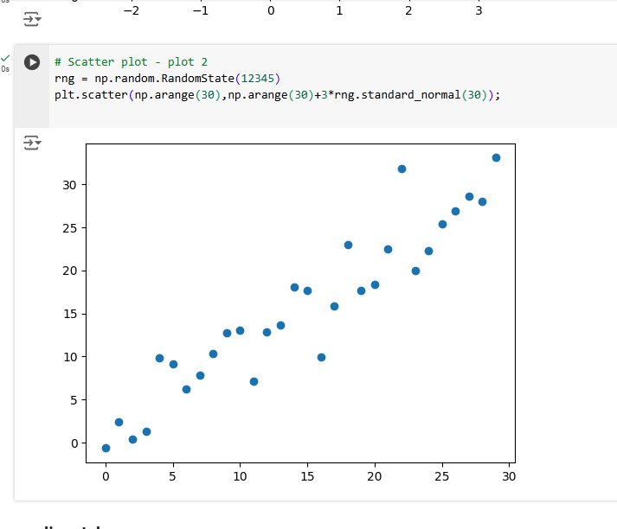

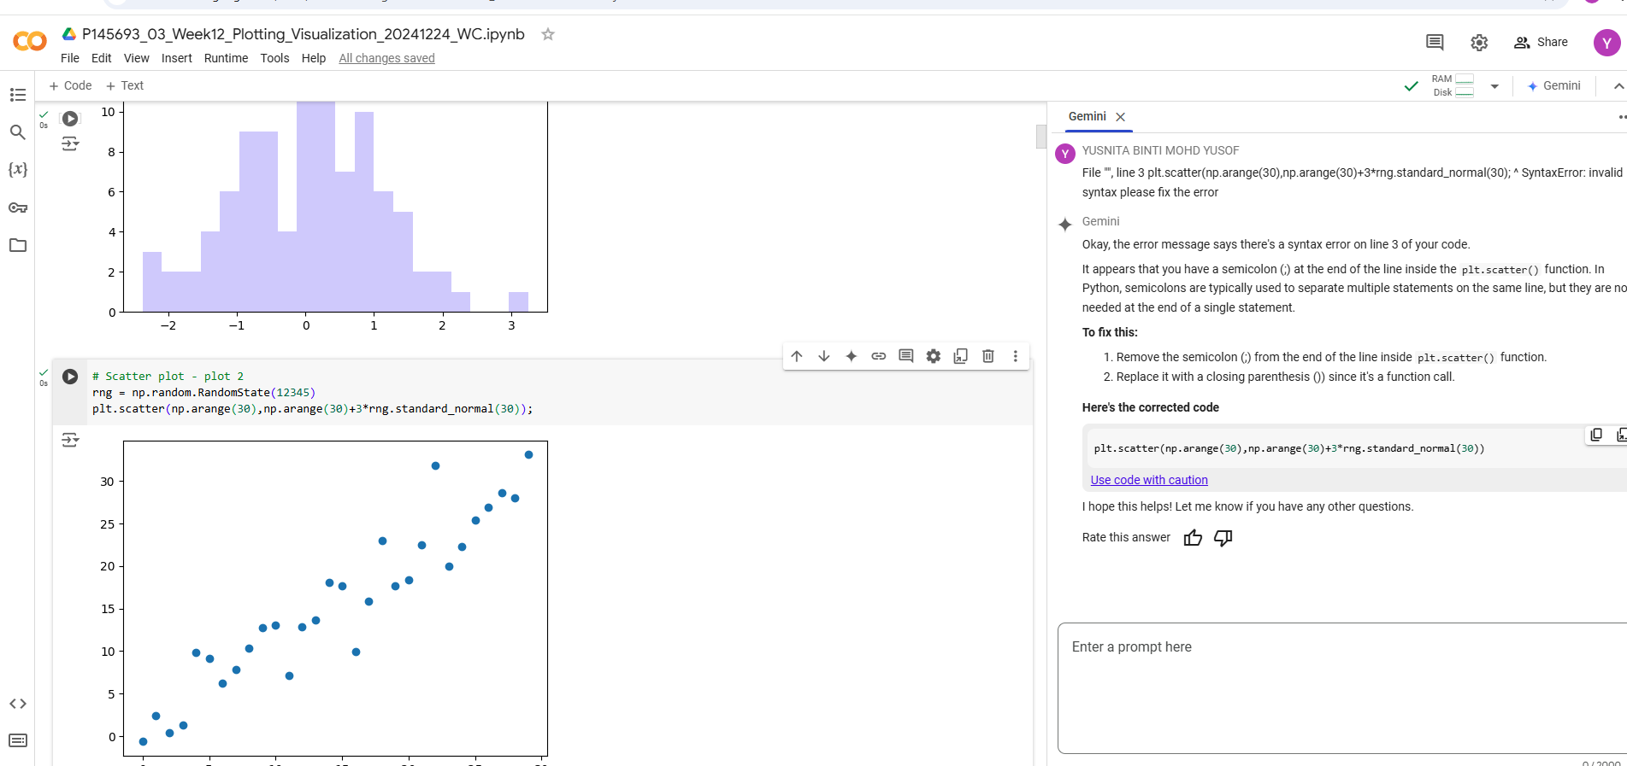

Goole colab kan ask gemini Ai

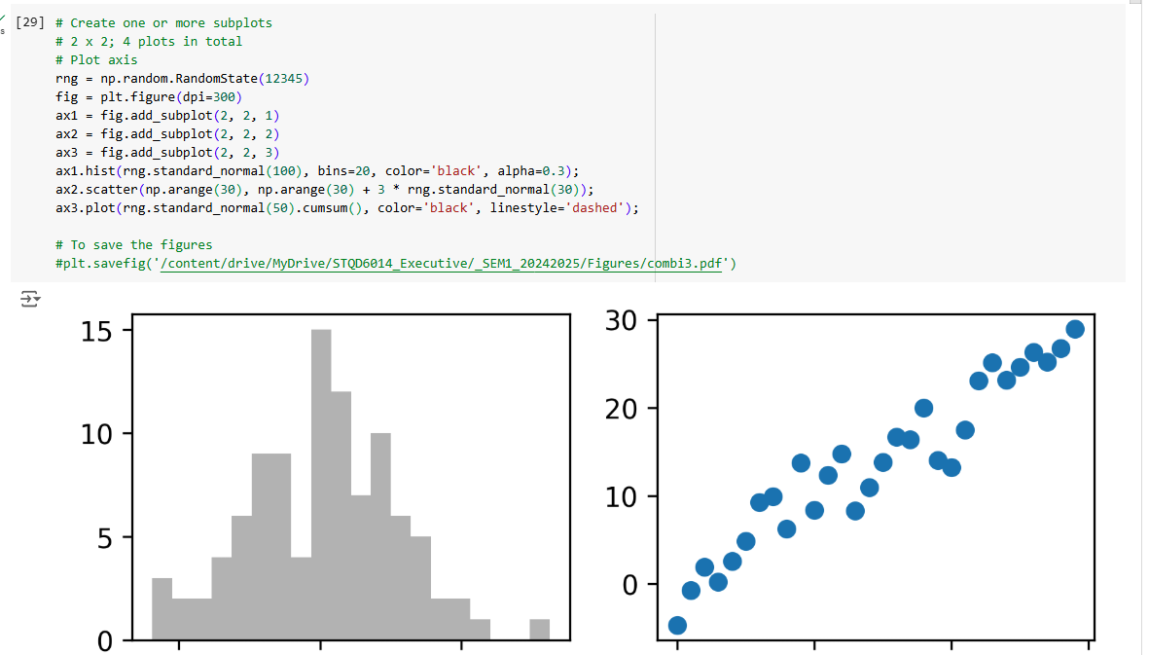

# Using a nested loop to populate 2x2 grid

for i in range(2):

    for j in range(2):

        axes[i, j].hist(rng.standard_normal(500), bins=50,

                        color='black', alpha=0.5)

for I in range(2)0.1

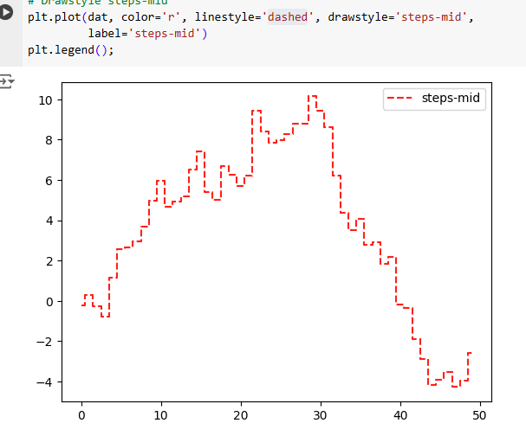

Steps-mid mediam- from one point to point

Fokus: for exam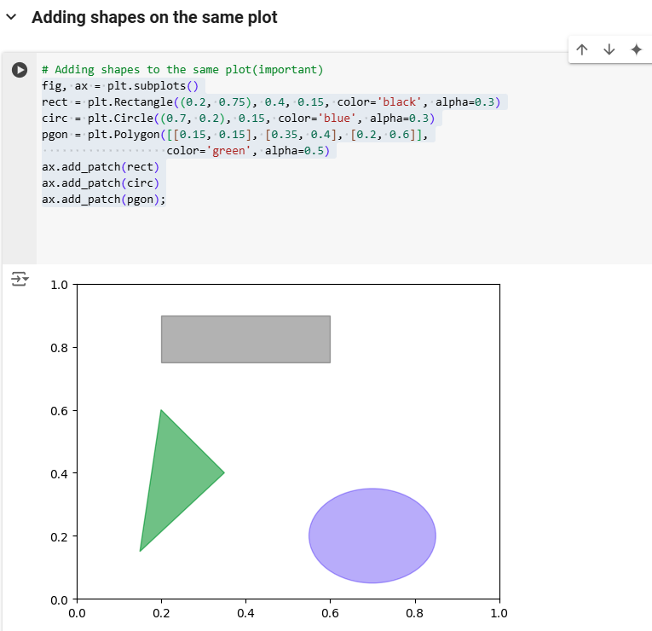

rect = plt.Rectangle((0.2, 0.75), 0.4, 0.15, color='yellow', alpha=0.9)

0.2, 0.75-starting point

circ = plt.Circle((0.7, 0.2), 0.15, color='blue', alpha=0.3)

pgon = plt.Polygon([[0.15, 0.15], [0.35, 0.4], [0.2, 0.6]],

                   color='green', alpha=0.5)

##([[0.15, 0.15], [0.35, 0.4], [0.2, 0.6]],-triangle shape

**Plotting with pandas and seaborn**

([[0.15, 0.15], [0.35, 0.4], [0.2, 0.6]],

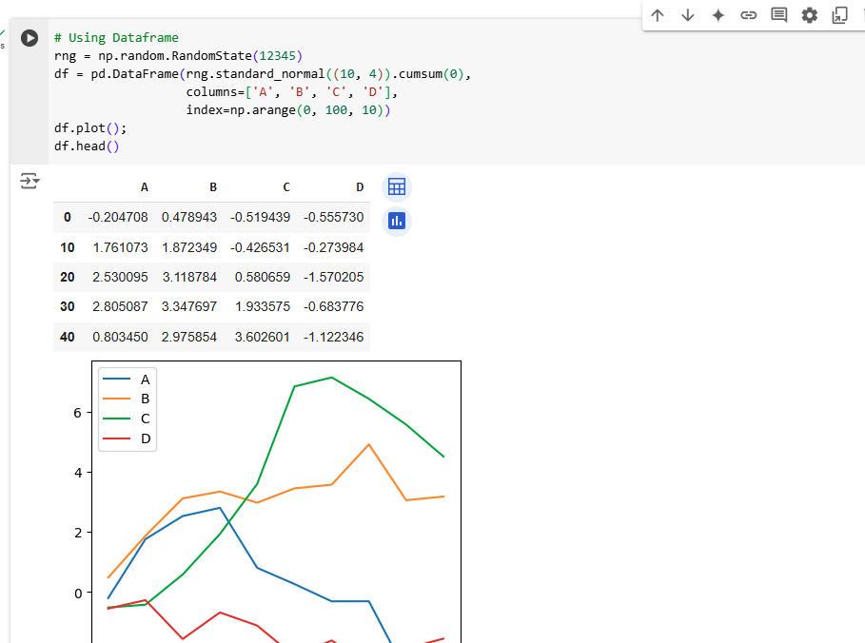

**standard_normal()** is a method of the RandomState class. It generates random numbers from a standard normal distribution (also known as a Gaussian distribution). This distribution has a mean of 0 and a standard deviation of 1.

**(10, 4)** is the shape argument passed to standard_normal(). It specifies the desired shape of the output array. In this case, it will generate a 2-dimensional array (a matrix) with 10 rows and 4 columns.