**VISVESVARAYA TECHNOLOGICAL UNIVERSITY**

**JNANASANGAMA, BELAGAVI - 590018**

[](https://www.google.co.in/imgres?imgurl=http://i727.photobucket.com/albums/ww276/sankethkumar/vtu_logo.jpg&imgrefurl=http://photobucket.com/images/vtu%20logo&docid=7vJL4VgBOFzETM&tbnid=dQewAEkp0o9foM:&vet=10ahUKEwi50anvqdXTAhWINY8KHXN8CooQMwgqKAEwAQ..i&w=269&h=320&bih=805&biw=1600&q=vtu%20symbol&ved=0ahUKEwi50anvqdXTAhWINY8KHXN8CooQMwgqKAEwAQ&iact=mrc&uact=8)

An Internship Report

**“INTERNSHIP ON WEB DEVELOPMENT”**

Submitted in partial fulfillment of the requirement for the award of the

Bachelor of Engineering

in

Computer Science & Engineering

SUBMITTED BY

**YUSOOF ALI**

**1AT15CS114**

UNDER THE GUIDANCE OF

**Mr. Vijay Swaroop A**

**ASSISTANT PROFESSOR**



Atria Institute of Technology

Anandanagar, Bangalore-560024



**Atria Institute of Technology**

**Anandanagar, Bangalore-560024**

**CERTIFICATE**

Certified that this internship work entitled “**WEB DEVELOPMENT USING PHP**” presented by “**YUSOOF ALI**” “**1AT15CS114**” of Atria Institute of Technology, Bangalore in partial fulfillment for the award of Bachelor of Engineering in Computer Science & Engineering of Visvesvaraya Technological University, Belagavi during 2017-2018. It is certified that all corrections/suggestions indicated for Internal Assessment have been incorporated in the report deposited in the department library. The internship report has been approved as it satisfies the academic requirements with respect to internship report as prescribed for the said Degree.

Mr. Vijay Swaroop Mr Vijay Swaroop Dr Aishwarya.P

Signature of Guide Signature of Coordinator Signature of HOD

External Viva:

Examiner 1 …………………. Examiner 2………………...

**ACKNOWLEDGEMENT**

The foundation for any successful venture is laid out not just by the individual accomplishing the task, but also by several other people who believe that the individual can excel and put in their every bit in every endeavor he/she embarks on, at every stage in life. And the success is derived when opportunity meets preparation, also supported by a well-coordinated approach and attitude.

I would like to express my sincere gratitude to the respected principal **Dr. K.V. Narayanaswamy,** for providing a congenial environment to work in. I also like to express my sincere gratitude to **Dr. Aishwarya.P,** Head of Department, Computer Science & Engineering, for her continuous support and encouragement.

I am indeed indebted to **Mr. Vijay Swaroop,** coordinator and guide for his continued support, advice and valuable inputs during the course of this Internship work.

Last, but not the least I would like to thank my family, who has acted as a beacon of light throughout my life.

My sincere gratitude goes out to all my comrades and well-wishers who have supported me through all the ventures.

**EXECUTIVE SUMMARY**

**Web development** is a broad term for the work involved in developing a website forthe Internet (World Wide Web) or an intranet (a private network). Web development can range from developing the simplest static single page of plain text to the most complex web-based internet applications (or just 'web apps') electronic businesses, and social network services. A more comprehensive list of tasks to which web development commonly refers, may include web engineering, web design, web content development, client liaison, client-side/server-side scripting, web server and network security configuration, and e-commerce development.

**Vue.js** is a JavaScript front-end framework that was built to organize and simplify web development.

The project focuses on making ideas in web UI development (components, declarative UI, hot-reloading, time-travel debugging, etc.) more approachable. It attempts to be less opinionated and thus easier for developers to pick up.

It features an incrementally adoptable architecture. The core library focuses on declarative rendering and component composition and can be embedded into existing pages. Advanced features required for complex applications such as routing, state management and build tooling are offered via officially maintained supporting libraries and packages.

|  |  |  |  |  |
| --- | --- | --- | --- | --- |
| Certificate of Internship This Acknowledges That  |  | | --- | | Yusoof Ali |  Has Successfully Completed The  |  |  |  | | --- | --- | --- | |  | Internship Program in Software Development |  | |
| |  |  |  |  |  | | --- | --- | --- | --- | --- | | August, 28  2018 | |  | | --- | | Arvind V | | **Signed**, Arvind V, Human Resources Head | |  | |

**Table of Contents**

|  |  |
| --- | --- |
| CHAPTER 01. ABOUT THE COMPANY/ORGANIZATION | 1 |
| CHAPTER 02. ABOUT THE DEPARTMENT | 5 |
| CHAPTER 03. TASKS PERFORMED | 13 |
| CHAPTER 04. REFLECTION NOTES (SPECIFIC OUTCOME) | 26 |

**Chapter -1**

**INTRODUCTION ABOUT THE COMPANY**

Certificate No.:DIPP8495

**Alfowin Ecommerce Private Limited**

Ecommerce Company -> Bangalore, Karnataka

**About Us:**

Alfowin Ecommerce Pvt. Ltd is an Ecommerce Company started in the Year 2016.

Our objective is to provide an innovative ecommerce solution for customers in India.

**Our Products are:**

TechiesBuy - [www.techiesbuy.com](http://www.techiesbuy.com)

Edads - [www.edads.in](http://www.edads.in)

**Company details**

**Email –** [info@alfowin.com](mailto:info@alfowin.com)

**Website**

[**http://www.alfowin.com**](http://www.alfowin.com/)



Recognized by: Certificate No – DIPP8495

CIN: U52609KA2016PTC098555

Address: No.16, R K Nivas, 2nd Floor 1st Main 2nd Cross Balaji Layout, Kalyan Nagar Post Horamavu, Bangalore KA 560043 IN

**DESIGN AND DEVELOPMENT**

With a rich experience in a wide variety of hardware and software, we design, develop, and transform a marketable idea of our customers into a saleable product. Our software product Development services range from idea generation, product conceptualization, design, development, testing, certification, manufacturing support, and subsequent product support. We at Alfowin provide competitive edge and time to market advantage through our proven software engineering methodologies.

With the dynamic e-market, we have evolved to keep pace with the latest technology trends. company products are aligned with the latest technology trends. We connect things, devices, and people to enable our customers to take their business operations to the next level

**MAINTENANCE AND SUPPORT**

We at Alfowin deliver continued engineering services and post-release support to ensure our customers draw optimum value out of their solutions. Our team runs routine performance check-ups, regression testing, and maintenance releases to boost product sustenance and expand product lifecycles.

Alfowin has services and advanced support engineers who can to assist you with critical issues and offer expert guidance.

## ACCURACY

We deliver unmatched data and product matching accuracy powered by human-aided machine intelligence.   
  
Due to our unique human-in-the-loop system, which feeds into our self-learning technology platform, we only get faster and more accurate with time. Alfowin has been laying great emphasis on Research and Development right from the early years. It has also been able to successfully partner at Startup India.

**OBJECTIVES**

* To be a customer focused company providing state-of-the-art products & solutions at competitive prices, meeting the demands of quality, delivery & service.
* To generate internal resources for profitable growth.
* To give thrust to exports.
* To create a facilitating environment for people to realize their full potential through continuous learning & team work.
* To give value for money to customers & create wealth for shareholders.
* To constantly benchmark company's performance with best-in-class internationally.
* To raise marketing abilities to global standards.
* To strive for self-reliance through indigenization.

## MASSIVE SCALE AT GREAT VELOCITY

Our proprietary data aggregator digs several layers deep into public web applications and captures several billions of data points from complex and diverse data sources.   
  
We address hyper-local use cases as well, with unique capabilities of accessing data from mobile applications, as well as for specific ZIP codes on e-Commerce websites.

**QUALITY POLICY**

We are committed to consistently deliver enhanced value to our customers, through continual improvement of our products and processes.

**QUALITY OBJECTIVES**

* Effective and efficient design and development process, considering the present and future needs of customers.
* Enhanced customer satisfaction by on-time delivery of defect free products and effective life cycle support.
* Continual upgradation and utilization of infrastructure and human resources.
* Mutually beneficial alliances with suppliers.
* Continual improvement of processes through innovation, technology and knowledge management.

**Chapter** **2**

**About the Department**

**E-commerce** is the activity of buying or selling of products on online services or over the Internet. Electronic commerce draws on technologies such as mobile, electronic funds transfer, supply chain management, Internet marketing and Online transaction processing.

Modern electronic commerce typically uses the World Wide Web for at least one part of the transaction's life cycle although it may also use other technologies such as e-mail. Typical e-commerce transactions include the purchase of online books and music, and to a less extent, customized/personalized online store inventory services. There are three areas of e-commerce: online retailing, electric markets, and online auctions. E-commerce is supported by Electronic Business.

### Media Technology

In the field of Media Technology, we examine how technical opportunities can be used to support, facilitate and develop communication between humans and machines in different contexts of society. Research in the Media Technology applies this through the business development, e-learning and media in multiple channels.

**1. The Customer.** To start building your quality system, you must begin with the end in mind. Specifically, what does the customer truly value? It may not be exactly what they tell you they care about. You need to be able to take their feedback, your observation and good data on their behaviors to understand the customer's true values.

**2. The Inputs.** On the other end of the system, you must understand the key levers as inputs to a good quality output. Basically, if we do these things right, our results should be just fine. For example, how both materials or parts and information is presented to users is crucial. Is it hard to select the right component? Is it hard to read the build sheet and know what decision to make? Standard work has also been a key component of quality output but is often treated as primarily an efficiency tool. Does the individual follow a standard process (whether it's written or not)? How can you tell? How can they tell?

**3. The Feedback.** Since quality is dynamic, we cannot just design it out of the system; we have to effectively react to it. Your feedback, and feed-forward, loops must be designed to be visible, relevant and timely. Are you feeding back the right information? Is it getting to the right person or role? And how long does it take to detect the issue, communicate it and react to it? Too often, the feedback isn't getting either to the people inadvertently causing the problem, or to those who can do something to fix it. And if it is, we create multiple quality signals that tell us eight different things in eight different ways. Which one am I supposed to react to? You can't react to the top issue on eight different signal inputs. You must design your feedback systems so that people can see the entire problem landscape and then make good decisions about where to put their resources.

**4. The Problem Solving.** Perhaps most importantly, you must connect and engage effective problem solving for the issues found. Too many think this means the procedure of whether we do an 8D or an A3 or a Six Sigma project. But more important than the tool or template is the effort taking place. Is there a committed resource to solve quality problems, or is there a committed time allocation for another resource? Do we solve these problems to true resolution or just work it until the next problem surfaces? Are we just fixing the problem or are we fixing the system as we learn?

**Linking Employee Performance to Results**

**Link Performance to Job Enrichment:** Employees want to feel that what they do is important. Doing more challenging work or working with different employees are just two examples.

**Link Employee Performance to Learning and Development:** Consider your employees' strengths and weaknesses.

**Link Employee Performance to Career Advancement:** Think about how certain actions give employees greater opportunities for advancement on the job.

**Link Employee Performance to Money and Rewards:** Identifying the monetary perks that exist for employees.

**Principles**

The International Standard for Quality management (ISO 9001:2015) adopts a number of management principles that can be used by top management to guide their organizations towards improved performance.

**Customer focus**

The primary focus of quality management is to meet [customer requirements](https://en.wikipedia.org/wiki/Customer_requirement) and to strive to exceed customer expectations.

**Rationale**

Sustained success is achieved when an organization attracts and retains the confidence of customers and other interested parties on whom it depends. Every aspect of customer interaction provides an opportunity to create more value for the customer. Understanding current and future needs of customers and other interested parties contributes to sustained success of an organization [[5]](https://en.wikipedia.org/wiki/Quality_management#cite_note-5)

**Leadership**

Leaders at all levels establish unity of purpose and direction and create conditions in which people are engaged in achieving the organization’s quality objectives.

**Rationale**

Creation of unity of purpose and direction and engagement of people enable an organization to align its strategies, policies, processes and resources to achieve its objectives.

**Engagement of people**

Competent, empowered and engaged people at all levels throughout the organization are essential to enhance its capability to create and deliver value.

**Rationale**

To manage an organization effectively and efficiently, it is important to involve all people at all levels and to respect them as individuals. Recognition, empowerment and enhancement of competence facilitate the engagement of people in achieving the organization’s quality objectives.[[7]](https://en.wikipedia.org/wiki/Quality_management#cite_note-7)

**Process approach**

Consistent and predictable results are achieved more effectively and efficiently when activities are understood and managed as interrelated processes that function as a coherent system.

**Rationale**

The quality management system consists of interrelated processes. Understanding how results are produced by this system enables an organization to optimize the system and its performance.[[8]](https://en.wikipedia.org/wiki/Quality_management#cite_note-8)

**Improvement**

Successful organizations have an ongoing focus on improvement.

**Rationale**

Improvement is essential for an organization to maintain current levels of performance, to react to changes in its internal and external conditions and to create new opportunities.[[9]](https://en.wikipedia.org/wiki/Quality_management#cite_note-9)

**Evidence based decision making**

Further information:[**decision making**](https://en.wikipedia.org/wiki/Decision_making)

Decisions based on the analysis and evaluation of data and information are more likely to produce desired results.

**Enterprise Quality Management Software**

The intersection of technology and quality management software prompted the emergence of a new software category: Enterprise Quality Management Software (EQMS). EQMS is a platform for cross-functional communication and collaboration that centralizes, standardizes, and streamlines quality management data from across the value chain. The software breaks down functional silos created by traditionally implemented standalone and targeted solutions. Supporting the proliferation and accessibility of information across supply chain activities, design, production, distribution, and service, it provides a holistic viewpoint for managing the quality of products and processes.

**Quality terms**

* Quality Improvement can be distinguished from Quality Control in that Quality Improvement is the purposeful change of a process to improve the reliability of achieving an outcome.
* Quality Control is the ongoing effort to maintain the integrity of a process to maintain the reliability of achieving an outcome.
* Quality Assurance is the planned or systematic actions necessary to provide enough confidence that a product or service will satisfy the given requirements.

**Databases**

Main article**:**[**Database**](https://en.wikipedia.org/wiki/Database)

Database management systems emerged in the 1960s to address the problem of storing and retrieving large amounts of data accurately and quickly. One of the earliest such systems was [IBM](https://en.wikipedia.org/wiki/IBM)'s [Information Management System](https://en.wikipedia.org/wiki/IBM_Information_Management_System) (IMS), which is still widely deployed more than 50 years later. IMS stores data [hierarchically](https://en.wikipedia.org/wiki/Hierarchical_database_model), but in the 1970s [Ted Cod](https://en.wikipedia.org/wiki/Edgar_F._Codd)eproposed an alternative relational storage model based on [set theory](https://en.wikipedia.org/wiki/Set_theory) and [predicate logic](https://en.wikipedia.org/wiki/Predicate_logic) and the familiar concepts of tables, rows and columns. The first commercially available [relational database management system](https://en.wikipedia.org/wiki/Relational_database_management_system)(RDBMS) was available from[Oracle](https://en.wikipedia.org/wiki/Oracle_Corporation) in 1980.

All database management systems consist of a number of components that together allow the data they store to be accessed simultaneously by many users while maintaining its integrity.[[citation needed](https://en.wikipedia.org/wiki/Wikipedia:Citation_needed)] A characteristic of all databases is that the structure of the data they contain is defined and stored separately from the data itself, in a [database schema](https://en.wikipedia.org/wiki/Database_schema). Data structures are applied are for efficient ways of storing and retrieving the data as well as for reducing time taken to access the data.

Most of the world's digital data is unstructured, and stored in a variety of different physical formats[[b]](https://en.wikipedia.org/wiki/Information_technology#cite_note-format-31) even within a single organization.

The [extensible markup language](https://en.wikipedia.org/wiki/XML) (XML) has become a popular format for data representation in recent years. Although XML data can be stored in normal [file systems](https://en.wikipedia.org/wiki/File_system), it is commonly held in [relational databases](https://en.wikipedia.org/wiki/Relational_database) to take advantage of their "robust implementation verified by years of both theoretical and practical effort". As an evolution of the [Standard Generalized Markup Language](https://en.wikipedia.org/wiki/Standard_Generalized_Markup_Language) (SGML), XML's text-based structure offers the advantage of being both machine and human-readable.

**Data retrieval**

The relational database model introduced a programming-language independent [**Structured Query Language**](https://en.wikipedia.org/wiki/SQL) (SQL), based on [**relational algebra**](https://en.wikipedia.org/wiki/Relational_algebra)**.**

The terms "data" and "information" are not synonymous. Anything stored is data, but it only becomes information when it is organized and presented meaningfully: 1–9 Most of the world's digital data is unstructured, and stored in a variety of different physical formats[[b]](https://en.wikipedia.org/wiki/Information_technology#cite_note-format-31) even within a single organization. [Datawarehouses](https://en.wikipedia.org/wiki/Data_warehouse)began to be developed in the 1980s to integrate these disparate stores. They typically contain data extracted from various sources, including external sources such as the Internet, organized in such a way as to facilitate [decisionsupportsystems](https://en.wikipedia.org/wiki/Decision_support_system) (DSS): 4–6

**Data transmission**

[Datatransmission](https://en.wikipedia.org/wiki/Data_transmission) has three aspects: transmission, propagation, and reception. It can be broadly categorized as [broadcasting](https://en.wikipedia.org/wiki/Broadcasting)**,** in which information is transmitted unidirectionally downstream, or [telecommunications](https://en.wikipedia.org/wiki/Telecommunications), with bidirectional upstream and downstream channels.

XML has been increasingly employed as a means of data interchange since the early 2000s, particularly for machine-oriented interactions such as those involved in web-oriented [protocols](https://en.wikipedia.org/wiki/Communications_protocol)such as [SOAP](https://en.wikipedia.org/wiki/SOAP)**,** describing "data-in-transit rather than ... data-at-rest". One of the challenges of such usage is converting data from relational databases into XML [Document Object Model](https://en.wikipedia.org/wiki/Document_Object_Model) (DOM) structures: 228–31

**Data manipulation**

Hilbert and Lopez identify the exponential pace of technological change (a kind of [**Moore's law**](https://en.wikipedia.org/wiki/Moore%27s_law)**):** machines' application-specific capacity to compute information per capita roughly doubled every 14 months between 1986 and 2007; the per capita capacity of the world's general-purpose computers doubled every 18 months during the same two decades; the global telecommunication capacity per capita doubled every 34 months; the world's storage capacity per capita required roughly 40 months to double (every 3 years); and per capita broadcast information has doubled every 12.3 years.

Massive amounts of data are stored worldwide every day, but unless it can be analyzed and presented effectively it essentially resides in what have been called data tombs: "data archives that are seldom visited". To address that issue, the field of [**data mining**](https://en.wikipedia.org/wiki/Data_mining)**–** "the process of discovering interesting patterns and knowledge from large amounts of data" – emerged in the late 1980.

**Mission**

* Employees are committed to impart knowledge and utilize utmost skill.
* Promote independent inquiry, research and logical thinking.
* Benchmark and continuously upgrade infrastructure.
* Collaborate with industry and higher learning institution.
* Creative and Innovate Idea generation.

**Chapter 3**

**Task performed**

**RECORD OF CHANGES**

|  |  |  |
| --- | --- | --- |
| **SL No** | **DATE** | **TASK PERFORMED** |
| 01 | 15-02-2018 | Project Planning |
| 02 | 20-02-2018 | Requirements definition and Analysis |
| 03 | 01-03-2018 | Design and Prototyping |
| 04 | 05-03-2018 | Setting up the tools and related installations |
| 05 | 08-03-2018 | Creating Homepage, contact and about page |
| 06 | 15-03-2018 | Signup and login creation, along with client-side validation |
| 07 | 22-03-2018 | Creation of career tracker, resume creator and a chat app |
| 08 | 25-04-2018 | Forum like app creation using vuejs |

1. **Project Planning:**

We first decided the purpose of the plan and who will be using the web app. We came about the idea of helping students to train in skills that are required for them and usage of latest technologies and providing an environment for designers to build large scale app. SCRUM based approach was applied where a scrum master was appointed to take regular information of progress from each of the members working in the project.

The plans created during this phase will help you to manage time, cost, quality, change, risk and issues. They will also help you manage staff and external suppliers, to ensure that you deliver the project on time and within budget.

**2. Requirements and Analysis of The Plan:**

Analyzing the purpose of the internship and the requirements of the internship, requirements include the pages that has to be included in the website, post regarding to the pages and the content of the pages it includes the images, logo, videos, references. Deciding the style and theme to be used in the app was decided. This Project Requirement Phase helps to identify all of the resources required to complete your project successfully.

The app was decided to be focused on Mobile first approach, frameworks like Bootstrap 4 were decided to accomplish the task. We created a resource schedule, which enables to plan the consumption of each type of resource, so that there is enough resources to complete the project. The technologies required for the job, the number of time and people were decided in this stage. The quality and assurance template is followed to produce and meet the needs of the customer. A list of control tasks where specified to create the schedule for the activities. It ensures that our deliverables meet our customer needs, every time.

1. **Design and prototyping**

After, the purpose of the Website has been found and the content has been defined, we need to organize the content of the Website. Many ways to organize the Website exists. The main reason behind the sitemap creation is to build a user-friendly and easy to navigate website.

In this case, a **wireframe** or **mock-up** is created. A wireframe is a visual representation of user interface that you’re going to create. But it doesn’t contain any design elements such as colors, logos, etc. It only describes the elements that will be added to the page and their location. It’s artless and cheap in production sketch. Mockups were made using photoshop tools like adobe and photopea to decide the layout. The mockups were modified and updated as and when required to obtain the required design.

Correct information needed to be gathered related to create the page and the post. The Information gathered is depended upon the requirements. The requirements are specified earlier and the information is included as per as the requirements of the Organization. An admin panel is incorporated for contact for queries and feedback.

**4. Setting up the tools and required installations:**

Installation of WampServer to create dynamic web applications with Apache, PHP and MySQL. WampServer automatically installs everything you need to intuitively develop Web applications. You will be able to tune your server without even touching its setting files.

Adding bootstrap and jQuery, in addition to vuejs which were installed using nodejs and help of npm package manager.

A theme changes the design of your website, often including its layout. Changing your theme changes how your site looks on the front-end, i.e. what a visitor sees when they browse to your site on the web. We used a bootstrap theme which was freely available for Bootstrap 4.

**Benefits of themes:**

When you create a theme, you decide how that content looks and is displayed. There are many options available to you when building your theme. For example:

Your theme can have different layouts, such as static or responsive, using one column or two. Your theme can display content anywhere you want it to be displayed.

Your theme can specify which devices or actions make your content visible. Your theme can customize its typography and design elements using CSS.

Other design elements like images and videos can be included anywhere in your theme.

themes are incredibly powerful. But, as with every web design project, a theme is more than color and layout. Good themes improve engagement with your website’s content *in addition* to being beautiful.

What are themes made of? What are themes made of?

At their most basic level, themes are collections of different files that work together to create what you see, as well as how your site behaves.

**5. Creating Home, contact, about page**

The first thing we will need is an actual database.. Once we’ve signed up, click **create new** in the mysql Deployments tab.

Once we’ve created the database, we need to create an account so that we can authenticate ourselves. Click on the database name, then **users,** and **add database user**. Write down the username and password you chose since we will need them later. Content writing involves also creation of catching headlines, text editing, writing new text, compiling the existing text, etc., which takes time and effort. As a rule, the client undertakes to provide website content ready to migrate to the site. It is better when all website content is provided before or during website coding.

Now that the database is ready, we started with creating the pages, including home page, which consists of the logo, the login page, banner and info cards.

The About and contact page consists of information about the company and their contact information. It was all created using Bootstrap 4 and Jquery, PHP handled the user validations. Flexbox CSS was also used to style the web Application, in cases where centering or aligning the elements were important. Images and logo designed by the company were added to the App and performance of the app was ensured in all the pages.

**6. Signup and login creation**

## Logging into MySQL

we must log into MySQL before you can start creating a database.. To log in, open a terminal window and issue the command:

mysql -u root -p

We'll be prompted to enter the password for the MySQL root user. After a successful login, We'll be presented with a prompt that looks like .

## **Creating a database**

First, we must create the actual database to be used. We'll create a database called staff. To do this, we issue the command (from the MySQL prompt):

CREATE DATABASE event

Once we've created the database, we have to switch to the newly created database before we can add to it. To do this, issue the command:

USE event;

## Creating a table

Create a table within the database, we'll create a table called email with the columns name, email, and ID. To do this, issue the command:

CREATE TABLE email (id INT, name VARCHAR(20), email VARCHAR(20));

**Note:** INT stands for integer (numbers) and VARCHAR stands for variable characters (numbers and alphanumeric). In the above command VARCHAR is limited to 20 characters; if you need more than that, you can increase the value, such as VARCHAR(50).

Once created, we should see Query OK, 0 rows affected. To see your table listed, issue the command:

SHOW TABLES;

## Adding data to table

. We'll add information for a fictional member of the editorial staff. The data to be added is:

* Name: Olivia
* ID: 01
* Email: olivia@company.com

The command to add this would be:

INSERT INTO email (id,name,email) VALUES(01,"Olivia","olivia@company.com");we can view the information added to the table with the command:

SELECT * FROM email;

All static web page elements that were designed during the mock-up and layout creation should be created and tested. Then, special features and interactivity should be added. A deep understanding of every website development technology that you’re going to use is crucial at this phase.

The registration page takes student details, like USN, name and college. Google maps and Google Auto-complete API was used for location searching.

Client side validation was done using jquery to avoid invalid or incorrect input from the user, which were further validated in the server side using PHP.

The passwords given by the user were hashed and stored in the database, to ensure security to the user. The passwords had to be a minimum of 6 characters long. The registration once done, needs to be confirmed by clicking a link sent to the users registered Email-id.

On successfully registering the user can login their account using their credentials. The passwords are again validated using a secure hashing function.

Incase of incorrect username or password, an alert is given to the user about it. There is a “Forgot Password” option for users who forgot their passwords, a link for new password is sent to their registered email ID using which the user can create a new password and stay secured.

There is a college login as well, where the POC can register and login to their portal, the college can look at the students registered in their college and have a look at the tracker and send notifications to the students.

CSS3 pseudo class :target and font awesome icons were used to show the login form and provide a link to switch to the registration form.

**7. Inserting images in pages and posts:**

Images can improve the design and the appearance of a web page.

## HTML Images Syntax

In HTML, images are defined with the <img> tag.

The <img> tag is empty, it contains attributes only, and does not have a closing tag.

The src attribute specifies the URL (web address) of the image:

<img src="*url*">

## The alt Attribute

The alt attribute provides an alternate text for an image, if the user for some reason cannot view it (because of slow connection, an error in the src attribute, or if the user uses a screen reader).

The value of the alt attribute should describe the image:

### Example

<img src="img_chania.jpg" alt="Flowers in Chania">

## Image Size - Width and Height

You can use the style attribute to specify the width and height of an image.

### Example

<img src="img_girl.jpg" alt="Girl in a jacket" style="width:500px;height:600px;">

**8. Creation of career tracker, resume creator and chat app**

A new tab called career tracker was added, which allowed students to view their progress throughout their education career. The tracker allows students to improve upon their performance or maintain it, in case they were doing good. The tracker allows students to give their marks throughout and their career and view their improvements and percentage they currently have.

A graph was included to show the students their progress in their career, the graph was implemented using jQuery and charts.js. The input given to it is the students details, which gives the output of their progress in the form of a graph. The students can print the resulting graph in the form of a PDF.

To help the student further, a resume builder was implemented. It helps students to create resumes of standard format by filling only 7 steps. The UI was done using Javascript and jquery, which allows contents to be added to the resume dynamically.

The resume after filling it can be taken for a print out in the form of a PDF. The resume details are saved in the database for viewing or printing their resumes in the future.

A chat App has been made which enables student to give feedback or ask help related to career. The admin can respond to each of the students in the form of messages. The chat app was ceated using Bootstrap and Jquery, the chat app is responsive in design and can be viewed in both mobile and desktop without any hassle.

Changing of the layout, changing of the entire theme and the backgrounds, adding the news tabs in the navigation bar, including the recent images of the organization as specified, updating the information

**9. Forum like app using vuejs**

Vue (pronounced /vjuː/, like **view**) is a **progressive framework** for building user interfaces. Unlike other monolithic frameworks, Vue is designed from the ground up to be incrementally adoptable. The core library is focused on the view layer only and is easy to pick up and integrate with other libraries or existing projects. On the other hand, Vue is also perfectly capable of powering sophisticated Single-Page Applications when used in combination with modern tooling and supporting libraries.

A forum is created to post questions or doubts of students, which can be answered by the advisor`s. The questions can be answered by the advisors and solve students queries.

Vuejs was implemented to create the forum. The users can search for topics based on some category and view or answer the questions posted. The vuejs v-model data binding is used to bind the data and is updated as and when it is changed by the users. It is a progressive framework and light weight to achieve high performance and lowered space.

The questions and answers are stored in the database, along with the time/date of when it was posted. Vuejs requests PHP for the data, which is given through a post request. The link to each questions can be shared and viewed by any users.

**CHAPTER 04**

**Reflection Notes (Specific Outcomes)**

Web Development is one of the emerging idea of the IT Industry, through the internship we have learnt about the specific things about the web development, HTML is important for the web development with the help of the HTML, CSS websites and the Blogs are created. overall websites are created by using the HTML and CSS.

Website development can include anything from simply programming the data of a website to adding client liaison, content, network security and web server configuration, e-commerce development and

more. It usually ranges from creating the simplest, plain text to the most difficult web-based applications, social network services and electronic business.

Backup is the final step of the website management which helps the user to take the backup of the entire pages and the posts from the website and store it in the local media and the cloud storage, sometime user may face the in convince of the website data crash, to overcome the data loss from the website backup plugins comes in handy.

Computer coding is the universal language of the planet. People who know how to code will be able to communicate across countries and cultures, be innovative, and solve problems more efficiently, with no barriers to impede their success.

**HOME PAGE**

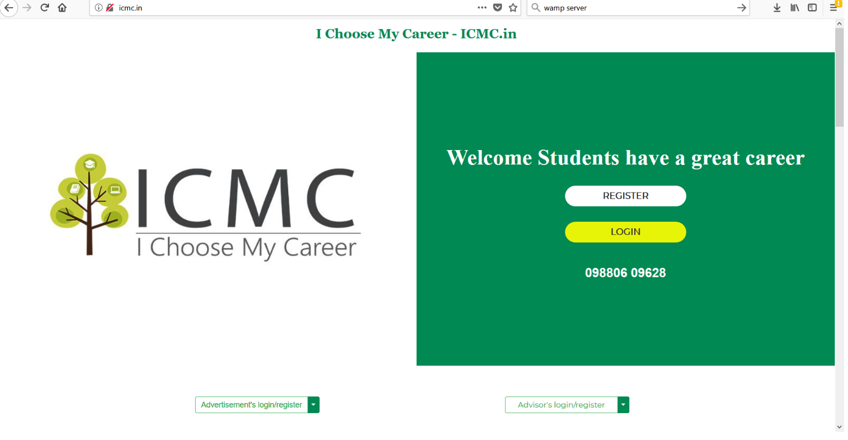

**REGISTRATION PAGE**

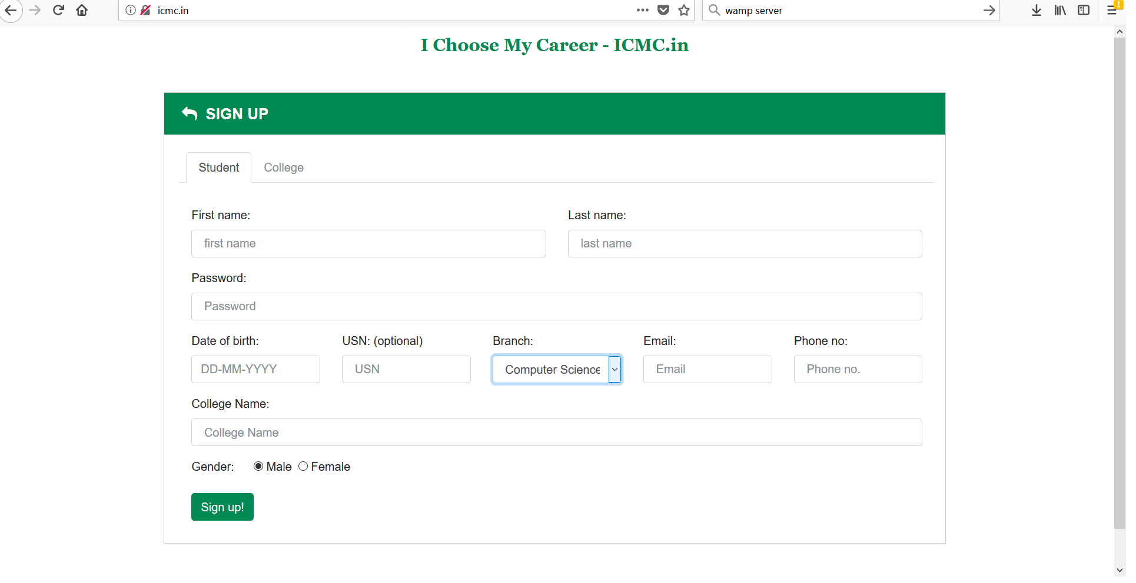

**MY ADVISOR**

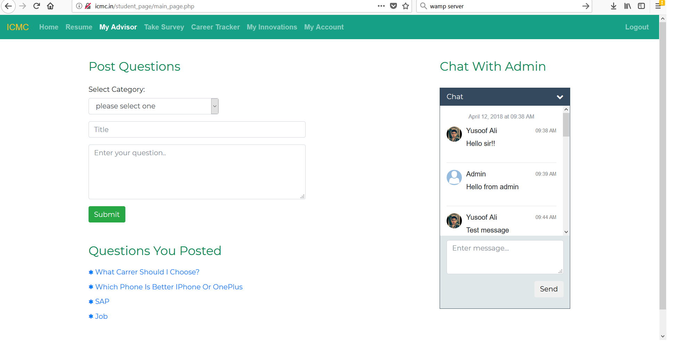

**CAREER TRACKER**



