**VISVESVARAYA TECHNOLOGICAL UNIVERSITY**

**JNANASANGAMA, BELAGAVI - 590018**



An Internship Report

**“WEB APPLICATION USING SPRING”**

Submitted in partial fulfillment of the requirement for the award of the

Degree of Bachelor of Engineering

in

Computer Science & Engineering

SUBMITTED BY

**“SURAJ RK”**

**“1AT15CS104”**

UNDER THE GUIDANCE OF

**Mr. Vijay Swaroop A**

**ASSISTANT PROFESSOR**



Atria Institute of Technology

Anandanagar, Bangalore-560024



**Atria Institute of Technology**

**Anandanagar, Bangalore-560024**

**CERTIFICATE**

**Certified that this seminar work entitled “WEB APPLICATION USING SPRING” presented by “SURAJ RK” “1AT15CS104” of Atria Institute of Technology, Bangalore in partial fulfillment for the award of Bachelor of Engineering in Computer Science and Engineering of Visvesvaraya Technological University, Belagavi during 2017-2018. It is certified that all corrections/suggestions indicated for Internal Assessment have been incorporated in the report deposited in the department library. The seminar report has been approved as it satisfies the academic requirements with respect to seminar report as prescribed for the said Degree.**

|  |  |  |
| --- | --- | --- |
| **Signature of Guide** | **Signature of Coordinator** | **Signature of HoD** |

**Mr. Vijay Swaroop Mr. Vijay Swaroop Dr. Aishwarya.P**

**ACKNOWLEDGEMENT**

The foundation for any successful venture is laid out not just by the individual accomplishing the task, but also by several other people who believe that the individual can excel and put in their every bit in every endeavor he/she embarks on, at every stage in life. And the success is derived when opportunity meets preparation, also supported by a well-coordinated approach and attitude.

I would like to express my sincere gratitude to the respected principal Dr. K.V. Narayanaswamy, for providing a congenial environment to work in. I also like to express my sincere gratitude to Dr. Aishwarya.P, Head of Department, Computer Science, for her continuous support and encouragement.

I am indeed indebted to Mr. Vijay Swaroop, coordinator and guide for his continued support, advice and valuable inputs during the course of this seminar work.

Last, but not the least I would like to thank my family, who has acted as a beacon of light throughout my life.

My sincere gratitude goes out to all my comrades and well-wishers who have supported me through all the ventures.

**Executive Summary**

**Web development** is a broad term for the work involved in developing a website forthe Internet (World Wide Web) or an intranet (a private network). Web development can range from developing the simplest static single page of plain text to the most complex web-based internet applications (or just 'web apps') electronic businesses, and social network services. A more comprehensive list of tasks to which web development commonly refers, may include web engineering, web design, web content development, client liaison, client-side/server-side scripting, web server and network security configuration, and e-commerce development

**Spring** makes it easy to create Java enterprise applications. It provides everything you need to embrace the Java language in an enterprise environment, with support for Groovy and Kotlin as alternative languages on the JVM, and with the flexibility to create many kinds of architectures depending on an application’s needs.

Spring supports a wide range of application scenarios. In a large enterprise, applications often exist for a long time and have to run on a JDK and application server whose upgrade cycle is beyond developer control. Others may run as a single jar with the server embedded, possibly in a cloud environment. Yet others may be standalone applications (such as batch or integration workloads) that do not need a server.

Spring is open source. It has a large and active community that provides continuous feedback based on a diverse range of real-world use cases. This has helped Spring to successfully evolve over a very long time.

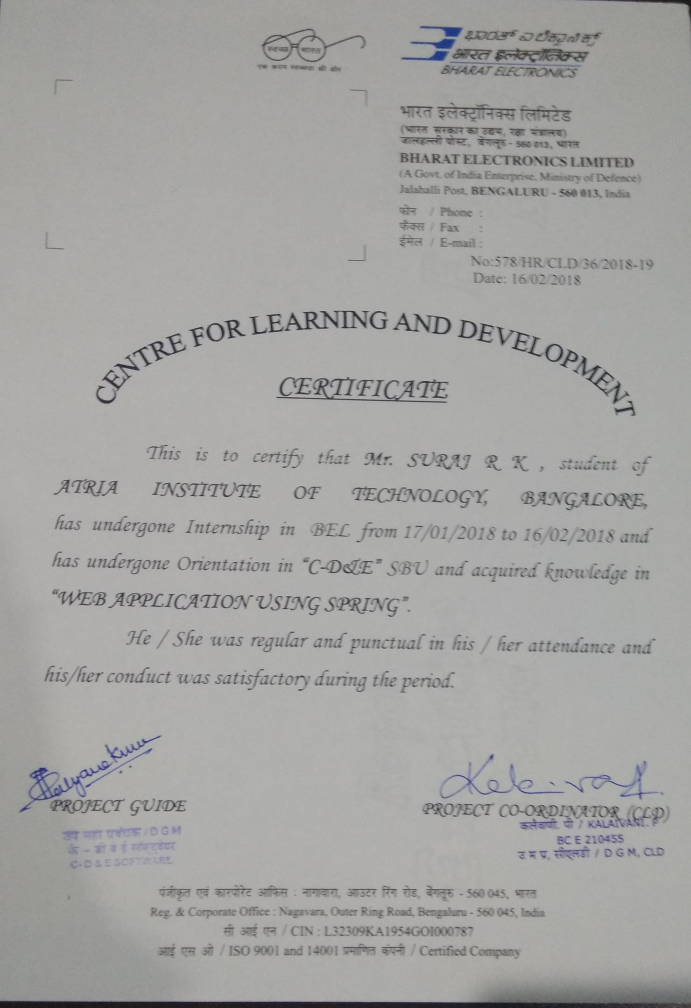

**Table of Contents**

|  |  |
| --- | --- |
| CHAPTER 01. ABOUT THE COMPANY/ORGANIZATION | 1 |
| CHAPTER 02. ABOUT THE DEPARTMENT | 12 |
| CHAPTER 03. TASKS PERFORMED | 18 |
| CHAPTER 04. REFLECTION NOTES (SPECIFIC OUTCOME) | 31 |

**CHAPTER 1**

**ABOUT THE COMPANY/ORGANIZATION**

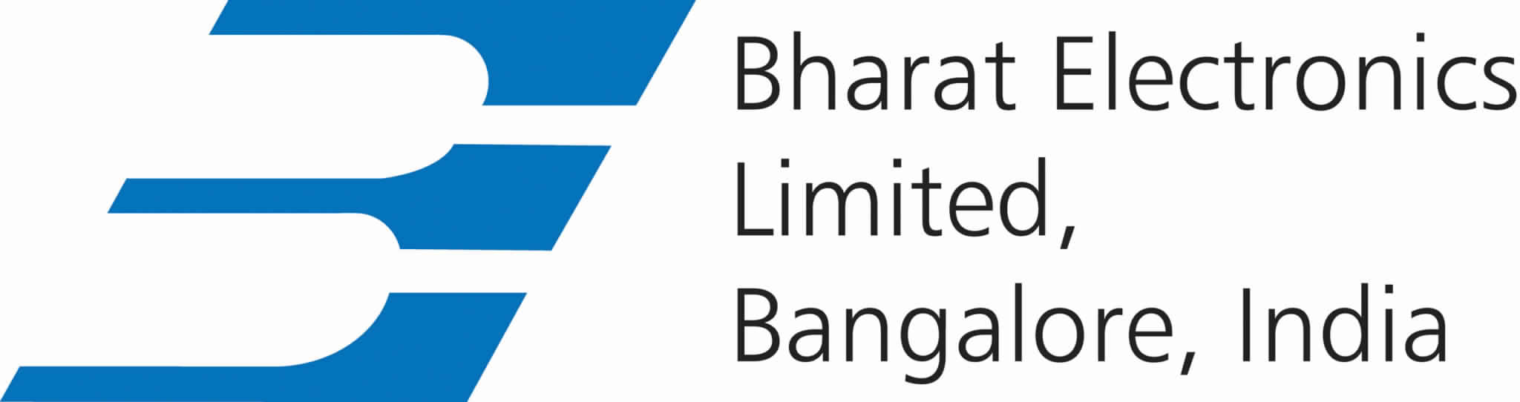

**HISTORY**

In 1954, in a newly independent India, the need was utmost to develop indigenous industry. The dream of a self-reliant India gave birth to many Public Sector Undertakings. Bharat Electronics Limited (BEL) was one such dream, which has come a long way since then with the far-sighted vision of its pioneers, the dedication and hard work of its employees, support and faith of its customers and the Government of India. The Government’s clarion call for ‘Make in India’ resonates with what BEL has been successfully doing for over 6 decades.

From humble beginnings in 1954, when BEL was set up in association with CSF, France (now, Thales), to manufacture basic communication equipment, BEL now produces a wide range of state-of-the-art equipment in fields such as Defence Communication, Radars, Naval Systems, C4I Systems, Weapon Systems, Homeland Security, Telecom & Broadcast Systems, Electronic Warfare, Tank Electronics, Electro Optics, Professional Electronic Components and Solar Photovoltaic Systems, BEL also provides turnkey system solutions. Civilian products from BEL include Electronic Voting Machines, Tablet PC, solar-powered traffic signal systems and Access Control Systems.

Starting from a single Unit in Jalahalli, Bangalore, BEL has established its presence across the country by setting up eight other Units – in Ghaziabad, Pune, Machilipatnam, Panchkula, Kotdwara, Navi Mumbai, Chennai and Hyderabad. Each Unit has a specific product mix and customer focus. BEL has also set up a wide network of offices and service centres countrywide as well as two overseas offices – at New York and Singapore.

BEL was established to meet the specialized electronic equipment requirements of the Indian Defence Services. While this continues to be its prime focus, the Company has a significant presence in the civilian market, too. BEL exports some of its products and services to a number of countries as well.

BEL has been laying great emphasis on Research and Development right from the early years. It has also been able to successfully partner as production agency with many DRDO labs. From a meagre turnover of Rs.2 lakhs in 1956-57, BEL has grown manifold to record a turnover of Rs.7,510 crores (provisional) in 2015-16.

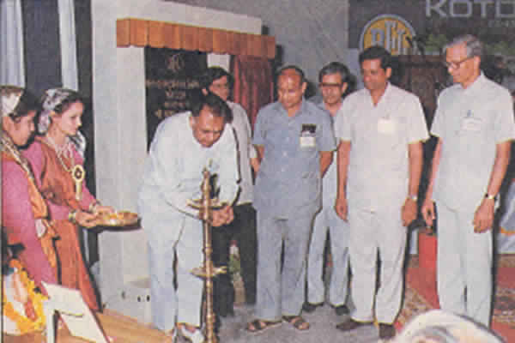

BEL is not only a successful business story but also an organization which cares for people and society. Even before the term ‘Corporate Social Responsibility’ gained currency, BEL has undertaken innumerable CSR activities and continues to do them with a lot of passion and commitment. BEL has set up educational institutions, including a special school for the mentally challenged. It has also set up hospitals, fine arts clubs and sports facilities. These and other welfare initiatives ensure a good quality of life for employees and their dependents. Some of these facilities also serve the local community. BEL is currently concentrating on promoting education, sanitation, health care, rural development, employment and enhancing vocational skills, while ensuring environmental sustainability.

'Clean and green' is true of every Unit of BEL. Concern for the environment is visible in the profuse greenery in all the Units. Afforestation, effluent treatment, used water recycling, generation and use of bio gas, rainwater harvesting, green buildings, setting up and using wind energy and solar energy power plants, to name a few, are some of the activities in this direction.

Awards galore have come BEL’s way, recognizing its emphasis on excellence. Recent accolades include India Today PSU Awards for ‘Best Global Presence Award’, ‘Eco Friendly Award’ and ‘Best R&D Innovation Award; Digital India PSE of the Year Award; Standing Conference of Public Enterprises (SCOPE) Meritorious Award (Gold Trophy) for HR Excellence for Best Practices in Human Resource Management; Mentor Graphics Silicon India Leadership Award for ‘Best VLSI/Embedded Design in Defence/Aerospace Sector’; International Aerospace Award for ‘Innovation’; SAP Award for Customer Excellence; SODET Gold Award for ‘Technology Innovation’; Government of Karnataka ‘State Export Excellence Award’ in the Electronics & Communications (excluding IT/BT & ITES sector) Medium/Large Industries sector; and Raksha Mantri’s Awards for Excellence.

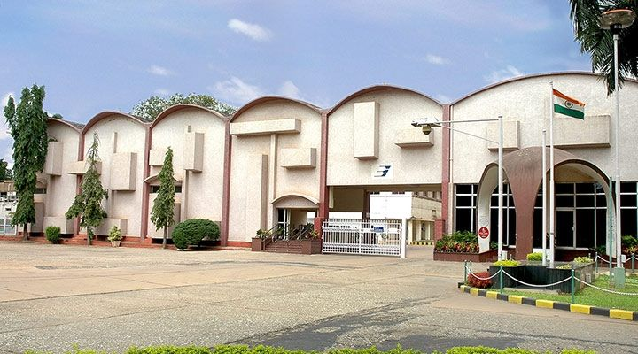

**VISION**

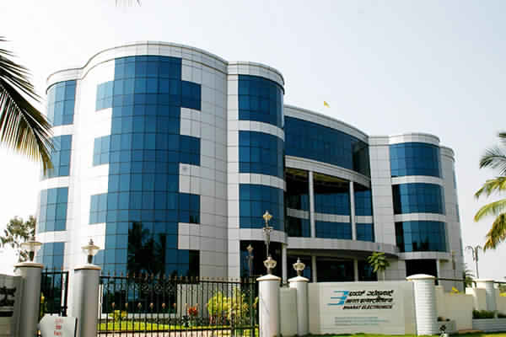

To be a world-class enterprise in professional electronics.

**MISSION**

To be a customer focussed, globally competitive company in defence electronics and in other chosen areas of professional electronics, through quality, technology and innovation.

**OBJECTIVES**

* To be a customer focussed company providing state-of-the-art products & solutions at competitive prices, meeting the demands of quality, delivery & service.
* To generate internal resources for profitable growth.
* To attain technological leadership in defence electronics through in-house R&D, partnership with defence/research laboratories & academic institutions.
* To give thrust to exports.
* To create a facilitating environment for people to realise their full potential through continuous learning & team work.
* To give value for money to customers & create wealth for shareholders.
* To constantly benchmark company's performance with best-in-class internationally.
* To raise marketing abilities to global standards.
* To strive for self-reliance through indigenisation.

**QUALITY**

**QUALITY POLICY**

We are committed to consistently deliver enhanced value to our customers, through continual improvement of our products and processes.

**QUALITY OBJECTIVES**

* Effective and efficient design and development process, considering the present and future needs of customers.
* Enhanced customer satisfaction by on-time delivery of defect free products and effective life cycle support.
* Continual upgradation and utilization of infrastructure and human resources.
* Mutually beneficial alliances with suppliers.
* Continual improvement of processes through innovation, technology and knowledge management.

**EVOLUTION OF QUALITY MANAGEMENT SYSTEM IN BHARAT ELECTRONICS**

Right from its inception in 1954, Bharat Electronics has understood the varying levels of quality and reliability requirements of its customers and has been striving to enhance their satisfaction level. The company has developed and improved Quality Systems and Procedures over the years.  
Starting with an inspection oriented Quality system during the initial years, the company shifted its focus towards MIL-Q-9858 Quality Management System during the early Seventies.  
During the Eighties, a number of initiatives were taken to improve the Quality Management System. They included release of documented QA manual; promotion of participative culture in the organization; launching of QC Circles & Suggestion Scheme, etc.

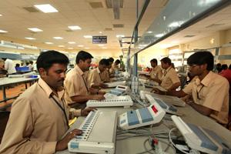

**INTRODUCTION OF TQM**

Bharat Electronics adopted the Total Quality Management (TQM) philosophy in the year 1990 under the acronym 'TORQUE' which stands for Total Organisational Quality Enhancement. TORQUE is based on the premise that the quality of products and services is not only the responsibility of the production/shop floor personnel, but other support services also who have a role to play in meeting and exceeding our customers? expectations through supply of quality products and services.

Some of the critical business performance indicators like transactional cycle time, manufacturing yield, inventory turnover ratio, customer complaints, QCC presentations, quality cost, etc are monitored on a monthly basis through SAP and corrective actions are initiated for continual improvement.

Starting from 1993, all Units / SBUs / Divisions of the company have been certified for ISO 9001 Quality Management System and ISO 14001 Environment Management System. Seven Units / SBUs (Ghaziabad, Panchkula, Kotdwara, Hyderabad, Military Communication, Electronics Warfare & Avionics and Export Manufacturing) are also certified for AS 9100 Aerospace Standards. The Central Software Development group of the company has CMMi Level 5 certification.

**THRUST AREAS OF TORQUE**

* Continual improvement of products and processes through deployment of Six Sigma methodology.
* Key processes stabilization and capability improvement through Statistical Process Control (SPC) techniques.
* Reduction of cycle time in all transaction areas.
* Improvement in quality of design through DFSS projects.
* Employee motivation and empowerment through self certification, QCC and Suggestion Schemes.
* Introduction of lean manufacturing concepts to achieve on-time delivery.

**BUSINESS EXCELLENCE**

The company has adopted CII-EXIM Bank Business Excellence Model to improve its overall strategic and operational excellence. Adoption of this Model since 2002 has helped the company in understanding the expectations of various stakeholders and in enhancing their satisfaction level.

The company has achieved the level of 'Commendation for Strong Commitment to Excel' and is striving to reach higher levels of excellence under the Model.

**BHARAT ELECTRONICS QUALITY INSTITUTE**

A Quality Institute has been created in 1999 by the company to impart education / training to the company's officers, customers and suppliers on various facets of quality management. Regular training programs are conducted for all employees of the company. Courses on topics such as Six Sigma, design for Six Sigma, reliability & maintainability, lean manufacturing, SPC, Project Management, etc are conducted regularly at the Quality Institute.

**STANDARDISATION**

Standardization & Quality are two inseparable parts of the TQM process and they play a complementary role. A Corporate Standards Department established four decades back has evolved more than 4000 standards on drafting, materials, systems & procedures, manufacturing processes, quality & workmanship, etc. These standards have provided effective support in design, manufacturing, vendor development and process standardization.

**QUALITY ASSURANCE FACILITIES**

The company has established state-of-the-art test facilities like environment test chambers, high altitude test facilities, bump & vibration test facilities, calibration facilities for electronic test instruments, EMI / EMC test facilities, etc. The calibration facility is certified as per ISO 17025 standard by NABL. Facilities for Highly Accelerated Life Testing (HALT), Highly Accelerated Stress Screening (HASS) and Multiple Environment Over Stress Testing (MEOST), combined environmental testing (Thermal & Vibration) are established for enhancing product reliability.

Reliability & statistical software tools are used by the company to demonstrate, predict and measure quality and reliability characteristics and parameters of products during design, development, manufacturing and life cycle stage

**Chapter** **2**

**ABOUT THE DEPARTMENT**

Vice President of India, Mr M Hamid Ansari, inaugurated the modernized BEL Software Technology Centre (BSTC) of Navratna Defence PSU Bharat Electronics Limited (BEL) on Jan 7 at Bengaluru. BSTC is a part of the Central Development and Engineering Group of BEL, Bengaluru.

BSTC is a part of the Central Development & Engineering

SK Sharma, chairman and managing director, BEL, said: “In modern day warfare, software is playing a crucial role. Realizing its importance, BEL has been building up expertise in software for defence applications. The major strength of this Centre is its capability to quickly grasp the requirements of the Defence forces and develop suitable software application to meet the operational requirements.”

BEL has identified software development and support as a major thrust area and the Software Division, was established within the BEL factory premises. The division performs software design, development and support tasks for complex defence networks and systems.

The Akash Missile System, for which Navratna Defence PSU Bharat Electronics Limited (BEL) is the nodal agency and supplies major sub-systems, was inducted into the Indian Air Force at a ceremony held at Air Force Station, Gwalior, today (July 10, 2015).

The induction of Akash into the Indian Air Force was marked by the symbolic handing over of the 'key' of the weapon system by Mr S K Sharma, Chairman & Managing Director, BEL, to the Defence Minister, Mr Manohar Parrikar, who in turn handed over the key to Air Chief Marshal Arup Raha, Chief of the Air Staff. Dr S Christopher, Director General, DRDO, was present.

The ceremony was also attended by senior dignitaries of the Ministry of Defence, Indian Air Force, DRDO and Defence PSUs.

Akash is a great success story of the 'Make in India' initiative and Bharat Electronics Limited is proud to be a part of it.

Barring a few electronic components, every bit of Akash has the 'Made in India' tag. Almost 92 per cent of the total cost of inputs is sourced within India. This is a very significant achievement. Akash is the first indigenously built missile air defence system in our country, which has been designed and developed by the DRDO. BEL is the lead integrator of the Akash Missile System for the Indian Air Force.

Akash is a role model for Public-Private Partnership. It is a massive, state-of-the-art missile system, which has been realised through professional project management spearheaded by BEL. While the Radars, Control Centres, Simulators, associated maintenance vehicles and the integrated software for the System are supplied by BEL, the missiles are from BDL, Squadron Control Centre from ECIL and the launchers are supplied by Tata Power SED and Land T.

BEL adopted concurrent engineering and production model with close co-operation of all the DRDO labs and other industry partners. This was a challenging task but BEL rose to the occasion and the order for the first two squadrons to Air Force stations Gwalior and Pune were delivered on time.

The System has been qualified after rigorous Quality Assurance checks and clearances by the Missile System Quality Assurance Agency (MSQAA). The Akash Missile System has been tested in extreme weather conditions at Pokhran during the prototype stage.

Further, it has undergone successful integration and extensive firing trials at Balasore. The Akash Missile System was tested for ECCM (Electronic Counter Counter Measure) features at the Gwalior Air Force Station with commendable results.

The IAF officers successfully tested Akash's capability in several simulated war scenarios. The finale of the firing trials was the NBLA (Near Boundary Low Altitude). Akash is probably the first in the world to have achieved this feat in this class of missiles.

With the experience gained in manufacturing and integrating the Akash Missile System for the Indian Air Force, BEL has built the capability to cater for the future requirements of Surface to Air Missile (SAM) systems in the country.

A new Strategic Business Unit headed by a General Manager was set up at our Bangalore Complex to manufacture Missile Systems.

BEL is geared up for futuristic programmes like the Quick Response Surface to Air Missile (QRSAM) and Medium Range Surface to Air Missile (MRSAM) and can execute them as turnkey projects. BEL has set up an outdoor test facility at its Bangalore factory covering an area of 30 acres for conducting radiation and communication checks.

BEL is in the process of setting up a huge missile manufacturing facility near Lepakshi in Andhra Pradesh with an investment of Rs.500 crores to undertake manufacture of all electronic sub-systems for SAM projects.

BEL already has in place state-of-the-art Quality Assurance facilities for the rigorous quality checks required for SAM systems. BEL can add any new feature required by the user within a short time.

Acquiring technology and building competency among its workforce has been the mantra in BEL. Towards furthering this, BEL has sponsored its engineers to undergo the MTech programme in Missile Technology at the Defence Institute of Advanced Technology (DIAT) to enhance their technical knowhow.

Akash and other SAM systems are highly software-driven. The BEL Software Technology Centre (BSTC) at Bangalore, which is CMMi level 5 certified, has been strengthened to design the complex software required for these SAM systems. BEL currently has over 300 dedicated software engineers working in BSTC.

Women scientists / engineers from DRDO and BEL matched their male counterparts in contributing to the Akash System. BEL is committed to promote long-term product and project support for the lifetime of the System through continuous technology upgrades.

Akash has been developed under the country's prestigious Integrated Guided Missile Development Programme for the air defence requirements of the Indian Defence forces. BEL has taken up a key role in the project along with DRDO, from the prototype development stage itself.

The Akash Missile System is an indigenously developed supersonic, short-range surface-to-air missile system with the capability to engage a wide variety of aerial threats like aircraft, helicopters and unmanned aerial vehicles up to a maximum range of 25 km and up to an altitude of 20 km.

Initially, the Indian Air Force placed an order for 2 Squadrons of Akash on BEL. This was followed by orders for six more squadrons. The Akash system for the Indian Air Force has been configured on trailers. The System is capable of simultaneously engaging multiple targets in all weather conditions and providing comprehensive short range missile cover to the vulnerable assets.

BEL designs, develops and manufactures products in the fields of:

* Electronic voting machines
* Voter-verified paper audit trail
* Traffic signals
* Radars
  + BEL Weapon Locating Radar
  + BEL Battle Field Surveillance Radar
  + Indian Doppler Radar
  + Samyukta Electronic Warfare System
  + Central acquisition radar (3D-CAR)
  + Reporter Radar
* Telecommunications
* Sound and vision broadcasting
* Opto-electronics
* Information technology
* Semiconductors
* Missiles
  + Akash (missile)
* Sonars
* Composite Communication System (CCS)
* Fire-control system
* Radar
* Electronic warfare systems
  + Samyukta electronic warfare system
  + F-INSAS
* Simulators
* Tank electronics
  + Combined day sight for Arjun MBT
* Defence communications
  + Data Link II communications system for the Indian Navy's P-8I
  + Combat management system for Indian Navy
* Solar systems
* Naval systems
* ADC&RS
* IACCS
* A low-cost tablet PC being used in the Socio-economic Caste Census 2011
* Biometrics Capturing for Nation Population Register
* Encrypters for the Ministry of Home Affairs
* IFF (Identify Friend or Foe) secondary radar
* VHF radio
* IEMC (Internal Environment Monitoring & Control) [earlier called SSMC]

Some products are manufactured by Bharat Electronics Ltd. with help of ToT (Transfer of Technology).

Research and Development is a key focus area at BEL. Research & Development activities started in 1958 and have been contributing steadily to the growth of BEL's business and self-reliance in the field of defence electronics and other chosen areas of professional electronics.

BEL's R&D Policy is to enhance the company's pre-eminence in defence electronics and other chosen fields and products through Research & Development. Major R&D objectives of BEL is development of new products built with cutting-edge technology modules to meet customer requirements ensuring that the developed products are state-of-the-art, competitive and of the highest quality. BEL has a three-tier R&D: the first tier being the Development and Engineering Divisions at the Unit / Strategic Business Unit level, whose role is to generate new business by developing new products and obtaining customer acceptance, provide product lifecycle support and upgrades, and develop processes and components as necessary; the second tier is the Central Development and Engineering Division which supports the Unit D&E Divisions with the supply of specialised technology modules and the third tier is the Central Research Laboratories (CRLs) at Bangalore and Delhi, whose role is to work on critical areas of technology and develop enabling technology modules.

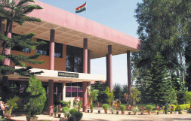

Bharat Electronics is currently trading at Rs. 3227.60, up by 90.55 points or 2.89% from its previous closing of Rs. 3137.05 on the BSE.

The scrip opened at Rs. 3170.00 and has touched a high and low of Rs. 3320.45 and Rs. 3152.50 respectively. So far 66058 shares were traded on the counter.

The BSE group 'A' stock of face value Rs. 10 has touched a 52 week high of Rs. 3320.45 on 09-Jan-2015 and a 52 week low of Rs. 895.00 on 04-Feb-2014.

Last one week high and low of the scrip stood at Rs. 3320.45 and Rs. 2797.75 respectively. The current market cap of the company is Rs. 25852.00 crore.

The promoters holding in the company stood at 75.02% while Institutions and Non-Institutions held 20.13% and 4.85% respectively.

Bharat Electronics (BEL) has inaugurated modernized BEL Software Technology Centre (BSTC) at Bengaluru. The Vice President of India inaugurated the centre of Navratna Defence PSU on January 07, 2015. BSTC is a part of the Central Development & Engineering Group of BEL-Bengaluru and is the software development centre of BEL.

BEL has been building up expertise in software for defence applications. The inauguration of the new facility is a major milestone in its endeavor in this direction. The major strength of this centre is its capability to quickly grasp the requirements of the Defence forces and develop suitable software application to meet the operational requirements.

BSTC presently includes more than 1,000 person years of collective experience in the software field, working for various software intensive systems. The focus of the division is software development and support for software intensive systems and projects for the other SBUs of BEL, Bengaluru.

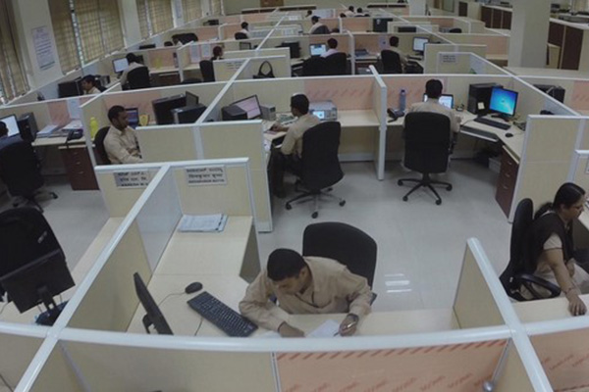

**Chapter 3**

**Task performed**

|  |  |  |
| --- | --- | --- |
| WEEK 1 |  | Training on SRING MVC FRAMEWORK and basic HTML and CSS. |
| WEEK 2 |  | Planning about tasks to be performed and installation. |
| WEEK 3 |  | Creating web pages. |
| WEEK4 |  | Minor Updates from the Organization: |

**TRAINING ON SPRING**

**Basics of Spring framework**

Spring could potentially be a one-stop shop for all your enterprise applications. However, Spring is modular, allowing you to pick and choose which modules are applicable to you, without having to bring in the rest.

The Spring Framework provides about 20 modules which can be used based on an application requirement.

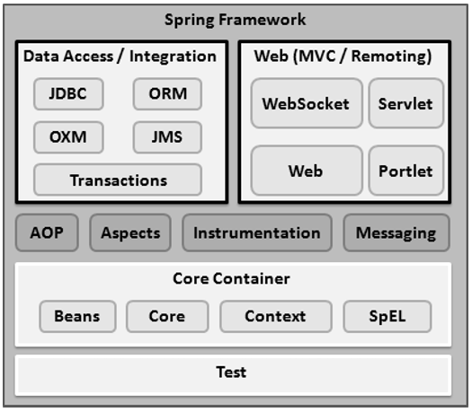

**Core Container**

The Core Container consists of the Core, Beans, Context, and Expression Language modules the details of which are as follows −

* The **Core** module provides the fundamental parts of the framework, including the IoC and Dependency Injection features.
* The **Bean** module provides BeanFactory, which is a sophisticated implementation of the factory pattern.
* The **Context** module builds on the solid base provided by the Core and Beans modules and it is a medium to access any objects defined and configured. The ApplicationContext interface is the focal point of the Context module.
* The **SpEL** module provides a powerful expression language for querying and manipulating an object graph at runtime.

**Data Access/Integration**

The Data Access/Integration layer consists of the JDBC, ORM, OXM, JMS and Transaction modules whose detail is as follows −

* The **JDBC** module provides a JDBC-abstraction layer that removes the need for tedious JDBC related coding.
* The **ORM** module provides integration layers for popular object-relational mapping APIs, including JPA, JDO, Hibernate, and iBatis.
* The **OXM** module provides an abstraction layer that supports Object/XML mapping implementations for JAXB, Castor, XMLBeans, JiBX and XStream.
* The Java Messaging Service **JMS** module contains features for producing and consuming messages.
* The **Transaction** module supports programmatic and declarative transaction management for classes that implement special interfaces and for all your POJOs.

**Web**

The Web layer consists of the Web, Web-MVC, Web-Socket, and Web-Portlet modules the details of which are as follows −

* The **Web** module provides basic web-oriented integration features such as multipart file-upload functionality and the initialization of the IoC container using servlet listeners and a web-oriented application context.
* The **Web-MVC** module contains Spring's Model-View-Controller (MVC) implementation for web applications.
* The **Web-Socket** module provides support for WebSocket-based, two-way communication between the client and the server in web applications.
* The **Web-Portlet** module provides the MVC implementation to be used in a portlet environment and mirrors the functionality of Web-Servlet module.

There are few other important modules like AOP, Aspects, Instrumentation, Web and Test modules the details of which are as follows −

* The **AOP** module provides an aspect-oriented programming implementation allowing you to define method-interceptors and pointcuts to cleanly decouple code that implements functionality that should be separated.
* The **Aspects** module provides integration with AspectJ, which is again a powerful and mature AOP framework.
* The **Instrumentation** module provides class instrumentation support and class loader implementations to be used in certain application servers.
* The **Messaging** module provides support for STOMP as the WebSocket sub-protocol to use in applications. It also supports an annotation programming model for routing and processing STOMP messages from WebSocket clients.
* The **Test** module supports the testing of Spring components with JUnit or TestNG frameworks.

We were asked to go through the book named “spring in action” which helped us gain knowledge about the basic understanding of the spring framework.

**Spring - IoC Containers**

The Spring container is at the core of the Spring Framework. The container will create the objects, wire them together, configure them, and manage their complete life cycle from creation till destruction. The Spring container uses DI to manage the components that make up an application. These objects are called Spring Beans, which we will discuss in the next chapter.

The container gets its instructions on what objects to instantiate, configure, and assemble by reading the configuration metadata provided. The configuration metadata can be represented either by XML, Java annotations, or Java code. The following diagram represents a high-level view of how Spring works. The Spring IoC container makes use of Java POJO classes and configuration metadata to produce a fully configured and executable system or application.

The Spring container is at the core of the Spring Framework. The container will create the objects, wire them together, configure them, and manage their complete life cycle from creation till destruction. The Spring container uses DI to manage the components that make up an application. These objects are called Spring Beans, which we will discuss in the next chapter.

The container gets its instructions on what objects to instantiate, configure, and assemble by reading the configuration metadata provided. The configuration metadata can be represented either by XML, Java annotations, or Java code. The following diagram represents a high-level view of how Spring works. The Spring IoC container makes use of Java POJO classes and configuration metadata to produce a fully configured and executable system or application.

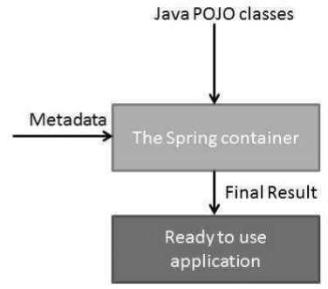

The objects that form the backbone of your application and that are managed by the Spring IoC container are called **beans**. A bean is an object that is instantiated, assembled, and otherwise managed by a Spring IoC container. These beans are created with the configuration metadata that you supply to the container.

**Spring Configuration Metadata**

Spring IoC container is totally decoupled from the format in which this configuration metadata is actually written. Following are the three important methods to provide configuration metadata to the Spring Container −

* XML based configuration file.
* Annotation-based configuration
* Java-based configuration

After acquiring the basic knowledge about the working of spring framework I was told to make a small project consisting of a website about library management.

I had to make use of front-end technologies like HTML, CSS, BOOTSTRAP for my project and made use of MYSQL write the queries for the extracting information from database.

This is brief note about the SPRING MVC which was used for developing the project.

# Spring - MVC Framework

The Spring Web MVC framework provides Model-View-Controller (MVC) architecture and ready components that can be used to develop flexible and loosely coupled web applications. The MVC pattern results in separating the different aspects of the application (input logic, business logic, and UI logic), while providing a loose coupling between these elements.

* The **Model** encapsulates the application data and in general they will consist of POJO.
* The **View** is responsible for rendering the model data and in general it generates HTML output that the client's browser can interpret.
* The **Controller** is responsible for processing user requests and building an appropriate model and passes it to the view for rendering.

**The DispatcherServlet**

* The Spring Web model-view-controller (MVC) framework is designed around a *DispatcherServlet* that handles all the HTTP requests and responses. The request processing workflow of the Spring Web MVC *DispatcherServlet* is illustrated in the following diagram −

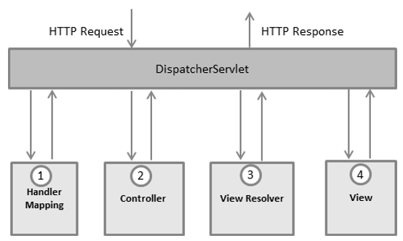

Following is the sequence of events corresponding to an incoming HTTP request to *DispatcherServlet* −

* After receiving an HTTP request, *DispatcherServlet* consults the *HandlerMapping* to call the appropriate *Controller*.
* The *Controller* takes the request and calls the appropriate service methods based on used GET or POST method. The service method will set model data based on defined business logic and returns view name to the *DispatcherServlet*.
* The *DispatcherServlet* will take help from *ViewResolver* to pickup the defined view for the request.
* Once view is finalized, The *DispatcherServlet* passes the model data to the view which is finally rendered on the browser.

The DispatcherServlet delegates the request to the controllers to execute the functionality specific to it. The **@Controller**annotation indicates that a particular class serves the role of a controller. The **@RequestMapping** annotation is used to map a URL to either an entire class or a particular handler method.

**INSTALLATION OF SOFTWARES AND PLANNING**

**Step 1 - Setup Java Development Kit (JDK)**

Downloading the latest version of SDK from Oracle's Java site − [Java SE Downloads.](https://www.oracle.com/technetwork/java/javase/downloads/index.html) Installing and configuring the setup. Finally seting the PATH and JAVA_HOME environment variables to refer to the directory that contains java and javac, typically java_install_dir/bin and java_install_dir respectively.

**Step 2 - Install Apache Common Logging API**

Downloading the latest version of Apache Commons Logging API from [https://commons.apache.org/logging/](https://commons.apache.org/logging/download_logging.cgi). After downloading the installation, unpack the binary distribution into a convenient location. For example, in C:\commons-logging-1.1.1 on Windows, or /usr/local/commons-logging-1.1.1 on Linux/Unix. This directory will have the following jar files and other supporting documents, etc.

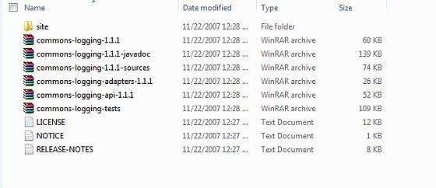

**Step 3 - Setup Eclipse IDE**

Installing Eclipse IDE, downloading the latest Eclipse binaries from <https://www.eclipse.org/downloads/>. After downloading the installation, unpack the binary distribution into a convenient location. For example, in C:\eclipse on Windows, or /usr/local/eclipse on Linux/Unix and finally set PATH variable appropriately.

After a successful startup, if everything is fine then it should display the following result –

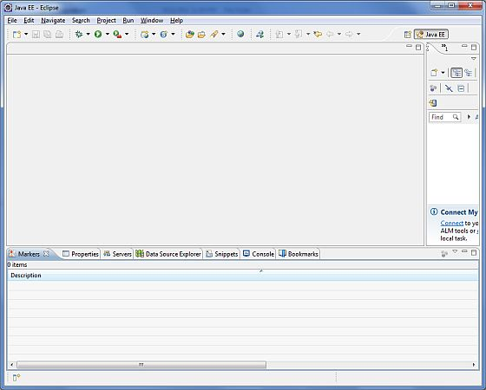

**Step 4 - Setup Spring Framework Libraries**

After all the following steps, then i proceeded to set up your Spring framework. Following are the simple steps to download and install the framework on your machine.

* Make a choice whether you want to install Spring on Windows or Unix, and then proceed to the next step to download .zip file for Windows and .tz file for Unix.
* Download the latest version of Spring framework binaries from <https://repo.spring.io/release/org/springframework/spring>.
* **spring-framework-4.1.6.RELEASE-dist.zip** was downloaded on Windows machine. After the downloaded file was unzipped, it gives the following directory structure inside E:\spring.

You will find all the Spring libraries in the directory **E:\spring\libs**.

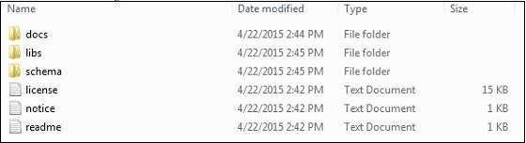

**Creating the web pages.**

I was given a task of creating a website making use of the spring framework. We had to create a small website on library management were we needed to first create the login page and the sign up page.

First we created the home page which contained the option for the user to select the whether he needs to register or he has already registered so he can just access the login option to login into his account.

HOME PAGE

The home page had the two basic operation that is to login and to register which consisted of html pages were when the users clicks on login or sign up option then the user name which was registered will get stored into the database using the spring mvc framework.

Once the user has registered then he can login into his account were the user name will crosschecked with the names in the database so if the particular person is present in the database then the person can securely access his account or else if there is no user present in the database then JavaScript prompt will tell the user that the particular username is invalid.

My sql is used to store the various information provided by the user into the database.



LOGIN PAGE

After login in successfully then this message will be displayed as the user name is already present in the database hence the user will be able to access the next page where he can see the list of books present the webpage.

Incase of a login failure then user cannot access the further and will be redirected back to the home page where he will able to register.

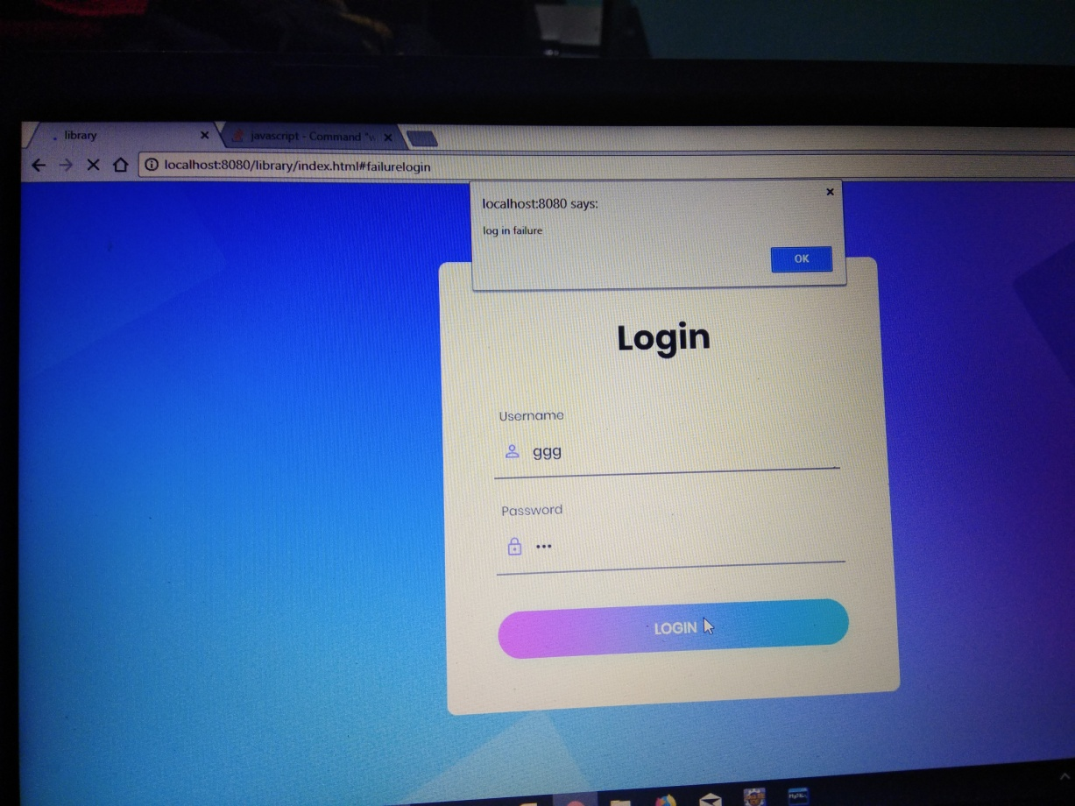

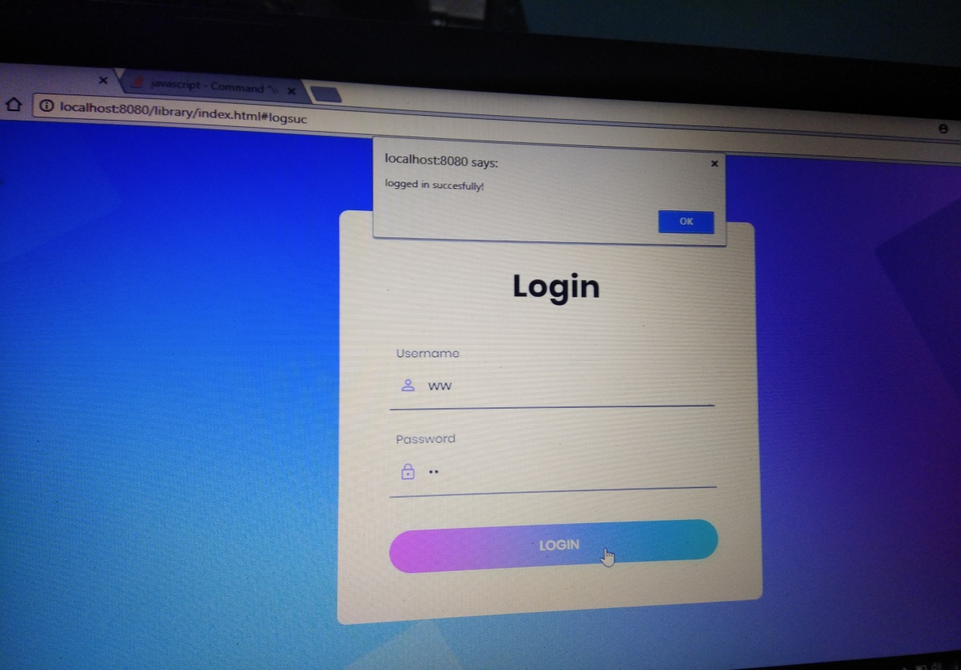

**Minor Updates from the Organization:**

As the end step of the website creation, updates are specified from the organization due to the change in the information and requirements from the organization, the minor updates includes changing of the layout, changing of the entire theme and the backgrounds, adding the news tabs in the navigation bar, including the recent images of the organization as specified, updating the information depending upon the current status.

**CHAPTER 04**

**Reflection Notes (Specific Outcomes)**

Web Development is one of the emerging ideas of the IT Industry, through the internship we have learnt about the specific things about the web development

Spring framework is by far the most actively being developed, and over the years it has grown its base many fold.

Spring Framework 5.0 is the first major release of the Spring Framework since version 4 was released in December of 2013. Juergen Hoeller, Spring Framework project lead, announced the release of the first Spring Framework 5.0 milestone (5.0 M1) on July 28, 2016.

Now, almost a year later, we are looking forward to Release Candidate 3 (RC3) to be released on July 18, 2017. This is expected to be the final release on the roadmap to the first GA (General Availability) release of Spring Framework 5.0.

Spring brings very recent, very modern programming module styles onto, say, older infrastructure. That is something that we have always been doing and I would argue it is even more important these days now in 2014, 2015. It is more important than it used to be 10 years ago since what we are seeing in the industry is an increasing disconnect between what you find installed in production and what is being advertised as the latest kind of specifications these days. At this very point, most people have a 2009 era - Java EE 6 environment in some form. Spring Framework 4.1 is basically a late 2014 framework that should bring in very recent spice into that environment. It really spices up the environment to a very modern day web input module in particular, perfectly capable of running on 2009 era infrastructure, but not being stuck on the 2009 era programming concepts and programming limitations. 