CodeAlpha
Cyber Security Internship Program

A Project Report on

NETWORK PACKET CAPTURING AND TRAFFIC ANALYSIS USING PYTHON (SCAPY)
(Task 1: Basic Network Sniffer)

Submitted in partial fulfillment of the requirements of the
CodeAlpha Cyber Security Internship

By

Yusra Farooq

January 2026

DECLARATION
I declare that this project report, titled “Network Packet Capturing and Traffic Analysis Using Python (Scapy),” is my own original work, carried out as part of Task 1 (Basic Network Sniffer) of the CodeAlpha Cyber Security Internship. This work has not been submitted, in whole or in part, for any other program, degree, or internship.
Yusra Farooq

ACKNOWLEDGMENT
I would like to thank CodeAlpha for the opportunity to complete this internship and for providing clear task guidelines that made this project possible. I am also grateful for the guidance and resources made available throughout the internship, which helped me understand practical concepts in network security and packet analysis.

ABSTRACT
This report presents a Mini Network Packet Analyzer developed in Python using the Scapy library, built to satisfy CodeAlpha Cyber Security Internship Task 1: Basic Network Sniffer. The program captures live network packets and extracts key details such as source and destination IP addresses, transport-layer protocol, port numbers, packet size, and payload content. Captured packets are classified by protocol (TCP, UDP, ICMP, or Other), and a summary report is generated at the end of the capture describing overall traffic composition. The project demonstrates practical understanding of how data flows through a network, the structure of common protocols, and the basics of packet-level traffic analysis, while remaining simple enough to explain and reproduce.

1. INTRODUCTION

1.1 Overview
Network packet capturing is the process of intercepting and examining data packets as they travel across a network. Every packet carries structured information, including source and destination addresses, protocol type, and payload data. Studying these packets is fundamental to network administration, troubleshooting, and cybersecurity, since it reveals how devices communicate and helps identify unusual or malicious activity.

1.2 Objective
The objective of this project is to build a Python program that captures live network traffic, analyzes the structure and content of each packet, and presents the results in a clear, readable format. The project uses the Scapy library to capture packets and display useful information such as source and destination IP addresses, protocol type, port numbers, packet size, and payload preview.

1.3 Scope
- Capture live packets travelling through the system's network interface.
- Identify the transport-layer protocol used by each packet (TCP, UDP, ICMP, or Other).
- Display source/destination IP addresses, ports, packet size, and payload preview.
- Maintain a running count of packets per protocol.
- Generate a traffic summary once capture is complete.

2. SOFTWARE AND HARDWARE REQUIREMENTS

2.1 Software Requirements
- Python 3.x
- Scapy library (scapy>=2.6.0)
- A code editor such as Visual Studio Code
- Windows 10/11, macOS, or Linux operating system

2.2 Hardware Requirements
- A computer with an active network interface (wired or wireless)
- Administrator/root privileges, required by Scapy for raw packet capture

3. THEORY
A network packet is the basic unit of data transmitted across a network. Each packet is wrapped in headers that describe how it should be routed and interpreted, including the source and destination IP addresses defined by the Internet Protocol (IP), and the transport-layer protocol used to deliver the data — most commonly the Transmission Control Protocol (TCP), the User Datagram Protocol (UDP), or the Internet Control Message Protocol (ICMP).
TCP is a connection-oriented protocol used for reliable delivery, such as web browsing over HTTPS. UDP is a connectionless protocol used where speed matters more than guaranteed delivery, such as DNS lookups and media streaming. ICMP is primarily used for diagnostic and control messages, such as the ping utility. Understanding these protocols is essential for interpreting captured traffic correctly.
Packet sniffing refers to intercepting and logging traffic passing over a network. It is a foundational technique in network security, used both defensively (to monitor for intrusions or misconfigurations) and, in the wrong hands, maliciously. This project focuses on the defensive, educational use case: passively observing traffic in a controlled environment to understand its structure.

4. METHODOLOGY AND ALGORITHM

4.1 Methodology
- Import the Scapy library, which provides the packet capture and packet inspection functions used by the program.
- Define counters for each protocol type of interest (TCP, UDP, ICMP, Other) and a running total.
- Use Scapy's sniff() function to capture a fixed number of live packets from the active network interface.
- For each captured packet, inspect its layers to extract the source IP, destination IP, protocol, port numbers, size, and payload (if present).
- Print the extracted details in a clean, labeled format for each packet as it is captured.
- Update the relevant protocol counter after each packet is processed.
- Once capture is complete, print a traffic summary showing total packets and the count for each protocol, along with a short traffic analysis statement.

4.2 Algorithm
- Start the program and initialize protocol counters to zero.
- Capture a fixed number of packets using sniff().
- For each packet, check whether it contains an IP layer.
- Extract the source and destination IP addresses and the packet size.
- Determine whether the packet is TCP, UDP, ICMP, or another protocol, and extract port numbers if applicable.
- Check for a payload (Raw layer) and print a short preview if one exists.
- Increment the corresponding protocol counter.
- After all packets are captured, print the total counts and a brief summary of the dominant traffic type.
- End the program.

5. IMPLEMENTATION
The program is implemented in Python using the Scapy library. It defines a callback function that Scapy invokes for every captured packet. The callback inspects the packet's layers, prints its details, and updates protocol counters. The sniff() function drives the capture loop, and a summary is printed once the target number of packets has been reached. The complete source code is given below.
from scapy.all import *
from datetime import datetime

tcp = 0
udp = 0
icmp = 0
other = 0
total = 0

print("="*75)
print(" MINI NETWORK PACKET ANALYZER")
print("="*75)
print("Capturing 20 packets...\n")

def analyze(pkt):

global tcp, udp, icmp, other, total

total += 1

print("="*75)
print("Packet Number :", total)
print("Time :", datetime.now().strftime("%H:%M:%S"))

if IP in pkt:

print("Source IP :", pkt[IP].src)
print("Destination IP:", pkt[IP].dst)
print("Packet Size :", len(pkt), "Bytes")

if TCP in pkt:
tcp += 1
print("Protocol : TCP")
print("Source Port :", pkt[TCP].sport)
print("Dest Port :", pkt[TCP].dport)

elif UDP in pkt:
udp += 1
print("Protocol : UDP")
print("Source Port :", pkt[UDP].sport)
print("Dest Port :", pkt[UDP].dport)

elif ICMP in pkt:
icmp += 1
print("Protocol : ICMP")

else:
other += 1
print("Protocol : Other")

if Raw in pkt:
try:
data = pkt[Raw].load.decode(errors="ignore")
print("Payload :", data[:80])
except:
print("Payload : Binary Data")

else:
print("Payload : No Payload")

sniff(prn=analyze, count=20)

print("\n")
print("="*75)
print("NETWORK TRAFFIC SUMMARY")
print("="*75)

print("Total Packets :", total)
print("TCP Packets :", tcp)
print("UDP Packets :", udp)
print("ICMP Packets :", icmp)
print("Other Packets :", other)

print("\nTraffic Analysis")

if tcp > udp and tcp > icmp:
print("Most traffic was TCP (Web browsing, HTTPS, etc.)")

elif udp > tcp and udp > icmp:
print("Most traffic was UDP (DNS, Streaming, etc.)")

elif icmp > 0:
print("ICMP packets detected (Ping/Network Diagnostics)")

print("\nPacket capture completed successfully.")

6. RESULTS AND DISCUSSION
The program was executed on a local machine with an active internet connection and successfully captured live packets. Below is a sample of the console output produced during a test run.
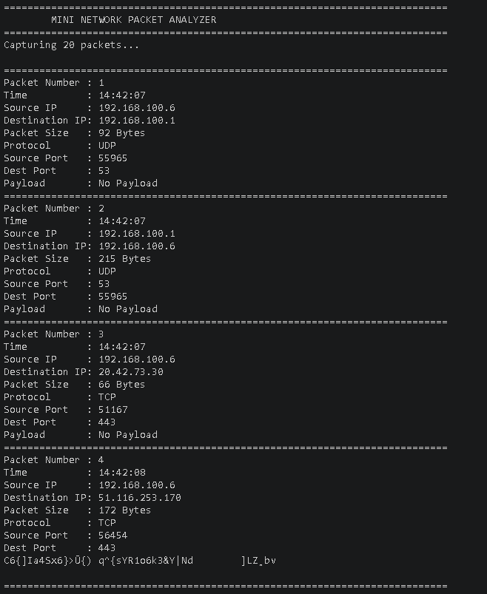
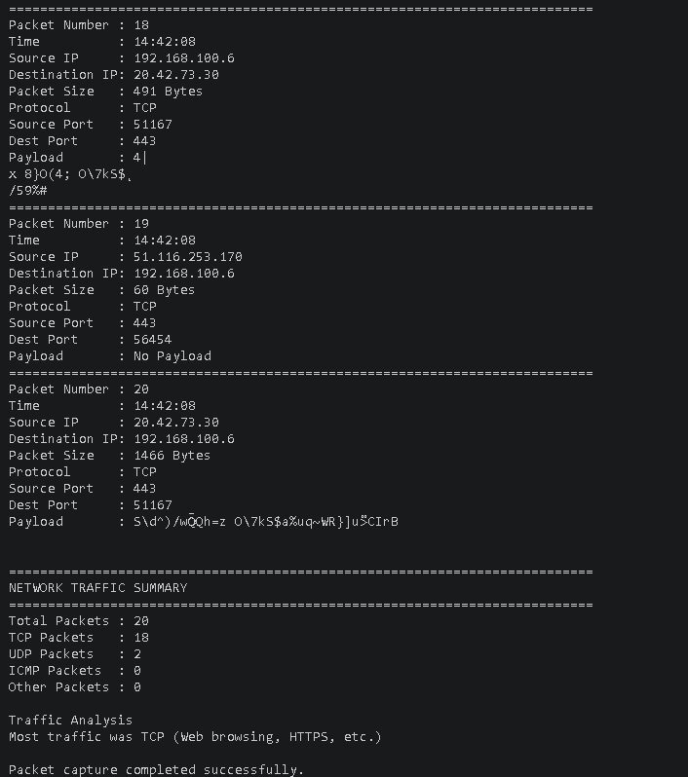

Traffic Analysis
Most traffic was TCP (Web browsing, HTTPS, etc.)
Packet capture completed successfully.

During testing, the majority of captured packets were TCP, which is expected for typical web browsing activity over HTTPS. A smaller number of UDP packets were observed, corresponding largely to DNS lookups, and occasional ICMP packets appeared during network diagnostic activity. These results confirm that the program correctly classifies traffic and reports an accurate summary.

7. CONCLUSION
This project successfully demonstrates how Python and the Scapy library can be used to capture and analyze live network traffic. It provided practical, hands-on experience with packet structures, common network protocols (TCP, UDP, and ICMP), and basic traffic analysis techniques. Completing this task has strengthened my understanding of how data moves through a network and how that traffic can be observed and interpreted for security and diagnostic purposes, directly fulfilling the requirements of CodeAlpha Cyber Security Internship Task 1.

7.1 Applications
- Network monitoring and diagnostics
- Cybersecurity and intrusion detection
- Protocol-level traffic analysis
- Network troubleshooting

7.2 Future Improvements
- Save captured packets to a PCAP file for later analysis in tools such as Wireshark
- Export traffic reports to CSV for record-keeping
- Add protocol-based filtering (capture only TCP, UDP, or ICMP)
- Add a simple menu-driven interface for choosing capture options
- Display live, continuously updating traffic statistics

