CodeAlpha
Cyber Security Internship Program

A Project Report on

PHISHING AWARENESS TRAINING: RECOGNIZING AND PREVENTING SOCIAL ENGINEERING ATTACKS
(Task 2: Phishing Awareness Training)
Submitted in partial fulfillment of the requirements of the
CodeAlpha Cyber Security Internship
By
Yusra Farooq
July 2026

DECLARATION
I declare that this project report, titled “Phishing Awareness Training: Recognizing and Preventing Social Engineering Attacks,” is my own original work, carried out as part of Task 2 (Phishing Awareness Training) of the CodeAlpha Cyber Security Internship. This work has not been submitted, in whole or in part, for any other program, degree, or internship.

Yusra Farooq

ACKNOWLEDGMENT
I would like to thank CodeAlpha for the opportunity to complete this internship and for providing clear task guidelines that made this project possible. I am also grateful for the guidance and resources made available throughout the internship, which helped me understand practical concepts in social engineering, phishing detection, and security awareness training.

ABSTRACT
This report presents a Phishing Awareness Training presentation developed to satisfy CodeAlpha Cyber Security Internship Task 2: Phishing Awareness Training. The module explains what phishing is, how attackers design and deliver phishing attempts, and the social engineering tactics that make these attacks effective. It covers the major categories of phishing: email phishing, spear phishing, whaling, smishing, vishing, clone phishing, and fraudulent websites and teaches practical recognition skills through annotated real-world examples, including a sample phishing email and a spoofed URL. A real-world vendor-impersonation case study illustrates the financial and operational impact of a successful attack, and an interactive two question quiz with explanations reinforces the key takeaways. The presentation concludes with a concise set of best practices for avoiding phishing attempts. The project demonstrates a practical understanding of social engineering, attacker psychology, and defensive security awareness, while remaining accessible enough for a general audience with no technical background.

1. INTRODUCTION

1.1 Overview
Phishing is a form of social engineering in which an attacker impersonates a trusted person or organization to trick a victim into revealing sensitive information such as passwords, financial details, or system access. Unlike many cyberattacks, phishing does not rely primarily on technical exploitation e it relies on manipulating human trust, urgency, and fear. According to the FBI's Internet Crime Complaint Center (IC3), phishing was the single most reported cybercrime category in 2024, and independent industry research consistently links a large share of both public-sector data breaches and enterprise network compromises to phishing and spear phishing. Because a single successful phishing attempt can expose an entire organization's network, recognizing and resisting these attempts is one of the most valuable skills an individual or employee can develop.

1.2 Objective
The objective of this project is to design and deliver a phishing awareness training presentation that equips a general audience with the knowledge needed to recognize phishing emails, fraudulent websites, and social engineering tactics, and to respond to them safely. The presentation explains the mechanics of a typical phishing attack, categorizes the different attack channels attackers use, highlights the psychological techniques that make phishing effective, walks through a real-world case study, and tests comprehension through an interactive knowledge check.

1.3 Scope
- Define phishing and quantify the scale of the threat using current industry statistics.
- Explain the anatomy of a phishing attack from the initial bait through to the resulting damage.
- Distinguish between the major categories of phishing: email phishing, spear phishing, whaling, smishing, vishing, clone phishing, and website phishing.
- Identify the visible red flags in phishing emails and fraudulent websites, supported by annotated real-world-style examples.
- Describe the social engineering tactics impersonation, trust exploitation, emotional manipulation, and social media reconnaissance that attackers rely on.
- Present a real-world case study of a vendor-impersonation attack and the lessons it teaches.
- Reinforce learning with an interactive, scenario-based quiz and answer explanations.
- Summarize practical best practices for avoiding phishing attempts.

2. SOFTWARE AND HARDWARE REQUIREMENTS

2.1 Software Requirements
- Microsoft PowerPoint (or a compatible presentation application) for building and delivering the training module
- A PDF viewer, for distributing the presentation as a shareable handout

3. THEORY
Phishing is a social engineering technique in which an attacker impersonates a trusted entity a bank, a colleague, an executive, or a well-known brand in order to manipulate a victim into disclosing credentials, financial information, or other sensitive data. It is delivered through many channels, including email, text messages, phone calls, and fraudulent websites, and it depends on exploiting urgency, fear, curiosity, or trust rather than on breaking through technical defenses. A single successful click can compromise an entire organization's network, which is why phishing remains the most reported form of cybercrime.
Phishing attacks take several distinct forms. Email phishing is the classic, wide-net approach, in which deceptive messages mimic a trusted brand to harvest logins or payment details. Spear phishing narrows the target to a specific person or team, using personal or company details to appear credible, and is behind the large majority of enterprise network breaches. Whaling is a spear-phishing attack aimed specifically at executives or other high-value targets, often through fake board requests or urgent wire-transfer approvals. Smishing and vishing move the attack to SMS text messages and phone calls respectively, frequently using shortened links or spoofed caller ID to manufacture legitimacy. Clone phishing duplicates a legitimate, previously delivered email and swaps its link or attachment for a malicious version, while website phishing relies on fraudulent pages that imitate real login screens to harvest credentials directly.
Underlying nearly every phishing attempt is social engineering: the deliberate exploitation of human psychology rather than software vulnerabilities. Attackers borrow authority by impersonating executives, IT staff, or vendors; they exploit existing trust relationships, including compromised colleague accounts; and they lean on emotional triggers such as fear, curiosity, greed, or urgency to short-circuit careful thinking. Attackers also mine public social media profiles for personal details job role, location, interests to make bait messages feel personal and credible. Recognizing these patterns, rather than memorizing any single example, is what allows a person to resist phishing attempts they have never seen before.

4. METHODOLOGY AND DESIGN

4.1 Methodology
- Research current phishing statistics and attack trends from authoritative sources (FBI IC3, Verizon DBIR, SANS) to ground the training in real data.
- Structure the session as a logical progression: define the threat, explain how an attack unfolds, classify attack types, teach recognition skills, expose the psychology behind the attacks, walk through a real case, test comprehension, and summarize defensive habits.
- Design each slide around a single idea, pairing concise text with visual cues icons, statistics, and annotated examples so the material remains engaging rather than text-heavy.
- Build realistic, illustrative examples of a phishing email and a spoofed URL and annotate each with its specific red flags.
- Include a real-world style case study that connects the abstract concepts to a concrete financial and organizational impact.
- Close the session with an interactive knowledge check and a set of best practices that the audience can apply immediately.

4.2 Presentation Structure
- Slide 1 – Title slide introducing the program and headline phishing statistics.
- Slide 2 – Session roadmap outlining the seven topics to be covered.
- Slide 3 – Definition of phishing and the scale of the threat.
- Slide 4 – Anatomy of a phishing attack, from bait to damage.
- Slides 5–6 – The six major categories of phishing attacks.
- Slide 7 – Red flags for recognizing phishing emails.
- Slide 8 – An annotated sample phishing email with each red flag labelled.
- Slide 9 – Recognizing fake websites through URL inspection and other cues.
- Slide 10 – The social engineering tactics behind successful attacks.
- Slide 11 – A real-world vendor-impersonation case study and its lessons.
- Slide 12 – Best practices for avoiding phishing.
- Slides 13–14 – An interactive two-question knowledge-check quiz with explained answers.
- Slides 15–16 – Closing summary, references, and contact information for reporting suspicious messages.

5. IMPLEMENTATION
The training module was implemented as a sixteen-slide presentation. The opening slides establish why phishing matters, citing that phishing was the most reported cybercrime category to the FBI's Internet Crime Complaint Center in 2024, that a significant share of public-sector breaches involved phishing according to the Verizon Data Breach Investigations Report, and that the large majority of enterprise network breaches trace back to spear phishing according to SANS research. From there, the anatomy of an attack is broken into five stages the bait, the hook, the trap, the catch, and the damage to show the audience that breaking the chain at any single stage stops the entire attack.
The six phishing categories email phishing, spear phishing, whaling, smishing, vishing, and clone phishing, alongside fraudulent websites are each defined with a short description and a representative example, so the audience can map any message they receive onto a recognizable pattern. Recognition is then taught through two annotated examples: a sample phishing email with each red flag labelled directly on the message (a mismatched sender domain, a generic greeting, manufactured urgency, a vague sign-off, and a suspicious link), and a fraudulent URL example demonstrating a misspelled domain and unusual subdomain structure. A dedicated slide addresses the psychological tactics behind social engineering impersonation and authority, exploited trust, emotional manipulation, and social media reconnaissance supported by data showing that even low-stakes, casual bait messages can be highly effective because they lower a recipient's guard.
A real-world style case study follows, describing a mid-size enterprise that fell victim to a spear-phishing attack in which a criminal impersonated a trusted vendor and altered payment details on a spoofed invoice, resulting in funds being sent to the attacker before the discrepancy was caught. Five concrete lessons are drawn from the case, including independent verification of payment changes and role-specific training for finance staff. The module concludes with six best practices verifying requests independently, never replying to spam, guarding personal information, keeping software updated, training the whole team on an ongoing basis, and reporting suspicious messages followed by a two-question interactive quiz, complete answer explanations, and a closing call to “pause before you click.”

6. RESULTS AND DISCUSSION
The presentation was reviewed slide by slide to confirm that the content, statistics, and visual design communicate the intended lessons clearly. Selected slides from the final deliverable are shown below.
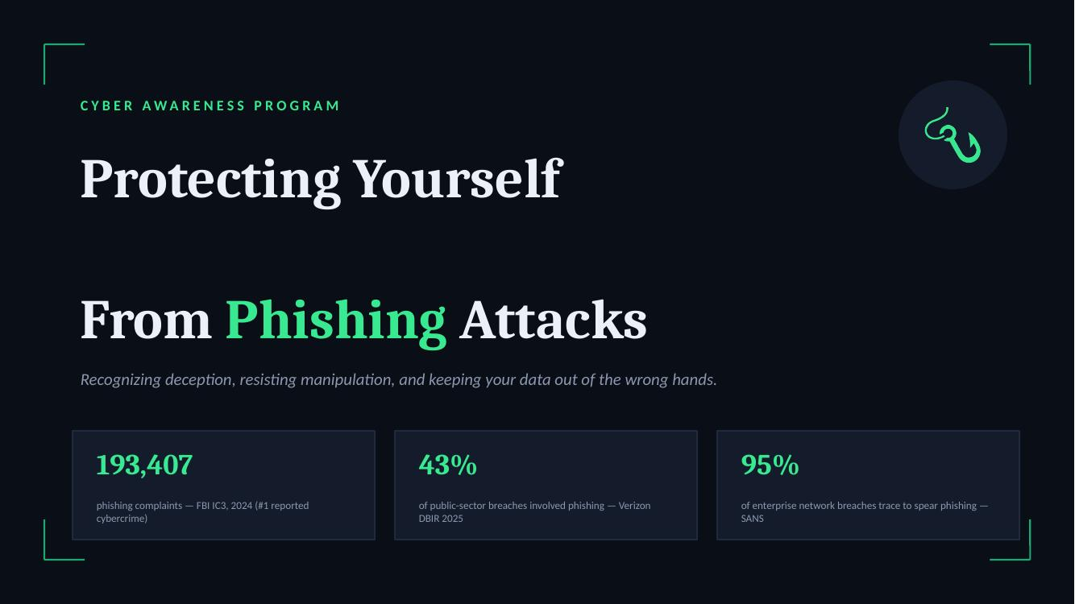
Figure 1: Title slide introducing the training program and headline phishing statistics.
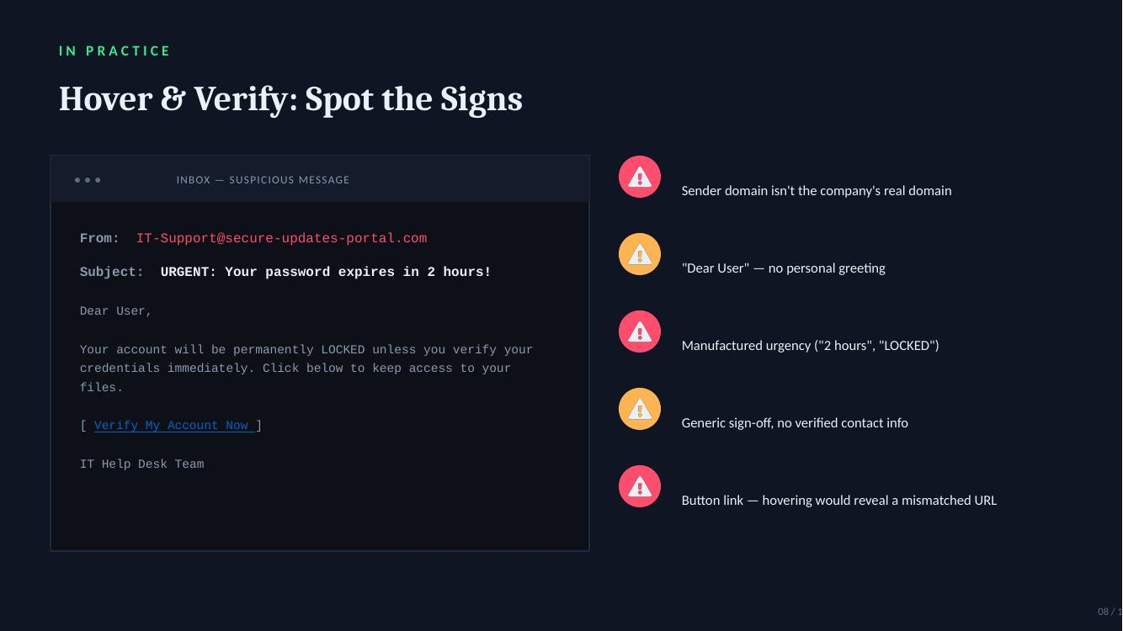
Figure 2: Annotated sample phishing email with each red flag labelled for the audience.
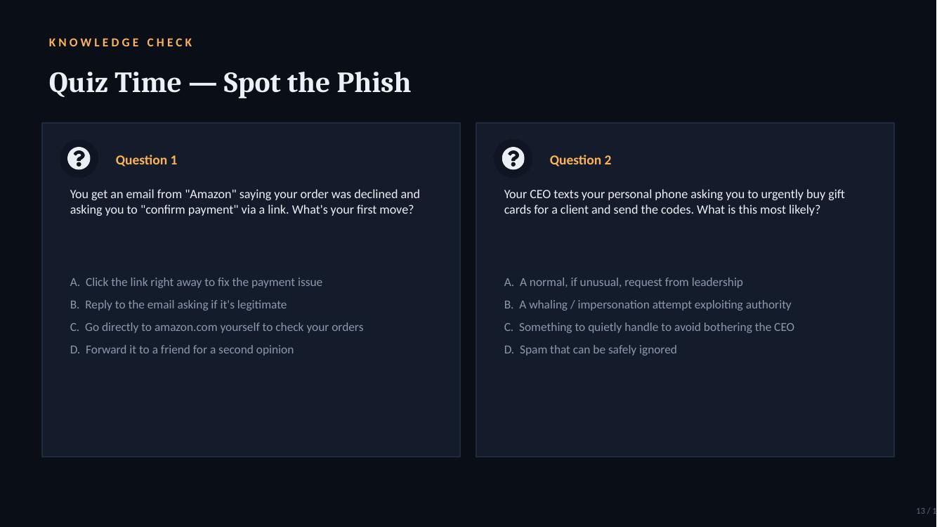
Figure 3: Interactive knowledge-check quiz used to reinforce the training material.
The final presentation successfully walks a general, non-technical audience from a basic definition of phishing through to practical, independently verifiable defensive habits. The annotated email and URL examples were the most directly actionable slides, since they translate abstract advice (“look for red flags”) into a labelled, concrete example the audience can compare against their own inbox. The case study grounded the material in a realistic financial consequence, which helps counter the common assumption that phishing only targets careless individuals rather than well-run organizations. The quiz format, followed immediately by worked explanations, reinforced the single most important habit taught throughout the session: verifying any unusual or urgent request through a separate, independently trusted channel rather than through the link, number, or reply option provided in the suspicious message itself.

7. CONCLUSION
This project successfully demonstrates how a structured, example-driven presentation can build practical phishing-recognition skills in a general audience. It provided hands-on experience with researching current threat statistics, breaking down attacker methodology into a teachable structure, and designing recognition exercises that translate directly into real-world vigilance. Completing this task strengthened my understanding of both the technical delivery mechanisms of phishing and the social engineering psychology that makes it so consistently effective, directly fulfilling the requirements of CodeAlpha Cyber Security Internship Task 2.

7.1 Applications
- Employee security-awareness onboarding and refresher training
- Organization-wide phishing-prevention campaigns
- Educational modules for students and general public digital-literacy programs
- Supplementary material alongside simulated phishing test campaigns

7.2 Future Improvements
- Convert the presentation into a self-paced, clickable e-learning module with score tracking
- Expand the quiz into a larger, randomized question bank for repeat training cycles
- Add short video walkthroughs of real (redacted) phishing attempts
- Include role-specific tracks for finance, HR, and IT staff
- Track completion and quiz performance to measure organizational risk over time

