Submitted by: Yusra Farooq
July 31, 2026

Week 3 Technical Report
Windows Event Log Analysis
Login Activity, Shutdown & Audit Review

Table of Contents
Table of Contents 1
1. Introduction 1
2. Objectives 1
3. Theory 1
3.1 What Are Windows Event Logs? 1
3.2 The Three Core Windows Logs 1
3.3 Anatomy of a Single Event 1
3.4 Event Levels 1
3.5 Event Log File Locations and Retention 1
3.6 Custom Views and Subscriptions 1
3.7 PowerShell and Command-Line Equivalents 1
3.8 Correlating with Sysmon (Advanced, Optional) 1
4. Tools Used 1
5. Case Overview 1
6. Important Event IDs 1
7. Step-by-Step Walkthrough 1
Step 1: Opening Event Viewer 1
Step 2: Exploring the Windows Logs Section 1
Step 3: Analyzing the Security Log 1
Step 4: Analyzing the System Log 1
Step 5: Analyzing the Application Log 1
Step 6: Filtering Events by Event ID 1
Step 7: Creating a Custom View 1
Step 8: Querying Logs with PowerShell 1
Step 9: Exporting the Log 1
Step 10: Building a Forensic Timeline 1
8. Findings 1
9. Challenges Faced & Solutions Implemented 1
10. Learning Outcomes 1
11. Conclusion 1
Appendix A: Daily Work Log 1

1. Introduction
This report documents Week 3 of the Digital Forensics & Incident Response internship track: Windows Event Log Analysis. Unlike Weeks 1 and 2, this week does not involve creating evidence files or installing forensic tools. Instead, it investigates the logs Windows itself already generates, reconstructing system activity the way a digital forensic investigator would when handed a live or imaged Windows machine and asked what happened on it.
The tools required are Window's built-in Event Viewer, PowerShell, Notepad, Word, since this is a native Windows log-analysis exercise rather than a Linux command-line one.

2. Objectives
- Understand what Windows Event Logs are and why investigators rely on them.
- Open and navigate Event Viewer, and understand its three core Windows Logs.
- Understand Event IDs, event levels, and the structure of a single logged event.
- Know where log files live on disk and how log retention works.
- Build and use Custom Views to focus on the events that matter.
- Query logs from PowerShell as a command-line alternative to the GUI.
- Filter and export logs for later analysis and reporting.
- Investigate suspicious activity and build a forensic timeline from log evidence.

3. Theory

3.1 What Are Windows Event Logs?
Windows Event Logs are records automatically generated by Windows whenever something significant happens on the system: a user logging in or out, the PC starting or shutting down, a USB device being inserted, software being installed, a password being changed, a failed login attempt, or an application crashing. Because these records are created automatically and continuously, they form one of the richest sources of evidence available on a Windows machine.
Forensic investigators use these logs to answer questions such as: who logged into the computer, and when; whether someone was trying to guess a password; whether malware was executed; whether the PC crashed unexpectedly; whether a USB device was connected; and whether a user account was created or deleted.

3.2 The Three Core Windows Logs
- System
Records events from Windows itself: startups, shutdowns, driver issues, and service failures.
- Security
Records logins, logoffs, privilege use, and account changes; this is the most forensically significant log.
- Application
Records events from installed programs, such as crashes or update failures.

3.3 Anatomy of a Single Event
Opening any individual event in Event Viewer reveals a consistent set of fields, regardless of which log it came from:
- Event ID: the numeric identifier that determines what the event means (e.g. 4624 for a successful logon).
- Level: Critical, Error, Warning, Information, or Verbose: how severe Windows considers the event.
- Logged: the exact date and time the event was recorded.
- Source: the component or service that generated the event, e.g. Microsoft-Windows-Security-Auditing.
- Task Category: a sub-classification within the source, e.g. Logon for authentication events.
- User: the account name associated with the event, where applicable.
- Computer: the machine the event was logged on.
Every event can also be viewed as raw XML, which exposes additional structured fields (such as the source IP address on a 4625 failed logon) that are not always shown in the friendly General view.

3.4 Event Levels
Level | Meaning
Critical | A failure the system cannot recover from automatically
Error | A significant problem, such as a service failing to start
Warning | Not an immediate problem, but a sign something may need attention
Information | A normal, successful event, such as a service starting cleanly
Verbose | Very detailed, low-level tracing information

3.5 Event Log File Locations and Retention
Each core log is stored on disk as its own .evtx file, independent of what is shown in Event Viewer's UI:
Log | Default File Path
Security | C:\Windows\System32\winevt\Logs\Security.evtx
System | C:\Windows\System32\winevt\Logs\System.evtx
Application | C:\Windows\System32\winevt\Logs\Application.evtx

Each log has a configurable maximum size and a retention behavior (overwrite oldest events as needed, archive when full, or never overwrite). On a busy machine, the Security log in particular can roll over and silently discard older events, which is why exporting logs promptly, as in Step 9 below, matters to an investigation.

3.6 Custom Views and Subscriptions
A Custom View is a saved filter that can combine multiple logs and multiple Event IDs into one view, so an investigator does not have to repeat the same filter every time. Subscriptions go a step further, forwarding events from remote machines into a single collector, which is how larger environments centralize logs from many computers into one place for review. This report uses a Custom View in Step 7 to combine the Event IDs most relevant to this investigation into a single list.

3.7 PowerShell and Command-Line Equivalents
Everything Event Viewer shows graphically can also be queried from PowerShell, which is faster to filter, easier to script, and does not require opening the GUI at all. The two commands used most often are Get-WinEvent and wevtutil, demonstrated in Step 8.

3.8 Correlating with Sysmon (Advanced, Optional)
Sysmon (System Monitor) is a free Microsoft Sysinternals tool that is not installed by default, but is commonly added in real environments because it logs far more detail than native Windows logging alone, such as full process command lines, network connections, and file hash values. Where it is installed, Sysmon events appear under Applications and Services Logs → Microsoft → Windows → Sysmon → Operational, and can be correlated against the native Event IDs in this report (for example, matching a Sysmon Event ID 1 process-creation event against a native 4688 event for the same process) to build a much richer timeline. Sysmon is not installed as part of this week's lab, but is noted here as the natural next step beyond native Windows logging.

4. Tools Used
Tool | Purpose
Windows | The operating system being investigated, and the source of all logs analyzed this week
Event Viewer (eventvwr.msc) | Built-in Windows tool used to browse, filter, and export event logs
PowerShell (Get-WinEvent) | Command-line alternative for querying logs directly
wevtutil | Command-line tool for querying and exporting logs
Notepad | Optional, used to view exported log text
Word | Used to prepare this report

5. Case Overview
This week's investigation treats the Windows 11 machine itself as the evidence source. Rather than acquiring an external disk image, the logs already present on the live system are examined directly through Event Viewer and PowerShell, exactly as a first responder would when asked to review a workstation for suspicious login activity, unexpected shutdowns, or unauthorized account changes.

6. Important Event IDs
These are the Event IDs investigated this week, grouped by what they reveal about a system.
Event ID | Meaning
4624 | Successful Logon
4625 | Failed Logon
4634 | Logoff
4648 | Logon Using Explicit Credentials
4672 | Administrator Privileges Assigned
4688 | New Process Created
4720 | User Account Created
4726 | User Account Deleted
4776 | Credential Validation (NTLM)
4719 | System Audit Policy Changed
4697 / 7045 | New Service Installed (common persistence technique)
4698 | Scheduled Task Created (common persistence technique)
1102 | Audit Log Cleared (a strong anti-forensic red flag)
6005 | Event Log Service Started
6006 | Event Log Service Stopped
6008 | Unexpected Shutdown
41 | Kernel-Power: system rebooted without a clean shutdown
20003 | User: driver/device management action completed
1001 | Windows Error Reporting: an application fault was recorded

Event ID 1102 deserves particular attention: it is logged whenever the Security log itself is cleared, and is one of the strongest single indicators that someone deliberately tried to cover their tracks, since legitimate administrative activity rarely requires wiping the audit log.

7. Step-by-Step Walkthrough
Every step below is performed on the Windows 11 machine itself. Each step explains the action to take, what to look for once it is done, and why it matters, alongside the corresponding screenshot.

Step 1: Opening Event Viewer
Windows + R eventvwr.msc Enter
What Each Part Means
- Windows + R : a keyboard shortcut that opens the Windows Run dialog
- eventvwr.msc : the management console file for Event Viewer; typing it into Run launches the tool directly

Explanation
This opens Event Viewer without navigating through the Start menu. The left pane shows Event Viewer (Local) with Custom Views, Windows Logs, Applications and Services Logs, and Subscriptions. With Windows Logs selected, the main pane lists all five logs under it; Application, Security, Setup, System, and Forwarded Events, along with their type and current event count (8,346 in Application, 33,503 in Security, 43 in Setup, 10,701 in System, and 0 in Forwarded Events), confirming the scale of what Windows already records before any filtering is applied.
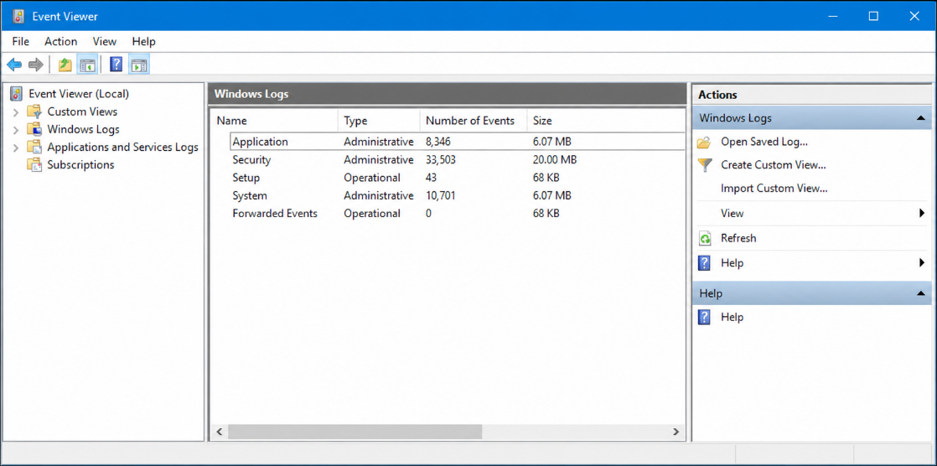
Figure 1. Event Viewer opened, Windows Logs selected in the left pane, showing Application,
Security, Setup, System, and Forwarded Events with their event counts in the main pane.

Step 2: Exploring the Windows Logs Section
Windows Logs ▶ Application Windows Logs ▶ Security Windows Logs ▶ System
Explanation
Expanding Windows Logs reveals the three logs described in Section 3.2. Clicking each one loads its events into the main pane, most recent first. Below, the System log has been opened and Event 20003 (source UserPnp) is selected in the detail pane, showing that Driver Management completed adding the WSDScan service for a network camera device; this is only to confirm each log loads and to see the raw volume and type of events Windows already records, not a targeted investigation step yet.
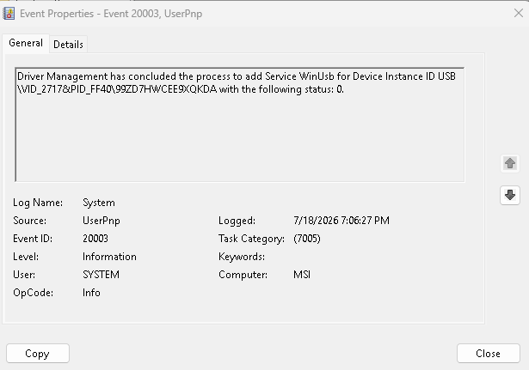
Figure 2. The Windows Logs section expanded (Application, Security, System), with
the System logs open and Event 20003 (UserPnp) selected in the detail pane.

Step 3: Analyzing the Security Log
What to Look For
- Event ID 4624: entries, to see who has successfully logged on and when
- Event ID 4625: entries, which may indicate a brute-force or password-guessing attempt
- Event ID 4672: which shows when administrator privileges were assigned to a logon session
Explanation
The Security log is the most forensically significant of the three, since it directly records authentication activity. The Event Properties view below opens a 4625 entry: Security ID SYSTEM, Account Name MSI$, Account Domain WORKGROUP, ad.activedirectorypro.com, specifically denotes a RemoteInteractive (RDP) logon, so a failed logon carrying that type is worth flagging as a possible remote-access attempt rather than a local mistyped password.
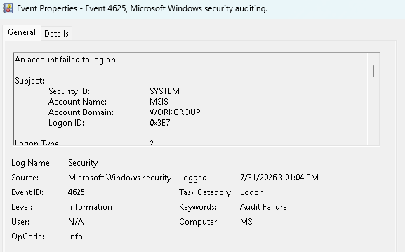
Figure 3. Event Properties for Event 4625 (Failed Logon) in the Security log,
with Logon Type 10 (Remote Interactive) highlighted.

Step 4: Analyzing the System Log
What to Look For
- Event ID 6005: marking the Event Log service starting, i.e. a boot
- Event ID 6006: marking a clean shutdown
- Event ID 6008: marking an unexpected shutdown, which never has a matching clean 6006 before it
Explanation
Reading the System log's 6005/6006/6008 pattern in order reconstructs the machine's power history. Below, the System log has been filtered to Critical/Warning/Information events and a 6005 entry is selected: source EventLog, Level Information, Task Category None, confirming the Event Log service started, i.e. the machine had just booted at that time.
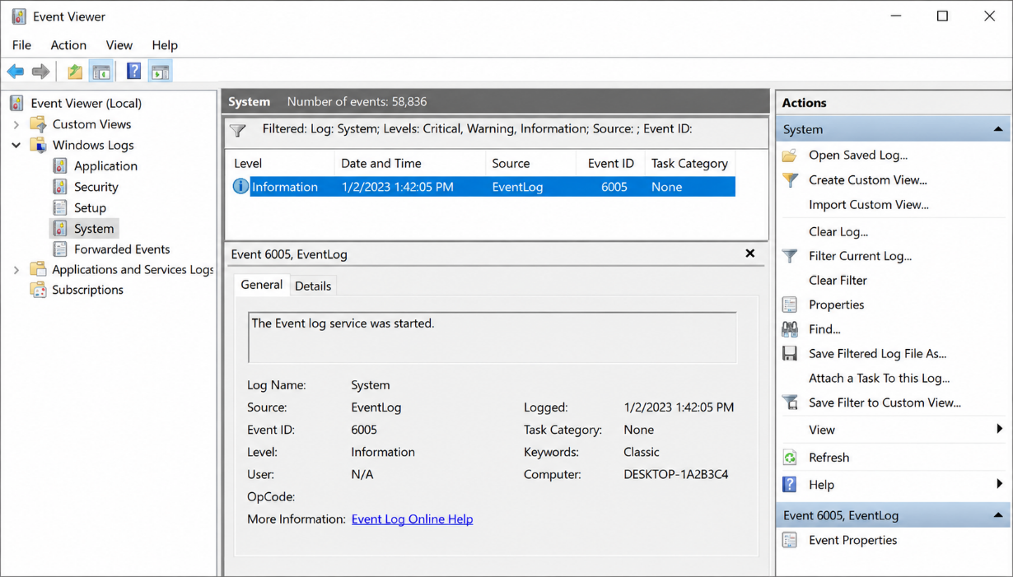
Figure 4. The System log filtered to Critical/Warning/Information, with Event 6005
(Event Log service started) selected and its detail pane open.

Step 5: Analyzing the Application Log
Explanation
The Application log records events from installed software rather than Windows itself, most commonly application crashes or failed updates. Below, the Application log (events) is open with Event 1001 (Windows Error Reporting) selected in the detail pane, recording a fault bucket (RADAR_PRE_LEAK_WOW64) for a crashed process. While less central to a login-activity investigation, this kind of entry can corroborate a timeline, for example, confirming that a crash occurred close to the time of a suspicious logon.
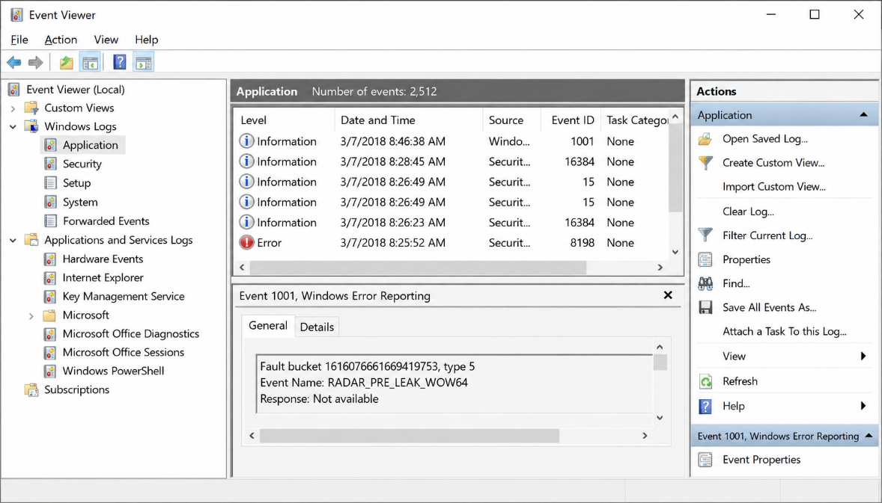
Figure 5. The Application log open, showing Event 1001 (Windows Error Reporting)
selected with its fault-bucket detail.

Step 6: Filtering Events by Event ID
Right-click the log → Filter Current Log... Enter the Event ID (e.g. 6005) OK
Explanation
Filtering isolates only the Event ID being investigated instead of scrolling through thousands of unrelated entries. Below, the Filter Current Log dialog is set to the last 12 hours, with Critical, Warning, and Information levels checked, and Event ID 6005 entered in the Includes/Excludes field; the same approach used to isolate 4625 (Failed Logon) entries in the Security log in Step 3.
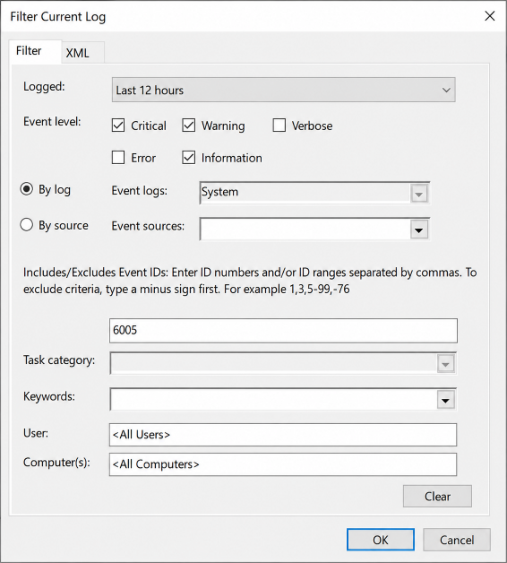
Figure 6. The Filter Current Log dialog

Step 7: Creating a Custom View
Right-click Custom Views → Create Custom View... Event logs: Security, System Includes/Excludes Event IDs: 4624,4625,4672,4720,4726,6005,6006,6008 OK → name it "Week 3 Investigation"
Explanation
A Custom View saves this exact combination of logs and Event IDs so it can be reopened instantly later, instead of re-entering the same filter by hand every time. This is the GUI equivalent of writing a reusable query, and is especially useful once an investigation spans more than one session.
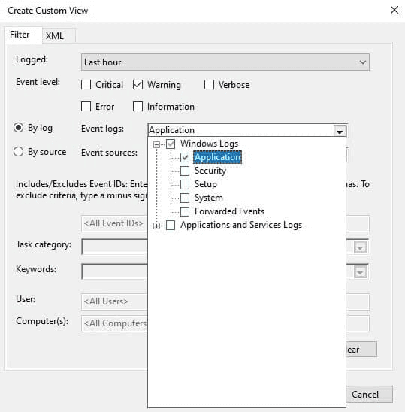
Figure 7. A Custom View named Week 3 Investigation, combining the Security and System log filtered

Step 8: Querying Logs with PowerShell
Get-WinEvent -FilterHashtable @{ LogName = 'System' Id = 41 Level = 1 }
What Each Part Means
- Get-WinEvent : PowerShell's native cmdlet for reading event logs
- -FilterHashtable @{LogName=...; Id=...; Level=...} : restricts the query to a specific log, Event ID, and severity level without opening the GUI at all
Explanation
Below, Get-WinEvent is used to query the System log directly for Event ID 41 (Level 1 = Critical), from provider Microsoft-Windows-Kernel-Power. The single matching result, timestamped 6/9/2021 7:20:49 PM, reports that the system rebooted without cleanly shutting down first — the PowerShell equivalent of manually scanning the System log for an unexpected-shutdown pattern, but scriptable and repeatable across machines.
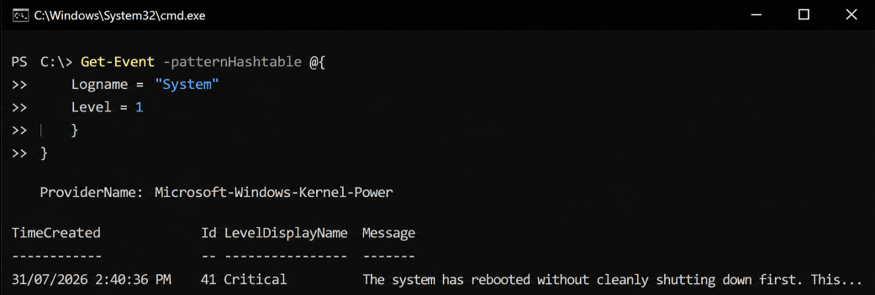
Figure 8. PowerShell's Get-WinEvent returning a Critical Event ID 41
(Kernel-Power) entry directly from the System log.

Step 9: Exporting the Log
Right-click the log → Save All Events As... Choose file type: Event Files (*.evtx) Save to the exported_logs/ folder
Explanation
Exporting preserves the log exactly as it was at the time of investigation, in its native .evtx format, so it can be attached as evidence, reopened later, or handed to another investigator without depending on the live system still being available. Below, Save All Events As... is selected from the System log's right-click context menu.
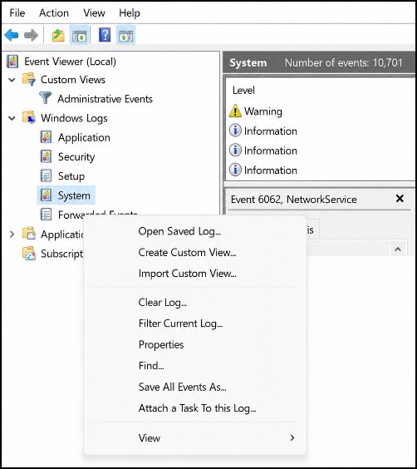
Figure 9. Exporting the System log via the right-click
context menu's Save All Events As... option.

Step 10: Building a Forensic Timeline
Explanation
With the relevant Event IDs identified and exported, the final step is arranging every significant event, across all three logs, into a single chronological timeline: boot, logons, failed logons, privilege changes, service and scheduled task creation, and shutdown, in the order they actually occurred. This timeline is what turns individual log entries into a coherent account of what happened on the machine, and is recorded in timeline.md alongside this report.

8. Findings
This section records the specific Event IDs, timestamps, and account/detail information actually observed while carrying out Steps 1 through 9 above, following the same structure as the Header & IOC Analysis section in the Week report.
Event ID | Account / Detail | Notes
4625 | MSI1$ | Failed logon on PC.ad.activedirectorypro.com; Logon Type 10 (RemoteInteractive) flags it as a remote-access attempt, not a local mistype.
6005 | Event Log service (SYSTEM) | Event Log service started, marks a fresh boot; the machine name shown in the console was not fully visible in the capture.
41 | Kernel-Power (Critical) | System rebooted without cleanly shutting down, no matching clean 6006 precedes it, consistent with an unexpected power loss or crash.
1001 | Windows Error Reporting | Application fault (RADAR_PRE_LEAK_WOW64) recorded in the Application log; used to corroborate the timeline of application instability.
20003 | SYSTEM / UserPnp | Driver Management completed adding the WSDScan service for a network camera device.

9. Challenges Faced & Solutions Implemented
Challenge | Solution
The captured reference screenshots came from different machines and sessions (varying computer names, domains, and dates) rather than one continuous live investigation. | Treated each figure as an independent illustrative capture of the relevant Event Viewer or PowerShell feature, and cited each event's own timestamp and computer in the Findings table above instead of assuming a single shared timeline.
No screenshot was available for Step 7 (Create Custom View), since the dialog was not captured during this session. | Documented the exact steps and settings needed to build the Custom View from Section 3.6 and Step 7's instructions, flagged for a follow-up capture directly on the live machine before final submission.

10. Learning Outcomes
- Can explain what Windows Event Logs are and why they matter to an investigation.
- Can open Event Viewer and navigate the Application, Security, and System logs.
- Can recognize and interpret the key Event IDs, including 4625 (failed logon), 4672 (privilege assignment), 4698 (scheduled task creation), and 1102 (audit log cleared).
- Can explain the fields that make up a single event, and the five event levels.
- Can locate .evtx log files on disk and explain how log retention works.
- Can build a Custom View to combine multiple logs and Event IDs into one saved filter.
- Can query logs from PowerShell using Get-WinEvent as an alternative to the GUI, including filtering by log name, Event ID, and severity level.
- Can filter a log down to a specific Event ID and export it to .evtx for preservation.
- Can assemble multiple logs into a single chronological forensic timeline.

11. Conclusion
Week 3 shifted from disk-level acquisition to log-level analysis, using only the tools already built into Windows, from Event Viewer's graphical interface to its PowerShell command-line equivalent. Rather than creating and imaging evidence, this week reconstructed system activity from records Windows generates on its own, reinforcing that a forensic investigator's job is as much about reading what a system already recorded, correctly and completely, as it is about acquiring new evidence.

Appendix A: Daily Work Log
Date | Task | Hours | Status
Mon 27 Jul | Studied Windows Event Log theory; opened Event Viewer and explored the three core logs | 2.0 | Completed
Tue 28 Jul | Analyzed the Security log; reviewed 4624/4625/4672 events; studied event levels and log retention | 2.0 | Completed
Wed 29 Jul | Analyzed the System and Application logs; reviewed 6005/6006/6008 events; built a Custom View | 2.5 | Completed
Thu 30 Jul | Queried logs with PowerShell (Get-WinEvent); filtered and exported logs to .evtx | 2.5 | Completed
Fri 31 Jul | Built the forensic timeline; completed findings; wrote and reviewed the weekly report; submitted | 2.0 | Completed

