Submitted by: Yusra Farooq
28 August 2026

Week 7 Technical Report
Incident Response Lifecycle & Timeline Creation
Consolidating Weeks 1-6 Timeline
Table of Contents
1. Introduction
2. Objectives
3. Theory
3.1 The Incident Response Lifecycle
3.2 What Is a Forensic Timeline, and Why Build One?
3.3 Timestamp Normalization and Confidence
3.4 Mapping Events to MITRE ATT&CK Tactics
3.5 Scoping: Deciding What Belongs on the Timeline
4. Tools Used
5. Case Overview: Reviewing Weeks 1-6
6. Files
Master Timeline
7. Step-by-Step Walkthrough
Step 1: Reviewing Weeks 1-6 for Dateable Events
Step 2: Deciding Scope: Which Weeks Belong on This Timeline
Step 3: Normalizing and Merging the Timeline
Step 4: Building the Visual Timeline
Step 5: Mapping the Incident to the IR Lifecycle
8. Findings: Master Timeline & IR Phase Mapping
9. Challenges Faced & Solutions Implemented
10. Learning Outcomes
11. Conclusion
Appendix A: Daily Work Log

1. Introduction
This report documents Week 7 of the Digital Forensics & Incident Response internship track: Incident Response Lifecycle and Timeline Creation. This week introduces no new evidence of its own. Instead, every prior week’s report Weeks 1 through 6 was reviewed in full, and every dateable, evidentially significant event belonging to the same case was consolidated into one master timeline. The incident as a whole is then mapped against the four phases of the NIST SP 800-61 incident response lifecycle.
A key part of this week’s work was determining which of the six prior weeks actually belong on this timeline. Not all of them do. Section 3.5 and Section 7 (Step 2) explain that decision in detail, but in short: Weeks 1, 4, 5, and 6 all investigate the same case the phishing and intrusion campaign against NexBank, Case DFIR and are merged below. Weeks 2 and 3 were procedural skills exercises against separate, unrelated evidence sets, and contributing their events to this timeline would misrepresent the case. They are excluded, and that exclusion is stated explicitly rather than left unexplained.
2. Objectives
- Review Weeks 1 through 6 of this internship and extract every event relevant to Case DFIR.
- Understand the four phases of the NIST SP 800-61 incident response lifecycle.
- Understand why a consolidated forensic timeline is more valuable than isolated per source findings.
- Practice normalizing timestamps from multiple independent sources into a single consistent format, and recording confidence honestly where an exact time was not available.
- Correctly scope a timeline: include what belongs to the case, and explicitly exclude what does not.
- Map recovered events to MITRE ATT&CK tactics to describe attacker behavior in standard terminology.
- Map the reconstructed incident against each phase of the IR lifecycle, including recommended next actions.
3. Theory
3.1 The Incident Response Lifecycle (NIST SP 800-61)
NIST SP 800-61 defines incident response as a continuous cycle of four phases, rather than a one-time linear process:
- Preparation: Establishing the tools, procedures, and training needed to handle an incident before one occurs; evidence-handling standards, hashing procedures, and access to the right forensic tools.
- Detection & Analysis: Recognizing that an incident has occurred and determining its scope, timeline, and root cause. This is where forensic investigation the work carried out across Weeks 1-6 belongs.
- Containment, Eradication & Recovery: Limiting damage (containment), removing the attacker’s foothold (eradication), and restoring normal operations (recovery).
- Post-Incident Activity: Documenting what happened, identifying control gaps that allowed it, and feeding lessons back into Preparation for the next cycle.
Because the last phase feeds directly back into the first, this is properly a cycle rather than a one-off sequence which is why Figure 1 in this report is drawn as a loop rather than a straight line.
3.2 What Is a Forensic Timeline, and Why Build One?
A forensic timeline is a single, chronologically ordered record of every dateable event recovered from every evidence source in a case. Individually, Week 1’s email/IOC analysis, Week 4’s browser/email artifacts, Week 5’s memory capture, and Week 6’s second-wave phishing analysis each told a partial story. Merged into one timeline and sorted by timestamp, they reveal the actual sequence of the incident: which event caused which, how long the attacker’s access persisted, and whether activity clusters around specific moments. This is exactly how this exercise surfaced something no single week’s report showed on its own see Section 8.
3.3 Timestamp Normalization and Confidence
Every evidence source records time differently, and not every source recorded an exact time at all. Week 1’s report, for example, records only the date the phishing email was received (13 July 2026), not a time of day. Rather than inventing a false precision, every event in this timeline is tagged with a Timestamp Confidence value: Exact for timestamps taken directly from source evidence (browser history entries, email Date headers), and Approximate for timestamps that had to be reasonably inferred from surrounding context. This distinction is preserved all the way through into the master timeline table, the spreadsheet, and the visual timeline, rather than being flattened away.
3.4 Mapping Events to MITRE ATT&CK Tactics
The MITRE ATT&CK framework provides a standard vocabulary for describing attacker behavior (Initial Access, Execution, Command and Control, and others), independent of the specific tool or actor involved. Tagging each timeline event with its tactic makes the timeline readable at a glance a reviewer can see the shape of the attack without reading every row and makes it directly comparable to other incidents and to threat-intelligence reporting that uses the same framework.
3.5 Scoping: Deciding What Belongs on the Timeline
Not every internship exercise is part of the same case. Before merging anything, each week’s report was checked for two things: does it name the same workstation, user, domain, or IP as the other weeks, and does its own case identifier match. Weeks 1, 4, 5, and 6 all passed this check against Case DFIR. Weeks 2, a generic seized-laptop disk-imaging exercise) and 3 (Windows Event Log analysis on an unrelated host, PC.ad.activedirectorypro.com) did not. Merging their events in anyway would have produced a timeline that looked more complete but was actually wrong a timeline is only useful if every event on it genuinely belongs to the case being investigated.
4. Tools Used
- Weeks 1-6 source reports reviewed in full as the source material for this week’s timeline.
- Microsoft Excel to compile, sort, and filter the consolidated master timeline.
- sha256sum to hash every evidence and deliverable file produced this week.
5. Case Overview: Reviewing Weeks 1-6
Case DFIR runs through four of the six prior weeks:
Week | Focus
Week 1 | Email header & IOC analysis of the original phishing email (m. tariq)
Week 2 | Disk imaging practice on a separate, purpose-built evidence set
Week 3 | Windows Event Log analysis on an unrelated host
Week 4 | Browser and email forensics on the same NexBank workstation from Week 1
Week 5 | Live memory forensics recovering the same C2 IP seen in Weeks 1 & 4
Week 6 | A second phishing wave using the same lure domain as Week 4, against a different employee

Read together, Weeks 1, 4, 5, and 6 describe a single, continuing campaign rather than four separate incidents. Week 1 opened the case with a credential-harvesting email sent to m.tariq@nexbank-corp.com from secure-it-service.net (Reply-To mail-secure-portal.com, sending IP 185.220.101.47). Week 4’s browser history shows that same link being clicked, followed shortly after by a second, malware-delivering email from a different lure domain, freegiftcards-claim.net, on the same morning. Week 5’s live memory capture, roughly a month later, found 185.220.101.47 the exact IP from Week 1 still active as a command-and-control address. Week 6 found a second wave of the freegiftcards-claim.net campaign, now targeting a different, from a new IP in the same /24 block. Section 7 walks through how these were merged; Section 8 presents the result.
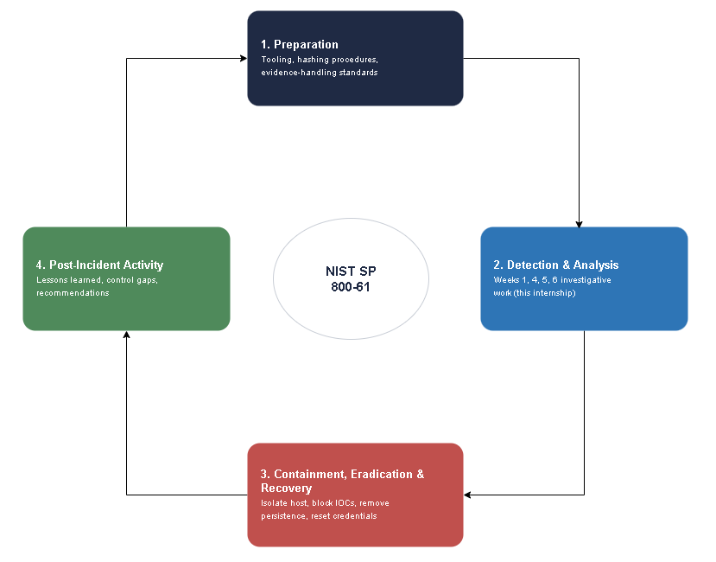
Figure 1. The NIST SP 800-61 incident response lifecycle. Weeks 1, 4, 5, and 6 of this internship sit entirely within Phase 2 (Detection & Analysis); Phases 3 and 4 are addressed as recommendations in Sections 8 and 11.
6. Files
A single consolidated workbook and its supporting files make up this week’s deliverable set.
Master_Timeline.xlsx: Consolidated Timeline Workbook & Hash Manifest
Master_Timeline.xlsx holds the eleven events recovered from Weeks 1, 4, 5, and 6, each recorded with its date, time, source week, description, MITRE ATT&CK tactic, and a timestamp-confidence flag (Exact or Approximate), sorted chronologically with filtering enabled on every column.
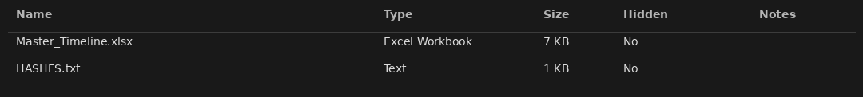
Figure 2. The Week 7 deliverable set: the consolidated timeline workbook and its hash manifest.

File | SHA-256
Master_Timeline.xlsx | fedd491471a2072ef5c9c4ac8db3e800a50a1f80b5d62d606a3e99aae57ccbef
7. Step-by-Step Walkthrough
Step 1: Reviewing Weeks 1-6 for Dateable Events
Explanation
Each of the six prior reports was read in full and checked for two things: any timestamp or date tied to an actual event (not an investigator work-log entry), and any indicator a domain, IP, username, or case ID that could tie it to another week. This step is what surfaced the Week 1 IOCs (secure-it-service.net, mail-secure-portal.com, 185.220.101.47) reappearing in Week 4’s browser history, and the same IP reappearing again in Week 5’s memory capture.
Step 2: Deciding Scope: Which Weeks Belong on This Timeline
Explanation
As explained in Section 3.5, Weeks 2 and 3 were checked against the same criteria and did not match: different case IDs, different hostnames, no shared indicators with Weeks 1, 4, 5, or 6. They were excluded from the timeline that follows, and that exclusion is recorded explicitly in this report (Section 5) rather than silently dropped.
Step 3: Normalizing and Merging the Timeline
Explanation
Every event identified in Step 1 was entered into a single working spreadsheet, with its date and time written in plain form (e.g. 13 Jul 2026) rather than a coded format, alongside its source week, a plain-language description, its MITRE ATT&CK tactic, and a timestamp-confidence flag. The full set was then sorted chronologically and filtering was enabled on every column so a reviewer can isolate a single tactic, source week, or confidence level directly in Excel. Two events the original Week 1 email and the Week 5 memory acquisition are marked Approximate because their source reports did not record an exact time; every other event is Exact, taken directly from a browser history entry or an email header.
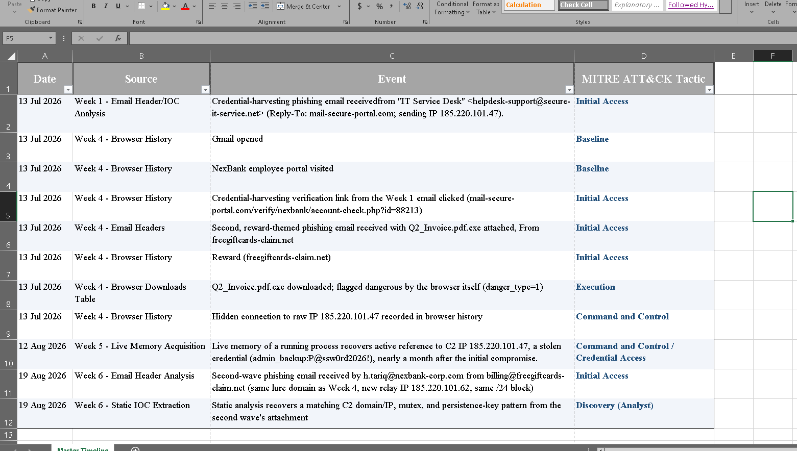
Figure 3. Master_Timeline.xlsx, showing all eleven events merged with each event’s source week, tactic
Step 4: Building the Visual Timeline
Explanation
The sorted sheet was rendered as a vertical visual timeline, with each event’s tactic color-coded and its confidence noted next to the time. This view makes the shape of the incident immediately visible, then a nearly five-week silence before Week 5’s memory capture caught the same C2 IP still active, and finally a second wave against a different employee on 19 August.
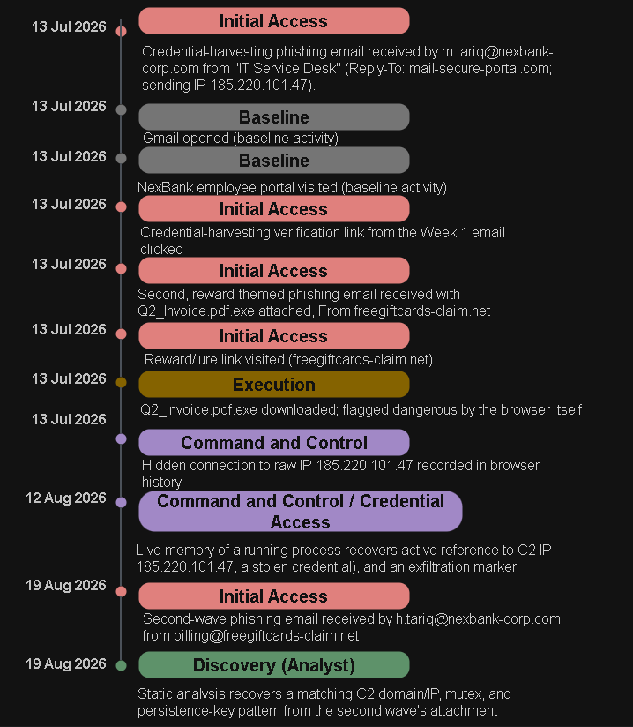
Figure 4. Visual master timeline of Case DFIR-2026-0714, consolidated from Weeks 1, 4, 5, and 6 and color-coded by MITRE ATT&CK tactic.
Step 5: Mapping the Incident to the IR Lifecycle
Explanation
With the timeline complete, the incident was placed against each phase of the lifecycle introduced in Section 3.1. Weeks 1 through 6 of this internship are, retroactively, the Detection & Analysis phase for this incident carried out over roughly six weeks, starting about the same day as the actual compromise but not concluding until now. Section 8 presents the recommended actions for the two phases that have not yet been carried out: Containment/Eradication/Recovery, and Post-Incident Activity.
8. Findings: Master Timeline & IR Phase Mapping
The complete master timeline for Case DFIR:
Date | Source | Event | Tactic
13 Jul 2026 | Week 1 | Credential-harvesting phishing email | Initial Access
13 Jul 2026 | Week 4 | Gmail opened (baseline) | Baseline
13 Jul 2026 | Week 4 | NexBank employee portal visited (baseline) | Baseline
13 Jul 2026 | Week 4 | Week 1 verification link clicked (mail-secure-portal.com) | Initial Access
13 Jul 2026 | Week 4 | Second phishing email received, Q2_Invoice.pdf.exe attached | Initial Access
13 Jul 2026 | Week 4 | Reward/lure link visited (freegiftcards-claim.net) | Initial Access
13 Jul 2026 | Week 4 | Q2_Invoice.pdf.exe downloaded, flagged dangerous | Execution
13 Jul 2026 | Week 4 | Hidden connection to raw IP 185.220.101.47 | Command and control
12 Aug 2026 | Week 5 | Live memory: same C2 IP, stolen credential, exfil marker | C2 / Credential Access
19 Aug 2026 | Week 6 | Second-wave phishing email received | Initial Access
19 Aug 2026 | Week 6 | Static analysis recovers matching C2/mutex/persistence IOCs | Discovery (Analyst)

IR Lifecycle mapping for this incident:
Phase | Status for This Incident | Recommended / Completed Actions
1. Preparation | Partially in place | Evidence-hashing and preservation procedures (Weeks 1 & 2) were followed correctly; email authentication (SPF/DKIM/DMARC enforcement) was not, which is what allowed both phishing waves through.
2. Detection & Analysis | Complete | Weeks 1, 4, 5, and 6 together reconstructed the full attack chain from initial access through a live, persistent C2 connection and a second wave against a new target.
3. Containment, Eradication & Recovery | Not yet performed | Isolate the affected host(s) from the network; block 185.220.101.0/24, secure-it-service.net, mail-secure-portal.com, and freegiftcards-claim.net at the firewall/DNS layer; reset credentials for m.tariq and h.tariq (and the exposed admin_backup account from Week 5); rebuild affected hosts from a known-clean image.
4. Post-Incident Activity | Not yet performed | Document the detection gap between Week 4 and Week 5; enforce a DMARC reject policy for inbound mail; add alerting on repeated contact to the same external IP across sessions; deliver phishing-awareness training referencing both lures used in this campaign.

The most significant finding is the same one this exercise was designed to surface: no single week’s report showed the full picture. Week 1 saw a phishing email. Week 4 saw a browser and a second email. Week 5 saw a live memory artifact. Week 6 saw a second wave. Only once all four are placed on one timeline does the actual shape of the campaign become visible a single-morning compromise on 13 July, active and undetected for roughly a month, followed by the same infrastructure being reused against a second employee in August.
9. Challenges Faced & Solutions Implemented
Challenge | Solution
Week 1’s report recorded only a date for the phishing email, not a time | Tagged the event Approximate and placed it consistently with the Week 4 browser timeline, rather than inventing a false precise time; documented this reasoning in Section 3.3 and directly in the workbook itself
Not every prior week belonged to the same case, but all six needed to be reviewed to find that out | Checked every week against shared case IDs, hostnames, domains, and IPs before merging anything; explicitly excluded Weeks 2 and 3 with the reasoning documented (Section 3.5, Section 5) rather than silently dropping them
A flat eleven-row table made the campaign’s shape (a tight cluster, then a month-long gap, then a second wave) hard to see at a glance | Built a color-coded visual timeline (Figure 4) with confidence annotations, in addition to the table, so the pattern is visible immediately

10. Learning Outcomes
- Can review a set of prior forensic reports and correctly identify which ones describe the same case.
- Can explain all four phases of the NIST SP 800-61 incident response lifecycle and where forensic investigation fits within it.
- Can normalize timestamps from multiple independent evidence sources into a single consistent format, and can distinguish an exact timestamp from an inferred one rather than presenting both with false equal confidence.
- Can build a consistent, filterable timeline workbook that a reviewer can query directly rather than a static write-up.
- Can tag events with MITRE ATT&CK tactics to describe attacker behavior in standard terminology.
- Can map a reconstructed incident against the IR lifecycle and produce concrete containment/eradication/recovery and post-incident recommendations.

11. Conclusion
Week 7 reviewed all six prior weeks of this internship and confirmed that four of them Weeks 1, 4, 5, and 6 describe a single continuing incident, Case DFIR, while two — Weeks 2 and 3 are separate, unrelated exercises correctly excluded from this timeline. Merging the four connected weeks confirmed one continuous campaign: a credential-harvesting email opened the case on 13 July, a second email delivered a flagged executable within the same two hours, a raw-IP connection was recorded that same afternoon, and that exact IP was still active in live memory nearly a month later shortly before the same lure domain resurfaced against a second employee in August. Mapping this timeline against the NIST incident response lifecycle shows that Week’s 1-6 constituted an extended Detection & Analysis phase, and makes clear what Containment, Eradication, Recovery, and Post-Incident Activity now need to look like. The core lesson of this week is as much about discipline as technique: a timeline is only trustworthy if its scope is deliberately chosen, its exact and inferred timestamps are kept distinguishable, and everything excluded is excluded on stated grounds rather than left unexamined.
Appendix A: Daily Work Log
Date | Task | Status
Mon 24 Aug | Reviewed Weeks 1-6 in full; identified shared case indicators and confirmed scope (Weeks 1, 4, 5, 6 in; Weeks 2, 3 out) | Completed
Tue 25 Aug | Extracted from the four in-scope weeks and wrote them in plain date/time form; flagged Exact vs. Approximate confidence | Completed
Wed 26 Aug | Compiled the consolidated timeline into Master_Timeline.xlsx and hashed the final workbook | Completed
Thu 27 Aug | Built the visual timeline and IR lifecycle diagram; mapped the incident to each IR phase | Completed
Fri 28 Aug | Wrote and reviewed the report; finalized findings and recommendations; submitted | Completed

