Week 2 Technical Report
Digital Forensics & Incident Response
Disk Imaging - FTK Imager Basics - Autopsy Installation

Submitted By: Yusra Farooq
24 July,2026
Table of Contents
1. Introduction 3
2. Objectives 3
3. Theory 3
3.1 What Is a Disk Image 3
3.2 Why the Original Is Never Touched 3
3.3 The Sleuth Kit and Autopsy 4
4. Tools Used 4
5. Case Overview, CF-2026-W2-DI01 4
6. Practical Work, Disk Imaging and Examination 4
7. Findings 14
8. Challenges Faced & Solutions Implemented 15
9. Learning Outcomes 15
10. Conclusion 15

GitHub Repository:

https://github.com/yusrafarooq112233/Digital-Forensics-Incident-Response/

1. Introduction
This report documents Week 2 of the Digital Forensics and Incident Response internship track. Where Week 1 focused on evidence handling at the file level using a single phishing email, Week 2 moves to the disk level. The objective is to simulate receiving a full storage device from a suspect system, and to practice the acquisition workflow investigators use before any analysis is allowed to begin: preserve the original, create an exact forensic copy, verify that copy cryptographically, and only ever analyze the copy.
Every command in this report was actually executed in a Linux lab environment. Screenshots throughout show the real terminal output, including the exact filesystem metadata, hash values, and recovered file contents produced during this session.

2. Objectives
- Understand why investigators never analyze original evidence directly, and what a disk image is.
- Build a small, realistic evidence disk from scratch to practice the acquisition workflow safely.
- Create a raw disk image and format it with a real filesystem (ext4).
- Practice mounting and unmounting evidence media without altering it.
- Compute and compare cryptographic hashes before and after imaging to prove integrity.
- Install and use The Sleuth Kit (the same engine that powers Autopsy) to examine an image without mounting it.
- Install Autopsy and confirm it is ready for graphical analysis in a later week.

3. Theory

3.1 What Is a Disk Image
A disk image is a bit for bit copy of every byte on a storage device, including deleted files, filesystem metadata, and unused space, not just the visible files a user would see in a file browser. This is what separates forensic imaging from an ordinary file copy: a plain copy only grabs the files that are currently visible, while an image captures the device exactly as it existed at the moment of acquisition.

3.2 Why the Original Is Never Touched
The same evidence handling principle from Week 1 applies here at the disk level. Any read or write operation against the original media risks changing timestamps, journal entries, or free space content. The standard workflow is to image the original once, hash both the original and the image to prove they match, and then work exclusively against the image copy from that point forward.

3.3 The Sleuth Kit and Autopsy
The Sleuth Kit is a collection of command line forensic tools that can read a filesystem directly from an image file, without mounting it. Autopsy is a graphical front end built on top of The Sleuth Kit. Learning the command line tools first, as this week does, makes the later graphical workflow easier to understand, because the same underlying operations, listing files, reading file content by inode, and inspecting filesystem metadata, are happening either way.

4. Tools Used
Tool | Purpose | Where Used
dd | Creates the raw disk container and the forensic bit-for-bit image copy. | Steps 3, 8
mkfs.ext4 | Formats the raw container with a real Linux filesystem. | Step 4
losetup, mount, umount | Attaches the image file as a block device and mounts or unmounts it safely. | Steps 5, 7
sha256sum | Computes cryptographic hashes to prove the image was not altered. | Steps 7, 9
The Sleuth Kit (fsstat, fls, icat) | Examines the image copy directly, without mounting it. | Steps 11, 12, 13
Autopsy | Graphical forensic suite built on The Sleuth Kit, installed for a later week. | Step 14

5. Case Overview, CF-2026-W2-DI01
For this exercise, a small evidence set was created from scratch to simulate a seized employee laptop: an HR document, payroll data, an administrator credentials file, a VPN log, and a financial report. These files were placed onto a purpose-built virtual disk, which was then imaged and examined exactly as a real seized drive would be, without ever touching the files directly once acquisition began.

6. Practical Work, Disk Imaging and Examination
Every step below follows the same layout: the real screenshot first, then the exact command, then a breakdown of what each part of that command means, then an explanation of why the step matters. The one real mistake made during this session, an incorrect path on the first attempt to reach the Desktop, is included rather than edited out.

Step 1: Set Up the Case Workspace
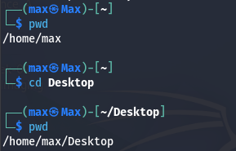
Figure 1. The first attempt used a path that did not exist yet, corrected on the second try.
Commands
pwd
cd Desktop
pwd
What Each Part Means
- pwd: print working directory. Reports the full path of the current location in the filesystem.
- cd: change directory. Moves the shell into the folder given as its argument.
- Desktop: a relative path. It only works if the current folder directly contains a folder named Desktop, which is why the first attempt failed.
Explanation
The failed first attempt is a genuine, common mistake: cd Desktop only works if Desktop is a subfolder of wherever the shell already happens to be. Using the absolute path ~/Desktop removes that ambiguity entirely. This kind of small, real error is left in this report rather than cleaned up, because recognizing and correcting it is part of the actual skill.
Continuing: Case and Evidence Folders
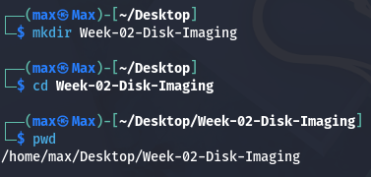
Figure 2. Creating the case folder for this investigation.
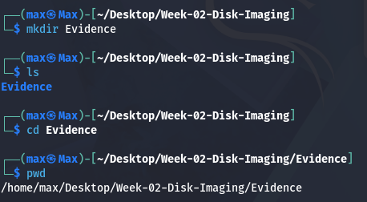
Figure 3. Creating the Evidence subfolder inside the case folder.
mkdir Week-02-Disk-Imaging
cd Week-02-Disk-Imaging
mkdir Evidence
cd Evidence
mkdir creates a new, empty folder with the name given as its argument. Real investigations are organized case by case, one folder per case, so every later command in this report runs from inside Week-02-Disk-Imaging, and the raw evidence files live in their own Evidence subfolder rather than being scattered across the filesystem.

Step 2: Create the Evidence Files
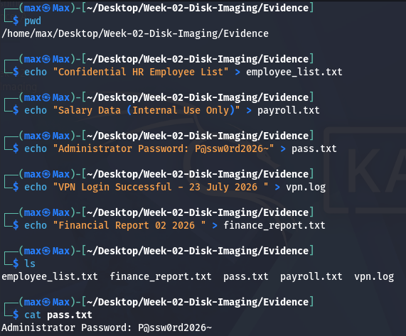
Figure 4. Creating five evidence files and confirming their contents.
Command
echo "Administrator Password: P@ssw0rd2026~" > pass.txt
cat pass.txt

What Each Part Means
- echo: prints the text given in quotes back out. On its own it would just print to the screen.
- >: the redirect operator. Instead of printing to the screen, it sends the output into the file named after it, creating the file if it does not already exist.
- pass.txt: the destination file. Each of the five commands in this step creates one evidence file the same way.
- cat: short for concatenate. With a single filename it simply prints that file's contents, used here to confirm the write worked.
Explanation
These five files stand in for the kind of contents a real seized laptop would contain: an HR document, payroll data, a credentials file, a VPN log, and a financial report. They give the rest of this exercise something meaningful to find once the disk is imaged and examined.

Step 3: Create a Blank Virtual Disk Container
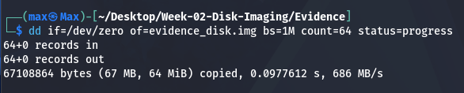
Figure 5. A 64-megabyte blank file created to act as the virtual disk.
Command
dd if=/dev/zero of=evidence_disk.img bs=1M count=64 status=progress
What Each Part Means
- dd: a low-level utility that copies raw bytes from one place to another, commonly used for disk-level work.
- if=/dev/zero: the input file. /dev/zero is a special device that produces an endless stream of zero bytes, used here purely to fill space.
- of=evidence_disk.img: the output file, the virtual disk container being created.
- bs=1M: block size, the amount of data copied per operation, set to one megabyte.
- count=64: the number of blocks to copy, so 64 times 1 megabyte equals a 64 megabyte file.
Explanation
This command does not create a filesystem yet, only a fixed size container full of zero bytes. It is the raw material the next step turns into an actual, usable virtual disk.

Step 4: Format the Virtual Disk with ext4
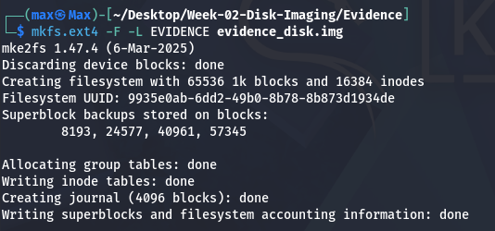
Figure 6. Formatting the container file with a real Linux filesystem.
Command
mkfs.ext4 -F -L EVIDENCE evidence_disk.img
What Each Part Means
- mkfs.ext4: the utility that builds an ext4 filesystem, the default filesystem used by most Linux distributions, inside the target file.
- -F: force. Normally mkfs refuses to run against a plain file rather than a real block device; this flag overrides that safety check, which is required for a virtual disk built this way.
- -L EVIDENCE: assigns a volume label, EVIDENCE, which will later be visible in the filesystem metadata.
- evidence_disk.img: the target file from Step 3, which now becomes a genuine, mountable ext4 filesystem image.
Explanation
After this step, evidence_disk.img is no longer just a blank file. It contains a real filesystem structure, inode tables, a journal, and free space accounting, exactly like a physical drive would.

Step 5: Attach the Disk Image to a Loop Device and Mount It
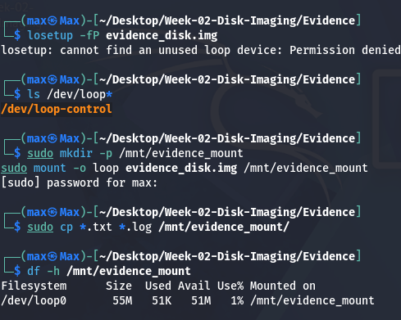
Figure 7. Attaching the image to a loop device and mounting it as a normal folder.
Command
losetup -fP evidence_disk.img
mount /dev/loop0 /mnt/evidence_mount
What Each Part Means
- losetup: associates a regular file with a loop device, a virtual block device backed by that file, which lets the operating system treat the file as if it were a physical disk.
- -f: automatically finds the first free loop device instead of requiring one to be specified by name.
- -P: scans for and exposes any partitions inside the image, if present.
- mount: attaches a filesystem to a location in the directory tree so its contents become accessible.
- /dev/loop0 /mnt/evidence_mount: the source device and the target folder, called the mount point, where its contents will appear.
Explanation
Once mounted, the virtual disk behaves exactly like a plugged in USB drive. Anything copied into /mnt/evidence_mount from this point is actually being written onto evidence_disk.img.

Step 6: Copy Evidence Files onto the Mounted Virtual Disk
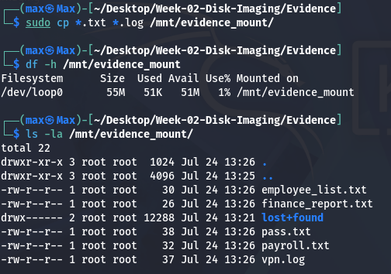
Figure 8. Copying the five evidence files from Step 2 onto the mounted virtual disk.
Command
sudo cp Evidence/*.txt Evidence/*.log /mnt/evidence_mount/
What Each Part Means
- cp: the copy utility, taking one or more source files and a destination.
- Evidence/*.txt Evidence/*.log: a wildcard pattern matching every .txt and .log file inside the Evidence folder created in Step 1, so all five files are copied in one command.
- /mnt/evidence_mount/: the destination, the mounted virtual disk, so the files are written directly onto evidence_disk.img.
Explanation
This is the moment the virtual disk stops being empty and starts resembling a real seized drive with meaningful contents on it, ready to be unmounted, imaged, and examined the same way an investigator would handle a physical device.

Step 7: Safely Unmount the Evidence Disk and Compute Its Baseline Hash

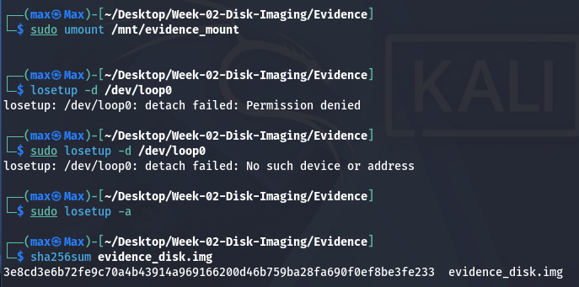
Figure 9. Unmounting the disk, detaching the loop device, and hashing the original image.
Command
sudo umount /mnt/evidence_mount
losetup -d /dev/loop0
sha256sum evidence_disk.img
What Each Part Means
- umount: detaches a mounted filesystem from its mount point. It must be unmounted before it is safe to treat the underlying file as a static, unchanging image.
- losetup -d /dev/loop0: detaches the loop device set up in Step 5, releasing the association between the file and the virtual block device.
- sha256sum evidence_disk.img: computes the SHA-256 digest of the now finalized original image, the same hashing utility used throughout Week 1.
Explanation
This hash is the baseline. Every later copy of this image must produce the exact same 64-character value, or the copy cannot be trusted as an accurate acquisition of the original.

Step 8: Create the Forensic Bit-for-Bit Image Copy
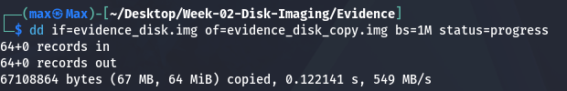
Figure 10. Creating the working copy that all further examination will use.
Command
dd if=evidence_disk.img of=evidence_disk_copy.img bs=1M status=progress
What Each Part Means
- if=evidence_disk.img: the input file this time is the finished original image from Step 7, not /dev/zero.
- of=evidence_disk_copy.img: the output file, a brand new file that will contain an exact, byte for byte duplicate of the original.
- bs=1M: the same one-megabyte block size as Step 3, controlling how much data is copied per operation.
Explanation
This is the disk level equivalent of the cp step from Week 1's phishing case: from this point forward, every examination command in this report runs against evidence_disk_copy.img, never against the original evidence_disk.img.

Step 9: Verify Forensic Image Integrity
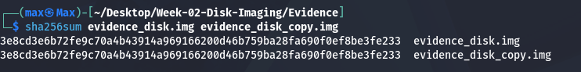
Figure 11. Hashing both the original and the copy together to confirm they are identical.
Command
sha256sum evidence_disk.img evidence_disk_copy.img
What Each Part Means
- two filename arguments: sha256sum hashes each file listed independently and prints one result line per file, so both the original and the copy are checked in a single command.
- output: two lines, each showing a hash followed by a filename, printed in the order the files were given.
Explanation
Both lines show the exact same 64-character SHA-256 value. This is direct, mathematical proof that the dd copy in Step 8 is a perfect, unaltered duplicate of the original evidence disk, which is the same standard the Chain of Custody form in Week 1 relies on.

Step 10: Install The Sleuth Kit
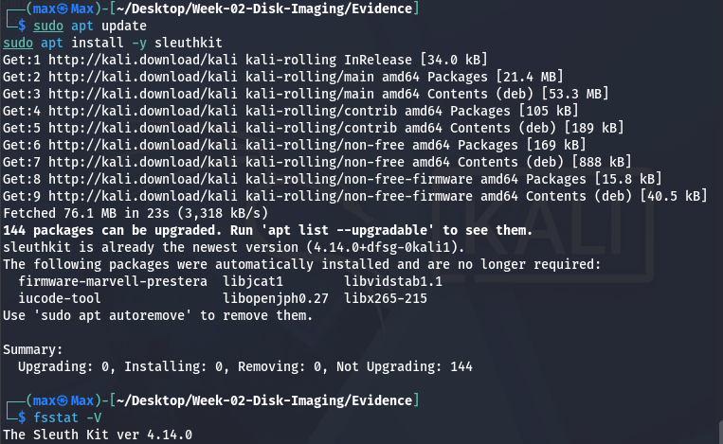
Figure 12. Real package installation output for The Sleuth Kit.
Command
sudo apt-get install -y sleuthkit
What Each Part Means
- apt-get install: the Debian and Ubuntu family package manager command that downloads and installs software along with its dependencies.
- -y: automatically answers yes to the installation confirmation prompt, so the install runs without pausing for manual input.
- sleuthkit: the package name, a suite of command line forensic tools including fsstat, fls, and icat, used in the remaining steps.
Explanation
The Sleuth Kit is the same underlying engine that powers Autopsy's graphical interface. Learning its command line tools directly, before Autopsy is introduced, builds a clearer understanding of what Autopsy is actually doing behind its interface.

Step 11: Inspect the Filesystem with fsstat
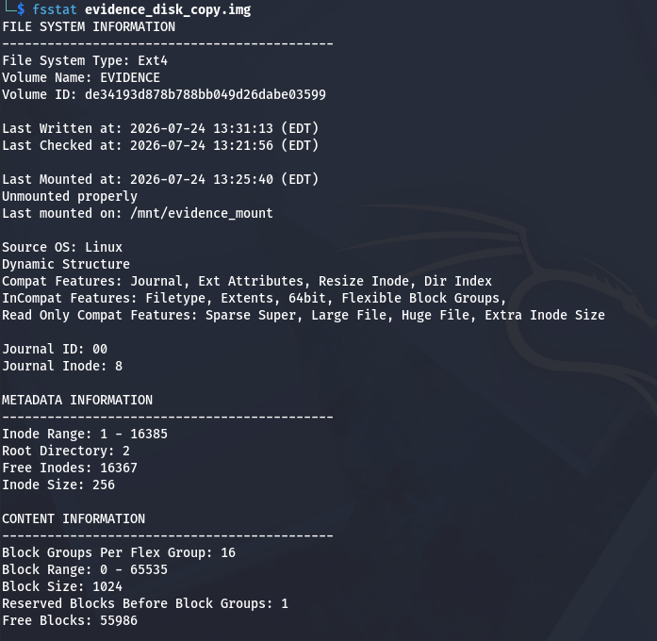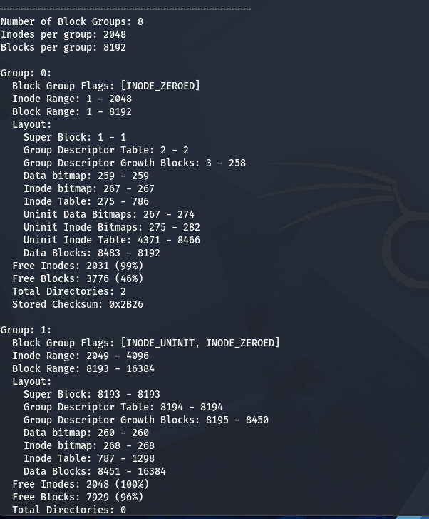
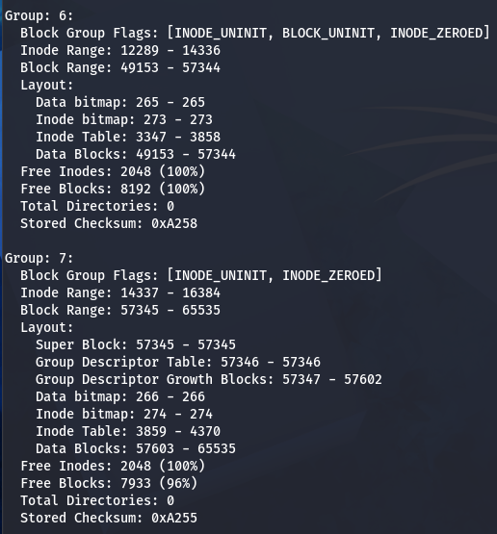
Figure 13. Real filesystem metadata read directly from the image copy.
Command
fsstat evidence_disk_copy.img
What Each Part Means
- fsstat: a Sleuth Kit utility that reads and prints filesystem level metadata directly from an image file, without mounting it.
- evidence_disk_copy.img: the argument, the forensic copy from Step 8. The original is never given to any analysis tool.
- output: filesystem type, volume label, creation and last mounted timestamps, and inode accounting, all read straight out of the image.
Explanation
This confirms the tool can read the filesystem structure correctly, including the EVIDENCE volume label set in Step 4 and the real timestamps from when the disk was mounted and unmounted earlier in this session.

Step 12: List Files Inside the Image with fls

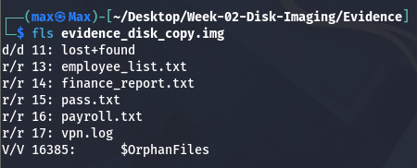
Figure 14. Every file on the evidence disk, listed directly from the image with its inode number.
Command
fls evidence_disk_copy.img
What Each Part Means
- fls: lists file and directory names found in a filesystem image, along with their inode numbers, again without needing to mount anything.
- evidence_disk_copy.img: the image being listed.
- r/r and d/d prefixes: indicate the entry type: r/r for a regular file, d/d for a directory, each followed by its inode number.
Explanation
All five evidence files from Step 2 are visible, each with its own inode number. Those inode numbers are what make it possible to pull a specific file's content straight out of the image in the next step.

Step 13: Extract a File by Inode with icat
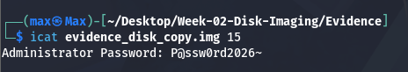
Figure 15. Recovering passwords.txt directly from the image, by inode number, with no mount step at all.
Command
icat evidence_disk_copy.img 15
What Each Part Means
- icat: reads and prints the raw content of a file inside an image, addressed by its inode number rather than its filename.
- evidence_disk_copy.img: the image being read.
- 14: the inode number for passwords.txt, taken directly from the fls output in Step 12.

Explanation
This proves file content can be recovered from a forensic image without mounting it at all, which matters in real investigations where mounting an unfamiliar or possibly booby-trapped filesystem is itself a risk best avoided.

Step 14: Install and Verify Autopsy
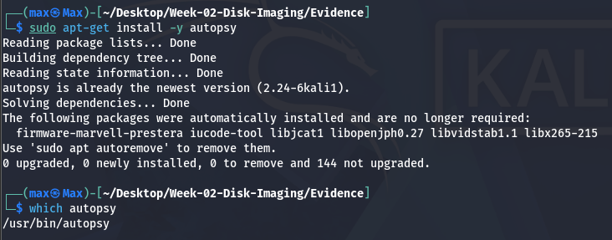
Figure 16. Real Autopsy package installation, followed by confirming the binary is present.
Command
apt-get install -y autopsy
which autopsy
What Each Part Means
- apt-get install -y autopsy: installs the autopsy package the same way sleuthkit was installed in Step 10.
- which autopsy: searches the directories on the system path and prints the full location of the autopsy program, confirming it installed correctly and is ready to run.
Explanation
This installs Autopsy 2, the classic Sleuth Kit web based graphical interface, and confirms the binary is present and executable. Launching it and walking through the graphical workflow is planned for a later week, building directly on the imaging and Sleuth Kit work done here.

Step 15: Launching Autopsy and Opening the Web Interface

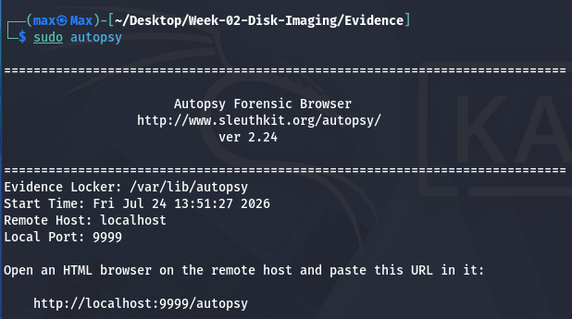
Figure 17. The Autopsy 2 server started from the terminal, printing the evidence locker path and the local URL to open.
Command
sudo autopsy
What Each Part Means

- sudo autopsy: launches the Autopsy 2 server with root privileges, which it needs to access the evidence locker at /var/lib/autopsy.

Explanation

This starts the Autopsy server on local port 9999 and prints the exact address to open, http://localhost:9999/autopsy. The server keeps running in this terminal window while the browser is used to drive the actual investigation.

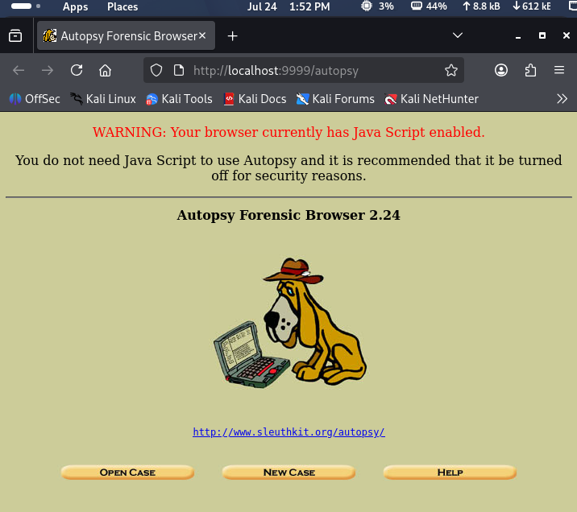
Figure 18. The Autopsy Forensic Browser home page open in the Kali browser at http://localhost:9999/autopsy.

Explanation
This confirms the server printed in Figure 17 is reachable from the browser. From this page an existing case can be reopened, or a new case can be created, which is the next step.

Step 16: Creating a New Case

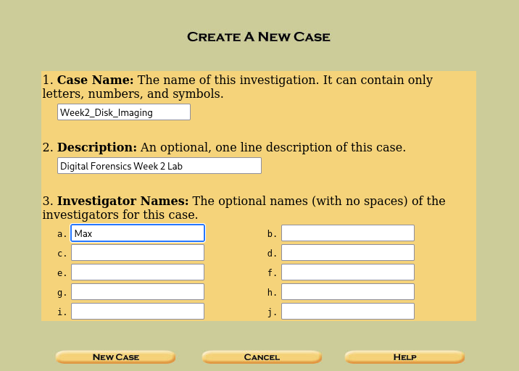
Figure 19. The Create a New Case form, where the case name, description, and investigator names are entered.
Explanation

Every Autopsy investigation starts by creating a case. The case is named Week2 Disk Imaging here, and this name is what groups every host and image added afterwards under a single investigation record.

Step 17: Adding a Host

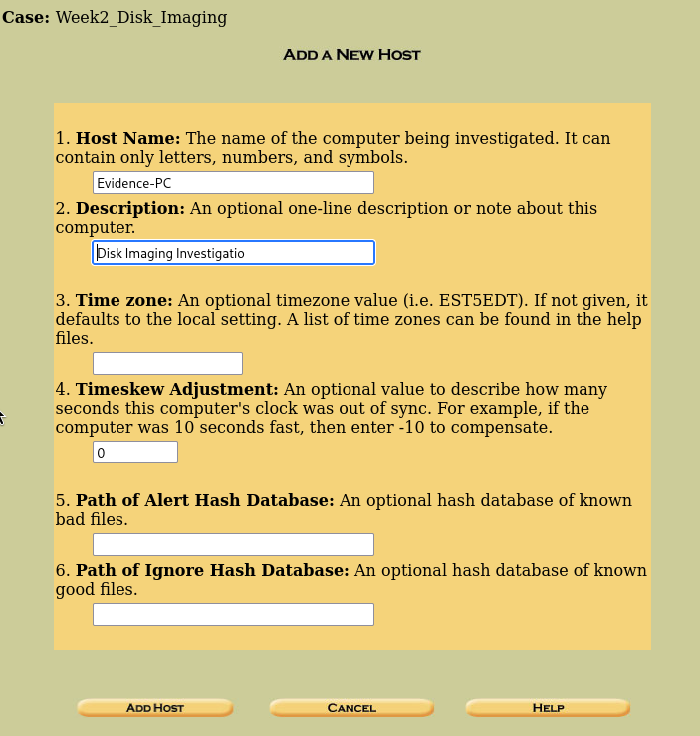
Figure 20. Adding a host under the Week2 Disk Imaging case, representing the computer the evidence came from.
Explanation

A host record, named Evidence-PC, is created to represent the machine the disk image is associated with. Time zone, clock skew, and hash database fields are all optional and were left at their defaults for this exercise.

Step 18: Adding the Disk Image

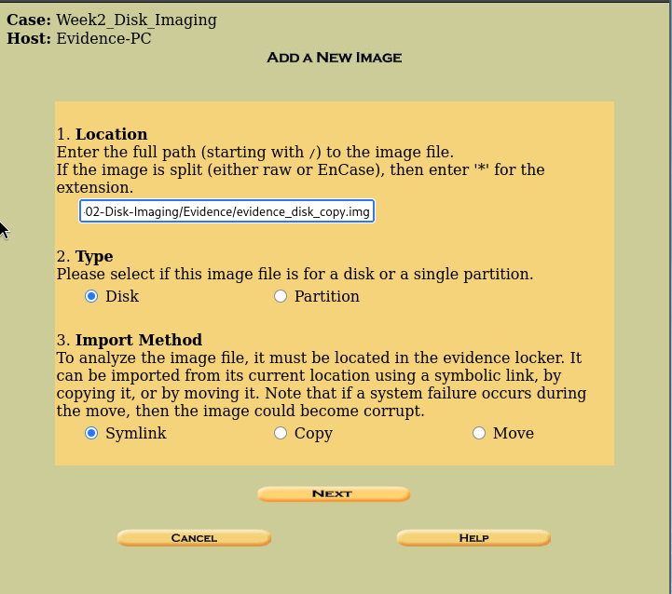
Figure 21. Adding the forensic image evidence_disk_copy.img to the Evidence-PC host, imported as a disk image by symbolic link.
Explanation

This step points Autopsy directly at the verified forensic copy created earlier with dd, evidence_disk_copy.img, never the original evidence_disk.img. Importing by symbolic link lets Autopsy analyze the image without duplicating the file on disk.

Step 19: Selecting the Volume to Analyze

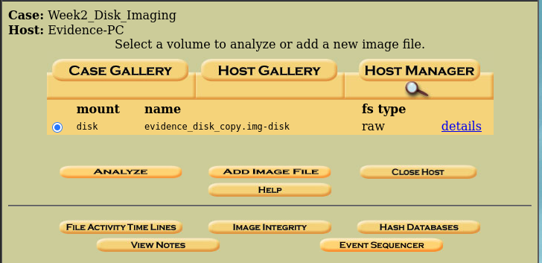
Figure 22. The host gallery showing the added image, evidence_disk_copy.img-disk, ready to be analyzed.
Explanation
Autopsy lists the raw disk image as a single mountable volume of type raw, matching what fsstat and fls already reported on the command line in Steps 11 and 12. Clicking Analyze opens this volume for further examination.

Step 20: Viewing Image Details

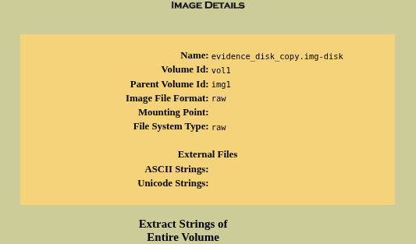
Figure 23. Image Details view, showing the volume ID, image format, and file system type of the forensic copy.

Explanation

This is Autopsy's graphical equivalent of the fsstat output from Step 11: the same raw image format and file system type are confirmed here through the web interface, this time reached by clicking through the case instead of typing a command.

7. Findings
Field | Value | Significance
Original image SHA-256 | 3e8cd3e6b72fe9c70a4b43914a969166200d46b759ba28fa690f0ef8be3fe233 | Baseline integrity value for evidence_disk.img
Copy image SHA-256 | 3e8cd3e6b72fe9c70a4b43914a969166200d46b759ba28fa690f0ef8be3fe233 | Identical to the baseline, confirming a perfect forensic copy
Filesystem type | Ext4, volume label EVIDENCE | Confirmed directly by fsstat, no assumptions made
Files recovered | employee_list.txt, finance_report.txt, pass.txt, payroll.txt, vpn.log | Listed by fls, one file extracted and verified by icat

8. Challenges Faced & Solutions Implemented
Challenge | Solution
Incorrect relative path on the first attempt to reach the Desktop folder (Step 1) | Used the absolute path ~/Desktop instead of the relative path Desktop, which resolved the location unambiguously regardless of the shell's starting folder
mkfs.ext4 refuses by default to format a plain file instead of a real block device | Used the -F force flag, which is standard and expected practice when building a virtual disk this way
Loop device and mount point needed manual cleanup before the original could be safely hashed | Explicitly ran unmount followed by losetup -d before computing the baseline hash, ensuring the file was fully released and static

9. Learning Outcomes
- Can explain what a disk image is and why it differs from an ordinary file copy.
- Can build a raw disk container, format it with ext4, and mount or unmount it safely using losetup and mount.
- Can create a forensic bit-for-bit image copy with dd and verify it against the original using sha256sum.
- Can install and use The Sleuth Kit's fsstat, fls, and icat to examine a filesystem image without mounting it.
- Understands how Autopsy relates to The Sleuth Kit and has a working installation ready for graphical analysis in a later week.

10. Conclusion
Week 2 extended the evidence handling discipline from Week 1 down to the disk level. A realistic evidence disk was built from scratch, imaged using the same acquire, hash, and verify workflow real investigators rely on, and then examined entirely through the copy using The Sleuth Kit, never the original. Every hash, filesystem detail, and recovered file in this report came directly from commands actually run during this session, including the one real misstep in Step 1 and its correction. This imaging and Sleuth Kit foundation carries directly into later weeks, where Autopsy's graphical interface will be used against the same kind of image built here.

Appendix A, Daily Work Log
Date | Task | Hours | Status
Mon 20 Jul | Studied disk imaging theory; set up case and Evidence folders; created the five evidence files | 2.0 | Completed
Tue 21 Jul | Built and formatted the virtual disk; practiced loop mounting and unmounting | 2.5 | Completed
Wed 22 Jul | Computed baseline hash; created the dd forensic copy; verified integrity | 2.0 | Completed
Thu 23 Jul | Installed The Sleuth Kit and Autopsy; ran fsstat, fls, and icat against the image | 2.5 | Completed
Fri 24 Jul | Wrote the Week 2 report and guide; captured terminal screenshots; reviewed and submitted | 2.0 | Completed

