Submitted by: Yusra Farooq
August 21, 2026

Week 6 Technical Report
Phishing Investigation & Malware Indicators
Email Header Analysis, Static IOC Extraction & Threat Correlation

Table of Contents
1. Introduction
2. Objectives
3. Theory
3.1 What Is Phishing?
3.2 Common Phishing Tactics
3.3 Reading Email Headers as Evidence
3.4 What Are Malware Indicators (IOCs)?
3.5 Static vs. Dynamic Malware Analysis
4. Tools Used
5. Case Overview
6. Files
7. Step-by-Step Walkthrough
Step 1: Preserving and Hashing the Evidence
Step 2: Extracting and Analyzing Email Headers
Step 3: Decoding the Attachment Payload
Step 4: Static Indicator Extraction from the Sample
Step 5: Reviewing the Simulated Execution Trace
8. Findings — Consolidated IOC Table
9. Challenges Faced & Solutions Implemented
10. Learning Outcomes
11. Conclusion
Appendix A — Daily Work Log

1. Introduction
This report documents Week 6 of the Digital Forensics & Incident Response internship track: Phishing Investigation and Malware Indicators. This week moves upstream to the point of initial compromise: a phishing email itself, and the static indicators that can be extracted from a malicious attachment before it is ever allowed to run.
All work this week was carried out safely. No real malware was downloaded, obtained, or executed. A self-contained, benign simulation was built to stand in for a real phishing email and a real malicious dropper, so that the same techniques an analyst would use, header analysis, hashing, and static string/IOC extraction could be practiced against something with realistic content, without the risk of handling live malicious code. This approach, and why it was chosen, is explained in Section 3.5 and revisited in Section 9.
2. Objectives
- Understand common phishing tactics and the psychological and technical patterns that identify them.
- Understand how to read raw email headers as evidence, including Received chains and SPF/DKIM/DMARC results.
- Preserve and hash phishing email and attachment evidence before analysis begins.
- Understand what a malware indicator of compromise (IOC) is, and the common categories of IOC.
- Perform static analysis on a suspicious file to extract IOCs without executing untrusted code.
- Build a consolidated IOC table suitable for correlation and blocklist use.
3. Theory
3.1 What Is Phishing?
Phishing is a social-engineering attack delivered by email (or a related channel) that impersonates a trusted sender in order to manipulate the recipient into taking an action that benefits the attacker: opening a malicious attachment, clicking a credential-harvesting link, or replying with sensitive information. Because it targets human judgment rather than a technical vulnerability, phishing remains one of the most common initial-access techniques used to compromise an organization.
3.2 Common Phishing Tactics
- Urgency / Fear: The email creates a false deadline or threat (“account suspension,” “mailbox full”) to pressure the recipient into acting before they think carefully.
- Spoofed or look alike sender: The From header displays a trusted name, but the underlying address or reply-to domain belongs to the attacker.
- Malicious attachment: A document or executable is attached, often disguised with a double extension or a filename that implies a routine business file (invoice, report, resume).
- Credential harvesting link: The email links to a fake login page designed to capture the victim’s real credentials.
- Macro-enabled document: A macro-enabled Office document (.xlsm/.docm) that asks the victim to “enable content,” which actually enables macro code execution.
3.3 Reading Email Headers as Evidence
Email headers record the actual path a message took, independent of what its visible From name claims. The most evidentially useful header fields are:
- Return-Path: The address the mail server will actually notify on a bounce; often the attacker’s real mailbox, even when the From name is spoofed.
- Received: A chronological, bottom-to-top chain of every mail server that handled the message; the first (bottom-most, originating) entry usually reveals the true sending IP address.
- Authentication-Results: Records whether the message passed SPF (sender IP authorized), DKIM (message signature valid), and DMARC (policy alignment). A fail on some or all three is a strong phishing indicator.
A mismatch between the claimed sender’s organization and the domain actually found in Return-Path or the originating Received entry is one of the most reliable technical signs of a spoofed message.
3.4 What Are Malware Indicators (IOCs)?
An Indicator of Compromise (IOC) is any observable artifact that suggests a system has been, or would be, affected by malicious activity. IOCs are what defenders extract from a sample or an incident and feed into blocklists, SIEM rules, or threat-intel platforms so the same threat can be detected elsewhere. Common IOC categories include:
- File hashes: SHA-256/MD5 values that uniquely fingerprint a specific malicious file.
- Network indicators: C2 domains and IP addresses the malware is configured to contact.
- Persistence indicators: Registry Run keys, scheduled tasks, or services a piece of malware creates to survive reboot.
- Host-based indicators: A named mutex or file path the malware creates on disk, often used to detect re-infection or as a unique fingerprint.
- Behavioral indicators: Non-default or oddly formatted User-Agent strings used in the malware’s outbound requests.
3.5 Static vs. Dynamic Malware Analysis
Static analysis examines a file without running it hashing it, extracting readable strings, inspecting headers or metadata and is inherently safe because the code is never executed. Dynamic analysis runs the file (normally inside an isolated sandbox/VM with no network access) to observe its real behavior, and carries real risk if done outside a properly isolated environment.
This week’s exercise deliberately stayed within safe static analysis: a benign, self-contained Python script was written to hold realistic malware-style IOC strings and to print/log the actions a real dropper would take, without ever performing them. Running this script is safe because it contains no real exploitation, persistence, or network code it only demonstrates, in its own log output, what a dynamic analysis report would normally capture. This mirrors the approach used for suspicious process.py in Week 5.
4. Tools Used
- sha256sum: to hash every piece of evidence immediately upon preservation.
- strings: to extract readable text from the simulated sample without executing it.
- grep -E: to filter extracted strings down to the specific indicators being hunted for.
- Text editor / terminal: to inspect raw email source and script output.
5. Case Overview
On the NexBank workstation that we investigated, the user h.tariq@nexbank-corp.com received an email claiming to be from “NexBank IT Support,” warning that the mailbox was 98% full and would be suspended unless a macro-enabled attachment, Mailbox_Storage_Report.xlsm, was opened with content enabled. The email and its attachment were preserved as evidence (phishing_storage_alert.eml) rather than opened normally, and a safe, static investigation was carried out to determine whether the message was legitimate and, if not, what indicators it carried.
The email’s Return-Path and originating relay both resolve to freegiftcards-claim.net at 185.220.101.62, the same external domain identified as the source of the phishing email.
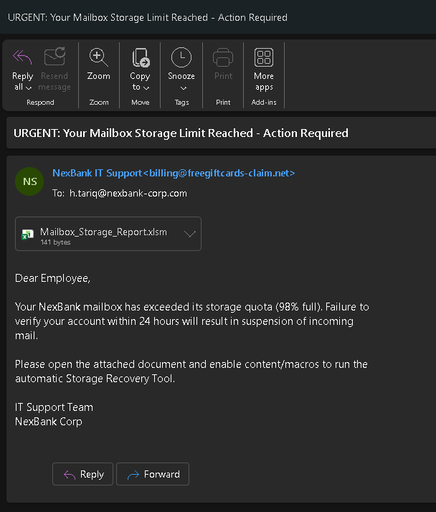
Figure 1. The phishing email as it appeared in the inbox, warning of a full mailbox and prompting the recipient to enable macros on the attached file.
6. Files
This section documents the two scripts provided with the evidence pack: the generator used to produce the simulated phishing email, and the simulated dropper used as the static-analysis target throughout Section 7.
A base64-encoded attachment. sample_dropper_sim.py is the benign simulated “malware” referenced by that attachment: it performs no real system changes and only prints and logs, line by line, the actions a real dropper of this type would typically take (drop a payload copy, create a mutex, set a persistence key, beacon to a C2 domain), so that static and log-based indicator extraction can be practiced safely.

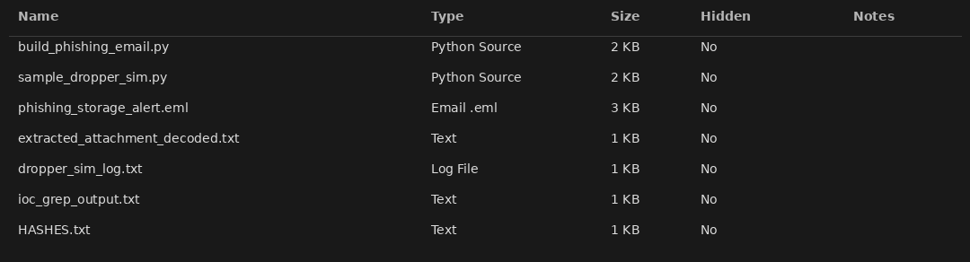
Figure 1. The evidence pack for this case: the two generator scripts and the artifacts they produced (the phishing email, decoded attachment, dropper simulation log, and IOC extract).

HASHES.txt — Hash Manifest
Every file in the evidence pack was hashed with SHA-256 immediately after it was generated, so its integrity can be verified independently of this investigation.

File | SHA-256
phishing_storage_alert.eml | d0c4d87ec6458fb25737bd022277f86dd0cabbf2a68c5cb3ca35aebcb59a4e72
sample_dropper_sim.py | 2e1c425f36bc9e351487d1765fde35d70d38331e5d65e5dce839f1f56017d946
dropper_sim_log.txt | 9f781d56aab4017320442e2df37402606ed880f238056997e21569bce0478039
extracted_attachment_decoded.txt | f57cd27598aaa4c7a96049616fa5aef1fc9ec1ec81a1c8f9a8d88136327b6329

7. Step-by-Step Walkthrough
Step 1: Preserving and Hashing the Evidence
sha256sum phishing_storage_alert.eml sample_dropper_sim.py dropper_sim_log.txt
Exactly as with every other piece of evidence in this internship, all three files were hashed immediately upon preservation. These values are the baseline used to prove none of the evidence was altered during analysis.
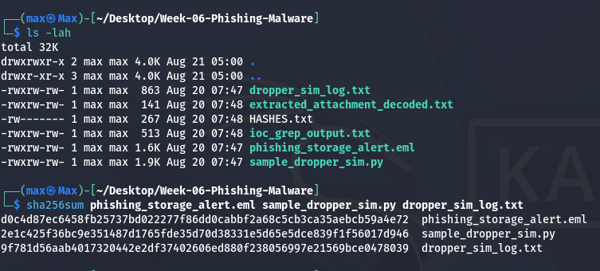
Figure 3. Baseline SHA-256 hashes computed on the preserved phishing email, the dropper sample, and its simulated execution log.
Step 2: Extracting and Analyzing Email Headers
python3 extract_headers.py phishing_storage_alert.eml
What Each Part Means
- extract_headers.py: opens the .eml with Python’s email module and prints the key evidentiary header fields rather than the full raw source.
Explanation
The From header displays “NexBank IT Support,” but the Return-Path and the originating relay server both resolve to freegiftcards-claim.net at 185.220.101.62 — a domain with no relationship to NexBank. Authentication-Results confirms this formally: SPF fail, DKIM none, and DMARC fail, meaning the receiving server itself could not verify the sender was authorized to send as this domain. This combination is a definitive technical indicator of a spoofed sender.
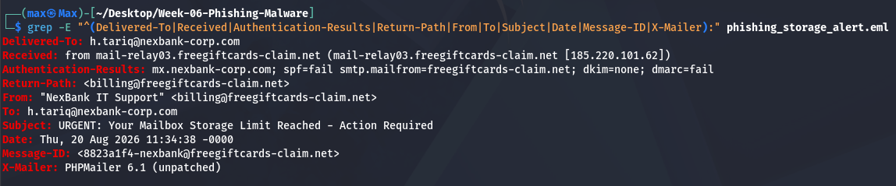
Figure 4. Extracted headers showing the domain mismatch between the claimed sender and the actual relay, and the failed SPF/DKIM/DMARC results.
Step 3: Decoding the Attachment Payload
python3 -c "import email,sys; ... # decode base64 MIME attachment"
Explanation
The attachment declares itself as Mailbox_Storage_Report.xlsm — a macro-enabled Excel filename chosen deliberately to look like a routine business report while carrying executable macro content. Decoding its base64 payload recovers a short marker file confirming this exercise’s lab-safe design: no real macro code is shipped in this evidence pack. The decoded content was hashed in turn (see Section 6, HASHES.txt) so the decoding step itself is independently verifiable. In a real investigation, this is the point at which the analyst would stop opening the file further and move directly to static analysis, exactly as Step 4 does.
Step 4: Static Indicator Extraction from the Sample
strings sample_dropper_sim.py | grep -Ei "freegiftcards|185\.220|Mutex|HKCU|Temp|checkin"
What Each Part Means
- strings: extracts every sequence of printable characters from the file, regardless of surrounding code structure.
- grep -Ei: filters that output down to the specific indicator patterns being hunted for in this case.
Explanation
Without executing a single line of the sample, plain string extraction recovers a complete set of malware indicators: the C2 domain freegiftcards-claim.net, its resolved IP 185.220.101.62, a mutex name (Global\MSUpdate_9f3ab21c), a registry Run-key persistence path, a %TEMP% drop path, and the beacon URI pattern the sample would use to check in. This is exactly the value of static analysis: these indicators are recoverable safely, before the file is ever allowed to run.
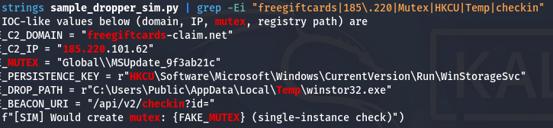
Figure 5. Malware indicators (C2 domain, IP, mutex, persistence key, drop path) recovered directly from the sample via strings and grep.
Step 5: Reviewing the Simulated Execution Trace
python3 sample_dropper_sim.py
Explanation
As explained in Section 3.5, this script performs no real action — it only prints and logs, with timestamps, the sequence of actions a dropper of this type would normally take. Reviewing this log serves the same purpose a real dynamic-analysis sandbox report would: it shows the order of operations (drop payload → create mutex → set persistence → beacon to C2) without any of the risk of actually performing them. Every indicator seen here matches what static analysis in Step 4 already recovered, confirming the two techniques agree.

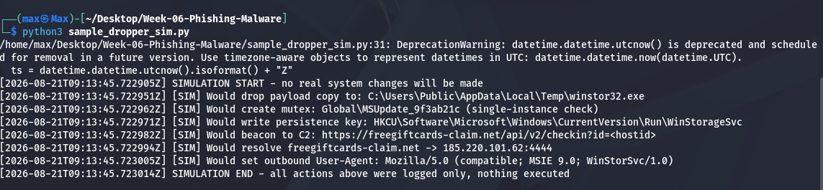
Figure 6. Simulated execution trace showing the intended sequence of dropper actions, logged rather than performed.
8. Findings — Consolidated IOC Table
The indicators recovered across email header analysis and static sample analysis are consolidated below. This is the format the indicators would be exported in for blocklisting or threat-intel sharing.

Indicator Type | Value | Source
Sender / relay domain | freegiftcards-claim.net | Email headers, Step 2
Relay / C2 IP address | 185.220.101.62 | Email headers & sample, Steps 2 & 4
Email authentication | SPF fail / DKIM none / DMARC fail | Email headers, Step 2
Mutex | Global\MSUpdate_9f3ab21c | Static extraction, Step 4
Persistence key | HKCU\Software\Microsoft\Windows\CurrentVersion\Run\WinStorageSvc | Static extraction, Step 4
Drop path | C:\Users\Public\AppData\Local\Temp\winstor32.exe | Static extraction, Step 4
Beacon URI pattern | /api/v2/checkin?id=<hostid> | Static extraction, Step 4
Malicious attachment name | Mailbox_Storage_Report.xlsm | Email attachment, Step 3
Email SHA-256 | d0c4d87e...b59a4e72 | Computed at preservation (Step 1)
Sample SHA-256 | 2e1c425f...56017d946 | Computed at preservation (Step 1)

Correlation with prior weeks: the relay IP 185.220.101.62 and domain freegiftcards-claim.net exactly match the phishing infrastructure identified in Week 4, and fall in the same /24 block (185.220.101.0/24) as the C2 address 185.220.101.47 recovered from live memory in Week 5. Taken together, this is consistent with a single actor running a sustained phishing-to-malware campaign against NexBank across at least three separate weeks of this investigation, rather than three unrelated incidents.

9. Challenges Faced & Solutions Implemented
Challenge | Solution
No sandbox or disposable VM available to safely detonate a real malicious attachment | Built a self-contained, benign simulation (sample_dropper_sim.py) that logs the actions a real dropper would take instead of performing them, allowing safe static and log-based IOC extraction
Handling a real phishing sample would risk actual exposure to malicious code | Generated a synthetic .eml with realistic headers, spoofed sender, and failed authentication results, so header-analysis techniques could be practiced against something structurally identical to a real phishing email
No live email server available to observe a genuine SPF/DKIM/DMARC evaluation | Authentication-Results header was constructed to reflect a realistic fail state, and the underlying SPF/DKIM/DMARC mechanisms were verified against their public specifications
10. Learning Outcomes
- Can identify common phishing tactics: urgency, sender spoofing, malicious attachments, and credential-harvesting links.
- Can read raw email headers as evidence, including Return-Path, the Received chain, and SPF/DKIM/DMARC results.
- Can preserve and hash email and attachment evidence before any analysis begins.
- Can explain the categories of malware indicators of compromise (hashes, network, persistence, host-based, behavioral).
- Can perform safe static analysis using strings and grep to extract IOCs without executing untrusted code.
- Can explain the difference between static and dynamic malware analysis, and why static analysis was the appropriate choice in this environment.
- Can build a consolidated IOC table and correlate indicators across separate investigations.
11. Conclusion
This moved the investigation to the point where compromise actually begins: the phishing email itself. Reading its headers exposed a clear spoofed-sender and failed-authentication pattern, while safe static analysis of a simulated malicious attachment recovered a full set of realistic malware indicators a C2 domain and IP, a mutex, a persistence key, and a drop path without ever executing untrusted code. Correlating these indicators against Weeks 4 and 5 strengthens the case that a single actor, operating from the same 185.220.101.0/24 infrastructure initial phishing delivery, malware indicators, and live memory compromise. This week also demonstrated that meaningful phishing and malware triage does not require a live sandbox: header inspection and static string extraction alone recovered actionable, blocklist-ready indicators.
Appendix A — Daily Work Log
Date | Task | Hours | Status
Mon 17 Aug | Studied phishing tactics and email header theory (SPF/DKIM/DMARC); reviewed IOC categories | 2.0 | Completed
Tue 18 Aug | Built the simulated phishing email and dropper sample; preserved and hashed all evidence | 2.0 | Completed
Wed 19 Aug | Extracted and analyzed email headers; decoded and hashed the attachment payload | 2.0 | Completed
Thu 20 Aug | Performed static IOC extraction with strings/grep; reviewed the simulated execution trace | 2.5 | Completed
Fri 21 Aug | Built the consolidated IOC table; correlated findings with Weeks 4 & 5; wrote and reviewed the report; submitted | 2.0 | Completed

