
PROJECT TITLE :
CAR RENTING SYSTEM
DISCIPLINE :
BCIT (1ST YEAR)
GROUP MEMBERS :
HAFSA NASIR CT 25068
YUSRA NOOR CT 25075
TEACHERS
MUHAMMAD ABDULLAH
FURQAN HUSSAIN

INDEX
- INTRODUCTION.
- OBJECTIVE.
- TOOLS AND TECHNOLOGY USED.
- SYSTEM OVERVIEW.
- CAR DETAILS.
- WORKING OF PROGRAM.
- SAMPLE OUTPUT.
- FLOW CHART.
- SYSTEM EVALUATION.
- FUTURE ENHANCEMENTS.
- CONCLUSION.

Abstract :
This project report presents the design and development of a Car Rental System implemented using the C programming language.
The program automates basic car rental operations such as viewing available cars, renting them, calculating payment amounts, and returning rented vehicles.
The goal of the project is to demonstrate how fundamental programming constructs loops, arrays, conditional statements, and user input can be combined to create a simple yet functional real-world management system. The program operates entirely on a command-line interface, making it a good demonstration of logical problem solving , control flow , and efficient use of programming fundamentals
Introduction :
Automation plays a major role in enhancing the accuracy, speed, and efficiency of modern business operations. In today’s fast-paced world, traditional manual car rental systems often suffer from issues such as slow processing, data inconsistency, and human error, leading to poor customer experience and management inefficiency.
To overcome these limitations, this project presents a Car Rental Management System developed in the C programming language. The system enables users to perform key operations such as viewing available cars, renting vehicles, and returning them in an organized and user-friendly manner. It also incorporates a basic payment verification feature to simulate real-world financial interactions between customers and service providers.
The primary goal of this project is to demonstrate how structured programming techniques—including loops, arrays, conditional statements, and user input handling—can be effectively applied to design a logical, efficient, and interactive application. This system not only automates the rental process but also showcases the power of C programming in solving practical management problems in a streamlined way.

Objectives :
The main objectives of this program are :
- To design a simple and efficient car rental management system.
- To apply structured programming techniques using loops and conditions.
- To automate the process of viewing, renting, and returning cars.
- To simulate a payment validation system for customer transactions.
- To demonstrate the logical design and implementation of a real-life management system through the C language.
Tools and Technologies Used :
- Programming Language: C
- Compiler: Dev C++
- Libraries Used: stdio.h and string.h
- Environment: Command-Line Interface (CLI)
- Programming Concepts: Loops, Arrays, Conditional Statements, Character Input and Output

System Overview :
The Car Rental System is a menu-driven console program that repeatedly interacts with the user until they decide to exit.
The system stores information about five cars in an array, where each element represents the car’s availability status (1 for available and 0 for rented).
Each car also has an assigned code (A–E) and a daily rental rate.
When a customer chooses to rent a car:
- The system checks if the car is available.
- It calculates the total rent based on the number of days entered.
- The system requests the exact payment and confirms the booking only if the entered amount matches the required total.
- The system also includes an option to return cars, which changes their status back to available.

Car Details :
Car Model | Daily Rent (PKR) | Code
ALTO | 5000 | A
CITY | 7000 | B
VITZ | 6000 | C
COROLLA | 10000 | D
CITY | 12000 | E

Working of the Program :
- Welcome Screen and Menu:
The program starts with a welcome message and presents a main menu with three options:
- View Available Cars
- Return Car
- Exit
- Viewing Cars:
When the user selects “View Available Cars,” the system lists all cars currently available for rent.
- Renting Process:
- The user enters the car code and the number of days.
- The system calculates the total amount (rent × days).
- The user is asked to enter the payment amount.
- If payment is correct, the car is rented (its availability changes from 1 to 0).
- If payment is incorrect, the car remains available.
- Returning Cars:
The user can return a rented car by entering its code.
If the car was previously rented, it becomes available again and a confirmation message is displayed.
- Exiting the Program:
The user can exit by selecting option 3, after which the program displays a goodbye message.

Sample Output :
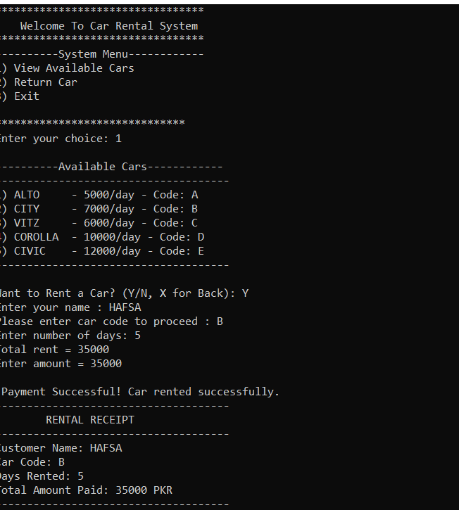
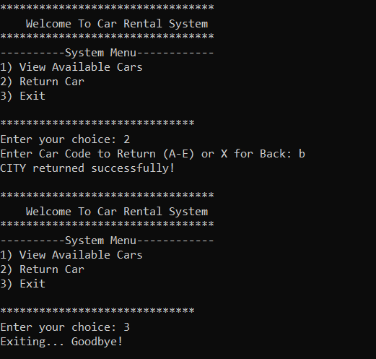
Source Code :

#include <stdio.h>
#include <string.h>

int main(void)
{
int choice;
char rentChoice;
int available[5] = {1, 1, 1, 1, 1}; // 1 = available, 0 = rented
char name[50];

while (1)
{
printf("*********************************\n");
printf(" Welcome To Car Rental System \n");
printf("*********************************\n");
printf(" System Menu \n");

printf("1) View Available Cars\n");
printf("2) Return Car\n");
printf("3) Exit\n");

printf("\n******************************\n");

printf("Enter your choice: ");
scanf("%d", &choice);

if (choice == 1) // view available cars
{
printf("\n------------Available Cars---------\n");
printf("-------------------------------------\n");
if (available[0]) {
printf("1) ALTO - 5000/day - Code: A\n");}

if (available[1]) {
printf("2) CITY - 7000/day - Code: B\n");}

if (available[2]) {
printf("3) VITZ - 6000/day - Code: C\n");}

if (available[3]) {
printf("4) COROLLA - 10000/day - Code: D\n");}

if (available[4]){
printf("5) CIVIC - 12000/day - Code: E\n");}
printf("-------------------------------------\n");

printf("\nWant to Rent a Car? (Y/N, X for Back): ");
scanf(" %c", &rentChoice);

if (rentChoice == 'X' || rentChoice == 'x') {
continue; // back to main menu
}

if (rentChoice == 'Y' || rentChoice == 'y')
{
char code;

printf("Enter your name : ");
scanf("%s",name);
printf("Please enter car code to proceed : ");
scanf(" %c", &code);

int days, amount, inp_amount;

if (code == 'A' || code == 'a' && available[0]) {
available[0] = 0;
printf("Enter number of days: ");
scanf("%d", &days);
amount = 5000 * days;
}
else if ((code == 'B' || code == 'b') && available[1])
{
available[1] = 0;
printf("Enter number of days: ");
scanf("%d", &days);
amount = 7000 * days;
}
else if ((code == 'C' || code == 'c' )&& available[2]) {
available[2] = 0;
printf("Enter number of days: ");
scanf("%d", &days);
amount = 6000 * days;
}
else if ((code == 'D' || code == 'd' )&& available[3]) {
available[3] = 0;
printf("Enter number of days: ");
scanf("%d", &days);
amount = 10000 * days;
}
else if ((code == 'E' || code == 'e' )&& available[4]) {
available[4] = 0;
printf("Enter number of days: ");
scanf("%d", &days);
amount = 12000 * days;
}
else {
printf("Invalid Car Code or Car already rented!\n");
continue;
}

printf("Total rent = %d\n", amount);
printf("Enter amount = ");
scanf("%d", &inp_amount);

if (inp_amount == amount)
{
printf("\n Payment Successful! Car rented successfully.\n");
printf("-------------------------------------\n");
printf(" RENTAL RECEIPT \n");
printf("-------------------------------------\n");
printf("Customer Name: %s\n", name);
printf("Car Code: %c\n", code);
printf("Days Rented: %d\n", days);
printf("Total Amount Paid: %d PKR\n",amount);
printf("-------------------------------------\n");

} else {
printf("Payment Failed! Please pay exact amount.\n");

if (code == 'A' || code == 'a')
available[0] = 1;

else if (code == 'B' || code == 'b')
available[1] = 1;

else if (code == 'C' || code == 'c')
available[2] = 1;

else if (code == 'D' || code == 'd')
available[3] = 1;

else if (code == 'E' || code == 'e')
available[4] = 1;
}

}
}
else if (choice == 2)
{
char code;
printf("Enter Car Code to Return (A-E) or X for Back: ");
scanf(" %c", &code);

if (code == 'X' || code == 'x') {
continue;
}

if ((code == 'A' || code == 'a' ) && !available[0])
{ available[0] = 1;
printf("ALTO returned successfully!\n");
}

else if ((code == 'B' || code == 'b') && !available[1])
{ available[1] = 1;
printf("CITY returned successfully!\n");
}

else if ((code == 'C' || code == 'c') && !available[2])
{ available[2] = 1;
printf("VITZ returned successfully!\n");
}

else if ((code == 'D' || code == 'd' )&& !available[3])
{ available[3] = 1;
printf("COROLLA returned successfully!\n");
}

else if ((code == 'E'|| code == 'e') && !available[4])
{ available[4] = 1;
printf("CIVIC returned successfully!\n");
}

else {
printf("Invalid Car Code or Car was not rented!\n");
}
}

else if (choice == 3)
{
printf("Exiting... Goodbye!\n");
break;
}
else
{
printf("Invalid Choice! Try again.\n");

}

}

return 0;
}

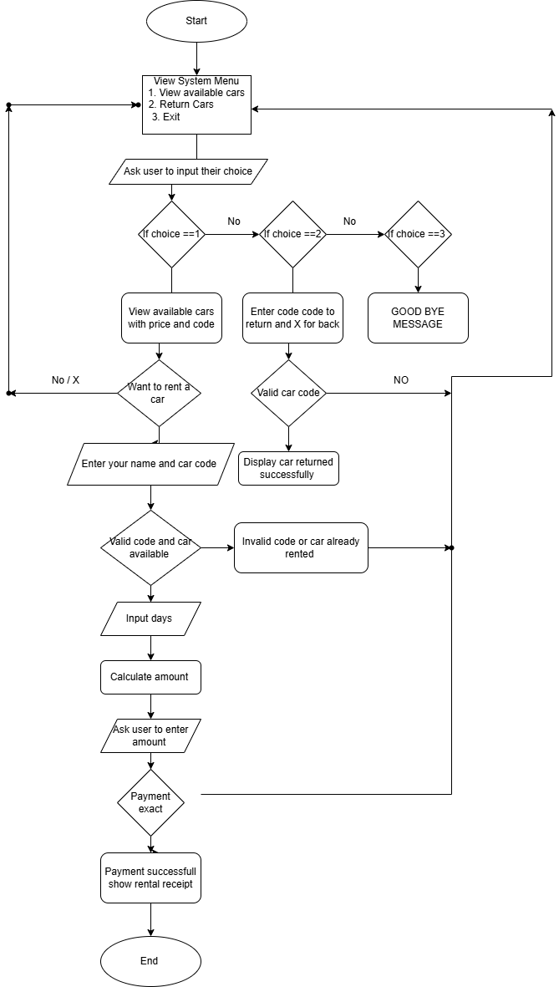
FLOW CHART OF THE PROGRAM
Assumptions
- The system operates through a command-line interface (CLI).
- A fixed set of five cars is available in the system.
- Payment must match the total rent amount exactly for a successful booking.
- Data is not stored permanently — all records reset when the program restarts.
- The user inputs are assumed to be valid (e.g., correct car codes and numeric entries).
Results :
The Car Rental Management System was successfully implemented and tested using multiple input scenarios. The system accurately handled viewing, renting, and returning operations while ensuring payment validation.
Key Outcomes:
- Accurate rent calculations and car status updates.
- Efficient error handling for invalid codes or incorrect payments.
- Smooth menu navigation through loops and conditions.
- Demonstrated clear understanding of arrays and conditional logic.
Overall, the program achieved its intended objectives and provided a reliable simulation of a small-scale car rental service.
System Evaluation :
The Car Rental System was tested under multiple conditions to evaluate its performance, accuracy, and usability. The program handled all input scenarios efficiently and displayed appropriate error messages for invalid inputs. The logical flow of the program ensures that each feature functions as expected. The simulation successfully mirrors real-world rental processes in a simplified console-based environment.
Overall, the system demonstrates reliability, consistency, and a well-structured design that fulfills all objectives set at the beginning of the project.

Future Enhancements :
- Add file handling to save car status permanently.
- Implement admin and customer login systems.
- Add real payment gateway integration or simulated receipts.
- Introduce discounts, billing, and customer records.
- Develop a graphical user interface (GUI) for better user experience.

Conclusion
The Car Rental System project successfully demonstrates how basic programming constructs in C can be used to build a practical application.
Through the use of arrays, conditionals, and loops, the project achieves a structured, efficient, and logical design.
It provides a strong understanding of:
- How data can be represented and modified in arrays.
- How user interaction can be managed via menus.
- How logical flow can simulate real-world processes.
Although simple in scope, this project lays the foundation for larger and more complex management systems.
It enhances problem-solving skills, logical thinking, and understanding of real-world programming applications.

