Open CV and kinect, First games

libfreenect has a tool called record, The syntax is
record [-h] [-ffmpeg] [-ffmpeg-opts <options>] <target basename>
Where <target basename> is the output directory, and will be created.
This just dumps data from the kinect $copyleft.

I could not work it with the -ffmpeg option (I think my CV installation is broken or incomplete).

If you run
$record out
you will get a directory called out, populated by files like those:
- a-1318471938.668382-1217619980.dump: I am not sure what these are, I suspect it might be the audio output.
- d-1318471939.803444-1285693250.pgm these are images of the distance view in black and white
- r-1318469862.858668-1224177648.ppm these are just images from the normal camera.
- An INDEX.txt file
$cd out
$ls r-*
picked one, than
ls d-NNNNNN* and found the one with the closest time stamp.
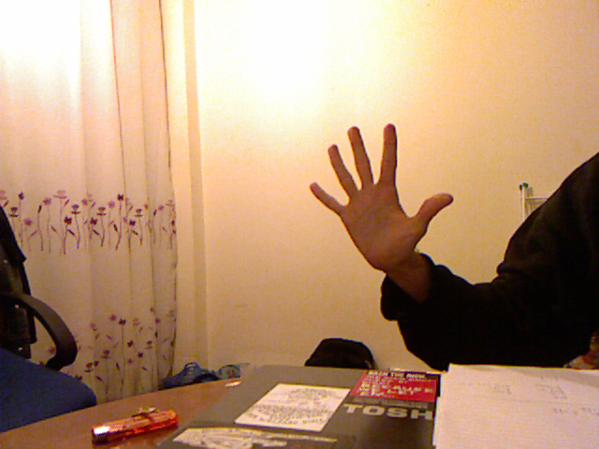 | 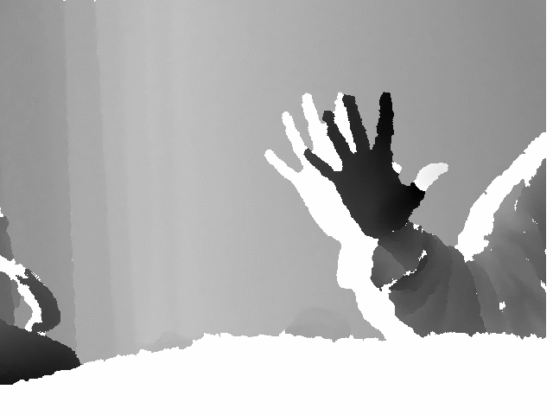
Tip – use:
$convert dNNN.ppm distance.png
$convert rNNN.pgm rgb.png
command to convert this ppm to a usable format. This is part of the ImageMagick package

This is evidently far from perfect, I still have my right thumb, and notice the refraction from the table seem to confuse it. At least I think that's what's causing this.

From here:
http://opencv.willowgarage.com/documentation/python/cookbook.html

#Laplacian
def laplacian():
im = cv.LoadImageM("rgb.gif", 1)
dst = cv.CreateImage(cv.GetSize(im), cv.IPL_DEPTH_16S, 3)
laplace = cv.Laplace(im, dst)
cv.SaveImage("rgb.laplacian.png", dst)

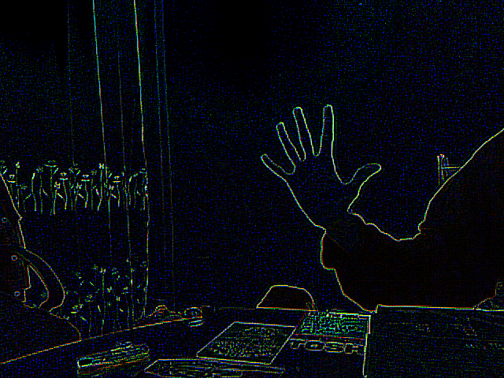  RGB laplacian | 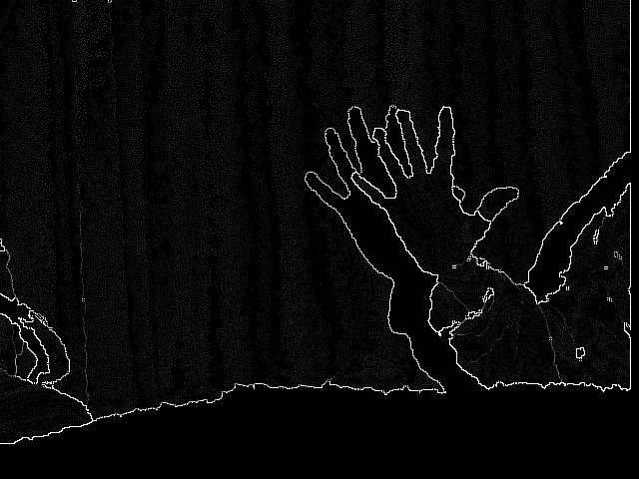  Distance laplacian

Then

def goodFeatures(img):
eig_image = cv.CreateMat(img.rows, img.cols, cv.CV_32FC1)
temp_image = cv.CreateMat(img.rows, img.cols, cv.CV_32FC1)
ret=[]
for (x,y) in cv.GoodFeaturesToTrack(img, eig_image, temp_image,10, 0.04, 1.0, useHarris = True):
ret.append((x,y))
return ret;

Will return a list of 10 features to track. I am not sure exactly what this does, but I think it basically looks for 10 points in which the change in colour is shapest.

Printing goodFeatures() for the images I've got, I get.
distance.png
[(412.0, 175.0), (32.0, 440.0), (454.0, 188.0), (409.0, 176.0), (48.0, 436.0), (400.0, 124.0), (493.0, 294.0), (472.0, 317.0), (491.0, 221.0), (437.0, 276.0)]
rgb.png
[(469.0, 423.0), (481.0, 389.0), (102.0, 463.0), (477.0, 396.0), (469.0, 401.0), (556.0, 198.0), (115.0, 460.0), (101.0, 458.0), (400.0, 195.0), (435.0, 401.0)]
distance-laplacian.png
[(562.0, 223.0), (440.0, 336.0), (630.0, 184.0), (615.0, 204.0), (565.0, 386.0), (497.0, 386.0), (628.0, 390.0), (607.0, 177.0), (18.0, 319.0), (516.0, 384.0)]
rgb-laplacian.png
[(43.0, 220.0), (469.0, 401.0), (101.0, 238.0), (185.0, 236.0), (75.0, 234.0), (69.0, 236.0), (556.0, 198.0), (112.0, 229.0), (146.0, 250.0), (150.0, 224.0)]

I then used

#Takes file names
def paintFeatures(inp,out):
scaleMat = cv.CreateMat(300, 300, cv.CV_8UC3)
img = cv.LoadImageM(inp,cv.CV_LOAD_IMAGE_GRAYSCALE); #input image
#cv.Resize(img,scaleMat);
gf=goodFeatures(img); # good features
omg = cv.LoadImageM(inp,1); #output image
cv.Resize(omg,scaleMat);
for (x,y) in gf:
cv.Circle(omg,(int(x),int(y)),5,(00,255,00))
cv.SaveImage(out, omg)

On all my images.

What I got was unimpressive result, it more or less completely failed to recognise most of what I would call good features. I gradually increased the number, at 10,000 I got what I think will be enough points to start doing something with:
 | Normal | Laplacian
RGB | 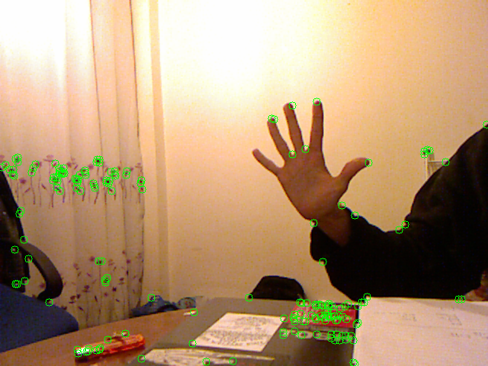 | 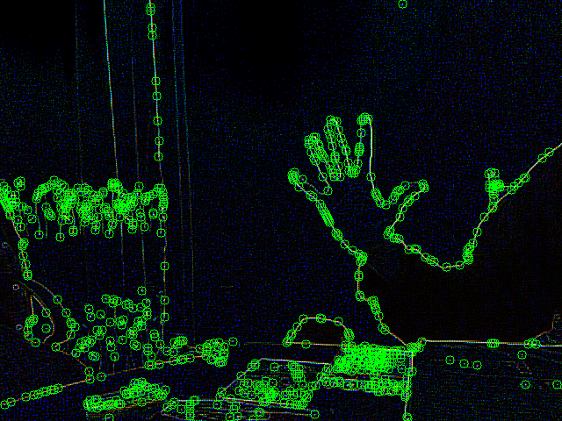
Distance | 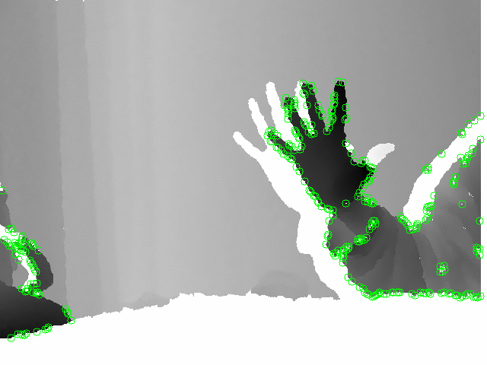 | 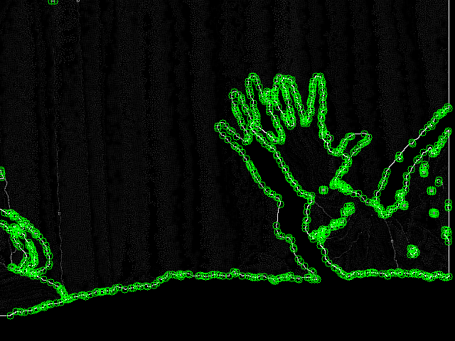

The python script that does this (The feature finding not the laplacian transform) looks like this:

#!/usr/bin/python
import cv,pygame,Image
dist_img=""
rgb_img=""
out_img=""
window=""
def goodFeatures(img):
eig_image = cv.CreateMat(img.rows, img.cols, cv.CV_32FC1)
temp_image = cv.CreateMat(img.rows, img.cols, cv.CV_32FC1)
ret=[]
for (x,y) in cv.GoodFeaturesToTrack(img,eig_image,temp_image,10000,0.04,1.0,useHarris=True):
ret.append((x,y))
return ret;

#Takes file names
def paintFeatures(inp,out):
scaleMat = cv.CreateMat(300, 300, cv.CV_8UC3)
img = cv.LoadImageM(inp,cv.CV_LOAD_IMAGE_GRAYSCALE);
#cv.Resize(img,scaleMat);
gf=goodFeatures(img);
print (inp);
print (gf);
omg = cv.LoadImageM(inp,1);
cv.Resize(omg,scaleMat);
for (x,y) in gf:
#print "x",int(x),"y",y
#print omg
cv.Circle(omg,(int(x),int(y)),5,(00,255,00))
cv.SaveImage(out, omg)

def main():
global rgb_img;
paintFeatures("distance.png","distance.features.png")
paintFeatures("distance-laplacian.png","distance-laplacian.features.png")
paintFeatures("rgb.png","rgb.features.png")
paintFeatures("rgb-laplacian.png","rgb-laplacian.features.png")

if __name__=='__main__': main()
Tip – In vi use
:runtime! syntax/2html.vim
to save the syntax as html, as above

Well that's it for now, now I have to figure out what I can do with all this.
Until next time...

