Simple games with semi-primes

Something bothers me about RSA, It seems like it is centred around large numbers, without which the security is null and void. It starts from the assumption that it is very hard to find 2 prime factors of a semi-prime given large enough values. I am in no position to dispute it, but I am entitled I think to feel uncomfortable that this premise might not be as sound as it appears.

I decided to play around with prime numbers. Nothing fancy, just simple algorithms to find them. For the most part I didn't even apply Fermat's algorithm, just brute tests, since I am mostly dealing with small numbers, it should suffice (I am not apologising):

def is_prime_brute(p):
if (p==2): return True;
if (p==3): return True;
if (p < 2): return False;
if (float(p)/float(2) == p/2):
return False; # Even number
max=int(math.sqrt(p))+1 #Plus one to compensate for rounding down
for i in range(3,max,2):
if( float(p)/float(i) == p/i): #Found factors, not a prime
return False
return True;

This simply takes a number and returns true if prime, false otherwise (or throws an error if not an integer).

Next, we want to find prime factors of any non prime integer:

#
# find all prime factors of n by recursive calls to self
#
def prime_factors(n):
ret=[]
for i in range(2,n): #Find the first factor

if (float(n)/float(i) == n/i): #whole divisor
if(is_prime_brute(i)):ret.append(i) #i is prime
else:
for f in prime_factors(i):
ret.append(f)
if(is_prime_brute(n/i)):ret.append(n/i) #n/i is prime
else:
for f in prime_factors(n/i):
ret.append(f)
break; #Should stop after first factor was found
return ret;

We are only concerned with numbers with only 2 prime factors:

factors=prime_factors(i)
if (len(factors)==2):

The nice property of semi-primes is that they can easily be graphed, using the two factors as the x and y coordinates.

The main loop looks like this:

#
# Iterates over numbers from 0 to "last",
# checks if these are made of 2 prime factors
# plot a point (Got to be a better way to do a pixel in pygame than a circle with radius 1)
# Output to terminal in a CSV format
# Update display if "update==true"
#
#@TODO figure out how to scale colours properly
#
def iterate_numbers():
global window
global last
global update
for i in range(0,last):
if (not is_prime_brute(i)):
factors=prime_factors(i)
if (len(factors)==2):
print "{0} ; {1} ; {2}".format(i,factors[0],factors[1])
colour=i
pygame.draw.circle(window,colour,(factors[0],factors[1]),1)
if(update): pygame.display.flip()

When all is said and done, we get a picture which looks like this:
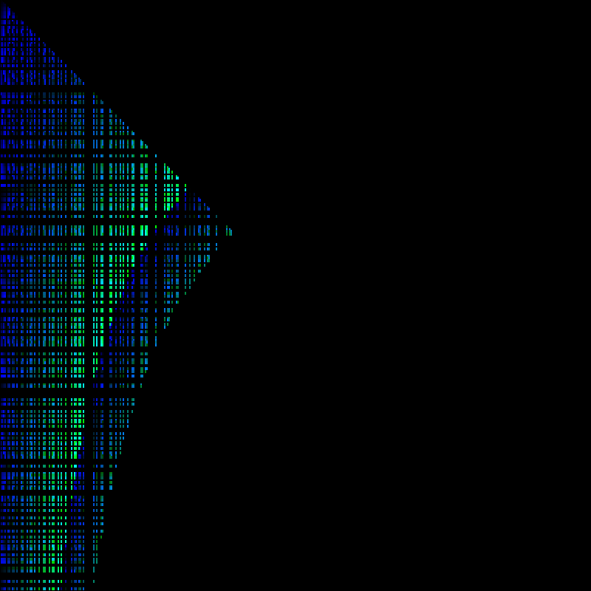
Prime factors are represented by x,y
From this, we can draw a few conclusions.
First, for ease later a few definitions:
Let P be a set of all primes,
Let
Let n be a semi-prime such that n=pq

The pick I assume is created from the numbers of which , (The prime factors are close to or equal one another)
As time progresses, it appears that we are much more likely to encounter a large prime multiplied by a small one than 2 medium primes.

Notice the curve? I can't think of how to calculate it's gradient, but I'll be happy to figure it out. To me this tells that all the factors of a large semi-prime will lay somewhere near this curve from it's square root.

I have tried running this up to 500,000 numbers, but it took hours, I would not recommend it.
However, when done, a few other interesting properties become apparent

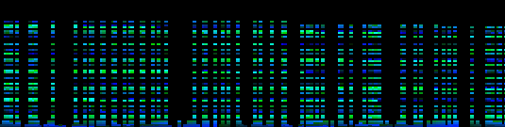
A segment of the generated image (Flipped for convenience)
From this, it appears that most primes fall many times on many semi-primes, some only compose a few semi-primes. Notice that the lowest few primes sometimes only compose a few large composites. There appears to be non in the middle. I have no explanation to this yet.

This has been fun, I doubt it illuminate anything that isn't already known, I doubt that hardened mathematicians would be impressed by this, but I had my fun.

Next time I want to do an Ulam spiral with primes and n=p*q ; p,q are primes. mapped to it, and lines going from each n to both p and q.

Please be as brutal as you wish on criticising this, I might not play with this for a while longer, but I am happy to find out all of the things I did wrong.

The code can be found here: https://github.com/yussidivnall/MathUtils/blob/master/numbertheory/primemap.py

The Image I generated of the first 500,000 semi-primes can be found here:
https://github.com/yussidivnall/MathUtils/blob/master/numbertheory/semiprimes_upto_500k.png

