Play stuff 2
I am not sure what waveforms technically mean, but here is the definition i am going to use.

a wave form is a sum of sinosoudials or a function composed of sinosoudials. this include things like a square wave . Any combination of sinousodials can technically be called a waveform, but some (square,saw,triangle etc), give some sort of form to the "waveform".

I will start off by explaining to the best of my understanding what square waves are methematically, and how to plot them and generate their wave sound file, I might do some other ones later, but the principle is the same.

Square waves
Square waves are formed from the addition of sin waves. specifically, the more odd (1/n)sin(nx) you add to the formula the closer you are to a square wave. technically, you can only have a square wave in infinity, but that's not relevant.

If you want to visualise this, imagine a normal sin wave. now imagine another sin at half the hight. also, this repeats 3 times for every full occiliation of the first wave.if you add those two together you get something like this:
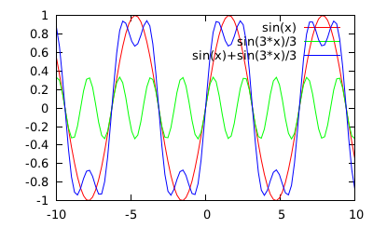 | gnuplot> plot sin(x),sin(3*x)/3 ,sin(x)+sin(3*x)/3
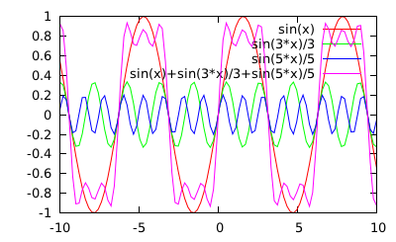 | gnuplot> plot sin(x),sin(3*x)/3,sin(5*x)/5 ,sin(x)+sin(3*x)/3+sin(5*x)/5

or

