Wave forms.

sox, octave and gnuplot.

To make sox do what you want to, you have to devote a lot of your time to reading "man sox". this is a very versitile program. It's "the Swiss army knife of sound processing". I have begun to experiment with it, and got some wonderful results. Shows tons of potential for doing all sorts great hobbiest sudo scientist (lame pun!) stuff.

Anyhow, the first thing to play with is this:
sox -t null /dev/null sine_500hz_3s.wav synth 3.0 sine 500.
This should give you a nice sine wave of 500 hz for 3 seconds.

Then, to get a spectrogram of it, just do a
sox sine_500hz_3sec.wav -n spectrogram;
display spectrogram.png

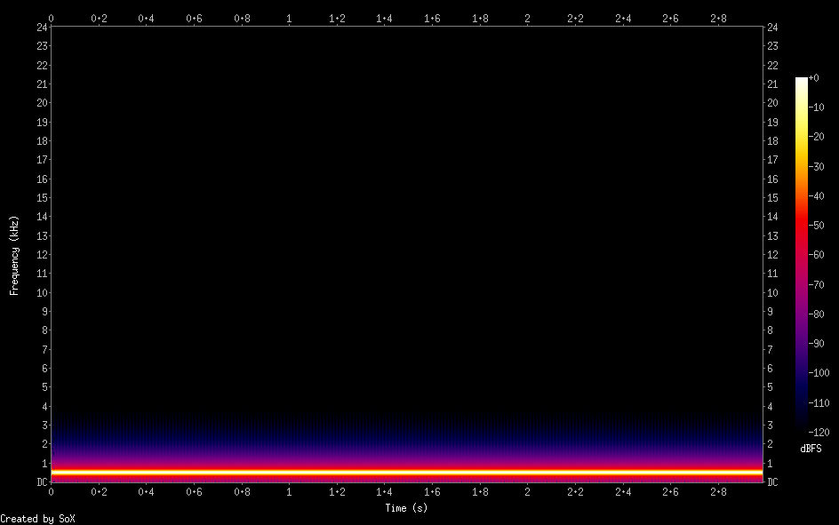
Frequency, time and amplitude.

As you can see, the most waves are at 0.5Khz

Let's centre this, and look at only the beginning of the wave.
sox sine_500hz_3sec.wav -n rate 1500 trim 0 4 spectrogram
This will clip the first 4 seconds (there's only 3) and limit the frequency to 1.5Khz
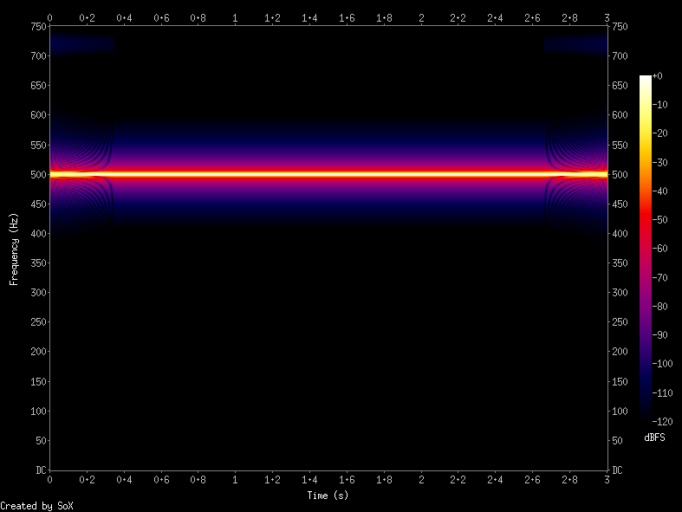
See the beginning and the ending of the file look odd, I am not sure exactly what it is, it could be an anomaly in sox, or in gnuplot. It reminds me a little of diffraction patterns, observe the dark streak at top of plot. If anyone can explain these I'd be happy.
sox sine_500hz_3sec.wav -n rate 1500 trim 0 0.9 spectrogram
For a closer look at the beginning of the file:
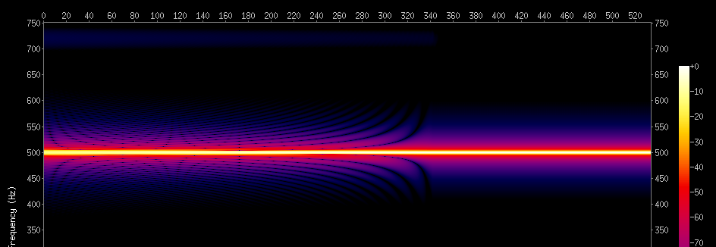
Notice, there are some oddities, like this is supposed to be 0.9 seconds, or 900 ms, but it only shows around 540ms.
Ok, Ok, It's kinda pretty but let's move on.

if i open the sine wave file in snd, It displays it like a square wave.
It also plays the file at a different pitch to the one mplayer and play do. luckily, there's a better solution altogether, sox --plot (octave | gnuplot) should be able get more useful data out of it.

This page has some information about how to convert wav files to plots:http://www.psychogeophysics.org/wiki/doku.php?id=plotting
It's useful, for example i could now do:
sox sine_500hz_3sec.wav -r 1000 test.dat && grep -v '^;' test.dat > test.datclean
then:
gnuplot
plot 'test.datclean' with linespoints
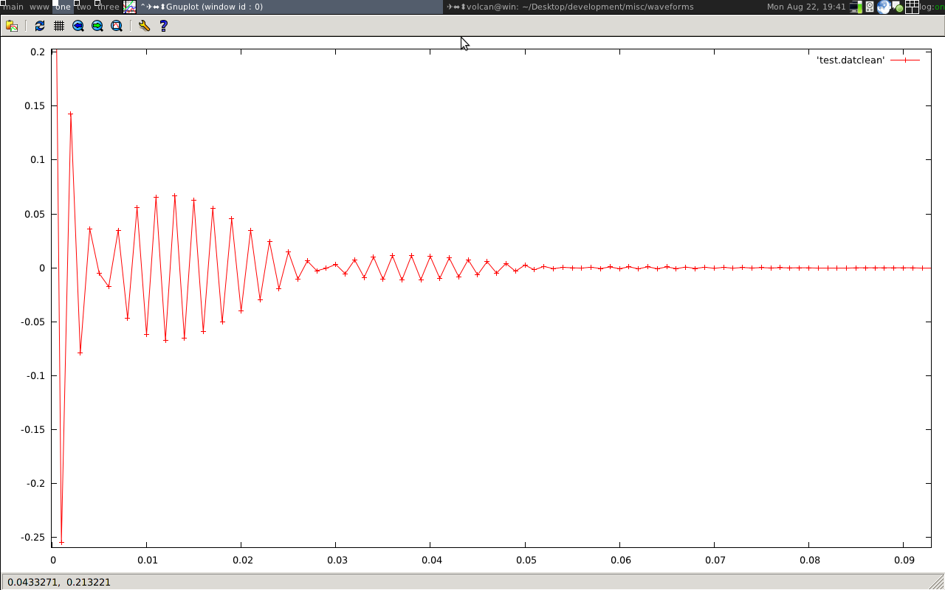
Plot of first 0.9 seconds
This is similar to the spectrogram, note that this is centred at 0, it doesn't label the axis by default, and i'm not sure what i'm seing here exactly. by comparing the spectrogram plot, i can assume that the x axis are such that 0.1 is 1 second. I would like to be able to get just a sine wave plot from this wave file. I think that to do this, I need to change the plot to amplitude time domain
Actually, that last statement is wrong. the at a frequncy of 500hz, the time periot T = 0.002s which seems to correspond to the above waveform. given T=1/f = 1/500.

TO DO, Decompose signal
Fourier formulae:
Discrete Time Fourier Transform (DTFT)

