Play stuff 2
I am not sure what waveforms technically mean, but here is the definition I am going to use.

a wave form is a sum of sinusoidals or a function composed of sinusoidals. this include things like a square wave,triangle wave, saw wave etc. Any combination of sinousodials can technically be called a waveform, but some (square,saw,triangle etc), give some sort of form to the "waveform".

I will start off by explaining to the best of my understanding what square waves are mathematically, and how to plot them and generate their wave sound file, I might do some other ones later, but the principle is the same.

Square waves

Square waves are formed from the addition of sin waves. specifically, the more odd (1/n)sin(nx) you add to the formula the closer you are to a square wave. technically, you can only have a square wave in infinity, but that's not relevant now.

If you want to visualise this, imagine a normal sin wave. now imagine another sin at third the hight. also, this repeats 3 times for every full oscillation of the first wave. If you add those two together you get something like this:

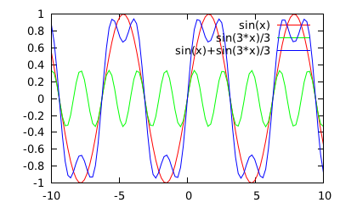 | 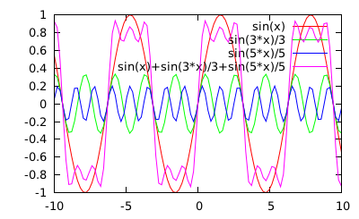
gnuplot>plot sin(x),sin(3*x)/3,  sin(x)+sin(3*x)/3 | gnuplot> plot sin(x),sin(3*x)/3,sin(5*x)/5,  sin(x)+sin(3*x)/3+sin(5*x)/5
The more you add, the closer to a square wave to resultant function looks.
From wikipedia, the function can be written like this:

Well sox's synth provides a square wave already, this is besides the point. to construct a squarish wave, you can
$play -n -c1 synth 1 sin(110) (1/3) sin(110*3) (1/5) sin (110*5)
To generate the first three increments of fundamental frequency 110hz.
The more you add the more it will sound like the 'play synth square' sound.

I have a small shell script called 'raise_to_square.sh', which demonstrates this, but beware that it's a horrid script and it might freeze your computer, I want to write a decent one which does other forms in python later.

Adding all the (1/n)sin(nx) gives a 'saw-tooth' wave

Incidentally, if you were to add the terms in this fashion using only the even terms you would get a formation of triangles, resembling a saw, in which the more terms you add the finer the 'teeth'

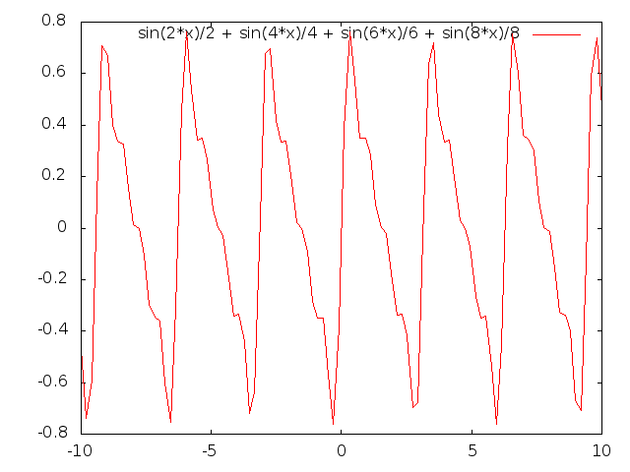
gnuplot> plot sin(2*x)/2 + sin(4*x)/4 + sin(6*x)/6 + sin(8*x)/8

Triangle waves are slightly more complicated...
From the wiki, a triangle wave is:

gnuplot> f(n,x)=( (-1)**n ) * (sin( (2*n+1)*x )) / ( (2*n+1)**2 );
gnuplot> plot (8/pi**2)*(f(0,x)+f(1,x)+f(2,x)+f(3,x)+f(4,x)+f(5,x))

