This is a simple Word document help us illustrate the cloneSection method.

Let us include an image first:

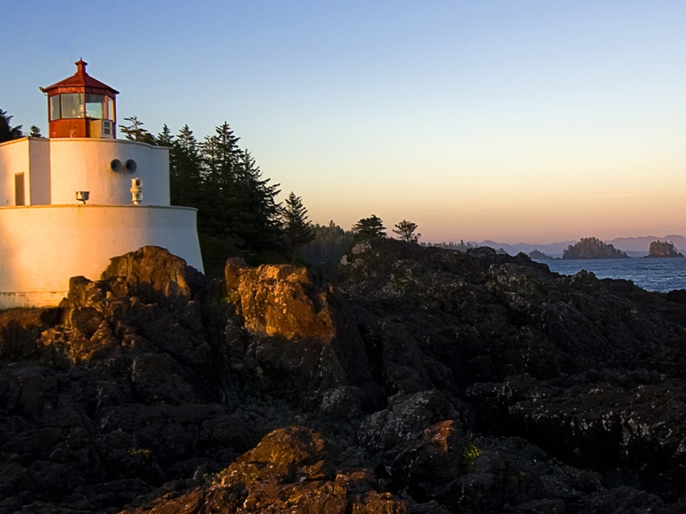

And a table:

|  |  |
| --- | --- |
| Sample Table | Data |
| First row | First data |
| Second row | Second data |

And a list to finish:

* One
* Two
* Three
  + Subitem

This is other section with a header, footer and contents.

$PLACEHOLDER$

A table:

|  |  |  |
| --- | --- | --- |
| Cell 1 | Cell 2 | Cell 3 |
| Cell 4 | Cell 5 | Cell 6 |

An image: