**1- Analysis Report of your web application: It is a report that contains the analysis of your project from your perspective and may include the following:**

**a-List of tables, their descriptions and expected fields.**

List of Tables:

* Patient: Patient ID(Primary), Social Security Number, Date of Birth, Name, Surname, Email, Gender, Phone Number, Blood Type, Diagnoses, Prescription
* Doctor: Employee ID, Name, Surname, Date of Birth, Hospital, Department, Position
* Admin: Admin ID(Primary), Namem, Surname.
* Tests: Test ID, Patient ID, Appointment Number, Doctor ID, Attachment
* Prescription: Prescription ID, Doctor ID, Patient ID, Drug name
* Appointment: Appointment Number(Primary),Date, Doctor ID, Patient ID, Hospital Name
* Hospital: Hospital Name(Primary), Address, City, State

**b- List of web pages, their definitions and purposes.**

* Main page: Buttons for About us, contact us, login, doctors, available technologies, Get appointment.
* Login Page: Includes option to enter credentials for patients or doctors.
* Admin Page: Option to Manage doctors, manage patients, manage appointments.
* Patient main page: Includes option to view closest hospitals (Popup), Manage appointments (in Page and get new appointment(page)), List of appointments(page) Patient Information includes(tests(Pop up button), prescriptions(Pop up button), reports(Pop up button), Diagnosis(Pop up button)), Online consultation.
* Doctor Main Page, Includes option to manage appointments(directs to new Page), View details of patients(directs to new Page to add tests, prescriptions, reports, diagnosis information), view/update my information(directs to new page),
* About us: basic information about the hospitals, available clinics.
* Contact Us page: Phone number, Email, message us.

**c- UML diagrams to show your system analysis (Case diagram, Flowchart Diagram, User Diagram, Interactivity diagram, ....).**  
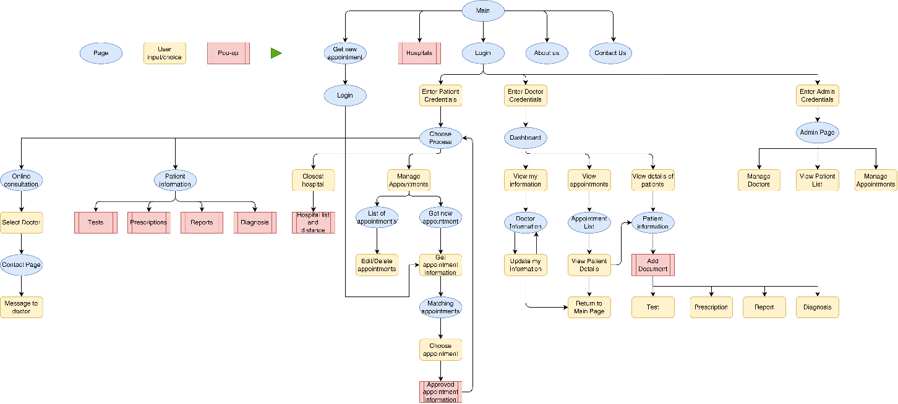

**d- ER diagram of your tables.**  
ER diagram of your database tables. Show the key connections between the tables and each other. Article a) will contain explanations of these tables.

The tools and platforms you will use to realize your e-Project.  
Specify the programs and platforms you will use throughout the project.

Visual Studio Code, HTML, CSS, JavaScript

**f- Your Timeline to finish your project by showing the stages and their start and finish dates.**

|  |  |  |  |  |  |  |  |  |  |
| --- | --- | --- | --- | --- | --- | --- | --- | --- | --- |
|  | 30-5 Nov | 6-12 Nov | 13-19 Nov | 20-26 Nov | 27-3 Dec | 4-10 Dec | 11-17 Dec | 18-24 Dec | 25-31 Dec |
| System analysis |  |  |  | exam |  |  |  |  |  |
| Research other hospital webpages |  |  |  | exam |  |  |  |  |  |
| Building template frontend |  |  |  | exam |  |  |  |  |  |
| Database design |  |  |  | exam |  |  |  |  |  |
| Adding necessary pages (html) |  |  |  | exam |  |  |  |  |  |
| Working on webpage design (css) |  |  |  | exam |  |  |  |  |  |
| Working on webpage functions (js) |  |  |  | exam |  |  |  |  |  |
| Bug fixing |  |  |  | exam |  |  |  |  |  |
| Finishing touches |  |  |  | exam |  |  |  |  |  |

**2- Design and create just three web pages from your website using HTML, CSS and JavaScript (Home, About Us, Contact Us).**  
Apart from these three pages, we do not want you to complete any other web pages yet. In the next stages, the remaining pages of the Project will be designed.  
Remember, your grade may be affected depending on how superior the projects are to each other. The more complete and functional (dynamic) your pages are, the higher score you can get.

https://github.com/yusuf-abdullatif/Hospitals-Management-System-for-Doctors-and-Patients.git