Enterprise Retail Data Warehouse
ETL Solution using SQL Server Integration Services (SSIS)
Final Project Technical Report

Prepared by: Yusuf Kamal
Date: August 2026

Table of Contents
Table of Contents 1
1. Introduction 1
1.1 Objective 1
1.2 Business Problem 1
1.3 Solution Architecture 1
2. Project Architecture 1
2.1 ETL Architecture Diagram 1
2.2 Databases 1
2.3 Deployment Model 1
3. Package Documentation 1
3.1 Full_Load.dtsx 1
3.2 Validation.dtsx 1
3.3 Transformation.dtsx 1
3.4 Incremental_Load.dtsx 1
3.5 Logging.dtsx 1
4. Data Validation Documentation 1
4.1 Validation Rules 1
4.2 Error Handling Strategy 1
4.3 Error Logging Approach 1
5. Business Transformation Documentation 1
5.1 Financial Calculations 1
5.2 Data Standardization 1
5.3 Business Classifications 1
5.4 Audit Info 1
6. Incremental Load Strategy 1
6.1 Change Detection Approach 1
6.2 Insert Strategy 1
6.3 Update Strategy 1
6.4 Duplicate Prevention Mechanism 1
6.5 Control Table: ETL_IncrementalControl 1
6.6 Error Handling 1
7. SSIS Framework using Configuration Tables (Bonus) 1
7.1 ETL_FullLoad_Config 1
7.2 ETL_IncrementalControl 1
7.3 Framework Benefit 1
8. Scheduling and Operational Monitoring (Bonus) 1
8.1 SQL Server Agent Job Scheduling 1
8.2 Email Notifications 1
9. Challenges 1
9.1 Truncate Table Typo 1
9.2 Configuring Database Mail and SSISDB for Operational Monitoring 1
9.3 Intermittent Data Flow Buffer Failures 1
11. Execution Results and Error Handling Examples 1
11.1 Successful Execution Evidence 1
11.2 Error Handling — Before / After Examples 1
Example 1: Truncate Table Typo 1
Example 2: Database Mail Authentication 1
Example 3: Shared Connection Manager Contention 1
10. Conclusion 1
10.1 Summary 1
10.2 Recommendations for Future Improvements 1

1. Introduction
This document presents the complete technical design, implementation, and results of the Enterprise Retail Data Warehouse ETL solution, developed as the final project for the Data Pill Data Engineering course. The project implements a full end-to-end ETL pipeline using SQL Server Integration Services (SSIS), covering staging, data validation, business transformation, full load, incremental load, centralized logging, job scheduling, and automated email notifications.

1.1 Objective
The objective of the project is to design and build a production-style ETL pipeline that extracts retail sales data from an operational source system, validates and cleanses it, applies business transformations, and loads it into a dimensional data warehouse ready for analytical reporting — while also supporting repeatable incremental loading and operational monitoring.

1.2 Business Problem
Retail organizations generate large volumes of transactional data across sales channels (in-store and online), customers, and sales quotas. Raw operational data is not analysis-ready: it may contain missing, invalid, or inconsistent values, is not organized for reporting, and has no mechanism to track incremental changes over time. The business needs a reliable, automated, and auditable pipeline that transforms this raw data into a trusted data warehouse layer that reporting tools can consume with confidence.

1.3 Solution Architecture
The solution is built entirely in SSIS (Project Deployment Model, deployed to the SSIS Catalog — SSISDB) and SQL Server, and follows a layered architecture:
- Source System — ContosoRetailDW (SQL Server sample star-schema database), treated as the operational source.
- Staging Layer (stg schema) — raw, untransformed copies of source tables, loaded via a dynamic/metadata-driven Full Load package.
- Validation Layer (vld schema) — validated rows for the four core business tables (Sales, Customer, OnlineSales, SalesQuota), with rejected rows routed to a central error log.
- Transformation Layer (dwh schema) — business-ready, transformed data including financial calculations, standardized attributes, business classifications, and audit metadata.
- Incremental Load Layer — change-detection-based load that keeps the dwh layer synchronized with source changes without a full reload.
- Operational Layer — centralized logging package, SQL Server Agent scheduling, and email notifications for job outcomes.

2. Project Architecture

2.1 ETL Architecture Diagram
The pipeline follows a strict one-directional flow through five logical layers:
Source (ContosoRetailDW) → Staging (stg.*) → Validation (vld.* + Error Log) → Transformation (dwh.*) → Data Warehouse / Reports
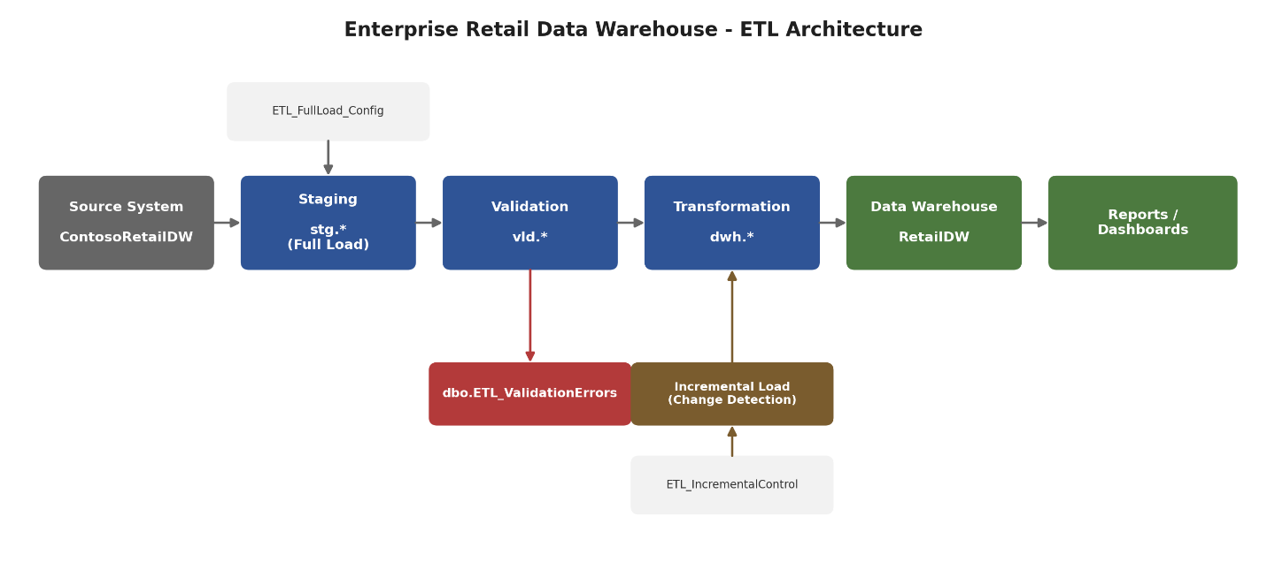
Figure 1 — End-to-end ETL architecture: source, staging, validation, transformation, data warehouse, and reporting layers, with the configuration-driven Full Load, centralized error logging, incremental load, and shared Logging.dtsx package shown alongside the main flow.

2.2 Databases
Database | Role
ContosoRetailDW | Operational source system (existing sample star-schema DB)
RetailDW | Target data warehouse — contains stg, vld, and dwh schemas plus control/log tables

2.3 Deployment Model
All packages are deployed using the SSIS Project Deployment Model to the SSIS Catalog (SSISDB), enabling centralized execution, environment management, and reporting via the built-in Catalog execution reports.

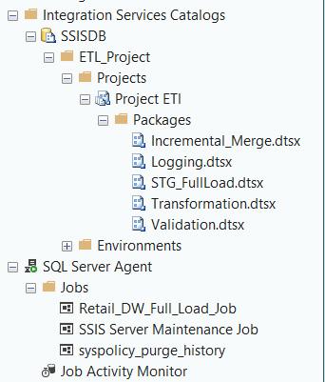

3. Package Documentation
This section documents each SSIS package in the solution: its purpose, inputs, outputs, and core logic.

3.1 Full_Load.dtsx
Attribute | Details
Purpose | Dynamic, metadata-driven Full Load of raw source data into the staging layer (stg schema) — approximately 25 tables.
Input | ContosoRetailDW source tables (Dim* and Fact* tables), driven by the ETL_FullLoad_Config configuration table.
Output | RetailDW.stg.* staging tables (one per configured source table).
Business Logic | A ForEach Loop Container iterates over active rows in ETL_FullLoad_Config; for each row, table name and connection metadata are mapped into SSIS variables and used to dynamically build/execute the extract-and-load Data Flow, avoiding one hard-coded Data Flow per table.
Validation Rules | None — this layer performs a raw, untransformed copy of source data.
Transformations | None (staging is a 1:1 copy); audit columns are attached as part of the load.

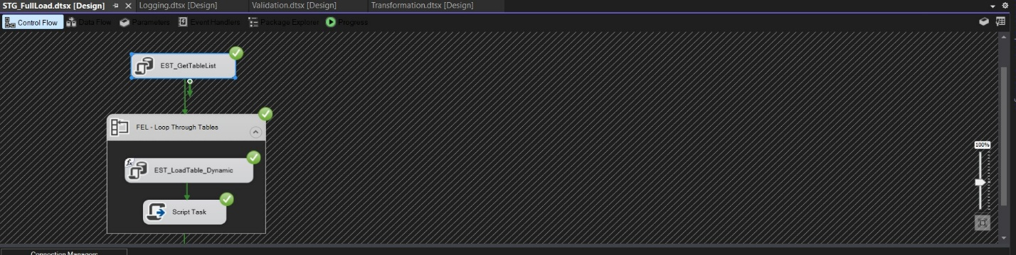

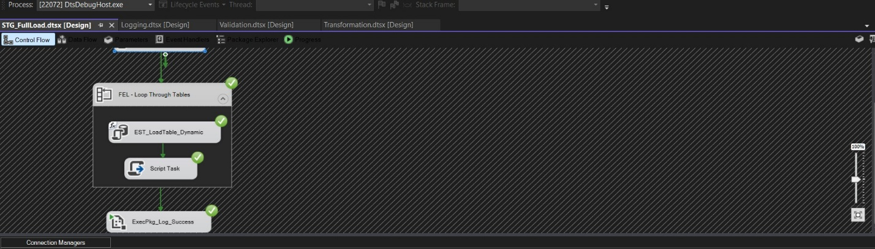

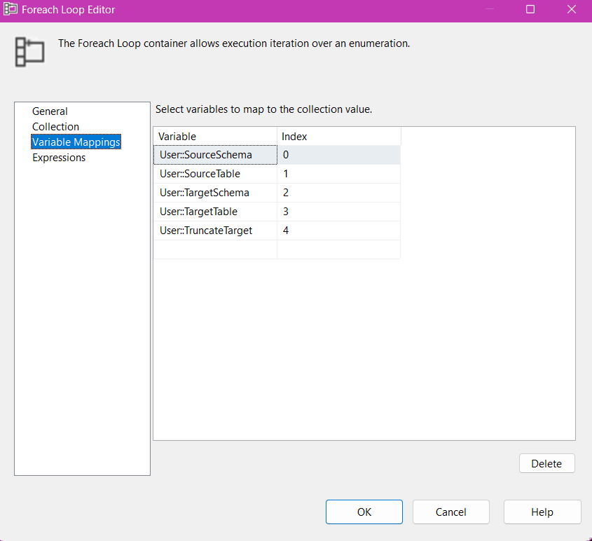

3.2 Validation.dtsx
Attribute | Details
Purpose | Validates the four core staging tables and separates valid rows from invalid rows.
Input | stg.Sales, stg.Customer, stg.OnlineSales, stg.SalesQuota.
Output | Per table, two categories of rejected rows: Business Rule Rejects (from the Conditional Split chain — e.g., ValidationErrors_Sales, Customer_Invalid, OnlineSales_Invalid, SalesQuota_Invalid) and Technical/Component Errors (from the Data Flow's built-in Error Output — e.g., Error_Sales, Customers_Errors, OnlineSales_Errors, SalesQuota_Errors). Valid rows go to vld.Sales, vld.Customer, vld.OnlineSales, vld.SalesQuota. No single centralized error table is used — each table has its own dedicated error outputs.
Business Logic | Four parallel Data Flow Tasks (one per table), each truncating its target validated table via an Execute SQL Task before loading, then applying a chained Conditional Split: Mandatory-field checks → Numeric/range checks → Business-rule checks (key columns are excluded from NULL checks by design).
Validation Rules | See Section 4 (Data Validation Documentation) for the full rule set per table.
Transformations | Derived Columns tag each Business Rule reject with an Error_Type/Error_Date/PackageName before it is written to that table's dedicated Invalid table. Rows that fail at the component level (e.g., data conversion, truncation) are captured separately via each Destination's Error Output (Redirect Row on Error) into that table's dedicated ErrorCode/ErrorColumn table.
Logging | After all four parallel Data Flow branches converge, a shared Logging.dtsx package is called once via an Execute Package Task to record the execution outcome.
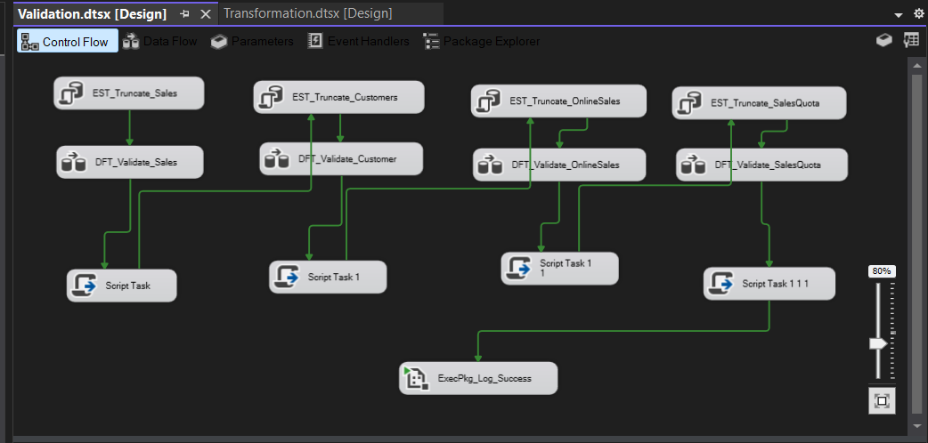
Figure 2 — Validation.dtsx Control Flow: four parallel branches (Sales, Customer, OnlineSales, SalesQuota), each truncating its validated table before its Data Flow runs, converging into a single ExecPkg_Log_Success call.

3.3 Transformation.dtsx
Attribute | Details
Purpose | Applies business transformations to validated data and produces the final, report-ready data warehouse layer.
Input | vld.Sales, vld.Customer, vld.SalesQuota. (vld.OnlineSales is validated but is not currently carried into the Transformation/dwh layer.)
Output | dwh.Sales, dwh.Customers, dwh.SalesQuota.
Business Logic | See Section 5 (Business Transformation Documentation) for the four transformation categories implemented: Financial Calculations, Data Standardization, Business Classifications, and Audit Info.
Validation Rules | None (validation already completed upstream) — this layer assumes .* rows are trustworthy.
Transformations | Financial Calculations (NetSalesAmount, GrossProfit, ProfitMarginPercent, NetQuantitySold, QuotaAchievementPercent); Data Standardization on dwh.Customer (proper-case names, phone cleanup, NULL handling).
The Transformation Data Flow processes three branches in parallel — Sales, SalesQuota, and Customers — each ending in an OLE DB Destination into the corresponding dwh table. The Sales and SalesQuota branches apply Financial Calculations followed by Business Classifications; the Customers branch applies Business Classifications followed by Data Standardization. All three branches converge on a common pattern of Audit Information followed by a Row Count check before loading into the destination table.
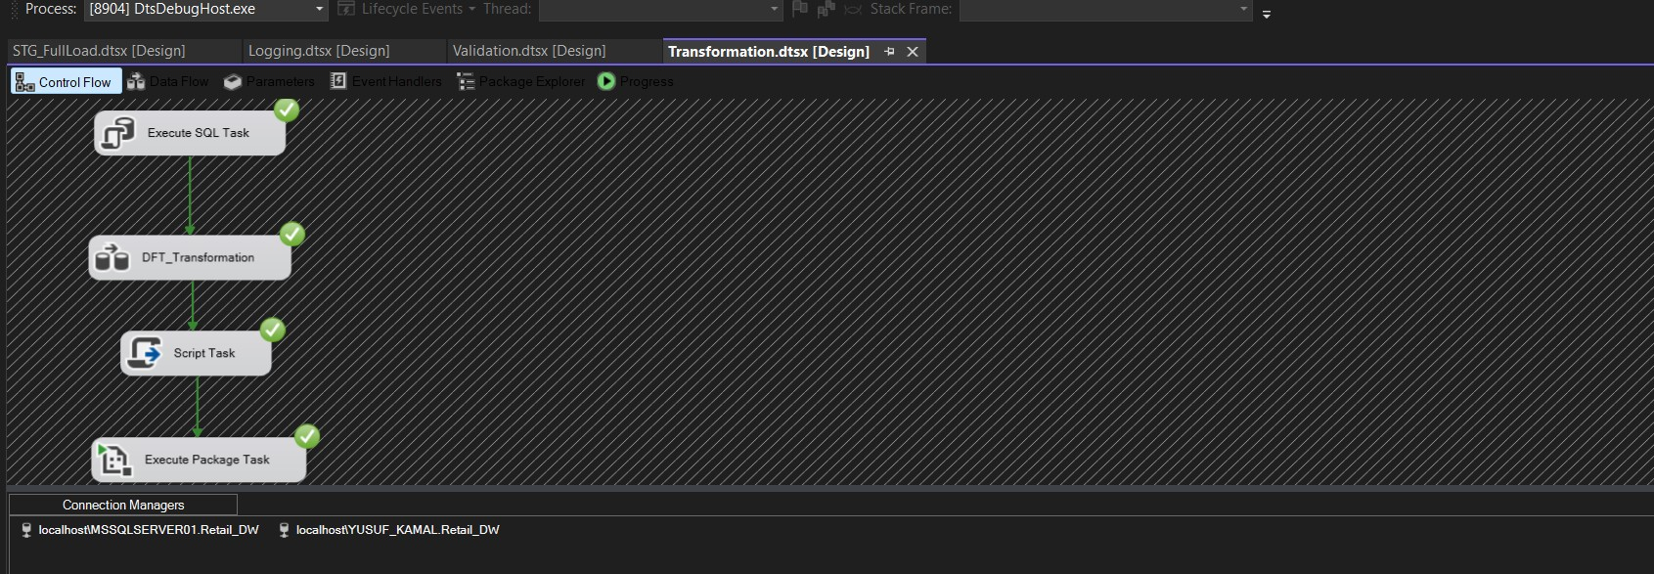
Figure 4a — Transformation.dtsx Control Flow: an Execute SQL Task precedes the DFT_Transformation Data Flow Task, followed by a Script Task and an Execute Package Task (Logging.dtsx).
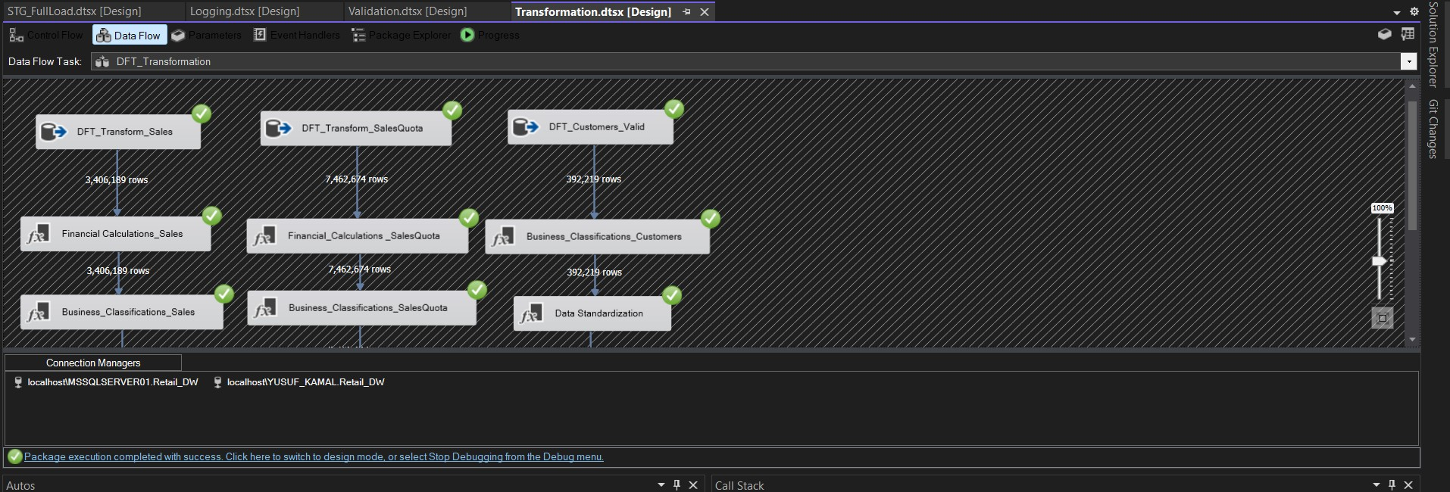
Figure 4b — DFT_Transformation Data Flow (part 1): Sales (3,406,189 rows), SalesQuota (7,462,674 rows), and Customers (392,219 rows) branches, each passing through Financial Calculations and/or Business Classifications.
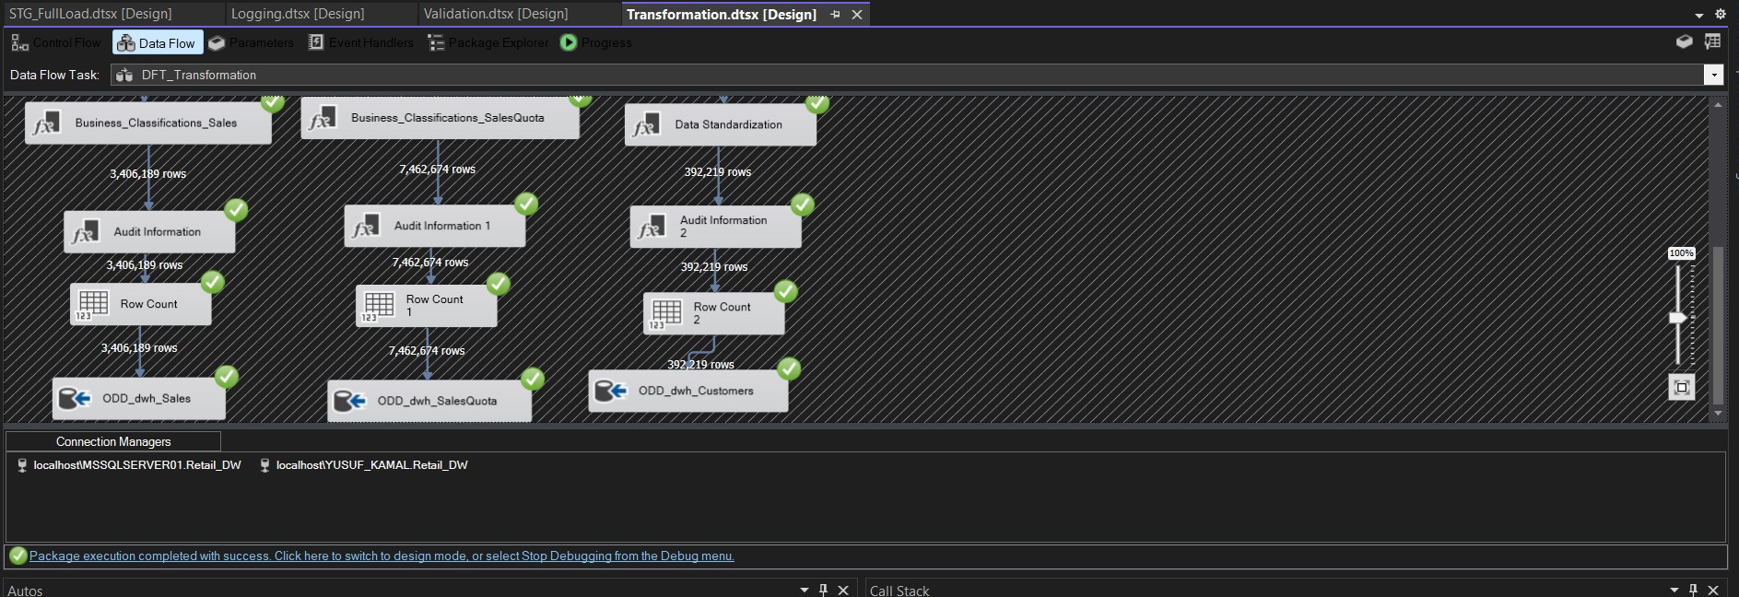
Figure 4c — DFT_Transformation Data Flow (part 2): each branch adds Audit Information and a Row Count check before loading into its ODD_dwh_* destination.

3.4 Incremental_Load.dtsx
Attribute | Details
Purpose | Keeps the dwh layer synchronized with source changes after the initial Full Load, without reprocessing the entire dataset.
Input | Source rows filtered by UpdateDate against the last recorded load watermark in ETL_IncrementalControl.
Output | Inserts and updates merged into stg.Sales, stg.OnlineSales, stg.SalesQuota, and stg.Customer via T-SQL MERGE (the Transformation package then reprocesses these staging tables into dwh.* on its next run).
Business Logic | See Section 6 (Incremental Load Strategy) for the full change-detection, insert, update, and duplicate-prevention design.

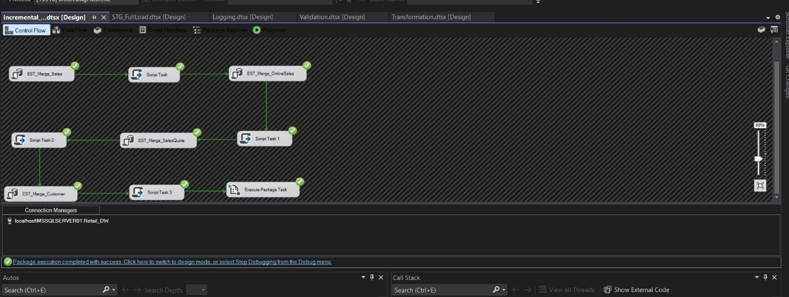

3.5 Logging.dtsx
Attribute | Details
Purpose | Centralized, reusable execution logging package, shared across all pipeline packages.
Input | Execution context passed from the calling package (package name, execution outcome, row counts).
Output | Execution log table (row per package run).
Business Logic | Invoked via an Execute Package Task from Full_Load.dtsx, Validation.dtsx, Transformation.dtsx, and Incremental_Load.dtsx, so every pipeline run is captured centrally rather than logged inconsistently per package.

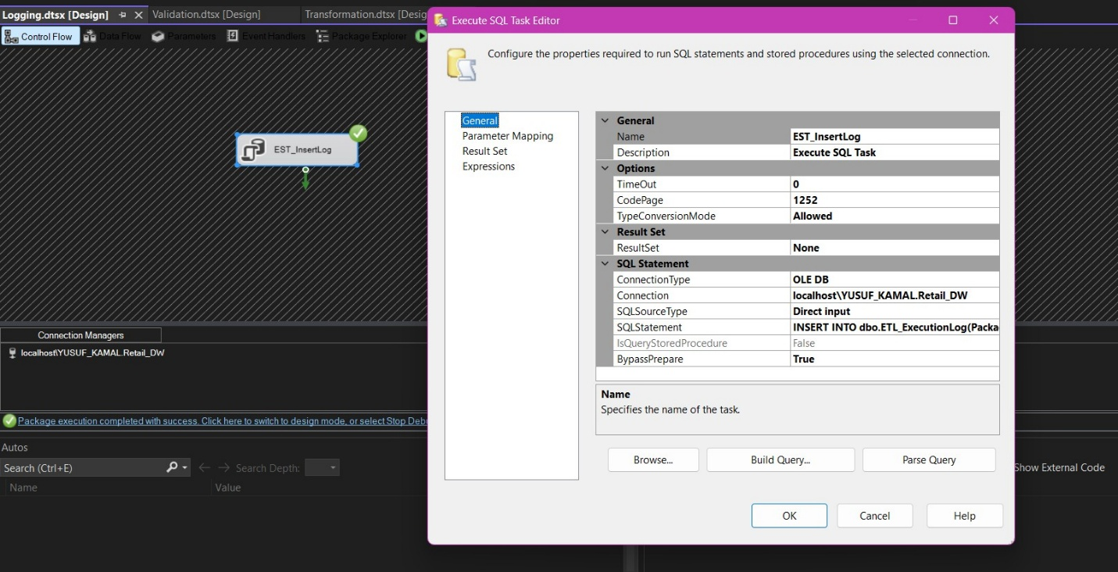

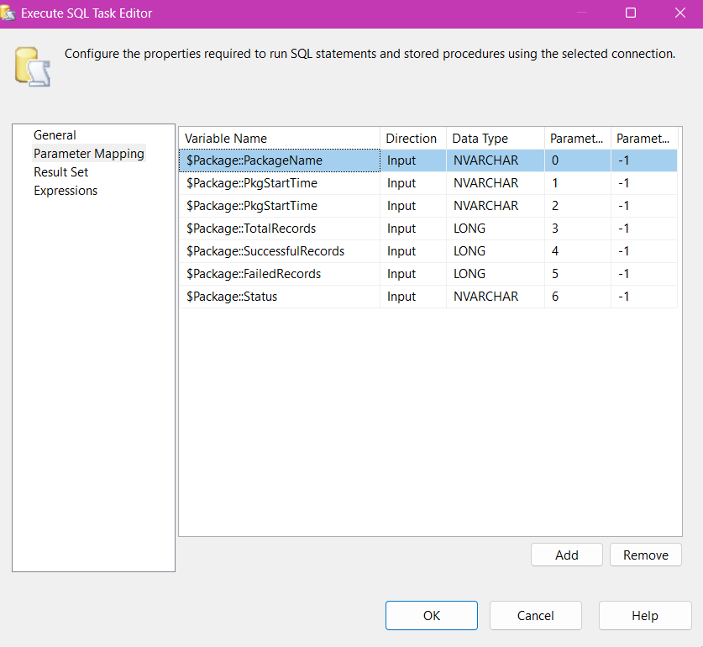

4. Data Validation Documentation

4.1 Validation Rules
Validation is implemented per table using a chained Conditional Split pattern. Each row passes through three sequential checks; a failure at any stage routes the row to the error path with the corresponding Error_Type. Primary/foreign key columns are deliberately excluded from mandatory-field checks since they are structurally guaranteed by the staging load.
Stage | Rule Type | Example Checks Applied
1 | Mandatory Fields | Required business columns (e.g., names, dates, amounts) must not be NULL/blank.
2 | Numeric / Range | Numeric fields (amounts, quantities, costs) must be non-negative and within plausible ranges.
3 | Business Rule | Domain-specific rules (e.g., valid date ranges, consistent quantity/amount relationships).

4.2 Error Handling Strategy
Rows failing any validation stage are not discarded — they are tagged with a Derived Column identifying the failure type and description, then merged from all four validation branches via a Union All transformation into a single, centralized error path. Valid rows continue to the corresponding vld.* table for that source.

4.3 Error Logging Approach

Each of the four validated tables (Sales, Customer, OnlineSales, SalesQuota) has its own dedicated pair of error tables rather than a single centralized error table: one for Business Rule Rejects (rows failing the Conditional Split chain, tagged with Error_Type, Error_Date, and PackageName) and one for Technical/Component Errors (rows failing at the component level — e.g., data conversion or truncation — captured via each Destination's built-in Error Output with ErrorCode and ErrorColumn). This separation distinguishes data-quality failures, which are business-rule violations expected to occur with real-world data, from execution-level failures, which typically indicate a pipeline or metadata issue that needs developer attention.

5. Business Transformation Documentation
The Transformation Layer implements four categories of business logic, applied to the validated data before it reaches the dwh schema.

5.1 Financial Calculations
Applied to the Sales and SalesQuota branches immediately after their respective Data Flow sources:
Table | Metric | Expression | Business Value
Sales | NetSalesAmount | SalesAmount - ReturnAmount - DiscountAmount | The true revenue figure, net of returns and discounts, for reporting.
Sales | GrossProfit | SalesAmount - TotalCost | A core profitability metric for management reporting.
Sales | ProfitMarginPercent | (SalesAmount == 0) ? 0.0 : ((SalesAmount - TotalCost) / SalesAmount) * 100.0 | Profitability as a percentage of sales, comparable across products/channels regardless of scale; guarded against divide-by-zero.
Sales | NetQuantitySold | SalesQuantity - ReturnQuantity | An accurate demand signal, excluding returned units.
SalesQuota | QuotaAchievementPercent | Actual sales amount vs. assigned SalesAmountQuota | A direct KPI for sales performance management, feeding the QuotaPerformanceCategory classification in Section 5.3.
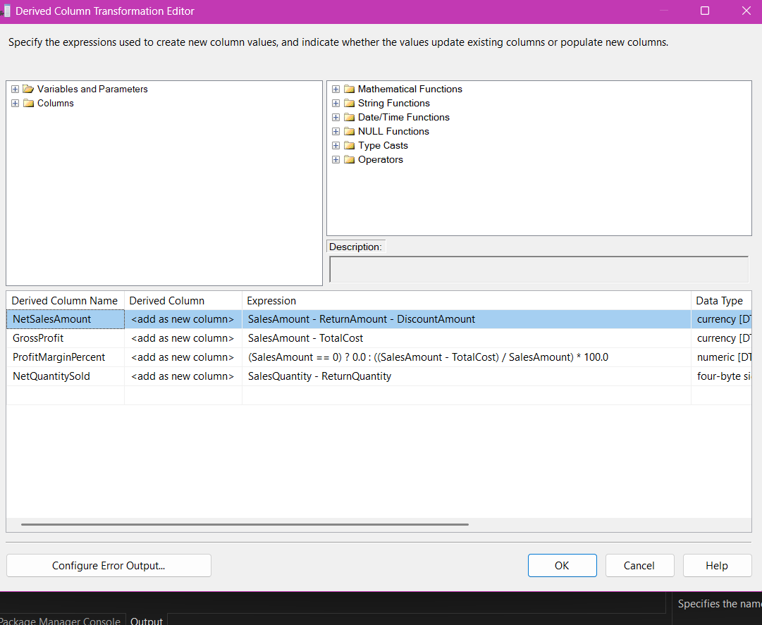
Figure 5a — Financial_Calculations_Sales Derived Column transformation: NetSalesAmount, GrossProfit, ProfitMarginPercent, and NetQuantitySold, with a divide-by-zero guard on ProfitMarginPercent.

5.2 Data Standardization
Applied to dwh.Customer:
- Proper-case formatting of customer names, ensuring consistent presentation across reports regardless of how names were entered at source.
- Phone number cleanup, normalizing formatting inconsistencies from the source system.
- NULL handling via replace-column Derived Column expressions, ensuring downstream reports and joins do not silently drop or mis-render missing values.

5.3 Business Classifications
Applied to Sales, SalesQuota, and Customer via dedicated Derived Column transformations (Business_Classifications_Sales, Business_Classifications_SalesQuota, Business_Classifications_Customers) immediately following Financial Calculations in the Sales/SalesQuota branches, and immediately before Data Standardization in the Customer branch. Each transformation uses conditional (ternary) expressions to convert a numeric measure into a business-friendly category stored as a new string column on the corresponding dwh table:
Branch | Output Column | Basis | Business Value
Sales | TransactionSizeCategory (nvarchar(10)) | SalesAmount, e.g. SalesAmount < 100 → "Small" | Lets reports group transactions by size band without repeating threshold logic in every query.
SalesQuota | QuotaPerformanceCategory (nvarchar(20)) | QuotaAchievementPercent | Turns a raw percentage into an at-a-glance performance tier for sales management reporting.
Customer | IncomeSegment (nvarchar(10)) | YearlyIncome | Supports customer segmentation and targeted marketing analysis by income band.
Customer | FamilySizeCategory (nvarchar(15)) | TotalChildren | Supports household-based segmentation for marketing and product-mix analysis.
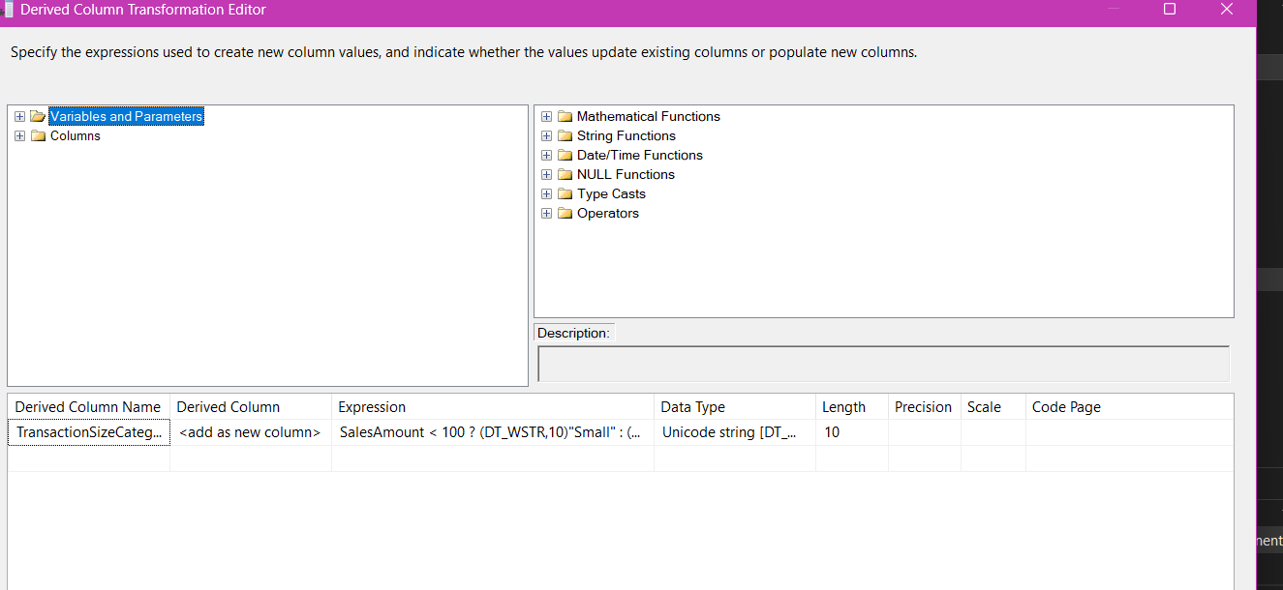
Figure 5b — Business_Classifications_Sales Derived Column transformation: TransactionSizeCategory derived from SalesAmount via a conditional expression.

5.4 Audit Info
Applied uniformly to all three branches (Sales, SalesQuota, Customer) via dedicated Derived Column transformations (Audit Information, Audit Information 1, Audit Information 2), immediately before a Row Count check and the final load into the corresponding dwh table. Four audit columns are attached to every row, each sourced from SSIS system/user variables rather than hard-coded values, so the audit trail is accurate per execution:
Column | Expression | Purpose
AuditLoadDate | GETDATE() | Timestamp of when the row was processed by the Transformation package.
AuditPackageName | (DT_WSTR,100)@[System::PackageName] | Identifies which SSIS package produced the row, for traceability across the pipeline.
AuditBatchID | (DT_WSTR,30)@[User::PkgStartTimeStr] | Groups all rows loaded within the same package execution into one traceable batch.
AuditETLUser | (DT_WSTR,100)@[System::UserName] | Records the execution identity (service account) that ran the load, for audit and security review.
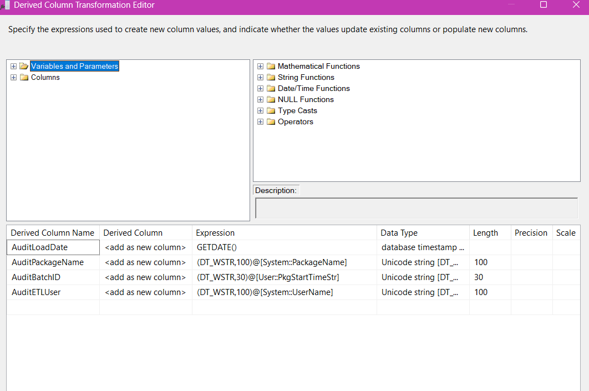
Figure 5c — Audit Information Derived Column transformation: AuditLoadDate, AuditPackageName, AuditBatchID, and AuditETLUser, sourced from GETDATE() and SSIS System/User variables.

6. Incremental Load Strategy
Incremental Load is implemented as a set of T-SQL MERGE-based stored procedures (one per source table: usp_MergeIncremental_Sales, usp_MergeIncremental_OnlineSales, usp_MergeIncremental_SalesQuota, usp_MergeIncremental_Customer), executed from the Incremental_Load.dtsx package via Execute SQL Task calls. Each procedure merges newly changed source rows directly into the corresponding staging table (stg.*); the existing Full Load pipeline's Validation and Transformation packages then carry those changes forward into vld.* and dwh.* on the next scheduled run.

6.1 Change Detection Approach
Each stored procedure reads a per-table watermark from dbo.ETL_IncrementalControl (LastLoadDate) and compares it against the source table's UpdateDate column in ContosoRetailDW. Only rows with UpdateDate greater than the watermark are selected as the MERGE source, so unchanged rows are never re-read or reprocessed. An early exit (IF NOT EXISTS ... RETURN) also skips the MERGE entirely when there is no new data, avoiding unnecessary work on a fully caught-up table.

6.2 Insert Strategy
The MERGE statement's WHEN NOT MATCHED BY TARGET clause handles new rows: any source row whose key (e.g., SalesKey) does not already exist in the staging table is inserted in full, including the original source ETLLoadID/LoadDate audit values.

6.3 Update Strategy
The WHEN MATCHED clause handles changed rows: for a key that already exists in staging, the procedure compares the tracked business columns (e.g., for Sales: SalesAmount, SalesQuantity, UnitPrice, UpdateDate) between source and target, and only issues an UPDATE when a real change is detected, refreshing UpdateDate to the current time (GETDATE()) so the change is visible to the next watermark comparison.

6.4 Duplicate Prevention Mechanism
Duplicate prevention is inherent to the MERGE statement itself: the ON Target.<Key> = Source.<Key> join condition guarantees each source row can only ever match at most one target row, so a row is deterministically routed to either the INSERT or the UPDATE branch — never both, and never inserted twice across repeated runs. This is combined with the UpdateDate watermark filter, which additionally ensures a row that has not changed since the last run is not even included in the MERGE source set.

6.5 Control Table: ETL_IncrementalControl
Tracks the last successful load watermark per table (Sales, OnlineSales, SalesQuota, Customer). Each stored procedure updates its row in this table to MAX(UpdateDate) from the just-processed source rows, but only after its MERGE completes successfully — ensuring the next run's watermark accurately reflects what was actually loaded.

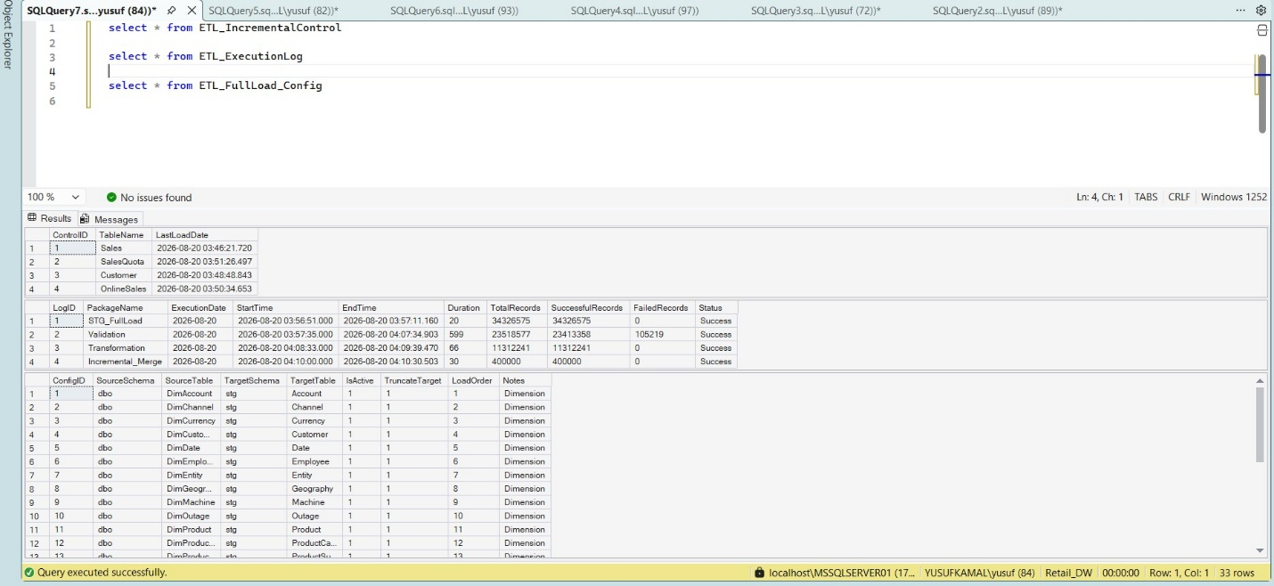

6.6 Error Handling
Each stored procedure wraps its MERGE in a TRY/CATCH block. Because SET IDENTITY_INSERT is enabled before the MERGE to allow explicit key values on insert, the CATCH block explicitly turns IDENTITY_INSERT back off before re-throwing the error (THROW), preventing the staging table from being left in a state where subsequent inserts would fail.

7. SSIS Framework using Configuration Tables
Rather than hard-coding table names, connection details, and load watermarks inside individual packages, the solution externalizes this metadata into two configuration/control tables, allowing the pipeline's scope and state to be changed without modifying package logic.
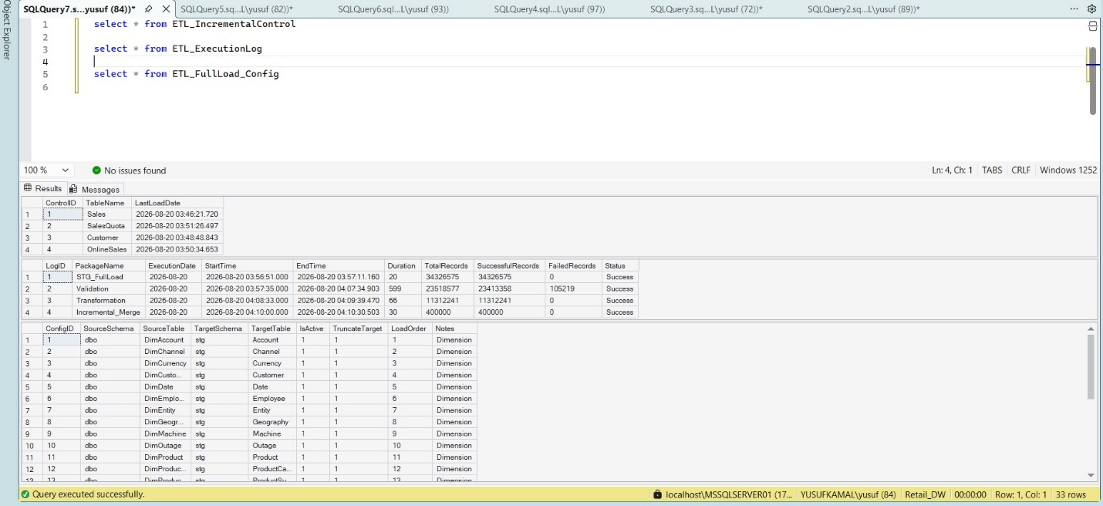

7.1 ETL_FullLoad_Config
Drives the dynamic, metadata-driven Full Load package. Each row identifies a source table to be staged; the ForEach Loop Container in Full_Load.dtsx iterates over active configuration rows and maps each one into SSIS variables consumed by the dynamic Data Flow. Adding a new table to the Full Load only requires a new configuration row — no package changes.

7.2 ETL_IncrementalControl
Tracks the last successful load watermark per table for the Incremental Load package (see Section 6.5).

7.3 Framework Benefit
This configuration-driven approach is the core of a reusable SSIS framework: extending the pipeline to new source tables or resetting incremental state is a data change, not a code change, which reduces deployment risk and development time for future extensions.

8. Scheduling and Operational Monitoring (Bonus)

8.1 SQL Server Agent Job Scheduling
The pipeline is deployed to the SSIS Catalog (SSISDB) and orchestrated through two separate SQL Server Agent Jobs, reflecting the different operational cadence of full vs. incremental processing:
Job | Steps | Trigger
Retail_DW_Full_Load_Job | Full Load → Validation → Transformation | Manual / on-demand (full rebuild of the warehouse)
Retail_DW_Incremental_Load_Job | Incremental Load | Scheduled daily
Logging.dtsx is invoked from within each of the four pipeline packages themselves (not as a separate job step), so every package run — regardless of which job triggered it — is captured centrally.

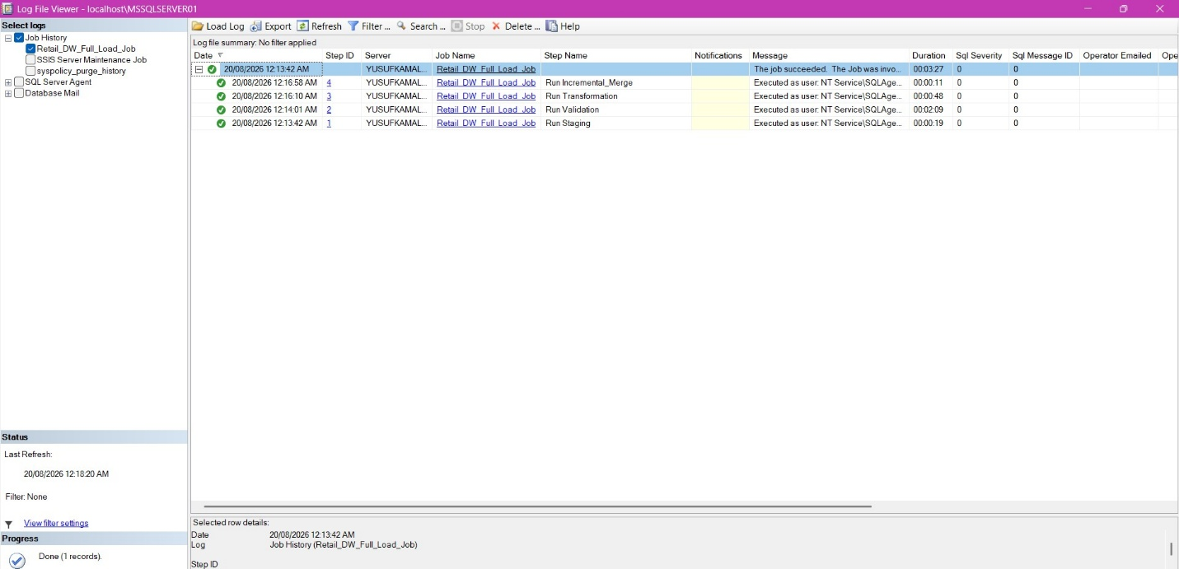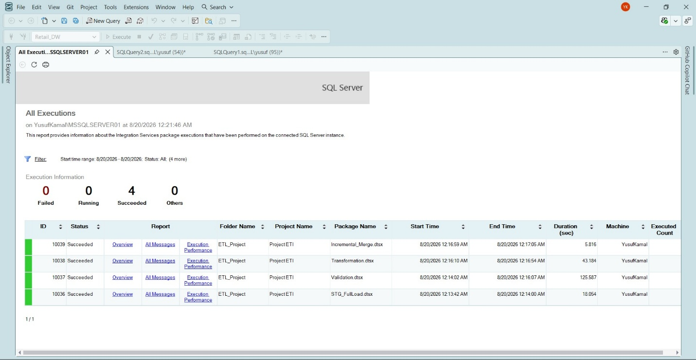

8.2 Email Notifications
Database Mail was configured with a dedicated SMTP account and profile, an Operator was created, and both SQL Agent Jobs were configured to email the Operator on job failure, enabling immediate awareness of pipeline issues without manually checking job history.



9. Challenges
Several real operational issues were encountered and resolved during development and deployment:

9.1 Configuring Database Mail and SSISDB for Operational Monitoring
Setting up the operational side of the project — the SSIS Catalog (SSISDB) for centralized deployment and execution reporting, and Database Mail for automated job notifications — surfaced several real-world configuration challenges that are common when moving from a development environment to something closer to a production setup.
The SSIS Catalog (SSISDB) was created and both projects deployed to it using the Project Deployment Model, which enabled the use of the built-in 'All Executions' report and the catalog.operation_messages system view for troubleshooting package failures directly from SSMS, rather than relying only on SQL Agent's own job history. This proved essential throughout the project for diagnosing the deeper Data Flow errors described in Section 9.3.
Database Mail configuration was the more involved challenge. The first attempt used the project owner's Outlook.com account as the SMTP provider, configured with Anonymous authentication on port 25. This failed immediately, since modern mail providers require both an authenticated session and an encrypted (TLS) connection before they will accept mail. The account was corrected to use Basic authentication with the correct Outlook SMTP server and port, but the connection continued to fail — this time because Microsoft has deprecated Basic Authentication for personal Outlook accounts entirely, regardless of how the account is configured.
The account was then switched to Gmail's SMTP server with an app-specific password, which Gmail still supports for Basic Authentication. This also failed initially, with the SMTP server reporting that a secure connection was required before authentication could proceed — the same class of error as the Outlook attempt, despite SSL being enabled on the account. Investigating further traced the root cause to the underlying .NET Framework on the database server, which defaults to older TLS versions unless explicitly configured to use TLS 1.2. This was resolved by enabling the SchUseStrongCrypto and SystemDefaultTlsVersions registry settings for the .NET Framework and restarting the server so the change would take effect.
A second, more subtle issue then surfaced: even after the TLS fix, authentication still failed. Reviewing the account's stored configuration directly in msdb.dbo.sysmail_server revealed that the SMTP username had been saved incorrectly — the account's display name ('Yusuf Kamal') had ended up in the username field instead of the actual Gmail address, apparently due to an inconsistency in how the Database Mail Configuration Wizard persisted the edited fields. Rather than continue troubleshooting the wizard, the account was dropped and recreated from scratch using T-SQL (sysmail_delete_account_sp followed by sysmail_add_account_sp), which guaranteed every field — server, port, SSL, username, and password — was set explicitly and correctly in a single, auditable step. A test email sent immediately afterward was delivered successfully.
Finally, once the mail account itself worked, job notifications still did not fire on a real job failure. This was traced to the SQL Server Agent's 'Enable mail profile' setting under Alert System: like several SQL Server Agent settings, it is read once when the Agent service starts and is not applied live, even after being saved through the GUI. Restarting the SQL Server Agent service (not the SQL Server service itself) resolved this, after which failure notifications were confirmed to arrive correctly for both SQL Agent Jobs.

9.2 Intermittent Data Flow Buffer Failures
The Validation package intermittently failed on different Data Flow Tasks across separate runs (first on the OnlineSales branch, then on the SalesQuota branch), despite the underlying source data being unchanged between runs — a strong signal that the cause was environmental rather than a data-quality problem. The first hypothesis was memory pressure: the SQL Server instance had no configured ceiling on its memory usage, so it was free to consume all available RAM and starve the separate SSIS runtime process of the memory it needs to build Data Flow buffers. Capping max server memory to a reasonable value and restarting the service did not fully resolve the issue on its own, which pointed to a second, more specific cause. Reviewing the Validation package's design showed that all four parallel Data Flow Tasks shared a single OLE DB Connection Manager; because the four branches run concurrently, the OLE DB provider can experience contention when several Data Flows try to use the same connection object at the same time, which is consistent with the failure moving unpredictably between branches on different runs. The fix was to give each Data Flow Task its own dedicated Connection Manager instance (four separate connections, one per branch) instead of sharing a single one. After this change was deployed, the Validation package ran successfully and repeatedly with no further buffer or PrimeOutput failures, confirming the shared connection as the true root cause.

10. Execution Results and Error Handling Examples

10.1 Successful Execution Evidence

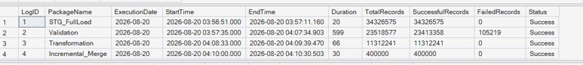

10.2 Error Handling — Before / After Examples

Example 1: Database Mail Authentication
Before: SMTP authentication was rejected regardless of provider — first Outlook, then Gmail — with the server reporting that a secure, authenticated connection was required before it would accept the message.
After: Enabling TLS 1.2 as the system default at the OS level and recreating the Database Mail account via T-SQL (to guarantee the username and password were stored correctly) resolved the issue; a test email was delivered successfully, and a subsequent live test — an intentionally failing job step — confirmed the Operator received the failure notification end-to-end.

Example 2: Shared Connection Manager Contention
Before: The Validation package intermittently failed on different Data Flow Tasks across separate runs, despite unchanged source data, pointing to a resource-contention cause rather than a data-quality issue.
After: The root cause was traced to a single OLE DB Connection Manager shared across all four parallel Data Flow Tasks (see Section 9.3). Assigning each Data Flow Task its own dedicated Connection Manager resolved the issue — the package has since run successfully and repeatedly with no further buffer or PrimeOutput failures.

11. Conclusion

11.1 Summary
This project delivers a complete, layered ETL pipeline for a retail data warehouse, built entirely on SQL Server Integration Services and SQL Server Agent. The solution covers dynamic staging, rule-based validation with centralized error logging, business transformation producing report-ready metrics, incremental change-detection loading, and full operational monitoring through centralized logging, job scheduling, and automated email alerting — implemented using a configuration-table-driven framework that allows the pipeline's scope to be extended without modifying package code.

11.2 Recommendations for Future Improvements
- Real-time / near-real-time ETL — replace or supplement the daily incremental batch with a change-data-capture (CDC) or streaming-based approach for lower data latency.
- Cloud integration — migrate or extend the pipeline to a cloud data platform (e.g., Azure Data Factory / Synapse) for elastic scale and managed orchestration.
- Dashboards — connect the dwh layer to a BI tool (e.g., Power BI) to expose the financial and sales-performance metrics built in the Transformation layer directly to business users.
- Automated monitoring — extend the current logging/notification setup with proactive alerting on data-quality thresholds (e.g., "a spike in row counts across the per-table Invalid/Error tables") rather than only job-failure notifications.
- Framework generalization — extend the ETL_FullLoad_Config-driven pattern already used for staging to the Validation and Transformation layers, further reducing hard-coded, per-table package logic.

