According to researches, computers can recognize users looking the usage patterns of keyboard. It is unique for each user like a finger print or retina.   
In my project, I developed a new user log-in system which tries to find an answer to this question. Is the current user owner of this account?   
  
Now, each website uses similar log-in system. If the username and password matches, current user can login the system. For example, our university or cloud system account user log-in pages, if a user types our username and password. The user can login our account and the user can change or delete our important information.   
  
In additionally, we learned Brute Force attack in class. The system can easily find the current username and password with this method.   
  
This user log-in system is not enough to protect our information, because this system is only protection in front of our identity. We should have much secure systems. We have "I am not a robot" or "text message verification" security layers.  
  
I developed another security layer with this project. This system takes user patterns of keyboard as an example and it learns these;

* Users' mistakes
* Users' speed
* Users' special keys (shift or caps lock)

For speed the keyboard has 4 different speed methods;

1. Released press
2. Released release
3. Pressed release
4. Pressed press

I used pressed press method. The system takes the time of between two keys. For each two keys, it calculates arithmetic mean and standard deviation. After, it creates an artificial neural network with this information. Then, it gives the weight for each neuron looking the earlier data. If there is so many data in the range of mean and deviation, this neuron's weight becomes higher.   
  
Lastly, it calculates the threshold for the network. Using this information, the system takes the current user's usage pattern of keyboard and it gives the new input to the network. If the input greater than threshold, the system allows to login the user and saves the input for improving the accuracy.   
  
Data for the user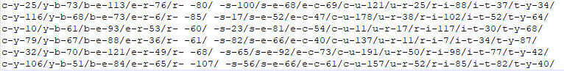

New input for another user

  
How it works with this data (show the network)

perceptron $$Artithmetic mean :\frac{25+116+10+79+35+106}{6}= 61.83$$

$$Standard deviation : \sqrt{\frac{{\left(61.83-25\right)}^{2}+{\left(61.83-116\right)}^{2}… {\left(61.83-106\right)}^{2}}{6}}=41.5$$ As a result, it has so many advantages, but also it has some disadvantages too.  
  
Our information will be more protected, but it will be harder to login.   
For each different device users' pattern will change. It can't be same input for every device.  
The system is not good as I think. Same algorithms must be change for example we should use k-means instead of arithmetic mean.  
  
However, it is very good to think that a system will have an ability to recognize user.