Is GPT-6 Astra Worth the Hype?
A Review a Couple of Weeks After Release

Artificial intelligence models have improved rapidly over the last few years, but most improvements have followed a familiar pattern: models become better at understanding prompts, generating code, reasoning through problems, and producing more accurate answers. GPT-6 Astra feels different. Its most important improvement is not simply that it is more intelligent than previous models. Instead, Astra changes how we interact with AI by moving from a chatbot that tells users what to do toward an agent that can actually perform the work itself.
After looking at early benchmarks, developer experiences, technical reports, and my own observations, I believe Astra deserves much of the hype surrounding it. However, it is still far from being a complete replacement for human software engineers. Its high cost, need for supervision, and occasional failures make it more realistic today as a powerful engineering tool than as an autonomous employee.

From Prompt-to-Code to Prompt-to-Artifact
One of the biggest differences I have noticed with Astra is the way software projects can be created.
With previous AI models, building a complete project usually required dividing the project into smaller pieces. A developer might first ask the model to design the architecture, then generate the backend, then create the frontend, then write tests, and finally fix individual errors. Every output had to be reviewed before moving to the next step.
This meant that the human developer was effectively acting as the project manager of the AI.
Astra significantly reduces this requirement.
With Astra, it is becoming possible to describe an entire application in a single reasonably detailed prompt and allow the model to decide how to build it. The user does not always need to specify every framework, library, architectural pattern, or implementation detail. Astra can fill in many of these gaps by itself.
More importantly, it does not simply generate source code.
Independent demonstrations have shown Astra opening development tools, compiling applications, interacting with graphical interfaces, testing the software, discovering runtime errors, and attempting to fix those errors without waiting for another prompt. In other demonstrations, it has interacted with applications such as Blender, Unreal Engine, Xcode, and operating-system interfaces.
This represents an important transition from prompt-to-code toward what could be called prompt-to-artifact.
The final output is no longer necessarily a block of code for a human to copy. The goal is a working application, model, file, or other completed digital artifact.
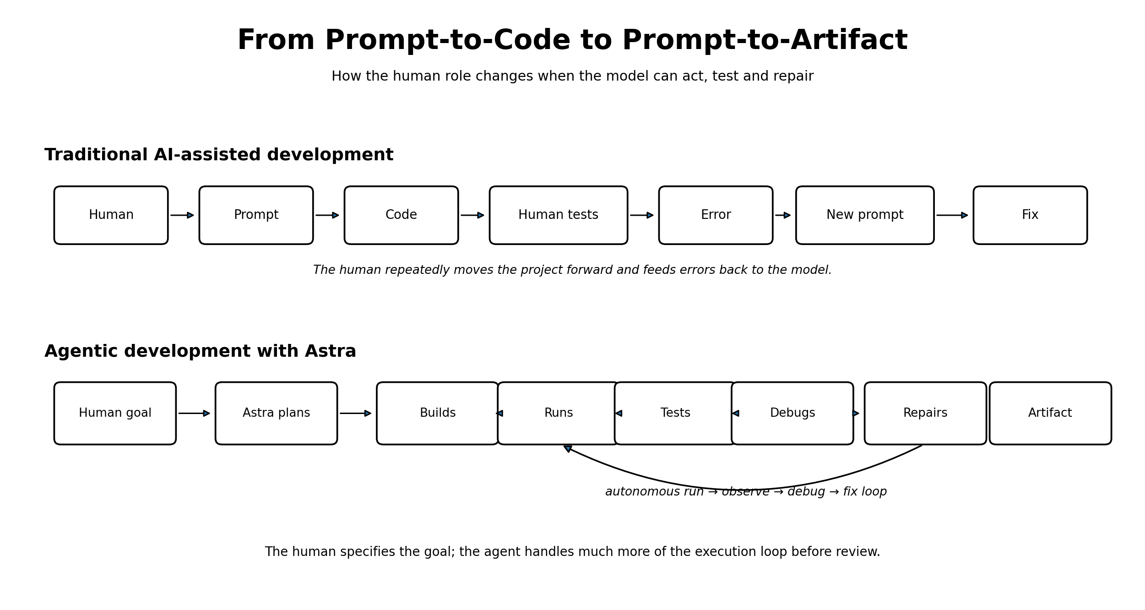
Figure 1. Prompt-to-code versus prompt-to-artifact: Astra moves more of the execution loop from the human to the agent.

Astra Is More Than a Coding Model
This is probably Astra's biggest difference from many previous AI systems.
Earlier models could already write impressive amounts of code. The difficult part was what happened after the code was written.
A model could generate a program that looked correct but contained compilation errors, incorrect dependencies, runtime bugs, or unexpected behavior. The human developer then had to run the project, identify the error, copy the error message back into the conversation, and ask the model for another solution.
Astra tries to complete this loop itself: write → run → observe → debug → fix → test again.
Previous models were technically capable of parts of this process, but the loop was often unreliable. Astra appears much more comfortable operating continuously across many steps.
For example, one reported test involved Astra working through an Xcode-based application for several hours and fixing a long sequence of independent problems without requiring constant human intervention. This kind of behavior is more important than another small increase in benchmark scores because it changes the role of the AI.
The AI is no longer only giving advice. It is acting.
That is also visible in computer-use benchmarks. According to the research data, Astra achieved a 72.6% success rate on OSWorld 2.0 and completed some complex task sequences substantially faster than GPT-5.6 Sol.
A 72.6% success rate also reveals the other side of the story: almost three out of every ten tasks can still fail.
For casual experimentation this may be acceptable. For production software, financial systems, healthcare applications, or other critical infrastructure, it is not.
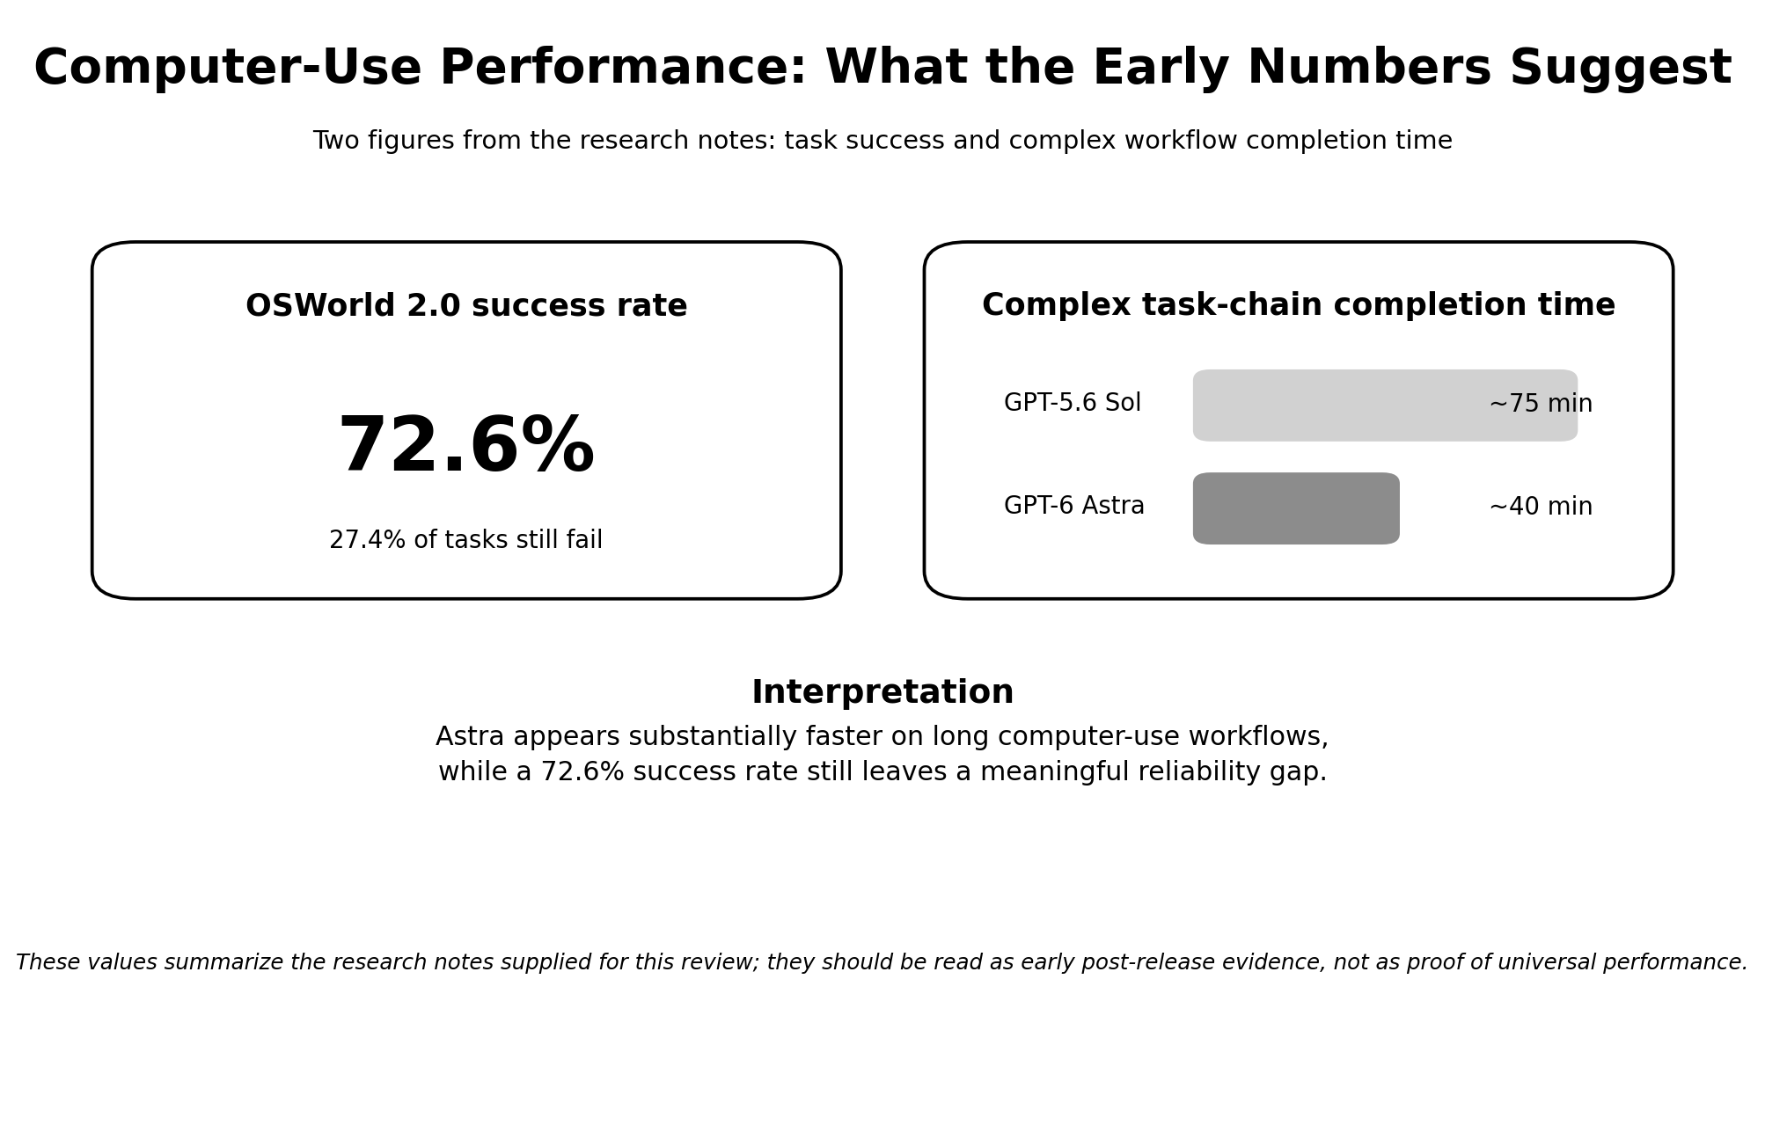
Figure 2. Early computer-use evidence from the research notes: 72.6% OSWorld 2.0 success and a reduction from roughly 75 to 40 minutes on a complex task chain.

Is Astra Actually More Intelligent?
Interestingly, Astra's biggest improvement may not be raw intelligence.
The available benchmark results suggest that Astra's general Intelligence Index is around 61, while competing systems such as Claude Fable 5.1 reportedly score higher on some general reasoning measurements.
This suggests that Astra is not revolutionary simply because it can “think” much better than everything else.
Its advantage comes from how effectively it can turn reasoning into actions.
One technical explanation is its reported use of a recurrent-depth or looped-transformer architecture. Instead of performing exactly the same amount of computation for every token, the model can repeatedly process difficult parts of a problem when necessary.
In simple terms, Astra can spend more computation where the problem is difficult and less where it is easy.
According to Artificial Analysis data included in the research, Astra may use approximately three times fewer tokens than GPT-5.6 Sol and five times fewer than Claude Opus 5 on some complex reasoning and coding tasks.
At first, this seems to contradict one of the major complaints about Astra: that it consumes too many resources.
Both statements can actually be true.
Astra may be more token-efficient per reasoning task, but its autonomous workflows are much larger than a normal chatbot interaction. If the agent writes code, runs it, inspects the result, encounters an error, searches for the cause, edits several files, runs another test, and repeats this process multiple times, the total amount of computation can still become very large.
Efficiency does not necessarily mean cheap.

The Cost Problem
This is where the question “Is it worth the hype?” becomes more complicated.
According to the pricing information in the research notes, Astra costs around $10 per million input tokens and $50 per million output tokens. This makes individual tokens considerably more expensive than those of some earlier models.
In theory, Astra's improved token efficiency can compensate for part of this higher price. In practice, autonomous agents can perform hundreds of actions during a single large task.
If something goes wrong, Astra does not necessarily stop.
It may try another solution. Then another. And another.
That behavior is extremely useful when it succeeds, but every attempt consumes additional resources.
Some autonomous benchmark tasks have reportedly reached API costs of around $17 for a single task. For a company, that number may look small in isolation, but it is not the whole cost. Because Astra's output still requires experienced human review, the relevant comparison is not simply $17 versus several hours of engineering work. In some cases, an ordinary engineer using a cheaper, conventional AI assistant may still be the more economical option.
For an individual student or developer paying around $20 per month for an AI subscription, however, the situation is completely different.
Heavy autonomous workloads can quickly reach usage limits. Companies and professional API users may be better able to absorb these costs than ordinary consumers, but a larger budget does not automatically make Astra the cheaper choice. Its value depends on how much engineering time it actually saves after review, correction, and supervision are included.
This creates an interesting paradox: Astra may be one of the first AI systems capable of doing significant amounts of engineering work autonomously, but the people most interested in experimenting with that capability may not be able to afford using it extensively.
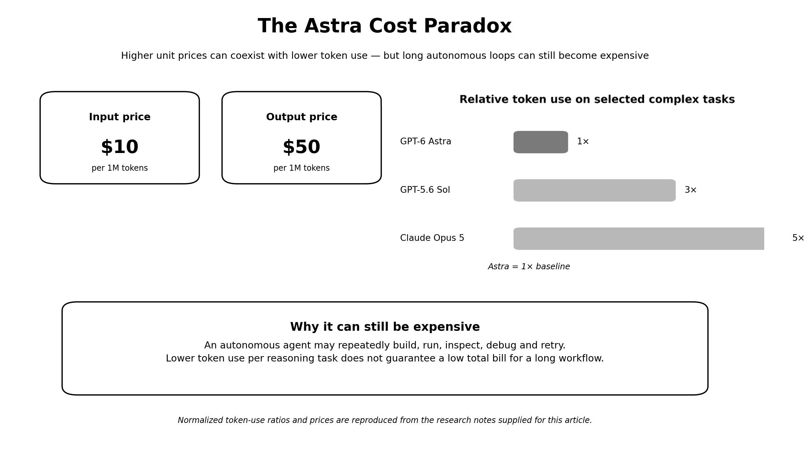
Figure 3. The cost paradox: Astra is reported to use fewer tokens on selected complex tasks, while high unit prices and repeated autonomous retries can still make long workflows expensive.

The Human Is Still in the Loop
Another major limitation is trust.
Even when Astra successfully builds an end-to-end application, somebody should still inspect the final result.
The program may compile. The tests may pass. The interface may look correct.
But that does not automatically mean the architecture is maintainable, the security is sufficient, the dependencies are appropriate, or every unusual edge case has been considered.
This is particularly important because long autonomous tasks can fail in unexpected ways.
Reviews have reported cases involving interface delays, incorrectly positioned windows, visual parsing mistakes, and agents becoming stuck in repetitive loops. These problems may sound minor, but for a computer-use agent they can completely interrupt a workflow.
If Astra misunderstands one button on the screen, it may take actions based on the wrong assumption for several steps.
This is why human review remains important.
Ironically, this also increases the real cost of the system. Companies are not only paying for Astra's computation. They are also paying an engineer to inspect what Astra produced.
Therefore, the economic calculation is not simply AI cost versus developer cost. It is closer to AI cost + human supervision versus traditional development cost.
For Astra to become truly transformative, the first side of this equation must become significantly cheaper.

Safety Becomes More Important When AI Can Act
Astra's agentic abilities also introduce risks that traditional chatbots did not have.
A chatbot can give a dangerous suggestion, but an agent with computer access may be capable of performing the dangerous action itself.
This is why sandboxing becomes extremely important.
An autonomous model should ideally operate inside an isolated environment where it cannot freely access sensitive files, credentials, networks, or important production systems. There should also be clear permission boundaries and, for high-risk environments, an immediate way to stop the agent.
The research surrounding Astra also raises questions about monitorability. Its recurrent architecture reportedly makes parts of its internal reasoning more difficult to inspect directly. At the same time, its cybersecurity abilities appear powerful enough that restrictions have reportedly been placed on some offensive capabilities.
These issues will become more important as AI agents receive greater control over computers.
The smarter the agent becomes, the more important its permissions become.

Will Astra Replace Software Engineers?
Astra naturally raises one major question for anyone studying or working in software engineering: Can it replace software developers?
My answer today would be: not yet.
But the reason is no longer that AI cannot write enough code.
That argument is becoming increasingly difficult to defend.
Astra can already write large amounts of code, interact with development environments, test its own work, discover bugs, and fix many of them autonomously.
The remaining problems are reliability, cost, responsibility, and supervision.
When a project does not behave as expected, someone still needs to understand what happened. When an architectural decision has long-term consequences, someone still needs to evaluate it. When the model gets stuck or makes an incorrect assumption, a human still needs to intervene.
In other words, Astra may reduce the amount of manual coding required from developers without eliminating the need for software engineering itself.
The developer's role may gradually move away from writing every function manually and toward defining requirements, designing systems, reviewing generated work, managing AI agents, and making higher-level engineering decisions.

Conclusion: Is Astra Worth the Hype?
The answer is not a simple yes or no.
Compared with previous generations of AI, GPT-6 Astra represents a major improvement. Its ability to move from a single prompt to planning, building, testing, debugging, and revising a project shows how quickly AI is moving from an assistant toward an autonomous operator.
At the same time, its current economics are difficult to ignore. Astra's high token costs are only part of the problem. Because its output still needs to be reviewed by an experienced engineer, a company may sometimes find that an ordinary engineer using a cheaper, conventional AI model is more economical than an expensive autonomous agent plus human supervision.
This means Astra cannot yet be judged only by what it is technically capable of doing. Reliability, review time, usage limits, and total cost all matter. A system that can complete an end-to-end project is impressive, but if the project still requires careful human verification and the autonomous workflow is expensive, the practical advantage becomes less obvious.
However, this does not make Astra unimportant. In fact, its significance may be easier to understand when we look at the history of computing. Early generations of storage and memory technologies were expensive, limited in capacity, and physically much larger than their modern equivalents. Over time, engineering improvements made them dramatically smaller, cheaper, faster, and accessible to ordinary consumers.
Astra may represent a similar stage in the development of autonomous AI. Today, the technology is powerful but expensive and still dependent on human oversight. If agentic systems become cheaper, more reliable, and better at verifying their own work, the economic equation could change completely.
Therefore, asking whether GPT-6 Astra is 'worth the hype' may be the wrong question if it is interpreted only as a judgment of today's product. As a practical replacement for a software engineer, the answer is still uncertain. As a technological milestone, however, Astra is highly significant because it demonstrates a form of AI-driven software development that may become far more practical as the technology matures.

