Ultrasound Medical Imager

Final Dimensions: 10*14 cm²

3D Model
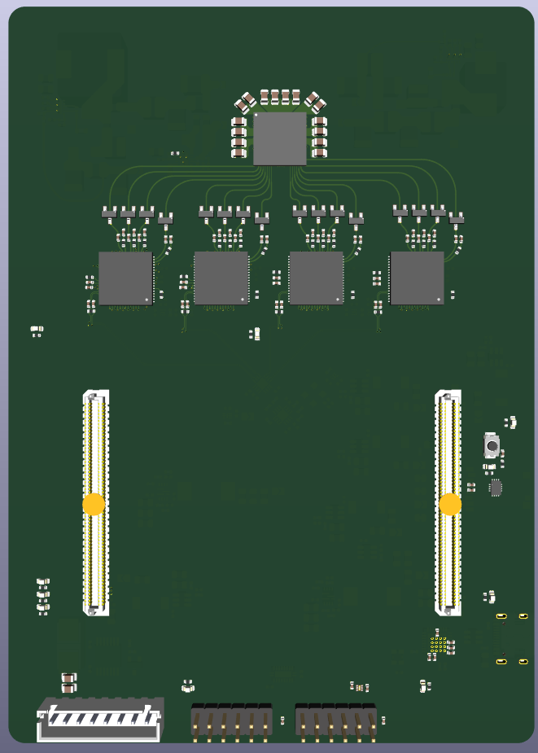
Figure 1: Top view of the PCB.
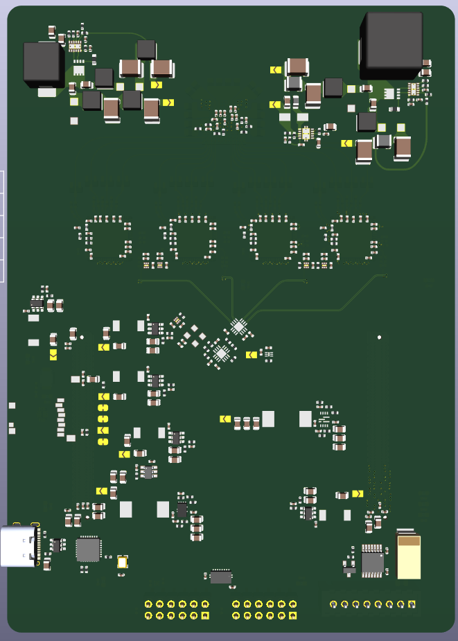
Figure 2: Bottom view of the PCB.

