ONLINE VOTING SYSTEM
DATA FLOW DIAGRAM (DFD)
BCA – 5th Semester, Section A
Group Members: Sarthak Deora, Yusuf Sk
  - Based on the project requirements in the supplied Online Voting System SRS.

1. DFD Level 0 — Context Diagram
This diagram treats the Online Voting System as one process and shows its data exchanges with the Admin, Voter and Candidate.
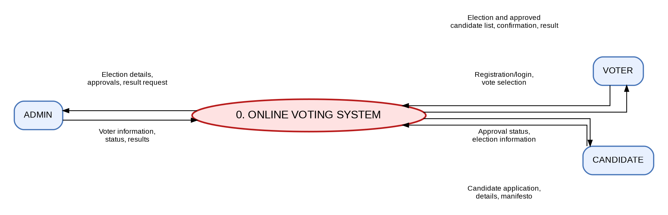

2. DFD Level 1 — Process Diagram
This diagram expands the system into registration/login, election management, candidate application review, candidate listing, vote casting and result calculation.
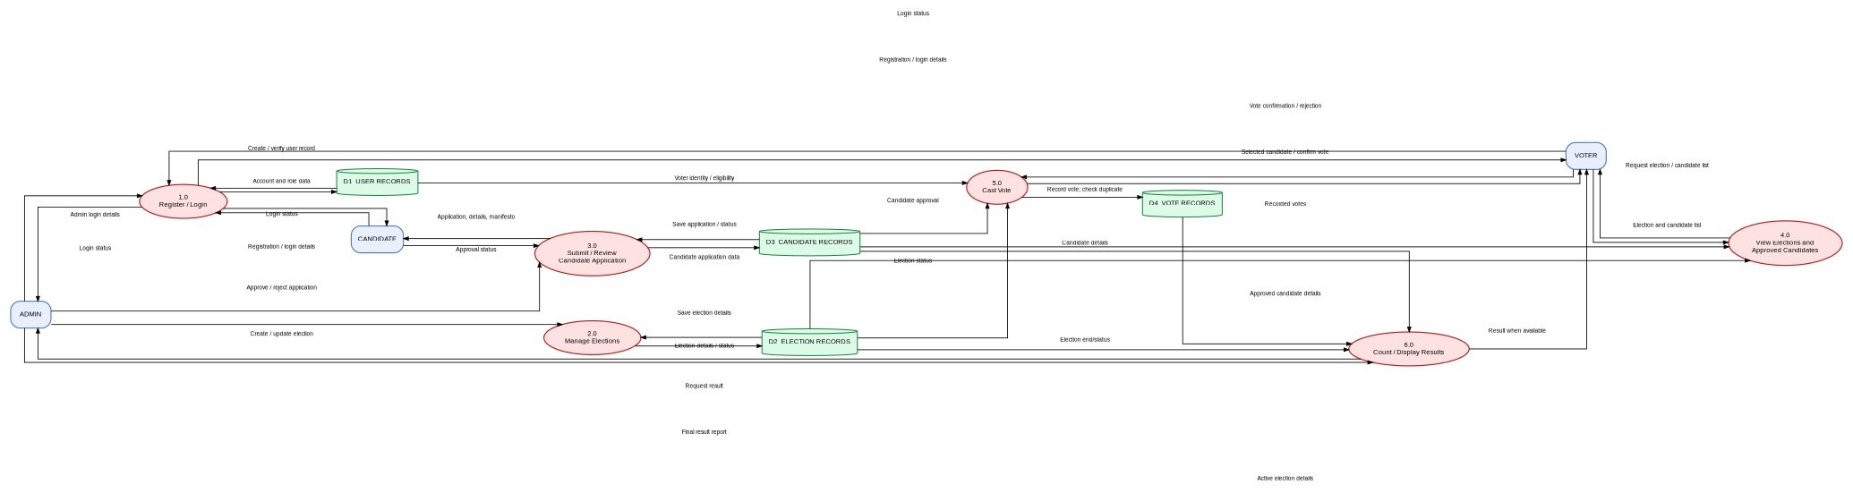

3. Process and Data Store Reference
ID / Name | Purpose
1.0 Register / Login | Registers users and validates login credentials and roles.
2.0 Manage Elections | Admin creates, updates and manages election details.
3.0 Submit / Review Candidate Application | Candidate submits details and manifesto; Admin approves or rejects.
4.0 View Elections and Approved Candidates | Voter views active election details and approved candidates.
5.0 Cast Vote | Checks relevant eligibility/status, records a vote and prevents a second vote in the same election.
6.0 Count / Display Results | Counts recorded votes and displays results when available.
D1 User Records | Logical store for account, login and role data.
D2 Election Records | Logical store for election details and status.
D3 Candidate Records | Logical store for candidate applications, details and approval status.
D4 Vote Records | Logical store for submitted vote records.

4. Notes for Final Submission
- The diagram reflects the features stated in the SRS: election creation, candidate application and approval, voter login, one vote per voter per election, automatic vote counting and result display.
- D1–D4 are logical data stores, not verified database table names. Rename them to match the actual MySQL schema used by the PHP project.
- Confirm the arrows and processes against the implementation before submitting, because the SRS describes requirements but does not include the PHP source code or database schema.

