Cairo University  
Faculty of Computers and Artificial Intelligence

**CS251**

**Intro. to Software Engineering**

YAO

Software Requirements Specifications

Version 1.0

|  |  |  |  |
| --- | --- | --- | --- |
| **ID** | **Name** | **Email** | **Mobile** |
| 20210502 | Yusuf Elsayed Abdelrahman Badr | [yusufbadr@yahoo.com](mailto:yusufbadr@yahoo.com) | 01063033085 |
| 20210251 | Ali-Aldeen Mohamad Mostafa | [alialdin.mohamad@gmial.com](mailto:alialdin.mohamad@gmial.com) | 01120765911 |
| 20210060 | Osama Maher Masoued | [osama392maher@gmail.com](mailto:osama392maher@gmail.com) | 01020083229 |

March 2023

Contents

Team 3

Introduction 3

Software Purpose 3

Software Scope 3

Definitions, acronyms, and abbreviations 4

System Models 9

Use Case Model 9

System Navigation Map 10

Tools 11

Ownership Report 11

# Team

|  |  |  |  |
| --- | --- | --- | --- |
| **ID** | **Name** | **Email** | **Mobile** |
| 20210502 | Yusuf Elsayed Abdelrahman Badr | [yusufbadr@yahoo.com](mailto:yusufbadr@yahoo.com) | 01063033085 |
| 20210251 | Ali-Aldeen Mohamad Mostafa | [alialdin.mohamad@gmial.com](mailto:alialdin.mohamad@gmial.com) | 01120765911 |
| 20210060 | Osama Maher Masoued | [osama392maher@gmail.com](mailto:osama392maher@gmail.com) | 01020083229 |

# Introduction

The purpose of this document is to clarify software requirements that are agreed upon by the stakeholders by specifying the needed functionalities of the software to minimize development time and cost by making the requirements clear. The target audience are the developers who will implement all the requirements.

## Software Purpose

* To make shopping for candies so much easier and accessible to every one
* Make it easier to owners to manage their business

## Software Scope

* Buying candies online
* Reordering past orders
* Managing loyalty points
* Managing discounts and catalog

## Definitions, acronyms, and abbreviations

|  |  |
| --- | --- |
| **Phrase** | **Definition** |
| Loyalty points | Those are points given to every user with every purchase and can be redeemed for money to spend on the site. |
| Maintainability | The ability to maintain the software by constant checks and tests. |
| Scalability | It’s the measure of a system's ability to increase or decrease in performance and cost in response to changes in application and system processing demands. |
| Resource usage | It’s how much the software will the software consume hardware resources. |
| Computing platform | It’s the platform that the software will process on. |
| Availability | It’s the measure of how much will the software will be available in a period of time. |
| Reliability | It’s the probability of failure-free operation of the software for a specified period. |
| Development process | It describes the development approach that will be taken. |

Functional Requirements

|  |  |
| --- | --- |
| Requirement ID | Statement |
| FR01 | Upon opening the website, the user shall see a homepage displaying best-seller products sold by the store along with a sign up/sign in button. |
|  | Each item will be composed of the following data:   * Name * Category * Description * Image * Brand * Price * Discount percentage if any |
| FR02 | Upon clicking on the sign up button, the user shall see a sign up page including personal information asked by the sign up page. These personal information fields are:   * E-mail * Password * Address |
| FR03 | The E-mail field should validate the following:   * Check if the Email exists and is valid * Check if the Email has never been used before for creating an account * Validate the account using a One Time Password(OTP) sent to the Email entered. Upon valid OTP, the registration is approved. * Otherwise, the registration is rejected and no account is created. |
| FR04 | The password field should adhere to secure password requirements |
| FR05 | Upon clicking on the sign in button, the user shall be prompted with two fields asking him to input his/her E-mail and password. |
| FR06 | The user shall view the products using the following categories:   * All items * Best-seller products * Type/Brand of candy |
| FR07 | There will be a search bar allowing the user to search for a specific product/brand. |
| FR08 | Upon logging in, the user will be able to add products to his/her shopping cart. |
| FR09 | The shopping cart shall have the following properties:   * Allows the user to change a product’s quantity, or remove an item * Validates that the quantity of a single sealed item is bound within a maximum of 50 units. * Validates that the weight of a single loose item is bound within a maximum of weight of 50 kilograms |
| FR10 | There will be a separate web page dedicated for the purchases of gift cards. |
| FR11 | In the checkout, there will be the following payment options:   * Cash On Delivery (COD) - can be used to pay for an order (or the remaining amount if any) * Smart Wallets – can be used to pay for an order (or the remaining amount if any) * One or more gift vouchers – the value of this/these vouchers shall be subtracted from the total sum. * Loyalty points can be redeemed to pay for an order or a part of an order. |
| FR12 | If Cash on Delivery (COD) is selected, the user should enter a valid phone number which is verified by a One Time Password (OTP) sent to the user to be entered to the system for successful verification. |
| FR13 | Upon a successful purchase, the user shall earn loyalty point according to the scheme decided by the admin. |
| FR14 | After successful payment, the user will be prompted to choose whether to use the shipping address on his/her profile or to enter another address. |
| FR15 | In the shipping cart, there shall be an option called ‘reorder’. Upon clicking on the reorder button, the user will be prompted to re-order the previous order with the same quantities. |
| FR16 | In the user profile, there will be a category called ‘Order History’. This will enable the user to view all of the his/her previous order activity/history. |
| FR17 | The system administrator will have a dedicated page to be able to manage items in the following ways   * Update catalogue with new items * Cancel items * Update item information |
| FR18 | The system administrator will have a dedicated page to view the following information about the system:   * Order made by users * Statistics about the following:   + Daily sales   + Monthly sales   + Sales of a time in a given period of time   + Most popular products |
| FR19 | The system administrator will have the privileges to do the following each in a dedicated page:   * Set a loyalty points scheme * Suspend a user |
| FR20 | The system owner has the privilege of adding new system administrators. |

Non-Functional Requirements

|  |  |
| --- | --- |
| Non-Functional requirements ID | Statement |
| Performance | Every panel should take about 3 seconds to load |
| Scalability | The site should support up to 1000 simultaneous users without experiencing a drop in performance |
| Resource usage | -The website shouldn’t use more than 50 mb of the memory  - system must consume less than 2% of the CPU’s time when run on a 1.8GHz machine under a certain operating system. |
| Maintainability | -The code should be well-organized and easy to understand, with clear documentation. -The site should be tested regularly to ensure that it is working properly. |
| Reliability | The server shouldn’t suffer more than one failure in 4 months. |
| availability | The site should be available 95% of the time and its down time shouldn’t exceed 20 mins in 20 years span |
| Recovery from failure | The system should be recovered within 12 hours of failure |
| Computing platform | The website should be working on every browser on every operating system |
| Development process | Our approach in the development should be agile |

# System Models

## Use Case Model

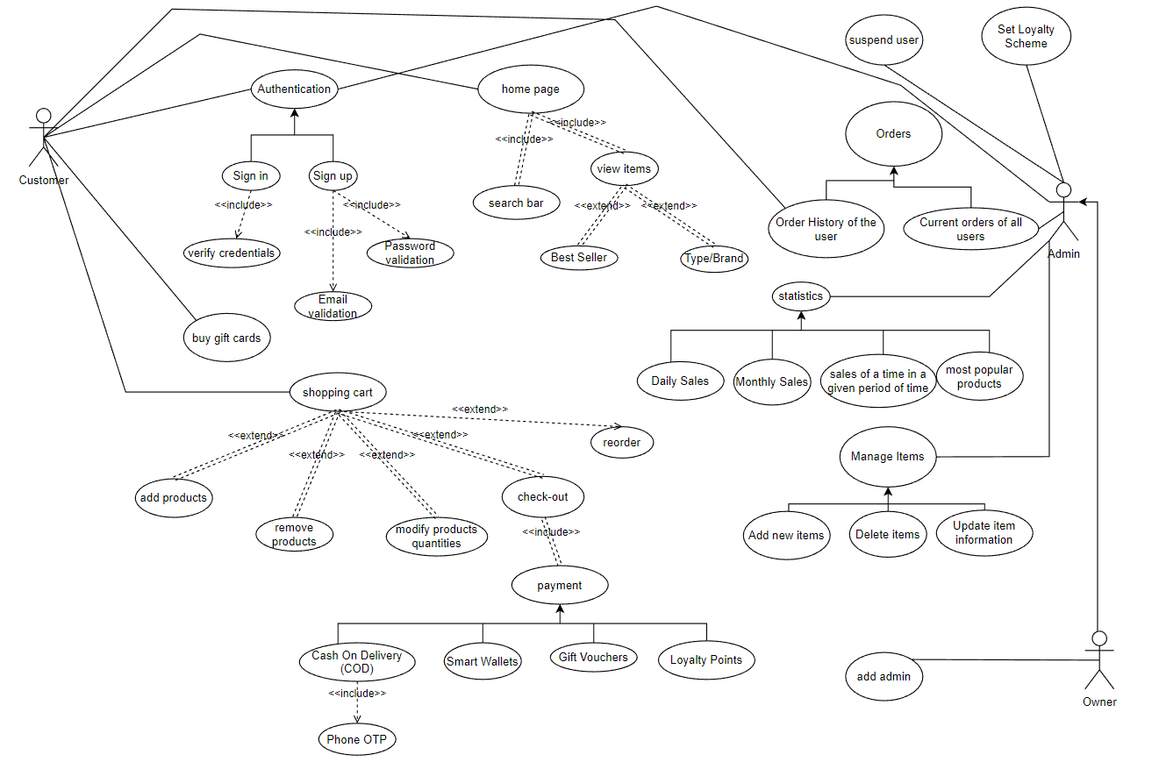

## System Navigation Map

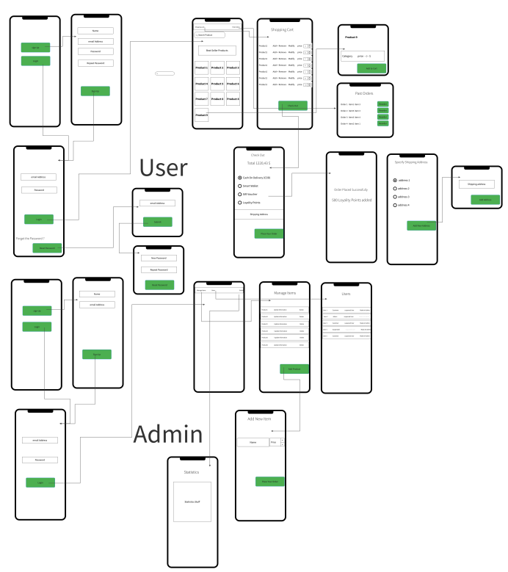

Please refer to this link for a clear view of the system navigation map:

## Enriched User Stories

* **User Story #1**

|  |  |
| --- | --- |
|  | US01 |
| **User Story Name** | Browsing Products on the Homepage |
| **Actors** | **Customer** |
| **Description** | **As a** customer**,**  **I want** to be able to browse the best-seller products on the homepage  **so that** I can easily see what the store has to offer. |
| **Per condition** | None |
| **Post condition** | Customer is able to view the best-seller products on the homepage. |
| **Acceptance Criteria** | **Given** that the customer visits the website**,**  **When** the customer opens the homepage**,**  **Then** the customer is able to view the best-seller products. |

* **Scenarios**

**Normal Scenario**

|  |  |
| --- | --- |
| **Actor Action** | **System Response** |
| 1- Customer visits the website |  |
| 2- Customer opens the homepage |  |
|  | 3- System displays the best-seller products. Customer can view the best-seller products. |

**Exceptional Scenario**

|  |  |
| --- | --- |
| **Actor Action** | **System Response** |
|  |  |
|  |  |
|  |  |

* **Screen Design**

* **Data Dictionary:**

Not applicable since no data is manually entered by the user at this stage

**_______________________________________________________________________________**

* **User Story #2**

|  |  |
| --- | --- |
| **User Story ID** | US02 |
| **User Story Name** | Signing Up for an Account |
| **Actors** | **Customer** |
| **Description** | **As** a customer  **I like** be able to sign up for an account  **So** that I can I can easily make purchases and track my orders. |
| **Per condition** | Customer is not signed in. |
| **Post condition** | Customer is signed up for an account. |
| **Acceptance Criteria** | **Given** that the customer visits the website**,**  **When** the customer clicks on the sign-up button**,**  **Then** the customer is redirected to the sign-up page**.** |

* **Scenarios**

**Normal Scenario**

|  |  |
| --- | --- |
| **Actor Action** | **System Response** |
| 1- Customer clicks on the sign-up button |  |
|  | 2- System redirects the customer to the sign-up page. |
| 3- Customer enters their personal information |  |
|  | 4- System validates the information and creates a new account for the customer. |
| 4- Customer is redirected to their new account page. |  |

* **Screen Design**

* **Data Dictionary:**

| **Element Label** | **Type/Length** | **Data Validation / Business Rule** |
| --- | --- | --- |
|  |  |  |
|  |  |  |
|  |  |  |
|  |  |  |

* **User Story #3**

|  |  |
| --- | --- |
| **User Story ID** | US03 |
| **User Story Name** | Reset Password |
| **Actors** | **Customer** |
| **Description** | **As** a customer**,**  **I want to** be able to reset my password securely in case I forget it or suspect that my account has been compromised. |
| **Per condition** | Customer is signed in and wishes to reset their password |
| **Post condition** | Customer's password is reset and they can sign in with their new password. |
| **Acceptance Criteria** | **Given** I am a signed-in customer  **When** I click on "Reset Password"  **Then** I am prompted to enter my email address  **When** I enter my email address and click "Submit"  **Then** a reset link is sent to my email  **Given** I have received the reset link  **When** I click on the link and follow the prompts  **Then** I am able to reset my password and sign in with my new password |

* **Scenarios**

**Normal Scenario**

|  |  |
| --- | --- |
| **Actor Action** | **System Response** |
| 1- Customer is signed in and wishes to reset their password |  |
| 2­- Customer clicks on "Reset Password" |  |
| 3- Customer enters their email address and clicks "Submit" |  |
|  | 4- System sends a reset link to the customer's email address |
| 5- Customer receives the reset link and clicks on it |  |
| 6- Customer is prompted to enter and confirm their new password |  |
| 7- Customer enters and confirms their new password and clicks "Save" |  |
|  | 8- System resets the customer's password |
| 9- Customer can now sign in with their new password |  |

**Exceptional Scenario**

|  |  |
| --- | --- |
| **Actor Action** | **System Response** |
| 1- Customer is signed in and wishes to reset their password |  |
| 2- Customer clicks on "Reset Password" |  |
| 3- Customer enters an invalid email address and clicks "Submit" |  |
|  | 4- System displays an error message stating that the email address is invalid |
| 5- Customer tries again with a valid email address and successfully resets their password |  |

* **Screen Design**

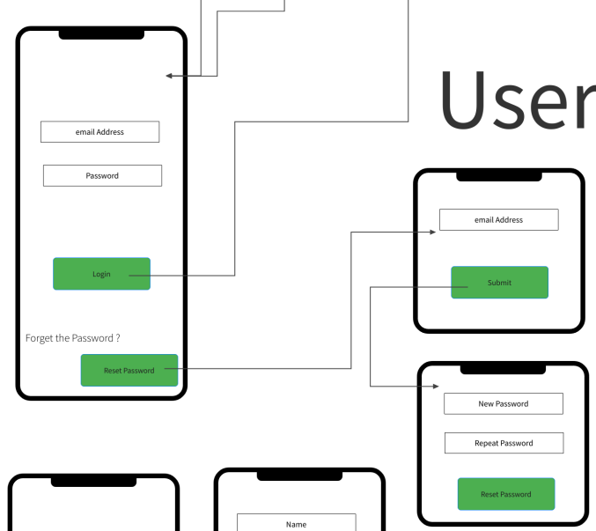

**Data Dictionary:**

Not applicable since no data is manually entered by the user at this stage

**User Story #4**

|  |  |
| --- | --- |
| **User Story ID** | US04 |
| **User Story Name** | Validating Email Field |
| **Actors** | **System** |
| **Description** | **As** a system,  **I want** to validate the email field  **so** that I can ensure that the email address is valid and unique. |
| **Per condition** | Customer is signing up for an account |
| **Post condition** | The email field is validated and the account is created. |
| **Acceptance Criteria** | **Given** that the customer enters their email address, **When** the system validates the email address, **Then** the system confirms that the email is valid and unique. |

* **Scenarios**

**Normal Scenario**

|  |  |
| --- | --- |
| **Actor Action** | **System Response** |
| 1- Customer enters their email address |  |
|  | 2- System validates the email address |
|  | 3- System confirms that the email address is valid and unique |
| 4- Customer is able to continue with the sign-up process. |  |

**Exceptional Scenario**

|  |  |
| --- | --- |
| **Actor Action** | **System Response** |
| 1- Customer enters an invalid or already used email address |  |
|  | 2- System displays an error message |
| 3- Customer is not able to continue with the sign-up process. |  |

* **Screen Design**

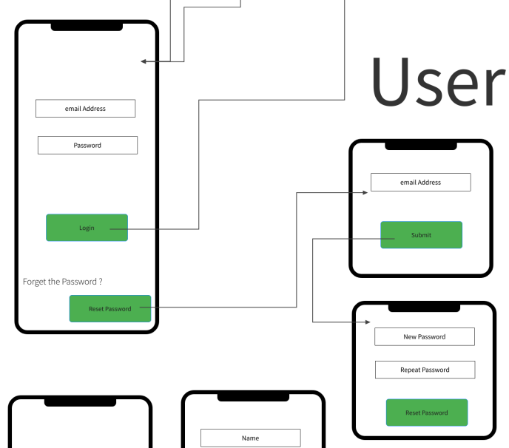

* **Data Dictionary:**

Not applicable since no data is manually entered by the user at this stage

* **User Story #5**

|  |  |
| --- | --- |
| **User Story ID** | US05 |
| **User Story Name** | View Product Details |
| **Actors** | **Customer** |
| **Description** | **As** a customer,  **I want** to be able to view the details of a product before making a purchase. |
| **Per condition** | Customer is on the homepage and clicks on a product. |
| **Post condition** | Customer is taken to a page displaying the details of the product they clicked on. |
| **Acceptance Criteria** | **Given** I am on the homepage  **When** I click on a product  **Then** I am taken to a page displaying the details of the product, including its name, category, description, image, brand, price, and any applicable discounts. |

* **Scenarios**

**Normal Scenario**

|  |  |
| --- | --- |
| **Actor Action** | **System Response** |
| 1- Customer is on the homepage |  |
| 2- Customer clicks on a product |  |
|  | 3- System takes the customer to a page displaying the details of the product, including its name, category, description, image, brand, price, and any applicable discounts. |

**Exceptional Scenario**

|  |  |
| --- | --- |
| **Actor Action** | **System Response** |
| 1- Customer is on the homepage |  |
| 2- Customer clicks on a product that is no longer available |  |
|  | 3- System displays an error message stating that the product is no longer available and suggests similar products to the customer |

* **Screen Design**

* **Data Dictionary:**
* Not applicable since no data is manually entered by the user at this stage
* **User Story #6**

|  |  |
| --- | --- |
| **User Story ID** | US06 |
| **User Story Name** | Search for Products |
| **Actors** | **Customer** |
| **Description** | **As** a customer,  **I want to** be able to search for products using keywords. |
| **Per condition** | Customer is on the homepage and wants to search for a product. |
| **Post condition** | Customer is presented with a list of products that match their search query. |
| **Acceptance Criteria** | **Given** I am on the homepage  **When** I type a keyword into the search bar and click "Search"  **Then** I am presented with a list of products that match my search query, including their names, categories, descriptions, images, brands, prices, and any applicable discounts. |

* **Scenarios**

**Normal Scenario**

|  |  |
| --- | --- |
| **Actor Action** | **System Response** |
| 1- Customer is on the homepage |  |
| 2- Customer types a keyword into the search bar and clicks "Search" |  |
|  | 3- System presents the customer with a list of products that match their search query, including their names, categories, descriptions, images, brands, prices, and any applicable discounts. |

**Exceptional Scenario**

|  |  |
| --- | --- |
| **Actor Action** | **System Response** |
| 1- Customer is on the homepage |  |
| 2- Customer types a misspelled keyword into the search bar and clicks "Search" |  |
|  | 3- System suggests a correction to the customer's search query and presents them with a list of products that match the corrected keyword |

* **Screen Design**

* **Data Dictionary:**

Not applicable since no data is manually entered by the user at this stage

* **User Story #7**

|  |  |
| --- | --- |
|  | US07 |
| **User Story Name** | Browsing Products on the Homepage |
| **Actors** | **Customer** |
| **Description** | **As a** customer**,**  **I want** to be able to browse the best-seller products on the homepage  **so that** I can easily see what the store has to offer. |
| **Per condition** | None |
| **Post condition** | Customer is able to view the best-seller products on the homepage. |
| **Acceptance Criteria** | **Given** that the customer visits the website**,**  **When** the customer opens the homepage**,**  **Then** the customer is able to view the best-seller products. |

* **Scenarios**

**Normal Scenario**

|  |  |
| --- | --- |
| **Actor Action** | **System Response** |
| 1- Customer visits the website |  |
| 2- Customer opens the homepage |  |
|  | 3- System displays the best-seller products. Customer can view the best-seller products. |

**Exceptional Scenario**

|  |  |
| --- | --- |
| **Actor Action** | **System Response** |
|  |  |
|  |  |
|  |  |

* **Screen Design**

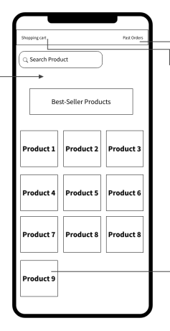

* **Data Dictionary:**

Not applicable since no data is manually entered by the user at this stage

**_______________________________________________________________________________**

* **User Story #8**

|  |  |
| --- | --- |
| **User Story ID** | US08 |
| **User Story Name** | Signing Up for an Account |
| **Actors** | **Customer** |
| **Description** | **As** a customer  **I like** be able to sign up for an account  **So** that I can I can easily make purchases and track my orders. |
| **Per condition** | Customer is not signed in. |
| **Post condition** | Customer is signed up for an account. |
| **Acceptance Criteria** | **Given** that the customer visits the website**,**  **When** the customer clicks on the sign-up button**,**  **Then** the customer is redirected to the sign-up page**.** |

* **Scenarios**

**Normal Scenario**

|  |  |
| --- | --- |
| **Actor Action** | **System Response** |
| 1- Customer clicks on the sign-up button |  |
|  | 2- System redirects the customer to the sign-up page. |
| 3- Customer enters their personal information |  |
|  | 4- System validates the information and creates a new account for the customer. |
| 4- Customer is redirected to their new account page. |  |

* **Screen Design**

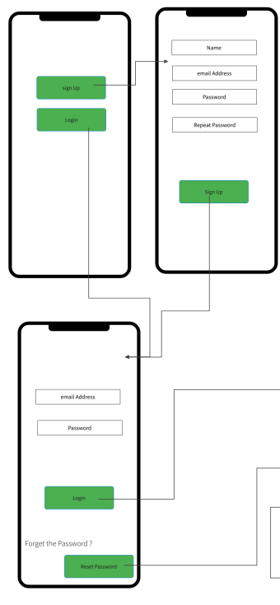

* **Data Dictionary:**

| **Element Label** | **Type/Length** | **Data Validation / Business Rule** |
| --- | --- | --- |
|  |  |  |
|  |  |  |
|  |  |  |
|  |  |  |

**User Story #9**

|  |  |
| --- | --- |
| **User Story ID** | US09 |
| **User Story Name** | Validating Email Field |
| **Actors** | **System** |
| **Description** | **As** a system,  **I want** to validate the email field  **so** that I can ensure that the email address is valid and unique. |
| **Per condition** | Customer is signing up for an account |
| **Post condition** | The email field is validated and the account is created. |
| **Acceptance Criteria** | **Given** that the customer enters their email address, **When** the system validates the email address, **Then** the system confirms that the email is valid and unique. |

* **Scenarios**

**Normal Scenario**

|  |  |
| --- | --- |
| **Actor Action** | **System Response** |
| 1- Customer enters their email address |  |
|  | 2- System validates the email address |
|  | 3- System confirms that the email address is valid and unique |
| 4- Customer is able to continue with the sign-up process. |  |

**Exceptional Scenario**

|  |  |
| --- | --- |
| **Actor Action** | **System Response** |
| 1- Customer enters an invalid or already used email address |  |
|  | 2- System displays an error message |
| 3- Customer is not able to continue with the sign-up process. |  |

* **Screen Design**

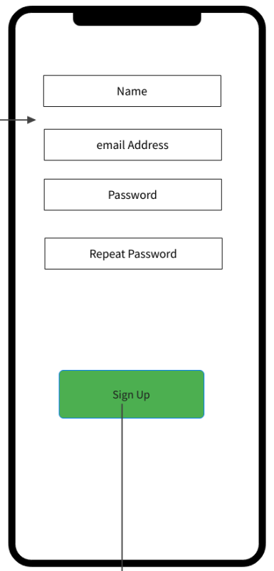

* **Data Dictionary:**

Not applicable since no data is manually entered by the user at this stage

* **User Story #10**

|  |  |
| --- | --- |
| **User Story ID** | US10 |
| **User Story Name** | Reset Password |
| **Actors** | **Customer** |
| **Description** | **As** a customer**,**  **I want to** be able to reset my password securely in case I forget it or suspect that my account has been compromised. |
| **Per condition** | Customer is signed in and wishes to reset their password |
| **Post condition** | Customer's password is reset and they can sign in with their new password. |
| **Acceptance Criteria** | **Given** I am a signed-in customer  **When** I click on "Reset Password"  **Then** I am prompted to enter my email address  **When** I enter my email address and click "Submit"  **Then** a reset link is sent to my email  **Given** I have received the reset link  **When** I click on the link and follow the prompts  **Then** I am able to reset my password and sign in with my new password |

* **Scenarios**

**Normal Scenario**

|  |  |
| --- | --- |
| **Actor Action** | **System Response** |
| 1- Customer is signed in and wishes to reset their password |  |
| 2­- Customer clicks on "Reset Password" |  |
| 3- Customer enters their email address and clicks "Submit" |  |
|  | 4- System sends a reset link to the customer's email address |
| 5- Customer receives the reset link and clicks on it |  |
| 6- Customer is prompted to enter and confirm their new password |  |
| 7- Customer enters and confirms their new password and clicks "Save" |  |
|  | 8- System resets the customer's password |
| 9- Customer can now sign in with their new password |  |

**Exceptional Scenario**

|  |  |
| --- | --- |
| **Actor Action** | **System Response** |
| 1- Customer is signed in and wishes to reset their password |  |
| 2- Customer clicks on "Reset Password" |  |
| 3- Customer enters an invalid email address and clicks "Submit" |  |
|  | 4- System displays an error message stating that the email address is invalid |
| 5- Customer tries again with a valid email address and successfully resets their password |  |

* **Screen Design**

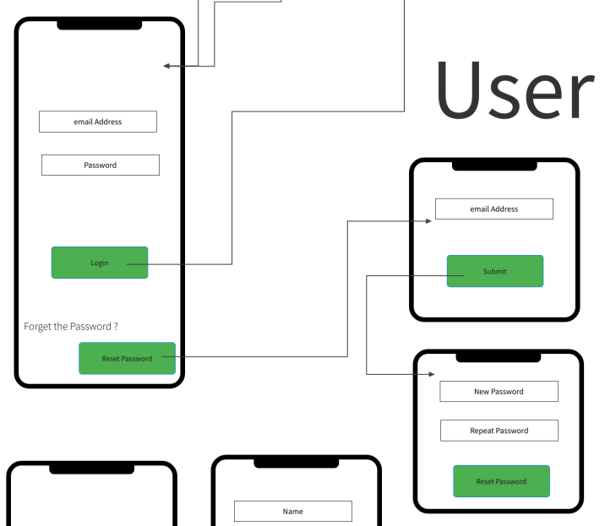

* **Data Dictionary:**

Not applicable since no data is manually entered by the user at this stage

* **User Story #11**

|  |  |
| --- | --- |
| **User Story ID** | US11 |
| **User Story Name** | View Product Details |
| **Actors** | **Customer** |
| **Description** | **As** a customer,  **I want** to be able to view the details of a product before making a purchase. |
| **Per condition** | Customer is on the homepage and clicks on a product. |
| **Post condition** | Customer is taken to a page displaying the details of the product they clicked on. |
| **Acceptance Criteria** | **Given** I am on the homepage  **When** I click on a product  **Then** I am taken to a page displaying the details of the product, including its name, category, description, image, brand, price, and any applicable discounts. |

* **Scenarios**

**Normal Scenario**

|  |  |
| --- | --- |
| **Actor Action** | **System Response** |
| 1- Customer is on the homepage |  |
| 2- Customer clicks on a product |  |
|  | 3- System takes the customer to a page displaying the details of the product, including its name, category, description, image, brand, price, and any applicable discounts. |

**Exceptional Scenario**

|  |  |
| --- | --- |
| **Actor Action** | **System Response** |
| 1- Customer is on the homepage |  |
| 2- Customer clicks on a product that is no longer available |  |
|  | 3- System displays an error message stating that the product is no longer available and suggests similar products to the customer |

* **Screen Design**

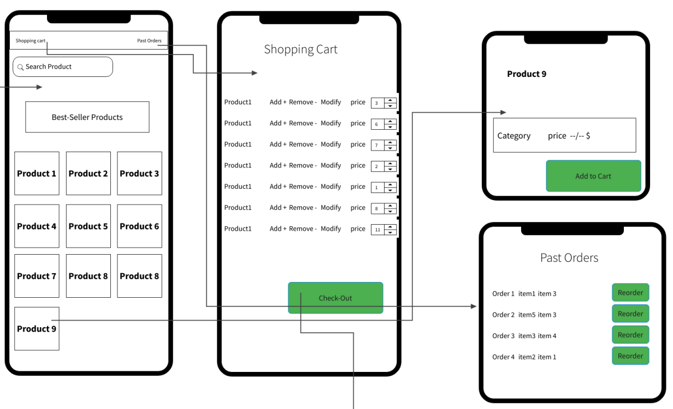

* **Data Dictionary:**
* Not applicable since no data is manually entered by the user at this stage
* **User Story #12**

|  |  |
| --- | --- |
| **User Story ID** | US12 |
| **User Story Name** | Search for Products |
| **Actors** | **Customer** |
| **Description** | **As** a customer,  **I want to** be able to search for products using keywords. |
| **Per condition** | Customer is on the homepage and wants to search for a product. |
| **Post condition** | Customer is presented with a list of products that match their search query. |
| **Acceptance Criteria** | **Given** I am on the homepage  **When** I type a keyword into the search bar and click "Search"  **Then** I am presented with a list of products that match my search query, including their names, categories, descriptions, images, brands, prices, and any applicable discounts. |

* **Scenarios**

**Normal Scenario**

|  |  |
| --- | --- |
| **Actor Action** | **System Response** |
| 1- Customer is on the homepage |  |
| 2- Customer types a keyword into the search bar and clicks "Search" |  |
|  | 3- System presents the customer with a list of products that match their search query, including their names, categories, descriptions, images, brands, prices, and any applicable discounts. |

**Exceptional Scenario**

|  |  |
| --- | --- |
| **Actor Action** | **System Response** |
| 1- Customer is on the homepage |  |
| 2- Customer types a misspelled keyword into the search bar and clicks "Search" |  |
|  | 3- System suggests a correction to the customer's search query and presents them with a list of products that match the corrected keyword |

* **Screen Design**

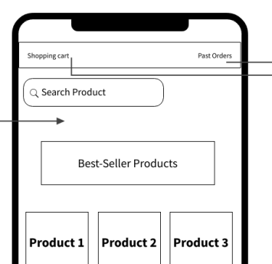

* **Data Dictionary:**

Not applicable since no data is manually entered by the user at this stage

* **User Story #13**

|  |  |
| --- | --- |
| **User Story ID** | US #13 |
| **User Story Name** | Searching for a product |
| **Actors** | Customer/admin |
| **Description** | **As** a customer or an admin.  **I like** to be able to search for an item by its name  **So** I get it without scrolling all the way to find it |
| **Per condition** |  |
| **Post condition** | The item is displayed to the customer |
| **Acceptance Criteria** | **Given** I am on the main menu  **When** I type the name of the product on the search bar  **Then I see the item** |

* **Scenarios**

**Normal Scenario**

|  |  |
| --- | --- |
| **Actor Action** | **System Response** |
| 1-user types item’s name |  |
|  | 2- system search for the item and display it |

**Screen Design**

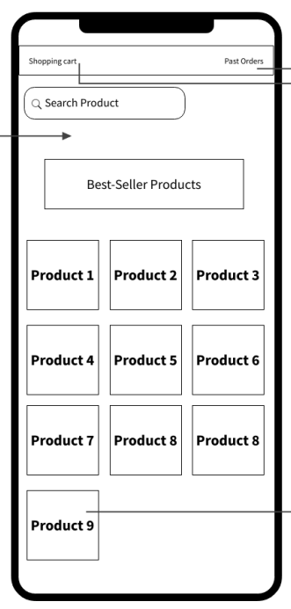

* **User Story #14**

|  |  |
| --- | --- |
| **User Story ID** | US #14 |
| **User Story Name** | Adding a product to the cart |
| **Actors** | Customer |
| **Description** | **As** a customer.  **I like** to add items to my shopping cart  **So** I can pay for them |
| **Per condition** | The user is logged in |
| **Post condition** | The item is added to the user’s shopping cart |
| **Acceptance Criteria** | **Given** I am a customer and am logged in  **When** I select add to cart on the item panel  **Then** the item is added to my shopping cart |

* **Scenarios**

**Normal Scenario**

|  |  |
| --- | --- |
| **Actor Action** | **System Response** |
| 1-user selects “add to cart” |  |
|  | 2- system adds the item to the user’s cart |

**Screen Design**

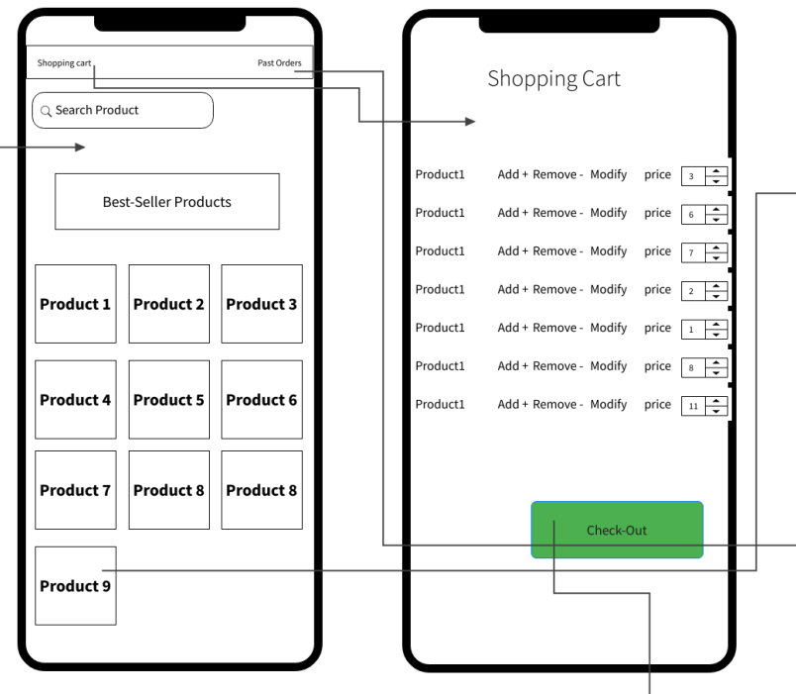

* **User Story #15**

|  |  |
| --- | --- |
| **User Story ID** | US #15 |
| **User Story Name** | Changing the quantity of the product in the shopping cart |
| **Actors** | Customer |
| **Description** | **As** a customer  **I like** to be able to change the quantity of a product in the cart  **So** I get as may units of an item as I want |
| **Per condition** | The user is logged in and have items in the cart |
| **Post condition** | The quantity of and item in cart is changed |
| **Acceptance Criteria** | **Given** I am logged In and I have an item or more in the cart  **When** I select + or – sign on the quantity field  **Then** the units counter increase or decrease as I want |

* **Scenarios**

**Normal Scenario**

|  |  |
| --- | --- |
| **Actor Action** | **System Response** |
| 1-user selects the + or - sign |  |
|  | 2- system increment or decrement the quantity |

**Screen Design**

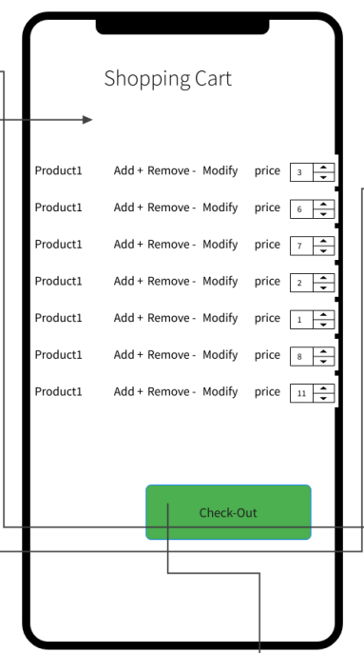

* **User Story #10**

|  |  |
| --- | --- |
| **User Story ID** | US #10 |
| **User Story Name** | payment |
| **Actors** | Customer |
| **Description** | **As** a customer  **I like** to choose the way of payment  **So** I pay the way it suits me |
| **Per condition** | The user is logged in and have items in the cart |
| **Post condition** | Different verifications happen to different ways |
| **Acceptance Criteria** | **Given** am on the checkout menu  **When** I chose the way of payment  **Then** I pay the way I want |

* **Scenarios**

**Normal Scenario**

|  |  |
| --- | --- |
| **Actor Action** | **System Response** |
| 1-user selects cash on delivery |  |
|  | 2- system prompt the user to input his phone number which is verified by a One Time Password (OTP) |
| 3-user selects e wallet |  |
|  | 4-system ask for the kind of the wallet and ask for it’s number if needed and send the purchase request to the organization. |
| 5-user selects one or more gift voucher |  |
|  | 6- system subtracts the voucher value from the total amount |
| 7 – user selects loyalty points |  |
|  | 8- the system subtract the points’ value from the total amount |

* **Screen Design**

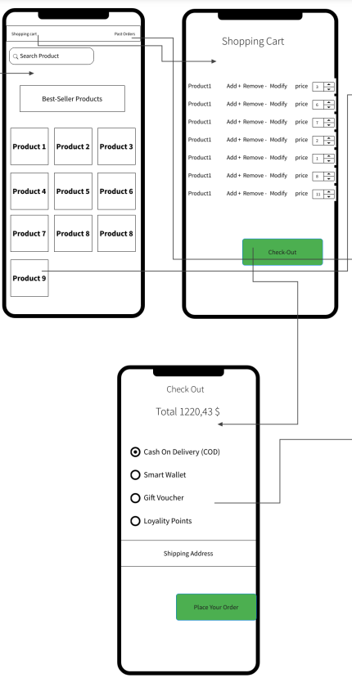

## Enriched User Stories

* **User Story #16**

|  |  |
| --- | --- |
| **User Story ID** | US #16 |
| **User Story Name** | Earning Loyalty Points |
| **Actors** | **Customer** |
| **Description** | **As** a customer  **I like** to be able to earn loyalty points after a successful purchase  **So** that I can redeem them later for goods/services |
| **Per condition** | Successful purchase by a signed in user |
| **Post condition** | User’s loyalty points get added to his/her account |
| **Acceptance Criteria** | **Given** I am a signed in user who is checking out his/her shopping cart  **When** I successfully complete my purchase transaction  **Then** loyalty points get added to my account |

* **Scenarios**

**Normal Scenario**

|  |  |
| --- | --- |
| **Actor Action** | **System Response** |
| 1- User attempt to complete his/her purchase transaction |  |
|  | 2- System marks the purchase operation as successful |
| 3- Loyalty points added to user’s account |  |

**Exceptional Scenario**

|  |  |
| --- | --- |
| **Actor Action** | **System Response** |
| 1- User attempts to complete his/her purchase transaction |  |
|  | 2- System marks the purchase operation as unsuccessful |
|  | 3- System display “Unsuccessful Purchase” |

* **Screen Design**

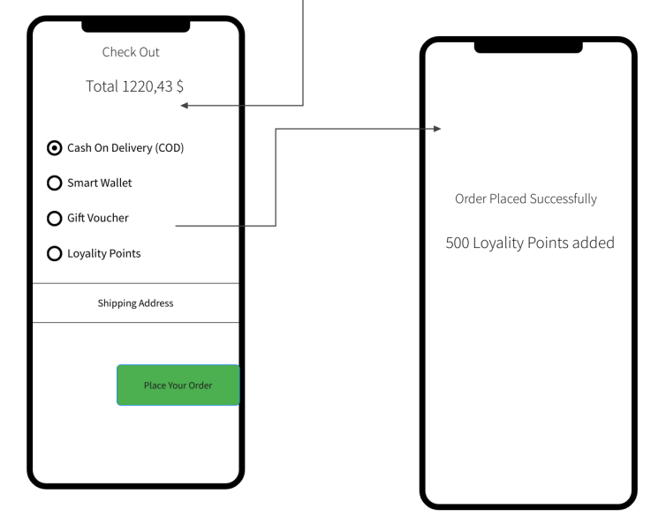

* **Data Dictionary:**

Not applicable since no data is manually entered by the user at this stage

**_______________________________________________________________________________**

* **User Story #17**

|  |  |
| --- | --- |
| **User Story ID** | US #17 |
| **User Story Name** | Specifying shipping address |
| **Actors** | **Customer** |
| **Description** | **As** a customer  **I like** to be able to specify the desired shipping address  **So** that I can get my goods delivered to the correct address |
| **Per condition** | Successful purchase by a signed in user |
| **Post condition** | User choses the desired shipping address |
| **Acceptance Criteria** | **Given** I am a signed in user who is checking out his/her shopping cart  **When** I successfully complete my purchase transaction  **Then** I can choose my shipping address to either be the shipping address already on my profile or enter another address |

* **Scenarios**

**Normal Scenario**

|  |  |
| --- | --- |
| **Actor Action** | **System Response** |
| 1- User attempt to complete his/her purchase transaction |  |
|  | 2- System marks the purchase operation as successful |
|  | 3- Systems prompts the user to either chose the shipping address already registered in the profile or the user can enter a different shipping address |
| 4- User choses the desired shipping address |  |
|  |  |

**Exceptional Scenario**

|  |  |
| --- | --- |
| **Actor Action** | **System Response** |
| 1- User attempts to complete his/her purchase transaction |  |
|  | 2- System marks the purchase operation as unsuccessful |
|  | 3- System display “Unsuccessful Purchase” |

* **Screen Design**

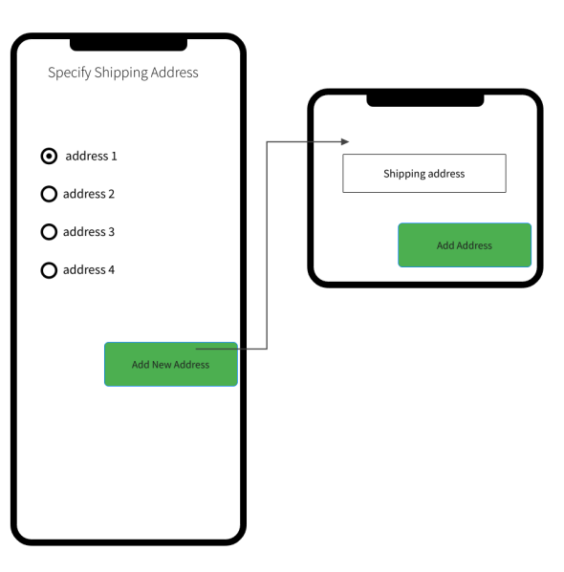

* **Data Dictionary:**

| **Element Label** | **Type/Length** | **Data Validation / Business Rule** |
| --- | --- | --- |
| ShippingAddress | String<1000 Char | Structured Text (Address Format) |

* **User Story #18**

|  |  |
| --- | --- |
| **User Story ID** | US #18 |
| **User Story Name** | Reordering a previous order |
| **Actors** | **Customer** |
| **Description** | **As** a customer  **I like** to be able to reorder my previous order  **So** that I can save the effort of manually re-choosing every item again |
| **Per condition** | Signed in user with the shopping cart open |
| **Post condition** | Users get his/her shipping cart filled with the exact items and quantities of his/her order |
| **Acceptance Criteria** | **Given** I am a signed in user who has his/her shopping cart open  **When** I click on the “reorder” button  **Then** my shipping cart should get populated with the exact items and quantities of my previous order |

* **Scenarios**

**Normal Scenario**

|  |  |
| --- | --- |
| **Actor Action** | **System Response** |
| 1- User clicks on “reorder” button |  |
|  | 2- System populates the user’s shopping cart with the items and quantities of the previous order |

**Exceptional Scenario**

|  |  |
| --- | --- |
| **Actor Action** | **System Response** |
| 1- User clicks on the “reorder” button |  |
|  | 2- System detects that the user has no previous orders |
|  | 3- System displays “No previous order!” |
|  | 4- System make no changes to the shopping cart |

* **Screen Design**

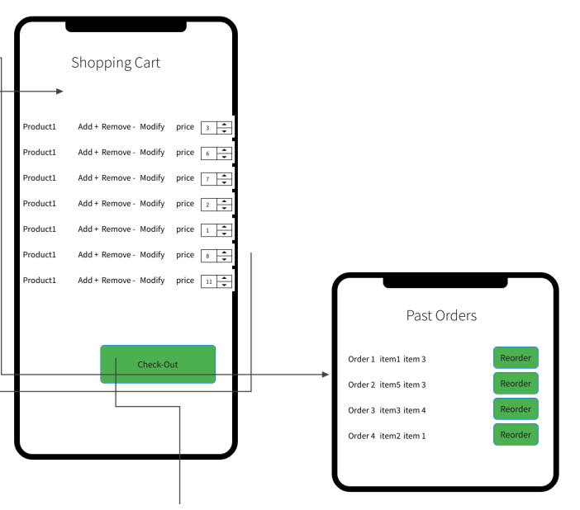

* **Data Dictionary:**

Not applicable since no data is manually entered by the user at this stage

* **User Story #19**

|  |  |
| --- | --- |
| **User Story ID** | US #19 |
| **User Story Name** | Order History |
| **Actors** | **Customer** |
| **Description** | **As** a customer  **I like** to be able to view all my previous order history/activity  **So** that I can know what items I have bought in the past |
| **Per condition** | Signed in user with his/her profile page opened |
| **Post condition** | User views his/her previous order history/activity |
| **Acceptance Criteria** | **Given** I am a signed in user who has his/her profile page opened  **When** I click on “Order History” button  **Then** I will view all my previous order history/activity |

* **Scenarios**

**Normal Scenario**

|  |  |
| --- | --- |
| **Actor Action** | **System Response** |
| 1- User clicks on “Order History” button |  |
|  | 2- System displays the user’s previous history/activity |

**Exceptional Scenario**

Not applicable

* **Screen Design**

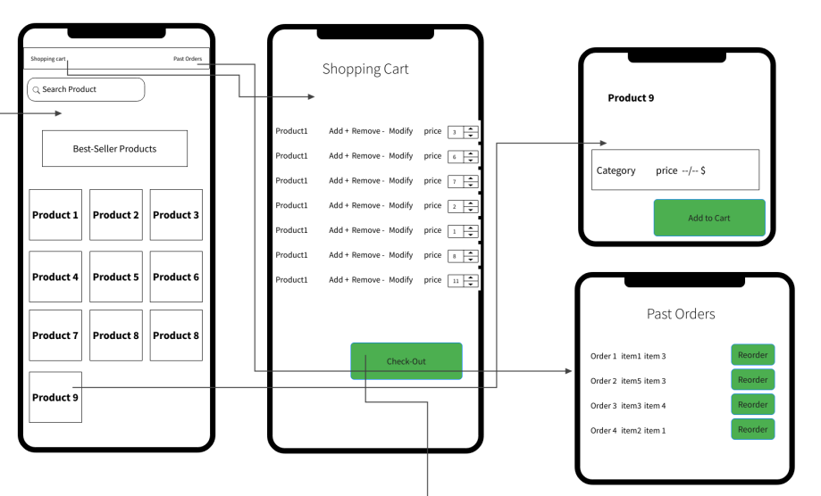

* **Data Dictionary:**

Not applicable since no data is manually entered by the user at this stage

* **User Story #20**

|  |  |
| --- | --- |
| **User Story ID** | US #20 |
| **User Story Name** | Managing Items |
| **Actors** | **System Administrator** |
| **Description** | **As** a system administrator  **I like** have a dedicated page to manage items  **So** that I can update catalogue with new items, cancel items and/or update item’s information |
| **Per condition** | Signed-in system administrator having “manage items” page open |
| **Post condition** | System administrator is able to manage/edit the items |
| **Acceptance Criteria** | **Given** I am a signed in system administrator  **When** I click on “Manage Items”  **Then** I have the ability to update catalogue with new items, cancel items and/or update item information |

* **Scenarios**

**Normal Scenario**

|  |  |
| --- | --- |
| **Actor Action** | **System Response** |
| 1- System administrator clicks on the “Manage Items” button |  |
|  | 2- System displays a dedicated web page allowing the system administrator to modify/update items |
| 3- System administrator does his/her desired modification on items |  |

**Exceptional Scenario**

No exceptional scenario since system administrator only need to click on “Manage Items” button to get this dedicated web page displayed

* **Screen Design**

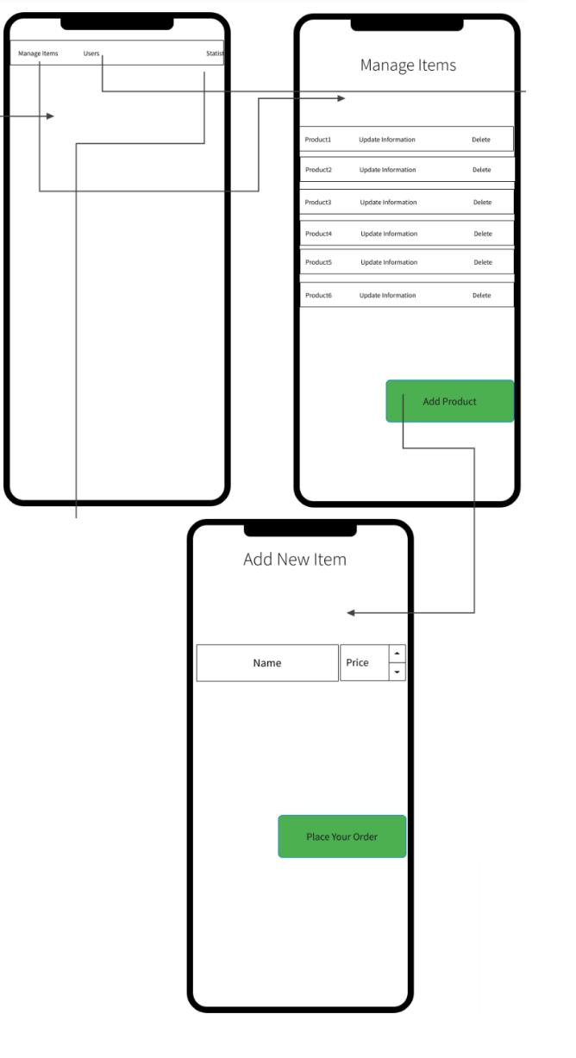

* **Data Dictionary:**

Not applicable since no data is manually entered by the user at this stage

* **User Story #21**

|  |  |
| --- | --- |
| **User Story ID** | US #21 |
| **User Story Name** | View Information about the system |
| **Actors** | **System Administrator** |
| **Description** | **As** a system administrator  **I like** view information about the system  **So** that I can measure how good is the performance of our brand. |
| **Per condition** | Signed-in system administrator |
| **Post condition** | System administrator is able to view information about the system |
| **Acceptance Criteria** | **Given** I am a signed in system administrator  **When** I click on “View Information”  **Then** I am able to view orders made by users and/or statistics about the website including daily sales, monthly sales, sales of a given period of time and/or most popular items. |

* **Scenarios**

**Normal Scenario**

|  |  |
| --- | --- |
| **Actor Action** | **System Response** |
| 1- System administrator clicks on the “View Information” button |  |
|  | 2- System displays a dedicated web page allowing the system administrator to view various information about the system |

**Exceptional Scenario**

No exceptional scenario since system administrator only need to click on “Manage Items” button to get this dedicated web page displayed

* **Screen Design**

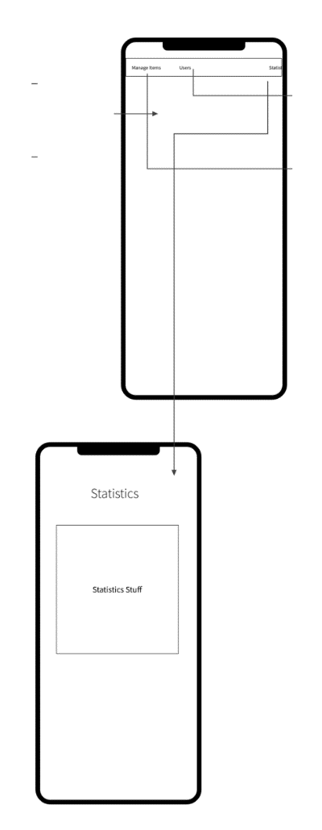

* **Data Dictionary:**

Not applicable since no data is manually entered by the user at this stage

* **User Story #22**

|  |  |
| --- | --- |
| **User Story ID** | US #22 |
| **User Story Name** | Setting loyalty points scheme |
| **Actors** | **System Administrator** |
| **Description** | **As** a system administrator  **I like** to have a dedicated page  **So** that I can set my own loyalty points scheme |
| **Per condition** | Signed-in system administrator having loyalty points page open |
| **Post condition** | System administrator can now set a loyalty points scheme |
| **Acceptance Criteria** | **Given** I am a signed in system administrator  **When** I click on “Loyalty Points”  **Then** I am directed to a page where I can set a loyalty points scheme |

* **Scenarios**

**Normal Scenario**

|  |  |
| --- | --- |
| **Actor Action** | **System Response** |
| 1- System administrator clicks on “Loyalty Points” |  |
|  | 2- System displays a page allowing the system administrator to set a loyalty points scheme |
| 3- Systems administrator enters the rate at which loyalty points is calculated (points per dollar spent) |  |
|  | 4- System approves loyalty scheme entered by the system administrator |

**Exceptional Scenario**

|  |  |
| --- | --- |
| **Actor Action** | **System Response** |
| 1- System administrator clicks on “Loyalty Points” |  |
|  | 2- System displays a page allowing the system administrator to set a loyalty points scheme |
| 3- Systems administrator enters 0 or a negative rate at which loyalty points is calculated (points per dollar spent) |  |
|  | 4- System declines this input and displays “points per dollar can only be greater than 0” |

* **Screen Design**

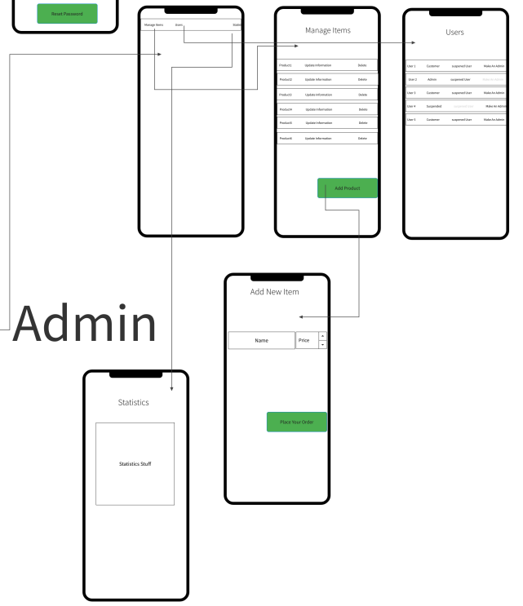

* **Data Dictionary:**

| **Element Label** | **Type/Length** | **Data Validation / Business Rule** |
| --- | --- | --- |
| LoyaltyRate | Double | Must be greater than 0 |

* **User Story #23**

|  |  |
| --- | --- |
| **User Story ID** | US #23 |
| **User Story Name** | Suspending a user |
| **Actors** | **System administrator** |
| **Description** | **As** a system administrator  **I like** to be able view a customer’s profile  **So** that I can suspend the customer’s account whenever deemed necessary |
| **Per condition** | Signed-in system administrator |
| **Post condition** | System administrator suspends a customer’s account |
| **Acceptance Criteria** | **Given** I am a signed in system administrator  **When** I have a customer’s profile opened, upon clicking on “suspend customer”  **Then** user customer gets suspended from the system |

* **Scenarios**

**Normal Scenario**

|  |  |
| --- | --- |
| **Actor Action** | **System Response** |
| 1- System administrator attempts to view the profile of an existing customer |  |
|  | 2- System displays the customer’s profile along with a button “suspend user” |
| 3- System administrator clicks on “suspend customer” |  |
|  | 4- Systems suspends customer |

**Exceptional Scenario**

No exceptional scenario since system administrator have the only option of choosing to click on “suspend customer” to be able to successfully suspend a customer.

* **Screen Design**

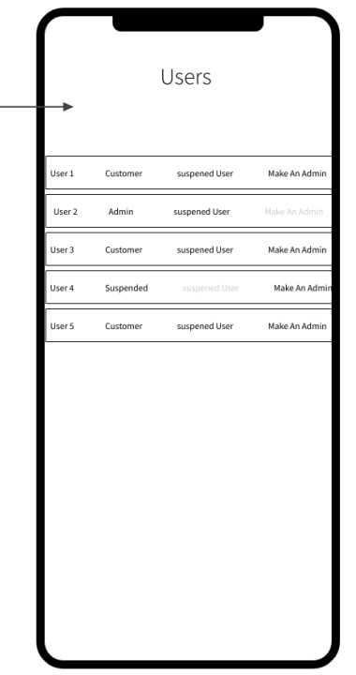

* **Data Dictionary:**

Not applicable since no data is manually entered by the user at this stage

* **User Story #24**

|  |  |
| --- | --- |
| **User Story ID** | US #24 |
| **User Story Name** | Adding a system administrator |
| **Actors** | **System Owner** |
| **Description** | **As** a system owner  **I like** to be able to add new system administrators  **So** that they can manage a part of the system |
| **Per condition** | Signed-in system owner |
| **Post condition** | System owners adds a new system administrator to the system |
| **Acceptance Criteria** | **Given** I am a signed in system owner  **When** I click on “Add Administrator”  **Then** I enter the email of the account to be given the administrator privileges and this account is now a system administrator |

* **Scenarios**

**Normal Scenario**

|  |  |
| --- | --- |
| **Actor Action** | **System Response** |
| 1- System owner clicks on the “Add Administrator” button |  |
|  | 2- System prompts the owner to enter the email of the account to be given administrator privileges |
| 3- System owner enters the appropriate email address |  |
|  | 4- System approves the associated account as a system administrator |

**Exceptional Scenario**

|  |  |
| --- | --- |
| **Actor Action** | **System Response** |
| 1- System owner clicks on the “Add Administrator” button |  |
|  | 2- System prompts the owner to enter the email of the account to be given administrator privileges |
| 3- System owner enters the appropriate email address |  |
|  | 4- System does not find any account with this given email address and display to the owner “Email address not found”. |

* **Screen Design**

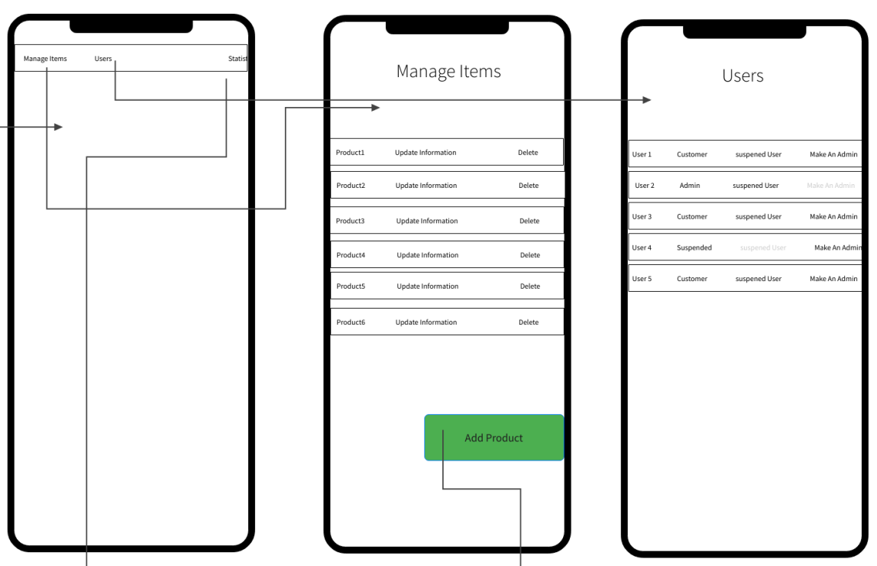

* **Data Dictionary:**

| **Element Label** | **Type/Length** | **Data Validation / Business Rule** |
| --- | --- | --- |
| EmailOfNewAdmin | String | Email format |
|  |  |  |
|  |  |  |
|  |  |  |

# 

# Tools

* app.diagrams.net
* mockflow.com

# 

# Ownership Report

|  |  |
| --- | --- |
| Student | Items he created |
| Yusuf Elsayed Abdelrahman Badr | Functional Requirements  Use Case Diagram  Enriched User Stories (US#16-US#24) |
| Osama Maher Massoud | Functional Requirements  System navigation map |
| Alialdin Muhammad | Functional Requirements  Non-Functional Requirements |