Cairo University  
Faculty of Computers and Artificial Intelligence

**كل التعليمات الحمراء تقرأ بعناية و تنفذ ثم تمسح و يكتب مكانها المطلوب**

**CS251**

**Intro. to Software Engineering**

Project Name

Software Requirements Specifications

Version 1.0

Team Names and Emails and Phone of Team Leader

Month & Year

Contents

Instructions [To be removed] اقرأ هذا الجزء ثم احذفه 3

Team 3

Document Purpose and Audience 3

Introduction 3

Software Purpose 3

Software Scope 3

Definitions, acronyms, and abbreviations 4

Requirements 4

Functional Requirements 4

Non Functional Requirements 4

System Models 5

Use Case Model 5

Enriched User Stories 5

System Navigation Map 7

Tools 7

Ownership Report 7

Policy Regarding Plagiarism: [To be removed] اقرأ هذا الجزء ثم احذفه 8

# Team

|  |  |  |  |
| --- | --- | --- | --- |
| **ID** | **Name** | **Email** | **Mobile** |
| 20210502 | Yusuf Elsayed Abdelrahman Badr | [yusufbadr@yahoo.com](mailto:yusufbadr@yahoo.com) | 01063033085 |
|  |  |  |  |
|  |  |  |  |

# Introduction

## Software Purpose

* **Summarize the purpose of the software**

## Software Scope

* **Any software could have too many components / Major features; but we should implement specific things...this is the scope**
* **In simple points, what is the software scope (focus on components / Major features, not tiny things)**

## Definitions, acronyms, and abbreviations

* **In a table, list all needed ones. Consider the audience**
* **Think as following: Document has abbreviation ATM... If audience doesn’t know it, let’s clarify it.**

# 

Functional Requirements

|  |  |
| --- | --- |
| Requirement ID | Statement |
| FR01 | Upon opening the website, the user shall see a homepage displaying best-seller products sold by the store along with a sign up/sign in button. |
|  | Each item will be composed of the following data:   * Name * Category * Description * Image * Brand * Price * Discount percentage if any |
| FR02 | Upon clicking on the sign up button, the user shall see a sign up page including personal information asked by the sign up page. These personal information fields are:   * E-mail * Password * Address |
| FR03 | The E-mail field should validate the following:   * Check if the Email exists and is valid * Check if the Email has never been used before for creating an account * Validate the account using a One Time Password(OTP) sent to the Email entered. Upon valid OTP, the registration is approved. * Otherwise, the registration is rejected and no account is created. |
| FR04 | The password field should adhere to secure password requirements |
| FR05 | Upon clicking on the sign in button, the user shall be prompted with two fields asking him to input his/her E-mail and password. |
| FR06 | The user shall view the products using the following categories:   * All items * Best-seller products * Type/Brand of candy |
| FR07 | There will be a search bar allowing the user to search for a specific product/brand. |
| FR08 | Upon logging in, the user will be able to add products to his/her shopping cart. |
| FR09 | The shopping cart shall have the following properties:   * Allows the user to change a product’s quantity, or remove an item * Validates that the quantity of a single sealed item is bound within a maximum of 50 units. * Validates that the weight of a single loose item is bound within a maximum of weight of 50 kilograms |
| FR10 | There will be a separate web page dedicated for the purchases of gift cards. |
| FR11 | In the checkout, there will be the following payment options:   * Cash On Delivery (COD) - can be used to pay for an order (or the remaining amount if any) * Smart Wallets – can be used to pay for an order (or the remaining amount if any) * One or more gift vouchers – the value of this/these vouchers shall be subtracted from the total sum. * Loyalty points can be redeemed to pay for an order or a part of an order. |
| FR12 | If Cash on Delivery (COD) is selected, the user should enter a valid phone number which is verified by a One Time Password (OTP) sent to the user to be entered to the system for successful verification. |
| FR13 | Upon a successful purchase, the user shall earn loyalty point according to the scheme decided by the admin. |
| FR14 | After successful payment, the user will be prompted to choose whether to use the shipping address on his/her profile or to enter another address. |
| FR15 | In the shipping cart, there shall be an option called ‘reorder’. Upon clicking on the reorder button, the user will be prompted to re-order the previous order with the same quantities. |
| FR16 | In the user profile, there will be a category called ‘Order History’. This will enable the user to view all of the his/her previous order activity/history. |
| FR17 | The system administrator will have a dedicated page to be able to manage items in the following ways   * Update catalogue with new items * Cancel items * Update item information |
| FR18 | The system administrator will have a dedicated page to view the following information about the system:   * Order made by users * Statistics about the following:   + Daily sales   + Monthly sales   + Sales of a time in a given period of time   + Most popular products |
| FR19 | The system administrator will have the privileges to do the following each in a dedicated page:   * Set a loyalty points scheme * Suspend a user |

# System Models

## Use Case Model

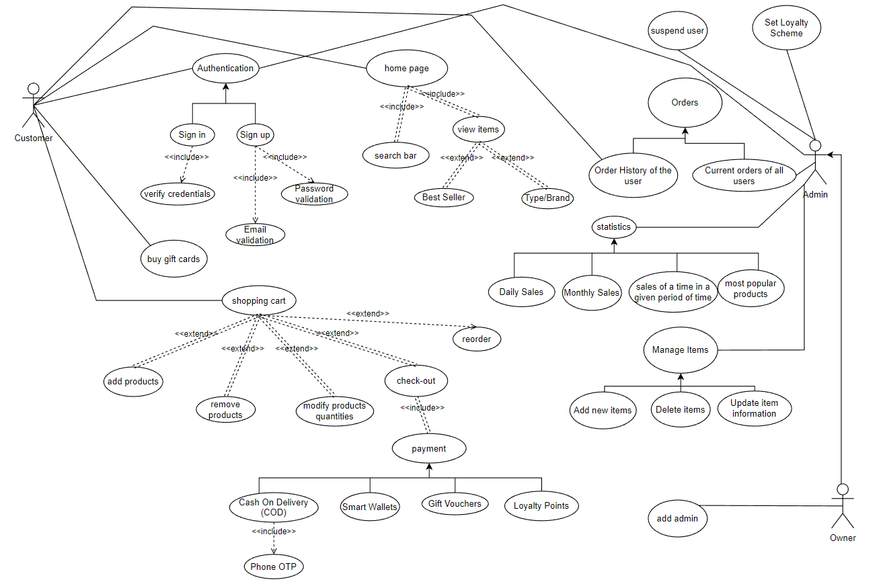

## Enriched User Stories

* **Using below table template, for each requirement write an enriched user story specifying the details of each use case and showing the interaction to implement this use case.** 
  + **If one requirement is so big, you could divide it to more than one user story.**
  + **If some requirements are not major, you could plugin them in other user stories.**
* **Flow of events should be very detailed**
* **User Story #1**

|  |  |
| --- | --- |
| **User Story ID** | US #1 |
| **User Story Name** |  |
| **Actors** |  |
| **Description** | **As** a …..  **I like** to be able to …..  **So** ………….. |
| **Per condition** |  |
| **Post condition** |  |
| **Acceptance Criteria** | **Describe when we can decide that this user story is correctly implemented and accepted. For example:**  **Given** I’m a logged-out system user and I’m on the Sign-In page  **When** I fill in the “Username” and “Password” fields with my authentication credentials and I click the Sign-In button  **Then** the system signs me in |

* **Scenarios**

**Normal Scenario**

|  |  |
| --- | --- |
| **Actor Action** | **System Response** |
| 1- User Enter Card and Password.  2- Click **Submit** |  |
|  | 3- System Verify user data  4- System displays list of Mobile companies |
| 5- User Select Vodafone from the list |  |
|  | 6- System retrieves Vodafone bills |
| 7- And so on |  |
|  |  |
|  |  |
|  |  |

**Exceptional Scenario**

|  |  |
| --- | --- |
| **Actor Action** | **System Response** |
| 1- User Enter Card and Password.  2- Click **Submit** |  |
|  | 3- Card is invalid  4- Systems rejects card and displays an error message |
|  |  |
|  |  |

* **Screen Design**

**Give a draft design of the screen(s) on which this user story will be implemented.**

**Do it as a as wireframe or a mockup. Use a tool to do that. Give each screen a number and name.**

* **Data Dictionary:**

| **Element Label** | **Type/Length** | **Data Validation / Business Rule** |
| --- | --- | --- |
|  |  |  |
|  |  |  |
|  |  |  |
|  |  |  |

**_____________________________________________________________________________________**

* **User Story #2**

|  |  |
| --- | --- |
| **User Story ID** | US #2 |
| **User Story Name** |  |
| **Actors** |  |
| **Description** | **As** a …..  **I like** to be able to …..  **So** ………….. |
| **Per condition** |  |
| **Post condition** |  |
| **Acceptance Criteria** | **Describe when we can decide that this user story is correctly implemented and accepted. For example:**  **Given** I’m a logged-out system user and I’m on the Sign-In page  **When** I fill in the “Username” and “Password” fields with my authentication credentials and I click the Sign-In button  **Then** the system signs me in |

…………………

…………………

**_____________________________________________________________________________________**

## System Navigation Map

* **Draw a navigation map that show how the screens are related (See example at** <https://stuff.mit.edu/afs/sipb/project/android/docs/training/design-navigation/wireframing.html>)

# Tools

* **Write a list of all tools used to develop the design (e.g., ArgoUML, Visual-Paradigm, mocqus, etc.)**

# Ownership Report

* **Remove the following notes and any red notes**
* **For every item in this document, write the owners.**
* **Team leader must verify the table with the team members.**

|  |  |
| --- | --- |
| Student | Items he created |
|  |  |
|  |  |
|  |  |

# Policy Regarding Plagiarism: [To be removed] اقرأ هذا الجزء ثم احذفه

* **Remove this part and all red instructions**
* **Students have collective ownership and responsibility of their project. Any violation of academic honesty will have severe consequences and punishment for ALL team members.**

1. **تشجع الكلية على مناقشة الأفكار و تبادل المعلومات و مناقشات الطلاب حيث يعتبر هذا جوهريا لعملية تعليمية سليمة**
2. **ساعد زملاءك على قدر ما تستطيع و حل لهم مشاكلهم فى الكود و لكن تبادل الحلول غير مقبول و يعتبر غشا.**
3. **أى حل يتشابه مع أى حل آخر بدرجة تقطع بأنهما منقولان من نفس المصدر سيعتبر أن صاحبيهما قد قاما بالغش.**
4. **قد توجد على النت برامج مشابهة لما نكتبه هنا أى نسخ من على النت يعتبر غشا يحاسب عليه صاحبه.**
5. **إذا لم تكن متأكدا أن فعلا ما يعد غشا فلتسأل المعيد أو أستاذ المادة.**
6. **فى حالة ثبوت الغش سيأخذ الطالب سالب درجة المسألة ، و فى حالة تكرار الغش سيرسب الطالب فى المقرر.**