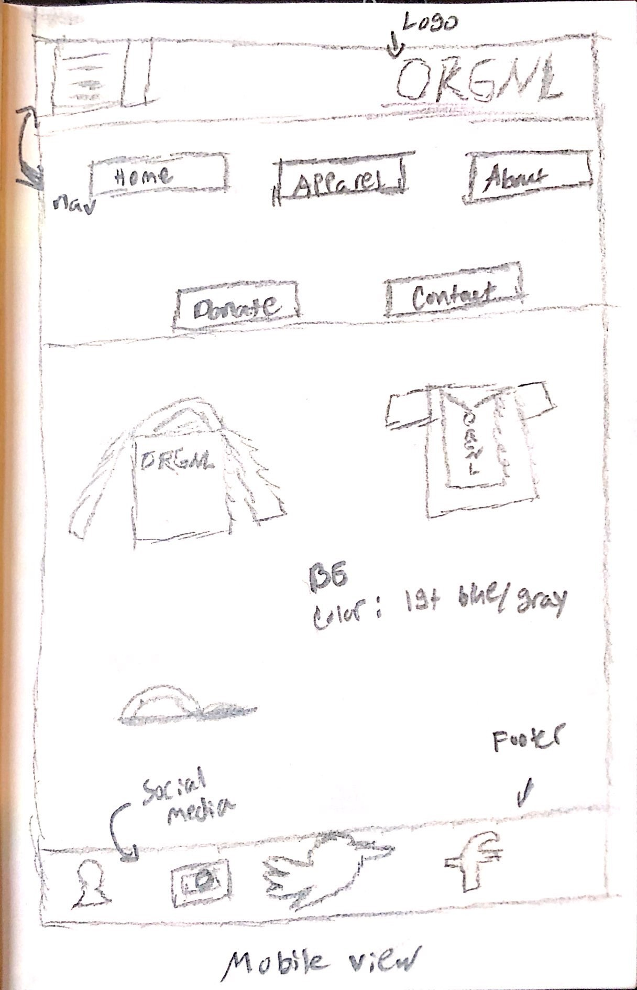

Small Screen:

Header: The header contains the logo on the right side and an expandable navigation menu on the left. The navigation menu expands to show 2 rows of 5 links.

Section: This section is the main area the user sees which showcases designs that are clickable and would take the user to the apparel page featuring those designs.

Footer: The footer just uses social media icons that would route the users to the social media site

Interactivity: Everything on the site would be clickable. The navigation buttons would take the user to the specific pages they click on. The apparel images in section 1 would take the user to the specific apparel items such as hoodies, shirts, or ball caps. The social media icons on the bottom would redirect the user straight to the Instagram, twitter etc. pages.

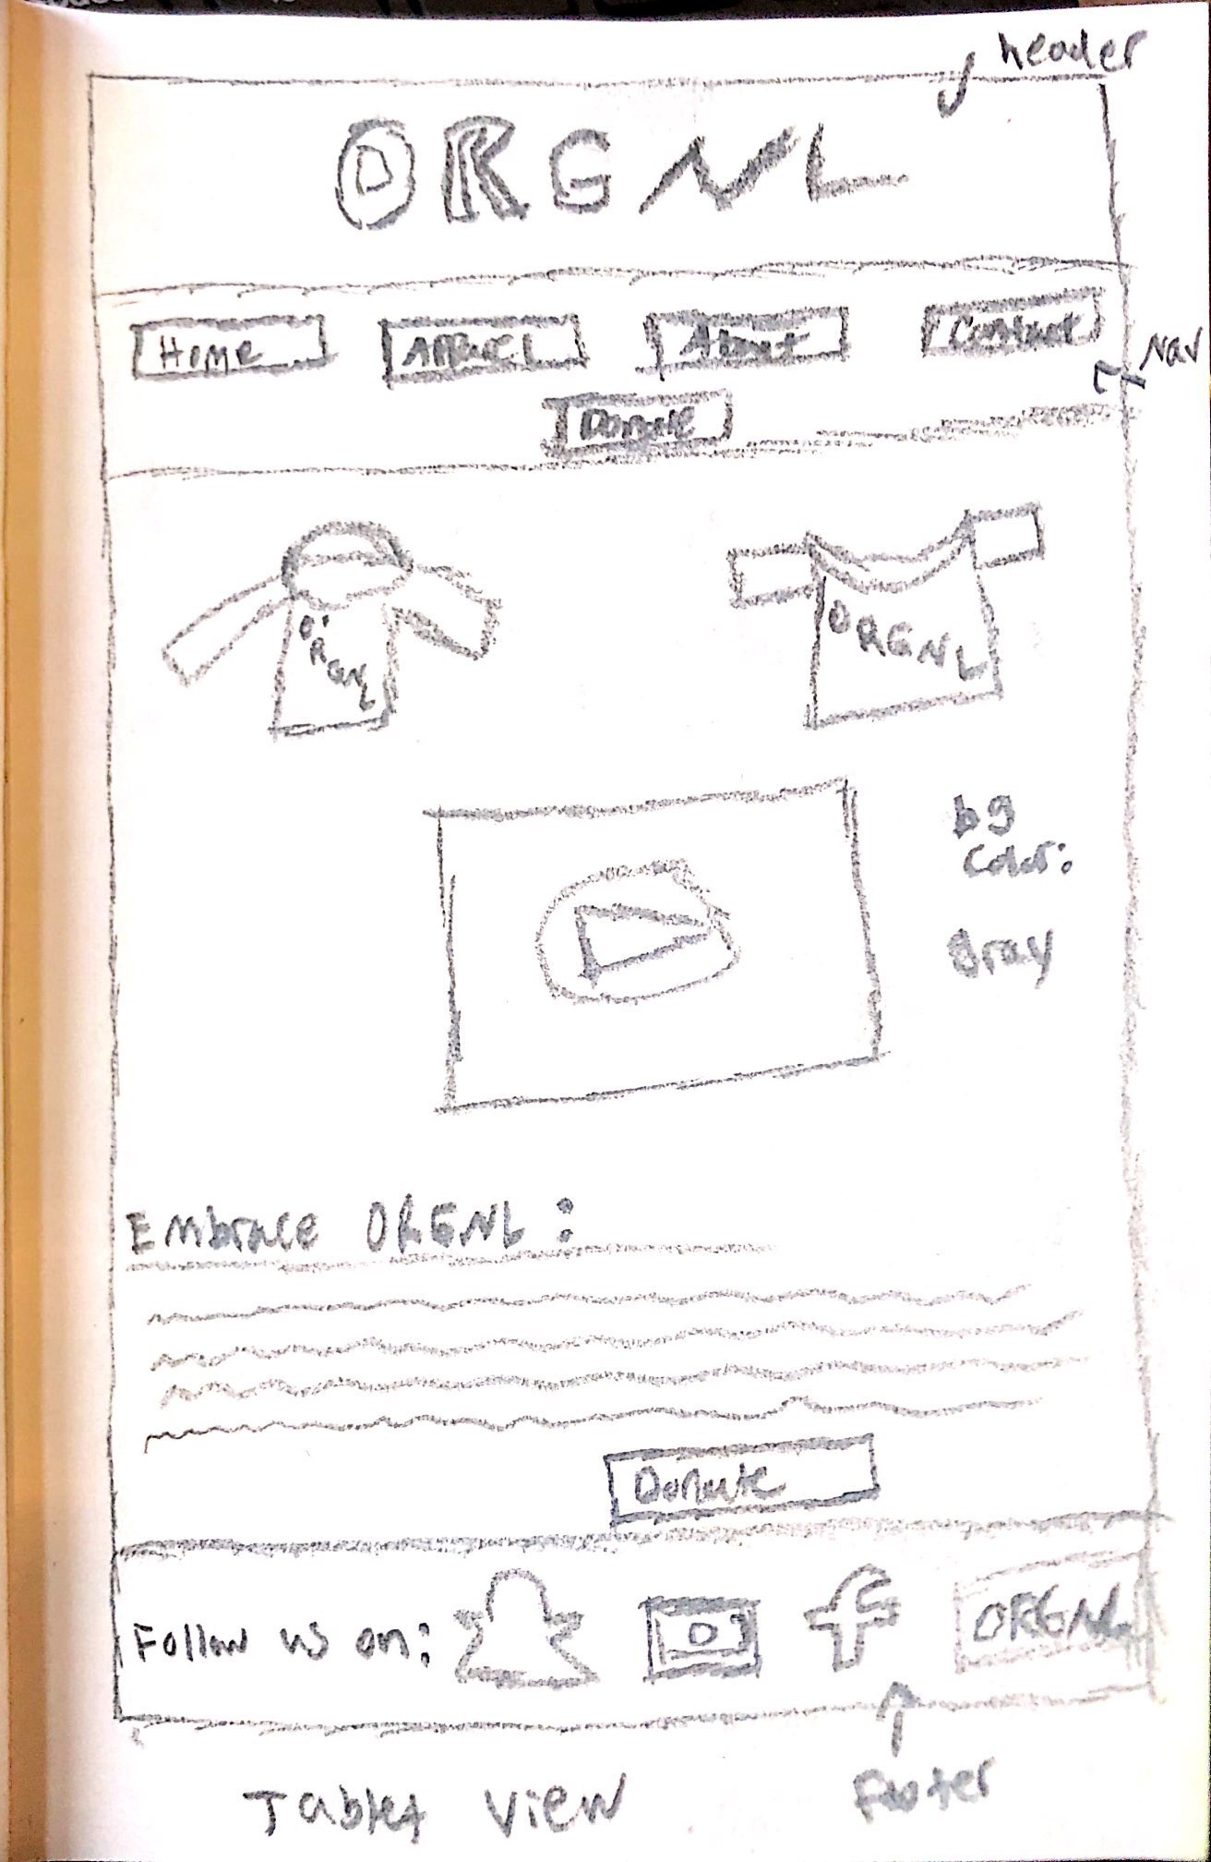n:

Medium Screen:

Header: The header contains the logo in the middle of the page. The navigation menu is below the logo with 2 rows, 4 sites up top and 1 below.

Section: This section is the main area the user sees which showcases designs that are clickable along with a video in the middle showcasing our work as well as exposing users to our crowdfunding camping. Below the video is a brief story on what we do and a button at the bottom to take the user to our donation page.

Footer: The footer has words along with the social media handles that takes the user to those respective sites.

Interactivity: Everything on the site would be clickable. The navigation buttons would take the user to the specific pages they click on. The apparel images in section 1 would take the user to the specific apparel items such as hoodies and shirts. The social media icons on the bottom would redirect the user straight to the Instagram, twitter etc. pages. The donation link would take the user to the donation page for the crowdfunding

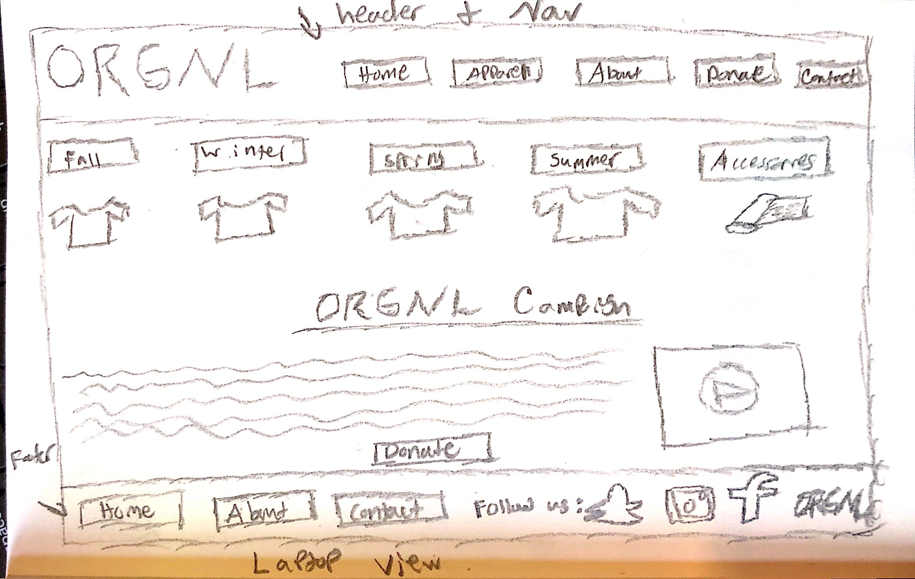

Large Screen:

Header: The header contains the logo on the left side and a full navigation menu in a row

Section: This section would showcase the apparel based on their styles, such as fall, winter, spring, and summer. Below the apparel would be information about our crowdfunding campaign with a video directly to the right floated to the side. Below the text about the campaign would be the donation link taking the user to the donation site.

Footer: The footer would be shortcuts to the navigation menu as well as our social media handles to the right and our logo.

Interactivity: Everything on the site would be clickable. The navigation buttons would take the user to the specific pages they click on. The apparel images in section 1 would take the user to the specific apparel items and the navigation buttons at the footer would take the user to those pages.