EE568-Assignment 2

1. 20 pole machine, 120 slots and 3 phase. For the design process, 2/3 pitch is selected (short pitch). Its slot per pole per phase (q) can be calculated as follows:

Its winding diagram will be as follows:

|  |  |  |  |  |  |  |  |  |  |  |  |
| --- | --- | --- | --- | --- | --- | --- | --- | --- | --- | --- | --- |
| **1** | **2** | **3** | **4** | **5** | **6** | **7** | **8** | **9** | **10** | **11** | **12** |
| A1 | A2 | -C1 | -C2 | B1 | B2 | -A1 | -A2 | C1 | C2 | -B1 | -B2 |
| B1 | B2 | -A1 | -A2 | C1 | C2 | -B1 | -B2 | A1 | A2 | -C1 | -C2 |

Then, angle between each coil (electrically) can be calculated as follows:

Furthermore coil pitch can be found as follows:

Then, distribution factor, pitch factor and winding factor can be calculated for fundamental harmonic

For 3rd harmonic, distribution factor, pitch factor and winding factor can be calculated as follows:

For 5th harmonic:

The dominant harmonic is fundamental harmonic as expected. On the other hand, choosing 2/3 short pitch, 3rd harmonic is eliminated. Moreover, magnitude of 5th harmonic is smaller. Thus, THD of the induced voltage is smaller and is close pure sinusoidal.

2) In this part, motor with 22 poles and 24 slots is chosen according to Emetor Winding Design. Its phase angle can be calculated as follows:

165°

Its winding diagram is given as follows:

|  |  |  |  |  |  |  |  |  |  |  |  |  |
| --- | --- | --- | --- | --- | --- | --- | --- | --- | --- | --- | --- | --- |
| **Slot no.** | **1** | **2** | **3** | **4** | **5** | **6** | **7** | **8** | **9** | **10** | **11** | **12** |
| **E. Angle** | **0** | **1815** | **3630** | **1485** | **3300** | **1155** | **2970** | **825** | **2640** | **495** | **2310** | **165** |
| **Angle** | **0** | **15** | **30** | **45** | **60** | **75** | **90** | **105** | **120** | **135** | **150** | **165** |
| **Phase** | A | B | -B | B | -B | -C | C | -C | C | A | -A | A |
| **Slot no.** | **13** | **14** | **15** | **16** | **17** | **18** | **19** | **20** | **21** | **22** | **23** | **24** |
| **E. Angle** | **1980** | **3795** | **1650** | **3465** | **1320** | **3135** | **990** | **2805** | **660** | **2475** | **330** | **2145** |
| **Angle** | **180** | **195** | **210** | **225** | **240** | **255** | **270** | **285** | **300** | **315** | **330** | **345** |
| **Phase** | -A | -B | B | -B | B | C | -C | C | -C | -A | A | -A |

Table 1: Slots, phases and phase angles of the machine with 22 poles 24 slots

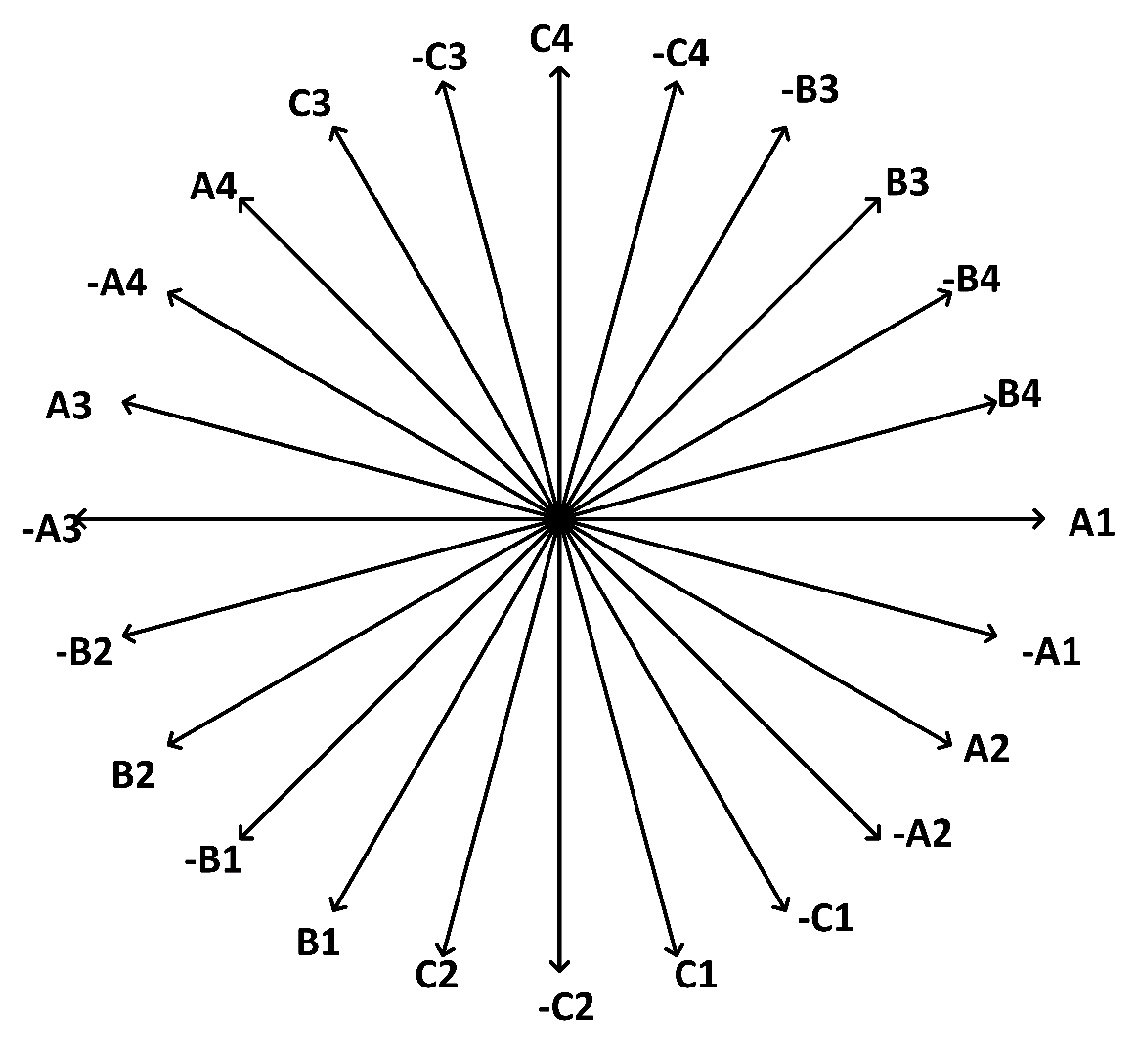

Figure 1: Phasor diagram of the machine for fundamental harmonic of the machine with 22 poles and 24 slots

For 3rd harmonic;

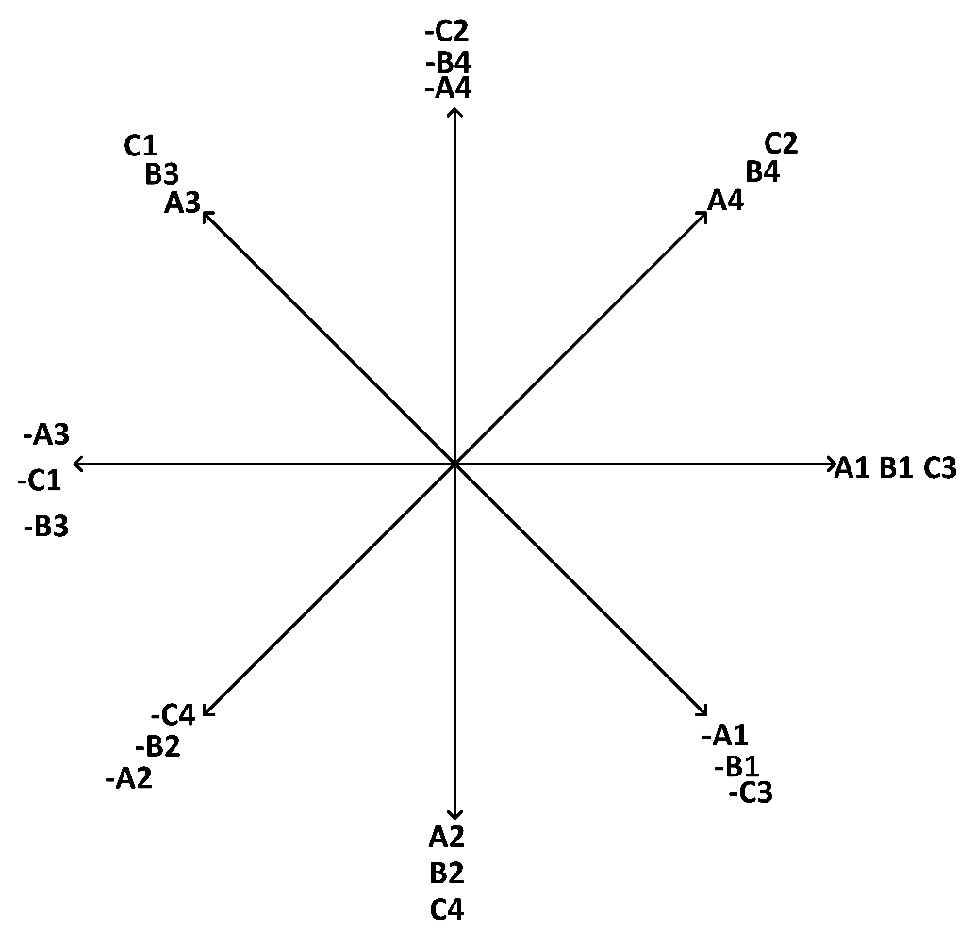

Figure 2: Phasor diagram of the machine for 3rd harmonic of the machine with 22 poles and 24 slots

For 5th harmonic:

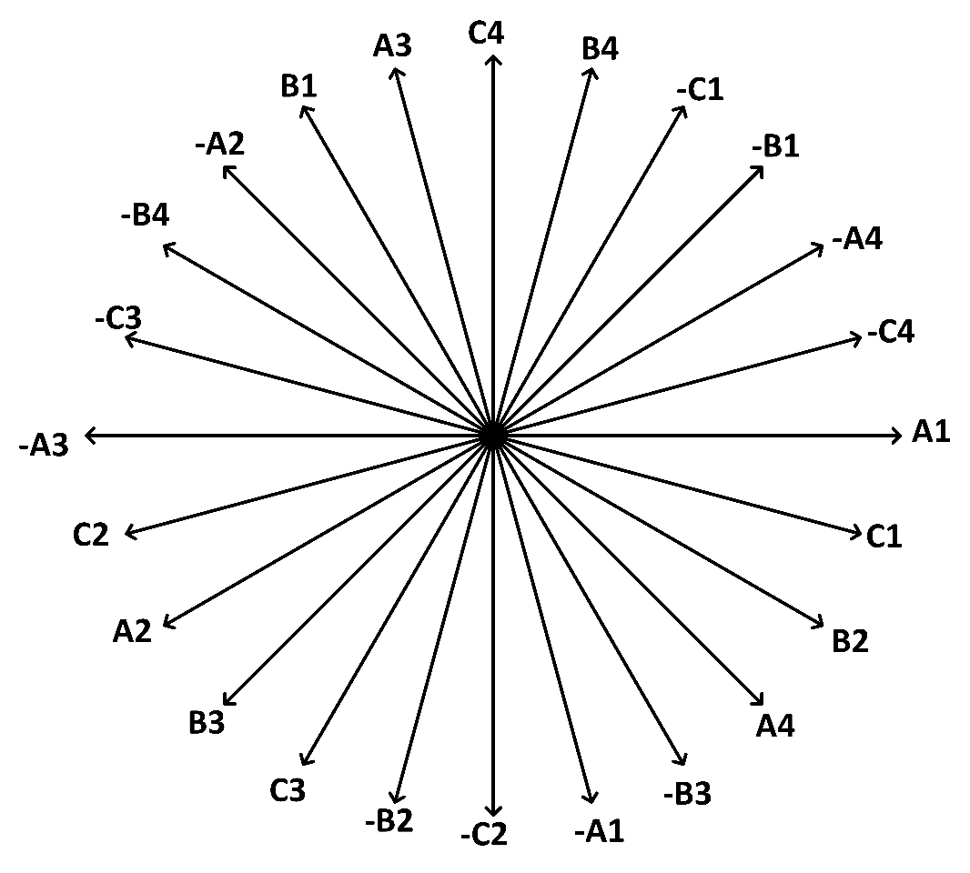

Figure 3: Phasor diagram of the machine for 5th harmonic of the machine with 22 poles and 24 slots

For another fractional slot machines design, 22 pole and 30 slots are considered.

132°

|  |  |  |  |  |  |  |  |  |  |  |
| --- | --- | --- | --- | --- | --- | --- | --- | --- | --- | --- |
| **Slot no** | **1** | **2** | **3** | **4** | **5** | **6** | **7** | **8** | **9** | **10** |
| **El. Angle** | 0 | 1452 | 2904 | 396 | 1848 | 330 | 792 | 2244 | 3696 | 1188 |
| **Angle** | 0 | 12 | 24 | 36 | 48 | 60 | 72 | 84 | 96 | 108 |
| **Phase** | A | B | C | A | B | -B | -C | -A | -B | -C |
| **Slot no** | **11** | **12** | **13** | **14** | **15** | **16** | **17** | **18** | **19** | **20** |
| **El. Angle** | 2640 | 132 | 1584 | 3036 | 528 | 1980 | 3432 | 924 | 2376 | 3828 |
| **Angle** | 120 | 132 | 144 | 156 | 168 | 180 | 192 | 204 | 216 | 228 |
| **Phase** | C | A | B | C | A | -A | -B | -C | -A | -B |
| **Slot no** | **21** | **22** | **23** | **24** | **25** | **26** | **27** | **28** | **29** | **30** |
| **El. Angle** | 1320 | 2772 | 264 | 1716 | 2168 | 660 | 2112 | 3564 | 1056 | 2508 |
| **Angle** | 240 | 252 | 264 | 276 | 288 | 300 | 312 | 324 | 336 | 348 |
| **Phase** | B | C | A | B | C | -C | -A | -B | -C | -A |

Table 2: Slots, phases and phase angles of the machine with 22 poles 30slots

For the fundamental harmonic:

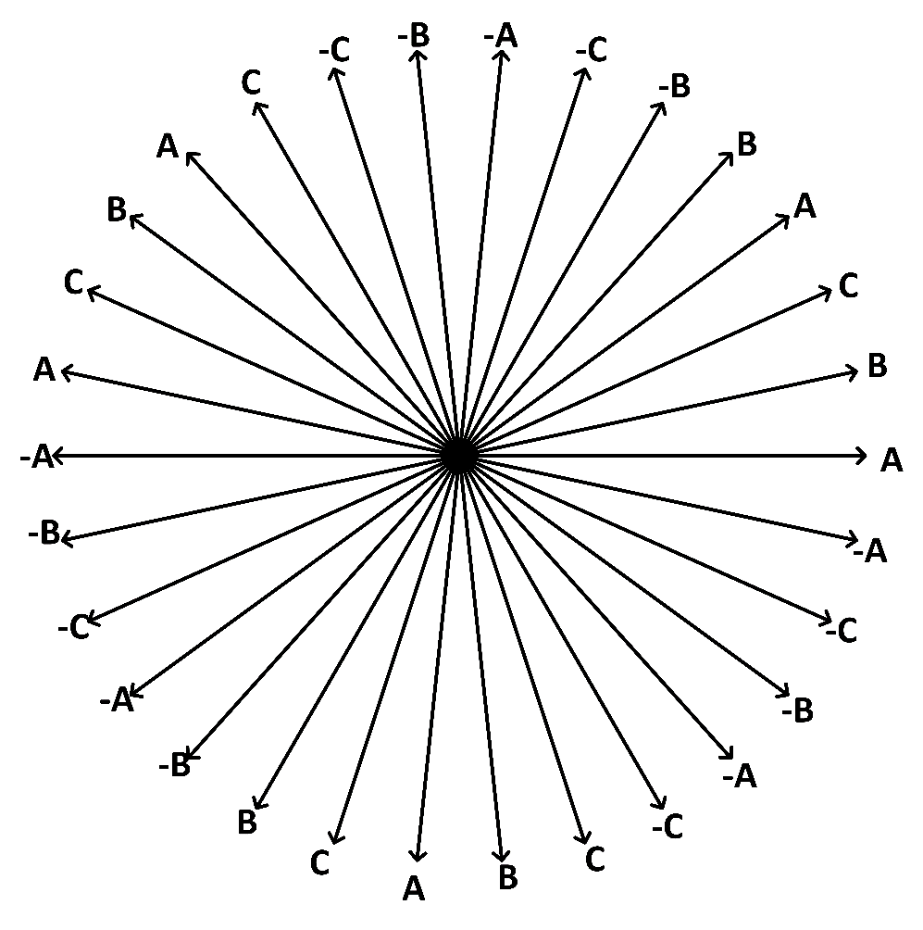

Figure 4: Phasor diagram of the machine for fundamental harmonic of the machine with 22 poles and 30 slots

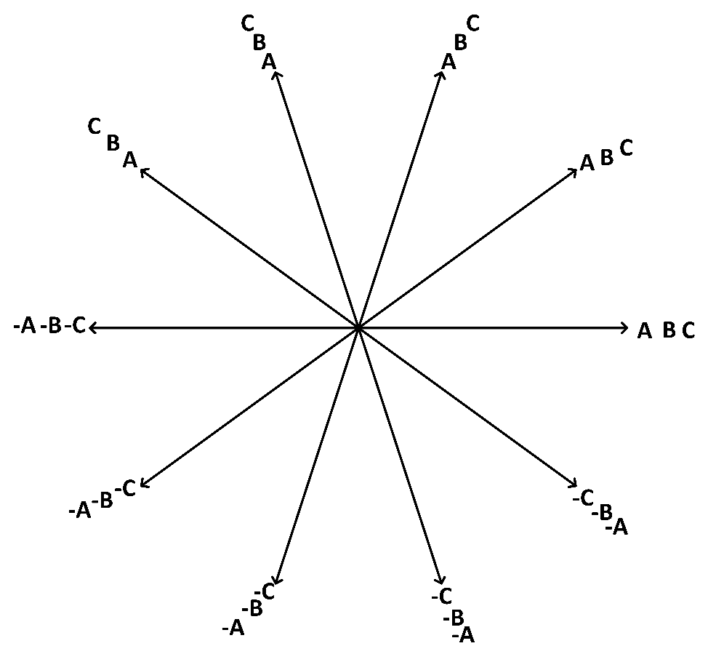 Figure 5: Phasor diagram of the machine for 3rd harmonic of the machine with 22 poles and 30 slots

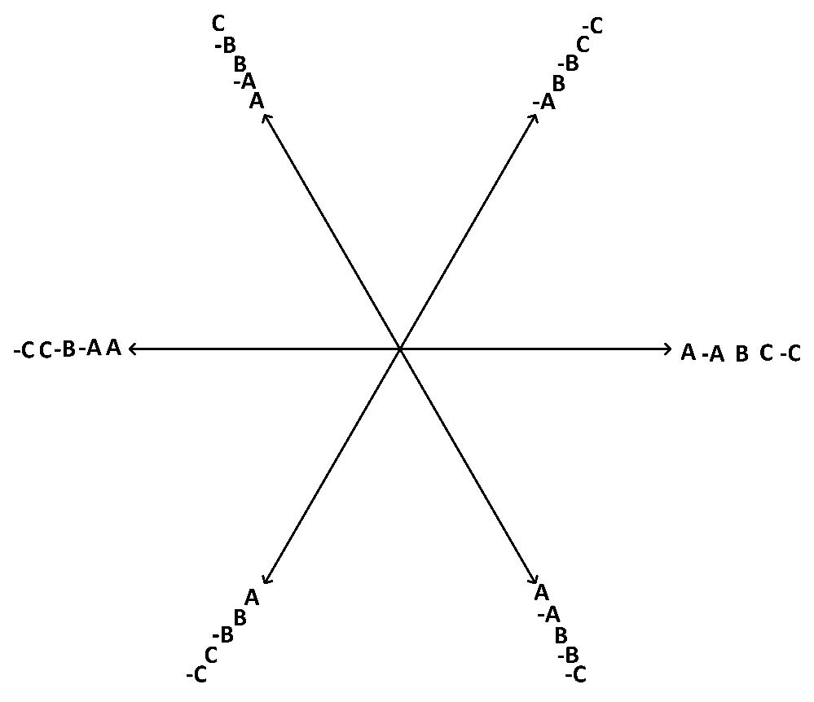

Figure 6: Phasor diagram of the machine for 5th harmonic of the machine with 22 poles and 30 slots

**Comparison of the designs:**

|  |  |  |
| --- | --- | --- |
|  | **22 poles and 24 slots** | **22 poles and 30 slots** |
| **Fundamental harmonic** | 0.958 | 0.873 |
| **Third harmonic** | -0.653 | 0.201 |
| **Fifth harmonic** | 0.205 | -0.1 |

Table 3: Winding factors of the harmonics and designs

As can be seen in Table 3, winding factor of the machine with 24 slots harmonics are higher than the machines’ with 30 slots harmonics. However, winding factor of fundamental harmonic of the first machine is higher. Also first machine windings are close to each other and length of the wires are shorter. This situation concludes with smaller resistance and least copper losses. As a result, second design has lower induced voltage under same conditions and higher copper losses. Thus, it can be said that first design is better.

3)

In this section, 22 pole 24 slot machine will be analyzed by using Finite Element Analysis in ANSYS MAXWELL. Moreover, frequency of the applied current is chosen as 50 Hz (272.72 rpm) and axial length is taken as 1 meter. Air gap is 1 mm, rotor diameter is 74 mm and outer radius of the machine 125 mm.

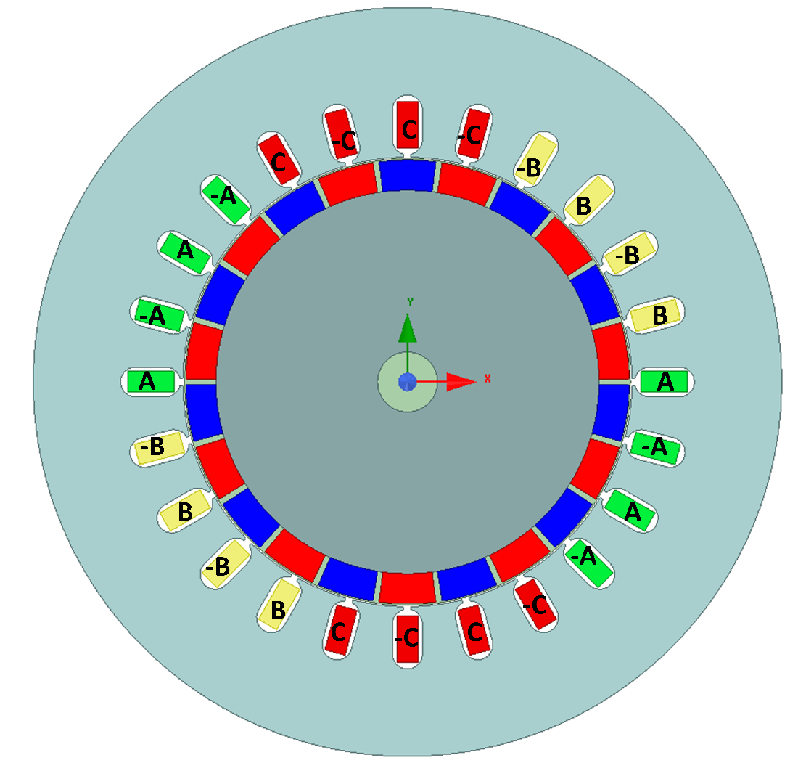

Figure 6: Cross section of the machine

Then, air gap flux density distribution in the air gap will be given. In the ANSYS MAXWELL, its magnitude and vector can be obtained. However, for a good observation, radial component of the flux density distribution should be given. By using calculator part, it can be obtained easily and given in Figure 7.

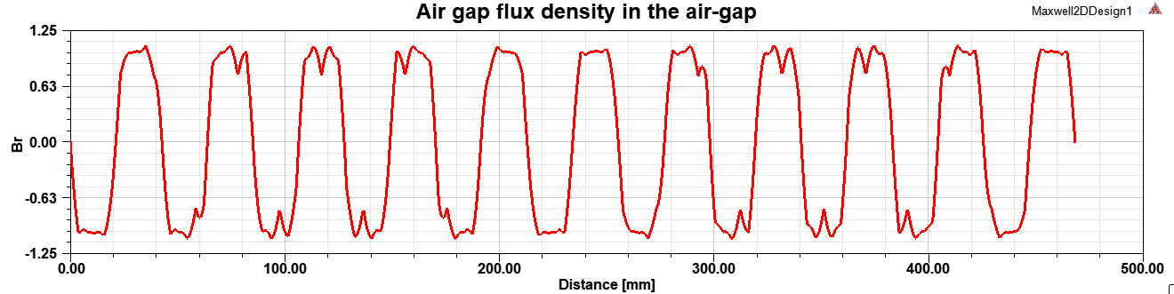

Figure 7: Air gap flux density distribution in the air gap (radial component)

Then, phase and line to line voltages are given in Figure 8 and 9.

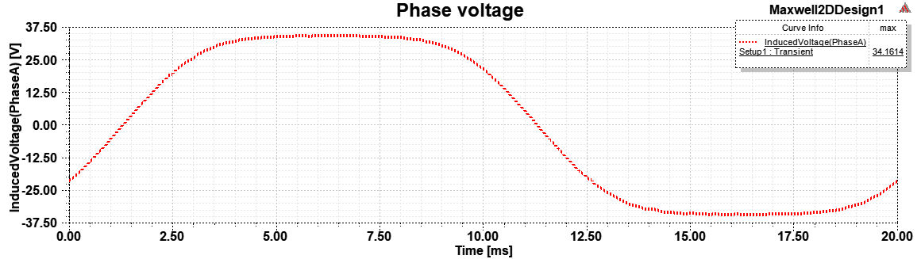

Figure 8: Phase A voltage at rated speed

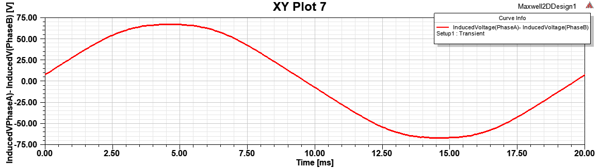

Figure 9- Line to line voltage (A-B) at rated speed

When phase and line-line voltages are compared, line-line voltage is more sinusoidal. Its third harmonic is canceled and its THD increases.

|  |  |  |  |
| --- | --- | --- | --- |
|  | Fundamental | 3rd harmonic | 5th harmonic |
| Phase voltage (Vl-l) | 39.15 | 5.6 | 0.517 |
| Air gap flux density (T) | 1.192 | 0.2616 | 0.085 |
| Flux per pole (mWb) | 16.04 | 1.17 | 0.23 |

Table 4: Harmonics of phase voltage, air gap flux density and flux per pole

In order to validate that winding factors are correct, harmonics are given in Table 4.

Then by using voltage equation given above, winding factors are corrected with small errors. This proves that winding factors are calculated correctly.

For permanent magnet machines, another critical issue is cogging torque. Cogging torque occurs due to the force between slot tooth and permanent magnets. This causes torque ripple and decreases the performance of the machine. It is given below:

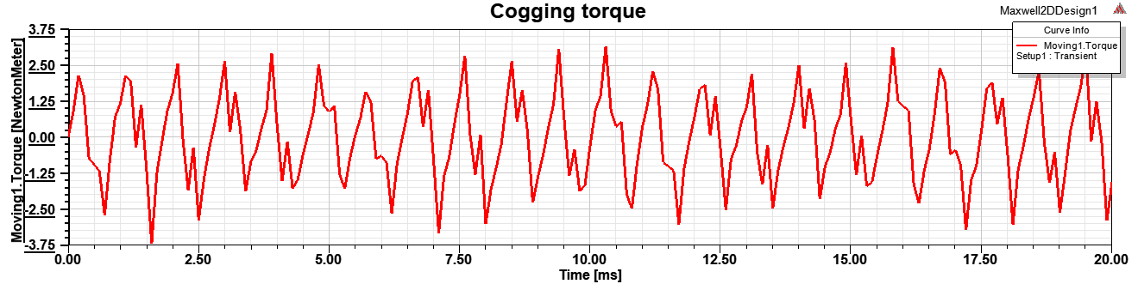

Figure 10: Cogging torque of the machine

In Figure 10, one period is shown. Frequency of the cogging torque of the machine is proportional to machine frequency and pole number. In one period of the machine, 22 periods of the cogging torque is observed.