Yusuf Basri YILMAZ

Project 3

EE568

1)Introduction

2)

2.1)

In this part, magnetic loading of the machine with the parameters given in Table 1 will be examined.

|  |  |
| --- | --- |
| **Parameters** | **Value** |
| Number of phases | 3 |
| Number of poles | 4 |
| Motor axial length (mm) | 100 |
| Air-gap clearance (mm) | 1 |
| Magnet to pole pitch ratio | 0.8 |
| Magnet type | NdFeB (N42) |
| Rotor diameter (mm) | 100 |
| Magnet thickness (mm) | 4 |
| Remanent flux of the magnet (Br) | 1.28 |
| Relevant coercivity of the magnet (µr) | 1.05 |

Table 1: Machine parameters

By using the equivalent magnetic circuit given in Figure 1 is used to find magnetic field in the air gap,

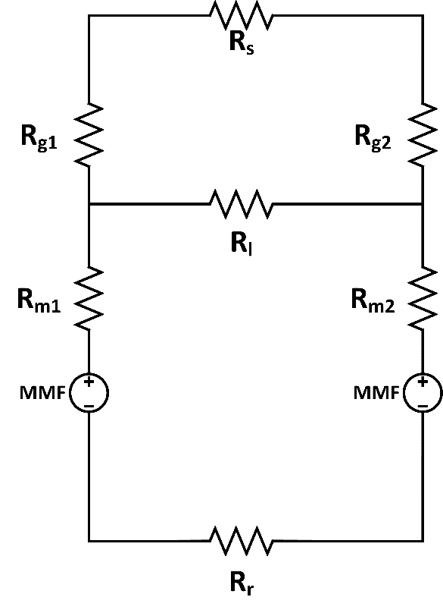

Figure 1: Equivalent magnetic circuit of the machine

Where Rs, Rr, Rl, Rg and Rm are reluctances of stator, rotor, leakage, air-gap and magnets, respectively. In this case, Rs, Rr and Rl are ignored. As a further step, MMF and reluctances of air-gap and magnets are calculated. For this purpose, area of magnet and airgap should be calculated initially.

=0.0063 m2 (1)

Then, by using general reluctance equation, reluctances can be found easily as follows.

(2)

(3)

Finally, MMF is calculated as follows:

(4)

Then, by using equivalent magnetic circuit of the machine and variables that are calculated above, magnetic flux density of the machine can be calculated as follows:

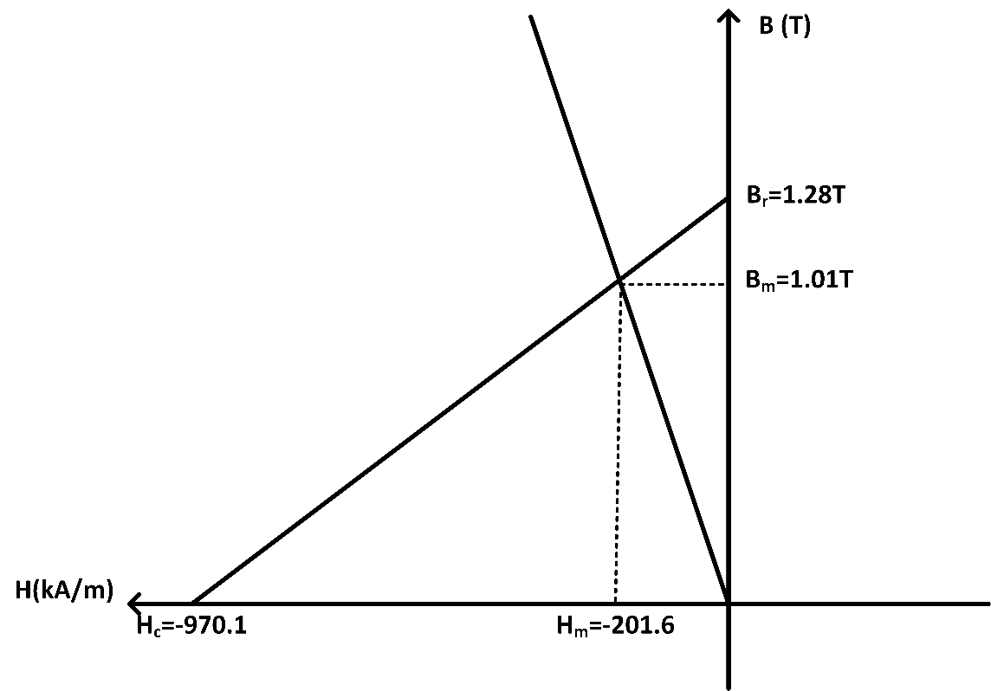

Figure 2: Load line and operating point on the B-H curve

2.2)

Magnetic loading of the machine can be calculated as follows:

(5)

2.3)

In this part, FEA validation of above parts is performed. FEA draw of the machine is given in Figure 2 and results are given in Figure 3.

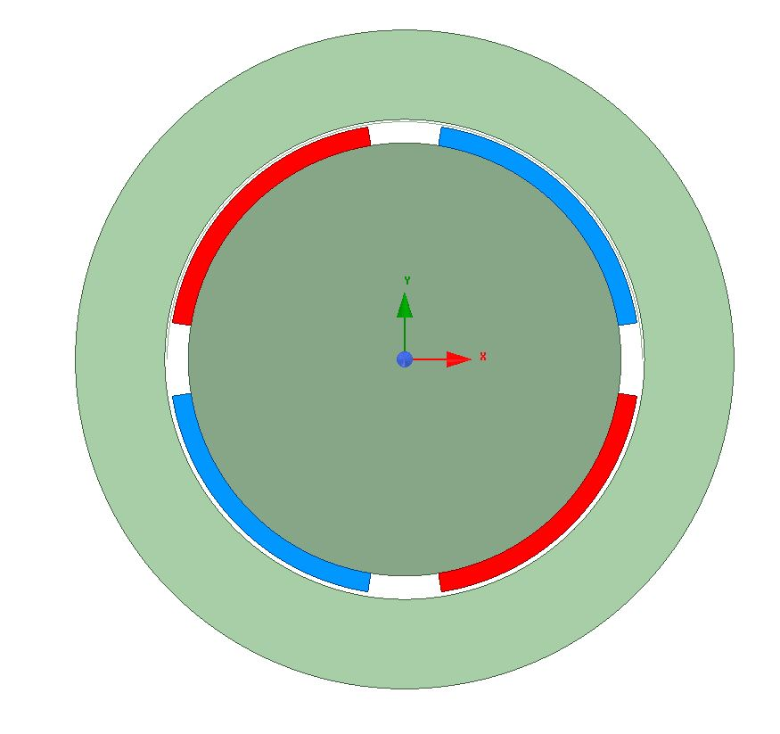

Figure 2: 2D FEA draw of the machine

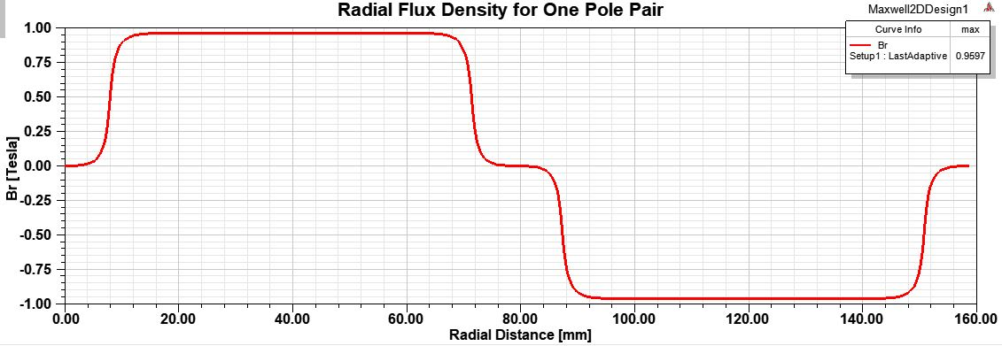

Figure 3: 2D FEA results of air gap flux density at r=(Ri+air-gap/2)

Analytical results and numerical results are close to each other but they are not equal to each other. While analytical calculations are performed, leakage flux can not be modelled and taken into consideration. However, numerical results includes leakage flux and this result is slightly smaller than analytical result.

3)

3.1)

In this part, slot number of the machine is chosen. In this case, q is taken two and the corresponding slot number is 24.

3.2)

In this part, wire diameter should be chosen. For this, the restriction is maximum current density (J) in the coil and it is 5 A/mm2. Also, coil current (I) for this machine is 2.5 Ampere. Then, minimum coil area can be calculated as follows:

=0.5 mm2 (6)

So, the wire diameter is chosen larger than that value in order to make sure that maximum current density in the coil is smaller than 5 A/mm2. If frequency is known and larger areas are acceptable, it can be discussed later. Then, AWG20 cable is chosen with 0.518 mm2  coil area.

3.3)

In this part, slot height, turn numbers in a slot and back core thickness are calculated. Firstly, slot ratio should be defined. Slot ratio is the ratio of diameter of inner part of slot to diameter of outer side of the slot (Di/Do). If it is chosen smaller, corresponding slot height is higher. Generally, it is chosen between 0.5 and 1. In this study, it is chosen as 0.6. Since Di is 102 mm, Do and slot height hs can be calculated easily as follows :

170 mm (7)

(8)

Moreover, turn number for each slot should be calculated. For this, slot area should be calculated. Firstly, the ratio of slot width to teeth width is chosen as 1 in this study. Then, width of a slot can be calculated as follows:

(9)

Then, fill factor is taken 0.6 for round wires and turn numbers can be calculated as follows:

(10)

Finally, back core thickness can be calculated by using the following equation (which is presented in the class) where kstacking is the stacking factor of the machine and it is taken as 0.95 in this study and toke flux density Byoke is taken 1.5 Tesla according to stator material:

(11)

3.4)

In order to calculated electrical loading, the formula given below is used (It is presented in the class):

(12)

Usual values of electrical loading for PMSM is presented in the class as 35-65 kA/m. The value that is found above is in this range. Therefore, it can be said that chosen parameters are logical by now.

3.5)

Average tangential stress of the machine can be found by using the equation given below where cosφ is taken 1 for PMSM:

(13)

Then, corresponding total force can be calculated as follows where is rotor surface area:

(14)